The Victorian Population Gambling and Health Study 2023

A brief summary of its findings.

**About the Survey**

The Victorian Population Gambling and Health Study was conducted as a phone survey of 11,000 Victorian adults in 2023, exploring patterns of gambling activity and associated financial and health issues.

The report mentions some challenges facing such investigations, its authors conceding that declining response rates, typically lower than 5% in Australian phone surveys, may reduce the representativeness through "...non-response errors, which refers to differences between those who are selected into a particular sample and those who end up completing the survey”. Mention is also made of a tendency for survey participants to under-report "...expenditure, frequency and negative consequences of gambling" due to a selective failure to recall such experiences or a reluctance to candidly report them. The findings of this investigation may be read with these considerations in mind.

**The Prevalence of Gambling**

The survey found that approximately half (53%) of Victorian adults had gambled during the previous 12 months, including similar proportions of women and men - at 51% and 56%, respectively.

The proportion of adults who had gambled, rose with age, from 40% of 18-24-year-olds, to its peak of 62% among people aged 65-74.

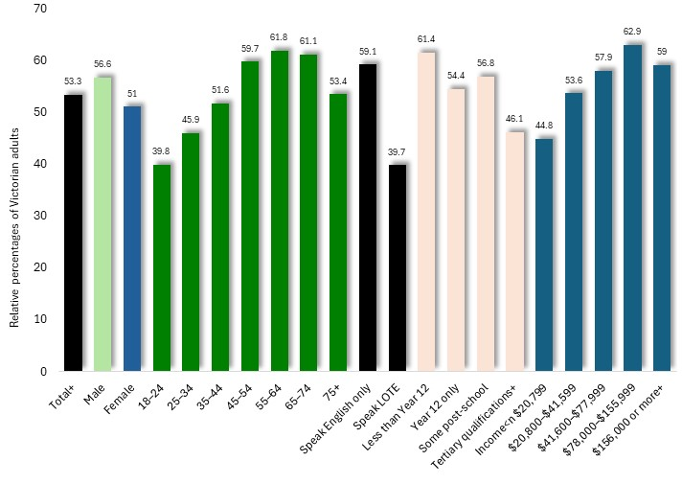Per cent of adults who gambled in the previous 12 months, by characteristics: Victoria, 2023

The proportion of Victorian adults who had gambled in the previous 12 months was generally higher among people who speak English only in their homes, among those with more limited formal education and among people on higher incomes.

**Participation in Gambling Types**

Approximately half (53%) of Victorian adults gambled in the previous 12 months, including over a third who participated in lotteries and one fifth in raffles.

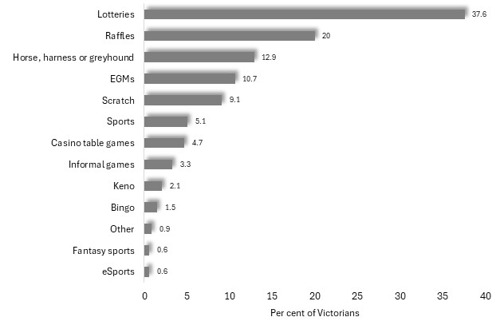Approximately one in nine (10.7%) Victorian adults had participated in EGM gambling and about one in twenty (5.1%) in sports betting.

Per cent of adults who gambled in the previous 12 months, by type of gambling: Victoria, 2023

Further information presented in the report shows that the proportion of Victorian adults who participated in gambling during the previous 12 months, had declined from 73% in 2008 to its present level of 53%, including a halving in rates of participation in EGM gambling from 21.5% to 10.7% during that period. Alone among the major forms of gambling, sports betting recorded a rise in participation, from 4% in 2008, to 5.1% by 2023.

Rates of participation in gambling vary widely among the various types of legal gambling. The diagrams presented below, illustrate these differences with odds ratios. For each variable shown here, such as sex, age, spoken language, educational attainment and income, one category is assigned the value '1', with the number assigned to other categories of that variable showing the rate of participation, relative to that category.

For example, in the diagram below, illustrating levels of participation in EGM gambling, the number 1 is assigned to males, with the number 0.9, assigned to females, showing that women are 90% as likely to participate in such gambling as men.

*Note: these odds ratios may only be compared among categories of a particular variable, such as sex, age, income and so on. The odds ratios may not be compared between categories of different variables, for instance, between 26-34 year-olds and people with year 12 education.*

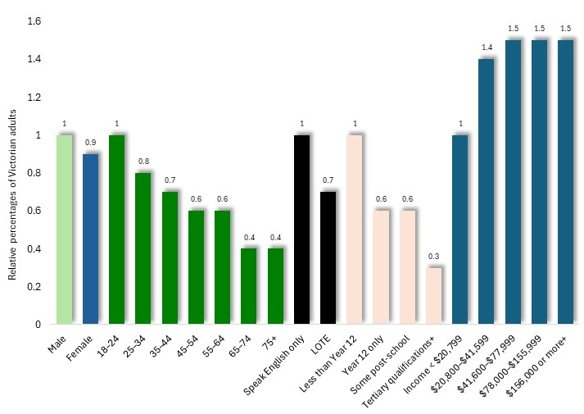

Odds Ratios, for participation in EGM gambling, by social characteristic: Victoria, 2023

Participation in EGM gambling tends to be slightly higher among men, younger adults, English-only speakers and those with limited formal education, and rises with increasing income.

The proportion of Victorian adults who participate in Casino gambling is more than twice as high among males as among women, is highest among young people, is somewhat higher among people with more limited formal education, and rises with increasing income.

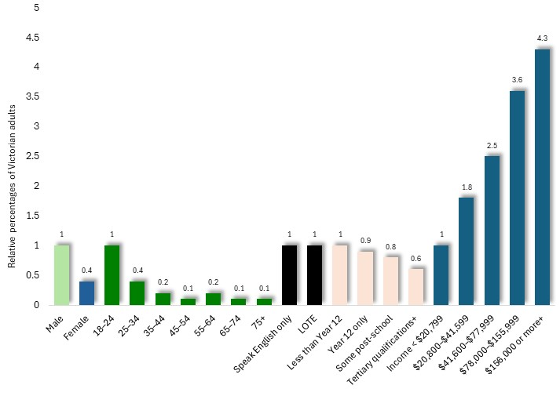

Odds Ratios, for casino gambling, by social characteristic: Victoria, 2023

The proportion of men who participate in sports betting is five times higher than for women, is highest among young people and those who speak English-only at home, and also rises with increasing income.

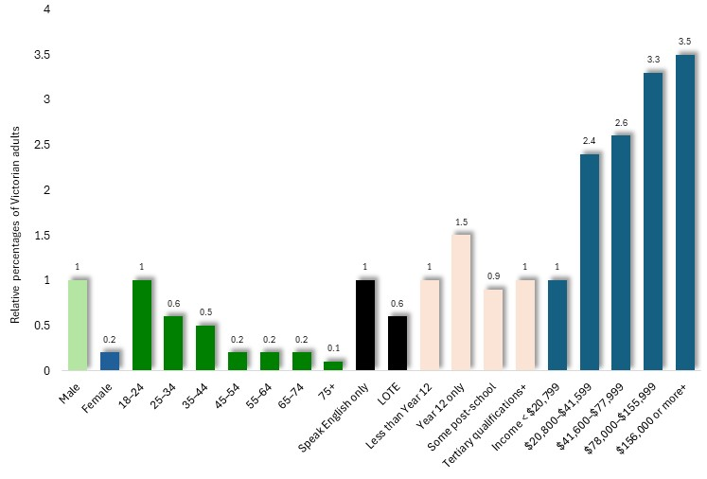Odds Ratios, for sports betting, by social characteristic: Victoria, 2023

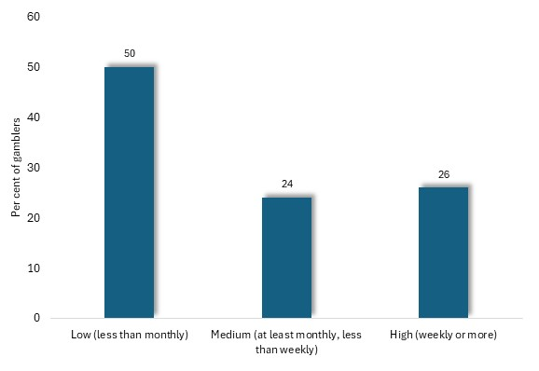**Gambling Frequency**

Half of Victorians who participate in gambling do so less than monthly, with about a quarter gambling at least monthly, but not weekly, and the balance participating at least every week.

Per cent of gamblers, by frequency of gambling: all gambling, Victoria, 2023

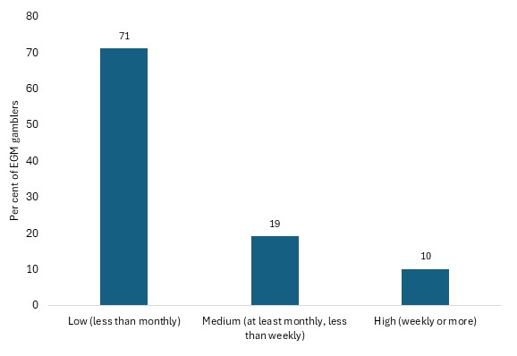

Among EGM gamblers, 71% participate less often than monthly, with only one-tenth - representing about 1% of Victorian adults - participating weekly.

Per cent of gamblers, by frequency of gambling: EGM gambling, Victoria, 2023

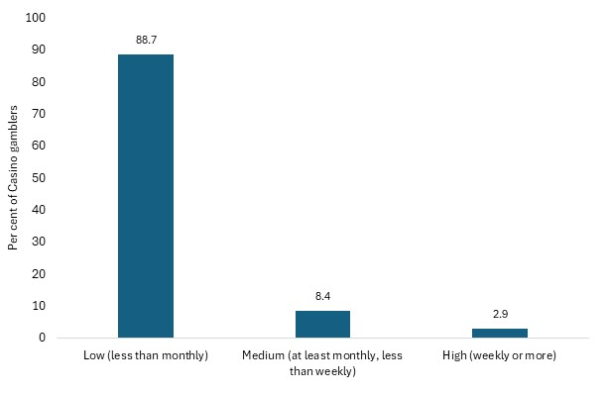

Similarly, among people who participate in Casino gambling, nearly nine-tenths do so less than monthly and only 2.9% as often as weekly.

Per cent of gamblers, by frequency of gambling: casino gambling, Victoria, 2023

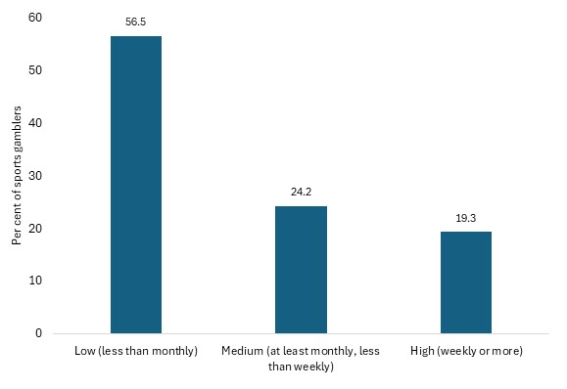Sports betters gamble more frequently than EGM or casino gamblers, with over half participating less often than monthly, but nearly one-fifth participating at least every week.

Per cent of gamblers, by frequency of gambling: sports gambling, Victoria, 2023

**Gambling Losses**

Survey respondents who participate in gambling acknowledged gambling losses averaging $2,453 in the preceding 12 months. The gambling activity associated with the highest level of losses was racing, accounting for average acknowledged losses of $5,915 per annum. [1]

Among people who participate in EGM gambling, losses to such gambling in the previous 12 months averaged $2,656 - a level which ranged from $158 among those who gambled on EGMs less often than monthly, to $8,212 among those who gambled at least weekly.

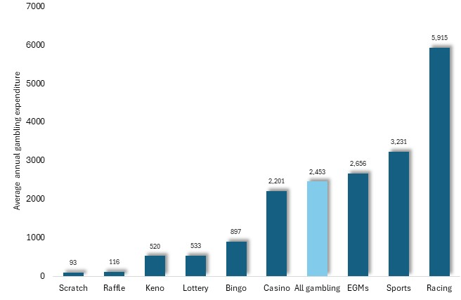

Average annual losses by gamblers, by type of gambling: Victoria, 2023

The accompanying chart sets out the proportion of gamblers who acknowledged losses of more than $10,000 in the previous 12 months, a figure which stood at 2.5% among gamblers in general.

Among EGM gamblers though, this rose to 6.1% - the highest percentage among all gambling types. Among Casino gamblers, 4.5% lost over $10,000 in the previous year, while for sports gamblers the figure was 4.2%. By contrast, less than 1% of scratch, raffle, lottery and Keno gamblers recorded such losses.

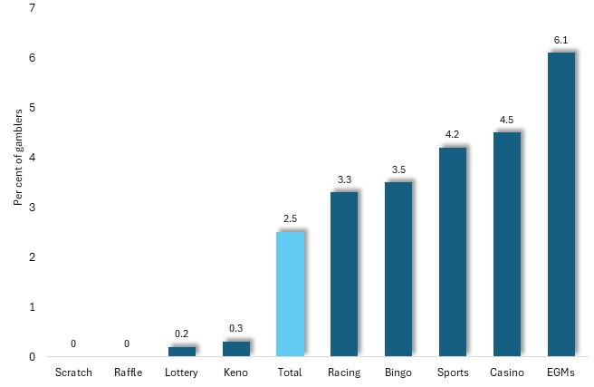

Per cent of gamblers who lost over $10,000 in the previous 12 months to gambling, by type of gambling: Victoria, 2023

**Gambling Losses and Social Characteristics**

We have seen that average annual losses acknowledged by gamblers in this survey was $2,453. This figure was over six times higher for males than for females, and highest among young people and those in their older age, among English speakers, those with tertiary qualifications and people on higher incomes.

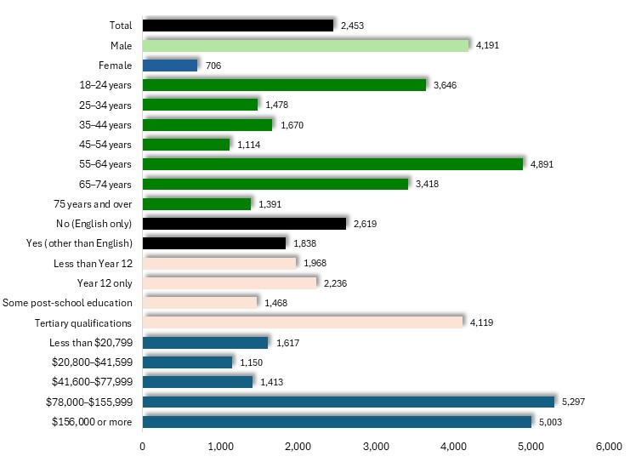

Average acknowledged losses to all forms of gambling *by gamblers*, in the previous 12 months, by community characteristics: Victoria, 2023

Among EGM gamblers, average acknowledged losses stood at $2,656. Losses were higher among non-English speakers, people with limited formal education and higher income earners.

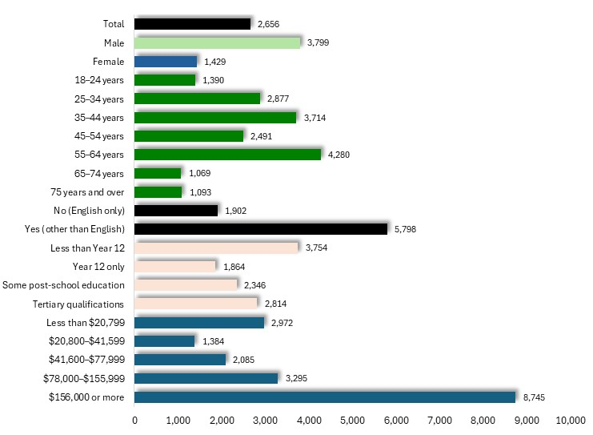

Average acknowledged losses to all forms of gambling by EGM gamblers, in the previous 12 months, by community characteristics: Victoria, 2023

It is scarcely surprising that losses incurred in the previous 12 months were highest among people who participate in gambling more frequently. For example, among those who gamble at least weekly, average acknowledged losses during the previous 12 months were $8,212, compared with $158 among those who participate less often than monthly. Similarly, among EGM gamblers, average losses among weekly gamblers stood at $5,344 compared with $312 among those who gambled less often than monthly.

**Online Gambling**

Nearly a quarter (23%) of Victorian adults (up from 19.2% in 2018/19), and 44% of gamblers, gambled online in the previous 12 months. The popularity of online gambling has risen in recent years. The proportion of Victorian adults who gamble online rose from 19% in 2018/19 to 23% by 2023, while among gamblers, the prevalence of online gambling increased from 27.6% to 44%. Among the most pronounced rises is the proportion of sports betters who gambled online, which quadrupled from 22% in 2008 to 86% by 2023; while the proportion of racing gamblers who bet online, rose eight-fold, from 6.8% to 55% in that period.

The proportion of gamblers who gambled online was similar for males and females, at approximately 48% and 40% respectively; declined gradually with age, from 61% of 25-34 year olds to 20.5% of people aged 75 or more; was similar for English and non-English speakers; was higher among people with tertiary qualifications, at 51%, compared with 30% of those with less than year 12 education; and was highest among high income earners, at 59% of those earning $156,000 or more p.a. compared with 35% of those on less than $20,799 p.a.

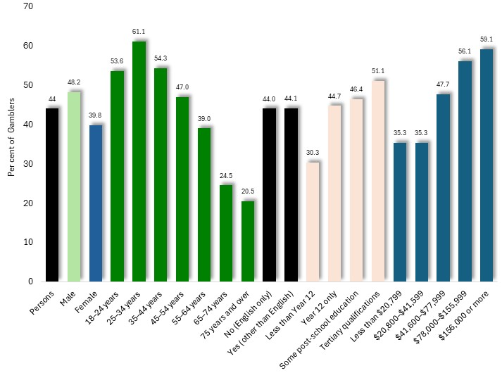

Per cent of gamblers who used online platforms to gamble in the previous 12 months, by characteristics: Victoria, 2023

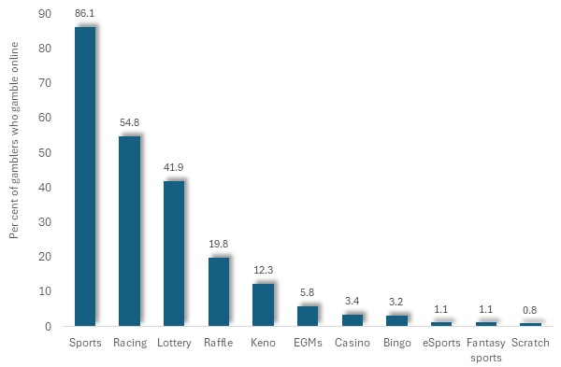The accompanying chart shows the percentage of gamblers who gambled online at some time during the previous 12 months. Among them, over four-fifths of sports gamblers and more than half of those who gambled on racing, used online means to participate in these activities.

Per cent of gamblers who participated in gambling online during the previous 12 months, by type of gambling: Victoria, 2023

**Participation in Online-only Gambling-like Activities**

In addition, 2.7% of Victorian adults participated in online-only gambling-like activities - generally through video gaming - including loot boxes, skins, fantasy sports and eSports betting. Levels of participation in these activities were seven times greater among males, and nearly 100 times more prevalent among young adults than among older people.

The pattern of participation in such online-only activities, with respect to such social characteristics, is reminiscent to that for online gambling, with the principal exception that levels of engagement differed little with income level.

Per cent of adults who participated in online-only gambling-like activities in the previous 12 months, by characteristics: Victoria, 2023

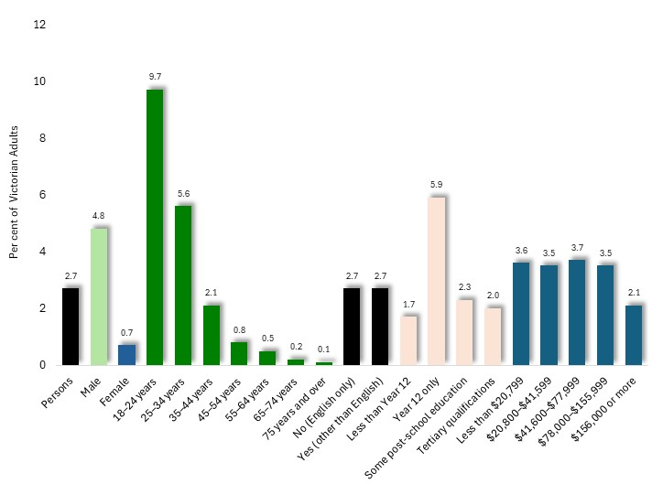

**Gambling Problems**

The prevalence of gambling problems, and the risk of problems, were measured in the study with the Problem Gambling Severity Index (PGSI), which features nine questions about feelings concerning gambling, financial problems stemming from gambling losses, and responses of friends of family to their gambling.

Overall, 8.5% of Victorian adults, including 11.2% of males and 5.9% of females, reported patterns of behaviour or consequences of gambling which placed them in the categories of low risk (5.3%), moderate risk (2.3%) or problem gambling (0.9%).

Among the gambling population 15.8% fell into this range, with 9.9% deemed at *low risk* of gambling problems, 4.2% at *moderate risk* and 1.7% classified as *problem gamblers* - the latter including 2.5% of males and 1% of females. (accompanying chart).

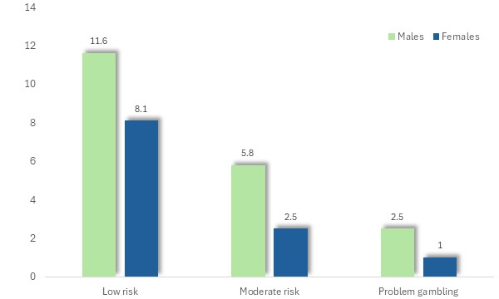

Per cent of gamblers classified as low-risk, moderate risk or as ‘problem gamblers’, by sex: Victoria, 2023

The proportion of gamblers classified as problem gamblers declined with age from 2.8% among 18-24-year-olds, to less than 1% among people aged 65 or more.

The prevalence of problem gambling was also highest among people who spoke languages other than English, those of lesser formal educational levels and people on lower incomes.

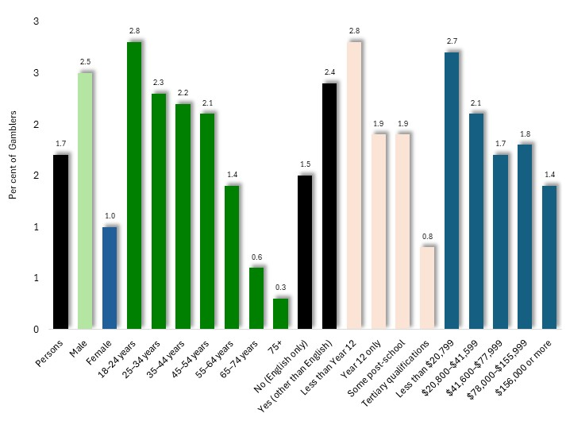

Per cent of gamblers who were classified as problem gamblers, by characteristic: Victoria, 20023

The proportion of gamblers who were classed as problem gamblers, also varied with gambling activity. Problem gambling was identified among 7.1% of EGM gamblers, 7.3% of those who gamble at the casino, 6.7% of sports betters and 3.7% of participants in racing gambling.

Among Victorian gamblers, 1.9% had been asked to take a break from their gambling, by venue staff, a figure which rose to 5.9% among people who gambled for 3 hours or more and 6.9% among problem gamblers. This finding appears to discredit the often-repeated claim by EGM venue operators that their staff closely scrutinise patrons for signs of problematic gambling and diligently intervene to curtail such behaviour.

**Gambling Harm**

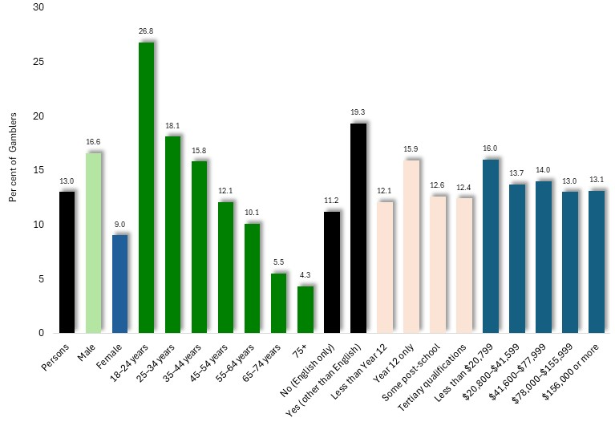The study found that 6.9% of Victorian adults, or 13% of gamblers, had experienced at least one form of gambling harm during the previous 12 months, such as financial difficulties, personal distress, or relationship conflict. The proportion of gamblers who had experienced such harm was highest among males, young adults, those who spoke languages other than English at home and people with year 12-only education. Little difference in the prevalence of gambling harm was observed by income level.

Per cent of gamblers who experienced any gambling harm, by characteristic: Victoria, 2023

The prevalence of the experience of gambling harm varied widely among gambling activities, ranging from 36% of people who gambled at the Casino, 35% of sports gamblers, 29% of those who gambled on EGMs, and 20% of racing gamblers.

**Gambling and Health**

Problem gamblers tended to have poorer self-assessed heath, higher levels of psychological distress and risky drinking, and more often smoked, than non-gamblers.

In particular, 34% of non-gamblers were ranked among the lowest quartile of general self-assessed wellbeing, compared with 86% of problem gamblers; 5.2% of non-gamblers were rated as experiencing psychological distress, compared with 43% of problem gamblers; 31% of non-gamblers were classified as risky drinkers, in contrast to 55% of problem gamblers, and 9.8% of non-gamblers smoke weekly, compared with 47% of problem gamblers.

**Awareness and Use of Gambler’s Support Services**

Nearly half (49%) of Victorian adults overall, and 42% of gamblers, did not know of any gambling support services. Among gamblers, those services most widely cited were the national Gambling Helpline, known to 34%, and Gamblers Anonymous, known of by 12%.

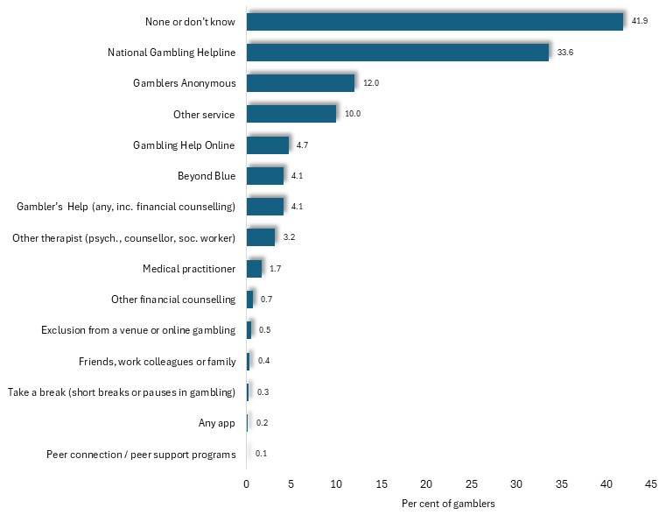

Per cent of gamblers who were aware of support services, by type of service: Victoria, 2023

Help had been sought for gambling problems in the previous 12 months by 23% of people classified as problem gamblers and 2.8% categorised as moderate risk gamblers.

**Gambling Advertising**

78% of Victorians had seen or heard gambling advertising in the previous week, chiefly on TV (51% of Victorians) through sport (38%), on posters (29%) and by radio (25%).

**Brief Profiles of Gamblers by Demographic Segment**

***Sex***

A similar proportion of women and men participate in gambling, including EGM gambling, and similar proportions participate in gambling online. Men however, are five times more likely to participate in sports gambling and more often engage in online-only gambling-like activities. Moreover, levels of gambling losses acknowledged by male gamblers are nearly five times higher than for women and their EGM losses are over twice those for women. Gambling problems are twice as common among male gamblers, is about twice that among women: 2.5% of men being classified as problem gamblers, compared with 1% of women; and 17% of men, compared with 9% of women, experience gambling problems.

|  |  |  |  |
| --- | --- | --- | --- |
|  | Males | Females | Males: % higher or lower than females |
| Participation in gambling | 56.6 | 51 | 11 |
| Participation in EGMs (odds ratio) | 1.0 | 0.9 | 11 |
| Participation in sports g. (odds ratio) | 1.0 | 0.2 | 400 |
| Participation in online gambling | 48.2 | 40 | 21 |
| Participation in online-only | 4.8 | 0.7 | 586 |
| Ave. G expenditure (gamblers) | $4,191 | $706 | 494 |
| Ave. G expenditure (EGMs) | $3,799 | $1,429 | 166 |
| Problem gambling - % gamblers | 2.5 | 1 | 150 |
| Gambling problems - % gamblers | 16.6 | 9 | 84 |

***Age***

While younger people (aged 18-24 for this comparison) are less likely to participate in gambling than older people (here, 55-64-year-olds), they are more likely to engage in EGM, sports, online and online-only gambling.

Though losses to gambling overall, and to EGMs, is lower among young gamblers, gambling problems among younger people are more prevalent than for older people, at 2.8% vs 1.4% respectively for problem gambling, and 27% vs 5.5% for gambling problems.

|  |  |  |  |
| --- | --- | --- | --- |
|  | 18-24 | 55-64 | 18-24 y.o.: % higher or lower than 55-64 y.o. |
| Participation in gambling | 40.0 | 62 | -35 |
| Participation in EGMs (odds ratio) | 1.0 | 0.6 | 67 |
| Participation in sports g. (odds ratio) | 1.0 | 0.2 | 400 |
| Participation in online gambling | 54.0 | 39 | 38 |
| Participation in online-only | 9.7 | 0.5 | 1840 |
| Ave. G expenditure (gamblers) | $3,646 | $4,891 | -25 |
| Ave. G expenditure (EGMs) | $1,390 | $4,286 | -68 |
| Problem gambling - % gamblers | 2.8 | 1.4 | 100 |
| Gambling problems - % gamblers | 27.0 | 5.5 | 391 |

***Educational Attainment***

People with limited formal education (less than year 12) are more likely to participate in gambling overall and on EGMs, through less likely to engage in online gambling; and they have a similar level of participation in sports gambling and in online-only gambling. Losses among gamblers of limited education are about half of those for people with a tertiary education - though higher for EGM gambling.

At 2.8%, problem gambling is more prevalent among gamblers with limited education than for those with tertiary education (0.8%), though rates of gambling problems are similar.

|  |  |  |  |
| --- | --- | --- | --- |
|  | less than yr 12 | Tertiary | < Yr 12: % higher or lower than tertiary |
| Participation in gambling | 61.0 | 46 | 33 |
| Participation in EGMs (odds ratio) | 1.0 | 0.3 | 233 |
| Participation in sports g. (odds ratio) | 1.0 | 1 | 0 |
| Participation in online gambling | 30.0 | 51 | -41 |
| Participation in online-only | 1.7 | 2 | -15 |
| Ave. G expenditure (gamblers) | $1,698 | $4,119 | -59 |
| Ave. G expenditure (EGMs) | $3,754 | $2,814 | 33 |
| Problem gambling - % gamblers | 2.8 | 0.8 | 250 |
| Gambling problems - % gamblers | 12.1 | 12.4 | -2 |

***Use of Languages other than English***

People who speak English only have slightly higher rates of participation in gambling, EGMs and sports gambling than those who speak languages other than English at home. The level of engagement in online gambling and online-only activities is similar among the two groups.

Gamblers who speak languages other than English have lower rates of annual gambling losses - though they have higher rates of losses to EGM gambling ($5,798 vs $1,902) - and are more likely to be problem gamblers (at 2.4%) than those who speak English only (1.5%).

|  |  |  |  |
| --- | --- | --- | --- |
|  | English | LOTE | English only: % higher or lower than LOTE |
| Participation in gambling | 59.0 | 40 | 48 |
| Participation in EGMs (odds ratio) | 1.0 | 0.7 | 43 |
| Participation in sports g. (odds ratio) | 1.0 | 0.6 | 67 |
| Participation in online gambling | 44.0 | 44 | 0 |
| Participation in online-only | 2.7 | 2.7 | 0 |
| Ave. G expenditure (gamblers) | $2,619 | $1,838 | 42 |
| Ave. G expenditure (EGMs) | $1,902 | $5,798 | -67 |
| Problem gambling - % gamblers | 1.5 | 2.4 | -38 |
| Gambling problems - % gamblers | 11.2 | 19.3 | -42 |

***Income***

People on the highest range of incomes (>$156,000) are more likely than those on lower incomes (<$12,600) to participate in gambling, including EGMs, sports and online, though less likely to engage in online-only activities.

Though gambling losses overall, and on EGMs, are greater among higher income gamblers, more lower income earners are problem gamblers, at 2.7% compared with 1.4% among higher income earners.

|  |  |  |  |
| --- | --- | --- | --- |
|  | lowest income | highest income | Low income: % higher or lower than highest |
| Participation in gambling | 45.0 | 59 | -24 |
| Participation in EGMs (odds ratio) | 1.0 | 1.5 | -33 |
| Participation in sports g. (odds ratio) | 1.0 | 3.5 | -71 |
| Participation in online gambling | 35.0 | 59 | -41 |
| Participation in online-only | 3.6 | 2.1 | 71 |
| Ave. G expenditure (gamblers) | $1,617 | $5,003 | -68 |
| Ave. G expenditure (EGMs) | $2,972 | $8,745 | -66 |
| Problem gambling - % gamblers | 2.7 | 1.4 | 93 |
| Gambling problems - % gamblers | 16.0 | 13 | 23 |

1. These expenditure figures should be treated with circumspection. If the average losses per EGM gambler are multiplied by the number of EGM gamblers in Victoria (equal to 10.7% of the State adult population of 5.44 million) to give an estimate of total Victorian EGM losses, the result is $1.547 billion, about half (51%) of *actual* losses recorded in 2023/24. This discrepancy confirms that a substantial proportion of EGM losses was unreported by respondents to the survey. Conversely, actual EGM losses in 2023/24, divided by the population of EGM gamblers (the State adult population x 0.107), yields an approximation of average losses during that year by EGM gamblers of $5,201 - about twice the figure given in the study.