**Calling for Expression of Interest**

**from**

**Community Groups & Not for Profits**

**Invitation to create a**

**Community Artwork Design for the**

**Harmony Square Letters**

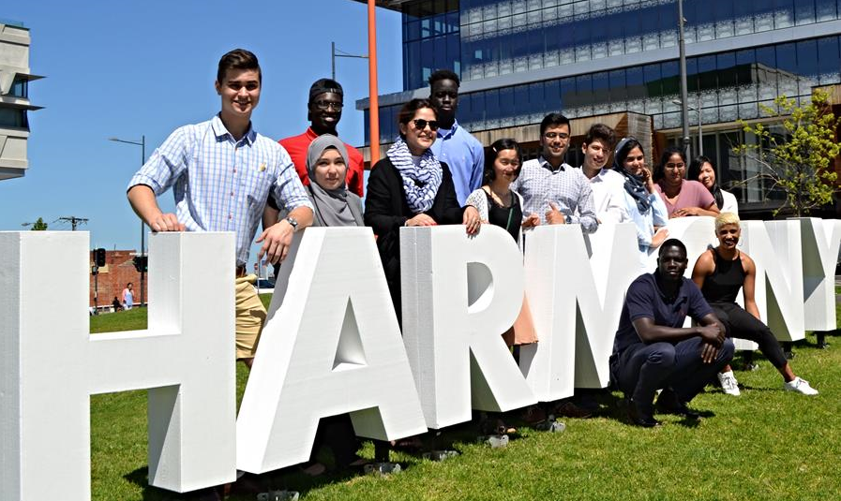

**INTRODUCTION**

The City of Greater Dandenong is seeking **Expressions of Interest (EOI)** from local community-based organisations / not for profits for a creative artwork design for the large Harmony Square letters.

The Harmony Square Letters are a much-loved temporary landmark and will be prominently displayed in Dandenong’s civic heart at the corner of Walker and Thomas Streets in central Dandenong. The location is between popular community destinations including the Library, Afghan Bazaar Cultural Precinct, and Civic Centre.

Each year a community organisation / not for profit will be invited to design a feature creative artwork for the letters. The creative artwork will be converted to a digital design and applied to the letters using a vinyl decal or wrap. As well as communicating the core value of ‘harmony’ it will put a spotlight on community themes and local stories about our people and place.

The letters will provide a wonderful point of pride and community engagement with photo opportunities for social media, local newspapers, selfies, sharing and Instagram‘able moments over the winter/spring period from May – November 2025.

**BACKGROUND**

Originally fabricated in 2015, the extremely popular Harmony Square large letters were created to publicly announce the name for Harmony Square when it first opened. In 2025 the letters are being remade in a new format, that enables the community to design the face of each letter, creating a unique look for each annual display period.

**PURPOSE OF THE PROJECT**

As well as creating a landmark placemaking and public art project, the Harmony Square letters fulfil the following purposes;

* Promotion of Harmony as a core community value.
* Involving the community in the creation and curation of their places and spaces.
* A creative canvas for community to share local stories and narratives.
* A space for elevating awareness of local community groups and their service to the community of Greater Dandenong

**CREATIVE BRIEF AND INVITATION TO COMMUNITY**

This EOI is open to local Greater Dandenong community organisations and not for profits that provide services and engage with local residents, businesses and visitors.

**The Project Requirements:**

* The project is open to a wide variety of mediums – such as illustration, collage, graphic design, text and photography.
* There are thirteen (13) large-scale letters spelling Harmony Square that make up the project.
* Local themes, community messages, local narratives & stories can be expressed through the creative artwork.
* The design is expected to be colourful, captivating and cohesive from a distance as well as legible up close.
* Submitters will be required to describe on one page their design, what it conveys and how this relates to the Greater Dandenong community.

**The Successful Community Group:**

*The selected community organisation or not for profit will be asked to;*

* Supply scanned imagery at a high resolution and/or original artwork at A3 size suitable to be scanned and produced onto the letters by a graphic designer assigned to this project.
* Use the 13 letter template provided by the City of Greater Dandenong to communicate the design intent.
* Review the final art files (created by the graphic designer) before printing to ensure the integrity of the community creative artwork is visually translated and upheld.
* Allow use of the final design to the City of Greater Dandenong for this expressed purpose.
* Understand that transferring the design onto each letter, supply of the three-dimensional product, installation and maintenance will be the full responsibility of the City of Greater Dandenong and its appointed qualified contractors.
* Maintain copyright over the creative artwork design and accept that the design will be licensed in its final form to the City of Greater Dandenong to promote, share and market for the duration of the display period.
* Be credited with signage accompanying installation of the letters and explaining the story behind the creative artwork design.
* Asked to participate in media and photo opportunities to promote the community, its services and the project.

**PROJECT FEES / PAYMENT**

An honorarium of $1,950* (inc GST) will be paid to the community organisation / not for profit. This includes:

* Development of any original artwork, illustrations or photos for scanning.
* Mock up onto the 13 letter template supplied by Council.
* Writing the accompanying story that explains the designs message.
* Meetings, phone calls and emails as needed with the graphic designer to ensure the community creative artwork is visually translated and upheld in the print ready files.

*Costs relating to graphic design, preparing print ready files, applying the printed vinyl wrap, installation and removal of the letters – are costs which will be fully managed and met by the City of Greater Dandenong.

**SUBMISSION REQUIRMENTS**

Submissions must be received via email to [placemaking@cgd.vic.gov.au](mailto:placemaking@cgd.vic.gov.au) by **4pm on Thursday 13th March 2025**. After this date late submissions will be closed.

Please submit the following;

* Short description of the community-based organisations / not for profit (location, background, purpose, target group) and why this opportunity interests you.
* Description of the theme or message you want your creative artwork design to communicate and its connection to Greater Dandenong community.
* Who in your organisation will be involved in generating the creative artwork design.
* Examples of any relevant projects that detail your community groups experience in successful creative outcomes.

* Do not supply any concept drawings (your ideas for this project) as part of this EOI

**Selection Criteria**

All submissions will be assessed against the following criteria

|  |  |
| --- | --- |
| **Topic** | **Weighting** |
| Capability of the Community Group / not for profit to successfully undertake the project (project management and past projects) | 25% |
| An appreciation of the project requirements | 25% |
| Relevance of the artwork theme to the Greater Dandenong community and the core value of harmony | 25% |
| Diversity of participants involved in making the creative artwork design (women, young people, children, older people, people living with a disability, LGBTQI) | 25% |

**PROJECT MANAGEMENT**

**Key Dates**

|  |  |
| --- | --- |
| **Submission Phase** | |
| Late January 2025 | EOI submissions open |
| 13th March 2025 | EOI submissions close at 4pm |
| 13-20 March | Selection against assessment criteria |
| 24th March | Community organisations notified of outcome |
|  |  |
| **Design Development Phase** | |
| 31st March | Initial project briefing and confirmation of tasks |
| 1 April – 21 April | Develop artwork, illustrations or photos for the 13 letter template |
| 14 – 21 April | Accompanying story that explains the designs message prepared by community organisation |
| 21 – 25 April | Graphic design and print files prepared (by others) |
| 28 – 30 April | Review / feedback and Sign Off by community organisation & Council |
| 5 May | Final artwork, graphic design files sent to production (by others) |
| 5-9 May | Printing and vinyl wrapping letters by a Council contractor |
|  |  |
| **Display Phase** | |
| 14 – 15 May | Letters transported to site and installed (by Council) |
| 19 – 20 May | Photo opportunity and co-promotion of the letters, artwork design, theme and community organisation |
| May - July | Social media campaign, promotion and key messages |
| May - October | Maintenance and weekly checking of letters condition |
| 31 October | Letters de-installed and vinyl wrap removed for storage (by Council) |

**Further Information**

This project is being delivered by the Placemaking and Revitalisation Team. If you have questions or wish to discuss your submission you are warmly invited to speak with the day-to-day contact person for this project;

Jenny Pemberton-Webb | Place Manager, Placemaking and Revitalisation

0414 015 906 | jpembe@cgd.vic.gov.au

Further Information: [www.greaterdandenong.com](http://www.greaterdandenong.com)



