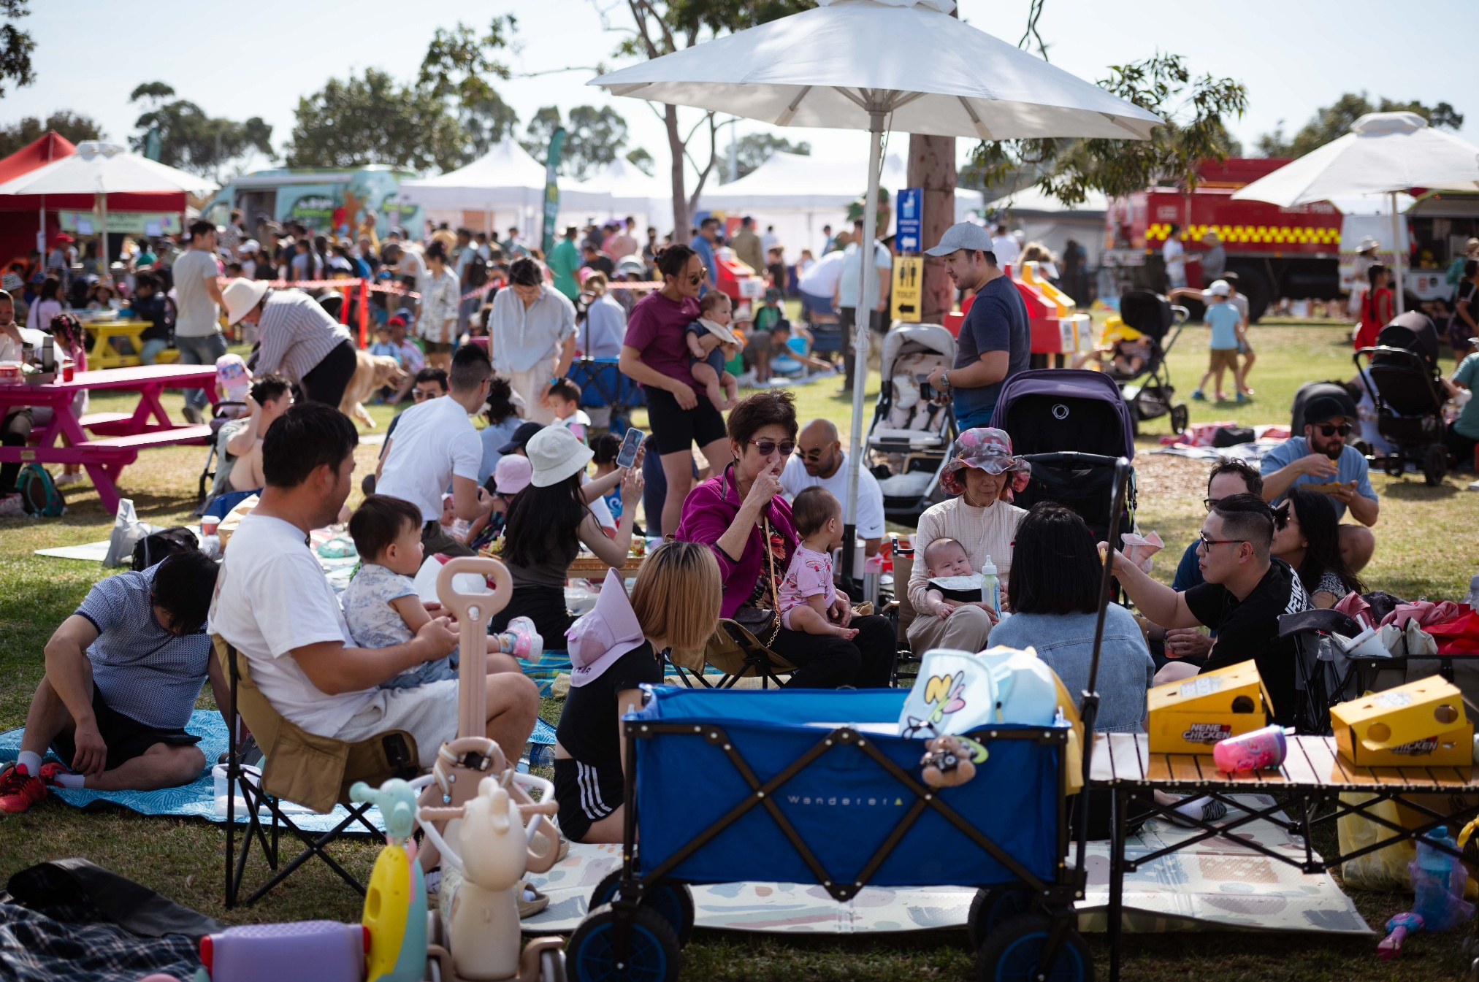



City of Greater Dandenong
Keysborough’s Big Picnic 2026
Community Stall Fact Sheet

Keysborough’s Big Picnic 2026
Event date: Sunday 29 March 2026
Event times: 11am – 4pm
Location: Frederick Wachter Reserve, 133-155 Kingsclere Ave, Keysborough
Expected attendance: 6,000
Event Description: Keysborough’s Big Picnic is the City of Greater Dandenong’s only pet friendly event. Held at Frederick Wachter Reserve, this family friendly picnic welcomes furry, feathered, or scaled companions. Attendants can with a day of live entertainment, delicious food and a variety of activities for all ages.

Deadlines
Expression of Interest closes: 27 January 2026
Successful traders informed: 30 January 2026
Invoices paid by: 20 February 2026

Please note
Some event details and deadlines may be subject to change by the City of Greater Dandenong Council.

Stallholder Application Instructions
- Please complete the online: Community Stall Application – Keysborough’s Big Picnic 2026
- Please complete as many sections of the form as you can and upload relevant documents. Some fields are mandatory. Applicants which provide detailed responses for all fields will be prioritised for selection.
- When submitting the form, wait until you have reached the submission confirmation screen before closing the window. If you get a notification about incomplete information, please complete these sections then click 'submit' again.
- If you don’t receive confirmation of your application within two days, please email events@cgd.vic.gov.au as we may not have received your form.
Important:
The act of applying does not guarantee participation in an event. You will be informed by email if your application has been successful.
Successful stall holders must ensure that all the relevant statutory and regulatory obligations have been complied with before attending the event. If you have not obtained the appropriate permits, you could face serious consequences such as on-the-spot fines and court action.
Assessment: All applications will be assessed on several different areas and weighted accordingly. It is recommended to consider the following selection criteria when completing the EOI form:
- Valid Public Liability Insurance
- Not for Profit or charitable organisation evidence
- Working with Children Checks
- Previous attendance and compliance with City of Greater Dandenong festivals and events and local law regulations.

Site Hire Fees
Community Stallholder is only for charity and community not for profit organisations (proof will be required). Community stallholders will be offered a free (3m x 3m) space when they can provide a free interactive activity that fits with the festival objectives.
Please note that:
- A Festivals and Events officer will be in contact to discuss your proposed activity, not all interactive activities will be approved.
- An information stall will not be classified as an interactive activity.
- A free space will not be provided if the community stallholders are selling food/drinks during the event or operate an information only stall.

Not for profit BBQ or Community Info stall
Length (serving side) x Width | Details | Fee
3m x 3m | Space only (marquee not provided) | $50.00
6m x 3m | Space only (marquee not provided) | $100.50
3m x 3m | Space and Council provided marquee | $310.00
6m x 3m | Council provided marquee | $580.50

Fees listed are based on common stall/van/truck/trailer sizes. If your proposed stall and display size is outside the listed options, please confirm site fees with Festivals and Events team by emailing events@cgd.vic.gov.au.
Options with ‘Space and a Council provided marquee’ include a set up marquee with three walls only but does not include furniture such as trestle tables, chairs and weights.
All stallholders bringing their own marquee must comply with all relevant regulations and provide adequate equipment including appropriate weights of 40kg per leg or higher if pending wind forecast. All marquees will be subject to approval to ensure quality and sturdiness.
Stallholders without adequate equipment or appropriate setup on the event day will not be permitted to trade and will be asked to leave. Limited equipment will be available for hire from onsite infrastructure contractor.
Additional Infrastructure Hire Fees
If you require trestle table, chairs or marquee weights, please see the costs below.
Item | Fee
Trestle Table | $20.00
Chair | $5.00
Marquee weights (40kg per leg) | $20.00 per leg

Power Hire Fees
If you require power, please see the costs below. We can provide the following:
Item | Fee
1 x 10-amp circuit | $45.50
1 x 15-amp circuit | $68.50

Terms and Conditions
Legal Requirements
Public Liability Insurance
A valid copy of your Public Liability Insurance on the date of the event is a compulsory requirement for participation in this event.
A Public Liability and Productions Liability insurance policy in a form approved by the Council; noting the Council as a Principal, insuring for a sum of not less than twenty (20) million dollars the Council and the Stallholder against all actions, costs, claims, charges, expenses and damages whatsoever which may be brought or made or claimed against the Council or Stallholder, or both arising out of or in relation to this agreement. The policy must also confirm that the insurance cover includes across liability clause extending the policy so that the words “the insured” shall be considered as applying to each party comprising the insured, as though a separate policy has been issued to each of the parties in the same manner as if that party were the only party name as the insured. Proof of this policy must be by way of certificate of Currency.
Such other policies the Council may reasonably require. It is highly recommended that this include a policy to cover damage to the contents of the site including all fixtures and fittings against loss or damage by fire, storm and tempest, explosion, earthquake, riots, strikes, malicious damage, impact by vehicles including aircraft and other aerial devices, extraneous water including flood, burglary, and damage by burglary and accidental damage for their full reinstatement and replacement value.
This will need to be supplied when submitting your application.
Working with Children Check
City of Greater Dandenong is a child safe organisation. It is a compulsory requirement for all staff working on the event day to hold a current and valid Working with Children Check (WWCC). These must be submitted with your application form and be brought on the day of the event.
Plastic Use Policy
Further to the Victorian Government state-wide ban on single use plastics, the City of Greater Dandenong is reducing the impact of plastic pollution through Council’s Plastic Use Policy which was implemented in 2019. The policy applies to several groups across the municipality including organisations or individuals conducting or participating in a festival, event, or activity on any Council owned and managed land or buildings.
As an event organiser and/or stallholder working on Council owned land or as part of a Council-run festival, event, or activity, you must not distribute, sell, provide or use the following single use plastic items:

- Bags
- Straws
- Balloons
- Single-use plastic and polystyrene cups, plates, bowls, cutlery and take away food containers

All unnecessary soft plastic packaging should also be avoided where possible.

A specific guide for event organisers and stallholders has been created to help you move away from the prohibited single use plastic items to ones that are much environmentally friendly. Read the guide here.

Fees
Applicants agree to pay the fees for any ticket items as per Confirmation of Hire Arrangements (wherever applicable) to the Council for the event. The fee is non-refundable unless the event is cancelled.
You will be invoiced upon confirmation of your participation in this event. All invoices must be paid by the invoice deadline on 20 February 2026.
The stallholder fee includes:
- Site location (space only)
- Optional extras upon request (marquee, tables, chairs, power)

Compulsory Induction
All event participants are required to complete a compulsory induction, which may be online or in person. Details will be provided closer to the event date.
The induction must be completed by all participants, otherwise you will not be permitted to trade on the day.
Fire Safety Equipment
All stalls with electrical equipment are required to be fully complaint with the AS2444-2001 Portable Fire Extinguishers and Fire Blankets – Selection and Location standard. Stalls not meeting these fire safety requirements will not be permitted to trade.

As a minimum, if you are successful and have electrical equipment, you must bring the following:

- 1 x 4.5kgs ABE fire extinguisher that has a maintenance service tag dated within the past 6 months
- 1 x large sized fire blanket

If your stall has multiple pieces of cooking equipment, it is recommended to bring multiple fire extinguishers and blankets. You must ensure your fire extinguisher has been serviced by a relevant licensed contractor within 6 months of the event date. If your fire extinguisher requires testing, please contact your local fire station or FES.
Other conditions
Once an application is approved, items as specified in the application cannot be changed. The Council reserves the right to reject applications or stop stalls from trading any items or engaging in any promotional activities not complying with the approved application, consumer protection guidelines, Council Policy, or being offensive to the public. This includes gambling activities, the selling of alcoholic drinks, items deemed to be dangerous and offensive.
That Council may, at the organiser’s discretion and for any reason including, but not limited to, public safety, resolve to temporarily close part of, or the entire Festival site during the scheduled period of event. You hereby acknowledge the Council’s right to take this action and hereby agree that in the event that if the Council does so, then you will not seek to claim any compensation nor otherwise seek to impose any liability on the Council of any nature whatsoever.
By completing an application to trade at the event, you agree to:
- Behave in a polite and professional manner to all participants, workers, event staff, volunteers and other stallholders involved.
- To respect the Council’s security arrangements and comply with the measures put in place to ensure a safe and secure Festival for both the public, event staff, workers, volunteers and stallholders.
- Take all reasonable care, including respecting the rights of other stallholders in the use of communal storage areas, including refrigerated space.
- Comply with decisions made by management of the festival, including any decisions relation to the stall site.
- Comply with all related sections of the Fair-Trading Act 1990 in the conduct of the stall site.
- Agree to indemnify and keep indemnified and to hold harmless the Council its servants and agents from and against all actions, costs, charges, expenses and damages whatsoever which may be brought or claimed against them, arising out of or in relation to this agreement, provided that this indemnity shall not apply where such actions, costs, charges, expenses and demands have arisen due to the negligence of the Council its servants and agents.
- You consent to appropriately dispose of your own waste generated by your stall. Failure to do so could lead to additional incurred fees and charges.
- You acknowledge and agree to refrain from selling or distributing any alcohol, offensive materials, toys resembling weapons, or illegal goods. Such actions are strictly prohibited.
The Council reserves the right to, after notice and opportunity to rectify, close any stall that does not comply with the terms and conditions of this agreement.
The Council holds the right to reject an application at its own discretion.
Event marketing
To promote the event, we will ask all participating stall holders to undertake the following:
- Engage with the Social Media promotion by sharing it with friends and posting about the event on your social media.
- List the event on your website, if available.
- Distribute hardcopy flyers, if appropriate.

Privacy statement
Personal information collected by Greater Dandenong City Council is used for municipal purposes as specified in the Local Government Act 2020 and will be used solely for the purpose in which it was collected or a directly related purpose.
Personal information will be stored securely for as long as administratively required, at which point it will be deidentified and destroyed. It will not be disclosed to any external party without your written consent, unless required or authorised by law. If you fail to provide the requested information, Council may be unable to provide certain services.
If you wish to access or amend your personal information, or if you believe your personal information has been breached, please contact Council’s Information Privacy Officer on 8571 1000.
Greater Dandenong City Council is strongly committed to the responsible handling of personal information and is compliant with the Privacy and Data Protection Act 2014 and the Health Records Act 2001. A copy of Council's Privacy and Personal Information Policy is available on Council’s website at https://www.greaterdandenong.vic.gov.au/information-privacy

