Application for Household Bins
Only residential ratepayers, or their authorised property manager or body corporate secretary acting on their behalf, may make a selection of bins.
Tenants cannot make changes to bin options without approval.

I can confirm I am the:

Residential Ratepayer:
(The owner of the property who pays the rates and charges of the property)

Owner’s Corporation/Property Manager or Real Estate Agent
(Authorised to act on behalf of the residential ratepayer)

Property Details
First name: | Surname:
Property address: Property Number:
Suburb: |  | Postcode:
Phone number/mobile: Email address:

Options
Please select from the following options:
I would like to order bins for my new property (Please complete section A)
I would like to change my bin option (Please complete Section A)
I would like to order an additional bin (Please complete Section B)

Section A – New property Bins & Change of Bin Option
Please tick which bin option you wish to have at your property:

Option A - $547 Option B - $506 Option C - $524

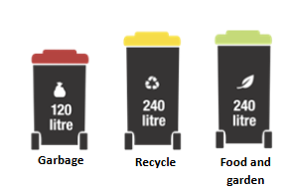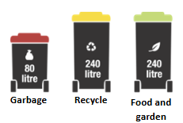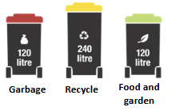

Option D - $484 Option E - $462 Option F - $425 Recycling Bin Upsize
$122.00
(One-off Charge)

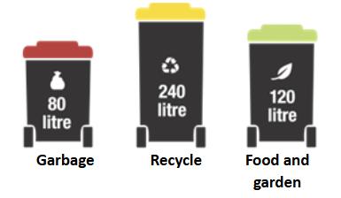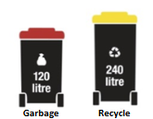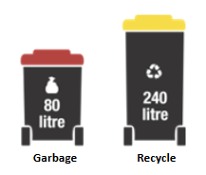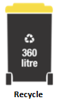

Change of bin option selection charge $23.00.
Section B – Additional Bins

I would like an ADDITIONAL 120 litre garbage bin (red lid)
Additional 120 litre garbage bin 2026 - 2027 financial year:
Annual service fee: $334.00
One-off cost for supply charge: $46.50


I would like an ADDITIONAL 240 litre recycling bin (yellow lid)

Additional 240 litre recycling bin 2026 - 2027 financial year:
Annual service fee: $58.00
One-off cost for supply charge: $55.50


I would like an ADDITIONAL 240 litre food and garden organics bin (green lid)
Additional 240 litre food and garden organics bin 2026 - 2027 financial year:
Annual service fee: $121.00
One-off cost for supply charge: $55.50

Owner/Property Manager Name:
Owner/Property Manager’s Signature: Date:

Return completed form to the City of Greater Dandenong
Post:  City of Greater Dandenong  PO Box 200  Dandenong  VIC 3175 | In person at a customer service centre  - Dandenong: 225 Lonsdale Street, Dandenong  - Springvale: 5 Hillcrest Grove, Springvale  - Parkmore: Shop A7, Parkmore Shopping Centre, Cheltenham Road, Keysborough | Email: council@cgd.vic.gov.au  Fax: (03) 8571 5196

