**Application for Heavy Vehicle Parking Permit**

In considering whether or not to issue a permit under Clause 22.1 (Local Law 3), an Authorised Officer must consider all the criteria as set out under Clause 22.3 (Local Law 3).

The submission of an application under this Local Law should not be seen as permission to keep a heavy or large vehicle on the land whilst the application is being considered.

| **Applicant details** | | |
| --- | --- | --- |
| First name: | Surname: | |
| Postal address: | | |
| Suburb: | | Postcode: |
| Phone number/mobile:       Fax number: | | |
| Email address: | | |

|  |  |
| --- | --- |
| **Truck details** | |
| Registration: | Make/model: |
| Colour: | Body type: |
| Weight/GVM: | Tare: |
| Length: | Height: |

|  |  |  |  |  |  |
| --- | --- | --- | --- | --- | --- |
| **Neighbours’ consent** | | | | | |
| **You must consult your neighbours before making this application.** Names and addresses of all adjoining neighbours who have consented/not consented (if insufficient space please attach additional pages) | | | | | |
|  | **Name** | **Address** | **Phone number** | **Consent Y/N** | **Signature** |
| **1** |  |  |  |  |  |
| **2** |  |  |  |  |  |
| **3** |  |  |  |  |  |
| **4** |  |  |  |  |  |
| **5** |  |  |  |  |  |

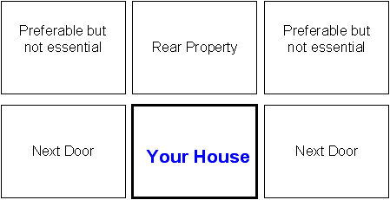

| **Permit details** | | |
| --- | --- | --- |
| Site plan attached: | | Yes  No |
| Time truck leaves: | Time truck arrives: | |
| Is the driveway constructed?(please tick): | | Yes  No |
| Loading/unloading from truck to property? (please tick): | | Yes  No |
| Is there alternative parking for the truck? (please tick): | | Yes  No |

|  |
| --- |
| **Declaration** |
| I declare that the above information is true and correct. I agree to abide by all terms and conditions specified in the permit.  Applicant signature: Date:    /    / |

|  |
| --- |
| **Payment options:** |
| **1)** Post or email form to City of Greater Dandenong and Council will contact you to facilitate a credit card payment over the phone.  **2)** Come to a Council customer service centre and pay in person.  **3)** Post form with cheque/money order to City of Greater Dandenong, PO BOX 200, DANDENONG, VIC, 3175. |

|  |  |  |
| --- | --- | --- |
| **Return completed form to the City of Greater Dandenong** | | |
| **Post:**  City of Greater Dandenong PO Box 200 Dandenong VIC 3175 | **In person at a customer service centre**   * **Dandenong:** 225 Lonsdale Street, Dandenong * **Springvale:** 397-405 Springvale Road, Springvale * **Parkmore:** Shop A7, Parkmore Shopping Centre, Cheltenham Road, Keysborough | **Email:** council@cgd.vic.gov.au  **Fax:** (03)8571 5196 |

|  |  |  |
| --- | --- | --- |
| **OFFICE USE ONLY** | | |
| Permit fee: | Receipt no: | CS Officer: |