Greater Dandenong Libraries’
Resource Sharing Guidelines
(Interlibrary Loans)

Requesting Items

  - Requests are submitted via the Greater Dandenong Libraries (GDL) online catalogue under ‘Request a Title’. Borrowers must be registered as a member of GDL to utilise this service.

  - Only items not found in either the GDL catalogue or in the Libraries Victoria (LV) Consortia catalogue may be requested for interlibrary loan. Please note that the following items are not available via interlibrary loan: Music CDs, Picture Books and Board books, Magazines, New Items (Books, Audio Books and DVDs) published in the last 6 months.

  - All recent publications (previous six months) should be requested for purchase via the GDL online catalogue under ‘Send a Request’. If the item does not meet GDL selection specifications, the resource sharing process will be followed.

  - There is a maximum of 5 concurrent requests per Full Greater Dandenong Libraries Membership. Temporary Memberships do not have access to resource sharing.

  - Requested interlibrary loan items can only be collected from Dandenong or Springvale library and are not transferrable within the LV Consortia.

  - Materials obtained from Victorian Public Libraries are free. Universities, Special Libraries, State Libraries (except for State Library Victoria) and the National Library of Australia charge a fee for lending their materials.

  - If the requested item is only available from a fee charging library, an email or letter requesting payment will be sent to the borrower. Once payment is received the item will be requested. Items incurring a fee will not be requested before payment is received. Every attempt will be made to source an item from a free location where possible.

  - State Library Victoria items are exempt from charges but are lent on the condition that they do not leave the borrowing library’s premises.

  - The loan period for interlibrary loans is three weeks, with the possibility of one renewal. Renewals must be requested before the due date.

  - Requests for journal articles should include as much citation detail as possible (i.e. title, author, pagination, volume, issue, and year). Journal articles can incur a fee. Consent to charges is required at the time of requesting.

Greater Dandenong Libraries’ Responsibilities

- GDL will endeavor to supply items promptly by processing requests within 3 working days.

- Items will be supplied within a 6-week period. Borrowers will be notified via post or email once their request is ready for collection at their nominated GDL branch.

- Borrowers will be notified within a 6-week period if an item cannot be supplied via resource sharing. Where email notification is not available, a letter will be sent alerting the borrower that the request was unsuccessful.

- Greater Dandenong Libraries has no control over response times from other libraries.

- Lending policies vary between library services. Greater Dandenong Libraries has no control over lending policies from other library services; however, this does not prevent GDL borrowers from requesting items of interest.

Borrowers’ Responsibilities

- Borrowers must adhere to the conditions of lending from responding libraries.

- Borrowers can request one renewal per item by contacting staff at Dandenong or Springvale library. Renewals are granted at the discretion of the lending libraries’ loan period.

- Borrowers must return items with the resource sharing barcode card still attached to the item. A fee applies to lost barcodes.

- Damaged/Lost items will incur replacement costs that must be paid for by the borrower. The charge appears as a bill on the borrower’s library membership to be paid at a GDL branch. GDL has no control over lending libraries’ replacement costs or policies.

- Greater Dandenong Libraries has the discretion to discontinue access to this service if borrowers do not adhere to the Resource Sharing Guidelines.

Need more information? – speak with a friendly Library staff member for further assistance.

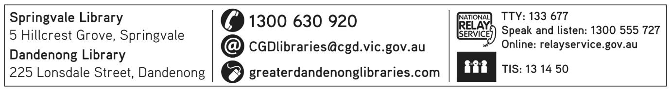
June 2023

