Freedom of Information Act 1982
Application for Local Law Permit
Footpath Activity

Permit fee:
Receipt no:
CS Officer:

Name of Applicant:
Business Name:
Address of Business:
Phone number/Mobile: Email:
Address to which permit will apply (if different from above):
TYPE OF PERMIT (please tick)
A-Frame Sign |  |  | A-Frame Sign – REAL ESTATE AGENT
Goods Display |  |  | Planter Box
Outdoor Eating Area Number of tables ___________

ADDITIONAL ITEMS SOUGHT UNDER OUTDOOR EATING AREA PERMIT
Portable Screens | Solid Screens |  |  | Gas Heaters
APPLICATION CHECKLIST
Have you attached:
- Site Plan (see template provided on rear)?
- Proof of identification/business registration?
- Pictures, diagrams or details of items to be placed on footpath?
- Proof of public liability insurance?
- Permit fee?

I declare that the information provided in this application is true and correct. I agree to abide by all terms and conditions specified in the permit.

Signature: Date:
Please return completed form and attachments, along with permit fee payment, to:
By mail: Regulatory Services Department  PO Box 200  DANDENONG VIC 3175  Cheques to be made payable to:  ‘City of Greater Dandenong’ |  | In Person: Customer Service Centres: Dandenong  39 Clow Street, Dandenong  Keysborough  Shop A,7 Parkmore Shopping Centre  Cheltenham Road, Keysborough  Springvale  397 – 405 Springvale Road, Springvale

Footpath Activity Permit
Furniture/Goods Display Placement Plan

Business Name:
Address:
Contact Person: Phone/Mobile:
Email:

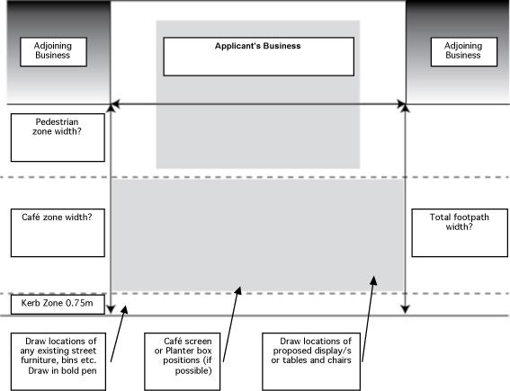

Placement Plan Checklist (please tick off each item)

Your business name
Dimensions written on plan where required
Any existing street furniture drawn on plan?
Proposed locations and number of goods display/s or tables and chairs drawn on plan?
Pictures of proposed display unit/s or furniture attached?
Pictures of proposed screens/planter boxes attached?


We respect your privacy. We will not sell or give away your personal information, unless required by law. Occasionally, we may use your details for our own research purposes or to let you know about other council information. If you want to see your personal data, modify your details, or if you receive information from us you do not want in the future please contact Council on 9239 5100.

