Events in Council Parks, Reserves and Open Spaces Event Emergency Procedure
Template for event organiser

Deadline: return to Council 14 days prior to event
Issues may arise during an event where it is necessary to evacuate all patrons and staff from the event site. This may be due to a number of reasons and will require certain steps to be followed.
- This document is a guide and a template to be completed by the event organiser.
- The Emergency Management Plan is to be submitted as part of the event application submission process. Failure to submit an Emergency Management Plan will result in an event permit not being issued.
- It is then the responsibility of the event organiser to provide this document to Site Manager and event staff on the day of the event.
- It is a requirement for the site manager to wear an identification tabard at all times on the event site. All other event staff should wear a standard hi-vis vest.

Event organiser to complete:
- Event name: Click here to enter text.
- Event date and time: Click here to enter text.

Key Contacts at the event:
- Site Manager: Click here to enter text.
- Event Organiser: Click here to enter text.
- Council Representative (on the day), as advised by Council: Click here to enter text.
Important information
- Emergency service onsite (Police/CFA/SES/Ambulance) take direct control of the situation.
- Emergency Services outrank event staff.

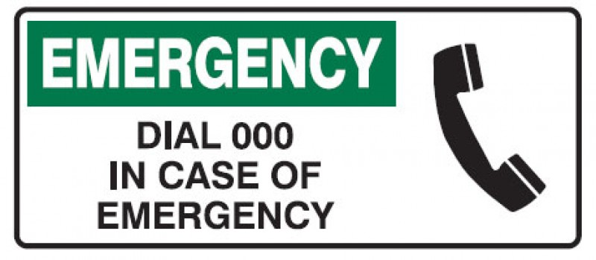
Emergency notification procedure

- Contact Emergency Services.
  - Emergency Phone Number: 000
  - Advise the Emergency Service of the following:
    - Location: Click here to enter text.
    - Access: Click here to enter text.
    - Access through: Click here to enter text.
    - Number of people affected.
    - Injury types, if any.
    - Incident description.
- Clear the immediate area.
- The Site Manager/Event Staff/Event Coordination Centre is to be notified of the situation at the earliest convenience by phone/radio/in person, if they are not directly involved with the situation.
- The Site Manager is to inform all event staff/volunteers and security that a site evacuation is necessary by radio.
- Start evacuation – Site Manager and Area Wardens:
  - Make a public announcement.
  - Encourage people to leave the event site and form orderly groups at the evacuation/emergency assembly point.
  - Direct people off-site.
  - Clear the site.
  - Ensure the site remains clear and follow Emergency Services advice.
  - Note: if required, ask a staff member/security to meet the arriving emergency services.
  - Site Manager is to liaise with Emergency Services.
- The Site Manager is to inform Council after-hours service (8571 1000) that an event evacuation is in process.
- Complete incident report forms at the completion of the incident.

INSERT SITE PLAN HERE – show emergency assembly/evacuation points

Emergency management information

General Considerations
- In the event of an evacuation warning, all persons are to turn off gas and other cooking appliances and follow the evacuation procedures to the nearest emergency assembly area.
- Each area of the event has its own specific emergency assembly area with Area Wardens in place to effect an evacuation if required.
- Contact the Site Manager/Area Warden for any situation you think may be potentially dangerous.
- In an emergency, do not perform tasks that you are not trained for or are able to do so safely.

Closest Emergency Centres/Contact Details:
- NOTE: In case of an emergency, call 000.
- Dandenong Hospital, 9554 1000, 135 David St, Dandenong.
- Dandenong Police Station, 9767 7444, 50 Langhorne St, Dandenong, dandenong.uni@police.vic.gov.au.
- Springvale Police Station, 8558 8600, 314 Springvale Rd, Springvale, springvale.uni@police.vic.gov.au.
- Dandenong CFA, 9791 7611, 120-122 Princes Hwy, Dandenong.
- SES, State Emergency Service Greater Dandenong Unit, 9684 6651, 42 Mills Rd, Dandenong.
- National Security Hotline 1800 123 400 (24 hour).
Site Safety Personnel Reporting Structure

EVENT BUMP IN/BUMP OUT DETAILS
- Bump in time (set up): Click here to enter text.
- No vehicles onsite after Click here to enter text.
- All vehicles (which are not part of the stall) must exit the event site.
- Pack up time: Click here to enter text.
- Site Manager is to supervise bump in/out at all times.
- Contractors and staff are to have a brief compulsory induction to the site by the Site Manager/Area Warden on arrival.
- All staff/contractors during the event bump in should wear high visibility vests.
- Public should be discouraged from entering the site during bump in/bump out.
- Any areas of the site during bump in/bump out which are not safe for the public to pass through should be cordoned off with safety bollards/witches hats.
- All vehicles moving at the event site are to be under supervision with hazard lights and compliant with the walking pace (5km/h) speed limit. All vehicles must be moved off the event site by Click here to enter text.
- Pedestrians are to be given right of way at all times.

SECURITY SCHEDULE

Click here to enter text.

STAFF SCHEDULE AND CONTACT DETAILS

Click here to enter text.

* Attach contact list.

PUBLIC ADDRESS ANNOUNCEMENT – Emergency Announcements
All announcements are to be made by the most senior event staff member at the site/MC/Stage Manager, as required on advice from the Site Manager.
- Evacuation
Ladies and Gentlemen: may I have your attention please? (Action: Wait for attention, repeat if necessary).
It has become necessary to temporarily stop the event and clear the area. Please assist us by following the directions of our event staff, security and volunteers to the Emergency Assembly Area.
(Insert evacuation instructions) Click here to enter text.
Thank you for your cooperation.
If necessary add: please remain calm and please do not run.
- Cancellation
Ladies and Gentlemen: may I have your attention please? (Action: Wait for attention, repeat if necessary).
Please note that today’s event has been cancelled due to circumstances beyond our control. The event site must be cleared for safety purposes. We ask you to be patient and leave in an orderly manner. Please follow the directions of Event Staff, Security and Volunteers to the nearest safe exit. Thank you for your cooperation.
- Alcohol Announcements
Ladies and Gentlemen: may I have your attention please? (Action: Wait for attention, repeat if necessary).
Please note that this event is a drug, alcohol and smoking free zone. As such, no alcohol or drugs are permitted at the event site. Penalties will apply. Thank you for your cooperation.
- Found Child Announcement
Ladies and Gentlemen: may I have your attention please? (Action: Wait for attention, repeat if necessary).
Please note that there is a child by the name of d INSERT CHILD’S NAME waiting at the Lost Children Location Click here to enter text. Thank you for your cooperation.
Note: if parent’s names are known, try saying these to get the parent’s attention.

LOST/FOUND CHILD RESPONSE GUIDE

Lost Children Location – Click here to enter text.

If you find a lost child
- Keep them calm and check the time.
- Ask them their name and check if they know their parent’s name/s.
- Ask where the child last saw the parents.
- Check if you can see their parent/s from where the child first lost sight of them.
- If the parent/s is/are not visible, please take them to the Lost Children Location or organise for an event staff to take the child there and alert the Site Manager, who will then alert all staff, volunteers and security.
- Fill out a Lost Children Form.
- The Site Manager will arrange for a public announcement to the child’s parents.
- Public announcement: Found Child Announcement
- Keep the child secure until he/she is collected by a parent/guardian.
- Ask to see ID when an adult collects a child. Note down adult’s details on the incident report form/Found Children Form.
- If the child is not collected by a parent/guarding within a reasonable amount of time (i.e. 30 minutes – 45 minutes), advise Site Manager and call 000.

If a parent lets you know that they can’t locate a child,
- Complete Lost Children Form and use it to get a description of the child from the parents, including
  - child’s age
  - boy/girl
  - hair colour
  - What they are wearing
  - Where they were last seen
  - Any other special details: i.e. wears glasses, has a medical condition, developmental disorder, etc.
- Notify the Site Manager.
- The Site Manager will notify all event staff, Area Wardens, volunteers and Security.
- The Site Manager will also set up search areas for all involved.
- Keep track of the parents while the search is on and keep them calm.
- Note: DO NOT MAKE A PUBLIC ANNOUNCEMENT
- If a search is unsuccessful after the entire site has been searched, Site Manager will contact the Police and advice of the situation.

