Social Conditions in Greater Dandenong

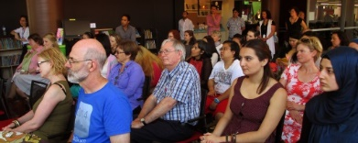

**Geography**

Greater Dandenong encompasses an area of 129 square kilometers in Melbourne’s south-east, approximately 24 km. from the CBD.

**Population**

At an estimated 175,000 people in 2021, the number of residents in Greater Dandenong has risen by 27,000 during the past two decades, and is forecast to grow by 28,000, to 203,000, during the next decade.

**Cultural Diversity** Per cent of Residents by Birthplace: Greater Dandenong, 2016

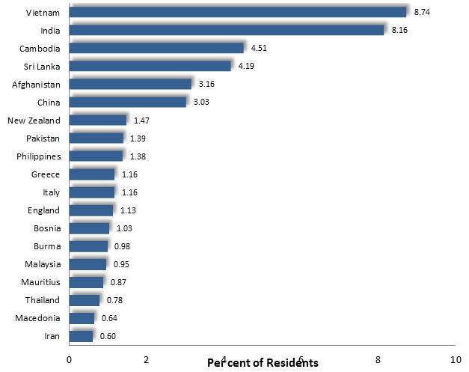Greater Dandenong is the most culturally diverse municipality in Australia, with residents from 167 different birthplaces. Well over half (64%) of its population is born overseas, and 61% from nations where English is not the main spoken language. Major birthplaces, aside from Australia, include India, Cambodia, Sri Lanka, Afghanistan, China, Pakistan, New Zealand and the Philippines.

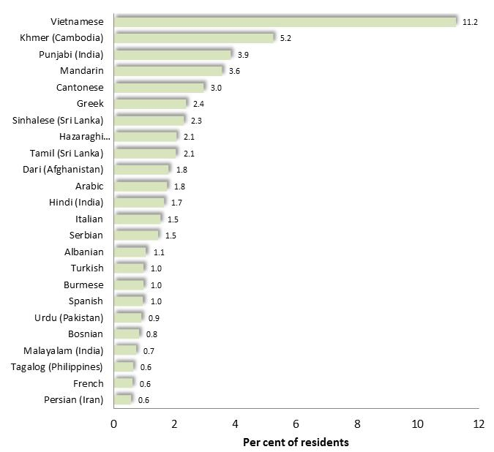**Spoken Languages**

In 2016, over two-thirds (70%) of the residents of Greater Dandenong spoke languages other than English – the largest proportion in Victoria and more than twice the state-wide level of 32%. Major non-English languages included Vietnamese, Khmer, Punjabi, Chinese languages, Greek and Sinhalese.

Number of Residents by Spoken Language: Greater Dandenong, 2016

Number of Residents with Limited English Fluency

by Spoken Language: Greater Dandenong, 2016 **English Fluency**

One in seven residents - accounting for 19,000 people or 13% of the population - has limited fluency in spoken English – four times the metropolitan level of 4%. Many residents who speak Vietnamese, Khmer and Chinese languages have limited English fluency.

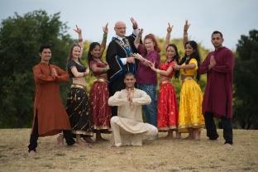

Family Types: Greater Dandenong, 2016 **Families**

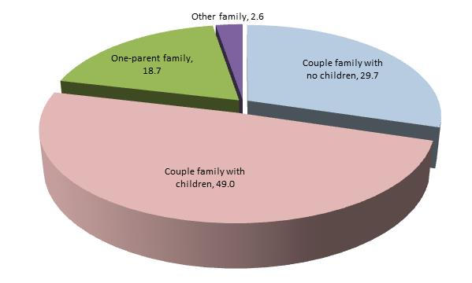There are 38,471 families in Greater Dandenong, with most of the balance lone person households. Nearly a third (30%) of families are couples, 49% couples with children, and 19% are headed by a single parent.

Over three-quarters of families with children were headed by overseas-born parents – compared with a quarter of families across Victoria.

**Disability**

The 2016 Census found that 6.8% of people in Greater Dandenong - compared with 5.5% across metro. Melbourne - were living with a severe or profound disability, requiring daily assistance with mobility, communication or self-care. These included a 1.8% of residents aged up to 24 years, 4.6% among those aged 25-64, 13% of those aged 65-69, 40% of 80-84 year-olds and 71% of residents aged over 90.

**Educational Outcomes**

The 2016 Census revealed that 13% of young people aged 20-24 years in Greater Dandenong had left school before completing year eleven, compared with 8.3% across Melbourne. Eighteen per cent of 20 to 24 year-olds were neither in paid employment nor enrolled in education in 2016 – the third highest level in Melbourne, and substantially more than the corresponding metropolitan figure, of 10.7%.

Unemployment Rates: Greater Dandenong and

Metropolitan Melbourne, 2008-2020 **Unemployment**

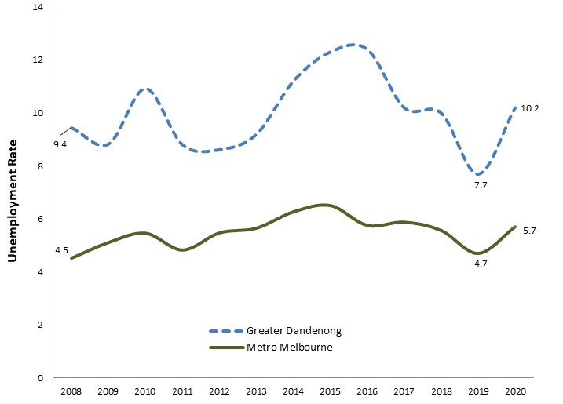Unemployment rates in Greater Dandenong have fluctuated in the past decade, most recently rising to 10.2% by mid 2020 – the highest level in Victoria and nearly twice the metropolitan average of 5.7%. This number represents 8,600 residents and rise of 2,300 since mid-2019.

**Unpaid Work**

The 2016 Census found that 12% of residents volunteered in the previous year - about half the Victorian level of 21%. In addition, 12% per cent of residents were providing unpaid assistance to someone with a disability (including 9.7% of males and 13.3% of females), while 26% of residents provided unpaid care to their own, or others’, children.

**Incomes**

In 2016, the median weekly gross income among Greater Dandenong residents was $476 - the lowest in Melbourne, and 73% of the metropolitan average of $785. Median incomes in Greater Dandenong stood at $403 among females, compared to $616 for males. Many household incomes are further diminished by gambling losses. In 2018/19, over $119 million was lost to electronic gambling machines in Greater Dandenong, equivalent to $910 per adult and the highest rate of losses in Victoria.

**Crime**

The rate of local offences has declined 14% in the four years to 2019/20, with violent offences falling 15%, and property offences by 18%. In the same period, drug offence rates rose 3%.

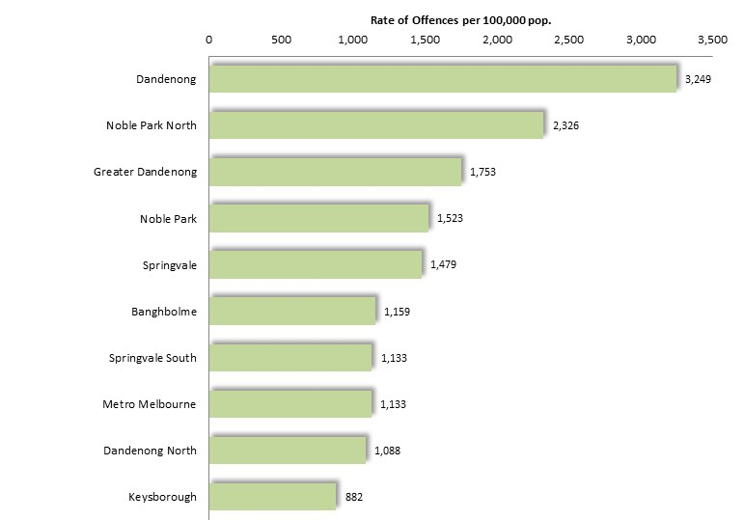Despite these declines, 2019/20 alleged offences rates in Greater Dandenong, compared with metropolitan Melbourne were: 50% higher for violent offences, 27% higher for property offences, 62% higher for drug offences and 42% higher for overall offences.

In 2019/20, the rate of police callouts to family incidents in Greater Dandenong, was the third highest in Melbourne.

Crime rates vary widely within Greater Dandenong. Rates of violent offences, for example, were almost twice as high in Dandenong in 2019/20 as the municipal average (diagram right).

Further information about conditions in Greater Dandenong and Victoria: [**www.socialstats.com.au**](http://www.socialstats.com.au)