Crime and Safety

**Rate Comparison**

The rate of alleged offences in Greater Dandenong has declined 14% in the four years to 2019/20, including a 15% decline in the rate of violent offences and 18% fall in property offences. During the same period, drug offence rates rose 3%.

Despite these declines, 2019/20 alleged offences rates in Greater Dandenong, compared with metropolitan Melbourne were:

* 50% higher for violent offences
* 27% higher for property offences
* 62% higher for drug offences and
* 42% higher for overall offences. (diagram below)

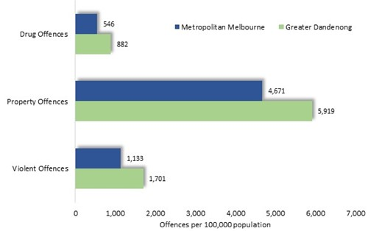

The local rates of violent and drug offences were the highest in the metropolitan area, outside the CBD, while the overall crime rate was the second highest in Melbourne.

Crime Rates: Greater Dandenong and metropolitan Melbourne, 2019/20

Overall Crime Rates: Greater Dandenong Suburbs, 2019/20

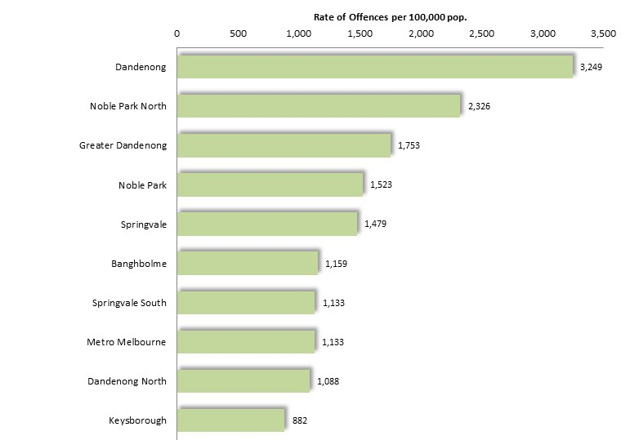

Crime rates vary widely within Greater Dandenong.

Rates of violent offences for example, were almost twice as high in Dandenong in 2019/20 as the municipal average and nearly four times the level in Keysborough (diagram left).

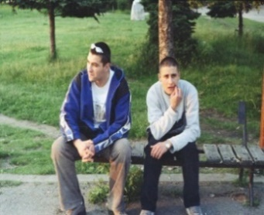**Crime Trends**

The decline in crime rates in Greater Dandenong during the past four years, reverses a trend of increasing crime rates in the decade from 2004/5 to 2014/15, during which overall offence rate rose by 19% and violent offences by 74%.

Changes in rates of violent crime and drug offences in Greater Dandenong and metropolitan Melbourne, during the period 2004/5 to 2019/20, are illustrated below.

*Violent Crime Rate: 2004/5-2019/20 Drug Crime Rate: 2004/5-2019/20*

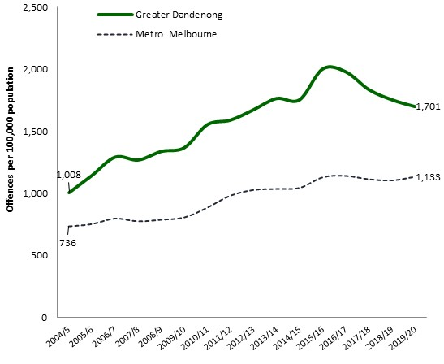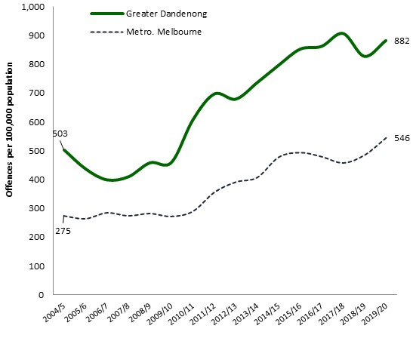

**Personal Safety**

The 2015 Vic Health Indicators Survey found that 64% of Greater Dandenong residents felt unsafe walking alone in their neighborhoods at night – more than the metropolitan percentage of 44% and the highest level in Victoria.

The proportion of people who feel unsafe in their neighborhoods at night in Victoria, rises from 39% of people aged 35-44, to 67% of residents aged 75 or more, and from 27% among men to 63% among women.



Percentage of people who feel safe walking at night in their neighborhood by age and gender: Victoria, 2015

The survey found that people in inner metropolitan and regional areas, those with high incomes and members of couple households, were more likely to feel safe at night.

Percentage of people who feel safe walking at night in their neighborhood

by selected characteristics: Victoria, 2015

