Aboriginal Residents
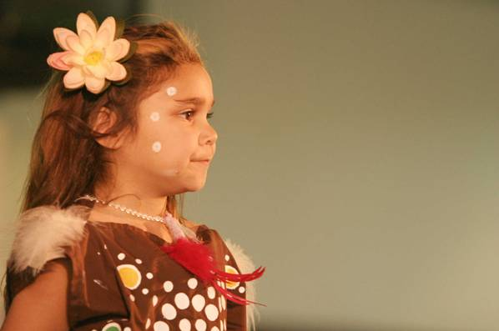
Population
The number of Aboriginal and Torres Strait Islanders recorded by the Census in Greater Dandenong trebled from 150 in 1981, to 516 by 2016, representing 0.3% of the population. Within this city and its adjoining municipalities, the 2016 Census recorded nearly 5,217 Aboriginal residents.
Those people living in Greater Dandenong are relatively young, with nearly one-half (48%) aged less than 24 years, compared with 32% of the general population. Conversely, 8% are aged 65 years or more, compared with 14% of non-Aboriginal residents. Their median age is 26 years, compared with 35 for the general population, reflecting their lower life expectancy and higher birth rates.
Per cent of Population by Age: Aboriginal and
Non-Aboriginal Residents, Greater Dandenong, 2016
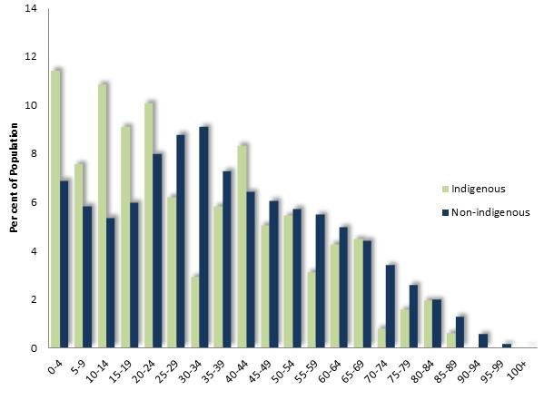
Housing
Aboriginal and Torres Strait Islanders in Greater Dandenong are half as likely to own or be purchasing their homes (33%) as the general population (61%), and more often rent their accommodation. Twenty-seven per cent of Aboriginal residents rent from government or community agencies, compared with 4% of non-Aboriginal residents.

Families Families with Children by Type: Aboriginal and
Non-Aboriginal Residents, Greater Dandenong, 2016
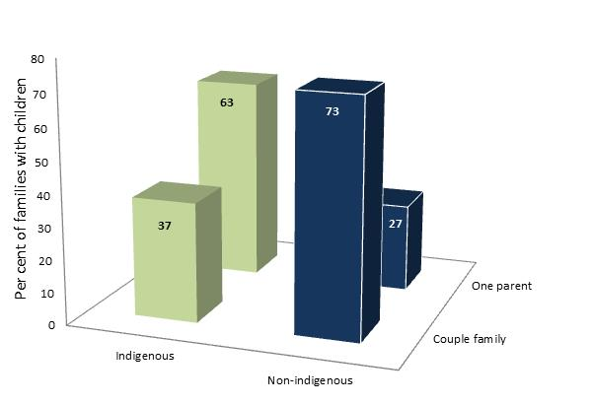
In 2016, nearly two-thirds (63%) of Aboriginal and Torres Strait Islander families with children in Greater Dandenong were one-parent families – the second highest rate among Aboriginal residents in Victoria and more than twice the level of 27% among the general population. In the same year, 46% of local Aboriginal families with children had no parent in paid employment.
Early birth rates were relatively high among young Aboriginal and Torres Strait Islander women, with 7.7% of 15-24 year-old women in Greater Dandenong having borne a child, compared with 3% of non-Aboriginal women of that age.
Education
The 2018 Australian Early Development Index found that 65% of Victorian prep. pupils of Aboriginal or Torres Strait Islander descent were vulnerable in one or more domains of development, compared with 20% of all prep. pupils across the State.
In 2016, 43% of young Aboriginal and Torres Strait Islander adults aged 20 to 24 years, had left school early – over three times the corresponding level of 13% among non-Aboriginal young adults in Greater Dandenong. Of Aboriginal residents aged 25 to 44 years, 4% held a degree or higher qualification in 2016, compared with 33% of people that age across Greater Dandenong.
Employment
The 2016 Census recorded an unemployment rate of 22% among Aboriginal and Torres Strait Islander residents of Greater Dandenong, compared with 10% among the general population.
Disability
The 2016 Census revealed that the prevalence of severe or profound disability requiring daily assistance with self-care, communication or mobility among people aged 20 to 64 years, was 12.1% among Aboriginal residents – more than the corresponding rate of 7.1% among the general population.
Geographic Distribution of Aboriginal Residents
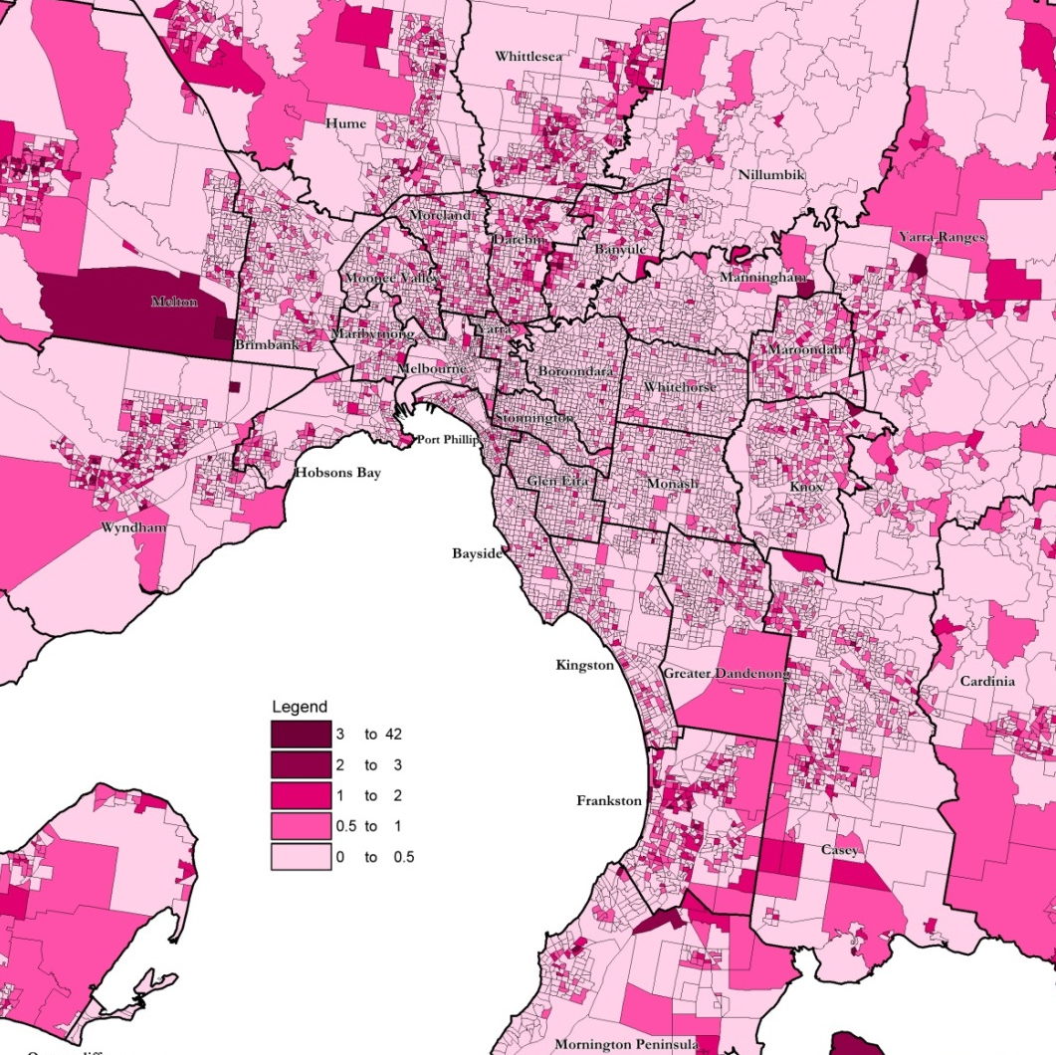
The accompanying map illustrates the distribution of Aboriginal and Torres Strait Islanders across metropolitan Melbourne, recorded in the 2016 Census.
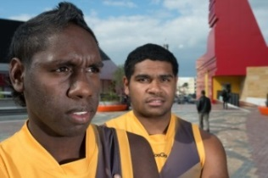

Trends in Social Conditions
An examination of the findings of the 2006 and 2016 Censuses provides a glimpse of changes in social conditions among Aboriginal and Torre Strait Islanders in Greater Dandenong during that decade.
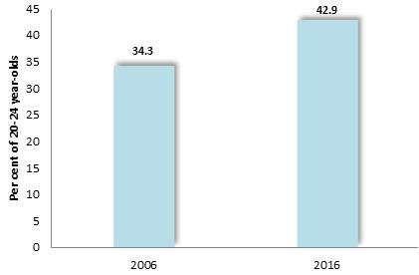
Per cent of 20-24 year-olds who had left school before completing year 11: Greater Dandenong, 2006 and 2016

The proportion of young Aboriginal and Torres Strait Islanders who had left school before completing year 11 rose from 34% to 43%, in the decade to 2016.

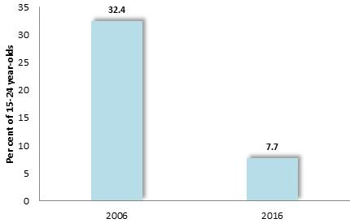

Per cent of Aboriginal 15-24 year-old women with children: Greater Dandenong, 2006 and 2016

During the same period, the proportion of 15 to 24 year-old Aboriginal and Torres Strait Islander women who had one or more children fell from 32% to 7.7%.

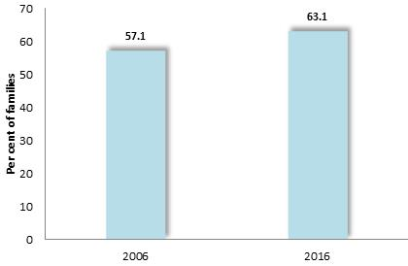
Per cent of Aboriginal families with children that are one-parent families: Greater Dandenong, 2006 and 2016

The proportion of families with children that were headed by one parent rose slightly between 2006 and 2016, from 57% to 63%.

The percentage of homes that were owned or being purchased by their Aboriginal and Torres Strait Islander occupants declined from 35% to 33% during the decade to 2016.

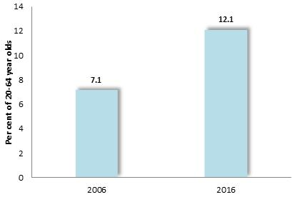

Per cent of 20-64 year-old Aboriginal residents with a severe or profound disability: Greater Dandenong, 2006 and 2016

The prevalence of severe or profound disability among Aboriginal and Torres Strait Islanders rose from 7.1% of 20 to 64 year-olds in 2006, to 12.1% by 2016.

Victorian and National Health and Social Outcomes
According to a range of measures, the general health of Aboriginal people across Victoria and Australia is less favorable than for people of non-Aboriginal backgrounds. Aboriginal people have higher rates of hospital admission than members of the general population, and are twice as likely to report their health as 'fair' or 'poor' (32% compared with 16%), according to the findings of the Victorian Population Health Survey. They have a life expectancy of approximately 10 to 12 years less than non-Aboriginal residents, mortality rates twice those of non-Aboriginal people in all age groups, an infant mortality rate nearly three (2.9) times higher than other Australians , and a 2019 suicide rate over twice the overall national level. In ‘Child Protection Australia 2014/15’, the Australian Institute of Health and Welfare reports that Aboriginal children are seven times more likely to be the subject of substantiated reports of child abuse than non-Aboriginal children (43.6 per 1,000 children compared with 6.4 per 1,000 respectively). Nationally, it is reported that Aboriginal women are hospitalized for violent assaults at a rate thirty-five times higher than for non-Aboriginal women In relation to drug-related problems, the Pennington Institute determined that the rate of unintentional drug overdoses among Aboriginal and Torres Strait Islanders was 19.2 per 100,000 population – over three times the corresponding rate among the general population.
Compared with than non-Aboriginal people, Aboriginal and Torres Strait Islander people aged 15+ were:

- 1.4 times more likely to have experienced family or personal stressors
- 2.7 times more likely to have experienced high/very high levels of psychological distress

- 3.3 times more likely to have diabetes/high sugar levels
- 3.7 times more likely to have kidney disease

- 1.2 times more likely to have heart or circulatory diseases
- 1.3 times more likely to have diseases of the ear or hearing problems

- 1.5 times as likely to be obese
- 2.6 times as likely as to be current daily smokers.

- 1.1 times more likely to have been sedentary or exercising at low intensity
- 0.6 as likely to have been exercising at high intensity

- subject to an infant mortality rate approximately twice the national level (6.2 infant deaths per 1,000 live births compared with 3.3 among the general population, in 2017)

- had a national suicide rate in 2019 of 27.1 per 100,000 persons – more than twice the rate among non-Aboriginal persons, of 12.9 per 100,000.

The municipality of Greater Dandenong and the adjoining municipalities of Casey, Frankston, Kingston, Knox and Monash.
These were physical, emotional, social, language and communication.
Dudgeon, P. (2017). Aboriginal and Torres Strait Islander Women and Mental Health. Australian Psychology Society. Accessed at psychology.org.au on 29 August 2017
Australian Institute of Health and Welfare (2012). Australia's Health 2012 - Summary of Findings. Australian Institute of Health and Welfare, Canberra
Edith Cowan University (2012). Overview of Australian Indigenous Health Status, 2011. Dept. Health and Ageing, Canberra
Australian Bureau of Statistics (2019). Causes of Death Australia, 2018
Dudgeon, P. (2017). Aboriginal and Torres Strait Islander Women and Mental Health. Australian Psychology Society. Accessed at psychology.org.au on 29 August 2017

