Housing
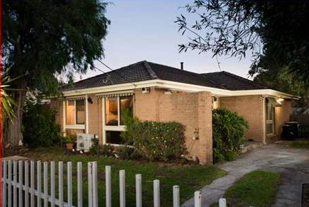
Housing Structure
In 2016, 70% of households in Greater Dandenong were detached, 11% flats and 17% semi-detached. During the decade to 2016, the number of detached dwellings in Greater Dandenong rose by approximately 5,000 and the number of semi-detached dwellings by nearly 6,000, while the number of flats declined by 3,700.
The distribution of housing structure varies across the metropolitan area: 85% of dwellings in Melbourne are flats, compared with just 0.5% in Cardinia. Flats tend to be concentrated among the inner-urban areas, though also in sections of Springvale, Noble Park and Dandenong within Greater Dandenong, particularly in proximity to transport corridors.
Distribution of Flats and Units: Metropolitan Melbourne, 2016
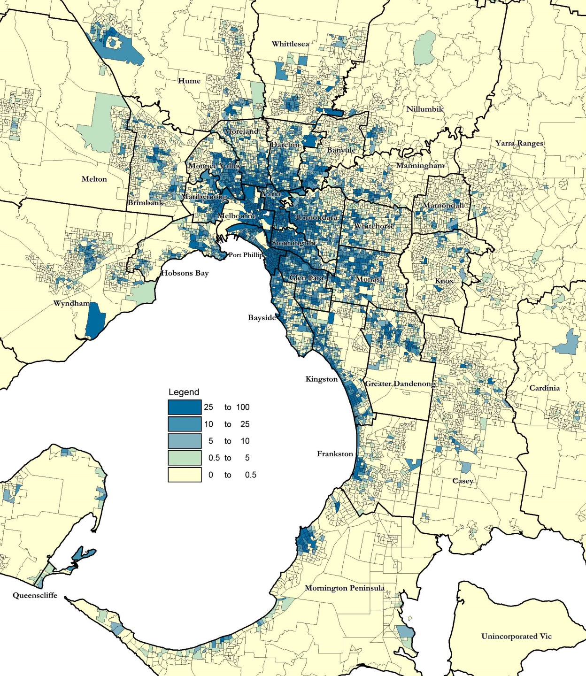
Housing Tenure
In 2016, over half (54%) of private dwellings in Greater Dandenong were either owned or being purchased by their occupants – a decline from 65% in 2011. Across metropolitan Melbourne, a slightly higher proportion of homes (57%), were owned or being purchased. In Greater Dandenong, 31.2% of dwellings are rented, compared with 26.3% across Victoria.
In Greater Dandenong, home ownership levels are lowest among recent settlers: 90% of Sudanese residents and over 75% of those from Afghanistan, Samoa, Burma, Pakistan and Iran rent their accommodation, compared with fewer than one in five from China, Vietnam, Cambodia, Greece, Croatia or Italy (accompanying diagram).

Per cent of Persons Renting their Homes, by Selected Birthplaces: Greater Dandenong, 2016
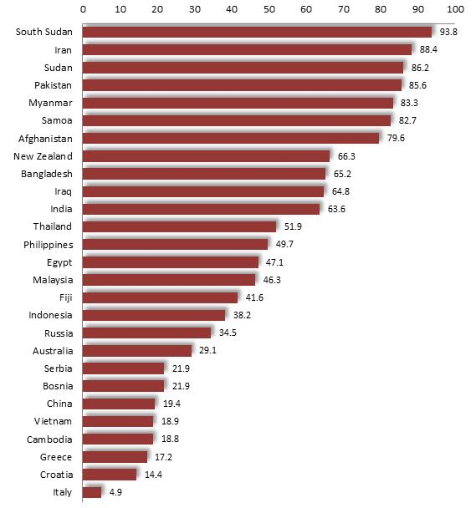

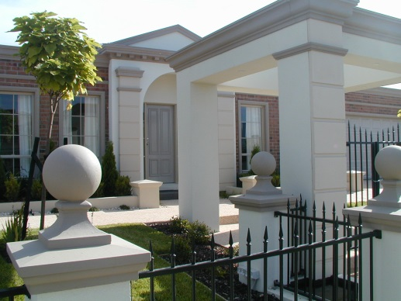

The accompanying map illustrates the distribution of rental dwellings throughout metropolitan Melbourne as at 2011. Notably, rental housing is largely concentrated in the inner-urban areas, as well as in parts of the north, west and south-east of Melbourne – including Clayton and the local suburbs of Springvale, Noble Park and Dandenong.

Distribution of Rental Housing: metropolitan Melbourne, 2016
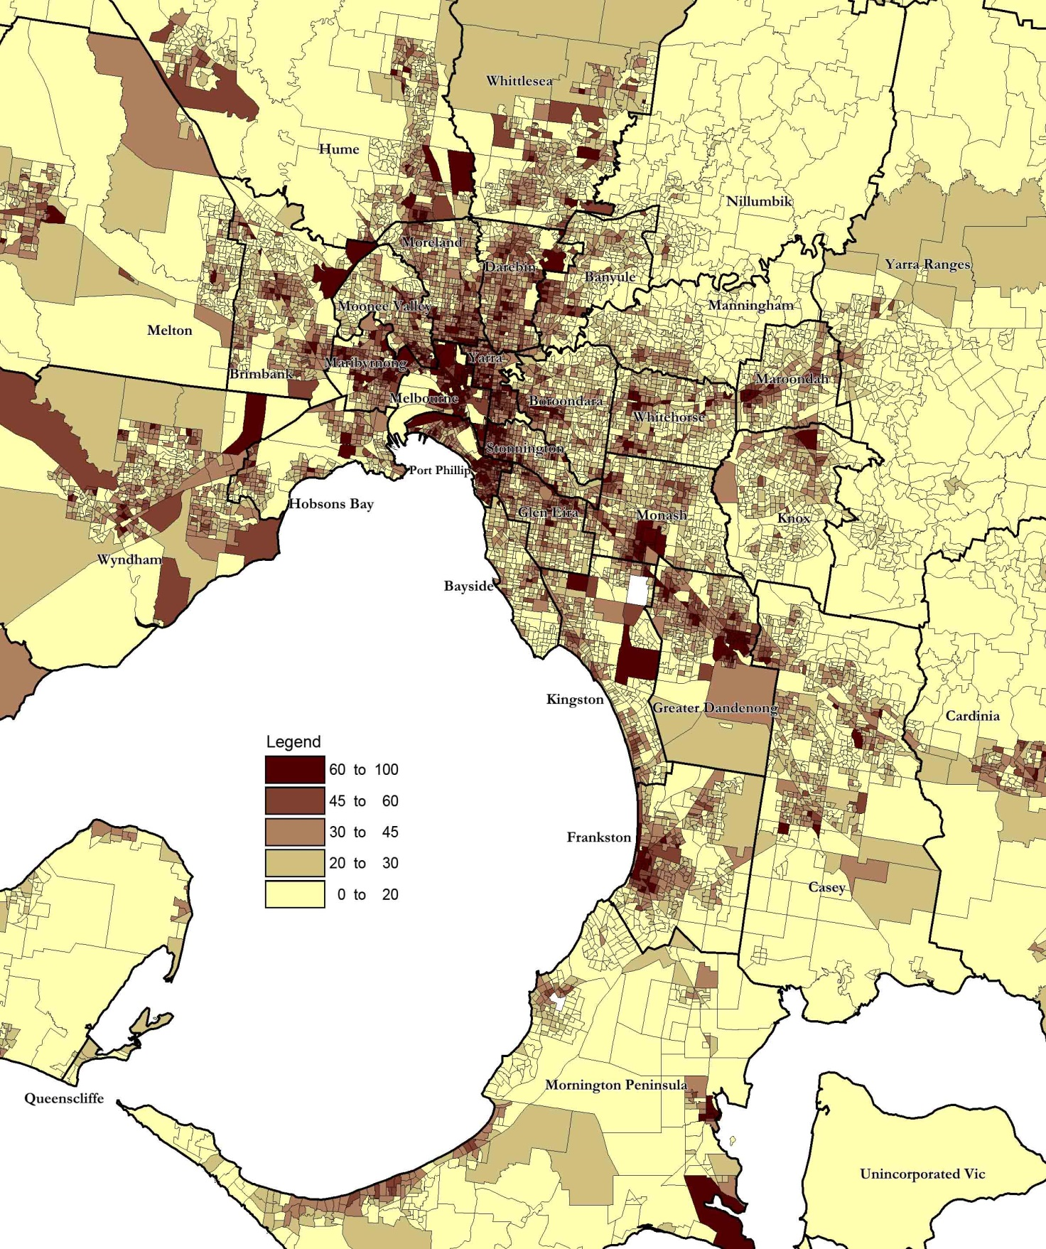
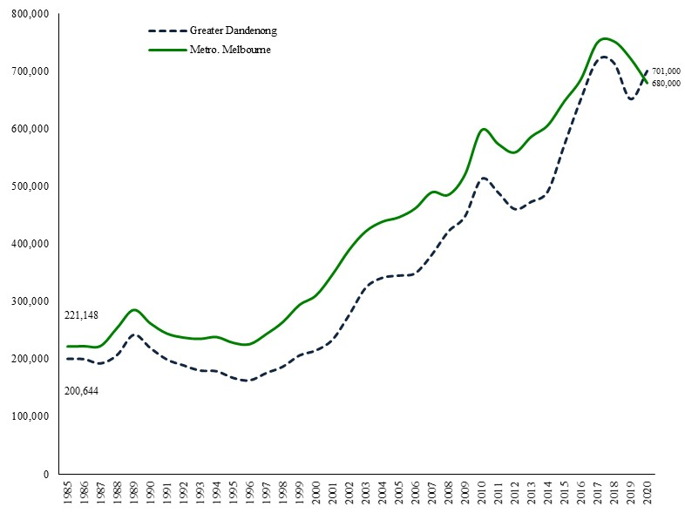
In the past 20 years, median housing costs in Greater Dandenong have more than trebled in real terms.
Local house purchase prices rose by 37% (after inflation) in the decade to 2020, compared with 14% across metropolitan Melbourne (diagram at right), reaching $701,000 by June 2020.
As a consequence, local price increases have outstripped growth in incomes, with the median cost of houses in Greater Dandenong rising from 3.2 years of median household income in 1996, to 8.1 years in 2016.
Median House Prices in Greater Dandenong, as a percentage of metropolitan prices: 1985 to 2020

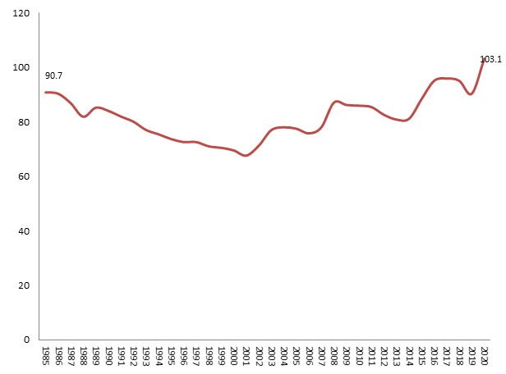
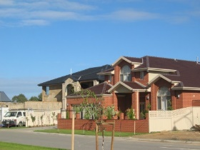
In keeping with these trends, median housing prices in Greater Dandenong have risen from approximately two-thirds (68%) of the metropolitan median in 2001 to 103% of the metropolitan median by 2020.

Median Unit Purchase Costs: Greater Dandenong and metropolitan Melbourne, 1985 to 2020 (adjusted for inflation)
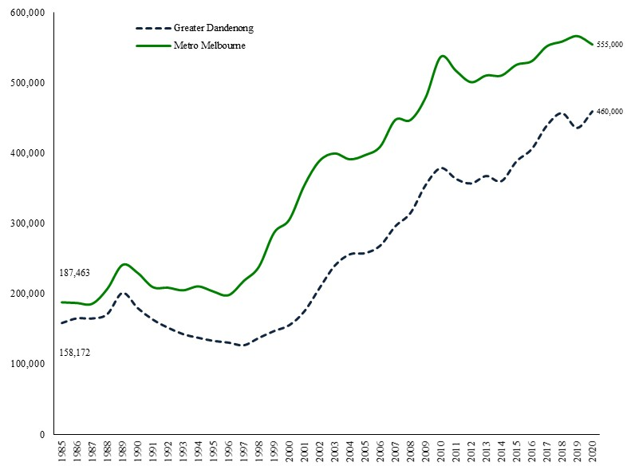
Meantime, the median price of three-bedroom houses in Greater Dandenong rose 4.2%, and two-bedroom flats by 5.9%, in real terms during the decade to 2020 – more than twice the rate of growth recorded across Melbourne during this period.
Causes of housing price increases across Australia during the past two decades include declining interest rates; economic and population growth; supportive tax conditions such as negative gearing and capital gains; and limited growth in housing supply. Consequences have included rising house prices and public housing waiting lists, coupled with a fall in vacancy rates and affordability.
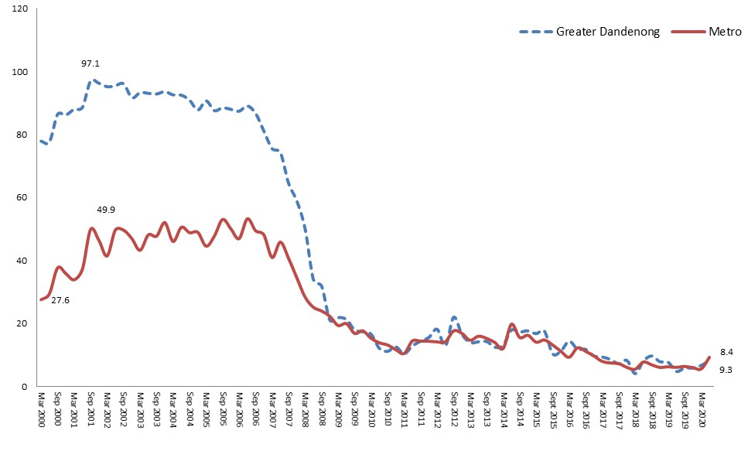
Rental Cost and Affordability

Per cent Rental Properties Affordable, Greater Dandenong and Metropolitan Melbourne 2000-2020

In June 2020, the average cost of renting a three-bedroom house in Greater Dandenong was $390 – similar to the metropolitan average of $400.
The proportion of rental properties affordable to Centrelink recipients in Greater Dandenong fell from 83% in 2001, to 9.3% by 2020 – similar to the metropolitan average (diagram, above), thereby aggravating the financial difficulties faced by many renting households.

Rent-related Financial Stress
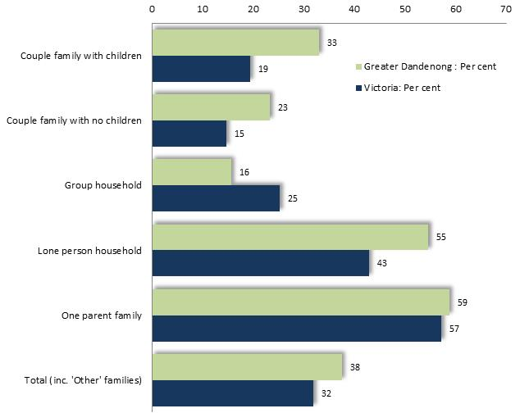
Findings from the 2016 Census concerning incomes, family structure and rental levels, were examined to document the extent of financial stress faced by families, after paying rent. Rental costs are deducted from household incomes for various types of one-family households, then equivalence scales applied to determine the percentage of households with an income, after paying rent, equivalent to a single person on the poverty line of $354 p.w. Households falling below that standard of living were regarded as experiencing rent-related poverty.
Percentage of Renters in Housing-related Poverty,
by Household Type: Greater Dandenong, 2016
In Greater Dandenong, 55% of lone person households and 59% of renting one-parent families were living in rent-related poverty.
By contrast, just 16% of group households faced such hardship.
Overall, 38% of renting households in Greater Dandenong faced poverty after paying their rent, the second highest level in Victoria , and higher than the comparable State figure of 32%.

Overcrowding of Private Dwellings
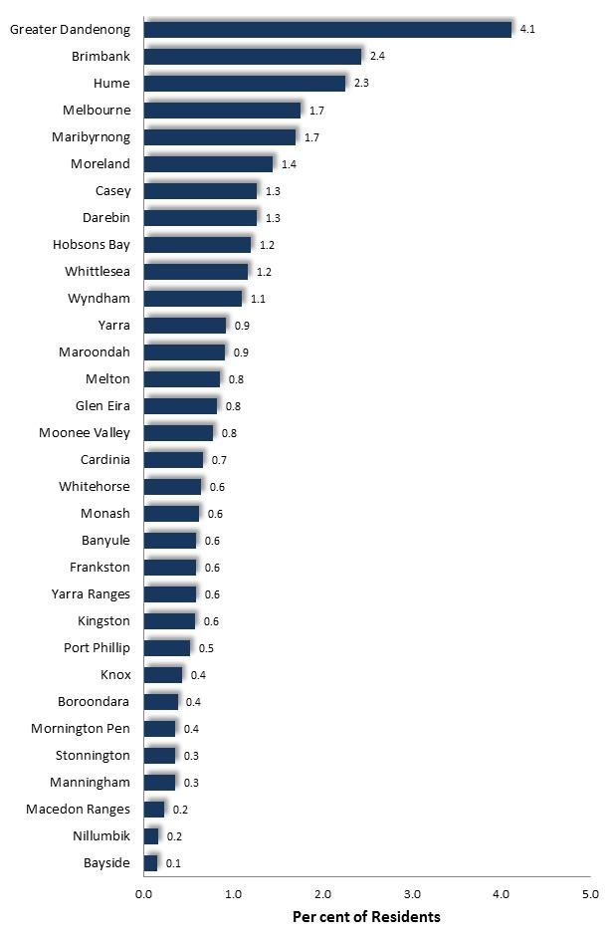
To measure the proportion of private dwellings that were overcrowded, conditions were defined as persons living in private dwellings where there are either:
- 4 or more persons in a dwelling with 0 or 1 bedrooms
- 6 or more persons in a dwelling of 2 bedrooms

Proportion of private dwellings that are overcrowded: metropolitan municipalities, 2016

Based on the findings of the 2016 Census, it was determined that 4.1% of private dwellings, numbering 5,720 homes, were overcrowded – the highest proportion in metropolitan Melbourne.

Among residents in rented accommodation, 7.2% were living in overcrowded conditions, compared with 2.2% of those in dwellings that were owned or being purchased by their occupants.
Most people (86%) living in overcrowded accommodation were members of families. Of family members in overcrowded dwellings, 81% were members of couple families with children, 13% members of one-parent families and 6% couples without children.
The distribution of overcrowding across metropolitan Melbourne, based on the findings of the 2016 Census, is illustrated below. High levels of overcrowding are evident in the south-eastern, northern and western metropolitan areas.
Percent of Private Dwellings which are Overcrowded: metropolitan Melbourne, 2016
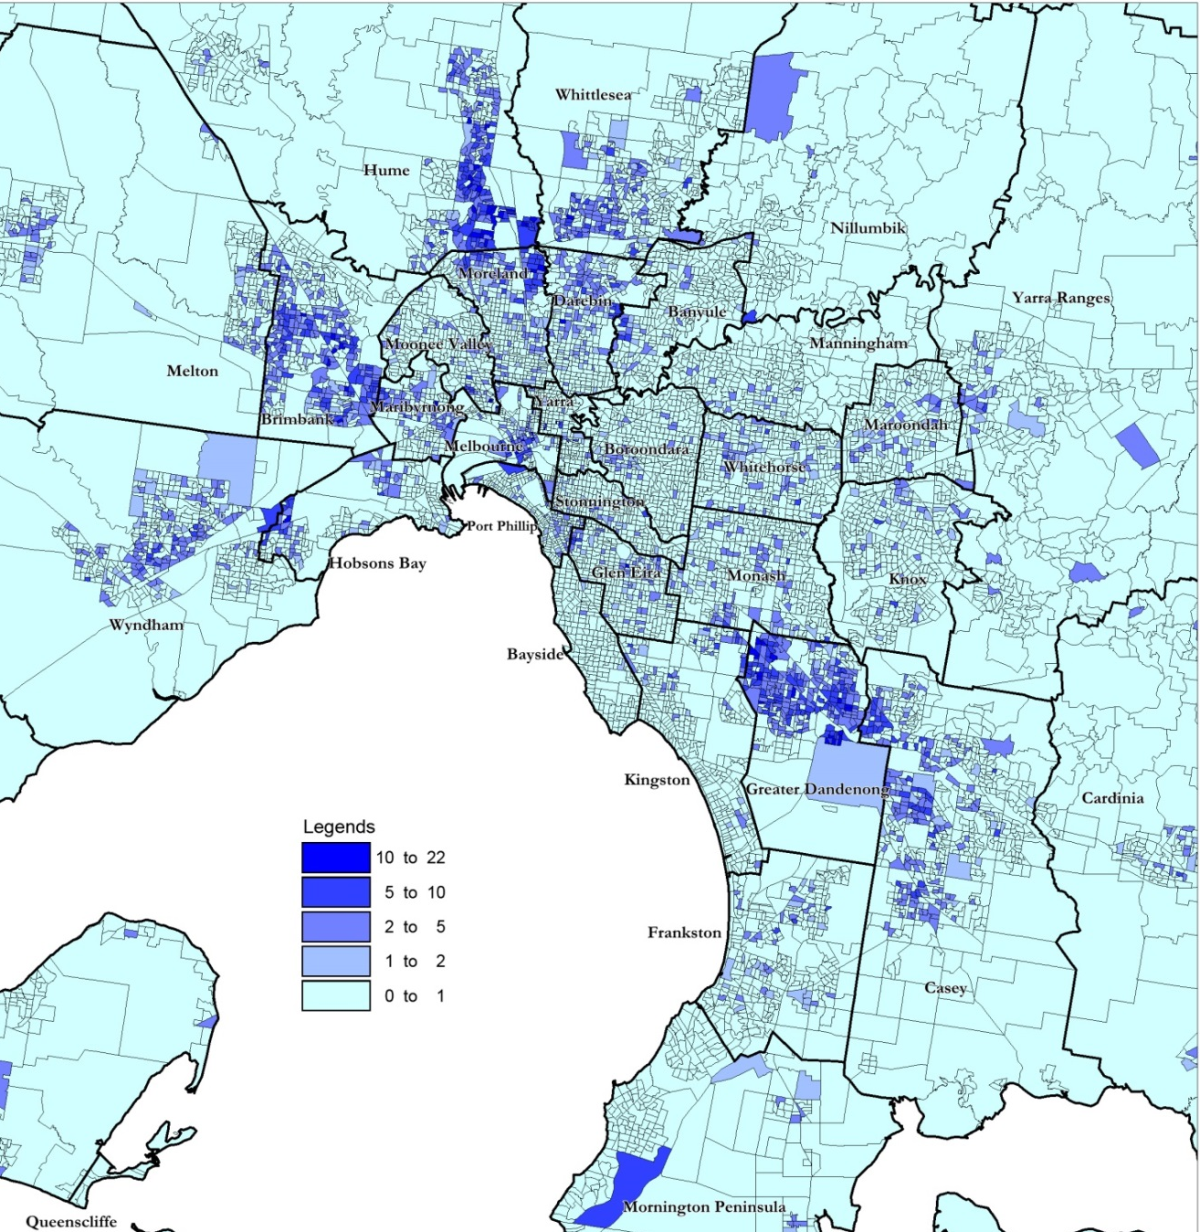

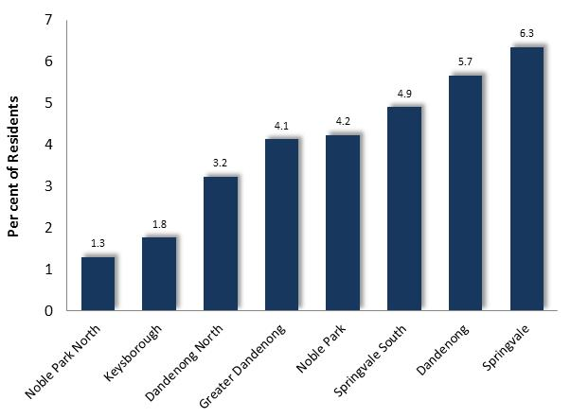

Overcrowding of dwellings: Suburbs of Greater Dandenong, 2016

Among the suburbs of Greater Dandenong overcrowding was most prevalent in Springvale and Dandenong, and least common in Noble Park North and Keysborough.

Homelessness
In 2018, the Australian Bureau of Statistics published estimates of the number of homeless people in each municipality and suburb, calculated from the results of the 2016 Census. Homelessness persons were defined as those sleeping outdoors, residing in homeless accommodation or boarding houses, living with friends temporarily, or enduring severely overcrowded conditions.
A total of 1,942 persons in Greater Dandenong were homeless, over three-fifths (61%) of them living in overcrowded circumstances (diagram, below).
Percent of Homeless Persons, by Type of Shelter: Residents of Greater Dandenong, 2016
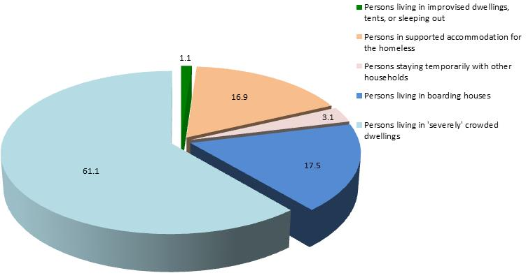
Homeless residents accounted for 1.2% of the population of Greater Dandenong – nearly three times the Victorian level of 0.42%. The number and percentage of homeless persons in Greater Dandenong were the highest in Victoria.

Number of Homeless Persons by Suburb: Greater Dandenong 2016
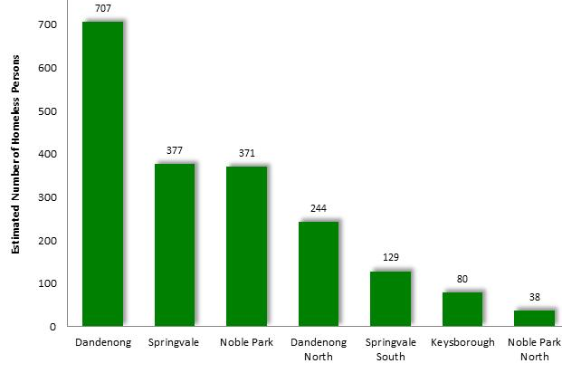
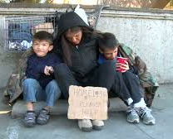
Homeless residents resided largely in Dandenong, Springvale or Noble Park, with few in Keysborough, Noble Park North or Springvale South.
At 2.3%, the percentage of residents who were homeless in the suburb of Dandenong was the highest in Victoria and five times the state level.

The number of homeless persons enumerated in each Victorian municipality is illustrated below. Municipalities with fewer than 50 homeless persons are omitted from the diagram.
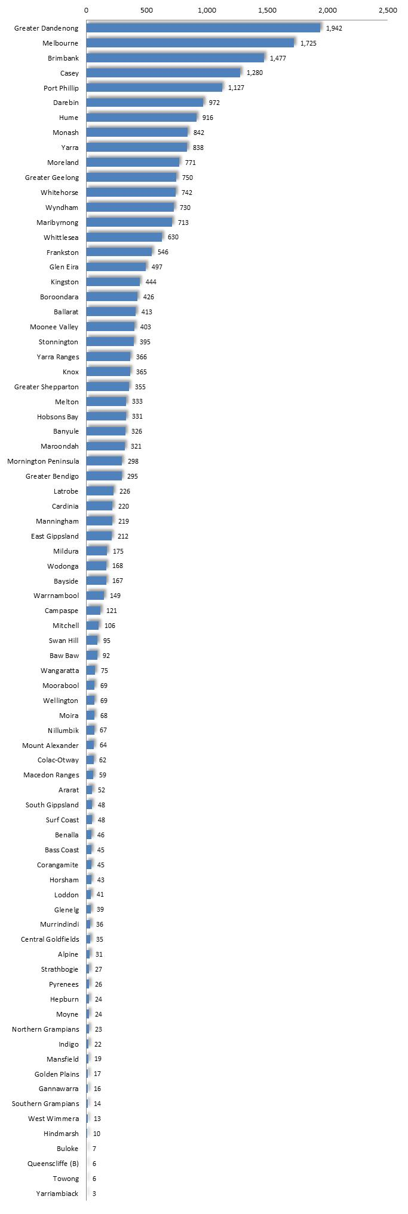
The accompanying map illustrates the proportion of persons who were homeless in 2016, among the SA2 areas of metropolitan Melbourne.
Notably, localities in the western metropolitan areas, north and south-east, such as Ardeer, Dandenong, Fitzroy, Footscray, Hughesdale, Laverton, Melbourne, Noble Park, Springvale, St Albans, St Kilda, Sunshine featured a relatively high prevalence of homelessness among their residents.

Homeless Persons per 1,000 Population, by SA2 Area: metropolitan Melbourne, 2016
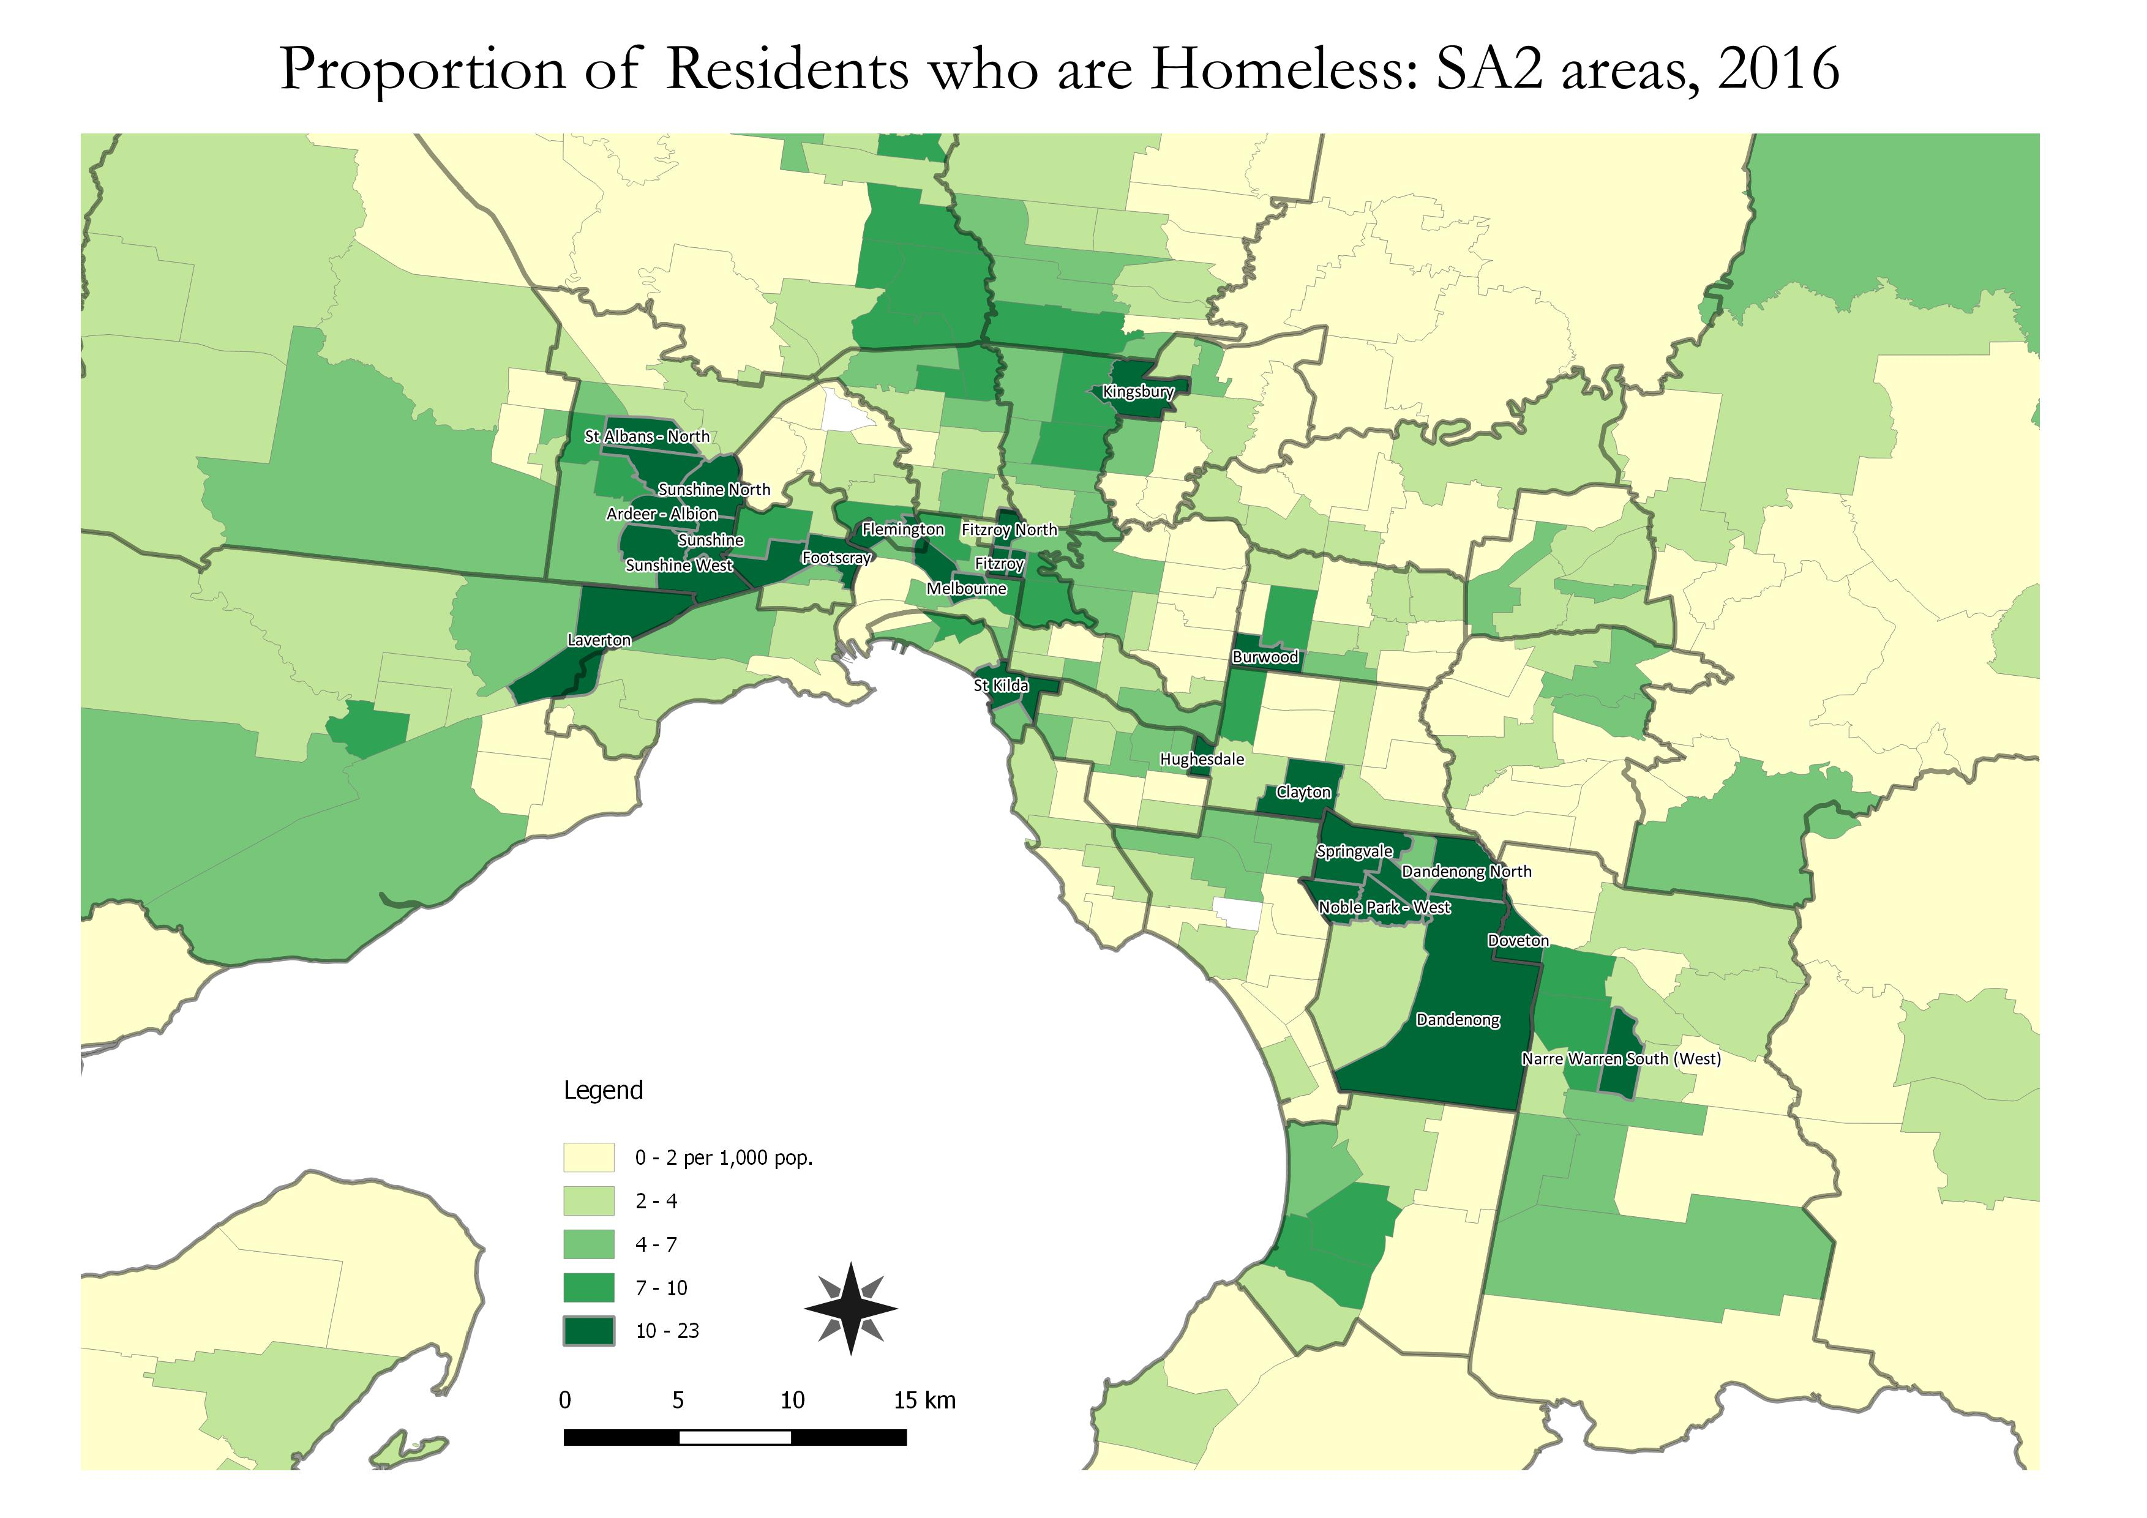

Non-Private Accommodation
In 2016, 3,107 residents of Greater Dandenong resided in non-private dwellings, 35% of them in retirement accommodation, 22% in nursing homes, 14% in hospitals, 12% in hotels or motels, 12% hospitals and 8% in boarding houses. (diagram below)

Number of Persons by Type of Non-private Accommodation: Greater Dandenong, 2016
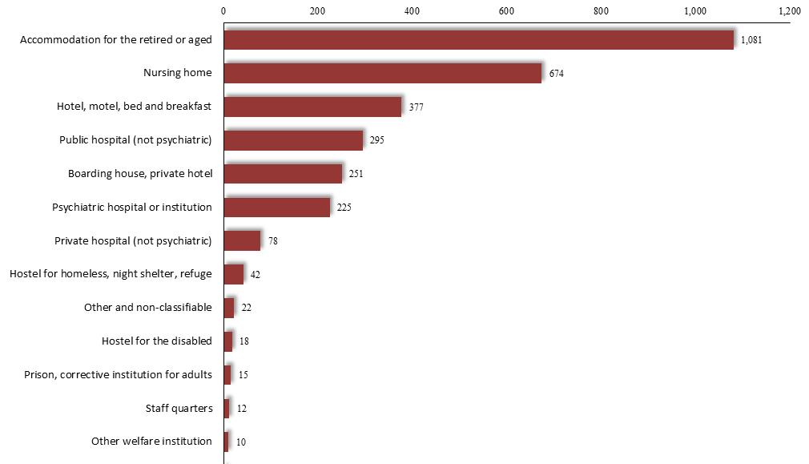

For technical reasons, overcrowding was defined for the purpose of creating this map, as dwellings with zero or one bedrooms and three or more occupants, two-bedroom dwellings with five or more occupants or three bedroom dwellings with six or more occupants.

