

A REVIEW OF
EGM GAMBLING-RELATED ISSUES
FOR LOCAL GOVERNMENT

Hayden Brown
City of Greater Dandenong

Updated September 2019

INDEX

I: The Gambling Industry and Gambling Losses 1

EGMs and Gambling 1

The EGM Gambling Industry and Distribution of Gambling Revenue 2

EGM Gambling Losses and Problem Gambling 3

Concentration of Losses among a Small Proportion of the Population 3

EGM Losses and Disadvantaged Municipalities 3

Gambling Losses and Incomes 7

EGM Density and Disadvantaged Municipalities 8

EGM Density and Gambling Problems 11

On-line and Sports Gambling 11

II: Nature and Causes of Gambling-related Problems 12

The Nature of Gambling Problems 12

Defining Gambling-related Problems 12

Causes of Gambling-related Problems 13

Psychological Conditions 13

Self-control and ‘Responsible Gambling’ 14

Cultural Factors 15

Frequency of Gambling 17

Access to Gambling Opportunities 17

Late-night Operation of Gambling Venues 17

Venue Characteristics and Gambling-related Problems 19

Pleasant staff 19

Proximity to the Venue 19

High numbers and choice of gaming machines 20

Bells and Whistles 20

Anonymity in larger venues 20

Size and Level of Activity in the Venue 20

Meals and Free Tea and Coffee 20

General Venue Characteristics 20

Staff Responses to Gambling Problems 21

Propensity to Seek Assistance with Gambling Problems 23

III: Effects of Gambling Problems 24

Financial Difficulties 24

Personal Stress 24

Family Stress and Violence 25

Work-related Difficulties 27

Crime and Deception 27

IV: The Prevalence of Gambling-related Problems 29

Prevalence of Gambling 29

Prevalence of Severe Gambling Problems 29

Limitations of Gambling Prevalence Surveys 30

Inaccurate Responses 31

Imprecise Measurement 31

A Narrow Focus 32

Gambler’s Help Data as an Indicator of the Prevalence of Gambling Problems 32

Low and Moderate-risk Gambling 32

Impact of Gambling Problems vs. the Prevalence of Problem Gambling 34

V: Characteristics of People with Gambling-related Problems 36

Gender 36

Age 36

Social Disadvantage and Gaming Problems 37

Incomes 38

Education 38

Unemployment and Joblessness 39

Occupations and Gambling Related Problems 39

Indigenous People 40

Personal and Health Problems 41

Cultural Influences 42

Young People 43

VI: Benefits Attributed to Gambling 45

Economic Effects of EGM Gambling 45

Community support Fund 45

Community Benefit Statements 46

VII: Reforms to the Gambling Industry 47

Suggested Reforms to the EGM Gambling Industry 47

Attributes of EGMs 47

Pre-commitment Mechanisms 48

The Effectiveness of Voluntary and Mandatory Systems 49

Enforced Breaks from Gambling 49

Consumption of Alcohol 50

Reductions in EGM Numbers 50

The Role of Government 50

Destination Gambling 50

Informing the Public and Strengthening Families 52

Gambling Machine Caps 53

2001: Five Capped Regions 53

2006: Nineteen Capped Regions 54

Addition of a New Capped Area & Adjustment of Caps: Oct. 2009 54

Further Caps: 2010 55

Adjustment and Extension to Caps in 2017 55

Code of Conduct and Self-Exclusion Program 56

Smoking Bans 57

State Government Legislation in 2017 58

VIII: Council Policy Responses 60

Responses to applications 60

Circumstances to be considered 60

Local discussion of gambling issues 61

Informing the Community 61

Charters 61

Advocacy 62

Surveys and Other Measures of Public Opinion 62

Alternative Recreation 63

Research 64

Community Benefit 64

EGMs on Council Property 64

Location 65

The Public Health Perspective 65

IX: Planning Considerations 68

Local Policy Framework 70

X: Websites 76

Acts 76

Planning Related Matters 76

Gambling Data 77

Productivity Commission Inquiry into Gambling 77

The Gambling Industry 78

BIBLIOGRAPHY 79

NOTES ABOUT GAMBLING ISSUES

I: The Gambling Industry and Gambling Losses
In 2017, the Victorian Commission for Gambling and Liquor Control (VCGLR) reported that there were 26,520 electronic gambling machines [EGMs or ‘pokies’] operating at 512 hotels and clubs throughout Victoria. Annual losses to these EGMs in 2017/18, of $2.7 billion, or $550 per adult, were divided among gambling venues and the state government.
About one in seven adults use gambling machines at least once each year, though fewer than one in ten play on a weekly basis. A 2014 Victorian gambling prevalence study (Hare, 2015) found that the proportion of adults who had participated in EGM gambling during the previous year, had declined from 21% in 2008 to 17% by 2015.
Even so, electronic gambling machines (EGMs or ‘pokies’) account for nearly half of all losses to government-regulated gambling and form the basis for most gambling-related problems. EGMs and losses tend to be concentrated among the least affluent localities – among those communities which can least afford such losses.
Further information about EGMs, player losses and gambling-related problems are presented here.
* * * *

EGMs and Gambling
The EGMs outside the Casino play a predominant role in gambling losses and gambling-related harm in Victoria, accounting for 48% of all legal gambling losses in 2016/17 (Queensland Government Statisticians Office, 2018).
Losses to EGMs in Victoria had declined by 25% in real terms during the past sixteen years. During the same period, racing losses declined by 38%, and losses at the Casino by 11%, in real terms.
Table 1: Losses to Legal Gambling, by Type of Gambling: Victoria, 2000/01 and 2016/17 ($millions)
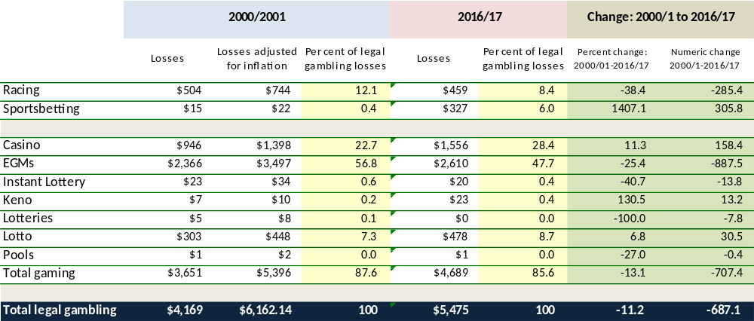
Changes in gambling losses presented in the right-hand columns are based on figures for 2000/01 which have been adjusted to account for inflation.
Chart 1: Losses to Legal Gambling, by Type of Gambling: Victoria, 1989 and 2016/17 ($millions) - Adjusted for inflation
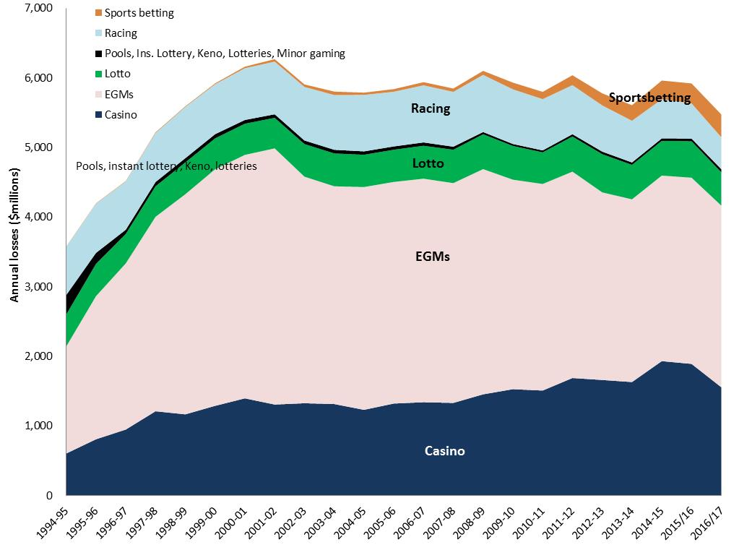
Changes in gambling losses during the period 1994/95 to 2016/17 are illustrated above, with figures prior to 2016/17 adjusted for inflation. After reaching nearly $6.3 billion (adjusted to 2016/17 dollars) in 2000/01, legal gambling losses declined slightly to $5.9 billion in 2016/17. Running counter to this trend, sports betting losses have risen substantially since the turn of the century, though it still accounted for just 5.5% of all legal gambling losses by 2016/17.

The EGM Gambling Industry and Distribution of Gambling Revenue

Under the Gambling Regulation Act 2003, a maximum of 30,000 gambling machines may operate within Victoria: 2,628 within the Melbourne Casino, and 27,372 machines evenly divided among clubs and hotels throughout the state. The Act further specifies that a maximum of 105 electronic gambling machines may be permitted within a single venue (Victorian Government, 2008).
The 504 venues with gambling machines outside the casino in 2018 were either hotels – premises which hold a general license under section 8 of the Liquor Control Reform Act, 1998, or clubs – which hold a full or restricted club license under section 10 of that act or are venues with a license under the Racing Act, 1958. Since all EGM gambling venues must hold a liquor license, if that license is cancelled, approval for EGM gambling at that venue is rescinded.
EGM gambling losses, or the revenue obtained from gambling machines, are distributed among the state and Federal Governments, was well as the clubs and hotels which serve as gambling venues. Hotels pay 8.3% of gambling revenue to the State Government Community Support Fund, which is allocated to problem gambling programs, drug education and treatment, youth programs, community advancement, sport and recreation, the arts, tourism and other purposes. Clubs on the other hand, are expected to contribute 8.3% of their gambling revenue to support the community, with its contribution documented in annual community benefit statements published by the VCGLR.

EGM Gambling Losses and Problem Gambling
In 2018/19, $2.7 billion was lost to EGM gambling within Victoria, the equivalent of $5.4 million per venue, $102,000 per machine, or $531 per adult. A convenient summary of the numbers of venues, gambling machines, losses and other details, for each Victorian municipality and venue, is available here or at www.socialstatistics.com.au > Gambling > Gambling venues machines and losses. Detailed information about gambling venues and losses by local government area are also available from the VCGLR.
The Victorian Longitudinal Community Attitudes Survey found that EGMs are the favored form of gambling among 84% of problem gamblers, with horse racing preferred by just 8% (McMillen and Marshall, 2004).
Not surprisingly, among all the forms of gambling, EGMs are most strongly associated with problem gambling (South Australian Centre for Economic Studies, 2005), with 28% of regular EGM gamblers experiencing severe gambling-related problems – compared with 13% of regular Casino patrons, and 3% of those who regularly gamble on racing (McMillen and Marshall, 2004). The Productivity Commission (2010: 5.1) concluded that problem gamblers account for 22-60% of total EGM losses, while moderate and problem gamblers in total account for between 42% and 75% of EGM losses – representing a mid-range of 58%
Further research indicates that EGMs have made the largest contribution to gambling problems in nearly all Western nations (Williams et al, 2007).

Concentration of Losses among a Small Proportion of the Population
Gambling not only has an adverse effect upon a relatively few people with severe gambling-related problems, but also contributes to financial stress among a larger number of people who persistently lose more money than they can afford. Nevertheless, only one in six adults gamble on EGMs, with 17% of the Victorian public gambling on EGMs at least annually (Hare, 2015). As a consequence, a significant proportion of EGM gambling losses is concentrated among a relatively small proportion of gamblers. This in turn, leads to adverse consequences for the gambler and any dependents:
A variety of research shows that patterns of gambling behavior and losses vary across a broad continuum, from those who do not gamble at all, or do so infrequently, to others who gamble often, and may therefore sustain persistent and substantial losses, relative to their means.

EGM Losses and Disadvantaged Municipalities
A variety of studies, reviewed further on, have found that gambling losses are largely sustained by those who can least afford them: people on lower incomes, in manual employment, those without paid work and people of limited educational attainments. Inversely, others in paid work, with more skilled occupations, higher incomes or educational attainments, by contrast, generally spend less on gambling.
This tendency is mirrored by differences in EGM gambling losses among various localities in Victoria, where the most disadvantaged communities tend to incur the highest gambling losses. In 2017/18 for instance, gambling losses among EGMs situated in Greater Dandenong - the least affluent locality in metropolitan Melbourne - stood at $968 per adult, nearly seven times higher than the corresponding rate of $141 in Boroondara – among the most advantaged municipalities in the State. Thus the residents of the community with the highest gambling losses in Victoria are among those least able to bear the financial burden.
The relationship between social disadvantage and gambling losses is illustrated in the accompanying diagram which, for each metropolitan municipality, matches annual EGM losses per 1,000 adults in 2018/19, to the unemployment rate in June 2019. Notably, the diagram shows the general tendency for higher rates of gambling losses to be incurred by the communities with the higher rates of unemployment.

Chart 2: EGM Losses per adult 2018/19 and unemployment Rate, June 2019: metropolitan municipalities
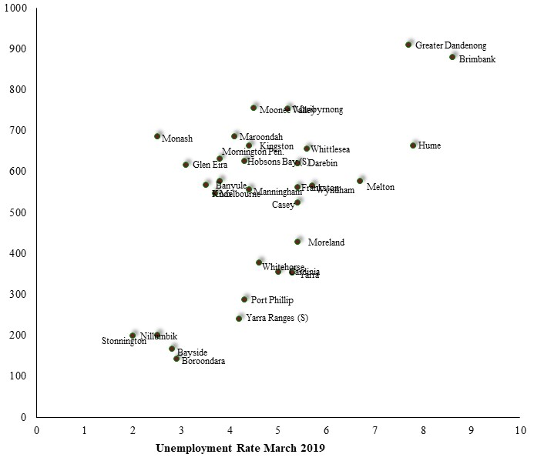

The highest losses are featured among localities of high unemployment and lower incomes, such as Greater Dandenong, Maribyrnong, Brimbank and Hume, while rates are lower among the more affluent inner metropolitan municipalities and those in the outer east and north-east. A similar association may be seen in the relationship between EGM gambling losses per adult and the SEIFA Index of Relative Socio-economic Disadvantage, formal educational attainments and median incomes.
EGM gambling losses per adult in 2018/19, for each Victorian municipality, are illustrated in the diagram below.
Chart 3: EGM Gambling Losses per Adult: Victorian municipalities, 2018/19
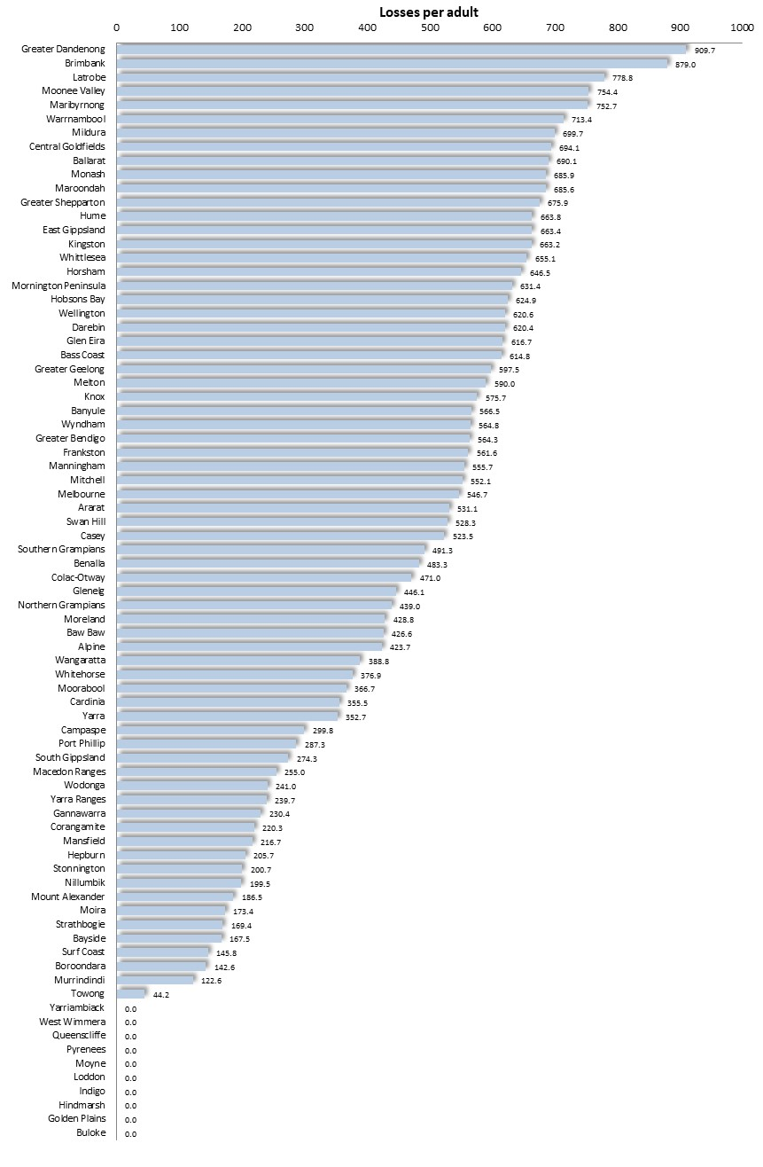
The rate of losses to gambling machines in each of the metropolitan municipalities in 2018/19 is also illustrated in the accompanying map.

Diagram 1: EGM Gambling Losses per Adult: Metropolitan Melbourne Municipalities, 2018/19
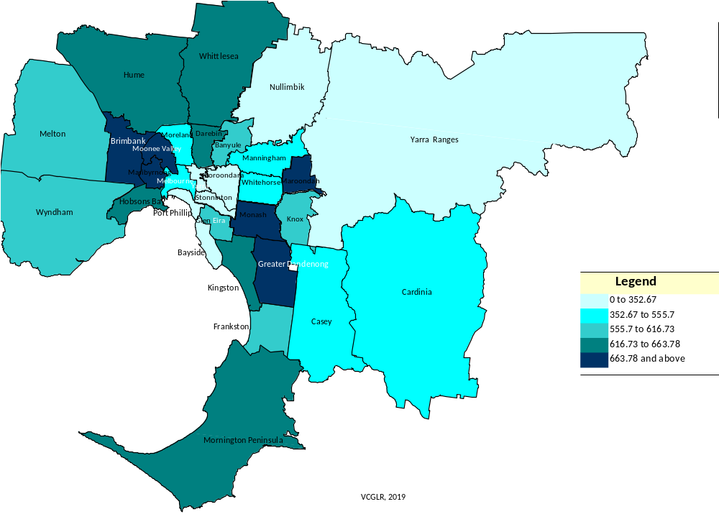

The link between conditions of social disadvantage and gambling losses is further underlined by the strong association between higher gambling losses and such conditions as elevated unemployment rates, lower median incomes, high proportions of one-parent families, lesser educational attainments, limited English fluency and low volunteering rates. The correlations between these social conditions and gambling losses – selected for 2016/17 to approximate the date of the August 2016 Census, with which losses per adult are compared - among metropolitan municipalities, are shown in table two, below.

Table 2: Gambling Losses per adult, 2016/17: Correlations with selected variables
Social Condition | Correlation
Median weekly income males (2016 Census) | -0.76
Persons in one-parent families as a percentage of all people in families (2016 Census) | 0.62
Unemployment Rate March 2017 | 0.59
Per cent population from Non-English-speaking backgrounds (2016 Census) | 0.55
Per cent persons with limited English fluency (2016 Census) | 0.61
Per cent of Prep pupils Vulnerable on 1 or more Domains of Development, 2015 | 0.56
Per cent females who left school before completing year 11 (2016 Census) | 0.51
Per cent of residents who Volunteer (2016 Census) | -0.71
Per cent renters living in rent-related financial stress (2016 Census) | 0.61
* High levels of disadvantage are denoted by a low SEIFA index. Therefore the negative correlations shown here reflect a strong association between disadvantage and higher gambling losses.
* Sources: Australian Bureau of Statistics, Census 2016 – Income, Population NESB; Department of Employment, Workplace Relations and Small Business – Unemployment Rates.

Gambling Losses and Incomes
Where losses are measured in relation to household income, the disparity between gambling losses among the most and least affluent localities is still more marked.
Chart 4: Estimated Proportion of Gross Individual Income Lost to Gambling by EGM Gamblers, 2016/17: Metropolitan Municipalities
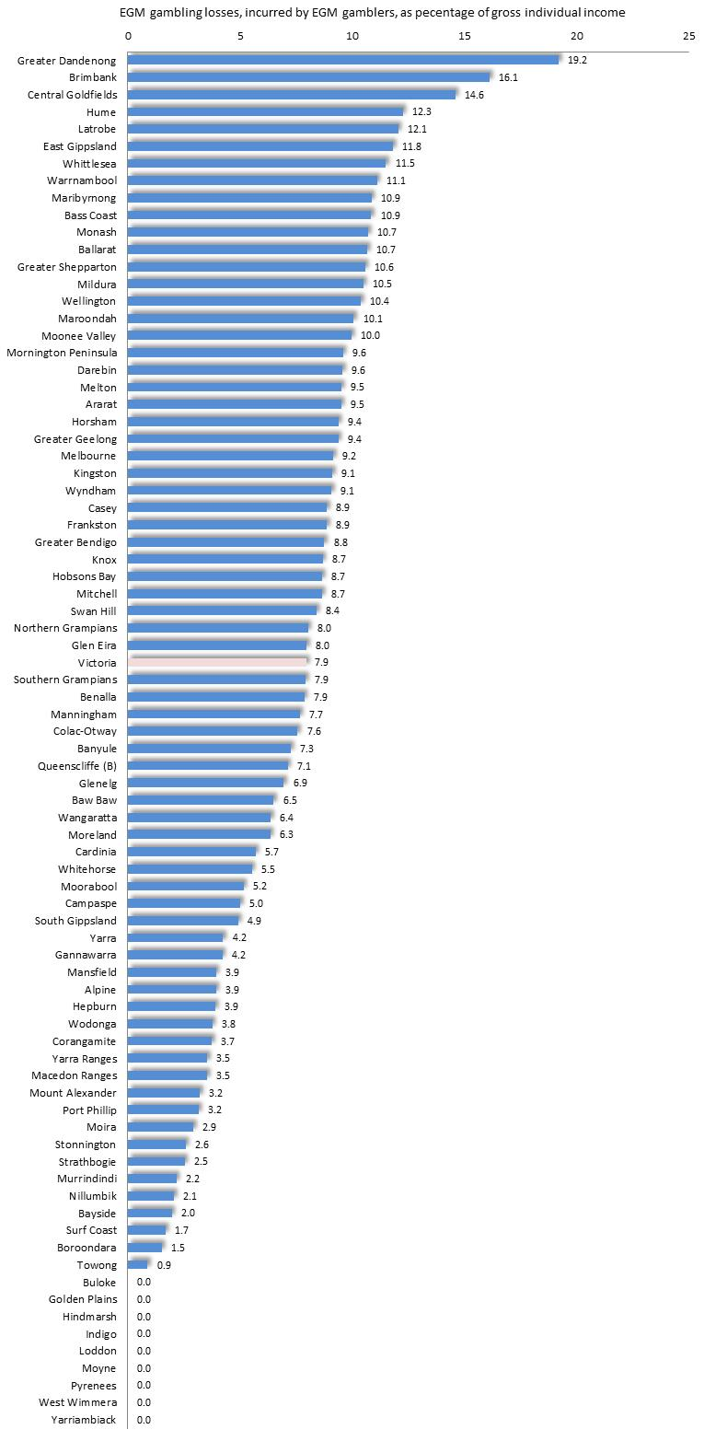
The relationship between EGM gambling losses, and income levels may be examined with keener focus by concentrating upon those individuals who actually gamble on electronic gambling machines. It may be recalled that 2014 Victorian Gambling Prevalence Survey (Hare, 2015) found that approximately 17% of adults in Victoria use EGMs in a given year. Accordingly, EGM losses in each municipality in 2016/17 may be used to calculate the approximate level of annual EGM losses for the approximately 17% of adults in each community who had used EGMs at some time during that year.
To estimate average losses incurred by EGM gamblers in each Victorian municipality, annual EGM losses per adult were multiplied by 100/17. This figure was then divided by the median gross individual annual income for adults in each municipality (based on the findings of the 2016 Census), to give a reckoning of the proportion of average, gross adult income, lost by EGM gamblers in each of these municipalities. According to estimates prepared in this fashion, EGM gamblers in Greater Dandenong lost an average of 19.2% of their gross income to gambling machines in 2016/17 By contrast, their counterparts in Boroondara lost just 1.5% of their incomes on EGM gambling.

EGM Density and Disadvantaged Municipalities
As with EGM losses, the density of EGMs throughout Victoria [measured as the number per 1,000 adult residents] tends to be highest among the least affluent municipalities. For example, the average EGM density in the most disadvantaged four metropolitan localities [as measured by 2016 median personal incomes] in 2018 was 5.8 per 1,000 adults, compared with 3.3 among the least disadvantaged localities. In the case of Greater Dandenong, the density of EGMS stood at 7.6 per adult in 2018 – the second highest concentration of gambling machines in metropolitan Melbourne and substantially in excess of the metropolitan average of 5.1.

Table 3: Rate of EGM Losses and EGM Density: Most and Least Affluent Victorian Municipalities
Least affluent localities | EGMs/1,000 adults, 2019 | Losses/ adult, 2018/19 | Most affluent localities | EGMs/1,000 adults, 2019 | Losses/ adult, 2018/19
Whittlesea | 4.1 | 655 | Port Phillip | 3.8 | 287
Hume | 5 | 664 | Stonnington | 2.5 | 2.1
Brimbank | 5.9 | 879 | Yarra | 3.6 | 353
Greater Dandenong | 7.3 | 910 | Bayside | 2.5 | 168
Average | 5.6 | $777 | Average | 3.1 | $203

The association between EGM density [EGMs per 1,000 adult residents] and the 2018 unemployment rate, for each metropolitan municipality, is presented in chart five, below.
Chart 5: EGM Density 2018/19 by Unemployment rate 2019: metropolitan Municipalities
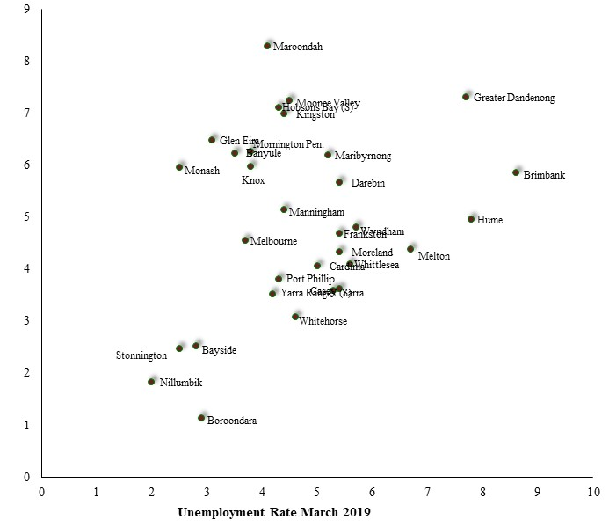
The density of gambling machines among the metropolitan municipalities, in 2018 is also illustrated in the accompanying map.

Diagram 2: Number of EGMs per 1,000 adults: Metropolitan Municipalities, 2019
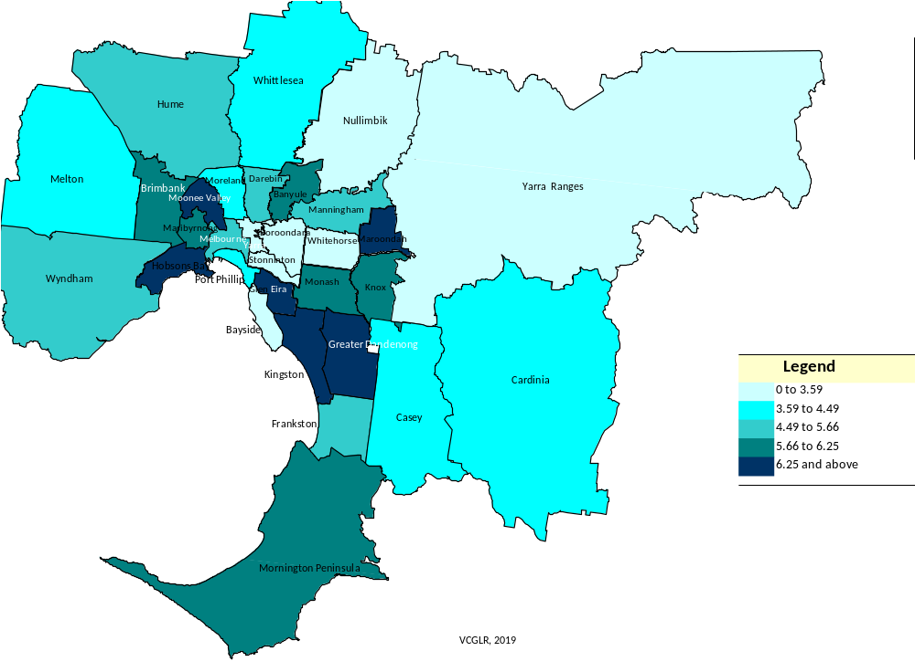

The resulting pattern partly reflects that of EGM losses, shown earlier, with the highest numbers of EGMs per 1,000 adults among localities of lower income levels, such as Brimbank and Greater Dandenong, while lower densities are featured among more affluent localities such as Bayside, Boroondara, Stonnington and Nillumbik.

The association between the location of EGM gambling venues – as well as their numbers of EGMs – and socio-economic disadvantage is illustrated in the accompanying map, which overlays the location of gaming venues in metropolitan Melbourne upon an illustration of the SEIFA Index of Relative Socio-economic Disadvantage. Red dots represent venues, with their sizes reflecting the number of EGMs operating in each.
Pale areas have the lower SEIFA Index and are therefore the most disadvantaged.
Notably, the higher densities of EGM venues tend to be found in inner-metropolitan localities and in more disadvantaged localities in the middle and outer suburbs. By contrast, the map depicts the low density of EGMs in the comparatively affluent locatlities within Manningham, Bayside, Yarra Ranges and Frankston.
Diagram 3: Location and Size of EGM Gambling Venues, 2018 and SIEFA Index of Relative Socioeconomic Disadvantage 2016

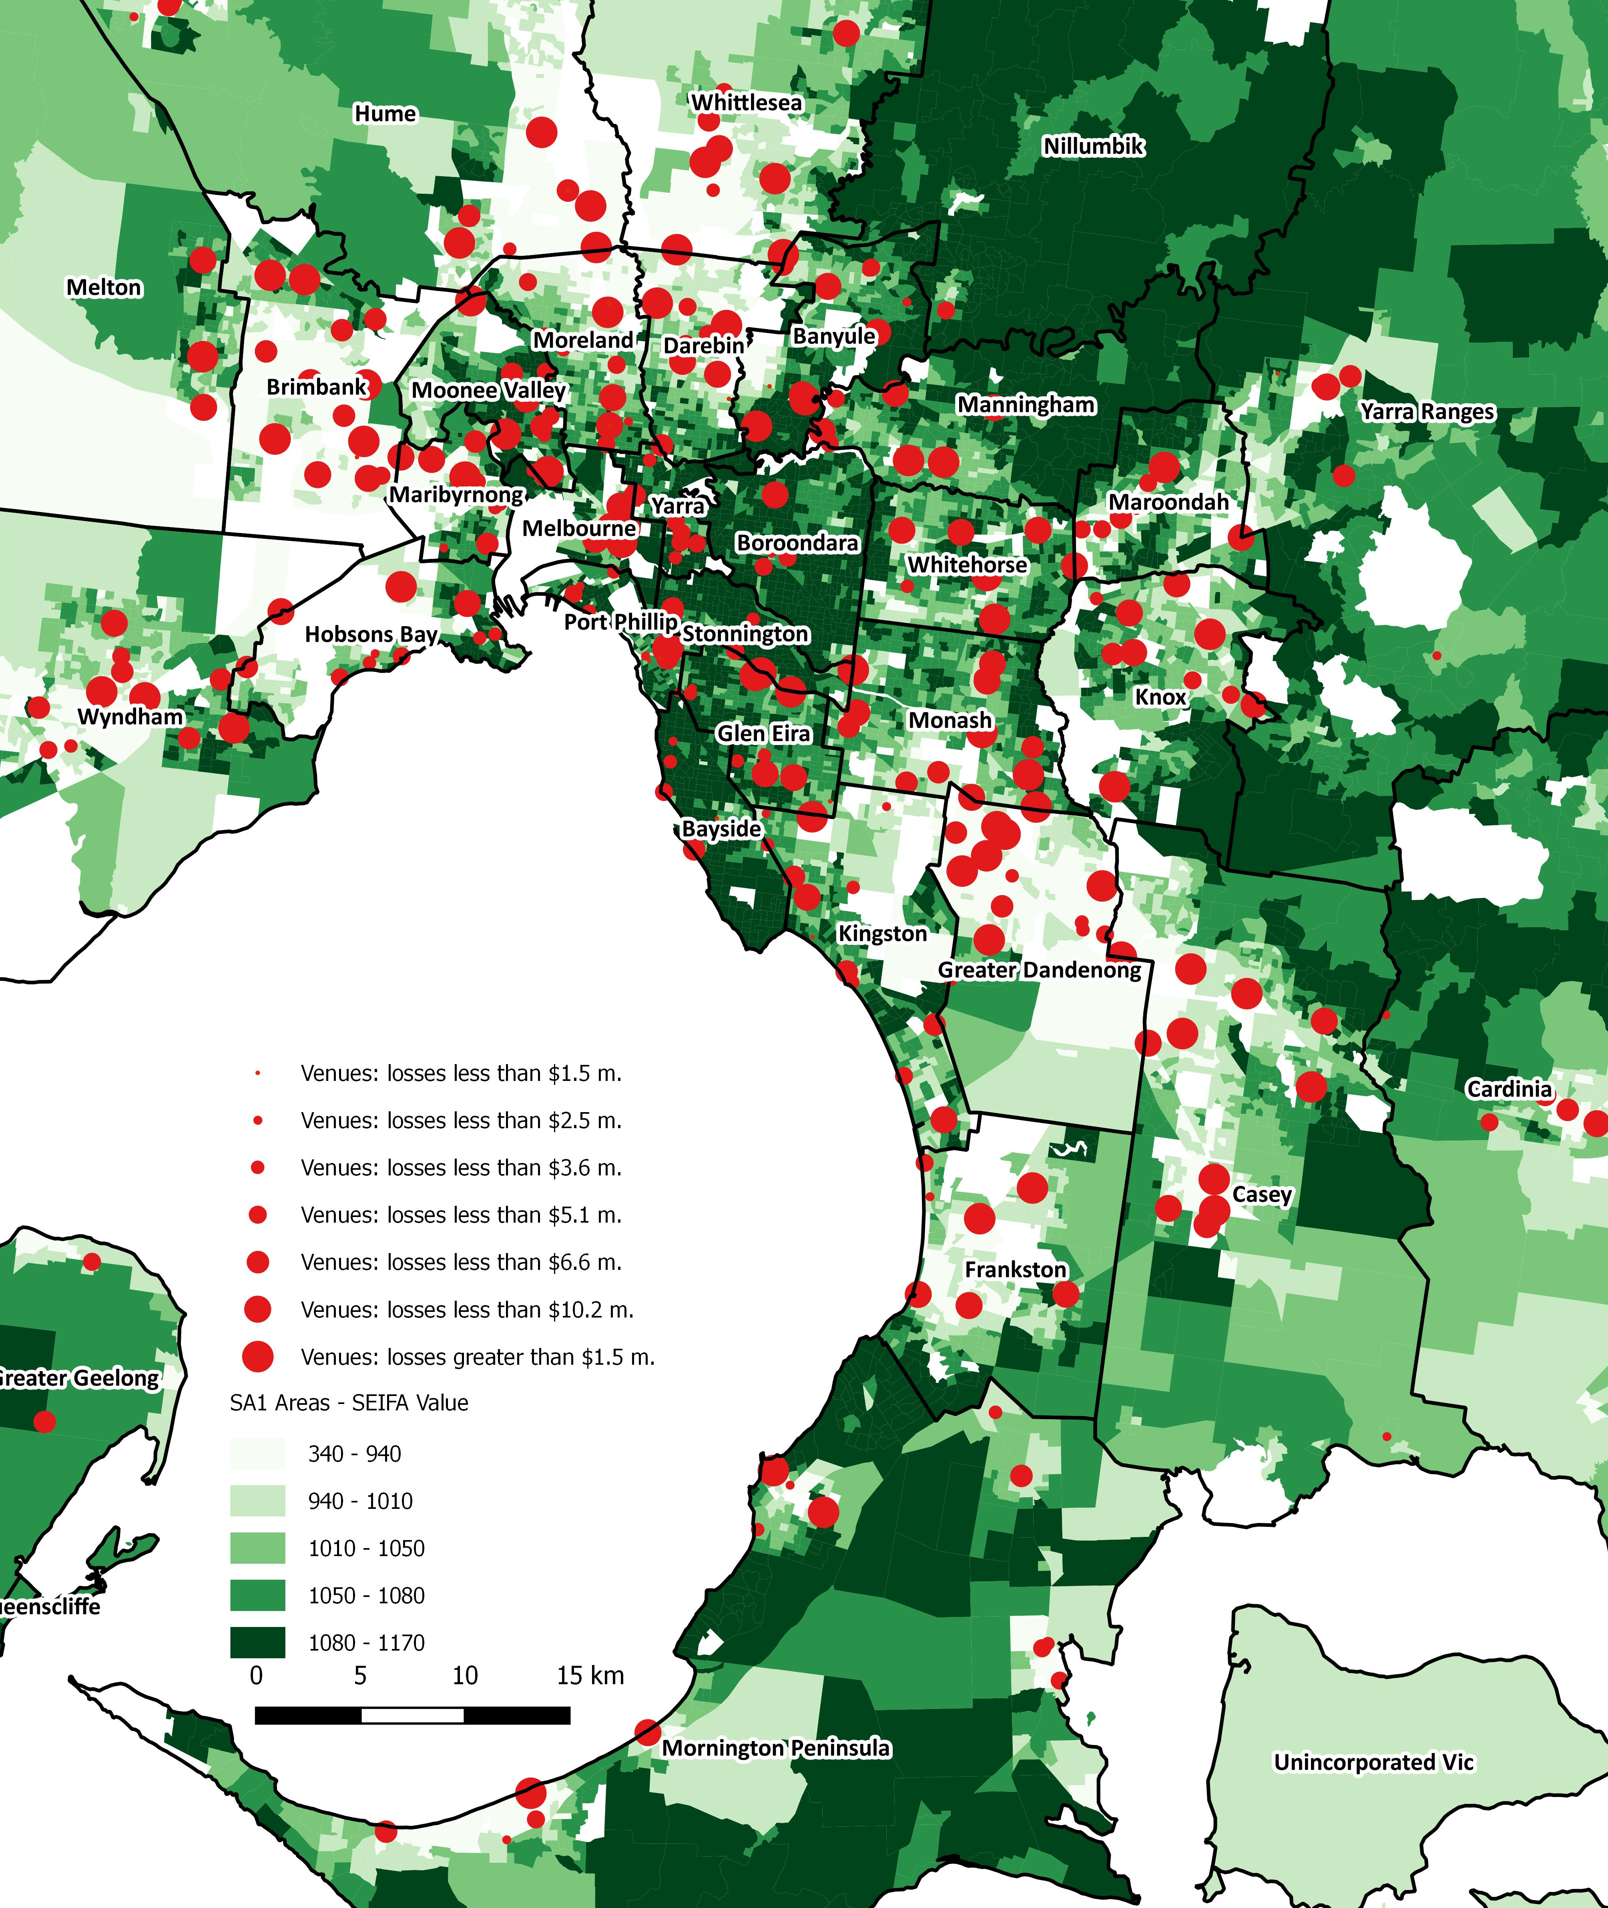

EGM Density and Gambling Problems
Contemplating evidence of the higher densities of EGMs in less affluent localities, the Productivity Commission observed that high densities of EGMs in disadvantaged areas “…can serve to concentrate the social costs in communities that are less able to bear them.” (1999: 30) and accentuate the withdrawal of incomes from these communities.
Evidence linking levels of gambling opportunity, including the density of EGMs or EGM gambling venues, with levels of gambling and gambling-related problems, is surveyed further on, in the section ‘Access to Gambling Opportunities’.

On-line and Sports Gambling
While EGM gambling is the predominant concern of this report, mention should be made of the rise of sports betting and other on-line gambling.
Change in gambling losses, by gambling modality: Victoria, 2000/01 to 2016/17
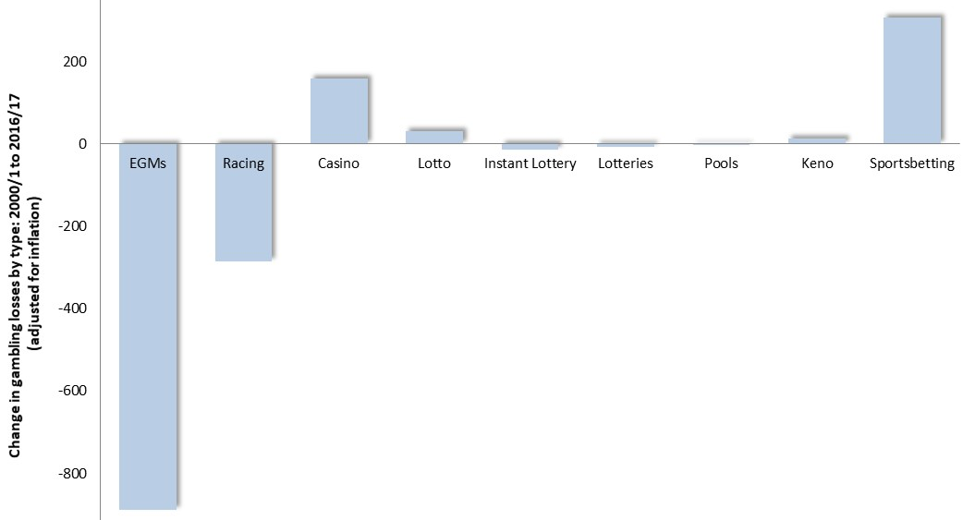
The burgeoning of social media during the past decade has made it an accessible and appealing means for the gambling industry to promote and conduct gambling. Losses to legal sports betting in Victoria rose from $15 million to $327 m. in the period 2000/1 to 2016/17 (Queensland Government Statisticians office, 2018).
A 2011 survey of Australian adults by Giansbury et al, found that 8% of Australian adults had participated in on-line gambling during the previous 12 months. They were largely younger, generally male, participated in a variety of forms of gambling and experienced higher losses than others. (Gainsbury et al, 2013; Gainsbury et al, 2011). A more recent 2014 Victorian study revealed that 1.8% of females had participated in sports betting in the previous year, compared with 8% of males – with its prevalence highest among 18-24 year-old males, at 15% (Hare, 2015).
Some young men are attracted to sports and on-line gambling as an affirmation of masculinity, sporting knowledge, and team affiliation (Milner et al, 2013), while others may be lured by the excitement and risk of gambling, the possibility of winning money, the social experience which often accompanies gambling or the association between drinking cultures and gambling, and the strengthening link being forged between the enjoyment of sport and gambling (Thomas and Lewis, 2012).
This issue is explored in further detail in the section ‘Characteristics of People with Gambling-related Problem’ > ‘Young People’ on page 33.

II: Nature and Causes of Gambling-related Problems

The Nature of Gambling Problems
The basis of most gambling-related problems is the loss of more money than a person, or their household, can comfortably afford. The resulting financial hardship may have detrimental effects upon personal and social life, family and employment, leading to personal disturbances, a diminished social life, family and marital discord, decreased attendance and productivity at work, deceptive or criminal actions to obtain money, and even homelessness.
Efforts to gauge the precise extent of gambling-related difficulties with population surveys have largely focused upon the most severe gambling problems, and are beset by questions related to their validity, accuracy, precision and consistency. Alternate approaches include the possibility of measuring the proportion of the population adversely affected by the gambling of others, and documenting the overall burden of gambling upon communities, including low, moderate and high-risk gamblers.
These issues are explored in further detail here.
* * * *

Defining Gambling-related Problems
Svettieva and Walker note that the various terms used to denote more severe gambling-related problems, such as ‘compulsive’, ‘pathological’ and 'problem gamblers’, are often ill-defined and interchangeably used. In addition though, these terms tend to reflect very different ideas about the nature of gambling problems (2008). Thus, while it is clear that gambling may contribute to a range of difficulties, opinion is divided on how to define and identify people who are experiencing such problems.
One term widely used in the literature, though of declining popularity, is ‘pathological gambling’, which characterises severe gambling problems as persistent or chronic mental disorders, featuring a preoccupation with gambling, loss of control and persistence with gambling despite adverse consequences (Unnamed, 2005; AllPsych Online, 2008). The diagnosis of ‘pathological gambling’ was first introduced into the 3rd edition of the American Psychiatric Association Diagnostic and Statistical Manual [DSM III] in 1980, then revised in the mid-1990s. ‘Pathological gambling’, according to DSM IV, is considered to be present when 5 or more of its ten diagnostic criteria are present (American Psychiatric Association, 2008; AllPsych Online, 2009).
Lately though, attention has shifted from the state of the individual, to the effects of gambling upon the family and broader community, with gambling-related problems being widely viewed as a public health issue. Accordingly, recent years have witnessed a growing emphasis upon the difficulties caused by gambling – rather than seeking a diagnosis of the individual – and upon harm minimisation as a remedy for such problems (Svettieva and Walker, 2008; SA Centre for Economic Studies, 2005B), reflecting a response to “…the adverse health, social and economic consequences of gambling for individuals, families…and society” (Canadian Centre for Substance Abuse, cited in SA Centre for Economic Studies, 2005B).
With these considerations in mind, commentators have tended to characterise severe gambling-related problems as 'problem gambling' or 'excessive gambling', in preference to ‘pathological gambling’. The SA Centre for Economic Studies (2005B) cites with approval an earlier definition of ‘excessive gambling’ by Blaszczynski as “…a level of gambling expenditure that is considered to be higher than can be reasonably afforded relative to the individual’s available disposable income, and which as a result, causes financial strain” (6: vi). The result, Dickerson et al (2007) add, may include “…harm to the individual player, and/or to this family…” which may reach into the community (cited in SA Centre for Economic Studies, 2005B).
This definition reflects a shift from the narrow conception of gambling problems as pathological or addictive conditions, to the broader vision of their adverse effects upon individuals and families. Such an approach has several advantages. First, it does not rely upon the proposition that gambling problems are a medical condition. Second, such a wide view of gambling problems encompasses the larger group of people who experience gambling-related problems and their social context, rather than upon a lesser number deemed to be afflicted with a clinical addiction or specific psychological affliction. Finally, by bearing in upon the effects of gambling problems rather than the individual, this perspective plainly recognizes the destructive implications of gambling-related problems for family, friends and the community, while repudiating a victim-blaming approach.

Causes of Gambling-related Problems
Causes of gambling problems are often complex and may involve individual factors, the nature of the gambling experience, and the accessibility of gambling opportunities.
Psychological Influences
The experience of individuals who are attracted to gambling as a way to alleviate boredom, social isolation, depression and other personal distresses, is well documented (Moodie, 2007; Ballon, 2006). Writing of homeless people in Australia, Talbot (2008) notes that for many, EGM gambling provides something to occupy their minds, while for others, the venue is a place to be among people. Echoing this finding, some gamblers interviewed in one study mentioned the role of venue workings in “…providing contacts and a form of social connectedness.” (Thomas and Lewis, 2012: 10). Rintoul and Deblaquiere too remark that many problem gamblers are socially isolated and gamble to alleviate loneliness (2019). Similarly, ACNielsen (2003) found that some gamblers played when they felt down, to alleviate loneliness or to escape difficulties in their social, home or work lives.
Accordingly, many people experiencing mental health or drug-related problems may be susceptible to gambling problems (McCready et al, 2008), with a Melbourne study finding that people with gambling-related problems were far more likely than others to be depressed or to use alcohol or other drugs to excess (Science Alert, 2008). Many women are attracted to gambling as a means to escape isolation and serious personal problems, such as domestic violence (Healthy, Wealthy and Wise Women, undated). Blaszcsynski maintains that, aside from those gamblers whose psychological disturbance is largely a consequence of gambling problems, for others, gambling problems may be aggravated by pre-existing emotional disturbances or biologically-based conditions, such attention deficit or impulse control disorders.
Howe et al (2018) report that frequent gambling is associated with depression and people suffering from problems with gambling report higher levels of depression. In addition, Giovanni et al (2017) found that persons with Post-Traumatic Stress Disorder are at high risk than the general population of experiencing gambling problems. Similarly, a 2017 study commissioned by the Victorian Responsible Gambling Foundation found that 41% of people seeking treatment for mental illness gamble and 6% had a problem with their gambling – eight times higher than among the general population (Lubman et al, 2017).
Adolescence itself may predispose some people to gambling related problems. Thomas and Lewis (2012) found that many adolescents enjoyed the excitement associated with the risk of gambling and the possibility of winning money, often as part of a social experience. Indeed, research reveals a higher prevalence of problem gambling among adolescents in Australia – in the range 2.4% to 16% (Miller, 2015).
Misconceptions and Deceptive Gambling Machine Design
Individual gambling behavior is also known to be influenced by irrational or superstitious conceptions about the probability of winning or the role of skill in gambling – notions that cause some gamblers to entertain unrealistic expectations of winning – as well as ineffective approaches to decision-making (Joukhador et al, cited in Moodie, 2007; Talbot, 2008). Such ideas may be fostered by aspects of EGM design, such as machines which display the required symbols just above or below the pay line to convey the misleading impression of a near win (Select Committee of the Legislative Council on Gambling Licensing, 2008; Harrigan, 2007), and by the manner in which gambling is presented and advertised. As one interview respondent explained in research conducted by AC Nielsen “Every machine comes so close to winning a major jackpot and you think, I’m just one off…” (2003: 45).
As Livingston explains: “…poker machines are conditioning machines...” which employ principles of operant conditioning to teach people “…that if they keep playing the machine they will get a series of intermittent rewards” (2008: CA5).
In relation to the design of gambling machines and accessibility of gambling, the Responsible Gambling Foundation (2015) cites the Productivity Commotion, which in its 2010 report on the gambling industry asserted that “…problems experienced by gamblers are as much a consequence of the technology of the games and their accessibility, and the nature and conduct of venues, as they are a consequence of the traits of gamblers themselves.”
Psychological Conditions
Psychological conditions which predispose to impulsivity may exert an influence upon gambling behaviour, with one inquiry finding that 25% of gamblers who sought counselling for gambling problems had attention deficit disorder - nearly twice the corresponding prevalence in the general community of 14%. (Waluk et al, 2015). Other researchers have reported conditions such as a lesser tendency than others to delay gratification among people with gambling-related problems (Navos et al, 2017), impulsivity and ‘grandiose-manipulative’ personality traits (Rucevic, 2016), and relatively low intelligence, high levels of impulsivity and prevalence of ADHD (Black 2013). Echoing the latter finding, a longitudinal survey of 6,145 young adults found that those who experienced signs of ADHD, or higher than average impulsivity in childhood were more likely than others to report gambling problems, high levels of gambling losses and multiple types of gambling activity, than others (Clark et al, 2013). Studies also indicate that many people with gambling related problems gamble to alleviate depression, loneliness, boredom or anxiety, often seeking to distract themselves from their concerns or to escape reality altogether at a gaming venue (Neilsen, 2003).
Self-control and ‘Responsible Gambling’
Some people with severe gambling-related problems report a loss of awareness and control as they become immersed in the experience of gambling. Commonly, the result is a state of mind described as trance-like, in which perception of events, time and consequences become confused (Pinkerton, 2005). As a witness to a recent Senate inquiry from a problem gambling service told it: problem gamblers “…go into blackouts, they loose time and cannot remember their actions” (Senate Standing Committee on Community Affairs, 2008: 20). AC Neilsen (2003) reached the same conclusion in their interview study of gambling experiences, noting that may gamblers become immersed in the experience of gambling, including the lights and sounds emanating from machines, with the result that they lost track of time and, to some extent, of reality.
Similarly, the Productivity Commission (2010) found that EGMs were the form of gambling most often associated with the psychological state of dissociation – where an individual ‘loses track of reality’, ‘played in a trance’, ‘lost track of time’ or ‘felt someone else was controlling their actions’. Typically, EGMs were cited by three-quarters or more of gamblers as the form of gambling most often associated with these mental states. The authors of this report concluded that proportion of adults who experience harm from gambling, or episodes of dissociation, rises with frequency of gambling, particularly as the frequency reaches and exceeds weekly exposure to gambling.
The Commission concluded that such states impair the ability of gamblers to “…reassess whether they wish to continue to gamble…” (2010: 4.14), a conclusion which seemingly discredits the notion of ‘responsible gambling, which postulates that gamblers can – and therefore, should – exert rational control over their behavior, when gambling. As Dickerson observed: “…the data we collected showed the virtual impossibility of regular…EGM players gambling responsibly…” (cited in Breakeven Tasmania, 2008).
Cultural Factors
A variety of circumstances relating to the cultural backgrounds of many migrants as well as the stresses and social isolation often associated with settlement may predispose some individuals to gambling problems.
Dickins, M. and Thomas A (2012) concluded that while CALD people overall appear less likely to gamble, those who do participate in such activities are more likely to experience gambling problems. Australian research, largely focused upon ethnic Chinese Australians, has identified some factors which may predispose some CALD groups to gambling problems: Popularity and acceptance of gambling is a cultural norm in Chinese culture (Feldman et al, 2014). Religious or spiritual beliefs in the influence of luck and its interaction with character are popular in Chinese culture, with a display of good luck purporting to demonstrate good character. Such notions are often coupled with unrealistic beliefs in personal ability to control outcomes of gambling (Dickins and Thomas, 2012; Feldman et al, 2014).
The appealing environment offered by casinos, in the relative absence of alternative, culturally-appropriate entertainment may also contribute to the prevalence of gambling among people of some cultures. For people of Chinese ethnicity in particular, casinos offer culturally sensitive and familiar entertainment – including Chinese New Year celebrations, evening activity reminiscent of their homeland and staff who speak non-English languages. In addition, the Casino provides inexpensive meals and drink in a safe environment with a glamorous and appealing décor, making it an attractive and prestigious location, particularly for recent settlers and those who have not adapted to Australian culture (Dickins and Thomas, 2012; Feldman et al, 2014). Interviewees in a study by Feldman et al (2014) observed that for some Chinese, showing guests around the Casino is a way of affirming their affluence and garnering respect (Feldman et al, 2014).
For some migrants with limited English fluency, an additional appeal of casinos and other gambling venues, may be the presence of bilingual staff or the opportunity to be among people without having to participate in conversation (Feldman et al, 2014).
For isolated migrants, including many older people, the Casino appeals as a place that is safe, accessible after dark, where they can be around other people and feel less lonely. In addition, those organizing excursions for older seniors clubs are often unfamiliar with the range of options available, and may be attracted to the cheap meals offered by venues (Feldman et al, 2014)
Many international students, including those of Chinese ethnicity, experience high levels of stress, depression and social isolation, often coupled with prevalent irrational beliefs about gambling, which may foster an attraction to gambling and to venues such as the Casino (Feldman et al, 2014). In addition, freed from parental and other constraints, some international students tend to lose control of their finances (Feldman et al, 2014).
Gaming machines may also be a captivating novelty for some recent settlers, who may perceive them as a means to acquire more money (Rintoul and Deblaquiere, 2019)
Abrupt exposure to various gambling opportunities may pique curiosity and trigger excessive involvement in gambling (Dickins and Thomas, 2012).
Stressors relating to settlement or experience in their country of origin may cause some migrants to be vulnerable to gambling problems (Dickins and Thomas, 2012). Feldman et al (2014) note that refuges and asylum seekers, in particular, often experience stress relating to challenges of adapting to Australian life, social isolation, poverty, boredom and look to gambling to improve their financial position.
The stigma associated with gambling problems may prompt some migrants to conceal issues from family and friends. In addition, professional counseling is unfamiliar to many, with most migrants preferring to deal with personal problems within their family (Dickins and Thomas, 2012)
Vulnerable migrants include younger people, older people – due often to boredom and social isolation, unemployed, less educated and those with limited English fluency (Feldman et al, 2014)
The research findings recounted here are echoed in the conclusions reached by the Ethnic Communities Council of Victoria (ECCV). In December 2017, EECV published findings arising from its consultations with representatives of a variety of cultural communities. It concluded that recent settlers and some cultural communities were at heightened risk of gambling related harm, due to limited prior exposure to, and understanding of, gambling products; increased access to gambling in Australia; and lack of culturally sensitive support for people with gambling problems. The ECCV added that women, older people and students of culturally diverse backgrounds were most particularly at risk of gambling-related problems.

Frequency of Gambling
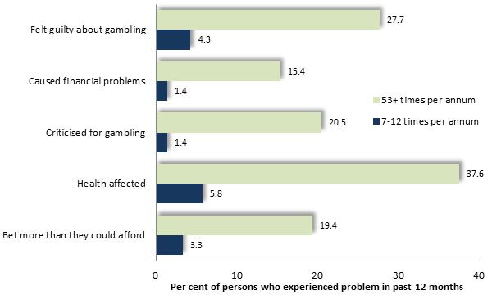
The Victorian Prevalence Survey 2008, compared the proportion of gamblers who experienced each of a selection of adverse effects of gambling, by frequency of EGM gambling. The prevalence of these consequences was up to fourteen times more prevalent among people who gambled at least weekly than among those who engaged in this activity 7-12 times per year. (accompanying diagram)

Chart 5: Adverse Effects of Gambling, by Frequency of Exposure to Gambling

Access to Gambling Opportunities
Evidence attests that accessibility to gambling – including gaming machine density – is associated with higher levels of gambling losses and problems. Some of these studies relate specifically to the density of gaming machines.
Storer, Abbott and Stubs (2009) examined findings of 34 gambling prevalence surveys, concluding that the number of problem gamblers rose with increased EGM density by between 0.6 and 1 per gambling machine, concluding that “The prevalence of problem gambling increases with increasing density of EGMs” (2009: 238). In addition, they concluded that the prevalence of problem gambling would plateau only once gaming machine density reached a level well in excess of the existing densities. Rintoul et al (2012) examined the association between EGM gambling losses per adult and socioeconomic disadvantage (measured by the SEIFA Index) across Melbourne suburbs and EGM density, concluding that “40% of the apparent effect of disadvantage was explained by the density of EGMs.” (2012: 1)
Other research relates to more general levels of gambling opportunity or access to gambling venues. The report ‘Risk Factors for Problem Gambling’ (2015) cites work by Valiliadis et al (2013) who determined that accessibility of gambling opportunities is associated with increasing gambling problems. Further research, recounted in ‘Problem Gambling in New Zealand: preliminary results from the New Zealand Health Survey’ (2012), found that people living close to gambling venues were more likely to experience gambling problems than others. ‘Risk Factors for Problem Gambling’ (2015) adduced the findings of Barratt (2014) who inquired into health-seeking patterns, reporting that increased access to gambling opportunities was accompanied by elevated levels of gambling-related harm.
Welte et al (2006) similarly concluded that proximity to gambling outlets was associated with an increased prevalence of problem gambling. Such a relationship between accessibility of gambling opportunities and the prevalence of gambling-related problems is affirmed and explained by various researchers and commentators. The Productivity Commission (2010: 14.6) found that “Accessibility stimulates demand, with the result that some gamblers are exposed to risk that were originally muted or absent”. In its earlier investigation of the gambling industry, the Productivity Commission observed that high densities of EGMs in disadvantaged areas “…can serve to concentrate the social costs in communities that are less able to bear them” (p: 30), a condition aggravated by the outflow of incomes from these communities as tax on gambling receipts.
The report ‘Destination Gambling’ (2008: 6) found that high accessibility makes “…gambling tempting for emotionally vulnerable problem gamblers” adding that “Where the presence of…gaming venues is increased, impulse behaviour will be more frequent”. Similarly, Lam and Mizarski (2009) contended that “Increasing opportunities to gamble would result in more individuals picking up the habit of gambling and potentially increase the incidence of problem gambling.” (pp. 273-4).
Harris and Griffiths (2017) recount evidence that increased gambling accessibility raises levels of participation and gambling-related problems, as “…those gambling at a level below or just below the limit for heavy or excessive gambling” increase their gambling intensity, thereby shifting “…those at risk into the problem gambling category, as well as converting those who gamble recreationally, problem-free, to at-risk gamblers.”
An illustration of the influence of gambling machines upon gambling-related problems has been provided by circumstances where EGMs have been removed or shut down. Williams et al (2007) cite the example of South Dakota where during the 1990s, its gambling machines were closed for three months, due to a legal dispute. During this period, the number of gambling-related inquiries and clients at four treatment agencies declined from 79 each month, to 4 in three months. Similarly, the removal of EGMs in South Carolina in 2000 was followed by a halving of the number of gamblers anonymous groups within 90 days, with many remaining support groups reporting a marked decline in attendance.
As it would appear, a substantial accumulation of research signifies that accessibility to gambling may increase the prevalence of gambling-related harm.
The conclusion that high EGM density accentuates a community’s vulnerability to gambling-related problems has been expressed by the VCGLR in its published decisions on gambling applications, among them: Greyhounds Entertainment, Greater Dandenong, 2014 and Croydon Hotel, Maroondah 2015. In Deer Park Club, Brimbank 2015, the Commission observed that Brimbank was a community which exhibited vulnerability to problem gambling due to its high gaming machine density, among other factors. In Greyhound Entertainment, Greater Dandenong 2014, the Commission cautioned that the risk of problem gambling was amplified by the fact that the locality was in a community where the gaming machine density was substantial. In Croydon Hotel, Maroondah 2015, the Commission accepted the proposition that the higher expenditure per adult and EGM density in Maroondah constitute evidence that the community is “…likely to be more vulnerable towards problem gambling” [para. 95].
Late-night Operation of Gambling Venues
The long opening hours of some venues, may contribute to the accessibility of gambling, especially to people at risk of gambling-related problems.
The report ‘Destination Gambling’ (2008) found that long opening hours increase accessibility and that higher-risk gamblers often play at night – echoing a view offered by the Productivity Commission (2010) and Victorian Responsible Gambling Foundation report ‘Behavioural Indicators of Responsible Gambling Consumption (2016). The report ‘Local Impacts of Electronic Gaming Machine Gambling in Moreland’ (2011) also concluded that extended opening hours were among appealing features of venues for problem gamblers. Similarly, Rintoul and Deblaquiere (2019) report that some gamblers report that gaming venues were the only place open late at night, when they left their home. Research by Hing and Haw (2010) found that extended venue opening hours were appealing to people experiencing gambling problems.
Other research presents evidence which, while indicating that a high proportion of gaming room patrons in the early hours of the morning have gambling problems (Neilsen, 2003), does not show that most problem gambling occurs during these hours, particularly as levels of gaming patronage at early hours of the morning are lower than at other times.
The Productivity Commission (2010: 14.36) recommended the establishment of a shutdown period for EGMs in all venues, from 2 am or earlier, for at least six hours. It added that a common shutdown period would deter gamblers from responding to venue closures by simply travelling to another venue. In support of its proposal, the Commission recounted the findings of a Canadian evaluation which reported that 26% of regular, after-midnight gamblers curtailed their gambling following the 2005 implementation of a closure of gambling venues at midnight. The impact of this measure differed among gamblers of different risk levels, with 18% problem gamblers, 8% moderate-risk gamblers, 3% low-risk gamblers and 2% of non-problem gamblers moderating their spending after the introduction of midnight closure of these venues.
Venue Characteristics and Gambling-related Problems
Some industry advocates maintain that venue practices, including display of signage and brochures about responsible gambling and sources of assistance, staff training and other measures, may substantially alleviate the harm caused by gambling. Available evidence however, casts doubt upon the proposition that ready availability of advice and assistance would substantially mitigate gambling-related problems. Rather, the general appeal, number and range of gaming machines, and long opening hours of many gaming venues may attract individuals who are susceptible to gambling-related problems.
Pleasant staff: The report ‘Problem Gambling from a Public Health Perspective’ (2009), found that proximity to home and ‘nice venue staff’ are among features of venues that hold appeal for some people with gambling problems. Klaus (2018) fond that welcoming environment was designed to encourage gaming patrons to remain gambling gas long as possible. Friendly and welcoming staff, physical warm and comfortable environment, and at non-threatening atmosphere are appealing features of venues to many gamblers (Rintoul and Deblaquiere, 2019).
Proximity to the Venue: Rintoul and Deblaquiere (2019) found that proximity to gaming venues was an attractive feature for many gamblers, with some reporting entering venue which they had encounter inadvertently as they were about their day to day business. Others found they were tempted to attend due to their convenient proximity, or that they had taken up gambling at a venue which they originally attended to have a social drink. Findings from a survey of gamblers conducted by Hing and Haw (2010) also confirmed that easy access to a gambling venue was an attractive feature to people experiencing gambling harm
High numbers and choice of gaming machines are appealing to some people with gambling-related problems. ‘Local Impacts of EGM Gambling in Moreland’ (2011) found that having a large number of gaming machines, adequate facilities so that one does not have to wait, and the availability of patrons’ favourite machines, were all associated with a higher prevalence of gambling harm. Similarly, Hing and Haw (2010) report that both problem and regular gamblers who participated in their survey found access to their favourite gaming machines to be an attraction of gaming venues.
Bells and Whistles: Gaming machines are difficult to overlook with Rintoul and Deblaquiere (2019) finding that ‘bells and whistles’ on EGMs often reminded patrons of the gaming machines and prompted some to go to the gaming room. Lights and sounds are reported to be attractive to some gamblers under the influence of ice, heroin or other drugs, with the colors and sounds stimulating for some, or congenial to the trans-like state experienced by others (Rintoul and Deblaquiere, 2019). Neilsen (2003) concluded that the music and lights which accompany the operations of the gambling machines appear to exert an attractive, and at times hypnotic, impact upon some gamblers – particularly those with gambling-related problems. One gambler interviewed by AC Neilsen commented that “…I want to get in an air conditioned room and have somebody bring me a drink and play pokies and look at the bells and whistles and lights, all the glamour of that sort of thing.” (2003: 45). Indeed, music, lights and other features of gaming machines were “…highly influential in encouraging gamblers to play longer” according to the authors of the report, with many enthralled by the experience of gambling losing track of time and events.
In addition, linked jackpots and bonus gaming machine features were found to be attractive to people experiencing gambling problems in a survey study conducted by Hing and Haw (2010).
Anonymity in larger venues: The Productivity Commission (2010) explored a further consequence of larger venues, expressing the view that it may be easier for staff in small venues to identify people with problems and help them – with the implication that larger gaming venues diminish this prospect. Other research has presented testimony of people with gambling problems, of whom some have observed that they favour venues whose size or other features such as location away from their local neighborhood – may afford them some degree of anonymity (Neilsen, 2003). Hing and Haw (2010) report that some evidence indicates that more frequent and heavy gamblers tend to seek out privacy.
Size and Level of Activity in the Venue: Rockloff concluded that venues of larger size and high numbers of patrons contributed to increased levels of gambling activity and losses, as patrons were spurred by relatively high frequencies of wins ‘broadcast’ across the gaming room through the lights and sounds generated by gaming machines.
Meals and Free Tea and Coffee: Interviews with gamblers conducted by Rintoul and Deblaquiere (2019) revealed that free tea and coffee or snacks, meals and the bar, often attracted patrons who then remain to participate in the gaming activities offered by the venue, some stating that they came to eat, then found themselves gambling unintentionally. Gaming venues provide a wide range of facilities to lure a ‘broad demographic’.
General Venue Characteristics
Rockloff et al (2015) reviewed research about the range of venue characteristics which attracted people who were experiencing gambling harm. Among their findings was the observation that lights and sounds emitted by EGMs in response to a win, contribute to enjoyment, arousal and a surge in self-esteem among gamblers and that such effects are more pronounced among problem gamblers than others.
Rockloff et al also recount findings from other investigators which indicate that machines with linked jackpots, free spins and double-or-nothing features are popular with problem gamblers. Their own research showed that attributes of venues that are appealing to problem gamblers include ‘close to home' (82% of high PGSI gamblers), the opportunity for social contact (56%) and availability of other activities (59%). Of gaming machines in particular their findings indicated that features such as a free spins or extra games (71%), jackpots (65%), and improved perceived chance of winning (76%) were among the attributes most alluring to problem gamblers.
Rockloff et al (2015) also employed a complex technique to induce 59 respondents to rate various features of venues, as well as other EGM gambling platforms. Features attractive to gamblers including potential problem gamblers included close to home (82%), quality of service (82%), general atmosphere (56%), availability of other activities (59%), physical layout of the venue (53%), amount of EGMs (53%), clientele (53%), social (56%), availability of cheap food and drink ((47%) with ‘Size’ attracting 35% of the high PGSI segment of the sample (numbering 34 respondents). Overall, ‘size’ attracted the fourth lowest rating for importance in selection of a gaming environment out of 17 factors related to the characteristics of a venue. It is not made clear what characteristics ‘size’ encompasses, though based on general comments in the report about other gambling and venue attributes, some respondents who identified this as an important feature may have favoured larger venues and others smaller or medium-sized venues.
A second survey, of 245 regular gamblers at Victorian clubs found that top concerns in choosing a venue included gaming platform (computer, mobile, casino, clubs/hotels), bet size – preferring small, social company – with some preferring company other solitude, proximity – whether to work, home, shops or somewhere new, adding that “other considerations were of lesser importance”
Overall author of the study concluded that “…the ideal environment for the average gambler consists of gambling at a club near home, with a group of friends, in a relatively quiet place with pleasant air-conditioning, with cheap food available and a safe pace to play in, on a classic game with quality animations and small bet sizes, where you feel safe and secure and there is a wide variety of other games to play when you are done.” (Rockloff, 2015: 35)
Hing and Haw (2010) conducted interviews with gamblers to ascertain the characteristics of gaming venues which were most attractive to them. These appealing features included:
- Easy access
- Easy access to ATMs
- Allowing uninterrupted gambling
- Extended opening hours
- Glitzy venue
- Service - good
- Safe environment
- Seating comfortable
- Low denomination machines and bonus features
Many of these features are present at most gaming venues.
Staff Responses to Gambling Problems
Improved training for venue staff in the recognition of behavior suggestive of gambling problems, and in steps to intervene to offer support or deter such people from gambling, has been proposed as a means to reduce problem gambling. (Delfabbro et al, 2007).
However, staff interaction with gamblers maybe sparse and have limited effect, according to Victorian Responsible Gambling Foundation report ‘Behavioural Indicators of Responsible Gambling Consumption. Its authors found that signs of problem gambling in patrons are “…often ignored unless a patron is aggressive or disturbing other patrons” (Rintoul: 35).
Similar findings emerged from an investigation featuring discussions with gamblers and gambling venue staff and management, coupled with unannounced observations of EGM venues, found “…only isolated evidence of supportive interactions between staff and gamblers to address gambling harm”. Its authors added that “…venues often fail to respond to signs of gambling problems and instead encourage continued gambling in contradiction of their CoC [gambling codes of conduct] responsibilities” (Rintoul et al, 2017).
A further Australian study, involving interviews with 48 venue staff, reported wide variation in signs construed as evidence of gambling problems. Its authors reported that “…most contemplated intervening only if patrons’ behaviour is seen as a threat to themselves or others” (Hing et l, 2013: 1). None of the staff interviewed stated that they would intervene if they observed gaming patrons ‘trying inappropriate means to borrow money’, “being anti-social”, “irrational verbalisations or talking to a machine”, making multiple ATM withdrawals, telling staff that money intended for bills or food had been gambled, gambling a big win away, being inordinately attracted to a particular EGM, gambling large sums of money or waiting for venues to open. Only a small minority of the staff interviewed stated that they would intercede if a patron appeared distressed or crying, changed a large amount of money, heard friends or family telling them to stop gambling, or complained that a win had not covered their losses. Aggressive behaviour was the single indicator which most staff stated would prompt them to intervene in a patron’s gambling (Hing et l, 2013)
Similarly, in an examination of the effectiveness of the identification and provision of assistance by venue staff to people with gambling problems, Livingstone et al (2014) found sparse evidence of the efficacy of such measures. The authors also concluded that there was no substantial foundation for confidence in the effectiveness of responsible gambling codes, signage in venues or messages on gaming machines.
Rodda and Cowis report that many venue managers and problem gamblers are of the opinion that venues lack the means or incentive to identify a problem gambler or effectively deal with the problem (2005). For example, in a survey of 230 gamblers who were familiar with venue staff, 22 of them classified as problem gamblers, only one was identified as having ‘some problems’ by venue staff. Venue staff also identified 15 others as having ‘some problems’ of whom the gambling screen classified them as having no risk or a low risk (Ladoucier et al, 2017).
Therefore, whatever assistance may be advertised or extended to gaming patrons, the available evidence does not sustain the expectation that risks of gambling-related problems at a venue would substantially alleviated by measures of these kinds.
Conversely, similar findings emerged from in-depth interviews, conducted in Melbourne by Rintoul et al (2017a) with gaming patrons with experience of gambling problems. Of the 36 gamblers who were asked about venue staff speaking with them in relation to their gambling, 32 had never experienced such an approach. This research was coupled with unannounced observations on 2-5 occasions, within each of 11 venues. In 34 hours of such observations, the investigators recorded numerous signs of probable gambling problems, including betting intensively, multiple cash withdrawals, gambling through mealtime and others. However, on no occasion were staff seen to approach to gaming patrons to encourage them to suspend their activities. Overall, the researchers reported “…an overall lack of staff interaction in the context of apparent gambling problems, staff encouraging gambling, a lack of intervention when gamblers were accessing cash, gamblers using multiple machines…”, observing “…only isolated evidence of supportive interactions between staff and gamblers to address gambling harm.”
Notably, ACNeilsen (3002) found that many gamblers are averse to interruption by staff in any case, responding with irritation if disturbed by staff feeling that such interruptions were an intrusion on their privacy, broke their concentration, might bring them bad luck or disturbed their pattern of play.
Propensity to Seek Assistance with Gambling Problems
Moreover, few gaming patrons avail themselves of professional services to which staff may seek to refer in any case. In 2017/18 approximately 6,500 Victorians sought counselling with Gamblers Help, the equivalent of 1.01% of the 12.5% of Victorian adults experiencing gambling harm.
Similarly, the Victorian Longitudinal Community Attitudes Survey found that, of regular gamblers in Victoria, just 2.4% had sought help with their gambling in the previous year. Among them:
- 2.4% had talked to someone in the venue about support services – representing approximately 1 in 2,000 regular gamblers, and
- 12% sought assistance from Gambler's Help, Gamblers Anonymous or Gambler’s Help lines in the previous year – equivalent to approximately 1 in 500 gamblers.

III: Effects of Gambling Problems
Gambling losses are largely funded by reductions in expenditure on essential household goods, such as food and clothing, resulting in a diminished standard of living for the children and other dependents of many regular gamblers. While for some gamblers accumulated losses may be significant, for others, on low or fixed incomes (Harrigan, 2007), even the sustained loss of modest amounts of money may have a substantial financial impact. Indeed, aside from those people who experience more severe financial problems as a result of gambling losses, a greater number of regular gamblers may persistently loose more money than they can comfortably afford, with the result that they and their families live less decently than otherwise.
Financial Difficulties
The South Australian Centre for Economic Studies (2005) found that, as the highest levels of gambling losses were incurred among people in the least affluent localities, most losses were funded not by savings, but by reduced spending on other goods. When asked how they would spend their extra funds if they did not gamble, 23% of a sample of people with gambling-related problems identified groceries and small household goods, and a similar proportion specified clothing and footwear. Just 20% stated that they would save these funds (South Australian Centre for Economic Studies, 2005). One of the most obvious consequences of the diversion of expenditure from such personal and household needs is a reduced standard of living. Financial harm experienced by all gamblers interviewed, with some going without meals or struggling to pay rent or mortgage (Rintoul and Deblaquiere, 2019). AC Nielsen (2003) found that gambling contributed to debt, ability to pay rent and meet other essential household costs.
The accumulation of debt, and bankruptcy, are common effects of persistent gambling losses, with many gamblers borrowing money, having to be bailed out by relatives, or resorting to crime as a means to obtain funds. Some gamblers lose their accommodation as a result of gambling-related financial difficulties (Healthy, Wealthy and Wise Women, undated), with researchers observing a high prevalence of gambling among homeless people and some estimating that as many as one-fifth of those across Australia have lost their accommodation due largely to gambling (Australian Broadcasting Commission, 2008).
Personal Stress
Investigations report a higher prevalence of personal distress, including depression and suicidal thoughts, and excessive alcohol or other drug use, among people with gambling-related problems (South Australian Centre for Economic Studies, 2005; Healthy, Wealthy and Wise Women, undated; SA Centre for Economic Studies, 2008). A C Nielsen (2003) interviewed gamblers who experienced a variety of personal distresses as a result of their gambling, including lowered self-respect, personal and family conflict, depression, anxiety, stress and suicidal thoughts.
A 2018 Swedish study found that the rate of suicide among people with gambling disorders was 15 times that of the general population. During the decade encompassed by this research, 19% of the approximately 2,000 gamblers under investigation had attempted suicide, 51% suffered from depression, 60% anxiety disordera and 41% substance-use disorders (Karlsson and Hakansson, 2018)
More generalized impacts of gambling upon quality of life have also been documented. In its investigation of gambling problems, the Productivity Commission found that 50% of people with severe gambling-related problems said gambling made life less enjoyable, compared with just 5% of other gamblers.
It should be cautioned though, that a range of studies show that a substantial proportion of people with severe gambling-related problems also have long-standing mood and personality disorders or alcohol or other drug-related problems with the implication that, for many individuals, gambling problems may aggravate pre-existing personal difficulties.
Family Stress and Violence
Available evidence indicates that the prevalence of family violence is higher in families which are experiencing gambling problems, than among others. Citing the findings of a review of international studies exploring the link between family violence and gambling, Dowling (2014) remarked: “…over half of people with gambling problems (56%) report perpetrating physical violence against their children. Dowling et al (2006) found high to low risk gamblers experienced a higher prevalence of family violence perpetration and victimisation than others, thereby establishing an association between these two circumstances. An Australian study by Suomi et al (2014a) of people seeking treatment for gambling problems, found that 34% were experiencing family violence, either as a perpetrator and/or victim, while further research also disclosed that family violence was more prevalent in families where problem gambling was occurring (Suomi, 2014b). In a review of a selection of other Australian studies, Dowling found that one-third to one-half (34-53%) of people with gambling problems, or their family members, report some form of family violence in the previous 12 months." (Dowling, 2014).
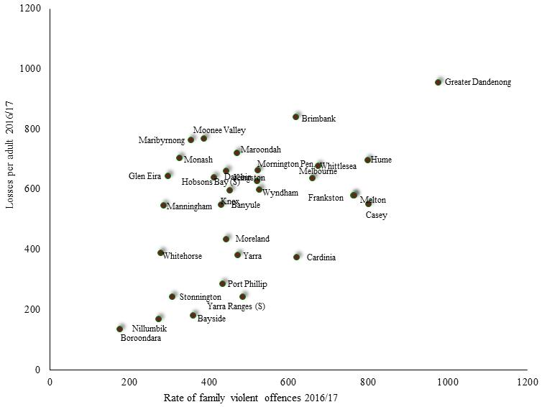
Confirming an association between gambling and family violence, other research has established a correlation between the prevalence of family violence in localities, recorded by police, and EGM gambling losses in those areas. An examination of the association between the rate of EGM losses per adult, and the rate of alleged violent offences within homes recorded by Victoria Police in across metropolitan Melbourne in 2015/16, reveals a marked association between these two factors (chart right).

Chart 6: EGM Losses per Adult 2016/17, by Rate of Family-related Alleged Violent Offences: metropolitan Municipalities

In a more extensive study, Markham et al (2016) recorded a significant positive association between EGMs per 1,000 adults and the rate of alleged family assaults, among Victorian postcodes, for the years 2005 to 2014, even after adjusting for differences in socioeconomic disadvantage, proportion of residents from non-English-speaking backgrounds and other factors.
Such evidence merely shows an association between gambling and family violence. Further investigations however, point to a causal link between gambling and family violence, with family violence sometimes contributing to gambling problems and gambling in other instances contributing to family violence. For example, women’s health in the South-east (undated) concluded that family violence may contribute to gambling problems, citing a range of research which attests that some victims of family violence, largely women, may seek solace in the relative safety and comfort of gambling venues and in the experience of gambling itself, with gambling problems representing a consequence of family violence in such circumstances.
On the other hand, further evidence affirms that gambling-related problems can lead to family dysfunction, conflict and violence (Australian Institute of Family Studies, 2014; Costello, 2008; Ferland et al, 2008), pointing to a direct causal relationship between gambling and family violence. Crane (2015) cites the CEO of a major Victorian welfare agency, who observed that “Problem gambling places great stress on relationships” with “family violence part of the mix with some problem gambling clients” adding that children often grievously affected by such aggression. Commenting upon such family conditions, one investigator explained: “The family environments of people with gambling problems are characterised by high levels of anger and conflict as well as low levels of clear and effective communication, less independence, less engagement in intellectual and cultural activities, a lack of commitment and support, little direct expression of feelings, and less participation in social and recreational activities…Moreover, the children of people with gambling problems are exposed to a range of family stressors, including financial and emotional deprivation, physical isolation, inconsistent discipline, parental neglect/abuse and rejection, poor role modelling, family conflict, and reduced security and stability.” (Australian Gambling Research Centre, 2014).
Survey findings also shed light upon the role which gambling problems may play in causing and aggravating family violence. Muellemar et al (2012) investigated women admitted to emergency departments, finding that of those experiencing violence from their intimate partner and whose partner also had gambling problems, 64% perceived a connection between these two conditions (Suomi et al, 2013). Authors of the report noted that “…of the participants who were interviewed in death, most reported that problematic gambling generally preceded the family violence (p. 1). The authors of the study concluded that gambling often leads to financial stress and mistrust, resulting in conflict and family violence.
Similarly, a New Zealand study of 254 people attending gambling treatment services, found that 50% had experienced physical, psychological, emotional, verbal or sexual abuse in the previous 12 months. Notably, among the 208 participants who took part in a further survey in the course of this research, 46% of those who had been victims of family violence expressed that view that the violence was a consequence of their partner’s gambling. (Bellringer et al, 2017).
Such findings are echoed by the results of research conducted by Suomi et al (2013) of 120 people seeking assistance as members of families with problem gamblers, which found that 53% reported family violence in the past 12 months, with 44% having been victims of such violence. Among a smaller sample of 32 of these survey participants who were interviewed as part of this investigation, most related that the family violence had followed the onset of gambling-related problems, Suomi et al reporting that “…problematic gambling generally preceded the family violence” (2013: 1). The authors of the study concluded that gambling often leads to financial stress and mistrust, resulting in conflict and family violence. Commenting on this study, Dowling remarked that while “…a commonly held view is that some people gamble as a mechanism to cope with being a victim of family violence…” the findings of this inquiry “…suggest that gambling problems precede both victimization and perpetration of family violence.” (Dowling, 2014: 4).
Dowling herself conducted a phone survey of 3,628 randomly-selected Australian adults, finding that, after controlling for social variables as well as drug use, that “Problem gambling was associated with increased odds of becoming a victim of family violence”, adding “…but the reverse was so …with family violence increasing the odds of experiencing problem gambling.” (Dowling et al, undated). Reflecting upon this and other research, Prof. Dowling concluded that the causal relationship between family violence and gambling operates in both directions, depending upon the particular circumstances of each family - a finding consistent with the evidence reviewed here. In the Victorian Responsible Gambling Foundation report ‘Social Costs of Gambling in Victoria’ Browne et al (2017) similarly concluded that family violence may be caused by gambling.
In interviews with gamblers and effected family members conducted by (Rintoul and Deblaquiere, 2019) some reported that financial stress linked to gambling triggered conflict which occasionally resulted in family violence.
Work-related Difficulties
Distracted by a preoccupation with gambling, many people with gambling-related problems experience difficulties associated with their employment, leaving work early to gamble or missing work altogether, and sometimes ultimately losing their employment as a result of gambling (Dowling, 2004; Australian Medical Association, 2013)
The New South Wales Office of Liquor, Gaming and Racing reports that 25% of people with gambling problems report that gambling detracts from their paid employment (Wieczorek and Zhou, 2014). Loss of employment was among the adverse consequences mentioned by gamblers in research conducted by AC Nielsen (2003)
Crime and Deception
Deceptive or criminal actions carried out in response to gambling problems, are widely reported (Livingston, 2008; Commonwealth of Australia, 2008; Sakurai and Smith, 2003; Centre for Criminology and Criminal Justice, 2000; Crofts, 2002) with a survey of 8,000 randomly-selected New Zealand residents found that 0.3% had committed crimes in response to gambling difficulties during the previous 12 months (Lin et al, 2008).
In an inquiry consisting of interviews of gamblers, high levels of crime were reported at venues, including drug dealing, loan sharking, stolen goods, while some gamblers themselves, resorted to crime including theft, fraud, robbery unregulated sex work, and drug dealing, to make money (Rintoul and Deblaquiere, 2019)

IV: The Prevalence of Gambling-related Problems

Prevalence of Gambling
A population survey of Victorian adults conducted in 2014, found that 15% had used EGMs in the previous year (Hare, 2015).
Many of those who gamble regularly experience difficulties in their personal, family or working lives as a result of financial stress caused by their gambling losses, or by the time spent gambling. Efforts to determine what proportion of the community experience gambling-related problems is discussed below.

Prevalence of Severe Gambling Problems
Over the past few decades, surveys have been conducted to determine how widespread gambling-related problems are in the community, to document differences in prevalence among various segments of the community, and to trace any changes in the extent of gambling problems over time. With few exceptions, such estimates have been reached in the basis of the findings of random surveys of the adult population, which focus upon the identification of severe gambling-related problems.
Several types of questionnaires have been employed to conduct these investigations. One of the most widely used is the South Oaks Gambling Screen [SOGS] whose 20 questions inquire about concealing gambling losses, arguing with family members about gambling, chasing losses, spending more money than intended, and borrowing from various sources. A score of 3 to 4 is generally interpreted as ‘possible pathological gambling’, and 5 or more as ‘probable pathological gambling’ or ‘problem gambling’.
Another questionnaire, the Canadian Problem Gambling Index, was designed for measuring community prevalence and features questions about similar issues, with a score of 8 or more of the 31 items construed as evidence of severe gambling problems, and a score of 3 to 7 signifying moderate risk (McMillen and Marshall, 2004).
The Victorian Gambling Screen, created in 2001, features 22 questions about effects of gambling on family relationships and finances, behaviour such as chasing losses, preoccupation with gambling and perceptions of the harm caused by gambling, and illusions about the skill involved in gambling. A score of 20 or more is interpreted as a gambling problem, and 9 to 20 as evidence of borderline gambling problems. (McMillen and Marshall, 2004).
While these three tests were designed to place differing levels of emphasis upon the various aspects of gambling problems, McMillen and Wenzel (2006) maintain they are essentially similar in their content.

In 2006, 10% of Australian adults surveyed by Roy Morgan Research conceded that they sometimes gamble more often then they should. The same proportion of respondents also stated that they, or a member of their family, had encountered problems with gambling - similar to 11% of respondents who acknowledged such experiences in response to a KPMG survey of selected localities in Melbourne (KPMG, 2000). Unlike many other inquiries, this survey was not solely focused upon severe gambling problems, and relied on respondents’ own perceptions of what constituted a gambling problem.
A 2008 survey of 15,000 Victorian residents concluded that 0.7% were problem gamblers, with a further 2.4% categorized as ‘moderate risk gamblers’ (Department of Justice, 2009B). Most recently, a 2011 survey of 1,500 Victorian adults, employing the Gambling Severity Index, concluded that 0.7% were problem gamblers and 2.4% ‘moderate-risk’ gamblers (Hare, 2011).
The 2014 Victorian Gambling Prevalence Study resulted found that approximately 0.81% of Victorian adults were problem gamblers. These included:
- 8.7% of Aboriginals
- 1% of males and 0.6% of females
- 0.95% of Non-English language speakers and 0.77% of English speakers
In addition to the 0.81% of problem gamblers, the survey concluded that a total of 3.6% were either problem or moderate risk gamblers. The proportion of people who fell into the latter category included 5.3% of males and 2.1% of females; 5% of people who spoke languages other than English at home, compared with 3.2% of others; and 14% of indigenous Australians.
While adding that this finding represented no significant change since 2008, the author of the report conceded that problem gamblers were playing more intensively and spending more than in 2008 (Hare, 2015).
However, the range of surveys conducted throughout this period is afflicted with critical limitations, relating to the candour with which people will discuss their gambling-related problems, the omission of people with gambling problems which fall below they threshold of the category ‘ problem gambler’, and others.

Limitations of Gambling Prevalence Surveys
While community surveys and other evidence furnish some suggestions about the prevalence and characteristics of problem gamblers, their findings should be interpreted with caution. Three major limitations of such surveys include:
- the apparent inaccuracy with which problem gamblers are distinguished from others
- inconsistency in measurement due to differences in questionnaires
- the criteria used for defining problem gambling and survey methods; and
- imprecise measurement arising from the difficulty of reaching conclusions about a small proportion of the population from the results of a sample survey.
Inaccurate Responses
Researchers have long noted with concern, that many people with gambling-related problems are inclined to conceal their difficulties, abstaining from participation in surveys or giving answers which minimize their problems (Walker, 2008). As a result, the proportion of respondents with gambling problems may be underreported. In one of the early trials of the SOGS, among 384 students, 28 were interviewed and found to have gambling problems. Yet of this number, 13, or 45%, were not detected by the survey (Cullerton, 1989; Lesieur and Blume, 1993). Thus, the true rate of prevalence of gambling-related problems among this sample was nearly twice that recorded by the questionnaire. The most likely reason was that some individuals chose to conceal the extent of their gambling problems in their responses to a survey. When the Productivity Commission asked 409 problem gamblers how they would have answered a phone survey on gambling, prior to seeking treatment, just 29% replied that they would have responded and given candid replies. If these results reflected the actual level of detection of severe gambling difficulties in sample surveys, then the proportion of Australian adults with gambling-related problems would be not 2.1%, as the authors of that report found, but three times higher, at over 6%.
A further reflection of the under-reporting of gambling losses may be seen in the findings of the 2003/4 Household Expenditure Survey, where Victorian respondents reported, on average, EGM losses of 64c per household (Australian Bureau of Statistics, 2008A) – equal to $63 million in total across Victoria - just 2.8% of actual EGM gambling losses, of $2,290 million that year (Victorian Casino and Gaming Authority, 2004) Not surprisingly, this source has been characterised as “notoriously unreliable” (South Australian Centre for Economic Studies, 2005: 197) as a source of gambling expenditure data.
On the other side of the coin are those people whom prevalence surveys may identify as having severe gambling-related problems, when these difficulties are in fact less extreme than the survey results import. In other instances, gambling problems may have been overcome and now lie in the past (SA Centre for Economic Studies, 2005B).
With some respondents mistakenly identified as problem gamblers, and as many as two-thirds of those with severe gambling-related problems overlooked in sample surveys of the general population, the accuracy of the findings of such prevalence surveys may not be relied upon with confidence.
A further limitation may be the subjective nature of the information sought in population surveys about gambling-related problems. The Productivity Commission (2010) observed that the measurement of gambling-related harm, as it is conventionally undertaken, is afflicted by the subjective nature of self-assessments of the frequency of harm (‘often’, ‘sometimes’ etc.) and the harm itself (’guilt’, ‘anxiety’, despair’ etc.) as well as difficulty determining the causal relationship between gambling and adverse consequences ascribed to it.
Inconsistent Survey Methods
The results of prevalence surveys may be further compromised by differences in the questionnaires used, the survey methods, the type of sample selected, and the cut-off point used to identify problem gamblers (Select Committee of the Legislative Council on Gambling Licensing, 2008; Doughney, 2007; Jonsson, 2007; Xenophon and the Australian Greens, 2008; Livingston, 2008). Such inconsistencies in the conduct and interpretation of surveys make it difficult to compare the findings of surveys conducted at varying times or among different communities. McMillen and Wenzel (2006) note that it would be preferable if governments settled upon a single, consistent method for measuring the prevalence of gambling-related problems.
Imprecise Measurement
A further limitation of prevalence surveys stems from the fact that, in selecting a sample of the population, chance alone may decide whether or not the sample actually contains the same proportion of people with severe gambling-related problems as the overall community which the sample is intended to represent. Typically, 5 to 20 out of every 1,000 people who participate in a community survey indicate that they have severe gambling problems. However, among samples drawn from the same population, such numbers are subject to chance variation - much as the number of heads in of a sequence of coin tosses may vary. When the prevalence of the characteristics being investigated is relatively low - as it is for gambling problems – chance exerts a relatively large influence upon the final result. Moreover, where many individuals selected to participate actually decline to do so - as in most population surveys - the range increases substantially, rendering the final result so imprecise as to be almost valueless.
A Narrow Focus
A further criticism of these surveys may be based not upon the way in which they measure gambling related problems but on what they measure. By focusing upon the individual characteristics of ‘pathological’ or ‘problem’ gamblers, such surveys overlook others who may experience gambling-related problems of a lesser intensity, as well as those adversely affected by the gambling of others.
Addressing the shortcomings of such prevalence studies, Young observes that this research is conceptually and methodologically defective but tends to be supportive of, and favoured by, the gambling industry (Young, 2012).
The narrow focus upon severe and addictive patters of gambling behaviour, coupled with the lack of precision, evident inaccuracy, and inconsistency of such surveys, raises questions about their validity. Speaking of efforts to measure the prevalence of gambling-related problems in Australia, Gary Banks, Chairman of the Productivity Commission observed that “…despite all the surveys, we remain quite uncertain as to whether problem gambling has diminished in recent years.” (2007: 22).

Gamblers Help Data as an Indicator of the Prevalence of Gambling Problems
Information concerning the number clients of Gamblers Help provides little indication of the actual underlying levels of gambling-related problems in a community, since few people with severe gambling problems seek formal assistance in a given year. The Productivity Commission estimated that 10% of problem gamblers sought formal assistance in one year, while the 2010 Productivity Commission report on the gambling industry put the figure in the range 8-17%. Research indicates that most people with serious gambling-related problems only accept professional counselling when they have ‘hit rock bottom’ or a pressed to do so by family members or others (Neilsen, 2003).
Fewer still, attend Gamblers Help services. 2017/18, 68 unique individuals from CGD sought counselling with Gamblers Help – the equivalent of 0.4% of residents with gambling problems (based on the assumption that 13% of adults experience gambling harm ranging from mild to severe) or 5% of problem gamblers (assuming that 1% of adults fit this designation) (Victorian Responsible Gambling Foundation, 2018).
Such small samples of problem gamblers may fluctuate due to changes in Gamblers Help resources or the publicity given to their services, without reflecting any real change in the underlying prevalence of gambling problems. Therefore, one cannot prudently rely on such information for tracing changes in the prevalence of gambling-related problems over time, or measuring differences in their prevalence from one area to another.

Low and Moderate-risk Gambling
The Productivity Commission cited with endorsement a selection of definitions of ‘problem gambling’ which each emphasise the presence of harm to the player, their family and/or the wider community, adding that such gambling problems form a continuum of harm, rather than being confined to the extreme end of the scale where ‘problem gambling’ is characterised. This perspective was echoed in a subsequent report by the Commission (2010), which concluded that harm caused by gambling affects not only problem gamblers, but those less severely affected by gambling. Authors of the report affirmed a preference for a ‘population health’ approach, in which all levels and types of harm are appraised in assessing the impact of gambling, rather than attention being confined to the “…the arbitrary group of harms that are clustered together in particular individuals.” (p. 5.7) – those labelled as ‘problem gambling’. Indeed, in examining the occurrence of the psychological condition of dissociation for example, the Commission concluded that people characterised as non-problem gamblers accounted for the majority of those who experienced this condition while gambling, noting that “…harm is experienced by many non-problem gamblers, with this group accounting for a greater share of the aggregated harm than problem gamblers” (2010: 4.24)..
Like-minded, Browne et al (2016) investigated gambling-related harm from a public health viewpoint, gauging all harms caused by gambling, rather than focusing upon “…causes or symptoms of problem gambling” (2016: 36). They provided an estimate of the relative proportion of gambling-related harm, experienced by people of different gambling risk categories, with low-risk gamblers accounting for 50% of total harm from gambling – owing to their preponderance among gamblers - moderate risk gamblers for 34% of gambling harm, and problem gamblers for 15%. The publication ‘Using a Public Health Approach to the prevention of Gambling-related Harm’ (2015) concluded that “While the rate of harm is much lower among non-problem gamblers than those who meet the criteria for problem gambling, the absolute number of people experiencing some form of harm is significant.” (p. 10). Accordingly, the Victorian Responsible Gambling Foundation report ‘Social Costs of Gambling in Victoria’ ascribes a higher cost to low-risk gambling of $292 million, than to the sum of moderate ($35 m) and high risk ($103 m) gambling (Browne et al, 2017). These views are also echoed in the report ‘Responsible Gambling Past, Present and Future’ (2016).
In a report published by the Victorian Responsible Gambling Foundation, Miller (2017) endorsed these findings, citing a population survey by Hare (2015) which found that 8.9% of Victorian adults were low-risk and 3% moderate-risk gamblers, compared with 0.8% of adults who were identified in the survey as ‘problem gamblers’. These 12.7% of Victorian adults account for three-quarters of the 17% of adults who gamble on EGMs in a 12-month period.
Miller also reviewed research about the characteristics of moderate and low-risk gamblers, finding that they were relatively uniformly distributed among categories of gender, age and language spoken at home, though more likely than members of the general population to have modest incomes, and less likely to own a home, hold a professional occupation or to be tertiary educated (Citing Queensland Government, 2012; Office for Problem Gambling, 2013; and Sproston et al, 2012).
Consequences of moderate and low-risk gambling documented in the literature include diminished savings and expenditure, emotional distress including shame, regret and anger; depression and anxiety; as well as drinking and smoking. (Browne et al, 2016; Hare, 2009). Further research, by the Allen Consulting Group (2012) cited by Miller, indicates that moderate risk gamblers rate their health less favorably than others.
Citing Hare (2015) Miller observes that low and moderate-risk gamblers exhibit substantially higher levels of gaming machine use than non-problem gamblers.
Other research indicates that low to high risk gamblers account for a substantial proportion of EGM gamblers, which increases with rising gambling frequency. In Victorian Gambling Study: a longitudinal study of gambling and health in Victoria, Billi et al (2014), concluded that persons with mild to severe gambling risk accounted for 27% of people who used EGMs less often than once a month, a figure which rose to 38% of those who gambled 1-3 times each month and 61% of those who gambled at least once a week.
Notably, many such gamblers tend to perceive their gambling behavior as controlled, responsible and relatively innocuous, particularly compared with ‘problem gamblers’ (Thomas et al, 2013). As a consequence, Miller observes, many are unreceptive to social marketing campaigns intended to deter problem gambling, as they do not identify with the portrayal of gambling featured in such campaigns. Similarly, Hing (2016) found that few sought assistance with gambling problems from Gamblers Help or other professional sources.

Impact of Gambling Problems vs. the Prevalence of Problem Gambling
A range of studies affirm that the proportion of the adult population who meet the criteria for ‘problem gamblers’ is in the order of 0.7% to 2%. The impression conveyed by these findings is that the extent of gambling-related problems is relatively modest. However, the findings of population surveys, which seek to determine the proportion of the population who conform to the formal definition of problem gamblers, tend to depreciate the extent of either gambling-related harm in the community and the proportion of the population and of gaming patrons, which are affected.
Three points are recounted here to set this matter in its due perspective.
First, problem gamblers account for a significant proportion of gambling patrons. The Productivity Commission (2010: 5.25) stated that “While problem gamblers may account for only 0.7% of the population they may account for 10 to 40 times this among venue patrons at any one time”. Referring to the findings of a Victorian survey, the Commission concluded that between 27% and 76% of regular EGM players were problem gamblers or moderate-risk gamblers. An analysis of the findings of the 2014 Victorian Prevalence Study showed that at least 41% of people gambling in a venue at any given time had moderate or severe gambling related problems (Brown, 2018). Focusing on people with the most acute gambling problems, the South Australian Centre for Economic Studies (2005) concluded that 28% of regular EGM gamblers experiencing severe gambling-related problems. In a recent study, 444 gaming patrons at 18 Victorian venues, were interviewed on their departure from the venue and the Problem Gambling Severity Index administered. Among them, 71% were found to be experiencing gambling harm (problem gambling: 20%; moderate harm: 26%; and low harm: 25%). (Bartley et al, 2017).
Second, even moderate-risk and problem gamblers account for a substantial proportion of gaming revenue. The Productivity Commission (2010: 5.1) concluded that problem gamblers account for 22-60% of total EGM losses, while moderate and problem gamblers in total account for between 42% and 75% of EGM losses – representing a mid-range of 58%.
Finally, as evidence recounted in the previous section shows, gambling problems do not relate only to problem gamblers in any case, but affect a wide range of gamblers to varying degrees, thereby further increasing the prevalence of problems among gambling patrons. The report ‘Using a Public Health Approach to the prevention of Gambling-related Harm’ (2015) concluded that “While the rate of harm is much lower among non-problem gamblers than those who meet the criteria for problem gambling, the absolute number of people experiencing some form of harm is significant.” (p. 10). The Productivity Commission was like-minded, recognising that “…harm is experienced by many non-problem gamblers, with this group accounting for a greater share of the aggregated harm than problem gamblers” (2010: 4.24). These views are echoed in the report ‘Responsible Gambling Past, Present and Future’ (2016). This issue is discussed further on, under the heading ‘Low and moderate-risk gambling’.

V: Characteristics of People with Gambling-related Problems
Surveys of the apparent level of gambling problems in the community have also provided some insight into some of the characteristics of people with gambling problems.
Gender
Survey findings indicate that the representation of women among people with gambling problems has increased in recent years. The 2011 survey of Victorians, commissioned by the Department of Justice though, concluded that problem gambling was more prevalent among males (accounting for 0.95%) than among females (0.47%).
The 2014 Victorian Gambling Prevalence Study found that 1% of males and 0.6% of females were problem gamblers and that 5.3% of males and 2.1% of females were problem or moderate risk gamblers (Responsible Gambling Foundation, 2015). Similarly, the Household, Income and Labour Dynamics in Australia (HILDA) population survey, conducted among 17,000 Australian adults by the Australian Gambling Research Centre found that both gambling expenditure and the prevalence of gambling-related problems were higher among males than females (Armstrong and Carroll, 2017).
A study of the prevalence of gambling problems in South Australia found that 4.1% of men experienced severe or moderate gambling harm, compared with 1.8% of women (Woods et al, 2018).
Age
A further aspect of socioeconomic disadvantage concerns the vulnerability of local older residents to gambling-related harm. Victorian research shows that residents aged 65 years are more likely to use gaming machines and to experience gambling problems than people of other age groups. Hare (2015) found that 23% of Victorians of retirement age used gaming machines in the past 12 months, compared with 13% of those aged 25-54.
Percent of Adults who are at Risk of Gambling Harm, by Age: 2014 (Hare)
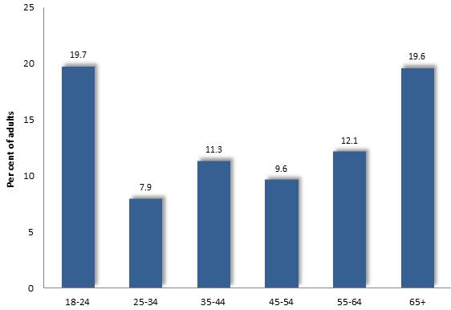
Hare’s 2014 investigation - ‘Study of Health and Gambling in Victoria’ - found that the proportion of Victorian adults who were problem, moderate-risk or mild-risk gamblers ranged from nearly 20% among the youngest and oldest adults, to approximately 8% among those aged 25-34 years (Hare, 2015). Overall, 12.5% of Victorian adults were determined to fall within the range of problem to mild-risk gamblers, compared with 20% of people aged 65 years or more.
Similarly, ‘Assessing Gambling Related harm in Victoria’ found higher than average prevalence of gambling problems among 55+ year olds (Browne et al, 2016).
The prospective implications of high rates of gaming participation among older people are compounded by their relatively low and often fixed incomes, particularly in socioeconomically disadvantaged communities. In the suburb of Dandenong for instance, older residents have lesser incomes than others – with the 2016 Census revealing that residents aged 55-59 are in receipt of incomes 56% of the metropolitan level for the same age group. In retirement age, older, local residents are more dependent upon the aged pension than others, with the number of aged pensioners in Dandenong in 2017, equivalent to 92% of residents aged 65 or more - compared with 64% across Melbourne. Moreover, the 2016 Census found that older residents aged 65 years or more were three times more likely to be renting than older people across Victoria, with 31% living in rented accommodation compared with 11% of people the same age across Victoria.
Similarly, a South Australian study found that the proportion of persons aged 55-64 who were problem or moderate-risk gamblers was 3.2% - higher than the overall figure of 2.9% (Woods et al, 2018).
Social Disadvantage and Gaming Problems
Socioeconomic disadvantage is associated with a relatively higher propensity to gamble and susceptibility to gambling-related problems. At the same time, the gambling industry, responding to the opportunities which such conditions present, has tended to install more gaming machines in disadvantaged areas – which in turn, raises gaming losses in such localities. In this way, socioeconomic disadvantage and gaming machine accessibility interact to contribute to elevated gaming losses in disadvantaged areas.
The association between overall socioeconomic disadvantage and prevalence of gambling-related problems on the other is supported by two lines of reasoning, each corroborated by substantial evidence.
First, population surveys disclose that people in disadvantaged circumstances – as for instance, lower incomes, lesser educational attainments or joblessness – are more likely to experience gambling problems or be at risk of such difficulties, than others. Evidence of these links is reviewed further on. Accordingly, it follows that that socio-economically disadvantaged areas, where such individuals are represented in higher proportions than elsewhere, would experience a relatively high prevalence of gambling-related problems.
Second, further evidence directly establishes that disadvantaged areas experience higher rates of gaming expenditure than others. Indeed, gaming losses per adult in 2015/16 in Greater Dandenong – the least affluent municipality in Melbourne - were approximately seven times greater than those recorded in Boroondara – among the wealthiest localities in Melbourne. Similarly, an Australian study found that suburbs that were most disadvantaged exhibited the highest average EGM losses per adult – with losses in the most disadvantaged fifth of suburbs at $849 per adult, nearly three times higher than the corresponding rate of losses in the least disadvantaged fifth of suburbs, of $298. (Rintoul et al, 2017b).
Such high levels of gambling expenditure are, in turn, associated with an elevated prevalence of gambling problems. The document ‘Risk Factors for Problem Gambling’ (2015) cites research by Markham, Young and Doran who report that rates of gambling expenditure are positively associated with prevalence of gambling related harm, with a rise in expenditure per adult from $10 to 150 associated with an increase in prevalence of gambling harm from 9 to 18%. The ‘Report to Municipal Association of Victoria’ (2014) examined trends across regions, finding that high rates of gambling problems are associated with increased EGMs density and high expenditure. It follows that localities of socio-economic disadvantage, where levels of EGM expenditure are highest, would therefore also experience elevated rates of gambling-related problems.
The authors of the report ‘Destination gambling’ (2008) offer a common-sense explanation of this pattern, observing that people in disadvantaged areas may experience greater harm from gambling than others due to their limited financial means, sources of financial support and employability, to compensate for any gambling losses.
Incomes
The 2014 Victorian Gambling Prevalence Study found that problem gambling was most widespread among people in receipt of low incomes, unemployed adults, among other segments of the community (Responsible Gambling Foundation, 2015). The report ‘Gambling Prevalence in South Australia 2012’, also found high rates of problem gambling among people with low annual personal incomes. Similarly, in a review of contemporary research, Miller (2015) concluded that low incomes and lower socio-economic status are associated with a higher prevalence of gambling. In its earlier study of gambling patterns in Australia, the National Institute of Economic Research concluded that losses were largely sustained by those who could least afford them: those on lower incomes or manual employment (NIER, 2000).
'Gambling Prevalence in South Australia 2012' (2013) determined that the prevalence of problem and moderate gambling declined from its peak among people in receipt of annual personal incomes less than $15,600, of 5.4%, before declining to its lowest level of 2.2% among people on incomes in excess of $130,000. These findings are illustrated in the accompanying table.
Table 4: Prevalence of moderate & problem gambling, by individual income, 2013, South Australia
 | % Problem/moderate gambling
$<15,600 | 5.4
$15,600-$31,199 | 3
$31,200-$51,999 | 4.1
$52,000-$77,999 | 3.3
$78,000-$129,999 | 3
$130,000+ | 2.2

The ‘Victorian Gaming Study: a longitudinal study of gaming and health in Victoria 2008-12’ (Billi: 2014) found that among its survey sample, problem gamblers were under-represented among those with incomes below $31,000 p.a. who accounted for 45% of persons identified as problem gamblers, but 61% of the adult population. This evidence appears to be anomalous though, with the report ‘Risk Factors for Problem Gambling’ (2015) stating that this finding “…has not been replicated in other studies”, concluding that “…the most common finding has been that low income is associated with higher rates of problem gambling” (p. 9).
Similar results are reported in the findings of a South Australian population survey found that 2.5% of people in receipt of incomes exceeding $150,000 per year were problem or moderate-risk gamblers, compared with 4.3% among those on incomes less than $25,000 p.a. (Woods et al, 2018).
Education
A variety of evidence attests that the prevalence of gambling and gambling-related problems is also higher among people with limited educational attainments, than others.
An investigation into gambling prevalence in South Australia (Office for Problem Gambling, 2013) also recorded a prevalence of problem gambling of 0.2% among those with university degrees as compared with 0.9% - or over four times higher – among people with secondary education only. The study 'Gambling Prevalence in South Australia 2012' (2013) concluded that the proportion of people who gambled at least fortnightly, ranged from 6.2% of those with university education, to 10.9% with trades qualifications and 14.3% of those with secondary only education. Turing to the prevalence of gambling problems, the investigators found that 1.7% of people with a university degree were moderate risk or problem gamblers, compared with 3.7% of those with secondary education only. The report concluded that problem gambling was more prevalent among people with no formal post-school qualification.
The report ‘Local Impacts of Electronic Gaming Machine Gambling in Moreland’ (2012) similarly found that 33% of residents with incomplete secondary school used gaming machines, compared with 14% of those with a bachelor degree and 7% with post-graduate qualifications.
The ‘Victorian Gambling Study’ (2011) reported that transitions to higher-risk gambling behaviour were associated with year 10 or lower educational attainments.
The report ‘Risk Factors for Problem Gambling’ (2015) cites investigations by Wardle et al (2010), Young et al (2006) and Sporston et al (2012), all of which recorded relatively high rates of problem gambling among people of limited educational attainments. In addition, overseas surveys have concluded that people with gambling problems tend to be less well educated than those without gambling problems (Cunha, 2017; McCready et al, 2008).
The 2015 HILDA survey also found that gaming expenditure and the prevalence of gambling problems was higher among less educated Australians than others. Survey respondents who had concluded their formal education at year 11 accounted for 15% of the survey sample but 29% of respondents identified as problem gamblers. By contrast, university graduates represented 28% of the sample, but only 18% of identified problem gamblers (Armstrong and Carroll, 2017)
Unemployment and Joblessness
Some research points to a higher prevalence of gambling problems among people who are unemployed, with the 2013 report 'Gambling Prevalence in South Australia 2012' ascertained that 11.2% of unemployed people were moderate-risk or problem gamblers, compared with 4% of those in full-time employment, 2.3% in part-time employment, 1.4% of people in home duties, 1.8% of retirees and 2.1% of students.
The HILDA survey also documented an association between joblessness and the prevalence of gambling problems, with unemployed Australians accounting for 3.1% of the sample, but 12% of problem gamblers. (Armstrong and Carroll, 2017). The survey also found that respondents whose main income was derived from welfare payments, were over-represented among those with severe gambling problems.
The report ‘Risk Factors for Problem Gambling’ (2015) also cites a selection of studies that found that unemployment is associated with gambling-related problems.
A South Australian population survey found that the prevalence of problem and moderate-risk gamblers was 5.4% among unemployed survey respondents, compared with 3.3% among those in full-time employment and 2.4% among those in part-time work (Woods et al, 2018).
Occupations and Gambling Related Problems
Other evidence indicates that people on lower incomes or in less skilled occupations tend to experience higher gambling losses (Wardle et al, 2007; Williams et al, 2007). The 2011 survey of Victorian adults concluded that rates of problem gambling were markedly higher among people employed as labourers and machine operators, than among those in professional and managerial occupations (Dept. Justice, 2011). The National Institute of Economic Research found that the more substantial losses were incurred by people in manual employment (NIER, 2000).
Hare’s 2009 study concluded that sales workers, machinery operators and drivers, and laborers were over-represented among moderate-risk gamblers. Sales workers accounted for 28% of moderate risk gamblers and 6% of the adult population; machinery operators and drivers for 12.3% of problem gamblers but 5.2% of the adult population; and labourers representing 18.1% of problem gamblers and 5.4% of the adult population.
The later report ‘Victorian Gambling Study: a longitudinal study of gambling and health in Victoria, 2008-2012, found that sales workers, machinery operators and drivers and labourers were substantially over-represented among problem gamblers in a population sample, while those employed as professionals, technicians and trades workers and clerical or administrative workers, were under-represented among those with serious gambling problems (Billi et al, 2014).
Table 5: Prevalence of Problem Gambling by Occupational Category: Victoria, 2012
 | Per cent of Problem Gamblers | Per cent of Victorian Adults
Over-represented among problem gamblers
Sales workers | 30.9 | 6.1
Machinery operators and drivers | 14.9 | 4
Labourers | 18.3 | 5.4
Under-represented among problem gamblers
Professionals | 12.4 | 32.3
Technicians and trades | 2.8 | 17
Clerical and administrative | 1 | 12.3

‘* * * *
Just as research reveals an association between higher prevalence of problem gambling and lower incomes, formal education levels, and menial occupations, other investigations indicate that such associations also hold for moderate and mild gambling-related problems also. Miller reviewed research about the characteristics of moderate and low-risk gamblers, finding that they were relatively uniformly distributed among categories of gender, age and language spoken at home, though more likely than members of the general population to have modest incomes, and less likely to own a home, hold a professional occupation or to be tertiary educated (Citing Queensland Government, 2012; Office for Problem Gambling, 2013; and Sproston et al, 2012
Indigenous People
Research findings concerning the prevalence of gambling problems, indicates that their prevalence is substantially higher among Aboriginal people than the general population.
Miller (2015) cites research conducted by Sproston et al (2012) who concluded that Aboriginal people were over twice as likely as members of the general population to experience gambling-related problems (at 1.7% compared with 0.8%). By contrast, the 2014 Victorian gambling prevalence study (Hare, 2015) found that 9% of indigenous adults were problem gamblers – compared with 0.81% of the general adult population, and 5.4% moderate risk gamblers – representing in total, 14% or one in seven Aboriginal adults in Victoria.
The report 'Gambling Prevalence in South Australia 2012' (2013) recounts the findings of a survey in which 20.8% of Aboriginal respondents stated that they gambled at least fortnightly, compared with 11.9% of non-aboriginal persons. Similarly, 8.9% of Aboriginals exhibited problem or moderate risk gambling behaviour, compared with 3% of non-aboriginals.
The HILDA survey, conducted by the Australian Gambling Research Institute, also found that indigenous people were overrepresented among those with gambling-related problems (Armstrong and Carroll, 2017).
Personal and Health Problems
Higher than average rates of personal distress and excessive alcohol or other drug use are also reported among people with gambling-related problems (McMillen and Marshall, 2004). A 2008 survey of Tasmanian residents found that, among regular gamblers, the prevalence of heavy smoking (100+ per week) was 15%, compared with 6% among others, while 18% of regular gamblers engaged in heavy drinking compared with 7% of others (SA Centre for Economic Studies, 2008). A Melbourne study of 2,000 adults, conducted by the Problem Gambling Research and Treatment Centre at Monash and Melbourne Universities, determined that problem gamblers were 19 times more likely than non-problem gamblers to experience psychological difficulties; 4 times more likely to exhibit hazardous alcohol use; 2.4 times more often depressed; 6 times more likely to be divorced, and less inclined to feel valued as members of the community or able to call upon friends for assistance (Science Alert, 2008). Similarly, a Canadian study of the general population found that people with alcohol or other drug-related problems were more likely than others to experience gambling problems (Reynolds, 2008). Walker (2008) cited US research by Petry, Stinson and Grant (2005), which estimated that 73% of people with gambling-related problems were also engaged in alcohol abuse, and by Petry et al, 2005, which reported that 50% experienced mood disorders, 41% anxiety disorders and 28% obsessive compulsive personality disorders.
These findings were echoed in the results of the Victorian Gambling Survey, Wave Two, which surveyed 5,000 Victorian residents in 2009 [those of a sample of 15,000 surveyed a year earlier, who agreed to be contacted later and could be reached]. The survey found that problem gamblers were more likely to experience depression, psychological distress, smoking, disruptive life events and lack of affiliation with the community. Among its findings:
- over half (51%) of problem gamblers reported depression, compared with 10% of non-problem gamblers;
- 32% reported psychological distress – based on the Kessler scale – compared with 12% of non-problem gamblers and 3% of the general population;
- 53% of problem gamblers smoked compared with 23% of all gamblers; 43% experienced the death of someone close the them, in contrast to 29% of all gamblers;
- 50% reported increasing arguments with someone close to them, compared with 9% of non-problem gamblers; and
- only 32% felt valued by society, compared with 70% of all gamblers.
Conditions associated with a higher likelihood of problem gambling among the survey respondents included poor physical and social health, alcohol abuse, menial occupations, low educational attainments, speaking languages other than English at home, one-parent families, and troubles with colleagues at work. It may be mentioned that the survey found that many people – though a minority - changed their gambling patterns and risk levels over time, with a third of problem gamblers having no previous history of gambling problems (Abbot et al, 2011).
The 2011 survey of Victorian adults found that problem gamblers reported higher rates of alcohol abuse, smoking, obesity, depression and anxiety, severe mental disorders and suicidal thoughts (27% vs. 6% among ‘moderate risk’ gamblers) than others (Hare, 2011). The same report found that problem gamblers more often reported distressing life events in the past year than others, including the death of someone close to them, divorce, legal problems, ill-health and difficulties at work.
Other research points to gambling activities as a means to escape social isolation, for some people. Miller (2015) cite Castren et al, whose research in Finland found that many people experiencing problems with their gambling were lonely. Similarly Thomas et al (2009) found that participation in gambling at venues is often motivated by a desire to alleviate loneliness.
More recently, a South Australian investigation found that the prevalence of severe gambling problems was ten times more probable among people with ‘poor’ self-reported health than among the general population.
Cultural Influences
Cultural factors, as well as stresses related to settlement in Australia, may exert an influence upon gambling behaviour, and in some instances, predispose to gambling-related problems. It may be cautioned though, that existing difficulties in measuring the prevalence of gambling-related problems are accentuated when considering a segment of the community, defined by birthplace or cultural identity, who may account for a small fraction of population survey respondents. Moreover, it is difficult to form sound conclusions about a segment of the community as diverse as those born overseas – who, aside from this single characteristic are as diverse as those born in Australia. As a consequence, the prevalence of gambling-related problems among people of different birthplaces, language groups or ethnic identities, has never been determined with finality.
The 2008-2012 Victorian Gambling Study found no significant differences in the proportion of English-speaking and non-English speaking people, who were problem gamblers, and that recent settlers were under-represented among problem gamblers, with those who had migrated to Australia during the past five years accounting for none of the problem gamblers in their population sample, but 5% of the overall population (Billi et al, 2014). Browne et al (2016), inquiring into a wide spectrum of gambling-related harm, found that 26% of such adverse effects affected people who speak languages other than English – which nearly matches the 24% of Victorian residents in 2011, who spoke languages other than English at home.
Hare (2015), in her report ‘Study of Gambling and Health in Victoria’ concluded that 5% of adults who spoke languages other than English in their homes were problem or moderate-risk gamblers, compared with 3.2% of English speakers.
Dickins and Thomas (2012) on the other hand, concluded that while CALD people overall appear less likely to gamble, those who do participate in such activities are more likely to experience gambling problems.
Further inquiries and commentary has tended to focus upon Australians of particular national backgrounds, particularly those of Asian birthplace or heritage, as possibly exhibiting a higher propensity to gambling and gambling-related problems, than the general population. Delfabbro, P. (2011) for example, notes that the Victorian Casino and Gambling Authority concluded that on the basis of appearances, people of South-east Asian heritage accounted for 25-31% of those who entered Crown Casino.
Research focused upon ethnic Chinese Australians, has concluded that gambling is relatively popular and widespread in Chinese culture (Feldman et al, 2014), influenced by spiritual beliefs in the influence of luck and its interaction with character, and often coupled with unrealistic beliefs in personal ability to control gambling outcomes (Dickins and Thomas, 2012; Feldman et al, 2014).
Further investigations also point to a broad acceptance of gambling among Vietnamese Australians as an enjoyable activity, source of quick money, and a means to demonstrate luck and skill. They also identify some culturally-specific beliefs about control over the outcomes of gambling which may contribute to gambling related problems among this community (Ohtsuka & Ohtsuka, 2010; Gilding and Lee, 2016; Dickins and Thomas, 2016). Similarly, Delfabbro, P. (2011) cites the finding of Zysk who reported that many Vietnamese entertain strong, irrational beliefs about their prospects of winning at gambling.
Other inquiries have shown that regardless of cultural background, for isolated migrants, or those with limited English fluency, the Casino and other gambling venues hold appeal as places that are safe, accessible after dark, and alleviate loneliness (Feldman et al, 2014). Further research indicates that stressors relating to settlement or experience in their country of origin expose some migrants to vulnerability to gambling problems (Dickins and Thomas, 2012; Feldman et al, 2014).
Young People
While this report largely concerns EGM gambling and its impact upon individuals and communities, mention should be made of the rising levels of gambling accessibility, marketing and participation in a variety of gambling types, among young people – trends which may have ominous implications for the prevalence of gambling-related problems in future.
Evidence indicates that approximately two-thirds of Australian adolescents had gambled in the past year (Purdie et al, 2011; Delfabbro, King and Phillips, 2014). Purdie et al (2011) found that types of gambling engaged in by young people aged 15-17 included sports betting (21%), internet gambling (13%), card games at a casino (6%), racing (28%) and pokies (9%) – all of this, despite the fact that gambling among people of this age is illegal.
A lesser proportion of these young people, of approximately 1 in 20, (Purdie et al, 2011; Delfabbro et al, 2009) gamble as often as once per week.
Other research has found that most young people who gamble also do so on-line (Hare, 2014; Gainsbury et al, 2015a)
Among factors which contribute to gambling among young people are:
- Exposure to pokie gambling venues, often marketed as ‘family-friendly’
- Ready access to, and aggressive marketing of, actual or simulated gambling activities on-line
- Advertising of sports betting at sporting matches and on TV, with an average of 51 gambling advertisements on TV during VFA football games (Thomas et al, 2012) and 111 during NRL rugby broadcasts (Lindsay et al, 2013).
- Notably, Miller (2017) observes that when advertisements are not permitted during designated times of peak viewing by children and young people, including the early evening, sporting broadcasts are exempted from this restriction.
- Positive attitudes of friends and family
Miller (2016) concludes that the burgeoning of gambling advertising, opportunities and activity among young people promotes early adoption of gambling habits and may contribute to an elevated prevalence of gambling among young people.
At a personal level, incentives for participation in gambling, particularly among young men, include peer acceptance and garnering a favorable public image. Deans reports that sports betting is favoured by young men, for reasons that include the perceived normality of sports betting, which has become ‘embedded in existing peer-based sporting activities’, conferring a sense of identity to man participants, helping many feels that they fit in, and forming a basis for sporting conversations with their peers. (page 35) Deans, 2017).
A broader study of gambling among young men found that Survey of 70 male problem gamblers who were seeking treatment found that many gambled on wagering and at the casino, in part, to feel “skilled and intelligent’ in public and among their peers. (page 35) (Hunt and Gonsalkorale, 2018)

VI: Benefits Attributed to Gambling
While the creation of employment by the gambling industry is often claimed as a benefit of EGM gambling, it would appear that gambling merely diverts expenditure and jobs from other sectors of employment. A further purported benefit of gambling – the expenditure of funds upon community projects from the Community Support Fund and by venues directly – represents a small return of funds lost to EGM gambling.
* * * *

Economic Effects of EGM Gambling
One of the benefits ascribed to EGM gambling is the employment generated in gambling venues (Select Committee of the Legislative Council on Gambling Licensing, 2008; Tabcorp, 2009), with the State Government observing that EGM gambling provides employment for thousands of people across Victoria (Department of Justice, 2006B, 2009). However, much of the employment associated with gambling comes at an even greater cost to other sectors of the economy.
Investigations of the spending patterns of gambling show that funds lost to gambling machines are largely diverted from expenditure on goods and services, such as household items (South Australian Centre for Economic Studies, 2005), with the consequence that growth in the retail sector is lower than it would have been if EGMS had not been introduced. For example, gaming venues often detect from expenditure at local businesses as they divert expenditure from other goods and services (Rintoul and Deblaquiere, 2019).
Moreover, evidence indicates that expenditure on EGM gambling creates fewer jobs in gambling venues than those lost from other sectors of the economy. A 2006 study of Victorian and Western Australian gambling concluded that 3.2 jobs were created for every million of EGM gambling expenditure, compared with 8.3 jobs per million services from sales of beverage and 20.3 jobs for every million spent on meals and food (South Australian Centre for Economic Studies, 2005)..
Weighing the evidence concerning the economic effects of gambling, the Victorian Competition and Efficiency Commission cited with endorsement the conclusions of the Productivity Commission in its 2010 review of the gambling industry, that “… the long-run economy-wide impact of an expansion in gambling activity is likely to be neutral.” (2012: 77).

Community support Fund
Under Section 3.6.6 (2)(c) and 3.6.12(1)&(1A) of the Gambling Regulation Act (2003), an 8.33% tax is imposed upon gambling revenue from hotels, in addition to the 24% levied upon all hotel and club venues. The 8.33% tax passes to the Community Support Fund which is allocated to problem gambling programs; drug education and treatment; youth programs; community advancement; sport and recreation; arts and tourism; veterans support; and other purposes.
The manner in which Community Support Funds are distributed to communities has been challenged, with the 2006 Report on the Consultations for the Gambling Licenses Review remarking on a “lack of transparency” in allocation of funds to local communities (Kirby, 2006). Such considerations hold particular relevance for some in local government and community organizations who see the Community Support Fund as a means by which the burden of gambling losses upon local communities may be partially redressed, through grants for community projects. Some commentators from local government and the community sector have therefore urged that local communities be afforded greater influence upon the choice of local projects to be supported, and that those communities which incur the higher losses to gambling be given preference in the allocation of those funds.
However, it lends perspective to note that, at best, the benefits of the Community Support Fund may only partially redress the effects of gambling upon communities, since the entire fund accounts for only 4% of all EGM gambling losses.

Community Benefit Statements
The Gambling Regulation Act requires that clubs which are EGM gambling venues provide an annual audited statement, called a Community Benefit Statement, of the funds which they have directed to “philanthropic… benevolent…sporting or recreational purposes” (Gazette S124 26 June 2003). This obligation is intended to show that clubs direct 8.3% of their gambling revenue to activities which benefit to the community. Clubs which are late in submitting Community Benefit Statements are required to pay 8.3% of their gambling revenue to the Community Support Fund until they do so; and where a shortfall is found to exist, the balance must be paid into that fund.
The requirement for these statements stems from the difference in the level of tax levied upon hotels and clubs. While hotels pay 33% of their gambling revenue to the state government - of which 8.3% is deducted to the Community Support Fund - clubs pay only 24.3% of their gambling revenue as tax, as it is expected that they will direct 8.3% of their gambling funds at least, to activities of benefit to the community. Community Benefits Statements are intended to verify that such funds have indeed been directed to community projects.
For several years though, doubt has been cast upon the accuracy of Community Benefit Statements as a reflection of the true level of support provided to the community by gambling venues. The types of expenditure which may be claimed as community benefits have included running costs, such as employment expenses; fixed assets, such as furniture, TVs and fridges; and subsidized goods and services. In 2017/18, Victorian clubs expended $24 million upon activities of evident benefit to the wider community - including donations, gifts, sponsorships, volunteering or support for ex-service personnel and their families – accounting for 2.6% of total club revenue from electronic gambling machines. The balance included employment costs, capital expenditure and subsidized services. The effect, some commentators maintain, is to enable clubs to avoid the tax which would normally apply to any discrepancy between the funds actually spent on community activities and the 8.3% required.
Such conclusions are corroborated by the findings of a 2012 investigation of community benefits by Monash University, which disclosed that in Victoria in 2010/11, just 2.4% of EGM gambling losses were returned to the community as expenditure on education, charitable efforts or volunteer expenses, the investigators concluding that “As a mechanism for providing benefits to the community, poker machines are…extremely inefficient” (Livingston et al, 2012: 18).

VII: Reforms to the Gambling Industry
Numerous changes in the conduct of EGM gambling in Victoria have been instituted by the Victorian Government in recent years, with little effect upon gambling losses or gambling-related problems. While a variety of reforms have been urged upon governments, evidence suggests that only the most substantial changes, such as banning of alcohol from gambling venues, and a substantial reduction in the number of EGMs and venues, are likely to achieve a marked and enduring effect.
* * * *

Suggested Reforms to the EGM Gambling Industry
Commentators have recommended a variety of reforms to the gambling industry, intended to reduce gambling losses and thereby alleviate gambling-related harm. These reforms address issues such as the ease and rate at which money can be lost to gambling machines, the ready access to funds at gambling venues, the promotion of gambling, and other issues.
Attributes of Gambling Machines
Several reforms which would have the effect of lowering the rate of gambling have been proposed, including removal of note acceptors; reductions in the maximum bet, number of lines a gambler may bet on, amount of credits which can be bet per line, and machine rate of play; and a lowering of the maximum sum which may be lost to $50 or so, per hour. (Select Committee of the Legislative Council on Gambling Licensing, 2008; Livingstone et al, 2006; Rodda and Cowis, 2005; Costello, 2008; Reynolds, 2008).
As free spins aggravate gambling losses by encouraging some players to keep playing - and loosing - to obtain the courtesy spin (Livingstone et al, 2006), it has been proposed that this feature be abolished.
Other commentators warn against jackpots, a representative from the Interchurch Taskforce noting before the Senate Standing Committee, that large prizes encourage many players to keep gambling in order to secure a win or recover money already lost (Senate Standing Committee on Community Affairs, 2008).
Reflecting upon features of the design of gambling machines that tend to encourage gambling, some commentators contend that losses incurred at individual EGMs should be monitored to identify the attributes of EMGs which are associated with higher gambling losses. Such information, they propose, could then be used by governments to devise further restrictions upon EGM design to reduce gambling losses (Livingstone et al, 2006;). Other investigators point to evidence which appears to favour other EGM design modifications, with one review of 27 studies concluding that strategies that were most effective at reducing gambling harm included pop-up messages on EGMs, $1 maximum bets, removal of large note acceptors, as well as other reforms such as removal of ATMs, reduced opening hours and smoking bans. (Tanner et al, 2017a)
Others express less confidence in the prospect that adjustments in EGM design may substantially reduce EGM losses. In their extensive review of evidence relating to the effect of modifications in EGM design and function, Williams et al concluded that modifications such as reductions in the speed of play and number of lines, eliminating early big wins by reducing maximum win size, reducing the frequency of near-misses and lessening the interactive nature of machines, are at best, likely to exert only a small influence. They reasoned instead, that any machine designed to provide sizeable rewards on an intermittent and unpredictable basis “…will tend to produce strong behavioral responses that are resistant to extinction” making EGMs “high risk devices with a strong association to problem gambling” (2007: 34).
Victoria has reduced the maximum bet permissible on an electronic gambling machine, to $5. Available evidence appears to indicate that further reductions in the maximum bet on EGMs would contribute to at least some reduction in losses incurred by problem gamblers, without markedly affecting the activity of other, ‘recreational’ gamblers.
An experiment which compared gambling patterns and losses on EGMs with and without a $1 bet limit, found that problem gamblers spent less on $1 bet limited machines than on EGMs without such restrictions (Blaszcynski et al, cited in Livingstone and Francis, 2015). In addition, in the Productivity Commission reported that problem gamblers bet more than half the time at levels exceeding $1, compared with just one in ten non-problem gamblers (Productivity Commission, 2010) and recommended the implementation of such limits to curtail losses by problem gamblers. Like minded, Livingstone and Francis conclude that reductions in bet limits on electronic gambling machines to $1”…would have little effect on…recreational gambling and would have a positive effect for problem gamblers…” (2015a: 5). In Victoria, it is estimated that such a reform would slow losses from average maximum of $840 per hour, to approximately $120.
In December 2016, Coles (owned by Wesfarmers) endorsed the $1 bet limit, proposing a trial on some of its more than 3,000 EGMs nation-wide as a means to moderate gambling losses by problem gamblers. This proposal was rebuffed by gambling machine manufactures, which characterized the proposal as too expensive to implement on a small scale.
Pre-commitment Mechanisms
The introduction of a pre-commitment mechanism is a measure which is widely advocated (Select Committee of the Legislative Council on Gambling Licensing, 2008; Rodda and Cowis, 2005; Costello, 2008). As it is commonly described, players would set the amount of money they are prepared to loose over a given period of days or weeks on an electronic device such as a card. After reaching that limit, the individual would be unable to play on any EGM until the pre-determined period had elapsed. In 2008, Norway introduced restrictions upon the operation of gambling machines which include the requirement of a pre-paid card required to gamble, which limits player losses to the equivalent of $80 per day and $400 per month. It was reported that, following the initial reforms, calls to a national gambler’s help line declined from 2,276 in 2007, to 330 in the first half of 2008 (Associated Press, 2008).
Pre-commitment mechanisms encourage gamblers to adhere to limits upon their gambling losses which they set before an episode of EGM (electronic gambling machine or ‘pokie’) gambling. The purpose is to help problem gamblers restrain themselves from losing more than they intended during an episode of gambling, by an earlier decision to set limits upon their own gambling losses.
In December 2013, the Victorian parliament passed legislation requiring that such a mechanism be installed in all EGMs by 1 December 2015. Called ‘YourPlay’, its operation involved these steps:
- Register online or at a venue, to obtain a player ID
- Acquire a venue card from a hotel, club or the Casino - which is linked to the player ID
- Set a limit on the card, to gambling losses within a particular period - online or at the venue
When playing on an EGM, gamblers may choose to insert their venue card. If they do, the card will:
- Warn them as they approach and reach their spending limit
- Maintain an on-line record of their gambling expenditure, which gamblers can access online
This system is voluntary, allowing people to decide whether or not to use a card in the first place, then whether to adhere to their spending limits.
By contrast, mandatory systems require gamblers to use a pre-commitment device to gamble on any EGM. Importantly, this means that if at an earlier time a gambler had set a limit upon the amount of money she or he were prepared to lose in a particular time period, the device would prevent them from playing on any EGM once they reach that self-imposed limit. Thus, a gambler’s earlier decision to set a limit upon their EGM losses would be a binding one.
The Effectiveness of Voluntary and Mandatory Systems
Research into the effectiveness of voluntary pre-commitment has concluded that “… there is no evidence to suggest that a voluntary, card-based gambling scheme offers any significant protection to gambling consumers relative to that offered by other responsible gambling measures.” (Nisbet 2005: 61) Pre-commitment would have little effect on decreasing gambling expenditures among those who were intent on continued gambling (Nower and Blaszczynski: 2010).
Public health expert, Dr Charles Livingstone, is like-minded, affirming that Australian trials exhibit a low uptake of voluntary pre-commitment of less than 2 per cent of gamblers. “In the main the people that need it most, are very unlikely to use it," he explained, adding that "If you want to introduce pre-commitment to help people to either stop or either limit the possibility, you need a universal [mandatory] system" (The Age: 2015).
In its 2010 report, the Productivity Commission concurred, observing that “…gamblers are not bound by the limits they impose on themselves in such a system. In effect, partial pre-commitment would give Ulysses a knife to cut his bonds when the Sirens call.” (Productivity Commission, 2010: 10.22). Instead, the Commission concluded that only “A ‘full’ [mandatory] pre-commitment system would allow players to set binding limits. This requires…a system that applies to all machines and venues” (2010: 10.1).
The gaming industry on the other hand, favours voluntary pre-commitment, as a measure that is unlikely to jeopardize its revenue as well as for its ‘negligible cost’ (Productivity Commission, 2010: 10.23).
Enforced Breaks from Gambling
Rodda and Cowis (2005) note that the unpredictable timing of rewards provided by EGMs tends to foster rising expectations of an impending win among many players. For this and other reasons, many players have limited control over their judgment while playing and experience difficulty ceasing gambling, once they are underway. The introduction of compulsory breaks from gambling at regular intervals (Rodda and Cowis, 2005), is suggested as a means to enable players to pause and thoughtfully consider their circumstances. In research conducted by Rodda and Cowis, problem gamblers, families affected by gambling, and gambling counselors all tended to favor enforced breaks as a means to reduce gambling loses and thereby reduce gambling related harm. The card required to play on gambling machines in Norway, provides such an interlude by shutting off the gambling machine for 10 minutes after an hour of continuous play to enforce a break from gambling (Associated Press, 2008).
Consumption of Alcohol
The restriction of the consumption of alcohol at gambling venues is a further measure which may reduce gambling losses and gambling-related problems. Williams et al (2007) point to a proven relationship between alcohol and excessive gambling, citing research Ellery, Stewart and Loba (2005), which concluded that moderate alcohol consumption is associated with a rise in duration and intensity of play, and gambling losses, a conclusion supported by the findings of Talbot (2008).
In August 2009, the Ministerial Council on Gambling released its National principles for the conduct of responsible gaming machine activity in clubs and hotels, which, among other points, stipulated that “Adults who are intoxicated by either alcohol or drugs should not be permitted to gamble” and that “Alcohol should not be served to patrons while they are at a gaming machine” (Macklin, 2009).
Reductions in EGM Numbers
Further steps which some commentators believe may contribute to a reduction in gambling losses include reductions in the total number of machines in the state (Talbot, 2008) – as distinct from caps, which have merely entailed the movement of some machines from a selection of disadvantaged municipalities to other localities.
The Role of Government
The Chairman of the Productivity Commission recently noted: “…given that 30% of industry revenue comes from those people at whom these measures are directed, the incentives for the industry to take effective actions are not strong” (Banks, 2007: 24). The future of such reforms therefore depends largely upon government, rather than the gambling industry.

Destination Gambling
Most Victorians live in relatively close proximity to an EGM gambling venue, with 90% of residents in metropolitan Melbourne, and 55% in non-metropolitan areas, residing within 2.5 km of a club or hotel with gambling machines (Department of Justice, 2008). A range of population studies have inquired about travel to gambling venues, a survey of 8,500 Victorian residents found that 32% of gamblers traveled less than 2.5 km to their most recent venue, and 57% less than 5 km (McMillen and Marshall, 2004). Other local research has produced similar findings (McMillen and Doman, 2004).
Many commentators propose that reducing the number of gambling venues, and situating them away from shopping venues and community precincts frequented by people in their everyday lives, would reduce the level of gambling-related problems by obliging most patrons to make a conscious decision to gamble, then travel to a specific out-of-the-way destination to do so. This is often termed ‘destination gambling’ - gambling at venues whose location “…would encourage pre-determined decisions to travel and gamble” (Department of Justice, 2008). The opposite – ‘convenience gambling’ – occurs when EGM venues are situated among or in proximity to shops, community facilities, transport hubs and other locations which people pass nearby each day, causing some people to gamble impulsively.
An important distinction to be made in considering the difference between convenience and destination venues is the density of gambling venues. The situation in Western Australia, where gambling machines are available only at Perth’s Birdswood Casino, may be the extreme example of a destination venue. Here, most patrons must make a deliberate decision to travel a considerable distance to the casino to gamble. Other descriptions of destination venues though, such as that given by the Department of Justice in its report ‘Destination Gambling: evaluating the benefits for Victoria’, merely envision a lesser number of larger gambling venues than at present, at an increased average distance from patrons.
In the case of Western Australia, South Australian Centre for Economic Studies (2005A) credits the existence of a single venue with the lesser per capita expenditure on all gambling in Western Australia [$460, compared with $1,133 in Victoria in 2002/3] and the lower estimated prevalence of severe gambling-related problems in that state [0.7% compared with 2.1% in Victoria]. However, it may not necessarily be inferred that a mere reduction in the number of gambling venues in Victoria, to produce a lesser number of regional venues, would cause a substantial decline in the level of gambling losses. In a 2008 report on this subject, the Victorian Department of Justice contended that the replacement of current venues with fewer destination venues would still leave a wide distribution of venues easily accessible by car. Problem gamblers, the report proposed, might adjust to any inconvenience of traveling a greater distance by gambling more intensely and for a longer period of time, while destination venues might appeal to gamblers who seek a level of anonymity not available at a smaller, local venue. In addition, the authors of that report concluded that geographic access is but one of many factors which influence gambling behavior (Department of Justice, 2008).
Other evidence however, indicates that the establishment of destination venues may indeed contribute to a reduction in gambling-related problems. A Canadian investigation, which explored the association between residential location and gambling patterns, revealed a link between gambling problems and proximity to a gambling venue (Rush et al, 2008). Similarly, a 2008 inquiry by the New Zealand Ministry of Health, drawing from the findings of its national Health Survey, information about the place of residence of its 12,500 respondents, and the location of gambling venues, concluded that people who resided near a gambling venue were more likely than others to experience gambling-related problems. This trend persisted even where neighborhoods of equal social disadvantage were compared, indicating that this result was not merely a reflection of the higher density of venues in disadvantaged localities. In light of its findings, the report recommended efforts be made to increase the distance people had to travel to their nearest venue (Mason, 2008). Further research, recounted in ‘Problem Gambling in New Zealand: preliminary results from the New Zealand Health Survey’ (2012), found that people living close to gambling venues were more likely to experience gambling problems than others. Welte et al (2006) similarly concluded that proximity to gambling outlets was associated with an increased prevalence of problem gambling.
While not conclusive, such evidence appears to support the idea that fewer venues would increase the average distance to a local venue and thereby reduce the level of gambling problems, though other factors, aside from geographic distance, may influence gambling behavior and partially offset the effect of reduced proximity.
On the other hand, evidence reviewed by Williams et al (2007) shows little or no association between the number of gambling venues and prevalence of gambling-related problems – a finding which, the authors remark, is unexpected in view of the established relationship between the number of alcohol outlets and levels of alcohol use.

Informing the Public and Strengthening Families
Williams et al (2007) propose that efforts to support families and improve parenting might prove effective in preventing gambling related problems, just as they have been found to be useful in preventing other personal and social problems among adolescents and adults. Similarly, the authors of this report propose that access to well-balanced peers, quality schooling and other positive activities, may exert a beneficial effect upon child and adolescent development, and thereby help to avert gambling problems, as it helps to prevent other difficulties.
Public awareness campaigns feature information about issues such as the potentially hazardous nature of gambling, signs of problem gambling, where to obtain assistance and encouragement to gamble within safe limits. Evidence cited by Williams et al (2007) concerning awareness campaigns about gambling and various health-related behavior indicates that, if repeated regularly (since knowledge and attitudes can subside over time) they can change community knowledge and attitudes. They contend that their influence upon behavior is less certain, although they have been effective when information is personally relevant – citing examples such as: information about health effects of the pill, and cautions about the cholesterol content of beef and fatty milk products. Referring to campaigns about gambling in particular, Williams et al cite evidence that they have limited impact on the general population but more effect upon gamblers – for whom the information presumably holds personal relevance – and have contributed to marked, though not sustained, rises in attendance at gambling counseling services (2007).
Programs instructing people about the probability of winning when gambling, and dispelling popular misunderstandings about probability, are designed to instill a more realistic understanding of the likelihood of winning and thereby encourage people to moderate their gambling behavior. Research about the effectiveness of such programs indicates that most have little or no effect upon gambling behavior (Williams et al, 2007) the authors suggest that, as with smoking or excessive alcohol consumption, knowledge of potentially harmful effects may be a necessary but not sufficient, condition to change harmful behavior.
Williams et al also examined a range of evaluations of school programs, finding that in the relatively few instances where impact has been evaluated there has been little if any effect upon gambling behavior. They cite the example of a school-based program in Canada, where 1,600 students from several schools participated and 400 served as a comparison. Six months after the program, participants had a better understanding of gambling, a resistance to gambling, and a decline in gambling behavior. However no differences in problem gambling were recorded.
The authors conclude their review of harm minimization measures by identifying several “moderately high” effectiveness problem gambling initiatives, including reductions in the number of gambling machines and venues, restrictions in the use of alcohol and tobacco while gambling. The authors identified no “high” effectiveness interventions.
Gambling Machine Caps
Caps, or limits, upon the number of gambling machines in each municipality or region (usually a portion of a municipality) are determined by the Minister for Gambling, either as a specific number of EGMs in each locality or a criterion by which the number of EGMs in each area may be calculated. The Commission for Gambling and Liquor Regulation then determines the limits upon the number of EGMs in each municipality or region (if the Minister has determined a criterion) then enforces any reductions in EGM numbers at venues which may be required to ensure that EGM numbers in each municipality do not exceed the caps.
2001: Five Capped Regions
In February 2001, caps were imposed upon the number of gambling machines within each of five geographic areas, to be introduced over three years from 15th February 2001. The selection of areas to be capped was based on social disadvantage [measured by the 2001 Census SEIFA Index of Socio-economic Disadvantage], EGM gambling losses per adult, and the number of gambling machines per 1,000 adults.
According to these considerations, the five municipalities chosen as the most vulnerable were Maribyrnong, Greater Dandenong, La Trobe, Bass Coast and Darebin. For reasons which remain unclear, the three metropolitan municipalities were then further modified, with the addition of some adjacent postcode areas, to produce the areas of Greater Dandenong plus, Maribyrnong plus and Darebin plus. The two rural local government areas were retained intact (Office of Gaming and Racing, 2005).

Thus the areas where caps on the number of gambling machines are to be applied are:
Maribyrnong plus: [157 removed] Maribyrnong City plus postcodes 3015, 3020, and 3031
Greater Dandenong plus [147 removed] Greater Dandenong plus 3170 [Mulgrave], 3177 [Doveton] & 3803 [Hallam]
Darebin plus [none removed] Darebin City plus postcodes 3058, 3060, 3061, 3074 and 3081
Bass Coast [41 removed] Bass Coast Shire
La Trobe [61 removed] La Trobe City

The maximum number of machines per 1,000 adults to be permitted within the five areas was set at 11.7 – a level higher than 90% of the municipalities in the state, and substantially greater than the Victorian average at the time, of 7.4 machines per 1,000 adults. The population of each area was then used to calculate the actual number of machines to be permitted in each area.
By February 2004, the caps had resulted in the removal of 406 machines from these five areas [which were placed in other localities], representing 7% of the total number of machines in these areas, or 1.3% of all machines throughout Victoria. A subsequent investigation, conducted by the South Australian Institute of Economic Studies, found no evidence that these reductions in EGMs had contributed to any fall in gambling expenditure in the capped areas (SA Centre for Economic Studies, 2005A).
2006: Nineteen Capped Regions
In October 2006, the State Government announced that nineteen regions [or twenty municipalities – with Greater Geelong and Queenscliffe counted as a single region] were to be capped within the 12 months from December 2006. As with the five areas selected in 2001, these regions were selected for their relatively high levels of social disadvantage, EGM numbers and gambling losses.
These regions consisted either of whole municipalities or one or more postcode areas within a municipality. The five local government areas which formed the basis of the 5 areas capped in 2001-4 were now capped as discrete municipalities. Thus the municipality of Greater Dandenong became a capped area, while portions of Casey [Hampton Park and Doveton] and of Monash [Mulgrave] - formerly included in the capped area ‘Greater Dandenong plus’ - were combined with other suburbs in those municipalities to become separate capped areas (Department of Justice, 2006A, 2006B).
The regions were capped at their existing ratio of EGMs to adults, or 10 machines per 1000 adults – whichever was less. The average density of EMGs across Victoria, by contrast, was substantially lower still, at 6.8 per 1,000 adults. To achieve the required density in these twenty areas, 540 machines were removed from six of the capped areas: Greater Dandenong (89), Hume, Latrobe, Maribyrnong, Monash and Warrnambool.
An indication of the limited effect of the caps announced in October, 2006, was provided by the gambling losses associated with the reduction in EGM numbers in the 19 capped regions. Information about venue level EGM losses, released for the first time by the Victorian Department of Justice, on 6th March 2009, makes it possible to measure the changes in EGM losses in all Victorian capped regions.
Between the years 2006/7 and 2007/8, 548 EGMs were removed from the capped areas, while EGM losses to venues situated in those areas rose by $28 million, or 5%. The effect of this reduction in EGM numbers differed little from the uncapped areas – which, in the same period, experienced a rise of 66 EGMs and an increase of $41 m. in gambling losses, or from the capped areas in the previous year (2005/6 to 2006/7) - when the number of EGMs rose by 11 and gambling revenue by $32 m.
Therefore, as it would appear, the relatively substantial reduction in EGM numbers in the capped regions, in a period which largely corresponds with the introduction of the caps, was not accompanied by a marked change in gambling losses.

Addition of a New Capped Area & Adjustment of Caps: Oct. 2009
In October, 2009, the then VCGR announced adjustments to the existing capped areas, the addition of a new capped region, and a general cap of 10 per 1,000 adults on municipalities or portions of municipalities not previously capped.
First, adjustments were made to existing capped areas in accord with a ministerial order of October, 2009, including:
- Addition of a new capped areas of Yarra Ranges (within the MSD), capped at 1092 EGMs.
- Other capped regions to be capped at 10 per 1,000 adults, or their existing density in the region, whichever is the lesser. As a result only two regions experienced a change in EGM numbers: Ballarat to 663 and Hume, to 435.
Where populations were required to calculate the number of machines permitted, the Estimated Resident Population for June 2008 was referred to. Any adjustments in EGM numbers were required to be completed by Dec. 31, 2009. Second, all areas not covered by caps, except Southbank, Docklands and Melbourne CBD, were to be capped at 10 EGMs per 1000 adults in 2010 (see below)

Further Caps: 2010
Though the Regional Electronic Gaming Cap Review (2005) recommended a universal cap of 8 EGMs per thousand adults, in 2009 though, the State Government set a higher level for uncapped regions (Victorian Government Gazette No S 361, 20 October 2009).
In 2010, all local government areas where caps currently did not apply – or uncapped portions of municipalities – were assigned a prescribed maximum density of 10 EGMs per 1,000 adults, except for the Melbourne central business district, Southbank and Docklands. Thus, municipalities which were partially capped (such as Banyule, Brimbank, Casey, Hume, Monash, Moreland and Whittlesea) had one limit imposed within the existing capped area, and another cap – of 10 EGMs per 1,000 adults – applying to the balance of the municipality. The caps were to be calculated on the basis of the Estimated Resident Population, published by the Australian Bureau of Statistics.
Livingstone and Francis concluded that the availability of gambling products, including the density of EGMs, contributes to the prevalence of gambling-related problems (2015b). They maintained that even in areas of relatively high rates of EGM expenditure, gambling losses would have to rise well above current levels to reach a point where the addition of further machines would make little difference to a locality already saturated with EGMs. In support of this proposition, they cited the experience of the municipality of Maribyrnong, contending that the slightly higher density of EGMs in that locality has contributed to a markedly higher rate of losses than the Victorian average, thereby demonstrating that the addition of a modest number of gambling machines even to a community already experiencing a high rate of gambling losses, may lead to a substantial rise in losses.

Adjustment and Extension to Caps in 2017
On 20 September 2017, the Minister for Consumer Affairs, Gaming and Liquor announced amended caps in municipalities or portions of a selection of municipal districts, excluding Melbourne central business district, Docklands and Southbank. These caps included a number of new and amended caps upon portions of a selection of municipalities as well as new municipal caps. The maximum EGM density (number per 1,000 adults) that would apply under these revised regional caps in each metropolitan municipality, based on the estimated number of adults in each municipality, is illustrated in the diagram below.
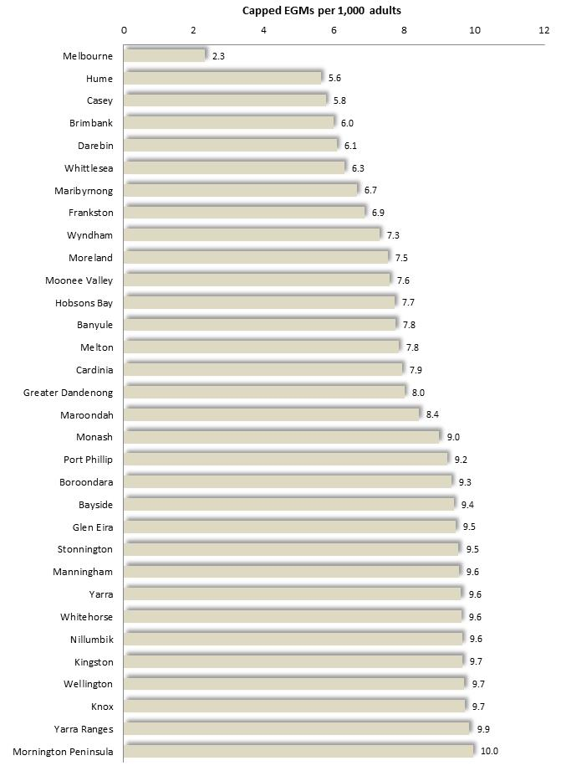

Diagram 7: Maximum EGM Densities which would apply under the 2017 caps, based on the estimated adult population of each metropolitan municipality.

Code of Conduct and Self-Exclusion Program
Amendments to the Gambling Regulation Act, enacted in 2007, required that gambling venues adopt a code of conduct and self-exclusion program, which must be approved by the VCGLR according to standards and guidelines determined by the Minister for Gaming.
In May 2008, the Department of Justice released a discussion paper and Ministerial direction which set out some of the essential requirements of a code of conduct and self-exclusion scheme.
A code of conduct would entail obligations in addition to those set out in the legislation. The guidelines specify that they be written in plain English and displayed in a prominent, accessible location in the venue. Information is to be included about responsible gambling, the rules of gambling, and the process of making a pre-commitment decision. The code is also required to provide directions to guide staff in dealing with customers, including assistance to those exhibiting signs of distress, handling complaints, rules for cashing checks, the prohibition of persons under 18 from gambling or entering gambling areas, and responding to unattended children on the premises.
Self-exclusion programs are also required to address issues such as the process for self-excluding and its duration, identification of an excluded person in the gambling area, provision of information to customers, staff training, data management and review of program effectiveness. By June 2009, every gambling venue was obliged to establish a self-exclusion program and adopt codes of conduct, approved by the Victorian Commission for Gambling Regulation (VCGR) now the VCGLR, and meeting guidelines set out by the Minister for Gaming. The VCGLR is also responsible for monitoring compliance with the codes of conduct and self-exclusion programs and may take disciplinary action against venue operators for breaches of the relevant requirements.
While such programs currently operate in Victoria and elsewhere, it has been observed that relatively few people with gambling-related problems actually participate in such programs, many re-enter venues without being detected, and a substantial proportion continue gambling (Williams et al, 2007; Talbot, 2008). Information about the Australian Hotels Association (AHA) Self-exclusion Program - the larger of two self-exclusion programs operating in Victoria in mid-2009 – illustrates the limitations of current programs. In May, 2009, approximately 2,100 people were currently excluded under this program (O’Sullivan, 2009), representing 0.06% of the adult population of the state - the equivalent of 1 in 17 of the approximately 1% of people typically identified in population surveys as ‘problem gamblers’. Moreover, since evidence from the Productivity Commission report, cited earlier, shows that as many as two-thirds of people with such difficulties do not identify themselves in surveys, then the 2,100 people currently participating in the AHA self-exclusion program may account for as few as 1 in 50 adults with severe gambling-related problems in Victoria.
To achieve optimal effect Williams et al (2007) propose that such programs should feature irrevocable bans as the best form of restraint, longer ban lengths to prevent relapse, exclusion from all venues rather than one or a few, computerized monitoring of identity, more strenuous promotion of such programs, and the offer of counseling support to participants.

Smoking Bans
The banning of smoking from enclosed workplaces during the period 2002-2007, required adjustments of gambling venues and gamblers, though with little enduring effect upon overall gambling levels.
Restrictions upon smoking in gambling venues were first introduced in September 2002, then followed in March 2006 by amendments to the Tobacco Act which made it an offence to smoke in an enclosed workplace. Licensed premises were initially not included until amendments taking effect in July 2007 removed the exception [Tobacco Act 5A(1) & (2)].
Smoking is now prohibited from enclosed premises, which are defined as areas substantially enclosed by roof and walls - whether permanent or temporary. However, smoking is permitted in outdoor dining or drinking areas, except where there is a roof, and walls covering more than three-quarters of the total notional wall area [Tobacco Act Pt2 5C]. Roofs and walls are any structures which largely impede the flow of air.
The smoking restrictions imposed in 2002 were followed by a decline of $266 million, or 11%, in EGM gambling losses across Victoria in the succeeding two years. A 2005 review of harm minimization measures observed that, indeed, the restrictions initially contributed to a decline in gambling among smokers and perhaps a slight rise among non-smokers (Caraniche, 2005). However, the authors of the report conclude that levels of gambling soon rose again, as new gamblers came onto the scene or as existing patrons adjusted to the changed conditions, perhaps aided by modifications made to gambling venues to accommodate smokers.

State Government Legislation in 2017
In 2017, the State Government enacted two pieces of legislation to adjust the regulation of EGM gambling:

2017 September, Gambling Regulation Amendment (Gaming Machine Arrangements) Bill 2017
- Created a 20 year term for the post-2022 gaming machine gambling arrangements
- Instituted a more progressive taxation system upon EGM gambling receipts
- Removed the ratio of club to hotel entitlements (currently 50:50), which would henceforth be determined by the Minister for Gambling
- Raised the limit upon the number of entitlements which may be held by a club venue operator from 420 to 840, with an allocation process intended to ensure that smaller clubs would not be disadvantaged
- Set a limit upon EFTPOS withdrawals from a venue at $500 within a 24 hour period
- Raised the winnings payment which must be paid by cheque from $1,000 to $2,000
- Prohibited the operation or promotion of cheque cashing at venues. Venues are currently permitted to cash one cheque per customer to a maximum of $400 per day
- Stipulated that cashless gambling may not be offered as an incentive to gamble and that credit may not be used to top up such cards or tickets
- Amended the system by which the minister may determine content of responsible codes of conduct and self-exclusion programs

2017 October, Gaming Legislation Amendment Bill 2017
- Banned the display of static betting advertising within 150 m. of a school, on or in public transport or roads infrastructure
- Granted authority to Minister to ban any betting on a contingency which is considered against the public interest.
- Stipulated that payment of unpaid jackpots which cannot be transferred to other jackpots, be made to the Responsible Gambling Fund
- Adjusted the mechanism by which the Minister may ban unacceptable gambling products
- Amended VCGLR operations and decision-making processes

The content of this legislation, which passed into law, fell short of the more substantial reforms proposed by many local governments at the time; among them:
- $1 maximum bets
- Improved gaming machine design
- Lower caps in vulnerable areas, and fewer gaming machines in total
- A ban on political donations by the gambling industry
- Banning of EFTPOS cash out at venues
- Prohibition of cashless gambling
- Introduction of a mandatory pre-commitment system
- Reduced venue opening hours

VIII: Council Policy Responses

Numerous councils in Victoria have a gambling policy. Such polices wary widely in their content and approach to gambling issues, but often encompass topics such as applications for approval of venues or EGMs, consultations with the community and industry, advocacy for reform, research, alternative recreational and social opportunities, assistance for people experiencing gambling-related problems, obtaining funds from the CSF or local venues for community projects, and gambling on council land or premises.
* * * *

Responses to applications: Some council policies specify steps which the council shall use to respond to applications for gambling venues or increased numbers of machines; among them:

- a framework or specific sequence of steps to be carried out in response to an application

- the establishment of an internal council committee to assist in preparing submissions to the VCGLR

- steps to inform the public to enable members of the community to express their views to council or forward submissions directly to the VCGLR

Many policies also set out a range of information which must be included in any proposal for a new venue or increased numbers of machines, such as particulars about the local demographics, community benefits expected from the proposal, the effect of moving machines from one locality to another, current and proposed distribution of machines, previous and forecast expenditure at the venue, details of estimated expenditure transferred from other venues, relevant information about the design of the premises, and the range of entertainment facilities proposed for the venue.

Some policies state that applications should be accompanied by the findings of a survey of the opinions of residents living in the vicinity of the current or proposed venue. Notably, a State Supreme Court decision in 2008 affirmed the validity of opinion survey results in deciding applications for approval of premises for gambling. (Supreme Court of Victoria, 2008)

Circumstances to be considered: Many policies identify a range of conditions which may, or must, be taken into account in assessing and responding to applications for venues or machines; some specify circumstances which will attract support or opposition; while others still, simply describe broad approaches to be taken to such applications.
Considerations to be weighed in responding to applications for venues or machines, cited in various gambling policies, include:
- local community views
- measures to protect local amenity from noise, traffic, patron’s behavior, compatibility with surrounding land use, need to limit patrons or hours of operation
- possible adverse effects upon the community, or upon the prevalence of gambling problems
- potential for economic growth, or possible adverse effects on the local economy
Opposition is expressed in some policies to:
- any new venues or machines, in the municipality or the region *
- rises in EGM numbers above the state average
- placement of EGMs in disadvantaged areas, or movement into disadvantaged areas
- venues in close proximity to places frequented by children or adolescents
Support may be given on condition that:
- the applicant agree to undertake initiatives to promote responsible gambling,
- the applicant support a code of practice, the terms of a charter (typically a general and non-binding agreement between council, industry and other stakeholders), the council gambling policy, or their specified conditions
- gambling be offered along with other recreational opportunities
- a social impact statement be prepared by the applicant

* Some commentators caution that a council policy of uniform opposition to all applications for venues or machines has several disadvantages: first, it may appear to commit council to the costly process of opposing all applications, regardless of their prospect of success; second, it has no legal force; and finally, such a policy may prevent council from using its policy to exert an influence upon the location of a venue as it might have if its policy specified criteria - such as local EGM density, disadvantage or land uses – which would guide the council’s response to the application.

Local discussion of gambling issues: Many gambling policies specify that council should consult with the gambling industry, community agencies or the broader community, about gambling issues. Various purposes are cited including encouraging responsible gambling practices, addressing impact of gambling, and negotiating EGM reductions.
Some policies refer to occasional forums open to a wider range of stakeholders, others to committees with specific membership and regular meetings, typically constituted of industry, community and council representation. Purposes proposed for such meetings include guiding council gambling-related activities; learning about gambling practices from industry; sharing information about gambling; and facilitating local service provision, advocacy or research.

Informing the Community: Steps to inform the community about gambling-related issues include efforts to reach the public through mass media, schools and Gambler’s Help.
Such activities include efforts to inform the community about gambling trends, available assistance for people with gambling-related problems, the nature of gambling problems, or the hazards of gambling and other issues, through local newspapers, council newsletters, the internet and brochures.
Encouraging schools to educate young people about gambling issues, or distributing information about gambling to schools is a strand of this kind of activity. Notably, a 2011 survey of Victorian adults found that 21% of problem gamblers and ‘moderate risk’ gamblers, had commenced gambling before the age of 18, and a further 50% between the ages of 18 and 24 years (Hare, 2011).
Other councils have sought to facilitate activities of Gamblers Help by educating the public about gambling issues, or identifying groups of people in the community in need of assistance or information.

Charters: Referred to in some council policies, these are sometimes known as accords or protocols and usually represent agreements reached between councils, local community agencies and gambling venues. They are often motivated by a desire on the part of councils to improve local conditions by encouraging adherence by local venues to a range of conditions intended to alleviate gambling related problems, such as banning ATMs from venues; payments by cheque; breaks from gambling; disclosure of community support; increased support for community activities, and payment of a levy to meet costs of auditing compliance with charter. Charters may also include provisions for improved collaboration between local agencies in responding to gambling related problems. With few, if any, exceptions though, gambling venues will not participate in charters which oblige them to impose restraints upon their activities that are not already stipulated by law or under the terms of their existing codes of conduct.

Advocacy: Advocacy specified in gambling policies includes support for local lobby groups, collaboration with other local governments in efforts to influence government policy, and direct approaches to the State Government. Reforms sought by councils include fewer EGMs; caps on EGMs; education about gambling issues; reductions in bet limits from $5 to $1; removal of EFTPOS facilities from gaming rooms; improved information about local gambling losses; increased research about the effects of gambling; reduced government dependence on gambling taxes; enforceable codes of conduct; removal of deceptive EGM design features; introduction of a mandatory pre-commitment system; improved self-exclusion mechanisms and others.
In addition, local reforms are sought, such as increased control by local communities or municipal government over EGM numbers and distribution within a municipality and other local conditions; and allocation of further CSF funds locally, government advice on all local CSF grants.

Surveys and Other Measures of Public Opinion: A number of councils have sought to document and present evidence of local public opposition to gambling applications, at hearings before the VCGLR.
The Victorian Commission for Gambling and Liquor Regulation (VCGLR) routinely considers the findings of any community surveys, petitions and other records of public opinion relating to gambling applications, that are presented by the applicant or relevant Council, citing as its justification, the Gambling Regulation Act 2003 (S. 10.4.2(1)), which stipulates that the VCGLR must conduct “…any investigations or inquiries that it considers necessary to consider the application properly.”
Nearly all community survey findings presented by councils in support of their opposition to applications are discounted by the VCGLR on the grounds of methodological flaws. These include not presenting respondents with sufficient information about the attributes of an application, a failure to secure a balanced and representative sample of residents, insufficient numbers of respondents, perception that public opposition reflected in the survey findings reflect a general concern about gambling rather than specific apprehensions about a particular application, mismatch between the geographic area covered by the survey and the catchment of the venue, and other considerations.
Accordingly, the prospects of such efforts leading to a successful outcome are slim. A review of over 60 applications for approval of EGMs or gaming venues – including all those decided in 2012/13 - identified 15 instances where the local council had opposed the application with evidence of public opposition drawn from survey findings, petitions or focus groups. In a famous, case – Romsey Hotel, Macedon Ranges, 2006 – evidence of public opposition decisively contributed to the rejection of the application by the VCGLR. In just one other instance, public opposition played a minor part in a decision to reject the application. The remaining 13 applications were either rejected for reasons unrelated to public opinion, or approved. As it would appear, efforts to present evidence of public opposition to a gambling application improve the prospects of a favourable result by just 7%.

Alternative Recreation: Some council policies simply refer to general efforts to improve access among the community to opportunities for recreation or volunteering.
Others specify particular measures designed to achieve this goal, including: working with neighborhood houses, encouraging venues to provide other recreational outlets, conducting research to inform development of recreational programs, and provision of local council grants to support recreational and social activity.
An example of a project which promoted alternative recreation is the Reducing Gambling Frequency Project, led by HealthWest and involving engagement with Maltese, Arabic, Italian and Greek community groups to deter them from participating in excursions to gambling venues. An advisory Group constituted of senior staff member, bilingual workers and leaders from each of the four cultural group met monthly to build solidarity and confidence, to review progress, share ideas, hear from speakers and obtain advice from the manager of the project – a HealthWest staff member. Members participated in three instructive seminars about the nature of gambling problems, their effects on individuals and the community, and strategies for engaging their community groups in the project. The bilingual workers from these community groups played a key role, encouraging community group leaders to support the goals of the project and engaging with community members throughout the life of the project.
A further project with a focus upon alternative recreation was conducted by Greater Dandenong Council in 2015, with the establishment of a user-friendly webpage, which enabled users to locate local opportunities to undertake a course of learning for fun or career development, access opportunities for social interaction, relaxation, hobbies, sport and other physical recreation, or simply for relaxation. It is unknowable however, to what extent such a resource would divert many people with existing or current gambling-related problems, from such activities.
Work with community groups to survey social groups attending gaming venues – based on the ‘bus trip’ surveys by another organization, which were designed to show participants in excursions to gambling venues the difference between the expected cost of such trips and the real cost – arising from gambling losses. It was expected that these efforts would increase community leaders’ understanding of the hazards of gambling and prompt them to avoid trips to gambling venues, resulting in fewer visits and lower losses to gambling, reduced gambling harm, enhanced understanding of the impact of gambling among members of these communities and increased empowerment of these communities.
- Relatively short-term funding but long-term increase in demand for services upon community groups
- Not all workers or community members liked the ‘bus trip’ survey because it sowed mistrust
- Bilingual workers needed more concrete strategies – to know exactly what the message should be and how to covey it.
- Some organizational leaders were not interested in the project, some maintained there was no harm in trips to gaming venues, resisted abandoning trips to venues, or contended that they did not have the authority to stop such trips and could lose members if they did.
- Since government was clearly seen to be doing little to deter problem gambling, the project goals seemed to some community members to be tokenistic
- Some project participants felt that there was not enough time to develop channels of communication to community members
- Either way, community groups needed to be able to organize outings to alleviate social isolation and many saw trips to gaming venues as cheap outings
The project raised awareness of gambling harm, with the project organisers commenting “conversations about alternative outings have started and groups are thinking about or have started planning alternatives.” (Greenstock, undated)

Research: In many instances, council policies specify a role for local government in either conducting or encouraging research about gambling issues. Most councils set out, in some degree at least, to monitor research and gambling trends to inform council policy and responses to gambling issues. Others may also conduct local research, incorporating gambling issues into other council research, encouraging other local agencies to conduct research or facilitating local research. Some council policies actually specify research topics which it proposes to encourage, such as investigations of gambling among culturally diverse residents or other segments of the community, harm minimization, community attitudes and others.

Community Benefit: Gambling policies often refer to efforts to increase the level of funds re-directed to the local community from the money lost to EGM gambling, either by increasing the local share of the Community Support Fund (CSF), or by encouraging gambling venues to increase their support for local community activities.

Some councils for instance, have urged the State Government to provide clearer information to community groups about access to the CSF; others support local agencies in accessing the CSF; and some encourage contributions to the local community by gambling venues, by either advising them of appropriate community groups or local need to assist them in directing their donations, or through a locally-administered fund.

EGMs on Council Property: Some council policies adopt a position in relation to the conduct of gambling in council-owned premises or land. Some are relatively general, referring to the requirement for guidelines, while others specify conditions which must be met before the council will offer its support.
- Develop guidelines for conduct of gambling on council-owned premises.
- EGM gambling to be permitted on Council-owned land or premises, only if certain conditions are met.
- that the gambling produces a net benefit to the community ,
- that the relevant venue support a responsible gambling charter,
- that commercial occupancy agreements be instituted,
- that the gambling venue be obliged to comply with relevant gambling regulations [which they are already].

- Other policies oppose all gambling on council-owned land or premises, citing concern that such activities may effectively subsidize gambling, compromise council’s ability to respond constructively and credibly to gambling issues, or that gambling in some council-owned premises would represent a harmful intrusion upon other activities, such as youth programs.

Location:

A number of municipal gambling policies offer guidance about the prospective location of gambling venues and machines, specifying the types of areas where venues and machines may be favored, or opposed.

Among the types of locations where gambling venues and machines are not favored:
- In areas of relative social disadvantage - often specifying that disadvantage should be measured with the SIEFA Index of Relative Socio-economic Disadvantage
- In locations where the density of machines currently, or would, exceed the state average - or some other criterion (such as 10 per 1,000 adults)
- In areas where people congregate in the course of their daily activities, such as transport hubs, community centers or shopping centers.
- In locations where the gambling activity would detract from surrounding land uses - as for instance, next to child care centers, schools, aged care facilities, children's, youth or family precincts.

Locations where gambling machines or venues are favored, in some policies, include:
- Areas of population growth, though not to be established before growth occurs
- The edge of activity centers
- Locations where alternative activities are available, in same hours that gambling will be available

The Public Health Perspective

In addressing gambling-related problems, whether by local government or other organisations, the Responsible Gambling Foundation urges a public health approach, whose essential features are outlined here.
In its 2015 outline of the public health approach to the prevention of gambling problems, Using a Public Health Approach in the Prevention of Gambling-related harm, the Responsible Gambling Foundation emphasises its emphasis upon the health of the overall population, rather than individuals. This approach is founded upon the premise that even a small increase in health across a large population, may reduce the burden of disease and that the responsibility for population health rests with individuals, community groups, business and governments. Among further points made about the public health approach to gambling:
- Interventions should be addressed to settings – where people live their everyday lives
- The internet is an important avenue in which to communicate with the public, and “…a significant setting in which to engage people of different demographics” (2015: 7). The report adds that the “Use of digital communication channels is rapidly increasing given its cost effectiveness, the ability to target, and ubiquity of digital decides and the ease and precisions in tracking reach” (2015:8).
- Complementary interventions across multiple fronts are important in addressing public health issues. A further priority is addressing disadvantage, with the report contending that the success of health interventions requires that socioeconomic disadvantage and health inequality be addressed. Community driven (bottom up) actions, featuring community consultation and collaboration, are preferable to those driven from above and often guided by ignorant presumptions about the needs of others. Also supports
- In relation to gambling, the authors of the report observe that an abundance of literature and research dwells upon severe gambling problems rather than the “…more frequent and less severe problems” affecting far more people, adding that most people experiencing problems with gambling are not problem gamblers. Focusing upon problem gambling therefore, will not in itself reduce the overall incidence of problem gambling.
- Actions to address gambling-related problems which the report recommends at individual and community levels:
- Informing the public of the real costs of gambling and the modest prospects of success
- Counteracting the prevalence of online and sports betting
- Strengthening support offered to problem gamblers by friends and family members
- Disseminating information to enable the community to participate in debate about gambling and to influence decisions taken by governments in relation to this issue. Elsewhere, the report adds that, while the Responsible Gambling Foundation refrains from participating in public debate, it does “provide information to individuals and organizations to enable them to participate in that public discussion in an informed way” (2015: 13).
- Advocating “…to influence policy and legislative initiatives can be effective levers…to affect population change…” (2015: 8).

The Canvas Project illustrates a public health perspective in some measure. This project was conducted by Monash Council with partners Gamblers Help Eastern, Kingston Council and Monash University. Its focus was on older Chinese residents and Chinese international students. The project featured several discreet activities, each seeking to prevent problem gambling, chiefly among these two key groups.

Autumn Nights: Four social activities for older residents: three film nights at Clayton Community Centre, and a food and fun night, attracting 223 participants in total

Gaming Venues Staff Training: Project managers developed ideas for training gaming venue staff on approaching CALD patrons. These ideas were discussed with venue managers who expressed a measure of support. However, their involvement was postponed due to their unwillingness to permit staff to attend.

Loan Agencies: The project sought to encourage pawn brokers to provide information about sources of advice and assistance to customers who displayed signs of gambling-related problems, and urged that the pawn broker staff not provide such customers with loans. The managers of these agencies refused to participate.

Sporting Clubs: A further strand of the project focused upon sporting clubs as a setting where gambling behaviour is influenced. The project secured agreement of one club to address gambling issues among its members through a Responsible Gambling Foundation Program. However the club subsequently reneged on an earlier agreement to participate, citing competing demands on club volunteer’s time.

Video Gaming Event: An ‘International Student leadership group’ of 15 Monash University students, recruited through ads in Monash Uni. Newsletter participated in workshops to learn about their local community, become acquainted with gambling issues and organize events. Over a period of 11 weeks, the group organized a video gaming event which showcased non-gambling games and board games, and featured an information session about hazards of gambling video games for parents. Three hundred people attended the event.

Innovative Ideas: The International Student leadership group’ and others workshopped ideas to promote responsible gambling, then presented their ideas at a community event.

Impact of Video Games on Young People: information session was conducted with an audience of 44 youth workers. Participants were instructed about the adverse effects of gambling video games, as well as referral options for people with gambling-related problems and strategies to deal with such problems. (Halliburton and O’Loughlin, 2015)

IX: Planning Considerations

The process of obtaining a planning permit for a gambling venue, or installation of gambling machines, is regulated by the Planning and Environment Act 1987 and the Victorian Planning Provisions, and influenced by municipal policy. A selection of the sections and clauses from these sources that are most relevant to gambling, are presented here.
* * * *

Planning and Environment Act (1987), Section 60

General considerations

Lists a number of considerations to guide decisions about planning applications.
Council must consider:
* the planning scheme
* the objectives of planning in Victoria
* all objections and other submissions
* any comments of a referral authority
* any significant effects of the proposal on the environment.

Council may consider
* any significant social or economic effects
* any relevant State environment protection policy
* any other adopted strategic plan, policy statement, code or guideline
* any adopted, but yet to be approved amendment to the planning scheme
* any agreement made pursuant to section 173 affecting the land
* any other relevant matter.

State Planning Policy Framework

Sets out objectives of planning in Victoria in relation to economic and social wellbeing:

11.03-5 Economic well-being
Planning is to contribute to the economic well-being of communities and the State as a whole by supporting and fostering economic growth and development by providing land, facilitating decisions, and resolving land use conflicts, so that each district may build on its strengths and achieve its economic potential.

11.03-6 Social needs
Planning is to recognize social needs by providing land for a range of accessible community resources, such as affordable housing, places of employment, open space, and education, cultural, health and community support (mental, aged, disabled, youth and family services) facilities. Land use and development planning must support the development and maintenance of communities with adequate and safe physical and social environments for their residents, through the appropriate location of uses and developments and quality of urban design.

Victorian Planning Provisions [VPPs] – also set out factors which may influence planning decisions.

General considerations

Clause 11.01
“The State Planning Policy Framework seeks to ensure that the objectives of planning in Victoria are fostered thorough appropriate land use and development planning policies and practices which integrate relevant environmental, social and economic factors in the interest of net community benefit and sustainable development.

Clause 65.01
“Before deciding on an application or approval or a plan, the responsible authority must consider, as appropriate:
* the matters set out in Section 60 of the Act
* the state Planning Policy Framework and Local Planning Policy Framework, including the Municipal Strategic Statement and local planning policies
* the purpose of the zone, overlay or other provision
* any matter required to be considered in the zone, overlay or other provision
* the orderly planning of the area
* the effect on the amenity of the area”
and other considerations.

Activity Centers
Several clauses of the VPPs urge that the development of business, retail, employment, housing, leisure, community and other facilities should be encouraged in activity centers.

Clause 12.01-2
Development is to respond to its landscape, valued built form and cultural context and achieve sustainable objectives. “…Developing a network of activity centers that are: … a focus for business, shopping, working, leisure and community facilities.”

Clause 12.06-2 [under ‘Social and Physical Infrastructure]
“Plan for a more equitable distribution of social infrastructure by: Identifying gaps and deficiencies in social and cultural infrastructure and encouraging their location in activity centers, especially those identified as Principal Activity Centers.

Clause 17.01
“Activity centers should be planned to:
…Incorporate and integrate a variety of land uses, including retail, office, education, human services, community facilities, recreation, entertainment and residential uses
where appropriate.”

Gaming
Clause 52.28 of the VPPs addresses gambling in particular. It stipulates, among other things, that EGMs only be installed if a permit is granted under the Planning and Environment Act, and may not be permitted in designated shopping complexes or strips (Department of Sustainability and Environment, 2006).

Clause 52.28-1: Purpose
- To ensure that gambling machines are situated in appropriate locations and premises.
- To ensure the social and economic impacts of the location of gambling machines are considered.
- To prohibit gambling machines in specified shopping complexes and strip shopping centres.

Clause 52.28-2: A permit is required to install gambling machines except in venues approved on or before 18 October 2006, where the maximum number of machines is not exceeded.
[Originally, clubs with EGMs were required to ensure that the gaming area constituted no more than 25% of the total area where alcohol was permitted to be consumed. As long as this condition was satisfied, the venue could add as many gaming machines as it wished, without seeking a planning permit.
In October 2006, Clause 52.28-2 of the Victorian Planning Provisions was introduced, stating that “A permit is required to install gambling machines except in venues approved on or before 18 October 2006, where the maximum number of machines is not exceeded”.
This meant that any venue established before that time, which adhered to the 25% rule, could continue to hold or add gaming machines, without seeking a planning permit, under this provision. This proposition was tested in the Supreme Court decision in McKinnon Hotel –v- Glen Eira, which affirmed the hotel’s existing use rights to use and install gaming machines as it had housed gaming machines in a gaming area that had not exceeded 25% of the area permitted for alcohol consumption, without incurring a requirement for a planning permit. By contrast though, if a venue which had not previously had gaming machines sought to acquire them, it would be bound by this clause, and therefore required to obtain a planning permit from the council.]

Clause 52.28-3: EGMs are not permitted in shopping centers listed in a schedule to this clause [52.28-3] or in strip shops listed in a schedule [52.28-4], except venues approved on or before Oct 2006. *

Clause 52.28-4: Defines strip shopping centers as areas with two or more adjacent buildings, of which a significant proportion are shops accessible to the public by road.

Clause 52.28-6: Adds further, more general considerations, for deciding an application for EGMs.
“Before deciding on an application, in addition to the decision guidelines of Clause 65, the responsible authority must consider, as appropriate:
- The State Planning Policy Framework and the Local Planning Policy Framework, including the Municipal Strategic Statement and local planning policies.
- The compatibility of the proposal with adjoining and nearby land uses.
- The capability of the site to accommodate the proposal.
- Whether the gaming premises provides a full range of hotel facilities or services or a full range of club facilities or services to members and patrons.”

* In October, 2008 VCAT reviewed a decision by the Frankston Council to refuse a permit for an increase in EGMs at the Langwarrin Hotel. Council had argued, among other things, that the venue was situated in a strip shopping centre which was listed in a schedule to clause 52.28-4 and that addition of further machines was therefore prohibited. VCAT however, concluded that the hotel was situated well past the end of the shopping strip and not clearly visible from the shopping area in any case, and approved the application in January 2009.

Local Policy Framework
Local policy framework can give objectives and directions for the placement of EGMs in appropriate locations in the municipality. The Department of Justice paper, ‘Taking Action on Problem Gambling: regional caps”, released in October, 2006, encouraged councils “…to develop local gaming machine policies for inclusion into their local planning frameworks, to specify factors council will consider in deciding an application for gambling machines. (Department of Justice, 2006A)
Among other things, one may include schedules to clauses 52.28-3 and -4 to specify shopping complexes and strips where EGMs will not be permitted.
For instance, Greater Bendigo Council took the following steps to incorporate instructions into its planning framework to guide decisions about gambling machines:
- Amended its Municipal Strategic Statement at clause 21.07 and 21.10 to introduce references to gambling machines and include their gambling framework as a reference document
- Added a schedule to clause 52.28, specifying strip and shopping complexes where EGMs are prohibited.
- Incorporated a list of areas where EGMs are discouraged, into a schedule to clause 81.01

However, legal specialists have cautioned that local planning policy on gambling may be only one of a range of circumstances that a responsible authority would consider in deciding whether to grant a planning permit.
Selected Sections of the Gambling Regulation Act (2003), relevant to Approvals Submissions

1. Application for Approval of Premises
Application for approval of premises requires a planning permit be obtained, or applied for
3.3.4
(1) The owner of premises or a person authorized by the owner may apply to the Commission for the approval of the premises as suitable for gaming.
(3) The application must contain or be accompanied by—
(i) a copy of a permit issued under the Planning and Environment Act 1987 permitting the premises to be used for gaming on gaming machines; or
(iii) a copy of an application that has been made in accordance with the Planning and Environment Act 1987 for a permit that, if granted, would permit the premises to be used for gaming on gaming machines.

3.3.5 Notification of responsible authority
Within 14 days after applying, the applicant must send a copy of the application to the relevant responsible authority within the meaning of the Planning and Environment Act 1987.
(The ‘relevant responsibility is usually, though not invariably, the local council)

3.3.6 Responsible authority may make submission
(1) The relevant responsible authority may make a submission to the Commission on an application for approval of premises—
(a) addressing the economic and social impact of the proposal for approval on the wellbeing of the community of the municipal district in which the premises are located; and
(b) taking into account the impact of the proposal on surrounding municipal districts.
(2) A submission must be in the form approved by the Commission and must include the information specified in the form.
(3) A submission must be made within 60 days (or the longer period allowed by the Commission) after the responsible authority receives a copy of the application.

3.3.7 Matters to be considered in determining applications
(1) The Commission must not grant an application for approval of premises as suitable for gaming unless satisfied that—
(c) the net economic and social impact of approval will not be detrimental to the wellbeing of the community of the municipal district in which the premises are located.
(3) The Commission must also consider any submission made by the relevant responsible authority under section 3.3.6.

Responsible Authority may appeal decision on application for approval of premises, to VCAT
3.3.14 Tribunal review of approval
(1) An applicant for approval of premises may apply to the Tribunal for review of a decision of the Commission on the application.
(2) A responsible authority that made a submission under section 3.3.6 on an application for approval of premises may apply to the Tribunal for review of a decision of the Commission granting the approval.
(3) An application for review must be made within 28 days after the later of—
(a) the day on which the decision is made;
(b) if, under the Victorian Civil and Administrative Tribunal Act 1998, the applicant or responsible authority requests a statement of reasons for the decision, the day on which the statement of reasons is given to the applicant or responsible authority or the applicant or responsible authority is informed under section 46(5) of that Act that a statement of reasons will not be given.

2. Application to Vary Existing License Conditions (number of machines, 24 hour opening etc.)
Application for more machines, 24-hour gaming, or specification/variation of days & dates of 24-hour gambling, must include a social impact assessment
3.3.4
(4) If an application for approval of premises as suitable for gaming includes an application for approval of 24 hour gaming on the premises, the application must also be accompanied by a submission—
(a) on the net economic and social benefit that will accrue to the community of the municipal district in which the premises are located as a result of the premises being open for gaming for 24 hours; and
(b) taking into account the impact of the proposal for approval on surrounding municipal districts.

3.4.17
(1) The conditions of a venue operator's license, including—
(d) variation of the days or dates on which 24 hour gaming is permitted in an approved venue under the license - may be amended in accordance with this Division.
(2) A venue operator's license may be amended in accordance with this Division to add a condition specifying days or dates on which 24 hour gaming is permitted in an approved venue, when none currently takes place.

3.4.18
(1) A request by a venue operator for an amendment of license conditions—
(c) in the case of an amendment referred to in section 3.4.17(1)(d) or (2) or an amendment to increase the number of gaming machines permitted in an approved venue, must be accompanied by a submission—
(i) on the net economic and social benefit that will accrue to the community of the municipal district in which the approved venue is located as a result of the proposed amendment; and
(ii) taking into account the impact of the proposed amendment on surrounding municipal districts.

Local council must be notified of an application for more machines
(2) If an amendment proposed by a venue operator is to increase the number of gaming machines permitted in an approved venue, the venue operator must send to the municipal council of the municipal district in which the approved venue is located a copy of the proposed amendment within 14 days after the proposal is made.

Local council may make a submission to VCGLR on application for more machines
3.4.19 Submissions in response to proposed amendments
(1) Within 60 days (or the longer time allowed by the Commission) after receiving a copy of a request for an amendment referred to in section 3.4.18(2) a council may make a submission to the Commission—
(a) addressing the economic and social impact of the proposed amendment on the wellbeing of the community of the municipal district in which the approved venue is located; and
(b) taking into account the impact of the proposed amendment on surrounding municipal districts.

3. Caps on Gambling Machine Numbers
3.2.4 Regional limits on gaming machines
(1) The Minister may from time to time, by order published in the Government Gazette—
(a) determine regions in the State for the purposes of this Chapter; and
(b) in respect of each region, specify the criteria which the Commission must use to determine the maximum permissible number of gaming machines available for gaming in the region.
(2) Within 60 days after an order under subsection (1) is published in the Government Gazette, the Commission must, by instrument published in the Government Gazette, and in accordance with the specified criteria, determine the maximum permissible number of gaming machines available for gaming in a region determined and in force under sub-section (1)(a) but so that the total for the State does not exceed the State limit.
(7) Not later than 5 years after the publication of a determination under sub-section (2) and thereafter at intervals not exceeding 5 years, the
Commission must—
(a) review the regional limits; and
b) if a regional limit is no longer appropriate, determine, by instrument published in the Government Gazette, a new regional limit in accordance with the criteria specified under sub-section (1)(b) but so that the total for the State does not exceed the State limit.

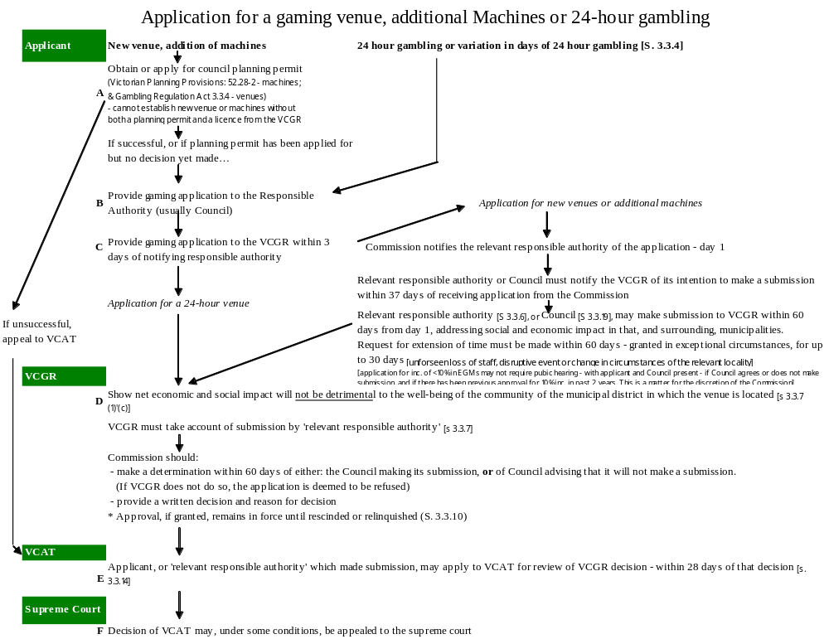
Success Rate in Opposition to Gambling Applications
The prospect of a Council successfully opposing an application for approval of EGMs or gambling premises, are low. In 2012/13, 21 gambling applications were contested by councils, with just one (or 4.7% of the total) successfully leading to a rejection of the application by the VCGLR.
Moreover, in a number of seemingly unwinnable cases, the council prudently chose to avoid the expense and inconvenience of contesting the application. Had these councils decided to oppose these applications, the proportion of applications opposed and won by councils would be lower still.
A more recent review of decisions on gaming applications rendered by the VCGLR between 2011 and 2016, conducted by the author, found that approximately one in twenty applications were refused.

X: Websites

To view the website, click on its name (in blue, underlined text). Otherwise, copy the address - presented in smaller, red font, below the website name - and paste it into your explorer address bar.

Acts

Gambling Regulation Act 2003
www.austlii.edu.au/au/legis/vic/consol_act/gra2003190/

Planning and Environment Act 1987
www.austlii.edu.au/au/legis/vic/consol_act/paea1987254/

Tobacco Act 1987
www.austlii.edu.au/au/legis/vic/consol_act/ta198773/

Liquor Control Reform Act
www.austlii.edu.au/au/legis/vic/consol_act/lcra1998266/

Racing Act
www.austlii.edu.au/au/legis/vic/consol_act/ra195867/

Government and Gambling Regulation

Department of Justice: Office of Gambling and Racing
Includes a range of information about laws, reviews and governments project relating to gambling in Victoria, as well as details concerning license hearings and findings.
www.justice.vic.gov.au/wps/wcm/connect/DOJ+Internet/Home/Gambling+and+Racing/

Gambling License Review

Presents information about state government planning for gambling arrangements to take effect in 2012.
http://www.gamblinglicences.vic.gov.au/

Venue Level Gambling Data

Information about EGM losses by venue for all Victorian clubs and hotels

http://www.gamblinglicences.vic.gov.au/media/docs/Venue_Level_Data_2005_06_2006_07_2007_08-1d4d47c0-5332-4a98-b26a-d93f15969493-0.XLS

Department of Planning and Community Development – Annual Report 2008/9 [Comm. Support Fund]
www.dvc.vic.gov.au/Web14/dvc/rwpgslib.nsf/GraphicFiles/Annual+report08+full+web+version/$file/Annual+report08+full+web+version.pdf

Victorian Commission for Gambling Regulation (VCGR)
www.vcgr.vic.gov.au/

- VCGLR Gambling Losses by LGA
http://www.vcgr.vic.gov.au/CA256F800017E8D4/research/6044B2232F9BB6C3CA25778100194372?Open
- VCGLR Monthly Gambling Losses by LGA
http://www.vcgr.vic.gov.au/CA256F800017E8D4/gamblinginfo/A9CDBCD1535E0085CA25790500031F7E?OpenDocument
- VCGLR Gambling Losses by Venue
http://www.vcgr.vic.gov.au/CA256F800017E8D4/research/7A16A720C176F940CA2577810018432D?Open
- VCGLR Gambling Venue & EGM details
http://www.vcgr.vic.gov.au/CA256F800017E8D4/LicInfo/5877F531B4CFCC7FCA25777700045455?OpenDocument
- VCGLR Gambling Venue & EGM Map
http://www.vcgr.vic.gov.au/CA256F800017E8D4/LicInfo/57B66692586529ACCA25777C00040BDA?OpenDocument
- VCGLR Inquiries and Hearings
http://www.vcgr.vic.gov.au/CA256F800017E8D4/Meetings/B7BBB0742438EFEDCA25777400808FE0?OpenDocument
- VCGLR Club Community Benefit Statements
http://www.vcgr.vic.gov.au/CA256F800017E8D4/LicInfo/05BC93C8D0A8099FCA257781001A0D51?OpenDocument
- VCGLR Caps and Limits
http://www.vcgr.vic.gov.au/CA256F800017E8D4/LicInfo/07758F2C146D2A1DCA25777D0081CC21?OpenDocument

Planning Related Matters

Victorian Planning Provisions
www.dse.vic.gov.au/planningschemes/VPPs/combinedPDFs/VPPs_All_Clauses.pdf

VCAT – Planning and Environment
www.vcat.vic.gov.au/CA256DBB0022825D/page/Planning+and+Environment?OpenDocument&1=65-Planning+and+Environment~&2=~&3=~

VCAT Decisions
www.austlii.edu.au/au/cases/vic/VCAT/

Advice, support and advocacy

Responsible Gambling Advocacy Centre
Promotes responsible gambling, helps people get the information they need to lobby for responsible gambling, and assists the community in finding the resources they require about gambling.
www.responsiblegambling.org.au/

Gamblers Help
www.problemgamblingvictoria.com.au/

Multicultural Gamblers Help Program
http://www.ceh.org.au/mghp/commorgs.aspx

www.gambleaware.vic.gov.au/
Presents advice about the nature of gambling and gambling problems, and sources of assistance.
www.gambleaware.vic.gov.au/

Problem gambling.com
Provides information about services for people who are experiencing personal, family, financial, work or other problems as a consequence of gambling.
www.problemgambling.com/

Know the Odds
Distributes an inexpensive educational kit designed to inform students about the hazards associated with gambling and assist them to understand the nature of gambling problems.
www.knowodds.org

Pokie Watch
Documents the compliance of Victorian gambling venues with laws and codes of practice, with the purpose of improving gambling practices. Members of the public may contribute information to this site.
www.pokiewatch.org/page/What+does+PokieWatch+tell+me+about+Victorian+pokie+venues%3F

Free Yourself
A self-help website which offers advice about dealing with gambling-related problems
www.freeyourself.com.au/

Social Impact of Pokes
An on-line tool which allows the operator to explore the consequences of gambling machines upon communities
socialimpactsofpokies.org.au

Responsible Gambling Advocacy Centre
The website of this organization provides a wide range of contemporary information and advice to local governments, community organizations and concerned residents about the nature, scope and effects of gambling, including publications, research, data, submissions, news, events and discussions.
www.responsiblegambling.org.au/

Gambling Data
VCGR Gambling Losses by LGA
www.vcgr.vic.gov.au/CA256F800017E8D4/Statistics/F57C8E1993956471CA25701C004BCCA7?Open

Gambling Losses, EGM numbers and density, and other municipal level data
http://www.vlga.org.au/resources/items/218159-upload-00001.xls

Venue Level Gambling Data

Information about EGM losses, by venue, for all Victorian clubs and hotels

http://www.gamblinglicences.vic.gov.au/media/docs/Venue_Level_Data_2005_06_2006_07_2007_08-1d4d47c0-5332-4a98-b26a-d93f15969493-0.XLS

Gaming Machine Entitlements Transfer Website

www.vcgr.vic.gov.au/CA256F800017E8D4/Entitlements/651480DDA9B4CF72CA2577A5001AFEA1?Open

Gambling Research

ACT Gambling and Racing Commission [includes research about patterns of gambling and gambling problems] www.gamblingandracing.act.gov.au/index.htm

Alberta Gambling Research Institute [Canada. Includes free, on-line access to articles, books & reports]
http://dspace.ucalgary.ca/handle/1880/79

Canadian Responsible Gaming Council [Canada. Including an online library]
www.responsiblegambling.org/en/research/newscan.cfm?SR=21

Centre for Gambling Studies [New Zealand, Auckland University]
www.fmhs.auckland.ac.nz/soph/centres/cgs/

Department of Justice: Office of Gambling – Research
www.justice.vic.gov.au/wps/wcm/connect/DOJ+Internet/Home/Gambling+and+Racing/Research+and+Statistics/

Diagnostic and Statistical Manual IV
http://allpsych.com/disorders/dsm.html

European Institute for the Study of Gambling [Netherlands]
www.easg.org/

Gambling Research Australia
Functions as a clearinghouse for all Australian gambling research as well as other gambling research issues and information
www.gamblingresearch.org.au/CA256DB1001771FB/HomePage?ReadForm&1=Home~&2=~&3=~

Journal of Gambling Issues [Canada]
www.camh.net/egambling/

National Centre for Responsible Gambling [US]
www.ncrg.org/

National Gambling Impact Study Commission [US]
http://govinfo.library.unt.edu/ngisc/index.html

Ontario Problem Gambling Research Centre [Canada]
Supplies links to a range of international research about the nature of gambling, its effects upon individuals, families and communities, as well as government policies and practices in this field.
www.gamblingresearch.org/

Productivity Commission 1999 Gambling Inquiry Report
www.pc.gov.au/projects/inquiry/gambling/docs/finalreport

Queensland Office of Economic and Statistical Research
Publishes an annual account of gambling losses and other data, by gambling type, for each Australian state.
www.oesr.qld.gov.au/publications/regular-publications/index.shtml

Responsible Gaming Council [Canada]
www.responsiblegambling.org/en/index.cfm

SA Independent Gambling Authority
www.iga.sa.gov.au/publications.html#ANZGL

University of Nevada gambling Links (US)
www.unr.edu/gaming/infolinks.asp

Victorian Casino and Gaming Authority: Research conducted until 2000
www.vcgr.vic.gov.au/CA256F800017E8D4/Statistics/36AB81950861EF0BCA25701C004FF69C?Open

Productivity Commission Inquiry into Gambling

Productivity Commission 2009 Gambling Inquiry
www.pc.gov.au/projects/inquiry/gambling-2009

Productivity Commission 1999 Gambling Inquiry Report
www.pc.gov.au/projects/inquiry/gambling/docs/finalreport

Productivity Commission Homepage
www.pc.gov.au

The Gambling Industry

Gaming Technologies Association
www.agmma.com/

Tattersall’s Gaming and Lottery Operators’
www.tattersalls.com.au/

Tabcorp
www.tabcorp.com.au/

Crown Casino – Publishing and Broadcasting Group
www.crowncasino.com.au/

Australasian Gambling Council
News, information and links relevant to the Australian gaming industry and conditions. Includes links to research and gambling-related data
www.austgamingcouncil.org.au/index.php
BIBLIOGRAPHY
Abbott, M., Hare, S., Jolley, D., Marshall, P., MacMillen, J., Villaneuva, E and Volberg, R. (2011) The Victorian Gambling Study: a longitudinal study of gambling and public health – wave two findings. Department of Justice, Melbourne.
AC Neilsen (2003). Evaluation of the Impact of the Three-hour Shutdown of Gaming Machines. Department of Gaming and Racing.
AllPsych Online (2009). The virtual psychology classroom. Accessed 23 February, 2009 at: http://allpsych.com/disorders/dsm.html allpsych.com/disorders/impulse_control/gambling.html.
American Psychiatric Association (2008). Diagnostic and Statistical Manual of Mental Disorders Fourth Edition, Text Revision.
Anglican Diocese of Melbourne Social Responsibilities Committee (2008). Submission to the Senate Inquiry on the poker Machine Harm Reduction Tax. Inquiry into Poker Machine Harm Reduction Tax [Administration] Bill, Poker Machine Harm Minimization Bill and ATMs and Cash Facilities in Licensed Venues Bill. Commonwealth Government, Canberra.
Armstrong, A. and Carroll, M. (2017). Gambling Activity in Australia: Finding from wave 15 of the Household, Income and Labour Dynamics in Australia (HILDA) Survey. Australian Gambling Research Centre and Australian Institute of Family Studies, Melbourne
Arnott, C. (2011). Local Impacts of Electronic Gaming Machine Gambling in Moreland. The Social Research Centre, Melbourne.
Associated Press (2008). Norway Imposes strict gambling rules. Associated Press. Featured in Canadian Responsible Gambling Accessed 10 January 2009, at Accessed 10 January 2009, at www.responsiblegambling.org/staffsearch/library_news_results_details.cfm?inteID=11553.
Australian Broadcasting Commission (2008). Gambling Addictions a Root Cause of Homelessness: researcher. The World Today - Tuesday, 29 January, 2008 12:26:00. Accessed 13th February, 2009, at: www.abc.net.au/worldtoday/content/2008/s2148892.htm
Australian Bureau of Statistics (2000A). Household Expenditure Survey 1998-1999. ABS, Canberra.
Australian Bureau of Statistics (2000B). Australian Housing Survey, 1999. ABS, Canberra. Accessed 23 February, 2009 at:
Australian Bureau of Statistics (2007). Basic Community Profiles. ABS, Canberra.
Australian Bureau of Statistics (2008A). Household Expenditure Survey, Australia: Detailed Expenditure Items, 2003-04. Cat. No. 6535.0.55.001. Commonwealth Government, Canberra. Accessed 16 February, 2009 at: www.abs.gov.au/ausstats/abs@.nsf/mf/6535.0.55.001
Australian Bureau of Statistics (2008B). Regional Population Growth: 2006-2007, ABS, Cat. 3218.0 Accessed on January 12 at:
Australian Gambling Research Centre (2014). The impact of gambling problems on families - AGRC Discussion Paper No. 1 – November 2014

Australian Institute of Family Studies (2014). The impact of gambling problems on families. AGRC Discussion Paper No. 1 – November 2014. Accessed at: https://aifs.gov.au/agrc/publications/impact-gambling-problems-families/what-are-impacts-gambling-problems-families on 12 June, 2018
Australian Medical Association (2013).Health Effects and Problem Gambling. AMA. Accessed at: https://ama.com.au/position-statement/health-effects-problem-gambling-2013
Ballon, B. (2006). The case of the bleak blackjack bettor: Clinical depression and pathological gambling. Journal of Gambling Issues, Vol. 16, 2006. Accessed 19 December 2008 at: www.camh.net/egambling/issue16/issue16/jgi_16_ballon.html
Banks, G. (2007). Gambling in Australia: are we balancing the equation? Speech to the Australian Gaming Expo Conference. Accessed 2 January, 2009 at: www.pc.gov.au/speeches/cs20070819
Bartley, H., Drake, H., Hetherington, B., and Maddern, C. (2017). Initial Implementation of Revised Victorian Responsible Service of Gaming Training: outcomes and lessons learned. Victorian Responsible Gambling Foundation and Office of Gambling and Liquor Regulation.
Barratt, MJ, Livingston, M, Matthews, S & Clemens, S.L. (2014), ‘Gaming machine density is correlated with rates of help-seeking for problem gambling: a local area analysis in Victoria, Australia’, Journal of Gambling Issues, no. 29, pp. 1–21.

Bellringer, M. du Preez, K.P., Pearson, J., Garrett, N., Koziol- McLain, J., Wilson, D. and Abbott, M. (2017). Problem Gambling and Family Violence in Help-Seeking Populations: Co-occurrence, Impact and Coping. New Zealand Ministry of Health, 15 May 2017, accessed at: https://www.health.govt.nz/publication/problem-gambling-and-family-violence-help-seeking-populations-co-occurrence-impact-and-coping
Ben-Tovim, D..I., Esterman, A., Tolchard, B. and Battersby, M. (2001). The Victorian Gambling Screen. Victorian Casino and Gaming Authority, Melbourne.
Billi, R., Stone, C.A., Marden, P., Yeung, K. (2014). The Victorian Gambling Study: a longitudinal study of gambling and health in Victoria, 2008-2012. Victorian Responsible Gambling Foundation, Melbourne.
Black, D. (2013). Neuropsychological performance, impulsivity, symptoms of ADHD, and Cloninger's personality traits in pathological gambling. Addiction Research and Theory, Vol. 21, Issue 3, pp 216-226 Accessed at: https://www.tandfonline.com/doi/full/10.3109/16066359.2012.705399
Breakeven Tasmania. (2008). The Break Even Program Addressing the Impacts of Poker Machines in Tasmania: Submission to the Senate Standing Committee on Community Affairs Inquiry into the Poker Machine Harm Reduction Tax (Administration) Bill 2008, the Poker Machine Harm Minimization Bill 2008 and the ATMS and Cash Facilities in Licensed Venues Bill November 2008. Accessed 20 February 2009 at: www.aph.gov.au/SENATE/COMMITTEE/CLAC_CTTE/poker_machine_harm_reduct/index.htm
Brown, H. (2018) Estimate of Breakdown of Gamblers in Venues at a point in time, by gender, age and gambling risk: 2014, Victoria. City of Greater Dandenong, Melbourne (Unpublished)
Browne, M., Langham, E., Rawat, V., Greer, N., Li, E., Rose, J., Rockloff, M., Donaldson, P., Thorne, H., Goodwin, B., Bryden, G., and Best, T. (2016). Assessing Gambling-related Harm in Victoria: a public health perspective. Victorian Responsible Gambling Foundation, Melbourne.
Browne, M, Greer, N, Armstrong, T, Doran, C, Kinchin, I, Langham, E & Rockloff, M (2017). The social cost of gambling to Victoria, Victorian Responsible Gambling Foundation, Melbourne.Caraniche (2005). Evaluation of Electronic Gaming Machine Harm Minimization Measures in Victoria, Final Report.
Castren, S., Basnet, S., Salahon, A., Pankakoiski, M. Rankainen, J., Alho, H. and Lati, T. (2013). Factors Associated with Disordered Gambling in Finland. Substance Abuse, Treatment and Policy. Vol. 18, no. 1, pp. 1-10
Centre for Criminology and Criminal Justice (2000). The Impact of Gambling and Crime Statistics. Victorian Casino and Gambling Authority, Melbourne
Centre for International Economics (2008). Gambling with Policy: the economic impacts of removing gaming machines from pubs and clubs. Centre for International Economics, Canberra.
Clark, C., Nower, L. and Walker, D.M. (2013). The relationship of ADHD symptoms to gambling behaviour in the USA: results from the National Longitudinal Study of Adolescent Health. International Gambling Studies, Vol 13, No. 1, ppp. 35-51
Commonwealth of Australia (2008). Submissions to the Senate Standing Committee on Community Affairs Inquiry into the Poker Machine Harm Reduction Tax (Administration) Bill 2008, the Poker Machine Harm Minimization Bill 2008 and the ATMS and Cash Facilities in Licensed Venues Bill November 2008. Commonwealth Government, Canberra. Accessed 20 February 2009 at: www.aph.gov.au/SENATE/COMMITTEE/CLAC_CTTE/poker_machine_harm_reduct/index.htm
Commonwealth of Australia (Department of Social Services) (2015). Review of Illegal Offshore Wagering
Costello, T. (2008). Rudd’s Crack at State Pokie Habit. Herald Sun, 1 April 1998. Accessed 18 January at: www.acl.org.au/national/browse.stw?article_id=20522

Crane, C. (2015). Problem gambling often linked with family violence, expert warns. Geelong Advertiser
Crofts, P. (2002). Gambling and Criminal Behaviour: An Analysis of Local and District Court Files. Casino Community Benefit Fund, Sydney
Cullerton, R.P. (1989). The Prevalence Rates of Pathological Gambling: A Look at Methods. Journal of Gambling Behavior, Vol. 5 (1), Spring, pp. 22-41, 1989.
Deans, E. G. (2017). The role of peer influences on the normalisation of sports wagering: a qualitative study of Australian men. Deans, E., Thomas, S., Daube, M. and Derevensky, Journal of Addiction Research and Theory, Vol. 25, Issue 2, pp. 103-113 Accessed at: https://www.tandfonline.com/doi/full/10.1080/16066359.2016.1205042
Delfabbro, P. (2011). Australasian Gambling Review. Independent gambling Authority, Adelaide
Delfabbro, P., Lambos, C., King, D. and Puglies, S. (2009). Knowledge and Beliefs about Gambling in Australian Secondary School Students and their Implications for Education Strategies. Journal of Gambling Studies, Vol. 25, No. 4, pp. 523-539
Delfabbro, P., Osborn, A., Nevile, M., Skelt, L. and McMillen, J (2007). Identifying Problem gambling in Gaming Venues. Gambling Research Australia, Nov. 2007, p. 16-20?
Department of Justice (2006). New Regional Caps on Electronic Gambling Machines. Victorian Government, Melbourne.
Department of Justice (2006A). Taking Action on Problem Gambling. Government of Victoria, Melbourne
Department of Justice (2006B). Taking Action on Problem Gambling: Regional Caps. Government of Victoria, Melbourne.
Department of Justice (2008). Destination Gambling: evaluating the benefits for Victoria. Victorian Government, Melbourne.
Department of Justice (2008). Destination Gambling: evaluating the benefits for Victoria. Dept. Justice, Melbourne
Department of Justice (2009). Gaming Machine Arrangements 2012. Victorian Government, Melbourne.
Department of Justice (2009B). Problem Gambling from a Public Health Perspective. Victorian Government, Melbourne.
Department of Justice (2011). The Victorian Gambling Study: a longitudinal study of gambling and public health, Wave Two. Victorian Government, Melbourne.
Department of Justice (2011). Victorian Gambling Survey – Wave Two. Victorian Government, Melbourne. Accessed 21 July, 2011 at:
Department of Planning and Community Development (2008). Annual Report 2007/8. DPCD, Melbourne
Department of Sustainability and Environment (2006). Changes to the Gaming Provisions in Planning Schemes: advisory note. Dept Sustainability and Environment, Melbourne.
Dickins, M. and Thomas A (2012). Gambling in culturally and linguistically diverse communities in Australia. Australian Gambling Research Centre. Institute of Family Studies.
Doughney, J. and Kelleher, T. (1999). Preliminary Local Area Gambling Research: Economic Effects. Victoria University, Melbourne.
Doughney, James. (2007). Lies, Damned Lies and Problem Gambling Prevalence Rates: the Example of Victoria, Australia. Victoria University, Melbourne.
Dowling, N. A., Carrie, E., Yousef, G. J., Merkouris, S. S., Suomi, E., Thomas, S. A, and Jackson, A., (2006). Problem Gambling and Family Violence: Findings from a population-representative study. Journal of Behavioural Addictions, Vol. 7, Issue 3, pp.
Dowling N., cited in J. Dowling (2014). ‘The Problem with Gambling’, The Age, November 16. Accessed at: http://www.theage.com.au/victoria/the-problem-with-gambling-20141125-11tqhc.html

Dowling, N., Suomi, A. and Ewin, C (undated) Problem Gambling and Family violence: findings from a population representative community study.

Dowling N. (2014). Impact of Gambling Problems on Families. Australian Gambling Research Centre.
Eadington, W.R. (1989). Problem Gambling and Public Policy: Alternative in Dealing with Problem Gamblers and Commercial Gambling. In, H.J. Shaffer, S.A. Stein, B. Gambino, T.N. Cummings and R.L. Custer (eds.), Compulsive Gambling: Theory, Research and Practice. Lexington Books, Lexington.
Ethnic Communities Council of Victoria (2017). EECV paper on gambling harm prevention in culturally diverse communities. EECV, Melbourne.
Feldman.S., Radermacher, H., Andersion, C., and Dickins, M. (2014). A qualitative investigation of the experiences attitudes and beliefs about gambling in the Chinese and Tamil Communities in Victoria. Responsible Gambling Foundation, Melbourne.
Ferland, F., Fournier, P., Laouceur, R., Brochu, P., Bouchard, M. and Paquet, L. (2008). Consequences of Pathological Gambling on the Gambler and His Spouse. Journal of Gambling Issues, Vol. 22, Dec. 2008 Accessed 2 January, 2009 at: www.camh.net/egambling/issue22/04ferland-fournier.html
Gainsbury, S. M., King, D., Delfabbro, P., Hing, N., Russell, A., Blasczczynski, A., and Derevenskly, J. (2015). The Use of Social Media in Gambling. Gambling Research Australia. Melbourne
Gainsbury, S., Russell, A., Hing, N., Wood, R., & Blaszczynski, A. (2013). The impact of Internet gambling on gambling problems: A comparison of moderate-risk and problem Internet and non-Internet gamblers. Psychology of Addictive Behaviors, 27(4),1092-1101.
Gainsbury, S., Russell, A., Hing, N., Wood, R., Lubman, D., and Blaszczynski, A. (2015). How the Internet is changing Australian Gambling: findings from an Australian Prevalence survey. Journal of Gambling Studies
Gambling Regulation Act, 2003 [Version no. 005] Victorian Government, Melbourne.
Gerstein, D., Hoffmann, J., Larison, C., Engelman, L., Murphy, S., Palmer, A., Chuchro, L., Toce, M., Johnson, R., Buie, T. and Hill, M. (1999). Gambling Impact and Behavior Study. Christiansen/Cummings Associates, New York.
Gilding, M. and Le, R. (2016). Gambling and Drugs: the role of gambling among Vietnamese women incarcerated for drug crimes. Australian and New Zealand Journal of Criminology, Vol. 49 (1)
Giovanni M, Fabiola S, Mariangela C, Nicola P, Ilaria T, Gianluca S, Maurizio P and Giannantonio Massimo D, ‘Gambling Disorder and Suicide: An Overview of the Associated Co-Morbidity and Clinical Characteristics’, International Journal of High Risk Behaviour and Addiction,6(3), 2017, 6.
Greenstock, L. (undated). Reducing Gambling requency with Culturally and Linguistically Diverse Communities. HealthWest, Melbourne.
Halliburton, E. and O’Loughlin, L. (2015). Clayton CANVAS Summary Report: 1 July 2014-30 June 2015. Monash University and Victorian Responsible Gambling Foundation, Melbourne
Hancock, L. (2008). Testimony before the Senate Standing Committee on Community Affairs. Reference: Poker Machine Harm Reduction Tax [Administration] Bill, Poker Machine Harm Minimization Bill and ATMs and Cash Facilities in Licensed Venues Bill. Hansard. 11 September 2008:. Commonwealth Government, Canberra.
Hare (2009). Problem Gambling from a Public Health Perspective: a study of gambling in Victoria. Department of Justice, Melbourne
Hare, S. (2015) Study of Gambling and Health in Victoria. Victorian Responsible Gambling Foundation and Victorian Department of Justice and Regulation.
Harrigan, K. (2007). Slot machine structural characteristics: Distorted player views of payback percentages. Journal of Gambling Issues, Vol. 20, 2007. Accessed 25 November, 2008 at: www.camh.net/egambling/issue20/06harrigan.htm Accessed at 25 November, 2008
Harris, A. and Griffiths, M. (2017) A Critical Review of the Harm-Minimisation Tools Available for Electronic Gambling. Journal of Gambling Studies. March 2017, Volume 33 (1), pp 187–221 Accessed at: Hing, N., Russell, A. and Hronis, A. (2016). Behaviourhttps://link.springer.com/article/10.1007/s10899-016-9624-8 on 1/6/2017
Healthy Wealthy and Wise Women (Undated). Who Picks up the Tab? Issues and Dilemmas for services providing mainstream support to women affected by gambling in Melbourne: Western Metropolitan Region. Women’s Health in the South-east, Melbourne.
Hing, N. and Haw, J. (2010). The Influence of Venue Characteristics on a Player’s Decision to Attend a Gambling Venue. Gambling Research Australia
Hing, N., Russell, A. and Hronis, A. (2016). Behavioural Indicators of Responsible Gambling Consumption. Victorian Responsible Gambling Foundation, Melbourne.
Howe P, Vargas-Saenz A, Hulbert C, and Boldero J, ‘Gambling and problem gambling in Victoria’, Victorian Responsible Gambling Foundation, Melbourne, July 2018, 16.
Hunt, C. and Gonsalkorale, K. (2018). Conformity to masculine norms among treatment-seeking male problem gamblers. International Gambling Studies, DOI: 10.1080/14459795.2018.1429482
Jonsson, J. (2007). An overview of prevalence surveys of problem and pathological gambling in the Nordic countries. Journal of Gambling Issues, Vol. 18, 2006. Accessed 24 November 2008 at Internet: www.camh.net/egambling/issue18/jonsson.html.
Karlsson A and Hakansson A, ‘Gambling disorder, increased mortality, suicidality and associated comorbidity: A longitudinal nationwide register study’, Journal of Behavioural Addictions, 2018.
Kirby, P. (2006). Gaming Machine License Arrangements Post-2012: Report by Peter Kirby on Public Consultations and Submissions. Office of Gaming and Racing, Victoria.
Ladoucier, R., Shaffer, P., Blaszczynscki, A. and Shaffer, H. (2017). Responsible gambling: a synthesis of the empirical evidence. Addiction Research and Theory, Vol 25, Issue 3, 2017, pp. 225-235
Lin, E., Casswell, S. and You, R.Q. (2008). Assessment of the Social Impacts of Gambling in New Zealand. Centre for Social and Health Outcomes Research and Evaluation, Auckland.
Lindsay, S., Thomas, S., Lewis, S., Westberg, K., Moodie, R. and Jones, S. (2013). Eat, Drink and Gamble’: marketing messages about “risky” products in an Australian major sporting series. BMC Public Health, Vol. 13, No. 1, pp. 1-11
Livingston, C. (2008). Testimony before the Senate Standing Committee on Community Affairs. Reference: Poker Machine Harm Reduction Tax [Administration] Bill, Poker Machine Harm Minimization Bill and ATMs and Cash Facilities in Licensed Venues Bill. Hansard. 11 September 2008:. Commonwealth Government, Canberra.

Livingston, C., Rintoul, A. and Francis, L. (2014). What is the evidence for harm minimisation measures in gambling venues? Victorian Responsible Gambling Foundation, Melbourne. Accessed at: https://www.responsiblegambling.vic.gov.au/information-and-resources/research/giro-research-updates/december-2014/what-is-the-evidence-for-harm-minimisation-measures-in-gambling-venues on 25/4/2017
Livingstone, C. and Fancis, L. (2015a). What is the Evidence to Support Reduction of Maximum Bets on Electronic Gambling Machines? Monash University, Melbourne.
Livingstone, C. and Fancis, L. (2015b). Discussion of the Likely Effects of Further Local Caps on EGM Numbers of Gambling Harm and the Prevalence of Problem Gambling. Monash University, Melbourne.

Rintoul, A. C., Linvinstone, C., Mellor, A. P. and Jolley, D. (2012). Modelling Vulnerability to Gambling-related Harm: how disadvantage predicts gambling losses. Addiction Research and Theory, Early Online. pp. 1-10
Livingstone, C., Kirseina, C. and Rintoul. A. (2012). Assessment of Poker Machine Expenditure and Community Benefit Claims in Selected Commonwealth Electoral Divisions. Monash University, Melbourne
Livingstone, C., Wooley, R. and Borrell, J. (2006). The Changing Electronic Gambling Machine (EGM) Industry and Technology. Australian Institute of Primary Care, Melbourne.

Livingston, C. (2016). Areas with more poker machines have higher rates of domestic violence, study finds. The Conversation. Accessed at: http://www.abc.net.au/news/2016-10-21/poker-machines-and-high-rates-of-domestic-violence/7949798 on 12 June, 2018
Lubman D, Manning V, Dowling N, Rodda S, Lee S, Garde E, Merkouris S, and Volberg R, ‘Problem gambling in people seeking treatment for mental illness’, Victorian Responsible Gambling Foundation, July 2017, 2
Macklin, J. (2009) Ministerial Council on Gambling – Communiqué Brisbane 10/7/2009 (Press Release) Accessed: 24 August, 2009 at:
Markham, F. Doran, B. and Young, M. (2016). The Relationship between electronic gaming machine accessibility and police-recorded domestic violence: a spatio-temporal analysis of 654 postcodes in Victoria.. Australia, 2005-2014. Soc Sci Med. Aug 162:106-14. (Markham et al, 2016)
Markham, F., Young,. And Doran, B. (2014). Gambling Expenditure Predicts Harm: evidence from a venue-level study. Addiction, Vol. 199, pp. 1509-1516
Mason, K. (2008). Raising the Odds? Gambling behavior and neighborhood access to gambling venues in New Zealand. New Zealand Ministry of Health, Auckland. Accessed 4th December, 2008 at: http://www.moh.govt.nz/moh.nsf/pagesmh/7783/$File/raising-the-odds-may08.pdf
McCready, J., Mann, R., Zhao, J. and Eves, R. (2008). Correlates of Gambling-related problems among older adults in Ontario. Journal of Gambling Issues, Vol. 22, Dec. 2008 Accessed: 2 January, 2009 at: www.camh.net/egambling/issue22/02mccready-mann.htmll
McMillen, J. (2008). Letter to the Australian Senate Community Affairs Committee on the Poker Machine Harm Reduction Tax (Administration) Bill 2008. Inquiry into Poker Machine Harm Reduction Tax [Administration] Bill, Poker Machine Harm Minimization Bill and ATMs and Cash Facilities in Licensed Venues Bill. Commonwealth Government, Canberra.
McMillen, J. and Doman, J. (2004). Problem gambling and Gambling Machine Density: a socio-spatial analysis of three Victorian Localities. International Gambling Studies Vol. 66 No. 1 pp. 5-29.
McMillen, J. and Marshall, D. (2003). Victorian Longitudinal Community Attitudes Survey. Centre for Gambling Research. Canberra
McMillen, J. and Marshall, D. (2004). 2003 Longitudinal Community Attitudes Survey. Gambling Research Panel Report No. 6, Melbourne, Victoria.
McMillen, J. and Wenzel, M. (2006). Measuring Problem Gambling: Assessment of Three Prevalence Screens. International Journal of Gambling Studies, Vol. 6, No. 2 pp. 147-174
Miller, H. (2015). Risk Factors for Problem Gambling: environment, geographic, social, cultural, demographic, socio-economic, family and household. Responsible Gambling Foundation, Melbourne

Miller, H. (2016). Responsible Gambling: past, present and future. Victorian Responsible Gambling Foundation, Melbourne
Miller, H. (2017). Gen Bet: has gambling gatecrashed out teens? Victorian Responsible Gambling Foundation, Melbourne
Miller, H. (2017). Hidden Harm: low-risk and moderate-risk gambling. Responsible Gambling Foundation, Melbourne.
Milner, L., Hing, N., Vitartas, P. & Lamont, M. (2013). Embedded gambling promotion in Australian football broadcasts: an exploratory study. Communication, Politics & Culture, 46 (2), 177 -198.
Moodie, C. (2007). An exploratory investigation into the erroneous cognitions of pathological and social fruit machine gamblers. Journal of Gambling Issues, Vol. 19, 2007. Accessed 25 November 2008 at: www.camh.net/egambling/issue19/pdfs/moodie.pdf.
Moody, G. (1995). The Roots, Significance, Value and Legislation of Gambling. Journal of Gambling Studies, Vol. 11 (1), Spring, pp. 35-59, 1995.
Muellemann, R.L., DenOtter, T., Wadman, M.C., Trant, T. P, and Anderson, J. (2002). Problem Gambling in the Partner of the Emerfgency Department Patient as a Risk Factor for Intimate Partner Violence. The Journal of Emergency Medicine Vol. 23, Vol. 2 pp. 307-312
National Institute of Economic and Industry Research (2000). The Economic Impact of Gambling. NIEIR, Melbourne.
Navas, J., Billieux, J., Perandrés-Gómez, A., López-Torrecillas, F., Cándido , A., and Perales, J. (2017). Impulsivity traits and gambling cognitions associated with gambling preferences and clinical status. Addiction Research and Theory, Vol. 17, Issue 1, pp 102-124

New Zealand Ministry of Health (2012). Problem Gambling in New Zealand: Preliminary Results from the New Zealand Health Survey. New Zealand Ministry of Health, Aukland
Neilsen (2003). Evaluation of the Impact of the Three-hour Shutdown of Gaming Machines. Department of Gaming and Racing.
Nightingale, T. (2013). Melbourne University researchers shocked by level of violence inflicted on relatives of gamblers. ABC News. Accessed on 30/9/2013 at: http://www.abc.net.au/news/2013-09-05/relatives-of-gamblers-suffering-violence/4938030
O’Sullivan, P. (2009). Address to Victorian Commission For Gambling Regulation Responsible Gambling Industry Information Session. Melbourne Park, Melbourne, 28 May, 2009
Office for Problem Gambling (2013). Gambling Prevalence in South Australia, Adelaide
Office for Problem Gambling 2013, Gambling prevalence in South Australia 2012, Adelaide
Office of Gaming and Racing (2005). Regional Electronic Gaming Machine Caps Review Panel: consultation paper. Department of Justice, Melbourne.
Office of the Premier (2006). Record Funding for Problem Gambling as Government Announces New Gaming Machine Limits. Press release 12 October, 2006. Victorian Government, Melbourne
Ohtsuka, K and Ohtsuka, T. (2010). Vietnamese Australians Gamblers View on Luck and Winning. Asian Journal of Gambling Issues and Public Health 1(1) pp. 34-36
Petry, N. M., Stinson, F. S. and Grant, B. F. (2005). Co-morbidity of DSM-IV Pathological Gambling and other Psychiatric Disorders: Results from the National Epidemiological Survey on Alcohol and Related Conditions. Journal of Clinical Psychiatry. Vol. 66, pp. 564-574.
Pinkerton, S. (2005). Letter to the editor. September 29, 2005 Journal of Gambling Issues, Vol. 16, 2006. Accessed 25 November, 2008 at: www.camh.net/egambling/issue16/issue16/jgi_16_pinkerton.html
Productivity Commission (1999). Australia’s Gambling Industries. Commonwealth Government, Canberra.
Productivity Commission (2010). Gambling 2010: inquiry report. Commonwealth Government, Canberra
Purdie, N., Matters, G., Hillman, K., Murphy, M., Ozolins, C. and Illwood, P. (2011). Gambling and Young People in Australia. Gambling Research Australia. Melbourne
Queensland Government (2012). Queensland Household Gambling Survey 2011-12.
Queensland Government Statisticians Office (2018), Australian Gambling Statistics, 1990–91 to 2016–17, 33rd edition. Accessed at: www.qgso.qld.gov.au/products/reports/aus-gambling-stats/
Queensland Office of Economic and Statistical Research (2007). Australian Gambling Statistics, 2004/5. QOESR, State Government of Queensland, Brisbane.
Queensland Office of Economic and Statistical Research (2017). Australian Gambling Statistics, 2004/5. QOESR, State Government of Queensland, Brisbane. Accessed at: http://www.qgso.qld.gov.au/products/reports/aus-gambling-stats/
Report to the Ministers for Social Services and the Minister for Communication and the Arts by Lead Reviewer, the Hon. Barry O’Farrell. Canberra.
Responsible Gambling Foundation (2015). Using a Public Health Approach in the Prevention of Gambling-related harm. Responsible Gambling Foundation 2015, Melbourne
Responsible Gambling Foundation (2015). Using a Public Health Approach in the Prevention of Gambling-related Harm. RGF, Melbourne
Responsible Gambling Foundation (2016). Study of Gambling and Health in Victoria 2016. Responsible Gambling Foundation, Melbourne. Accessed at http://www.responsiblegambling.vic.gov.au/information-and-resources/research/foundation-research-program/research-programs-and-activities/study-of-gambling-and-health-in-victoria on 23/2/2017
Reynolds, G. W. (2008). Testimony before the Senate Standing Committee on Community Affairs. Reference: Poker Machine Harm Reduction Tax [Administration] Bill, Poker Machine Harm Minimization Bill and ATMs and Cash Facilities in Licensed Venues Bill. Hansard. 11 September 2008:. Commonwealth Government, Canberra.
Rintoul, A. and Deblaquiere, J. (2019). Gambling in Suburban Australia. Institute of Family Studies, Melbourne.
Rintoul, A., Deblaquiere, J., & Thomas, A. (2017a). Responsible gambling codes of conduct: lack of harm minimisation intervention in the context of venue self-regulation, Addiction Research and Theory, Vol 25, Issue 6, 2017, pp. 451-461
Rintoul, A., Livingstone, C., Mellor, A. and Jolley, D. (2017b). Modelling vulnerability to gambling related harm: How disadvantage predicts gambling losses. Addiction Research and Theory, Vol 21, Issue 4, pp. 329-338 Accessed at: https://www.tandfonline.com/doi/full/10.3109/16066359.2012.727507
Rintoul, A., Deblaquiere, J. and Thomas, A. (2017a). Responsible Gambling Codes of Conduct: lack of harm minimization in the context of venue self-regulation. Addiction Research and Theory, Volume 25, 2017 - Issue 6. Accessed at: www.tandfonline.com/doi/full/10.1080/16066359.2017.1314465, on 27 May, 2019
Rockloff, M. (2010). The impact of an audience and venue size on poker machine gambling. Office of Gaming and Racing, Victorial Government Dept. of Justice, Melbourne.
Rockloff, M., Thorne, H., Goodwin, B., Moskovsky, N. Lagnham, E., Browne, M., Donaldson, P, Li, E. and Rose, J. (2015). EGM Environments that contribute to excess consumption and harm. Victorian Responsible Gambling Foundation. Melbourne
Rodda, S and Cowis, M. (2005). Evaluation of EGM Harm Minimization Measures in Victoria: Final Report. Victorian Gambling Research Panel, Melbourne.
Roy Morgan Research (2006). Australians want Local Councils to Decide where Poker Machines Go. Accessed November 25, 2008 at: www.roymorgan.com/news/polls/2006/4067/
Ručević , S. (2016). Gambling among Croatian young people: an exploratory study of the relationship between psychopathic traits, risk-taking tendencies and gambling-related problems. International Gambling Studies, Vol. 16, pp. 231-245
Rush, B., Veldhuizen, S. and Adlaf, E. (2008). Mapping the prevalence of problem gambling and its association with treatment accessibility and proximity to gambling venues. Journal of Gambling Issues, Vol. 22, 2008. Accessed 26 November, at: www.camh.net/egambling/issue20/05rush.htm Accessed on 25 November, 2008.
SA Centre for Economic Studies (2005A). Study of the Impact of Caps on Electronic Gaming Machines. University of Adelaide, Adelaide.
SA Centre for Economic Studies (2005B). Problem Gambling and Harm: towards a national definition. South Australian Centre for Economic Studies. Adelaide.
SA Centre for Economic Studies (2008). Social and Economic Impact Study into Gambling in Tasmania. Dept. Treasury and Finance, Adelaide
Sakurai, Y. and Smith, R. (2003). Gambling as a motivation for the commission of financial crime. Australian Institute of Criminology, Canberra
Science Alert (2008). Depressed gamblers Risk Addictions. Science Alert. Published June 2, 2008. Featured in Canadian Responsible Gambling. Accessed 10 January, 2009 at: www.responsiblegambling.org/staffsearch/library_news_results_details.cfm?inteID=11513.
Select Committee of the Legislative Council on Gambling Licensing. (2008). Final Report. Victorian Government, Melbourne.
Senate Standing Committee on Community Affairs. (2008). Inquiry into Poker Machine Harm Reduction Tax [Administration] Bill, Poker Machine Harm Minimization Bill and ATMs and Cash Facilities in Licensed Venues Bill. Commonwealth Government, Canberra. Accessed on 14 January 2009, at: www.aph.gov.au/SENATE/COMMITTEE/CLAC_CTTE/poker_machine_harm_reduct/report/report.pdf
Social Issues Executive of the Anglican Church Diocese of Sydney (2008). Submission to the Senate Inquiry on the poker Machine Harm Reduction Tax. Inquiry into Poker Machine Harm Reduction Tax [Administration] Bill, Poker Machine Harm Minimization Bill and ATMs and Cash Facilities in Licensed Venues Bill. Commonwealth Government, Canberra.
Social Research Centre (2013). Gambling Prevalence in South Australia. Government of South Australia, Adelaide
South Australian Centre for Economic Studies. (2005). Community Impacts of Electronic Gaming Machine Gambling. Adelaide.

Sproston, K, Hing, N & Palankay, C (2012), Prevalence of gambling and problem gambling in New South Wales, Office of Liquor Gaming and Racing, Sydney

Sproston, K., Hing, N. and Palarkay, C. (2012). Prevalence of Gaming and Problem Gambling in New South Wales. Office of Liquor Gaming and Racing, Sydney.

Storer, J., Abbott, JM. And Stubbs, J. (2009). Access or Adaptation: A meta-analysis of surveys of problem gambling prevalence in Australia and New Zealand with respect to concentration of electronic gaming machines. International Gambling Studies, Vol. 9, No. 3, pp. 225-244 (6)

Suomi, A., Jackson, A. Dowling, N.A., Patford, J., Thomas, S.A., Harvey, P., Abbott, M., Bellringer, M.E., Kozoil-McLain, J. and Cockman, S. (2013). Problem Gambling and Family Violence: family member reports of prevalence, family impact and family coping. Asian Journal of Gambling Issues and Public Health. Vol. 3, No. 13, pp. 1-15. August, 2013.

Suomi, A., Jackson, A., Dowling, N.A., Lavis, T., Patford, J., Thomas, S.A., Harvey, P., Abbott, M., Bellringer, M.E., Koziol-McLain, J., Battersby, J. and Harvey, M. (2014a). Problem gambling and family violence: Prevalence and patterns in treatment-seekers. Addictive Behaviors, Volume 39, Issue 12, December 2014, pp. 1713-1717

Suomi, A., Jackson, A., Dowling, N.A., Lavis, T., Patford, J., Cockman, S., Thomas, S.A., Harvey, P., Abbott, M., Bellringer, M.E., Koziol-McLain, J., and Battersby, J. (2014b). Problem Gambling and Intimate Partner Violence: a systematic review and meta-analysis. Trauma, Violence and Abuse. Vol. 17, No. 1 pp. 1-19

Supreme Court of Victoria (2008). Macedon Ranges Shire Council v Romsey Hotel Pty Ltd & Anor [2008] VSCA 45 (19 March 2008)
Svettieva, E. and Walker, M. (2008). Inconsistency between concept and measurement: the Canadian Problem Gambling Index (CPGI). Journal of Gambling Issues, 22, no page numbers.
Tabcorp (2009). Accessed 13 February, 2009 at: www.tabcorp.com.au/
Talbot, C. (2008). Gambling and Homelessness. Uniting Care Wesley Adelaide, Adelaide. Accessed 13th February, 2009 at: www.ucwesleyadelaide.org.au/publications/resources/gamblinghomelessness.pdf.
Tanner, J., Drawson, A., Mushquash, C., Mushquash, A. and Mazmanian, D. (2017). Harm Reduction in Gambling: a systematic review of industry strategies. Addiction Research and Theory, Vol. 25, Issue 6, pp. 485-494
Thomas, A., Pfeifer, J., Moore, S., Meyer, D., Yap, L. and Armstrong, A. (2013). Evaluation of the removal of ATMs from gaming venues in Victoria, Australia: Final Report September 2013. Brain and Psychological Sciences Research Centre, Swinburne University of Technology. Commissioned by: Department of Justice, Office of Liquor, Gaming and Racing
Thomas, A., Pfeifer, J., Moore, S., Yap, L. and Armstrong, A. (2013). Evaluation of the Removal ATMs from Victorian Gaming Venues. Dept. Justice, Melbourne.
Thomas, S. and Lewis. S. (2012) Conceptualization of Gambling Risks and Benefits. Monash University and Department of Justice, Melbourne.
Thomas, S., Lewis, S., Duong, J. and McLeod, C. (2012). Sports Betting Marketing During Sporting Events: a stadium and broadcast census of Australian Football League matches. Australian and New Zealand Journal of Public Health, Vol. 36, No. 2, pp. 145-152
Thomas, S.L., Westberg, K. and Derevensky, J.L. (2013). What influences the beliefs, behaviours and consumption patterns of ‘moderate risk’ gamblers. International Journal of Mental Health and Addiction, Vol. 11, No. 4, pp. 474-480
Tobacco Act, 1987 [Version no. 065] Victorian Government, Melbourne.
Vasiliadis, SD, Jackson, AC, Christensen, D & Francis, K 2013, ‘Physical accessibility of gaming opportunity and its relationship to gaming involvement and problem gambling: a systematic review’, Journal of Gambling Issues, vol. 28, pp. 1–46.
Victorian Commission for Gambling Regulation (2008). Annual Report 2007-2008. VCGR, Melbourne.
Victorian Commission for Gambling Regulation (2008B). Accessed on 3 December, 2008 at: www.vcgr.vic.gov.au/CA256F800017E8D4/Statistics/64C96ACCFB03A5EDCA257021002BF26C?OpenDocument.
Victorian Commission for Gambling Regulation (2009). Historic Data. VCGR, Melbourne. Accessed 21 February, 2009 at: http://www.vcgr.vic.gov.au/CA256F800017E8D4/WebObj/70480BB681B110A9CA25701C004D77D5/$File/EGM_expenditure_99-00_stats_v3.pdf
Victorian Commission for Gambling Regulation (2011). Annual Report 2010-2011. VCGR, Melbourne.
Victorian Competition and Efficiency Commission (2012). Counting the Cost: inquiry into the costs of Gambling. Melbourne. VCEC
Victorian Government (2008). Gambling Regulation Act Ministerial Direction. Victorian Government Gazette N. S123 Friday 2 May 2008.
Victorian Government (2008B). Gambling Regulation Act 2003 Ministerial Direction pursuant to Section 3.6.9 (3) of the Gambling Regulation Act. Victorian Government Gazette N. S69 Monday 17 March 2008.

Victorian Responsible Gambling Foundation (2015). Study of Gambling and Health in Victoria: findings from the Victorian Prevalence Study 2014. Victorian Responsible Gambling Foundation, Melbourne
Victorian Responsible Gambling Foundation (2018). Demographic Data for the City of Greater Dandenong: for FY 2017/2018. VRGF, Melbourne
Volberg, R.A. and Vales, P.A. (Undated). Prevalence Estimates of Pathological Gambling in Puerto Rico. Puerto Rico Department of Treasury, San Juan.
Walker, D. (2008). Challenges that Confront Researchers on Estimating the Social Costs of Gambling. American Gaming Association 10th Anniversary Research Series. Accessed 2 January, 2009 at: www.americangaming.org/publications/10th_anniversary_series.cfm.
Waluk, O.R., Youssef, G. and Dowling, N. A (2015). The Relationship Between Problem Gambling and Attention Deficit Hyperactivity Disorder. Journal of Gambling Behavior 32(2) August 2015

Wardle, H, Moody, A, Spence, S, Orford, J, Volberg, R, Jotangia, D, Griffiths, M, Hussey, M & Dobbie, F 2010, British gambling prevalence survey, National Centre for Social Research, London
Wardle, H., Sproston, K., Orford, J., Erens, B., Grffiths, M., Constantine, R. and Pigott, S. (2007). British Gambling Prevalence Survey 2007. National Centre for Social Research, London..
Welte, JW, Barnes, GM, Tidwell, MCO & Hoffman, J.H. (2008), ‘The prevalence of problem gambling among US adolescents and young adults: results from a national survey’, Journal of Gambling Studies, vol. 24, no. 2, pp. 119–33.
Wieczorek, M. and Zhou, F. (2014). Problem Gambling and the Workplace. New South Wales Office of Liquor, Gaming and Racing
Williams, R.J., West, B. L. and Simpson, R.I. (2007). Prevention of Problem Gambling: a comprehensive review of the evidence. Report prepared for the Ontario Problem Gambling Research Centre, Guelph, Ontario.

Women’s Health in the North (undated). Understanding the link between family violence and gambling.
Woods, A., Sproston, K., Brook, K., Delfabbro, P., and O’Neill, M. (2018). Gambling Prevalence in South Australia. Dept Human Services, Adelaide.
Xenophon, N. and the Australian Greens (2008). Minority Report: Senate Standing Committee on community Affairs. (2008). Inquiry into Poker Machine Harm Reduction Tax [Administration] Bill, Poker Machine Harm Minimization Bill and ATMs and Cash Facilities in Licensed Venues Bill. Commonwealth Government, Canberra.

Young, M, Markham, F & Doran, B (2012), ‘Placing Bets: gambling venues and the distribution of harm’, Australian Geographer, vol. 43, no. 4, pp. 425–44.
Young, M. (2012). Statistics, scapegoats and social control: A critique of pathological gambling prevalence research. Addiction Research and Theory, Vol. 21, Issue 1, pp. 1-11 Accessed at: https://www.tandfonline.com/doi/full/10.3109/16066359.2012.680079

The ten DSM IV criteria for ‘pathological gambling’ are as follows: - Is preoccupied with gambling (e.g. preoccupied with reliving past gambling experiences, handicapping or planning the next venture, or thinking of ways to get money with which to gamble). - Needs to gamble with increasing amounts of money in order to achieve the desired excitement. - Has repeated unsuccessful efforts to control, cut back or stop gambling. - Is restless or irritable when attempting to cut down or stop gambling. - Gambles as a way of escaping from problems or relieving a dysphonic mood (e.g. feelings of helplessness, guilt, anxiety, depression). - After losing money gambling, often returns another day to get even (chasing losses). - Lies to family members, therapists or others to conceal the extent of involvement with gambling. - Has committed illegal acts such as forgery, fraud, theft or embezzlement to finance gambling. - Has jeopardized or lost a significant relationship, job or educational career opportunity because of gambling. - Relies on others to provide money to relieve a desperate financial situation caused by gambling.
Productivity Commission 2010, Gambling, Report no. 50, Canberra, p. 14.28.
Access to gambling needs to be restricted where there is heightened risk of loss of control. Minors should not be allowed to gamble or be exposed to gambling areas within venues. Adults who are intoxicated by either alcohol or drugs should not be permitted to gamble. Information and support should be provided to patrons seeking help and those that have been identified by staff as potentially having a problem with gambling. Venues should act promptly to assist persons to self-exclude if requested. Venues should display problem gambling help information in the gambling area and venue more broadly. Venues have a responsibility to train their staff in problem gambling issues. Specifically trained contact officers should be available in venues to provide referral information or assist with undertaking exclusion. Venues should monitor suspected problem gamblers and take reasonable steps to offer them assistance. Venues should not knowingly allow problem gamblers to gamble in their venues. Breaks in play should be encouraged. Gambling areas should be smoke free. Alcohol should not be served to patrons while they are at a gaming machine. There should be daily shut down periods within each venue of at least three hours.
The other self-exclusion program operating in 2009 was conducted by Clubs Victoria.
A decision by the Supreme Court of Appeal in March 2008, upheld an appeal by the Macedon Ranges Shire against a decision by VCAT to grant approval of premises for gaming in the town of Romsey. The Supreme Count concluded that the findings of a survey of the residents of Romsey commissioned by the Macedon Ranges Shire Council, which registered overwhelming disapproval of the proposal to install gaming machines in the Romsey Hotel, should be considered in deciding the case. The court noted that the Gambling Regulation Act states that premises may only be deemed suitable for gambling if the decision maker is persuaded that ‘the net economic and social impact will not be detrimental to the wellbeing often community…in which the premises are located”. Accordingly, it argued that if approval of premises were likely to “cause unhappiness or discontent in that community….the consequence is “a ‘social impact of approval’ that will be ‘detrimental to the wellbeing of the community”, with the consequence that evidence relating to a possible detriment of that kind should be considered.

