A GUIDE TO SOCIAL STATISTICS
Turning Numbers into Knowledge
I: Social information can inform opinions and decisions, guide service or community planning, and support advocacy. Such information includes descriptions of people and their circumstances, as well as numerical information, which counts and categorizes people in communities and forms the subject of this document.
Counts of the whole community: Counting all people in a community provides the most accurate measure of the number and characteristics of people – even in smaller communities. The main source is the Census, which records information about age, sex, birthplace, languages, work, education and housing.
Random Samples: When it is too expensive to count all members of a community, a sample of people may be chosen instead. If they are selected randomly, then the percentage of people of each sex, age or other category will generally be much the same in this sample as for the wider community.
Workload Indicators: Many organisations, such as the police, hospitals and welfare agencies, count people or incidents as a record of their activities. Examples include health treatment, material aid, child abuse, family violence and crime. However, where these reflect only some of the circumstances or incidents of that kind in the community, they can provide no dependable suggestion about actual conditions throughout society.

“Doubt is the first step to knowledge” - Questioning the meaning of social statistics can help avoid misunderstanding or deception. Social information may paint an inaccurate picture: people may provide imprecise information due to lapses in memory or reluctance to disclose personal information that may embarrass them; questions may be ambiguous or unclear; and responses given in a survey or interview may be influenced by the way in which questions are asked. And even when accurate information is obtained, it may not be documented accurately, or might be presented in a deceptive or simplistic, fashion - with people assigned to categories which overlook wide differences in their circumstances, experiences and perceptions.
These limitations may be largely overcome though, if information about people is recorded carefully and interpreted with a thoughtful appreciation of its strengths and weaknesses.

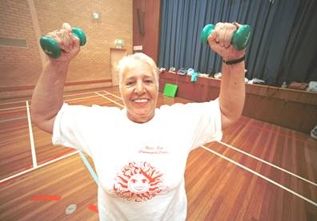
II: Selecting Information: "We are drowning in information and starved for knowledge". Among the most important steps in obtaining information about a community or group of people is to reach an understanding of what information is needed. Without a clear goal or question in mind, it may be difficult to know where and what information to look for, or how to use any information that comes to hand.
An understanding of which issue is being investigated is also important. If research is to be conducted into ‘ill-health’, ‘wellbeing’, ‘disadvantage’, ‘disability’, ‘homelessness’, or a particular ‘ethnicity’, it is well to commence with at least a broad understanding of what these terms are intended to mean.
Similarly, consideration may be given to the community or segment of the population being investigated. For many individuals, the size, geographic scope and nature of their ‘community’ may depend on their interests, lifestyles, mobility, employment and other circumstances. For example, a family living in Footscray may consider Dandenong, where they spend time with friends, to be part of their community.

III: Specifying: using information about specific groups of people. Social statistics that describe a community with a single number give no indication of how conditions may differ among various segments of the community. Specific information about relevant groups of people may help to clear this ‘fog of generality’.
eg: In one locality, unemployment stood at 11% but ranged from 58% of Somalian residents, to 4% among those from Italy.
eg: A 1996 survey of literacy reported 20% of people in Australia had the lowest level of literacy. Rates ranged from 83% among people who learned English after the age of twenty, to 2% of those with degrees.
To investigate conditions among a particular segment of the population – such as settlers, young people, those who are unemployed etc. – it is useful to select information which relates specifically to that group.
For instance, to learn about contemporary educational outcomes, one may monitor current educational outcomes for 20-24 year-olds - who recently completed school - rather than for the whole community, including older people who may have left school decades ago.
Indicators: An indicator is usually a small piece of information about people or a community, which supplies a suggestion about wider events, and is used to compare conditions between localities and segments of the community, or trace changes over time. Even where indicators are valid, consistent, sensitive to change yet stable enough to resist change fluctuations, regular, affordable and accessible, they can only, at best, point in the direction of an issue. To glimpse the variation and detail of conditions throughout the community, more specific information is required.

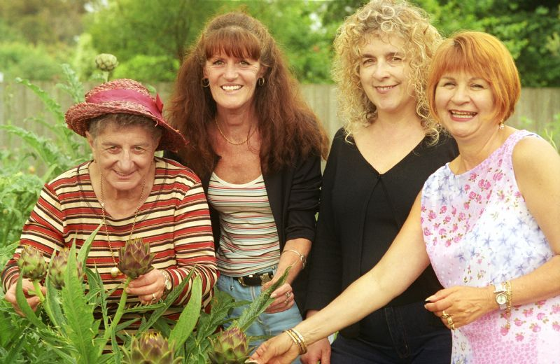
IV: Comparing - people between localities, segments of a community, or across time, can provide context and meaning to social information. For instance, the fact that 15% of younger Vietnamese sole parents have paid work would mean more if it were compared with the corresponding figure of 50% for the general population.
To make such comparisons, it is important to ensure that we are comparing the same thing. That makes definitions of the categories of people or events, important. Issues such as homelessness, poverty, unemployment, depression and others, may each have a variety of meanings.
Homelessness may mean…. | People with no shelter at all.......................... or | also those in refuges, cheap hotels, boarding houses and other temporary accommodation
Unemployed | People willing and able to work, but employed less than 1 hour per week [4.4% in 2007] …...or | Also those working part-time but who would prefer full-time jobs [5% in 2007]
Depression | Any prolonged sadness or depression or | Prolonged depression which is out of proportion to any external cause or circumstances
Income | Income before tax…………………………..or | Total after tax household income, plus the financial value of discounted health, transport, utilities and other services for welfare beneficiaries
However, the conditions being measured – especially those which vary across the human life span – may also may vary with age. So to compare groups of people, it may help to choose people of equivalent age.
For example, incomes tend to rise with age, then fall in later life as pensions replace paid employment as the main source of income. So to determine how incomes vary with birthplace – and not with age - one may consider the incomes of 34-44 year-old people of various birthplaces.
Percentages or other rates help when comparing one group or locality, with another. They show the number of people relative to the size of the community in which they reside. Rates of crime, for instance, are measured as the number of offences per 100,000 adults; and gambling losses are calculated as total losses per 1,000 adults in a community.

Using national or regional information to point to local conditions: While regional, state-wide or national information may be used to reach conclusions about a particular community, it is by no means certain that the social characteristics of people in that community will match those of the state or nation. For instance, household incomes recorded in the 2006 Census averaged $1,022 per week across Victoria, but ranged from $587 in Braybrook to $2,182 in Kooyong. Any attempt to estimate income levels in one locality, based on the state-wide average, would therefore be venturesome, to say the least.
This applies to groups of people, as well as localities. For example, 33% of people in Greater Dandenong own their own home; but this number ranges from 2% among young Sudanese adults, to 98% of older Italian-born residents.


V: Clarifying: information so its most important details are revealed
Most social statistics are presented in tables. A few steps can help to simplify their presentation and make tables easier to read and understand. Among them:
- removal of ‘not stated’ and other insubstantial categories
- adding categories together to create broader, simpler categories
- use of percentages to show more plainly how people are distributed among various categories.
For example, here is some information from the 2006 Census, about housing tenure.
❶ The table on the left shows the number of people in each of a range of categories of housing ownership in Brimbank 2006 | ❷ But if we wanted to know how many people owned, were buying, or renting their home, we could remove the 'not stated' and ‘Total Rented’ rows | ❸ Then, we could combine the categories into three groups: fully-owned, purchasing & rented. Finally, we may add a column of percentages

Housing Tenure | Number |  | Housing Tenure | Number |  | Housing Tenure | No. | %
Fully owned | 22,786 |  | Fully owned | 22,786 |  | Owned | 22,786 | 42
Being purchased(b) | 16,583 |  | Being purchased | 16,583 |  | Being purchased | 16,583 | 30
Rented: |  |  | Real estate agent | 10,156 |  | Rented | 14,765 | 27
Real estate agent | 10,156 |  | State housing authority | 574 |  | Other | 323 | 1
State housing authority | 574 |  | Person not in same household | 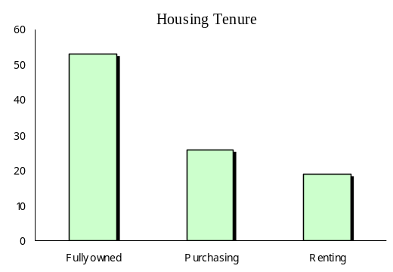  3,093 |  | Total | 54,457 | 100
Person not in same household | 3,093 |  | Housing co-op./community gp | 362
Housing co-op./comm. gp | 362 |  | Other landlord type | 193
Other landlord type | 193 |  | Landlord type not stated | 387
Landlord type not stated | 387 |  | Other tenure type(e) | 323
Total Rented | 14,765 |  | Total | 54,457
Other tenure type(e) | 323
Tenure type not stated | 1,320
Total | 55,777

❹

Clear Visual Presentation: Just as tables of numerical information may be presented in a way that makes it easier to read and interpret, charts and other diagrams can be used to communicate in a straightforward way.
Where too much information is set out in a single chart, the effect may be more kaleidoscopic than illuminating. Generally, plain and clear presentation of the most essential information, makes the task of interpreting such information easier for a wide audience.

VI: Obtaining social information
A few key sources of numerical social information are described here.
For Information about each Victorian Municipality: socialstatistics.com.au
❶ Goto the website: socialstatistics.com.au into your internet
❷ Select a topic from the list of tables on the page – each table features information about every Victorian municipality

Australian Bureau of Statistics: www.abs.gov.au
❶ Click on the word ‘Census’ in the upper part of the page | ❷ Select the type of information you want including QuickStats, tables and maps.
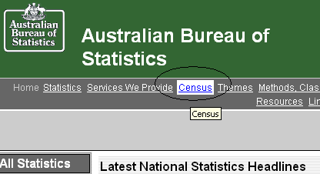
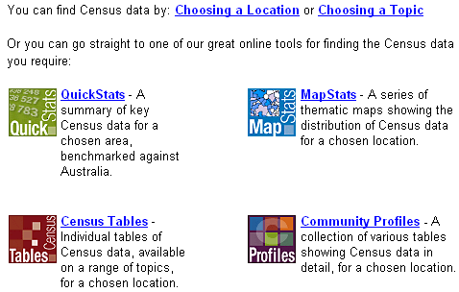

❸ Click on the ‘Search’ tab ❹ type in the name of a city, town, suburb, postal area etc.

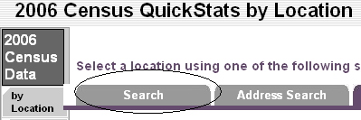
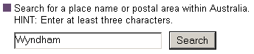

❺ Then follow the prompts to reach a table of social statistics about your chosen locality

Department of Sustainability & Environment: www.doi.vic.gov.au/doi/knowyour.nsf
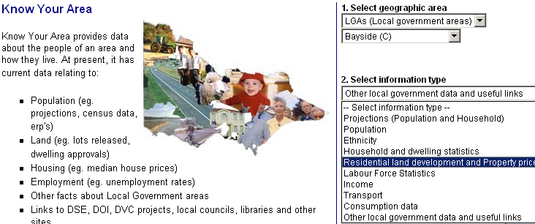
This website presents population estimates, census information about social conditions, housing sales prices, and local residential developments, for Victorian municipalities and suburbs.

❶ Within the ‘Know Your Area’ page which appears, select the locality, then the type of information you wish to view.

❷Follow the further prompts to select the information required.

* * * *
Such information is helpful in describing broad social conditions. But to learn more about people, including their experiences and perceptions, or for matters requiring thoughtful consideration, it may be necessary to stop counting and start listening. For it is here that a true understanding of people and communities begins.

