Notes about Gender Equity:

**Family Violence, Harassment and Stalking:**

Including their prevalence and link to gender equity

Violence within families, including the abuse of children, cannot be measured with accuracy. Instead, random surveys of the general population offer the best available method for measuring the prevalence of the such violence. One of the most important of these surveys in recent times was the 2016 Personal Safety Survey (Australian Bureau of Statistics, 2017c), conducted among 21,000 Australian adult women and men. Survey participants were asked about their experience of physical or sexual assault and violence (assault or threats of assault) since the age of 15 and in the past 12 months. The findings of this survey provide a glimpse of the extent and nature of violence within families and intimate relationships.

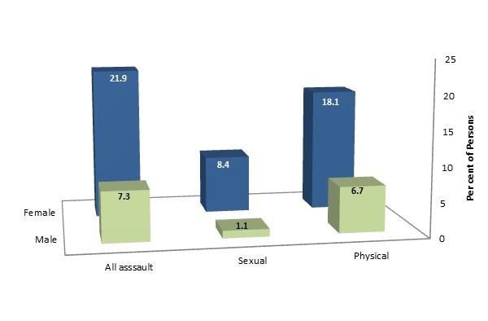

**Intimate Partner Violence**

Approximately 22% of women and 7% of men had been assaulted by a partner since the age of 15.

Per cent of persons who been assaulted by an intimate partner since aged 15, by gender of victim and type of assault

Women were three times as likely to have been physically assaulted by a partner as men, and nearly eight times more likely to have been sexually assaulted by a partner.

**The Prevalence of Intimate Partner Violence and the COVID Epidemic**

An online survey of 15,000 Australian women conducted in mid-2020, found that, among those who had been in cohabiting relationships within the previous year, 8.2% had experienced physical violence by their partner in the previous 3 months, 4.2% sexual violence, and 11.1% coercive control (three or more forms of emotion abuse, harassment and control in previous three months), by their partner - with 13.2% of women who had been in cohabiting relationships in the previous year, had experienced one or more of these types of abuse. Many survey participants reported that violence and abuse commenced or escalated during the pandemic. (Boxall et al, 2020).

**Police and Court Involvement**

Police became involved in approximately one in six (17%) of incidents of violence by a current partner among women, and in one in twenty five (4%) instances of current partner violence against men.

Police were contacted in a higher proportion of instances of violence involving a previous partner (table below).

Per cent of most recent instances of partner violence where police were involved, by category of partner and gender of victim

|  |  |  |
| --- | --- | --- |
|  | Current partner violence | Previous partner violence |
| *Females* | 17% | 35% |
| *Males* | 4% | 25% |

Among females, the proportion of the most recent instances of assault by a male perpetrator which resulted in charges being heard in a court, was 3% for sexual assault and 12% of physical assaults.

Nearly a quarter (24%) of women who experienced violence from a previous partner obtained a restraining order, with half (51%) of these women reporting that further instances of violence occurred after the order was obtained.

**Children as Witnesses to Partner Violence**

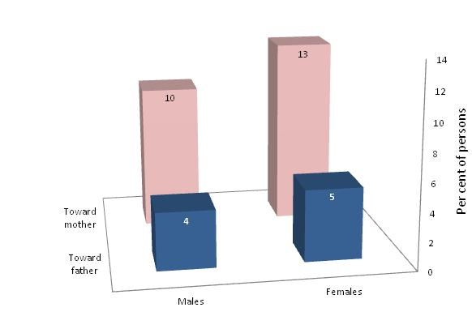Approximately one in ten (11%) Australian adults had witnessed violence inflicted upon their mother by a partner before the age of 18, and one in twenty-five (4.5%) had experienced violence by their mother toward her partner.

Per cent of persons who had witnessed violence between their parents during childhood, by gender of person and category of violence

Notably, those adults who had witnessed violence during childhood were over twice as likely to experience violence from a partner in adulthood (26%), as others (12%).

**Child Abuse**Per cent of adults abused in childhood, by gender of victim and type of abuse

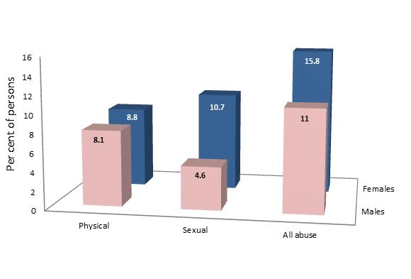Approximately one in six (16%) females and one in ten (11%) males stated that they had been abused before the age of 15.

National records of child abuse, published by the National Institute of Health and Welfare, relate that in 2013/14, 6,482 cases of substantiated child abuse were recorded among the 20% *most* socio-economically disadvantaged Australian communities, compared with 873 among the 20% *least* disadvantaged communities. These findings suggest that the prevalence of substantiated child abuse is over seven times higher among the most disadvantaged segments of the community, as among the least disadvantaged.

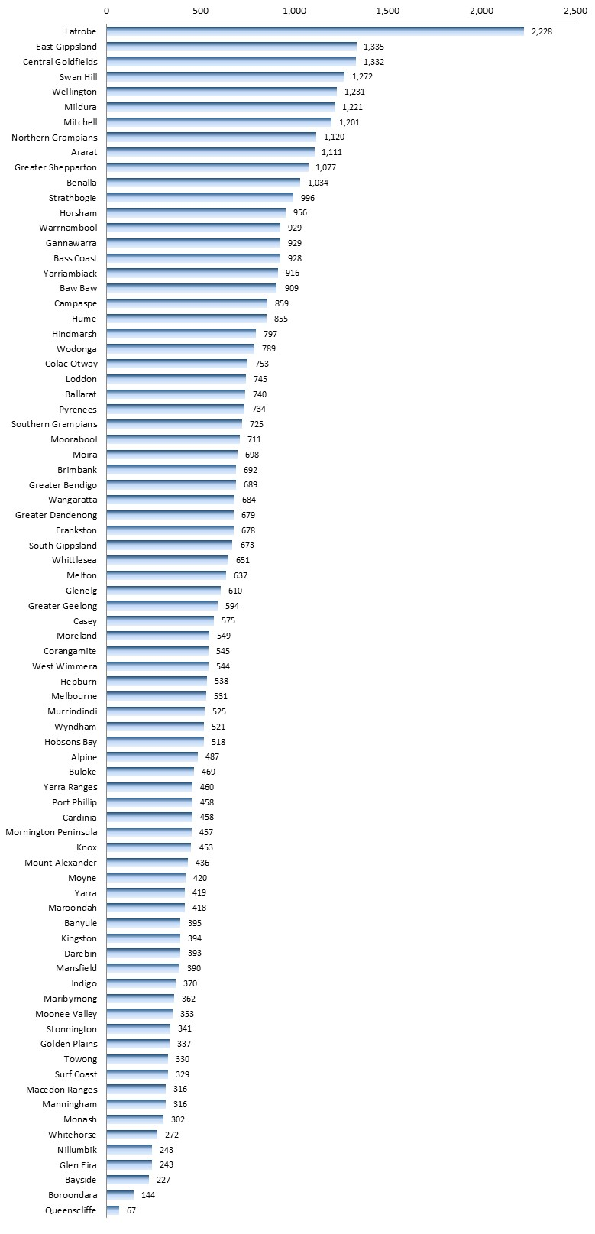Family-related alleged violent incidents, per 100,000 population

**Local Measures of the Incidence of Family Violence and Child Abuse**

Local measures of the incidence of family violence and child abuse are less reliable, since they only reflect those instances of violence which reach the attention of responsible agencies, such as the police, the courts and child protection authorities. One measure is of incidents of alleged violence within families, recorded by Victoria Police, termed ‘Family-related alleged violence offences’.

In 2018/19 the rate of such offences ranged from its lowest level in Boroondara, to its highest rate La Trobe Shire - fifteen times the rate recorded in Boroondara.

Family-related Alleged Violent Offences, 2018/19 [per 100,000 residents]

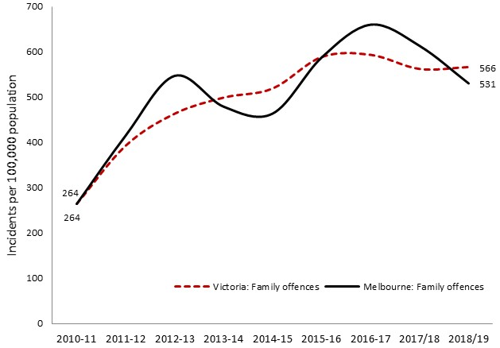Family Incidents per 100,000 population: Victoria and Central Melbourne, 2010-2019

The rate of family-related alleged violence offences recorded by police has risen by 113% across Victoria during the past six years, largely, it is supposed, because of a rise in the rate of reporting of such crimes.

**Stalking and Harassment**

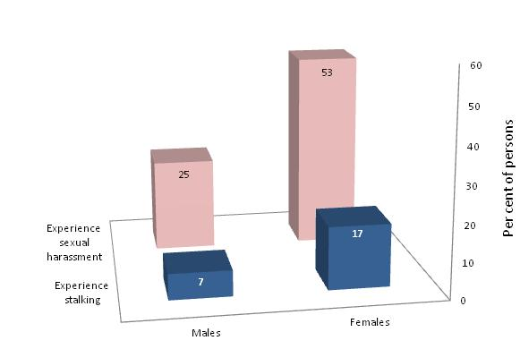Per cent of persons who had experienced sexual harassment or stalking in their lifetimes, by gender of victim

The 2016/17 Commonwealth Personal Safety Survey explored the experience of sexual harassment and stalking, finding that approximately half of women and a quarter of men had been sexually harassed since age 15, while stalking had been experienced by 17% of women and 7% of men.

Males accounted for 87% of the perpetrators of stalking against women and 93% of those who have sexually harassed women

**Harassment of Women on the Streets**

A related issue is the harassment of women on the street and in other public places. A 2014 survey inquired into women’s experiences of physical and non-physical harassments, and perceptions of personal safety among both women and men, on the streets.

This investigation found that 84% of women had experienced some form of *non-physical* harassment during their lives. And in the previous year alone, 38% had experienced honking, 30% wolf whistling, 37% leering, 28% vulgar gestures, 23% lewd comments, 25% sexist comments and 19% repeated unwelcome sexual advances. About two-thirds (65%) of women had experienced *physical* harassment on the street – usually (for 78% of respondents - when they were alone - including being followed, sexual touching or groping, having their path blocked, having someone expose themselves being kissed without consent or being threatened after rejecting the sexual advances of a stranger. Among those offenders whose sex was identified by survey participants, 87% were males.

The proportion of women who had been harassed in the previous year was highest among those of younger age, including 83% of those aged 18-24, compared with 21% of those aged 65 years or more.

Reflecting these experiences, the survey found that 40% of female survey respondents, and 17% of males, felt unsafe in their community at night. Consequently, many women reported that they adjusted their behaviour when on the streets at night during the previous year, including 93% of those aged 18 to 24, and 64% of those over 45 years. These changes in behaviour included avoiding working walking home alone at night (61%) and refraining from exercise alone outdoors at night (45%), arranging to text a friend when they arrived home safely (38%), walking directly under streetlights (36%), holding keys in their hands like a weapon when walking home (35%) and not leaving their drinks unattended (34%). The proportion of male respondents who adopted the same precautions on the streets was typically about half that among women.

**Gendered Drivers of Family Violence**

Attitudes, beliefs and behaviours which are widespread in our society contribute to harassment and violence against women. The 2017 report ‘Change the Story’ by Our Watch explored this issue in detail, identifying four gender-related circumstances which cause family violence or aggravate the severity of such crimes:

*Rigid gender roles and stereotyped constructions of masculinity and femininity*: men with conventional attitudes about the superior status and entitlement of males, and the differing roles of women and men are more likely than others to commit violence against women. A striking illustration of this connection was supplied by the findings of the 2013 VicHealth Community Attitudes Towards Violence Against Women survey, of 17,500 Australians aged 16 and over. The survey findings revealed attitudinal support for violence against women among 58% of respondents with low support for gender equity, compared with just 7% of those with high support for gender equity (diagram, left).

The authors of ‘Change the Story’ recommend that efforts be made to encourage all people - especially children and young adults – to repudiate conventional ideas about male superiority, control and status; adopt values and personal identities that embody respect and equality between women and men; and to share domestic and child-rearing responsibilities (22).

*Men’s control of decision-making and limits to women’s independence in public and private life*: Men who feel entitled to control women or consider them to be of lower status, are more likely to inflict violence upon them, and, where they control women through financial means, fear, isolation or other means, may often do so with impunity. The report urges that more women be provided with the means to obtain paid employment, thereby placing financial security and independence within their reach; barriers to their participation and decision-making in public life be removed; aggressive and dominating behaviour by men at work and in relationships be opposed; and opportunities be fostered for women to come together to socialise, provide mutual support and advocate for causes of common concern (22).

*Male peer relations that emphasize aggression and disrespect towards women*: social interactions among men who disrespect, belittle and dominate women tend to reinforce such patterns of thinking and accentuate violence. It is proposed that such beliefs be contested, with boys and men encouraged to adopt attitudes founded upon an understanding of the equal status, rights and entitlements of women and men.

*Excusing or justifying violence against women*: beliefs and ideas that support, excuse or discount violence against women. The report recommends strenuous efforts to resist and refute such notions (Our Watch, 2015)

**Sexual coercion**

A related topic is being compelled or intimidated into participating in sexual activity, often termed ‘sexual coercion’. DeVisser et al (2003)[1] report on the findings of interviews with a representative sample of over 20,000 Australians aged 16–59 years, in which the experience of sexual coercion at some time their lifetimes was reported by 4.8% of men and 22.4% of women, and by 3% of men and 10% of women at or before the age of 16 years. Consequences of such experienced included psychosocial distress, high levels of anxiety about sex, with few discussing these experiences with a professional. These findings are similar to those reported in a 2003 inquiry by the authors (DeVisser et al, 2014)[2].

**Reinforcing factors in family violence**

Our Watch (2015)[3] maintains that other social and political circumstances influence gender inequality and the frequency, severity and prevalence of violence against women. Termed ‘reinforcing factors’ by its authors, these include a tendency to commit or excuse violence; aggravation of violence by alcohol and other drugs; and the impact of socioeconomic disadvantage. To negate those conditions which reinforce violence against women, a number of broad approaches are recommended; among them:

* Refuting the notion that men are inherently aggressive, while cultivating heathy, respectful relationships and support for respect and equality among women and men.
* Encouraging parents not to inflict violence upon their children, coupled with the prevention of child abuse.
* Contesting excuses offered for violence given by some men.
* Fostering resilience within relationships and communities to enable them to endure disruptive social or economic change – which otherwise may challenge the sense of personal identity and self-esteem held by many men.
* Addressing poverty and other financial hardship; racial, cultural, religious or gender identity-based discrimination; the challenges of settlement; single parenthood; and other forms of disadvantage

The task of addressing the conditions which cause or contribute to violence against women may require persistent effort. As Our Watch (2018)[4] explains, “Because we know the underlying drivers of violence are complex, deeply entrenched and exist at all levels of our society, primary prevention also seeks to work at all levels of society. It is an ambitious, long-term approach, aiming for social transformation on a scale that will create a safe and equal society for every woman and her children.”.

1. deVissier, O., Smith, A.M., Rissel, C.E., Richters, J. and Grulich, A.E. (2003). Sex in Australia: Experiences of Sexual Coercion Among a Representative Sample of Adults. Australia and New Zealand Journal of Public Health 2003. Vol., 27(2), pp. 198-20
2. deVissier, O., Badcock, P.B., Rissel, C.E., Richters, J. Smith, A.M.A., Grulich, A.E. and Simpson, J.M. (2014). Experiences of sexual coercion in a representative sample of adults: the Second Australian Study of Health and Relationships. Sex Health, Nov. Vol. 11, No.5, pp. 472-80
3. Our Watch (2015). Change the Story: a shared framework for the primary prevention of violence against women and their children in Australia. Our Watch, VicHealth and ANROWS
4. Our Watch (2018). Changing the Picture: a national resource to support the prevention of violence against Aboriginal and Torres Strait Islander women and their children. Our Watch, Melbourne