Notes about Gender Equity:

**Public Attitudes to Family Violence and Gender Equity**

These notes present findings of a selection of surveys relating to public attitudes to gender equality, the rights and roles of men, sexual assault, family violence and related issues, as well as some of the characteristics of those who hold opinions or beliefs which are antagonistic to the rights of women.

**VicHealth Indicators Survey**

The 2015 VicHealth Indicators Survey recorded the level of agreement among respondents to two statements:

* Men should take control in relationships and be head of the household
* Women prefer a man to be in charge in a relationship

The result was a score representing the percentage of respondents with a low support for gender equity.

Segments of the community which expressed *the lowest support for gender equality* included younger people, men, those with limited education, unemployed people, people from non-English-speaking countries and those from outer-metropolitan localities.

The score – measuring low support for gender equality – ranged from 18% in Indigo Shire to 58% in Greater Dandenong, averaging 36% across Melbourne.

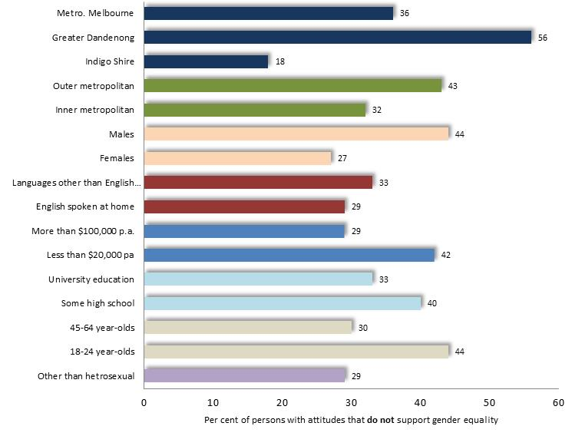Percentage of people who express **low** support for gender equality, by selected characteristics: Victoria, 2015

**Jesuit Social Services Survey**

In 2018, Jesuit Social Services surveyed 1,000 randomly-selected Australian men aged 18-30 about attitudes to masculinity in the fields of self-sufficiency, acting tough, physical attractiveness, rigid gender roles, heterosexuality and homophobia, and aggression and control over women.[1] The proportion of respondents which endorsed a selection of statements is shown here:

* *Self-sufficiency*: men should figure out their personal problems without asking other for help: 27%

A man who talks a lot about his worries fears and problems shouldn’t really get respect: 25%

* *Acting tough*: guys should act strong even if they feel scared or nervous inside: 47%

A guy who doesn’t fight back when other push him around is weak: 34%

* *Aggression*: men should use violence to get respect if necessary: 20%

A man should always have the final say about decisions in his relationship or marriage: 27%

If a guy has a girlfriend or wife, he deserves to know where she is all the time: 37%

* *Rigid gender roles*: men should bring money home for their families, not women: 32%

A man shouldn’t have to do household chores: 19%

* *Hypersexuality*: A ‘real man’ should have as many sexual partners as he can: 25%

The authors of the report concluded that pressures relating to being a man are reinforced and influenced by young men’s close relationships, including families, partners and friends. Notably, however, young men held more progressive views on what it is to be a real man, than what they believed society was telling them.

Among the survey participants, conventional participation of masculinity was associated with a higher prevalence of anti-social and self-destructive behaviour. Of those men who scored above average in their adherence to conventional ideas of masculinity:

44% had thoughts of suicide in the previous two weeks, compared with 22% of those with low scores;

56% perpetrated *verbal* bullying in the previous month, compared with 24% of others;

47% committed *physical* bullying in the previous month, compared with 7% of the others;

46% made sexual comments to women they did not know, in a public place, compared to 7% of others

22% refrained from taking action when witnessing men verbally or physically harassing women, compared with 4% of others;

38% had been in a traffic accident in the previous year, compared with 11% of the others.

**2017 National Community Attitudes towards Violence against Women Survey**

The survey inquired about the nature of, and attitudes towards, violence against women, as well as beliefs, opinions and attitudes towards gender equity. These findings are very briefly outlined here. The original report is located at: <https://ncas.anrows.org.au/wp-content/uploads/2018/11/NCAS-report-2018.pdf>

*Understanding of Family Violence* (per cent who endorsed each statement)

Level of understanding of the nature and patterns of violence against women

* Violence against women is common in our community: **72%**
* Men more often commit acts of domestic violence: **64%**
* Women are more likely to suffer harm from domestic violence: **81%**
* Levels of fear from domestic violence are worse for women: **49%**
* Women rarely make false claims of being raped: **26% disagree**
* Women who wait weeks or months to report sexual assault are probably lying: **11%**

Over 90% of respondents acknowledged the following actions as violence against women:

* Slap or pushes to cause harm or fear
* Forces other partner to have sex
* Tries to scare/control by threatening other family members
* Throws or smashes objects to frighten or threaten
* Repeatedly criticises to make partner feel bad or useless
* Controls social life by threatening partner from seeing family/friends

38% of respondents did not know how to obtain advice or support in relation to family violence

*Attitudes unsupportive of women facing domestic violence included those listed below:*

* Domestic violence is a matter to be handled in the family: **12%**
* It is a woman’s duty to stay in a violent relationship to keep her family together: **4%**
* Many women tend to exaggerate the problem of male violence: **23%**
* It is common for sexual assault accusations to be used as a way to get back at men: **42%**
* In my opinion, if a woman reports abuse by her partner to outsiders it is shameful

for the family: **13%**

*Attitudes which tend to excuse domestic violence*

* Domestic violence can be excused if it results from people getting so angry that they temporarily lose control : **12%**
* Domestic violence can be excused if, afterwards, the violent person genuinely

regrets what they have done: **14%**

* A man is less responsible for rape if he is drunk or affected by drugs at the: **8%**
* If a woman is raped while she is drunk or affected by drugs she is at least partly

responsible: **13%**

* Women often say ‘no’ when they mean ‘yes’: **16%**
* A lot of what is called domestic violence is really just a normal reaction to day-to-day stress and frustration: **20%**
* Sometimes a woman can make a man so angry that he hits her

when he didn’t mean to: **21%**

* Women who flirt all the time are somewhat to blame if their partner gets

jealous and hits them: **14%**

* Since some women are so sexual in public, it’s not surprising that some men think

they can touch women without permission: **21%**

* When a man is very sexually aroused, he may not even realize that the woman

doesn’t want to have sex: **28%**

* Rape results from men not being able to control their need for sex: **33%**

*Factors associated with a ‘high level of attitudinal support for violence against women’*

* Male gender
* Retirement age
* Limited educational levels
* Unskilled or semi-skilled occupations
* Low socioeconomic status
* Living in a rural area
* Supportive attitudes to violence in general
* Prejudicial attitudes to people based on personal characteristics such as sex, disability & aboriginality
* Limited understanding of violence against women

One sequence of questions inquired about attitudes towards violence against women. The responses were used to determine the proportion of respondents whose attitudes constituted a ‘high endorsement’ of attitudinal support for violence against women.

Such ‘high endorsement’ of violence against women was expressed by:

* **34%** of people in the lowest fifth of SES areas, vs.
* **21%** of people in the highest SES areas
* **20%** of people with university education, vs.
* **31%** of people with secondary education only
* **13%** of professionals, 14% of managers and 12% of clerical workers, vs.
* **33%** of machinery operators, 35% of labourers and 25% of trades and technicians

While marked differences in the prevalence of such views between people of different occupations, educational attainments and socioeconomic disadvantage are apparent, it is also clear that such attitudes are prevalent among all such segments of the community.

*Attitudes antagonistic to gender equality:*

* Men should take control in relationships and be head of the household: **16%**
* Women prefer a man to be in charge of a relationship: **25%**
* I think it is natural for a men to want to appear in control of his partner

in front of male friends: **34%**

* If a woman earns more than her male partner, it is not good for the relationship: **8%**
* In a workplace, men generally make more capable bosses than men: **14%**
* Men, rather than women, should hold responsible positions in society: **14%**

**2013 National Community Attitudes Towards Violence Survey**

This survey explored public perceptions of the nature, excuses for, and women’s responsibility for acts of violence and abuse. Responses given by women and men highlight both similarities and disparities in their perceptions, with many women, as well as men, expressing views antagonistic to gender equity.



**Other Relevant Findings**

13 reports that in a survey of 2,122 Australians recruited from online panels and social media, about half of young Millennial males who played online video games for an above-average length of time, tended to agree with traditional views on gender equality (13). The report’s authors postulate that “increased support for male leadership in home life may reflect an attempt to compensate for men’s loss of dominance in the world of work” (13).

Following discussions with women throughout Australia, 14 reports that women in rural areas stated that some “negative and discriminatory attitudes are amplified in these communities”, and that the resulting geographic isolation often presents women with fewer options for escape or support (14).

14 also cites findings of a 2015 OurWatch study which disclosed that one in six 12-24 year-olds believed that ‘women should know their place’ and more than a quarter believed that ‘male verbal harassment’ and ‘pressure for sex towards females’, were normal practices (14).

1. The Man Box: a study on being a young man in Australia’, by The Men’s Project and Flood, M. (2018). Jesuit Social Services Also reference 2 Zappa, P. and Fendel, M. (undated). The Men’s Project. Jesuit Social Services