COMMUNITY ENGAGEMENT

OVERVIEW
Sporting clubs play an integral role in building community identity and social cohesion; they provide focal points for community pride, engagement and achievement. In diverse communities – such as City of Greater Dandenong – sport can play an important role in bringing people together and improving community participation and engagement of residents. Whilst this may not be the end-goal for sporting clubs, using community engagement strategies to help grow participation, connections and engagement at your sporting club is incredibly beneficial.

There is no one definition of community engagement. However, for the purposes of this module, community engagement is defined as – sporting clubs working collaboratively together with City of Greater Dandenong residents to achieve mutually beneficial outcomes. Community engagement generally involves such things as consultation, participation, collaboration and empowerment, and should incorporate the diversity and dynamics of communities. The IAP2 model of community engagement, which is considered best practise, is outlined in the below image.

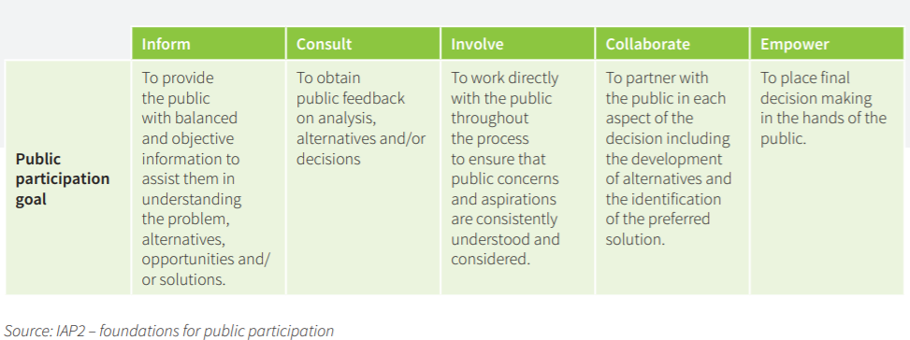
According to Clearinghouse for Sport (www.clearinghouseforsport.gov.au), sporting clubs have four main opportunities to meaningfully engage with residents to drive mutually beneficial outcomes. These include:
- Employment pathways
- Volunteering opportunities
- Community cohesion-building initiatives
- Facilities (providing a social focus that affects the perception of a neighbourhood)

Good club community engagement relies on sporting clubs working with local communities to identify a need you can address. Good community engagement will lead to:
- Better project and service delivery outcomes
- Improve the quality of policy being developed
- Build more resilient relationship with the community
- Enhancing reputation and check council is meeting local needs
- Increased understanding of community issues
- Better shared partnerships and networks
- Deal with complex issues and emerging issues
- Opportunities for a diversity of voices to be heard
- Communities can identify priorities for themselves and own the solutions

A quick example of community engagement, which addresses community needs could be; a community group is looking for a local venue (at low or no cost) to run their youth group from. Per chance, your sporting club has a winter allocation for two nights a week – but you’re currently not using the pavilion you’re allocated one of those nights. You are also looking for more participants in your junior side. Through leveraging community engagement principles, you invite this community group to use your pavilion access one-day per week to run their youth group. As part of this engagement, you also collaboratively identify initiatives, to engage new members or volunteers at you club.

PRINCIPLES GUIDING EFFECTIVE COMMUNITY ENGAGEMENT
For community engagement to be effective, sporting clubs need to plan the process well, prior to the individuals and communities it’s targeted at. This is usually done in three sections:
- Things to consider prior to beginning engagement
- Necessary preconditions for engagement
- What to consider for engagement to be successful?

Before starting a community engagement effort:
- Be clear about the purposes or goals of the engagement effort and the populations or communities you want to engage.
- Become knowledgeable about the community's culture, economic conditions, social networks, political and power structures, norms and values, demographic trends, history, and history of efforts by outside groups to engage it in various programs.
- Learn about the community's perceptions of those initiating the engagement activities.

For engagement to occur, it is necessary to:
- Go to the community, establish relationships, build trust, work with the formal and informal leadership, and seek commitment from community organisations and leaders to create processes for mobilising the community.
- Remember and accept that collective self-determination is the responsibility and right of all people in a community.
- No external entity should assume it can bestow on a community the power to act in its own self-interest.

For engagement to succeed:
- It is necessary to partner with the community to create change and improve health.
- Recognise and respect the diversity of the community. Awareness of the various cultures of a community and other factors affecting diversity must be paramount in planning, designing, and implementing approaches to engaging a community.
- Identify and mobilise community assets and strengths, by developing the community's capacity and resources to make decisions and act.
- To engage a community as well as individuals seeking to effect change, sporting clubs must be prepared to release control of actions or interventions to the community and be flexible enough to meet its changing needs.
- A long-term commitment by the engaging sporting club and its partners is vital.

COMMUNITY ENGAGEMENT IDEAS
From a sporting context, clubs often aim to leverage community engagement principles in order to drive membership. With this context in mind, new participation options are easier to come up with when you understand the needs of the groups you are trying to cater for through community engagement. For example: a local mid-week tennis competition for mothers, is likely to fail if the players do not have enough time between the conclusion of the activity and school pick-up.

Therefore, the process of community engagement can assist in identifying ways to modify sporting club offerings in order to address the needs of the targeted cohorts (to drive membership). The types of things that can be modified:
- The emphasis – social, fun, for beginners, for the complete novice
- Scoring or not keeping any records of results
- Keeping a ladder or not – just for fun
- Rules that make it safer, easier for beginners to succeed
- Playing area (size)
- Handicapping to mix the success
- Number of players on the field (less means each person can keep more involved) Goals (height or distance)
- Equipment (size, height and weight)
- Duration of game (reduce time, increase breaks)

Not all people are interested, have the physical capability, skills, or confidence to participate in your sport in its traditional format. Why not try something new to attract those that your sport has not attracted.

Some ideas and/or examples of this – via Club Help (https://www.clubhelp.org.au/club-resources):
- Pay as You Play Day – A tennis club could set aside Friday mornings for people of all ages and abilities to come along and play. Participants pay $3 per session, with attendees grouped according to those there on the day. This is promoted to younger families, family playgroups, and older retirement villages; following genuine consultation with the community groups.
- Six-a-Side Hockey – A hockey Association sets up a small pitch to play social at the local social housing complex. The emphasis is on socialisation and learning to play in preparation for the winter season. This program is created in consultation with the local social housing complex leaders.
- Touch Football in the Park – A touch Club takes its game to the community, by setting up informal Touch matches in local parks. Local cultural groups and churches are engaged, with some games being played in the garden’s in front of the community centres and places of worship.
- Twilight Family Softball – A softball club runs a summer twilight series for families to come together to play unstructured softball at no cost. The club provides BBQ’s and a social gathering place, for community groups to connect socially post event.
- Keen-Agers Table Tennis – Table Tennis enthusiasts set up friendly competition aimed at older adults and retirees. Low cost, daytime and promoted through falls prevention, cardiac rehab, probus groups etc.

