Private Lives 3: the health and wellbeing of LGBTI people in Australia. Key findings
Hill, A. O., Bourne, A., McNair, R., Carman, M. and Lyons, A. (2020). Private Lives 3: The health and wellbeing of LGBTIQ people in Australia. Australian Research Centre in Sex, Health and Society. Available here.
Survey Procedure and Sample
These notes recount the findings of a 2019 national survey of 6,835 LGBTI adults, recruited through Facebook (attracting 87% of participants), LGBTI organizations (8%) and word-of-mouth (6%), and conducted by the Australian Research Centre in Sex, Health and Society at La Trobe University.
Some of the characteristics of the survey participants are set out below:
- Approximately a third were men, two-fifths women, about 4% each were trans women and trans men, and 14% were non-binary.
- Twenty-one per cent identified as lesbians, 29% as gay, 20% as bisexual, 7% as pansexual, 12% as queer, 3% as asexual, and 8% as other sexual orientations.
- Participants were relatively young, with nearly a third (31%) aged 18-24 (compared with 9% among the Australian population) and 3% over 65 (cpd. with 16% of Australians).
- More than four-fifths (84%) were born in Australia
- Three per cent were Aboriginal or Torres Strait Islanders
- Nearly three quarters (74%) were atheists – compared with 30% of Australians overall.
Definitions
A selection of key terms used in the report are presented here.
Gender
Cisgender: a person whose gender matches the sex they were assigned at birth.
Trans/transgender: an individual whose internal gender does not match the sex they were assigned at birth.
Gender non-binary: a person whose gender identity that does not conform to traditional gender norms and may be expressed as other than woman or man.

Sexual Orientation
Gay: an individual who identifies as a man and is sexually and/or romantically attracted to other people who identify as men.
Lesbian: an individual who identifies as a woman and is sexually and/or romantically attracted to other people who identify as women.
Bisexual: a person who is sexually and/or romantically attracted to people of the same gender as well as people of another gender.
Pansexual: an individual whose sexual and/or romantic attraction to others is not restricted by gender, and may be attracted to any person, regardless of their gender identity.
Queer: a term used to describe a range of sexual orientations and gender identities.
(From Australian Institute of Family Studies (undated). LGBTIQA+: Glossary of Common Terms)

Acceptance
Most participants felt accepted at LGBTI events and venues (67%) or at work (61%). By contrast, 43% felt accepted at health services, 35% at social events, 31% in public, 29% at mainstream events, and 11% at religious events.
Levels of perceived acceptance were lowest among trans and non-binary participants. Sixty-one per cent and 69% of cisgender women and men respectively, felt accepted at work, compared with 50% and 49% of trans women and men respectively, and 43% of non-binary participants.
Similarly, 52% and 63% of cisgender women and men respectively felt accepted by their families, compared with 41% and 44% of trans women and men respectively, and 33% of non-binary participants.
In relation to sexual orientation, the proportion of participants who felt accepted at work was 64% among those identifying as lesbians, 70% gay, 54% bisexual, 50% pansexual, 54% queer, and 48% pansexual.
The proportions of participants who felt accepted by their families stood at 57% among lesbian participants, 64% among those who were gay, 43% bisexual, 38% pansexual, 42% queer and 36% asexual.

Unfair Treatment, Violence and Harassment
Over half (57%) of the participants felt they had been treated unfairly at some time in the previous year due to their sexual orientation, and 76% due to their gender identity.
Respondents also reported that they had been subject to violence, abuse and harassment (e.g.: being spat on or offensive gestures) in the previous year due to their sexual orientation or gender identity, including social exclusion, verbal abuse, harassment and written threats.
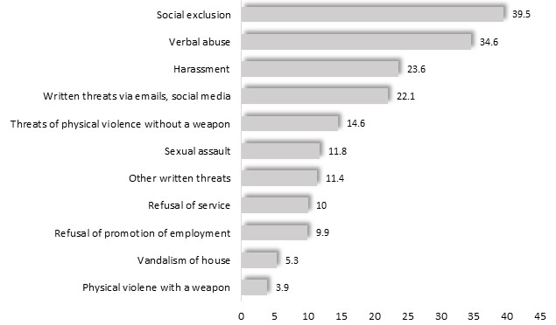

Violence or harassment experienced by participants in the previous 12 months, by type

Mental Health
Psychological Stress
Employing a sequence of survey questions, the survey identified ‘high’ or ‘very high’ levels of psychological stress among 57% of participants - four times the level of 13% recorded among the general population in the 2017/18 Population Health Survey.
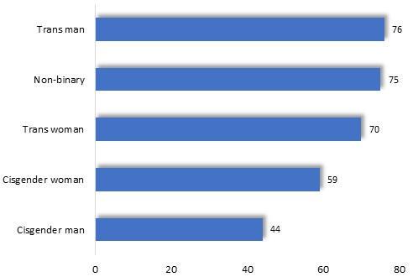
The prevalence of such stress was highest among trans and non-binary participants (right).

Prevalence of ‘high’ and ‘very high’ levels of stress, by gender

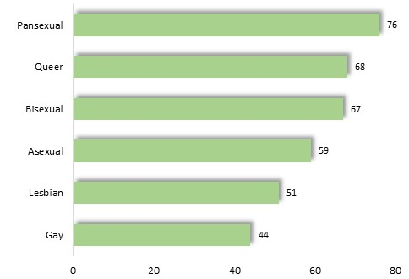

Elevated rates of psychological stress were also recorded among pansexual, queer and bisexual participants.

Prevalence of ‘high’ and ‘very high’ levels of stress, by sexual orientation

Depression, Anxiety and Post-traumatic Stress
Many participants had been diagnosed with psychological disorders in the previous 12 months. Depression had been diagnosed among 39% - nearly ten times higher than among the general population, of 4.1%.
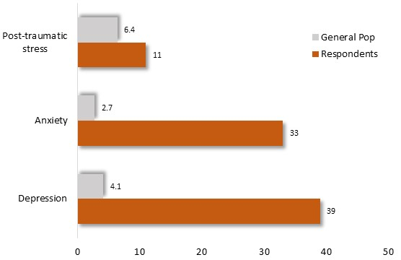
A third (33%) reported a diagnosis of anxiety disorder – over ten times the corresponding figure for the general population, and 11% reported post-traumatic stress disorder, compared with 6.4% among the general population.

Prevalence of selected psychological conditions: participants and general population

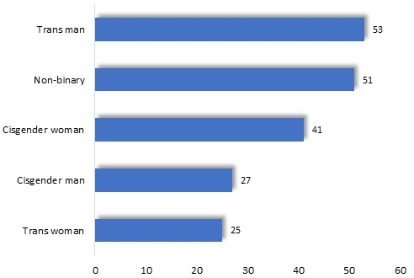
The prevalence of these diagnoses varied with sexual orientation and gender identity. For example, over half of those who identified as trans men or non-binary had been diagnosed with depression, a figure which declined to about a quarter among cisgender men and trans women (diagram, below).

Prevalence of diagnosed depression, by gender

A similar pattern emerged in relation to anxiety.

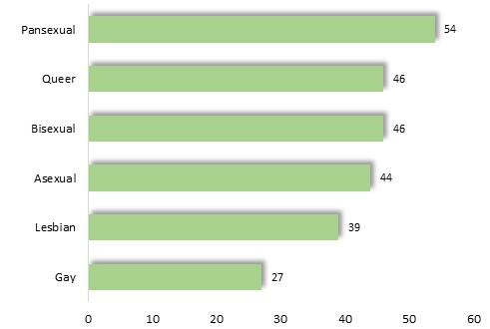
The proportion of participants who had been diagnosed with depression also differed with sexual orientation, with higher levels among those who pansexual, bisexual and queer.

Prevalence of diagnosed depression, by sexual orientation

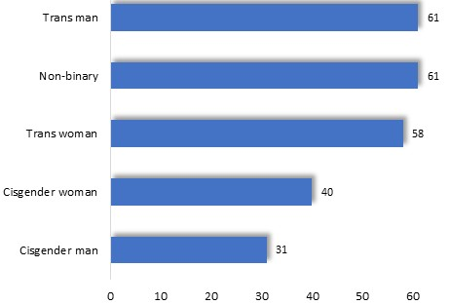
Suicide
Over two-fifths (42%) of participants had thought about suicide or wishing to die in the previous year, nearly twenty times the corresponding level of 2.3% among the general population.
The proportion of participants with suicidal thoughts in the previous 12 months was highest among trans and non-binary participants.

Proportion of participants who had suicidal thoughts in the previous 12 months, by gender

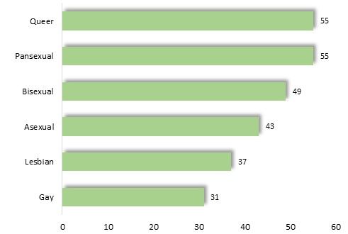
Such circumstances were also most common among queer, pansexual and bisexual survey participants.

Proportion of participants who had suicidal thoughts in the previous 12 months, by sexual orientation

In the previous year, 5.2% had attempted suicide – thirteen times the corresponding figure of 0.4% among the general population (From findings of the2007 National Survey of Mental Health and Wellbeing).

Smoking, Alcohol and other Drugs
One fifth (20%) of participants were current smokers, compared with 15% of the general population.
A quarter (25%) consumed more than two standard drinks per day on average (exceeding the 2009 National Health and Medical Research Council guidelines), higher than the corresponding level of 16% among the general adult population.
Patterns of alcohol consumption differed little by sexual orientation or gender identity.
Illicit drugs used by participants in the previous 6 months included marijuana, consumed by 30%, ecstasy (13%), cocaine (10%) and benzodiazepines (9%). Patterns of illicit drug use were generally similar among participants of different sexual orientations or gender identities.
Physical Health
Nearly one-third (31%) of participants assessed their health as ‘poor’ or ‘fair’ - including 35% of trans women and 42% of trans men - compared with 15% of the general community.
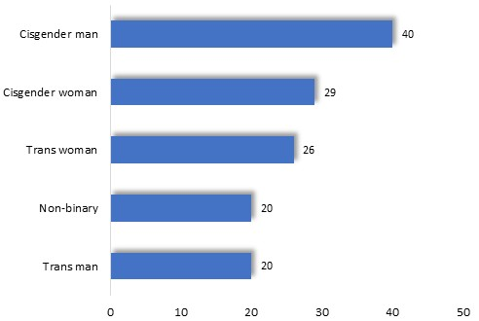
Conversely, ‘very good’ or ‘excellent’ health was reported by 40% of cisgender men, but only 20% of transgender men and non-binary participants (diagram right).
By contrast, 50% of Australian adults reported ‘very good’ or ‘excellent’ health in the 2017/18 National Health Survey.

Proportion of participants reporting ‘Very good’ or ‘Excellent’ health, by gender

Among participants of different sexual orientations, the percentage reporting ‘very good’ or ‘excellent’ health ranged from 40% among those who were gay to about one-fifth of those who were pan- or asexual.
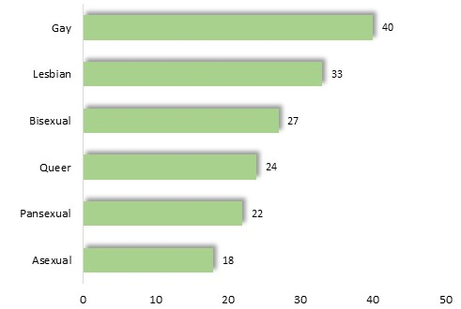

Proportion of participants reporting ‘Very good’ or ‘Excellent’ health, by sexual orientation

Health Service Usage and Satisfaction
Mainstream health services were more widely used than those specifically inclusive of LGBTI individuals, with 84% attending a mainstream medical clinic during the previous 12 months, compared with 5.7% attending a clinic catering only to LGBTI communities.
Transgender and non-binary people were more likely to attend clinics known to be LGBTI inclusive, with 45% of trans women, 41% of trans men and 33% of non-binary participants attending such clinics in the previous 12 months, compared with 18% of cisgender women and 13% of cisgender men.
Respondents though, perceived that medical facilities which catered to LGBTI communities were more respectful to them than mainstream services. For example, 59% of participants who attended a mainstream medical center perceived that their sexual orientation was ‘very’ or ‘extremely’ respected, compared with 95% of those who attended a clinic catering only to LGBTI individuals. Similarly, 38% of participants who attended a mainstream medical center perceived that their gender identity was ‘very’ or ‘extremely’ respected, compared with 90% of those who attended a clinic catering only to LGBTI communities.
Intimate Partner Violence
61% of participants reported that they had experienced abuse by an intimate partner at some time in their lives, including emotional abuse (48%), verbal abuse (42%), social isolation (27%) and physical violence (25%).
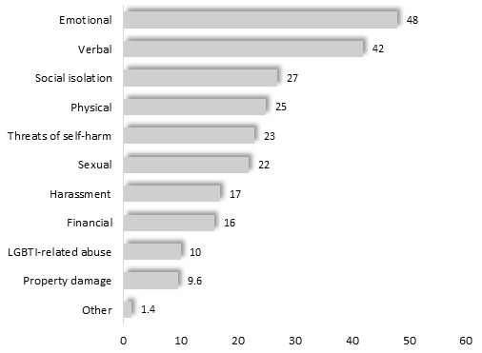

Proportion of participants who had ever experienced intimate partner violence, by type of abuse

Prevalence of the Experience of Violence, by Gender
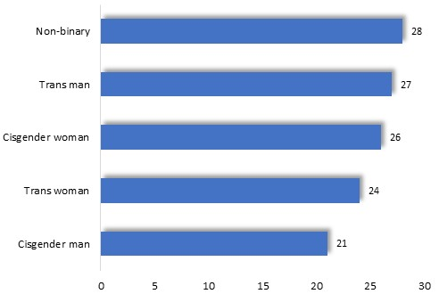
The proportion of participants who reported ever having experienced physical intimate partner violence, generally differed little with gender identity, with percentages ranging from 20 to 30% among all categories (accompanying diagram).

Proportion of participants who had ever experienced physical intimate partner violence, by gender

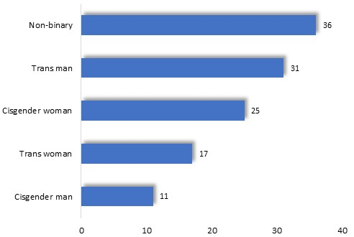
The prevalence of the experience of sexual abuse varied more widely with gender, declining from 36% among non-binary individuals, 31% among trans men, 17% among trans women, 25% among cisgender women and 11% among cisgender men.

Proportion of participants who had ever experienced sexual intimate partner violence, by gender

Prevalence of the Experience of Violence, by Sexual Orientation
The proportion of participants who had experienced physical violence by an intimate partner differed markedly with sexual orientation (below), with highest rates recorded among those who reported that they were pansexual, queer or lesbian.
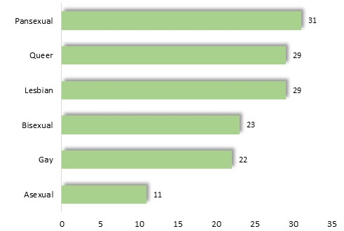

Proportion of participants who had ever experienced physical intimate partner violence, by sexual orientation

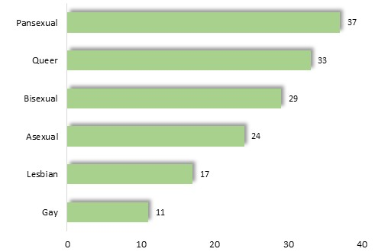
The proportion of participants who had experienced sexual intimate partner violence was highest among pansexual and queer individuals.

Proportion of participants who had ever experienced sexual intimate partner violence, by sexual orientation

Perpetrators of Intimate Partner Violence
Asked about the gender of the perpetrator in their most recent experience of intimate partner violence, 57% of participants identified a ‘cisgender man’, 34% a ‘cisgender woman’, 3.4% a ‘non-binary’ individual, 2% a ‘trans woman’ and 2% a trans man.
Two fifths of those who had experienced intimate partner violence, expressed the view that the abuse was at least partly due to their sexual orientation, gender identity/expression or intersex status.
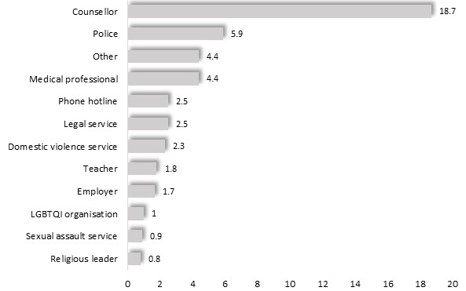
Reporting Violence and Abuse
Twenty-eight per cent of those who had experienced intimate partner violence stated that they had reported the most recent incident. Among them, 19% informed a counsellor or psychologist, 5.9% the police and 4.4% a medical professional.

Persons who reported their most recent incident of intimate partner by where the report was made

Homelessness
More than one third (35%) of trans men, 34% of non-binary participants and 32% of trans women had ever been homeless, compared to 20% of cisgender women and 17% of cisgender men.
Approximately one-third (34%) of pansexual and queer participants (33%) reported ever experiencing homelessness, compared to 22% of bisexual, 19% of lesbian, 15% of gay and 18% of asexual participants.
The most widely reported reasons for experiencing homelessness were financial stress, unemployment, mental health, family violence and rejection from family, with each of these issues identified by over 30% of survey participants.

Community Affiliation and Sources of Information
Nearly two thirds (62%) of participants agreed that participating in the LGBTI community was beneficial to them. Levels of participation in events and use of mass media at least monthly, are shown below.

Events/Media | Per cent of Respondents
LGBTI events | 24
LBGTI print media: | 38
LGBTI broadcasts | 43
LGBTI social media | 81

Based on findings of the 2007 National Survey of Mental Health and Wellbeing
Based on findings of the 2017/18 National Health Survey

