**Intimate Partner Violence among LGBTI Communities**

**Hayden Brown and Marek Krol**

This note briefly reviews commentary and evidence concerning intimate partner violence among people of diverse gender identity, sexuality and sex. Consideration is given to the prevalence of such violent relationships; its distinctive features within lesbian, gay, bisexual, transgender and intersex (LGBTI) communities; circumstances which cause or aggravate abuse within relationships; conditions which deter people from seeking advice or assistance; and measures to address such violence and its causes.

In these considerations, it should be emphasized that LGBTI individuals and communities are not homogeneous, for they encompass a wide variety of people, who may differ in their gender identity, sexual orientation, biological sex and other characteristics, as well as in their individual personal experiences and perceptions.

**Prevalence of Intimate Partner Violence**

The task of documenting the prevalence of intimate partner violence, as well as other circumstances, among LGBTI individuals is burdened by the practical difficulty of obtaining information from a randomly-selected, representative sample of their population (Witoslawski, 2020; National LGBT Health Alliance, 2009; Campo and Tayton, 2015). Instead, research often relies upon anecdotal evidence (National LGBT Health Alliance, 2009), or the findings of small samples drawn from social groups, clubs, college students, people who respond to online surveys, and other convenient sources (Stuart, 2018; Leith et al, 2020). Barrett (2015) for instance, observes that samples of people from social settings or LGBTI events, tend to over-represent those who are likely to be ‘out’, and people from urban localities, which can sustain larger social groups and events.

Moreover, the findings of such research may reflect differences in definitions of gender, sexuality, abuse and violence used by researchers (Carman et al, 2020); variations in the violent experiences recorded, such as physical, sexual , emotional, verbal, financial, identity and others (Stuart, 2018; Jeffries and Ball, 2008); differences in the balance of age, education level and other characteristics among research participants (Leith et al, 2020); and the variety of time-frames applied to recollections of the experience of violence - with some recording incidents across a lifetime and others in the more recent past (Campo and Tayton, 2015).

As a consequence, the findings of research about the LGBTI communities may not reflect a balanced representation of the experiences of all people of diverse gender identity and sexuality; and the results which emerge from one study may not necessarily be comparable with those of another.

*Prevalence estimates*

However, weighing the balance of these findings with due caution, many researchers and commentators conclude that the proportion of LGBTI people who have experienced intimate partner violence or abuse is similar – or higher among some segments of the LGBTI community – to that reported among heterosexual women (Fairchild 2020; Witoslawski, 2020; National Coalition Against Domestic Violence, undated; Rolle et al, 2018; Toesland, 2020; O’Halloran, undated; Halpern, 2004).

Research conducted by the Australian Research Center for Health and Sexuality among 5,476 Australians, found that 41% of LGBTI females and 28% of males had experienced intimate partner violence in their lifetimes (Campo and Tayton, 2015) – a result similar to a figure of 35% recorded among a US sample (Jeffries and Ball, 2008). It was not made clear though, whether the violence was inflicted by a partner of the same, or opposite, sex.

The 2019 ‘Private Lives’ survey of nearly 7,000 Australian adults found that 61% of respondents had experienced abuse by an intimate partner at some time in their lives, including emotional abuse (48%), verbal abuse (42%), social isolation (27%) and physical violence (25%). Asked about the gender of the perpetrator in their most recent experience of intimate partner violence, 57% of respondents identified a ‘cisgender man’, 34% a ‘cisgender woman’, 3.4% a ‘non-binary’ individual, 2% a ‘trans woman’ and 2% a trans man. Two fifths of those who had experienced intimate partner violence, expressed the view that the abuse was at least partly due to their sexual orientation, gender identity/expression or intersex status (Hill et al, 2020).

The proportion of respondents who reported having experienced physical intimate partner violence, generally differed little with gender identity, with percentages ranging from 20 to 30% among all categories (accompanying diagram).

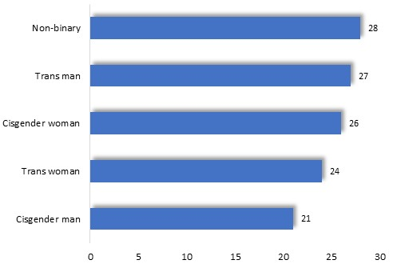

Prevalence of lifetime experience of *physical* intimate partner violence, by gender

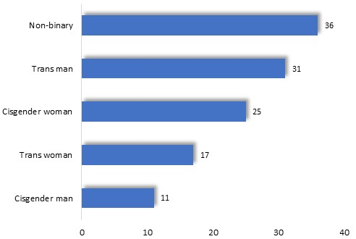The prevalence of the experience of sexual abuse varied more widely with gender, declining from 36% among non-binary individuals, 31% among trans men, 17% among trans women, 25% among cisgender women and 11% among cisgender men.

Prevalence of lifetime experience of *sexual* intimate partner violence, by gender

The proportion of respondents who had experienced physical violence by an intimate partner differed markedly with sexual orientation (below), with highest rates recorded among those who reported that they were pansexual, queer or lesbian.

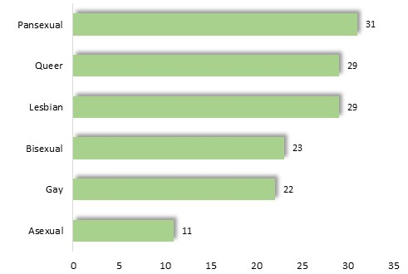

Prevalence of lifetime experience of *physical* intimate partner violence, by sexual orientation

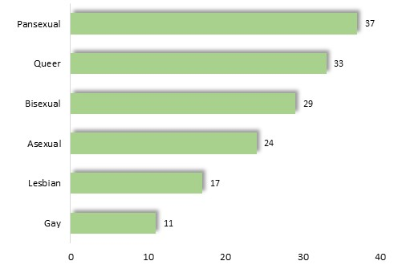The proportion of respondents who had experienced *sexual* intimate partner violence was highest among pansexual and queer individuals.

Prevalence of lifetime experience of *sexual* intimate partner violence, by sexual orientation

*Comparative estimates*

Other inquiries compare the rate of intimate partner violence among LBGTI people and heterosexual individuals, with results which point to a higher prevalence among LGBTI communities. Rolle et al (2018) cites US research by Brieding et al (2013) which recorded a lifetime experience of *severe* violence, of 49% among bisexual women, 29% among lesbian women and 24% among heterosexual women. Another investigation documented a prevalence of intimate partner violence of 40% among those who identified as gay or lesbian, and 32% among heterosexuals (Brown and Herman, 2015). And the Asian-Pacific Institute on Gender-based Violence (undated) cites findings of a 2013 US survey, in which 61% of bisexual women, 44% of lesbian women and 35% of heterosexual women reported that they had experienced physical or sexual violence, or stalking, during their lifetimes. In the more recent, 2017 Victorian Population Health Survey, of 34,000 randomly-selected Victorian adults, 13% of LGBTI survey participants stated that they had experienced family violence *in the previous two years* – almost three times the corresponding proportion of non-LGBTI individuals, of 5%. Types of abuse reported by LGBTI individuals included emotional (12.7%), physical (6.3%), financial (5.4%), spiritual (3.3%) and sexual (0.4%) (Victorian Agency for Health Information, 2020).

Among LGBTI people, a succession of findings show that the proportion of people who have experienced intimate partner violence appears to be higher among those who identify as female than among males, by a margin which ranges from 5% to 22% among the research surveyed here (Lie et al, 1991; Donovan, 2006; Pitts et al, 2006).

Some investigators have also documented a relatively high prevalence of the experience of intimate partner violence among bisexual women (Rolle et al, 2018; Brown and Herman 2015).

**Features of Intimate Partner Violence**

Abuse experienced within some LGBTI relationships has features in common with violence inflicted upon heterosexual women by their partners – including the existence of physical, sexual, financial, verbal, psychological or financial violence, and consequences such as isolation, fear, physical and psychological injury, helplessness and feelings of being trapped within an abusive relationship (Rolle et al, 2018; National Coalition Against Domestic Violence, undated). As with violence perpetrated within heterosexual relationships, experiences of intimate partner violence by LGBTI individuals may vary widely from one person to another, and among people of different cultural identities and heritage, income, formal education, age, ability or other characteristics (Brown, 2017B; Our Watch, 2017).

However, violence within LGBTI relationships may also incorporate some distinct features (Leith et al, 2020). These include threats to expose confidential information about sexuality or gender identity; isolation of a partner from the support of their wider LGBTI community; belittling their identity or sexuality; exploiting chronic illness, such as HIV/AIDS; denying the existence of abuse or minimizing its impact; and others.

*Exposure*

Threats to ‘out’ a partner or disclose their HIV status to their family, friends or colleagues, are a widely-reported method used to abuse, intimidate or control a partner (Li, 2020; Stuart, 2018; DVConnect, 2018; Dept. Social Services, undated; Stuart, 2018), and one characterized by the *Family Violence Prevention Act 2008* as a form of violence (Campo and Tayton, 2015).

*Connection to community*

Isolation from the support of friends and family by an abusive and controlling partner, is well documented among the abuse experienced by many heterosexual women (Crime Prevention Victoria, 2002; Office of Women’s Policy, 2002; Bagshaw and Chang, 2000; Hegarty et al, 2000). Similarly, some abusive partners within LGBTI relationships may seek to isolate a partner from their community (DVConnect, 2018; Family and Community Services, undated), which, for many people, forms a vital source of support (Meyer, 2003; Fairchild, 2020). Others may criticize their partner among LGBTI friends (Stuart, 2018), disparage the LGBTI scene or jealously discourage a partner from maintaining contact with the LGBTI community (Donovan, 2006).

*Verbal abuse*

Verbal abuse reported within some LGBTI relationships includes belittling a person’s sexuality, orientation or sex, body or physical appearance (National Coalition Against Domestic Violence, undated; Family and Community Services, undated); the use of homo-, trans- or bi-phobic insults (Stuart, 2018; Our Watch, 2017); implying that the person is not a real man or woman, or is not homosexual owing to the sexuality of their friends of previous partners (Human Rights and Equal Opportunity Commission, 1999; National Coalition Against Domestic Violence, undated); or pressuring an individual to adopt an appearance or pattern of behavior matching their conception of a particular gender identity or its expression (Fairchild 2010).

Li (2020) adds that some abusive individuals may seek to exploit their partners’ experiences of exclusion, discrimination, harassment and violence, imputing that they deserve abuse, because of their sexuality or gender identity.

*Chronic illness*

Circumstances associated with chronic illness, especially HIV/AIDS, may be exploited by abusive partners, with some seeking to exert control over a partner who is unwell, or conversely, to declare that their own health will decline if the victim/survivor of the abuse leaves the relationship (National Coalition Against Domestic Violence, undated). Instances where an abusive partner restricts access to medical treatment or medications are also documented (Stuart, 2018; Our Watch, 2017), as are efforts to infect a partner with HIV (National Coalition Against Domestic Violence, undated).

*Invalidating the experience of violence*

In other instances, abusive individuals may seek to absolve themselves of blame for their abusive conduct, claiming that such abuse does not exist within LGBTI relationships (Stuart, 2018), or maintaining that the violence was consensual or mutual (Li, 2020). Others may inform their partner that no-one will come to their assistance (Campo and Tayton, 2015), exploiting their experience of discrimination and exclusion; or declare that they deserve the abuse (Li, 2020) – an assertion that mirrors the harassment and abuse borne by many LGBTI individuals in the wider community.

**Particular Causes of Intimate Partner Violence and Abuse**

It is reported that many of the conditions which cause or aggravate violence against women in heterosexual relationships also contribute to intimate partner violence in LGBTI relationships. These include aggressive, masculine attitudes and behavior, controlling behavior by a partner in a relationship, alcohol and other drug use, the childhood experience of abuse, mental health issues and other circumstances - (Balsam and Szymanski, 2005; Selinger-Morris, 2018; Lewis et al, 2016; Goldenberg et al, 2016; Our Watch, 2017).

However, investigators also identify conditions which are largely specific to LGBTI people, and which may contribute to intimate partner violence. One framework intended to offer some explanation of such abuse emphasizes the influence of traditional ideas about male and female gender roles and status, and accompanying homophobic attitudes. Another framework postulates that personal stress occasioned by discrimination, harassment and violence directed toward LBGTI individuals, may occasionally fuel violence within their relationships.

*The influence of traditional ideas about gender status and roles*

A number of commentators maintain that conventional notions about the superior status and role of men, their entitlement to exert power and control within relationships, and attitudes which sanction or excuse violence by men, not only contribute to the abuse of women in heterosexual relationships, but also enkindle homophobic attitudes and intimate partner violence among some LGBTI people (Brown, 2017A; Fairchild, 2020).

Indeed, evidence appears to show that many LGBTI adults exhibit some of the characteristics associated with a traditional conception of male attitudes and behavior. In the 2019 ‘Man Box’ survey of young Australian men, published by Jesuit Social Services, the overall score assigned to survey participants ­ based upon the extent to which they professed traditional beliefs about masculine identity and behavior - averaged 30.1 among LGBTI survey participants, similar to the corresponding average for heterosexual men, of 35.1 (VicHealth, 2020). As Kai Noonan, of the AIDS Council of NSW, observes: “Gender inequality and patriarchy still effect our relationships as well, because we exist in the same society with the same message” (cited in Selinger-Morris, 2018).

Jeffries and Ball (2008) perceive a link between such traditional perceptions of masculinity, and intimate partner violence, contending that men with ‘stronger masculine identities’ exhibit a greater propensity toward violence within LGBTI relationships, than others. Within lesbian relationships on the other hand, it has been surmised that abuse is a consequence of the “…the assimilation among lesbian women, of misogyny and homophobia”, which may find expression in the form of violence against their partners (Rolle et al, 2018).[1]

It is proposed that the possibility that aggressive, homophobic ideas about male identity contribute to violence within both heterosexual and LGBTI relationships, represents a single unifying origin of intimate partner violence, and forms a common cause for the feminist and LGBTI rights movements (Fairchild, 2020). Carman et al (2020) also see parallels in the influence of conventional notions of masculinity upon violence within heterosexual and LGBTI relationships.

It is not clear though, how this framework would account for the higher rate of violence within lesbian relationships, when the prevalence of attitudes which accord higher status to men is markedly lower among women than men[2], yet violence within LGBTI relationships appears to be more widespread among people identifying as women.

In any case, not all researchers concur with the prominence given to conventional ideas about male status, roles and entitlement in this explanation of relationship violence. Lyons (2018) cites Dr Cornelisse, a physician specializing in LGBTI health, who observes that “…power dynamics within relationships are not always determined by gender.” Like-minded, Lettelier (1994) earlier advanced the proposition that conditions which maintain male power and privilege were insufficient alone to explain violence within LGBTI relationships, instead identifying, “…the use of violence to maintain power and control of one’s partner” as a cause.

*The impact of personal stress*

A further line of reasoning contends that prejudice against LGBTI people contributes to personal stress, while promoting the concealment of identity and the assimilation of homo-, bi- and trans-sexual attitudes. It is claimed that these conditions contribute to relationship violence.

This proposed sequence of events has its origin in the discrimination, exclusion and violence inflicted upon many LGBTI individuals in their family of origin, school, sport, work and the broader community. An abundance of evidence attests to the prevalence and impact of such abuse (Edwards and Sylaska, 2013; National LGBT Health Alliance, 2009).

Many young people experience antagonism and aggression within their families, stemming from their gender identity or sexuality (Family and Community Services, undated; Fairchild, 2020), an experience often accentuated within particular cultural groups (National LGBT Health Alliance, 2009). Smith et al (2014) for example, found that a quarter of a sample of 14-25 year-old trans and gender diverse Australians had experienced verbal or physical abuse at home, relating to their gender identity.

Victimization of young LGBTI people may persist at school, sport, social and other settings, with social exclusion from peers, harassment, threats, violence and accompanying fears for their personal safety (Australian Psychological Society, undated). The National LGBT Health Alliance (2009) cites research which found that just 12% of same-sex attracted young people in an Australian sample felt safe at school and 43% on the street.

Further research reveals similarly adverse experiences among adult members of LGBTI communities. One inquiry determined that 44% of a sample of 1,749 LGBTI Australians had experienced “verbal abuse relating to their sexuality or gender” and 16% had been physically abused (National LGBT Health Alliance, 2009). An online Australian survey found that verbal abuse on the basis of their identity had been experienced by 26% of male survey participants and 22% of females, harassment by 15% of males and females, threats of physical assault by 11% of males and 6% of females, and physical assault by 2.2% of males and 1.3% of females (Leonard et al, 2012).

High rates were reported by the New South Wales Attorney General Department (2003), which recounted evidence that 85% of a sample of gay men and lesbians had experienced harassment or violence, and approximately 25% physical assault. (cited in Flood and Hamilton, 2005). Thirty-four per cent of LGBTI survey participants in the 2017 Victorian Population Health Survey had experienced discrimination *in the previous year*, compared with 16% of others (Victorian Agency for Health Information, 2020).

In relation to employment, a survey conducted by the Australian Human Rights Commission (2018) documented a prevalence of workplace harassment among LGBTI individuals which was 70% greater than for others.

Many respondents to the 2019 Australian ‘Private Lives’ survey reported that they had experienced violence, abuse and harassment (eg: being spat on or offensive gestures) in the previous year, due to sexual orientation or gender identity, including social exclusion, verbal abuse, harassment and written threats (diagram, below).

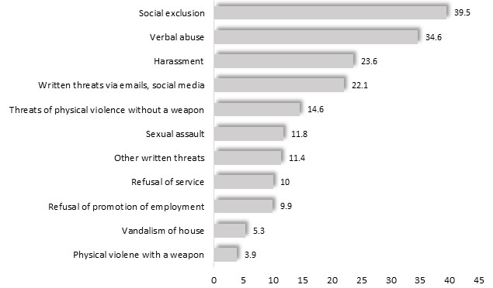

Violence or harassment experienced by respondents in the previous 12 months, by type

Many respondents to the survey also felt that they were not accepted among mainstream society, with 43% of respondents reporting that they felt accepted at health services, 35% at social events, 31% in public, 29% at mainstream events, and 11% at religious events. Levels of perceived acceptance were lowest among trans and non-binary respondents.

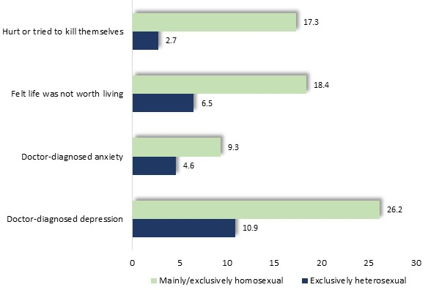Such exclusion, harassment, abuse and violence exact a grievous toll upon the mental health of many children, young people and adults. The Australian Psychological Society (undated) reports elevated average levels of anxiety, depression and depleted self-esteem among LGBTI people. In one inquiry, featuring discussions with 189 14-25 year-old gender diverse and transgender Australians, about half reported that they had been diagnosed with depression, while two-fifths had contemplated suicide and a similar proportion had attended a mental health clinician in the previous year (Smith et al, 2014). Among them, 48% stated that they felt stressed and 44% anxious, 40% were depressed and 38% had suicidal thoughts, while 16% experienced eating disorders and 11% drug-related problems

Mental health concerns: young women (McNair et al, 2004)

Similarly, in an Australian study of 15,000 22-17 year-old women, McNair et al (2004) found that, compared with heterosexual women, those who were mainly or exclusively homosexual experienced higher rates of doctor-diagnosed depression (26.2% compared with 10.9) or anxiety disorders (9.3% vs. 4.6%) in the previous four years, while a higher proportion of the homosexual women had felt that life was not worth living in the previous week (18.4% vs. 6.5%) and a greater proportion had hurt or tried to kill themselves in the previous six months (17.3% vs. 2.7%). (Diagram, above).

A further Australian study, of over 800 trans young people aged 14-25 and some of their parents, found that 75% had been diagnosed during their lifetimes with depression and 72% with anxiety; 80% had self-harmed and 48% had attempted suicide; and 89% had felt rejected or not included by their peers (Strauss et al, 2017).

LGBTI participants in the 2017 Victorian Population Health Survey also registered unfavorable mental health outcomes, including lower levels of satisfaction with life, with 28% assessing their life satisfaction as ‘fair’ or ‘poor’ compared with 20% of others; higher rates of psychological distress (24% compared with 15% of non-LGBTI individuals); and elevated levels of doctor-diagnosed depression or anxiety (45% compared with 26% of non-LGBTI survey participants) (Victorian Agency for Health Information, 2020).

Among respondents to the 2019 Australian ‘Private Lives’ survey, depression had been diagnosed among 39% - nearly ten times higher than among the general population, of 4.1% - based on findings of the 2007 National Survey of Mental Health and Wellbeing (Hill et al, 2020).

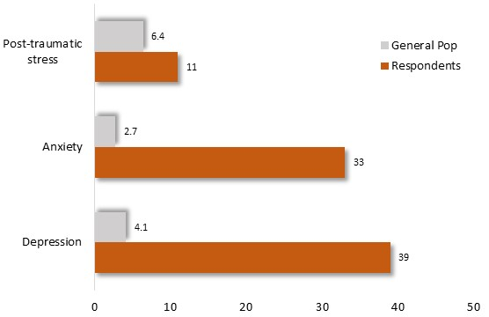A third (33%) reported a diagnosis of anxiety disorder in the past 12 months– over ten times the corresponding figure for the general population, and 11% reported post-traumatic stress disorder, compared with 6.4% among the general population. The prevalence of such recent diagnoses was highest among trans, non-binary, pansexual, queer and bisexual people.

Employing a sequence of survey questions, the survey also identified ‘high’ or ‘very high’ levels of psychological stress among 57% of respondents - four times the level of 13% recorded among the general population in the 2017/18 Population Health Survey. Levels of stress were highest among trans, non-binary, pansexual, queer and bisexual individuals.

Finally, approximately two-fifths (42%) of respondents to the ‘Private Lives’ survey had thought about suicide or wishing to die in the previous year, nearly twenty times the corresponding level of 2.3% among the general population, while 5.2% had attempted suicide, compared with 0.4% of the general population (based on findings of the2007 National Survey of Mental Health and Wellbeing) (Hill et al, 2020)..

Some maintain that these circumstances contribute to a condition sometimes termed ‘minority stress’, and defined as “… excess stress to which individuals from stigmatized social categories are exposed as a result of their social - often minority - position” (Meyer, cited in Stephenson and Finneran, 2017), as for instance, “…when the option of family life and personal intimacy are not freely offered and sanctioned for LGBTI people” (Meyer, 2003).

According to some commentators, the ensuing personal stress may deplete an individual’s sense of self-worth (Edwards and Sylaska, 2013) and foster “…a high level of inadequacy and powerlessness” (Campo and Tayton, 2015), inducing many LGBTI individuals to conceal their gender identity and sexuality (Goldenberg et al, 2016)[3] and to internalize homophobic attitudes (Fairchild, 2020; Meyer, 2003). It is proposed that for some individuals, the stress arising from their experiences of abuse, the necessity to conceal their identity or sexuality, and internalized homophobic attitudes, may fuel conflict and violence toward their intimate partners (Stephenson and Finneran, 2017; Rolle et al, 2018; Edwards and Sylaska, 2013).

Available evidence extends qualified support to this proposition, linking stress, homophobia and concealment of identity, with intimate partner violence among LGBTI individuals (Witoslawski, 2020; Meyer, 2003). A US study of 311 college students for instance, documented an association between ‘internalized homophobia’ and the experience of physical and sexual violence with relationships (Edwards and Sylaska, 2013). Similarly, a survey of 1,045 lesbian women discerned a link between discrimination and internalized homophobia, and intimate partner violence (Lewis et al, 2016). Meyer (2003) cites further evidence pointing to a relationship between concealment of identity and intimate partner violence.

Other researchers though, contend that the connection between minority stress on the one hand – including homophobia and concealment of identity – and intimate partner violence, on the other, remains unproven by the available evidence (Stephenson and Finneran, 2017; Balsam and Szymanski, 2005; Rolle et al, 2018).

* * * *

Both frameworks are founded upon the proposition that antagonistic public attitudes towards LGBTI people trigger a sequence of events which contribute to violence and abuse within some LGBTI relationships. As such, both frameworks point to the goal of dispelling such attitudes, while fostering respect for diverse, healthy identities and sexuality, as important directions in efforts to prevent intimate partner abuse.

**Barriers to Reporting Intimate Partner Violence and Seeking Assistance**

Circumstances which prevent or inhibit LGBTI individuals from obtaining support in relation to intimate partner violence include misconceptions about the nature of such violence; concerns about the impact of disclosure upon their partner or wider community; limited access to support from the LGBTI community; and the actual or perceived quality of support available from external agencies, including the police.

*Lack of acknowledgement of violence*

It is widely noted that intimate partner violence is often unacknowledged, including among the LGBTI community itself (National Coalition Against Domestic Violence, undated; Our Watch, 2017). Campo and Tayton (2015) express the view that failure to clearly perceive the extent and impact of imitate partner violence among members of LGBTI communities contributes to underreporting of such incidents and a tendency to minimize its impact.

One cause may relate to limited understanding of the nature of intimate partner violence. Commentators observe that some LGBTI individuals do not recognize their experience of coercive control within a relationship as a form of abuse (Leith et al, 2020; Donovan, 2006). Lettelier et al (1994) remark that many “…lack the awareness and language to describe their own victimization and therefore fail to take steps necessary to leave their violent partners.” Indeed, Merrill and Wolf (2000) found that limited understanding of intimate partner violence was the third most common reason for remaining in an abusive relationship – after financial and emotional dependence (Cited in Rolle et al, 2018).

Moreover, Donovan and Hester (2010) and others maintain that the popular awareness of intimate partner abuse within heterosexual relationships may cause some to overlook its relevance to LGBTI relationships, while reinforcing the widely-reported illusion that women are not, and cannot be, violent within a relationship (Stuart, 2018; DVConnect, 2018; Toesland, 2020).

*Perceptions that violence is inescapable*

Some victim/survivors of intimate partner violence within LGBTI relationships perceive that violence and abuse are an inescapable feature of relationships, perhaps owing to their experience of discrimination and abuse within their homes, schools and wider community, or within past intimate relationships (Stuart, 2018). Lettelier (1994) recalls one victim/survivor, who reflected: “I basically accepted my relationship as common to the gay experience…it seemed to be normal” (Lettelier, 1994).

A related consideration is mentioned by Kai Noonan of the AIDS Council of NSW (ACON), who adds that “many in the community have a higher threshold when it comes to tolerating abuse, due to a lifetime of discrimination as part of a minority group.” (cited in Witoslawski, 2020).

*Self-blame*

Some LGBTI individuals may harbor the misconception that if one employs physical force to defend themselves from an aggressive partner, they are equally implicated in the ensuing violence (Lettelier, 1994). In other instances, some may blame themselves for the abuse, owing to their sexuality or gender (Stuart, 2018), and some men may be reluctant to perceive themselves as victims, supposing that a ‘real man’ should have been able to defend himself against violence (Lettelier, 1994).

*Community connection*

A further circumstance which may restrain some from reporting violence, is the concern that LGBTI people should be seen to form relationships that are of the same merit as any other, with the implication that speaking up may discredit their community (Stuart, 2018; Selinger-Morris, 2018; Barrett, 2015).

For others though, lack of contact with the community, as a source of guidance and role models, may deprive them of the support they require to respond to violence (Donovan, 2006 – citing Ristock, 2002).

*Relationship concerns*

It is also reported that some LGBTI individuals may feel constrained from seeking support by concerns about their relationship, including a perceived obligation to care for a partner (Donovan, 2006); sympathy for their partner’s personal experience of homophobic exclusion and discrimination (Leith et al, 2020); fear of loneliness (Jeffries and Ball, 2008); or the value of the relationship to themselves as a “confirmation of their identity and sense of self” (Donovan, 2006).

*Service response*

The experience of homo-, bi- or transphobia among the wider community may deter many LGBTI individuals from seeking assistance to end violence within a relationship (Pitts et al, 2006). Indeed, in one investigation it emerged that the majority of a sample of those who experienced violence within relationships did not seek assistance from an external agency – echoing a trend seen in responses to violence within heterosexual relationships (NZ Family Violence Clearinghouse, 2016).

Perceived and actual deficiencies in service delivery, including misunderstanding of the needs of LGBTI individuals by some welfare professionals, reportedly discourage some people from seeking assistance (Stuart, 2018; Centre for American Progress, 2011; Toesland, 2020). Moreover, it has been observed that service providers may hold views that heterosexual relationships are the only legitimate expression of sexuality (Our Watch, 2017); that violence among men is either a natural interaction in some relationships, harmless or mutual (Rolle et al, 2018; Barrett, 2015); that men should be able to defend themselves (Lettelier, 1994); or that lesbian relationships do not incorporate power imbalances (Our Watch, 2017).

Research findings substantiate concerns among LGBTI people about the availability of safe and supportive assistance from service providers (DVConnect, 2018; Leonard, 2012). In a US study of welfare and family violence workers, 96% expressed the view that they provided ‘welcoming and non-discriminatory’ assistance, though most of their LGBTI clients stated that they *did not* address their needs or concerns (Rolle et al, 2018). Moreover, an inquiry conducted by the AIDS Council of NSW found that only one-fifth of the staff members interviewed, from 65 family violence services, perceived themselves as “fully competent” to support people from LGBTI communities (Campo and Tayton, 2015).

It is reported that limitations in the availability of suitable, sensitive and safe services may be more acute still, for people of a culturally diverse backgrounds, Aboriginal and Torres Strait Islander heritage and residents of smaller, closer-knit rural communities (National LGBT Health Alliance, 2009; Family and Community Services, undated).

Many people who experience violence or abuse within a relationship may be uncertain as to where to find assistance, in any case. Among LGBTI respondents to the 2017 Victorian Population Health Survey, 23% stated that they did not know where to go to obtain support in relation to family violence (Victorian Agency for Health Information, 2020).

At the same time, Smith et al (2014) remarks that: “… concealment can disconnect individuals from reaching out to support and community services that otherwise may have been a source of resilience.”

*Police response*

Among police, lack of understanding, limited awareness, discrimination and homo-, bi- or trans-phobia, may restrain many people from LGBTI communities from seeking assistance (Witoslawski, 2020; Campo and Tayton, 2015; Lyons, 2018). Such circumstances may have improved over time, with Pitts et al (2006) observing that half of a group of LGBTI individuals who sought the protection of the police expressed themselves content with the response – though only a small proportion of those surveyed had reported their experience of intimate partner violence to the police.

**Prevention and Support in Relation to Intimate Partner Violence**

Proposed and existing measures to address violence within LGBTI relationships, extend to education and modelling of respectful behavior at schools; youth programs featuring social activities, personal support and opportunities for social activism; informing and supporting their families of origin; provision of information and services to LGBTI communities; and efforts to effect broader social changes to address the foundations of discrimination.

*Supporting and engaging young people*

Peer-led and other programs for young people are commended as a way to foster confident identity and healthy sexuality among LGBTI young people (Loft, 2016; Brown, 2017A). Smith et al (2014) report on the findings of an on-line survey and focus groups featuring 189 14-25 year-old gender-diverse and transgender Australians, which found that the opportunity to meet with friends and peers, coupled with family support, markedly enhanced their confidence and self-esteem. One trans young person remarked: “I also really appreciate having community – I’m in a trans youth group which has been enormously helpful for me to have somewhere to be myself and talk to other people who know how I’m feeling and are going through similar things to myself.”

It is also reported that participation in activism and advocacy for reform may help to foster a sense of belonging and empowerment for many young people in peer-led youth groups and programs (National LGBTI Health Alliance, 2018).

*Support in rural communities*

Lesser numbers of LGBTI people in rural areas, and their geographic dispersion, may foster isolation, afford fewer opportunities to participate in LGBT social activities, and deprive many of anonymity – exposing them to discrimination, exclusion and abuse (Q-Life, undated; ReachOut, undated; Gottschalk, 2007).

Such conditions contribute to exclusion from peers and heightened concerns for safety among many LGBTI young people in rural areas (Jones, 2017) coupled with elevated rates of self-harm, suicidal behaviour and drug-related problems (Arnold and Rosensteich, undated). Jones (2017) report that many LGBTI young people therefore plan to leave such areas for the more inclusive social environment of the city.[4]

In addition, available local services are often inadequate to meet the needs of LGBTI young people in rural communities (Cowbow Community Health, undated; Lundhorst, 1997; Foster, 1997).

Some commentators therefore urge that increased training, specialized service provision, and other resources be provided in rural communities (Jones, 2017; The Equity Project, 2020). In one program, a team of advocates visited rural centers to promote community understanding and support, establish networks, spur improvements in service delivery to LGBTI people, and promote local leadership in such efforts (Engage Victoria, 2020).

*School programs*

Whaling et al (2019) report that many gender or sexually diverse young people feel that school programs feature insufficient, relevant content in sex education, and are wary of classroom discussions about sexuality or relationships for fear of disclosure or embarrassment. Such perceptions point up the possible need for further teacher training, adjustment of curriculum, accompanied by modelling and expression of inclusive, respectful attitudes by teachers - proposals endorsed in the literature (Smith et al, 2014).

The National LGBTI Health Alliance (2018) emphasizes the role of teachers in cultivating a safe, congenial school environment, observing: “Having support from leaders, such as teachers and supervisors, increased social connectedness and accessible role models, leading to overall wellbeing.” Inversely, Smith et al (2014) found that trans and gender diverse pupils who did *not* perceive their teachers as supportive were four times more likely to drop out of school than others.

*Family support*

A US study of 245 21-25 year old LGBTI young adults established that family support plays a crucial role in assisting young LGBTI people to form a healthy sense of personal identity (Snapp et al, 2015), a finding substantiated in an Australian study of trans and gender diverse young people (Strauss et al, 2017). On the other hand, parental rejection of children on the basis of their gender identity or sexuality is associated with unfavorable health and developmental outcomes (Katz-Wise et al, 2017).

Enhanced support and information for parents and siblings of LGBTI individuals, including professional services and parent groups, is therefore widely favoured as a means to help them understand and affirm their child’s sexuality and expressed gender (National LGBT Health Alliance, 2009; Loft, 2016). Such outcomes may, in turn, reduce stress and concealment of identity, promote a healthy, confident sexuality, and thereby lower the prevalence of intimate partner violence.

*Informing LGBTI communities*

It is further proposed that efforts be made to foster an awareness of intimate partner violence among LGBTI people; include them in developing campaigns to inform the community of the existence, nature and impact of violence; inform them about sources of assistance to address intimate partner violence; and raise the profile of LGBTI people, as clients, in the promotion of relevant services (Leith et al, 2020; Loft, 2016).

*Strengthening connections with LGBTI communities*

An Australian interview study found that the LGBTI community was a valued and beneficial source of companionship and personal validation among LGBTI individuals (Leith et al, 2020). Meyer (2003) adds that the ‘solidarity and inclusiveness’ with a peer group that respects and includes them, may help to dispel the stresses of discrimination and diminish its contribution to intimate partner abuse. Relevantly, Stephenson and Finneran (2017) relate evidence that close connections with their community are associated with a decline in the incidence of intimate partner violence among LGBTI people.

In addition, Brown (2017B) maintains that encouraging personal contact between the general community and LGBTI individuals, and raising the prominence of the LGBTI community, contributes to more respectful attitudes, thereby helping to foster respect and assuage antagonism.

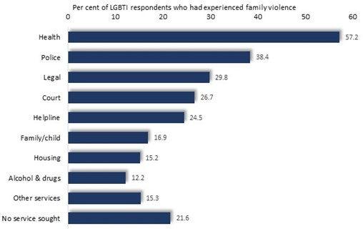*Responsive service provision*

Service development is endorsed as a means to adapt generalist services to the needs of LGBTI individuals, and extend specialist assistance to them, where required. Evidence indicates that a variety of services may be approached by LGBTI individuals for assistance in addressing intimate partner violence, with the implication that such initiatives may be relevant to a variety of services. For example, agencies approached for assistance by LGBTI participants in a recent Victorian survey are recorded in the accompanying diagram (Victorian Agency for Health Information, 2020).

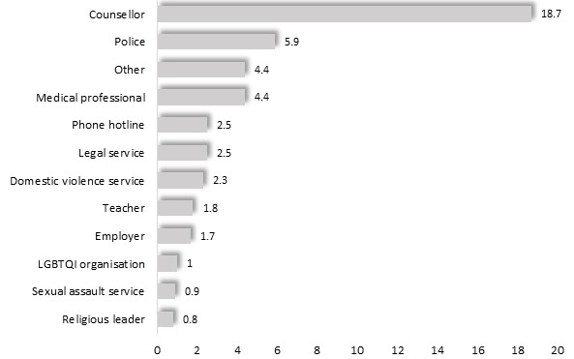In the 2019 ‘Private Lives’ survey 28% of those who had experienced intimate partner violence stated that they had reported the most recent incident. Among them, 19% informed a counsellor or psychologist, 5.9% the police and 4.4% a medical professional (Hill et al, 2020).

Persons who reported their most recent incident of intimate partner by where the report was made

Notably, in contrast to the findings reported above, the Private Lives survey inquired about the most recent incident, rather than where respondents had *ever* reported such violence, and aggregated the findings in a different manner, making comparison difficult.

In considering such circumstances, some writers therefore propose further training for mainstream service providers, to enable them to better understand the experiences, identities and relationships of LGBTI people; respond to their experiences of intimate partner violence; and make appropriate referrals (Toesland, 2020; Li, 2020; Witoslawski, 2020; Stuart, 2018). To this end, Drummond Street Services conducts training for service providers, with a ‘Rainbow Tick’ assigned to services as accreditation for the completion of the program (Selinger-Morris, 2018) – a measure which the 2016 Royal Commission into Family violence proposed that all funded family violence service providers undertake.

In addition to training, the Royal Commission endorsed increased funding for LGBTI services (Victorian Government 2016). Related proposed measures include the provision of shelters, perpetrator programs and other specialized services adapted to the needs of LGBTI people (Dept. Social Services, undated; Smith et al, 2014; O’Halloran, undated).

Police training is also favored as a means to build an understanding of the experiences and needs of LGBTI individuals who report intimate partner violence (Witoslawski, 2020; Centre for American Progress, 2011; Stuart, 2018; Li, 2020; Toesland, 2020). By 2020, Victoria Police had appointed approximately 230 lesbian, gay, bisexual, transgender, intersex and queer liaison officers (GLLOs) to foster trust between police and LGBTI individuals, train and advise police, assist community members, participate in events and conduct presentations about police support for LGBTI people (Victoria Police 2020). Such initiatives hold the prospect of encouraging LGBTI people to report intimate partner violence to the police.

*General community education*

Research points to a high prevalence of antagonistic attitudes among the general community to people of diverse gender and sexuality - one which varies widely among different geographic areas and segments of the community.

Prevalence of the belief that homosexuality is immoral by age, educational attainment and socioeconomic status

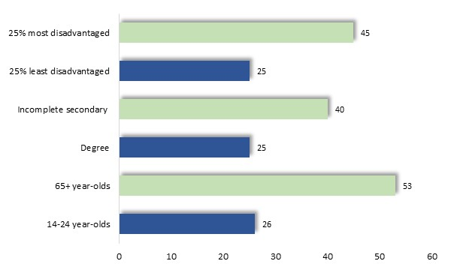A survey of 25,000 Australians aged 14 or more found that 35% (including 43% of men and 27% of women) believed homosexuality is immoral. Such views were most prevalent among those who were older, had limited formal education, were socioeconomically disadvantaged and, in Melbourne, highest in outer suburbs and lowest in the inner-metropolitan areas[5]. (Flood and Hamilton, 2005) (Diagram, left).

Encouragingly however, McCann (2019) presents findings from the 2017 Household, Income and Labour Dynamics in Australia (HILDA) Survey which show that the proportion of Australians who are supportive of the rights of LGBTI people had risen in the decade to 2015.[6]

Community education to challenge stereotypes, improve awareness and dispel antagonism is seen as essential to address homophobic and violent behavior, and thereby alleviate violence within relationships (Witoslawski, 2020; National LGBT Health Alliance, 2009; Loft, 2016; Australian Human Rights Commission, 2013). In planning such social changes, including any accompanying programs or legislative reform, LGBTI people should be included from the conception of such initiatives, with acknowledgement and representation of their diverse identity, sexuality, life experiences, and consideration of factors such as age, ability, education and socioeconomic status, cultural background and heritage. Accordingly, the 2016 Royal Commission into Family Violence urged that an LGBTI taskforce be formed to shape service development, guide broader approaches to prevention and identify future avenues of research (Victorian Government, 2016).

Efforts to address deeper causes of discrimination against LGBTI individuals, and curtail intimate partner violence, are proposed by Our Watch (2017) which observes that “…the focus of prevention initiatives must go beyond…individual identity characteristics…to the social structure, practices and norms which discriminate against them”.

The gender and minority stress frameworks, outlined earlier, point to homophobic attitudes, and traditional notions about masculine identity and entitlement, as foundations of much of the intimate partner violence within LGBTI relationships, suggesting these as among the issues which may be addressed by community programs and movements.

APPENDIX

**Common terms used to Describe differences in Gender Identity, Sexual Orientation and Biological Sex**

A selection of terms is used here to refer to categories of biological sex, sexual identity and sexual orientation:

*Biological sex*: ‘intersex’ - people whose biological sex is not distinctly male or female.

*Sexual orientation*: ‘lesbian’ and ‘gay men’ - people who are homosexual, being sexually attracted chiefly to people of the same biological sex.

‘bisexual’ - people attracted to both women and men.

*Gender*: ‘diverse gender identity’ - those who perceive their identity as neither female nor male, both, or having no gender.

‘transgender’ or ‘trans’ - people whose gender identity does not match their biological sex; though the term may also be used to encompass a range of gender identities.

Finally, terms such as ‘homophobia’, ‘biphobia’, ‘transphobia’ and others refer to prejudicial and antagonistic attitudes towards LGBTI people.

The accompanying diagram illustrates these broad categories of gender identity, sexual orientation and biological sex. However, a variety of other terms are in common use, reflecting the breadth of gender, sexual diversity and personal identity among all people.



BIBLIOGRAPHY

Arnold, M. and Rosenstrietch, G. (undated). The mental health of sexuality, sex and gender diverse Australians. UnitingCare West, National LGBTI Health Alliance

Asian-Pacific Institute on Gender-based Violence (undated). LGBTQ Intimate Partner Violence.

Australian Human Rights Commission (2013). Lesbian, Gay, Bisexual, Trans and Intersex Equality.

Australian Institute of Health and Welfare (2017). National Drug Strategy Household Survey 2016: detailed findings. AIHW

Australian Institute of Health and Welfare (2019). Australia’s Health 2018. AIHW

Australian Institute of Health and Welfare (2020). National Drug Strategy Household Survey 2019: detailed findings. AIHW

Australian Psychological Society (undated). What issues might a child who is transgender or gender diverse face?

Bagshaw, D., Chung, D., Couch, M., Lilburn, S. and Wadham, B. (1999). Reshaping Responses to Domestic Violence: Executive Summary. University of South Australia, Adelaide

Balsam, K.F. and Szymanski, D.M. (2005). Relationship Quality and Domestic Violence in Women’s Same-sex Relationships: the role of minority stress. Psychology of Women Quarterly. Vol 29 (2005), pp. 258-269

Barret, B.J. (2015). Domestic Violence in the LGBT Community. Encyclopedia of Social Work.

Breiding, M.J., Chen, J. and Walters, M.L. (2013). The National Intimate Partner and Sexual Violence Survey: 2010 findings of victimization by sexual orientation. Atlanta, Georgia: National Centre for Injury Prevention and Control

Brown, E. (2017A). ALIGHN Guide: Gender norms, LGBTQI issues and development. ALIGN – Advancing Learning and Innovation on Gender Norms

Brown, E. (2017B). ALIGHN Guide: Gender norms, LGBTQI issues and development – Executive summary and terminology. ALIGN – Advancing Learning and Innovation on Gender Norms

Brown, T.N. and Herman, J.L. (2015). Intimate Partner Violence and Sexual Abuse Among LGBT People. UCLA School of Law

Campo, M. and Tayton, S. (2015). Intimate Partner Violence in Lesbian, Gay, Bisexual, Trans, Intersex and Queer Communities. Australian Institute of Family Studies.

Carman, M., Fairchild, J., Parsons, M., Farrugia, C., Power, J. and Bourne, A. (2020). Pride in Prevention: A guide to primary prevention of family violence experienced by LGBTIQ communities. Rainbow Health Victoria

Centre for American Progress (2011). Domestic Violence in the LGBT Community

Clark, T. C., Lucassen, M. F. G., Bullen, P., Denny, S. J., Fleming, T. M., Robinson, E. M. and Rossen, F. V. (2014). The Health and Well-Being of Transgender High School Students: results from the New Zealand Adolescent Health Survey. Journal of adolescent health. Vol. 55, No.1, pp. 93-99

Cobaw Community Health (undated). LGBTI and Mental Health in Rural Victoria

Crime Prevention Victoria (2002). Safer Streets and Homes: a crime and violence prevention strategy for Victoria, 2002-2005. Department of Justice, Melbourne

Department of Education and Training (2020). Safe Schools. Victorian Government.

Dept. Social Services (undated). Domestic and Family Violence within LGBTIQ Communities. Australian Government, Canberra

Donovan, C., Hester, M., Holmes, J. and McCurry, M. (2006). Comparing Domestic Abuse in Same Sex and Heterosexual Relationships. University of Sunderland

Doull, M., Watson, R.J., Smith, A., Homma, Y. and Sayec, E. (2016). Are we levelling the playing field? Trends and disparities in sports participation among sexual minority youth in Canada. Journal of Sport and Health Science. Vol. 7. Issue 2, pp. 218-226. Accessed at: <https://www.sciencedirect.com/science/article/pii/S2095254616300916>

DVConnect (undated). LGBTIQ Domestic, Family and Sexual Violence

Edwards, K.M. and Sylaska, K.M. (2013). The Perpetration of Intimate Partner Violence among LGBTQ College Youth: the role of minority stress. Journal of Youth and Adolescence. Vol 42, pp. 1721-1731

Engage Victoria (2020). LGBTIQ Equality Rural and Regional Program. Dept. Premier and Cabinet

Fairchild, J. (2020). PiP Webinar: LGBTIQ Inclusive Prevention in Conversation with Rainbow Health Victoria. May 27, 2020

Family and Community Services (undated). I’m LGBTIQ and Experiencing Domestic Violence.

Flood, M. and Hamilton, C. (2005). Mapping Homophobia in Australia. The Australia Institute.

Foster, S.J. (1997). Rural Lesbians and Gays: Public Perceptions, Worker Perceptions, and Service Delivery. Journal of Gay & Lesbian Social Services. Vol. 7, No. 3

Goldenberg, T., Stephenson, R., Freeland, R., Finneran, C. and Hadley, C. (2016). Struggling to be the Alpha: sources of tension and intimate partner violence in same-sex relationships between men. Culture, Health and Sexuality. Vol. 18, No. 8, pp. 975-889

Gottschalk, L. (2007). Coping with stigma: Coming out and living as lesbians and gay men in regional and rural areas in the context of problems of rural confidentiality and social exclusion. Rural Social Work and Community Practice. Federation Business School

Hegarty, K., Hindmarsh, E. and Gilles, M. (2000). Domestic Violence in Australia: definition, prevalence and nature of the presentation in clinical practice, Medical Journal of Australia, Vol. 173, pp. 363-367

Hill, A. O., Bourne, A., McNair, R., Carman, M. & Lyons, A. (2020). Private Lives 3: The health and wellbeing of LGBTIQ people in Australia. Australian Research Centre in Sex, Health and Society

Jeffries, S. and Ball, M. (2008). Male Same-sex Intimate Partner Violence: a descriptive review and call for further research. Griffith University

Jones, T. (2017). Comparing Rural and Educational Contexts for LGBTI students. Australian and International Journal of Rural Education. University of New England

Katz-Wise, S., Rosario, M. and Tsappis, M. (2016). LGBT Youth and Family Acceptance. Pediatr Clin North Am. 2016 Dec., Vol. 63, No. 6. pp. 1011–1025

Leonard, W., Mitchell, A., Pitt, M. and Patel, S. (2008). Coming Forward: the underreporting of hetrosexist violence and same-sex partner abuse in Victoria. Gay and Lesbian Health Victoria

Leonard, W., Pitts, M., Mitchell, A., Lyons, A., Patel, AS., Couth, M. and Barrett, A. (2012). Private Lives 2: The second national survey of the health and wellbeing of GLBT Australians. Australian Research Centre in Sex, Health and Society

Lettelier, P. (1994) Gay and Bisexual Domestic Violence Victimization: challenges to feminist theory and response to violence. Violence and Victims. Vol. 9, No. 2

Li, A. (2020). Unique Issues Around Domestic Violence in LGBTQI Community. Canberra Family Lawyer. April 30, 2020

Lieth, B., Gray, R., Hamer, J., Broady, T., Kean, J., Ling, J. and Walker, T. (2020). Developing LGBTQ Programs for Perpetrators and Victims/Survivors of Domestic and Family Violence. Australia’s National Research Organization for Women’s Safety

Loft, B. (2016). Breaking the Binary Code Project: celebrating gender and sexuality diversity, challenging stereotypes and relationship expectations

Lyndhorst, T. (1997). Lesbians and Gay Men in the Country: Practice Implications for Rural Social Workers. Journal of Gay & Lesbian Social Services. Vol. 7, No. 3

Lyons, A. (2018). Partner Violence in LGBTQI Relationships. News GP

McCann, H. (2019). Why more Australians are Supporting Gay Rights. University of Melbourne.

McNair, R., Kavanagh, A., Agues, P and Tong, B. (2004). The Mental Health Status of Young Adult and Mid-life Non-heterosexual Australian Women. Australian and New Zealand Journal of Public Health, Vol. 29 No. 3 pp. 265-271

Merrill, G.S. and Wolfe, V.G.A. (2000). Battered Gay Men: an exploration of abuse, help-seeking and why they stay. Journal of Homosexuality. Vol. 39, pp. 1-30

Meyer, I.H. (2003). Prejudice, Social Stress and Mental Health in Lesbian, Gay, and Bisexual Populations: conceptual issues and research evidence Psychological Bulletin. Sept, Vol. 129, No. 5, pp. 674-697

National Coalition Against Domestic Violence (undated). Domestic Violence and Lesbian, Gay, Bisexual and Transgender Relationships. National Coalition Against Domestic Violence

National LGBT Health Alliance (2009). Submission to the Inquiry into the Impact of Violence on Young Australians

National LGBTI Health Alliance (2018). Synthesis of Current Evidence for Good Practice in the Prevention of Suicide for LGBTI People. National LGBTI Health Alliance

National LGBTI Health Alliance (2020). Snapshot of Mental Health and Suicide among LGBTI Young People. National LGBTI Health Alliance

New South Wales Attorney General Department (2003). You shouldn’t have to hide to be safe: A report on Homophobic Hostilities and Violence against Gay Men and Lesbians in New South Wales. NSW State Government

New Zealand Family Violence Clearinghouse (2016). New Report on Partner and Sexual Violence in Rainbow Communities

O’Halloran, K. (undated). Family Violence in an LGBTIQ Context. Domestic Violence Resource Centre of Victoria.

Our Watch (2017). Summary Report: primary prevention of family violence against people from LGBTI communities. Gay and Lesbian Health Victoria and Victorian State Government

Pitts, M., Smith, A., Mitchell, A. and Patel, S. (2006). Private Lives: a report on the health and wellbeing of GLBTI Australians. Gay and Lesbian Health Victoria

QLife (undated). Regional and Rural: a qhealth guide for professionals. National LGBTI Health Alliance

ReachOut (undated). The insider’s guide to being LGBTQIA+ in rural and remote areas

Renzetti, C. (1994). On Dancing with a Bear: reflections on current debates among domestic violence theorists. Violence and Victims. Vol. 9, No. 2, pp. 195-202

Ristok, J. (2002). No More Secrets: violence in lesbian relationships

Rolle, L. Giardina, G., Caldarera, A.M., Gerino, E. and Brustia, P. (2018). When Intimate Partner Violence Meets Same Sex Couples: a review of same sex intimate partner violence. Frontiers of Psychology. Vol. 9, pp. 1506

Selinger-Morris, S. (2018). The ‘Revolutionary’ Programs Giving Hope to LGBT Domestic Violence Survivors. ABC News, 12 July, 2018

Smith, E., Jones, T., Ward, R., Dixon, J., Mitchell, A. and Hillier, L. (2014). From Blues to Rainbows: the mental health and well-being of gender diverse and transgender young people. Australian Research Centre in Sex, Health and Society

Snapp, S., Watson, R., Russell, S., Diaz, R., Ryan, C. (2015). Social Support Networks for LGBT Young Adults - Low-cost Strategies for Positive Adjustment. Family Relations. Vol. 64, No. 3, pp. 420-430

Stephenson, R. and Finneran, C. (2017). Minority Stress and Intimate Partner Violence Among Gay and Bisexual Men in Atlanta. American Journal of Men’s Health. July, Vol. 11, No. 4, pp. 952-961

Strauss, P., Cook, A., Winter, S., Watson, V., Wright Toussaint, D., Lin, A. (2017). Trans Pathways: the mental health experiences and care pathways of trans young people: summary of results. Telethon Kids Institute, Perth.

Stuart, S. (2018). Domestic Violence in Rainbow Families. University of Queensland

The Equity Project (2020). Australian LGTQI and Policy Guide 2020. The Equality Project

Toesland, F. (2020). Coronavirus Restrictions Highlight LGBTQ Domestic Abuse. Out Health and Wellness.

VicHealth (2020). Unpacking the Man Box: what is the impact of the Man Box attitudes on young Australian men’s behaviours and well-being? Jesuit Social Services and VicHeath.

Victoria Police (2020). LGBTIQ Liaison Officers. Accessed at: <https://www.police.vic.gov.au/LGBTIQ-liaison-officers>

Victorian Agency for Health Information (2020). The health and wellbeing of the lesbian, gay, bisexual, transgender, intersex and queer population in Victoria: Findings from the Victorian Population Health Survey 2017. Melbourne.

Victorian Government (2016). Victorian Royal Commission into Family Violence. Victorian Government, Melbourne

Waling, A., Kerr, L., Fraser, S., Bourne, A. and Carman, M. (2019). Young People, Sexual Literacy, and Sources of Knowledge: a review. LaTrobe University

Witoslawski, A. (2020). LGBTI Domestic Abuse ‘Unseen’. Canberra Times. April 9, 2020

1. The prevalence of violence within lesbian relationships is unexpected to some, with Dr Philomena Horsley of the Centre for Women’s Health, Gender and Society at the Melbourne School of Population and Global Health, observing that women sometimes say: “But I’m in a relationship with a women, we’re equal, there aren’t any power dynamic so this can’t be a situation of abuse” (Lyons, 2018).
2. For example, the 2015 VicHealth Indicators Survey recorded the level of agreement among respondents to two statements: ‘Men should take control in relationships and be head of the household’; and ‘Women prefer a man to be in charge in a relationship’. The result was a score representing the percentage of respondents with a low support for gender equity. These statements were endorsed by 44% of males and 27% of females (VicHealth Indicators Survey, 2015)
3. Meyer, 2003 cites evidence which shows that concealment of identity denies many LGBTIQ people the fellowship, acceptance and affiliation of other LGBTIQ individuals and has detrimental effects upon individuals - just as other evidence shows that disclosures within close, interpersonal relationships confer health benefits.
4. Notably, the far lower proportion of couples in Victorian rural areas, as compared with inner-metropolitan localities, who identified themselves as of the same sex in the 2016 Census, (ABS, 2017H), is consistent with the perception of rural communities as less hospitable social environments to people of diverse gender identity or sexual orientation – implying a need for support for young people in such localities, tailored to local conditions.
5. A pattern reflected in the 2017 Australian Marriage Law postal vote, where reform attracted the support of fewer than 40% of voters in Greater Dandenong, Brimbank and Hume, compared with 78% of those in inner-metropolitan Yarra, Melbourne and Port Phillip (ABS, 2017I).
6. McCann explains: “A comparison of attitudes in 2005 versus 2015 shows that both men and women are now more likely to agree with the statement: “Homosexual couples should have the same rights as heterosexual couples do.’’ With scoring ranging from 1 (strong disagreement) to 7 (strong agreement), men’s attitudes have shifted from 3.3 (2005) to 4.8 (2015), and women’s attitudes from 4.0 (2005) to 5.3 (2015).”