Disability, Ageing and Carers, Australia 2018

Disability Prevalence
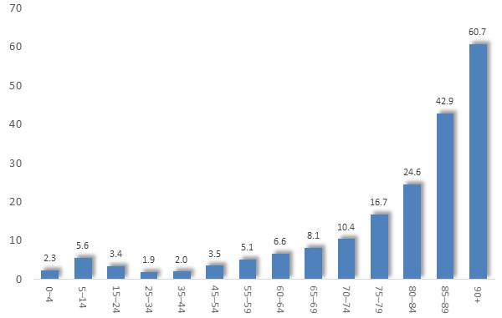
In 2018 17.7% of Australians had a disability, including the same proportion of females and males.
The prevalence of disability rose from fewer than one in twenty preschoolers and young adults, to half of people over 65.

Prevalence of Disability by Age: Australia, 2018

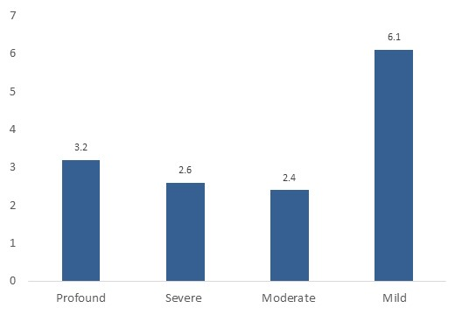

Levels of Disability
5.7% of people had a disability resulting in profound or severe limitations in core activities - including 5.5% of males and 6% of females.
Eight per cent of people experienced restrictions in relation to education or employment.

Prevalence of Disability by Severity: Australia, 2018

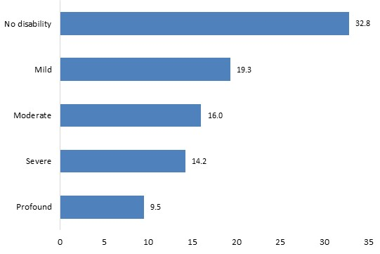
Education
Levels of formal educational attainment varied with level of disability. For instance, about one in ten people with a profound disability held a university degree, compared with a third of those with no disability.

Per cent of Persons with a Bachelor Degree or Higher Qualification, by Level of Disability: Aus., 2018

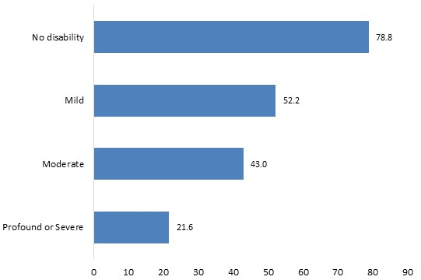
Employment
Levels of employment rise from about a fifth of those with a profound disability to half with a mild disability – still less than the 79% of people with no disability.

Per cent of Persons in Paid Employment, by Level of Disability: Aus., 2018

Among disabled people in paid work, 4.4% required special equipment, 2.5% allocation of special duties, 0.8% assistance from someone at work, and 0.7% modified fittings.
Incomes
People with moderate or mild disabilities reported similar incomes to those with no disability. Income levels were markedly among those with a profound or severe disability though, with 9% on the highest two-fifths of income levels, compared with 36% of people with no disability.

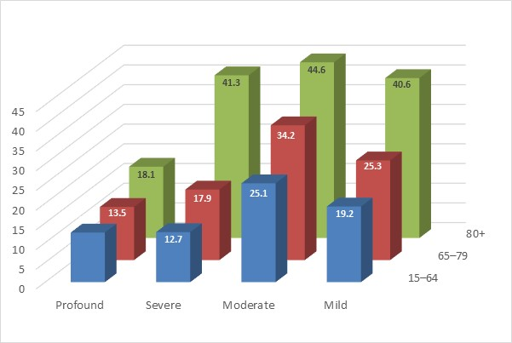
Housing
95% of people with a disability resided in households – a figure which ranged from 79% of people with a severe disability to almost all of those with a mild disability.
One-fifth (20.5%) of those who resided in private dwellings lived alone, including 12% of people with profound disability, to 16% with severe and 23% with mild disability. By contrast, 8% of people with no disability lived alone.

Proportion of Disabled Persons in Private Dwellings who are Living Alone, by Level of Disability: Aus., 2018

Aids and Assistance
Communications, management of medical conditions, mobility and self-care were among the most common kinds of aids most often required for day-to-day living among, disabled persons.

Type of Aids | ……..Per cent……..
 | Persons living alone | All disabled persons
Communication | 31.4 | 29.4
Managing health conditions using medical aids | 20.9 | 20.2
Moving around places away from home or establishment | 18.2 | 14.1
Showering or bathing | 14.4 | 12.4
Moving about the house or establishment | 10.4 | 10.2
Toileting | 8.2 | 8.1
Managing incontinence | 6.1 | 7.1
Getting into or out of a bed or chair | 5.7 | 6.3
Meal preparation | 2.3 | 2.6
Dressing | 2.0 | 3.9
Type of mobility aid used
Cane (Sonar canes, etc.) | 3.4 | 1.7
Walking stick | 9.4 | 6.2
Crutches | 1.1 | 1.0
Walking frame | 10.0 | 7.6
Wheelchair (Manual) | 2.3 | 3.7
Wheelchair (Electric) | 0.7 | 0.6
Scooter | 2.8 | 1.2
Specially modified car or car aids | 0.5 | 0.4
Other mobility aids | 5.9 | 5.4

The activities for which assistance was required included communication, self- and medical care, mobility, home maintenance and others.

Activities for which Assistance Required
Mobility | 78
Health care | 63
Transport | 52
Self-care | 52
Household chores | 48
Cognitive or emotional tasks | 47
Property maintenance | 46
Meal preparation | 26
Communication | 25
Reading or writing tasks | 23

Carers
Nearly 11% of all Australians were carers, including 12.3% of all females 9.3% of males.
About seven tenths (72%) of primary carers were women, with 2% of males and 5% of females serving as primary carers

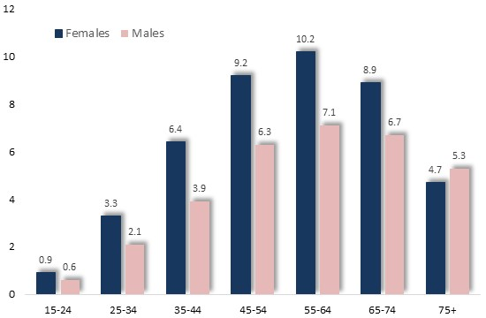

The proportion of people who provide unpaid care rises to later middle age, before declining in older age.

Per cent of Persons who are Carers, by Age and Gender: Aus., 2018

Carers and Recipients of Care
Of carers aged 15-64, 55% held paid employment, including 54% of males and 56% of females.
Among primary carers, females were less often the partner or child of the recipient of that care than males. However, 33% of female primary carers were caring for their child, compared with 11% of male primary carers. In other words, among children with a primary carer, women were the carers in approximately three-quarters of instances.

Median hours of care provided by primary carers was 10 hours per week, a figure which was slightly higher among women (10.2 hrs.) than men (9.5 hrs.).

For the full survey findings, click here, or visit: https://www.abs.gov.au/AUSSTATS/abs@.nsf/DetailsPage/4430.02018?OpenDocument

