PATTERNS OF SOCIAL MEDIA USE, 2020

In 2019/20, an on-line survey of 2,012 Australian social media users was commissioned by Sensis.
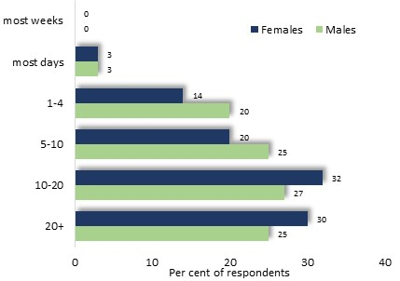
Internet Usage
Nearly a third of the survey participants used the internet twenty or more times a week, and a similar proportion on ten to twenty occasions each week. The frequency of internet use was slightly higher among women than men.

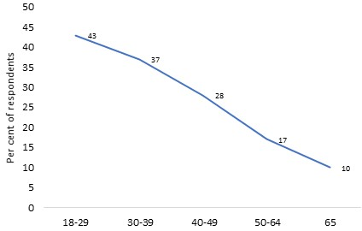

Frequent internet usage declined steeply with age, with 43% of 18-29 year-old survey participants using the internet more than 20 times a week, compared with 10% of those aged 65 years or more

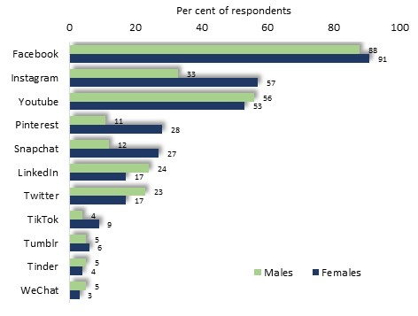
Social Media Platforms
The most popular social media platforms included Facebook, used by nine-tenths of survey participants, as well as Instagram and YouTube.
Instagram, Pinterest, Snapchat and Tiktok were decisively more popular among women, while males were more likely than women to use LinkedIn and Twitter.

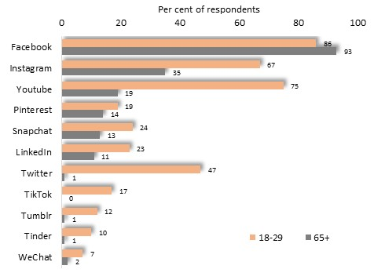

Age also exerted an influence upon the popularity of most social media platforms, for while the proportion of survey participants who used Facebook was similar among older and younger people, the proportion of survey participants who used other social media platforms declined decisively with age. For example, while 47% of younger people used Twitter, this figure fell to 1% among people of retirement age.

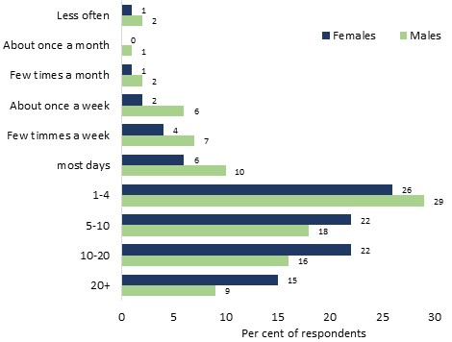
Frequency of Social Media Use
Among the survey participants, 15% of women and 9% of men used social media least twenty times a day on average, and about three-quarters at least once a day. In general, women used social media more frequently than men.

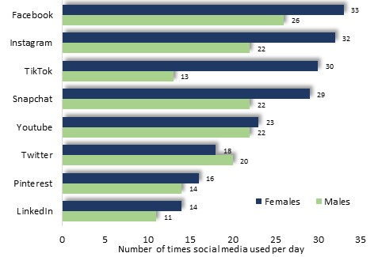

On average, women used Facebook, Instagram, Tiktok and Snapchat about thirty times a day, while men used these platforms less often.

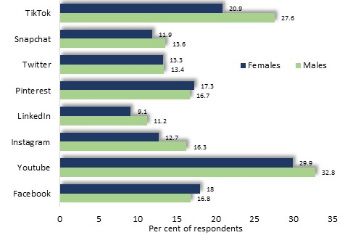
Duration of Social Media Use
Further inquiries concerned the average time spent on major social media platforms on each session. Among YouTube users, average duration of sessions was 33 mins. among males and 30 mins for females.
Users of Tiktok also spent an appreciable amount of time at a typical session, averaging 28 minutes among males and 21 minutes for females.
By contrast, the average duration of sessions on LinkedIn was about ten minutes.

