Literacy



The information presented here is largely drawn from the findings of the 2011–12 Programme for the International Assessment of Adult Competencies, conducted every ten years across Australia, which measured levels of literacy and numeracy among a random sample of Australians, through face-to-face interviews. The survey assessed respondents’ ability to understand written English as well as their proficiency in numerical calculations.

English literacy levels were grouped into six ranges, from ‘below Level 1’ to ‘Level 5’ - the highest level. Persons at or below Level 1 literacy are described here as having ‘limited English literacy’.

**Literacy: Age and Gender**

Overall, approximately 14 per cent, or one in seven, women and men across Australia aged 15 to 74, had limited literacy. Among younger age groups, a higher proportion of males than females had limited literacy, whereas among older Australians, limited English literacy was more prevalent among women.

For both women and men, the proportion of people with limited English literacy declined slightly from the teenage prevalence of 11.6% (13.9% among males and 9% among females), to 8.8% among those aged 35 to 39 years, before rising to nearly a third among people aged 65 to 74 (accompanying diagram).

Per cent of Persons with Limited English Literacy, by Age and Sex: Persons aged 15-74 years, Australia, 2012

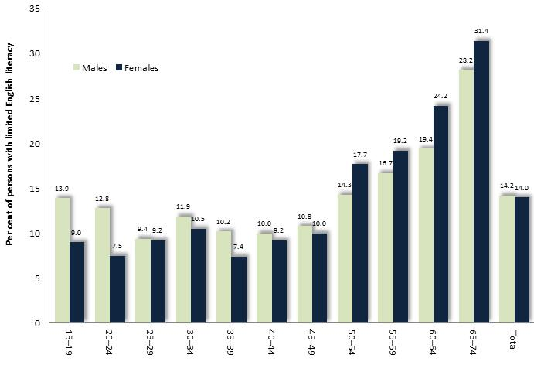

**Literacy: English as a First or Second Language**

Survey respondents were asked if English was their first language, or a second language.

Among people aged 15-74 years whose first language was English, 12% had very limited English literacy, compared with 25% of those whose first language was not English.

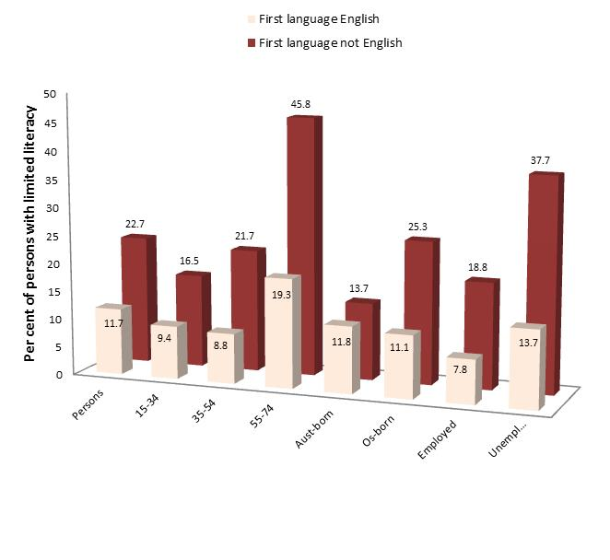*Among people born overseas*, limited English literacy was approximately twice as prevalent among those for whom English was a second language than among people for whom English was a first language. (Diagram below)

Per cent of Persons with Limited English Literacy, by Selected Characteristics: Australia, 2012

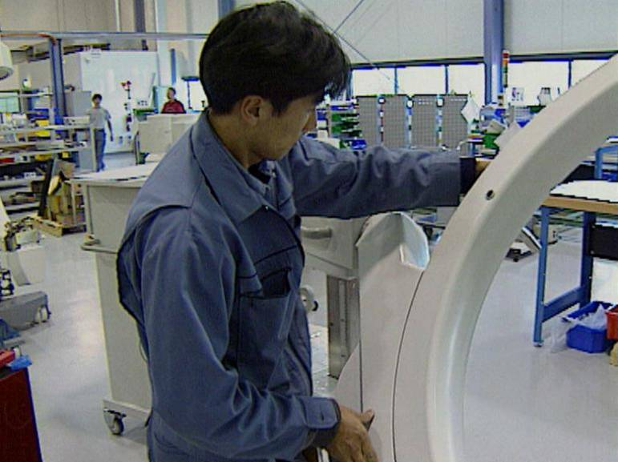**Literacy: Labour Force Status**

The proportion of people with limited English literacy was lowest among those in paid employment, higher among people who were unemployed, and highest among those not in the labour force. Among people of each labour force category, a higher proportion of males than females, had limited literacy in English.

Per cent of Persons with Limited English Literacy, by Sex and Labour Force Status: Australia, 2012

These results are set out in the table below.

|  |  |  |  |
| --- | --- | --- | --- |
|  | Employed | Unemployed | Not in labour force |
| Males | 11.0 | 17.2 | 24.9 |
| Females | 8.3 | 11.5 | 24.0 |
| *Persons* | *9.8* | *14.4* | *24.3* |

**Literacy and Access to Modes of Written Communication**

In everyday life, people with limited levels of literacy are far less likely than those with high literacy, to read diagrams, books or maps, or to write or read memos, letters or emails.



Access to, or Use of, Written Media by Literacy Level: Australia, 2012

**The Prevalence of Limited English Literacy among Victorian Municipalities**

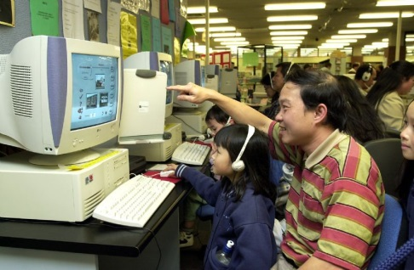To generate sound estimates of the overall proportion of people aged 15-74 with limited literacy in specific localities, the prevalence of limited literacy among various combinations of age, educational and birthplace were determined from an earlier national survey of literacy – the 2006 Adult Literacy and Life Skills Survey - then coupled with information about the population of these segments of the community, based on the findings of the 2006 Census. The results – while somewhat out-of-date - suggested that approximately 26% of residents of Greater Dandenong aged 15 to 74 - or 21,000 people - have limited English literacy (Literacy Level One), compared with 16% of Victorian residents.