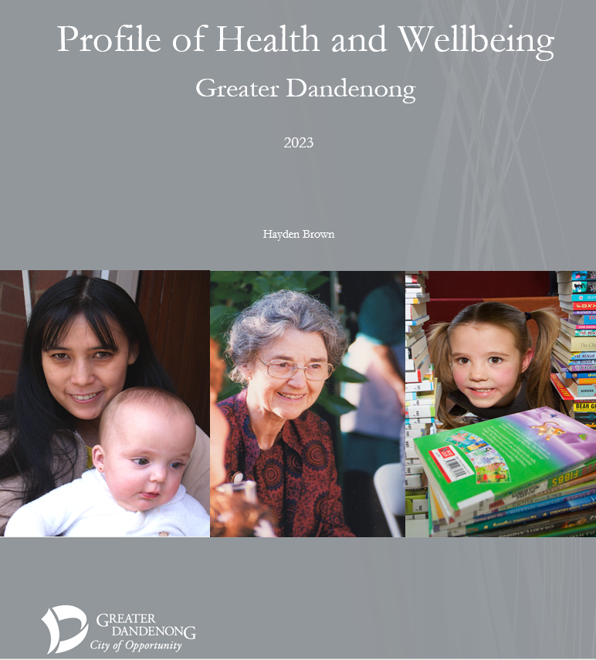

CONTENTS
POPULATION
Population 1
Young People 2
Families, Births and Children 5
Older Residents 10
Cultural Diversity and Settlement 13
People Seeking Asylum 15
Languages 19
Religion 21
Indigenous Residents 24
LGBTI Communities 27

EDUCATION, WORK AND MATERIAL CONDITIONS
Education 31
Employment 37
Business 41
Incomes 42
Gambling 45
Housing 47
Transport 52
Socioeconomic Disadvantage 54

SOCIAL CONDITIONS
Social Inclusion 59
Volunteering 62
Arts and Culture 63
Gender Equity 65
Family Violence 72
Crime 75

HEALTH
Physical Health 78
Sport and Recreation 82
Mortality 89
Disability 92
Nutrition 95
Obesity 98
Food Security 100
Diabetes 102
Cancer 104
Mental Health and Psychological Wellbeing 106
Suicide 112
Alcohol 114
Illicit Drugs 116
Smoking 120
Climate Change 123

Population

Population Trends Estimated Population: Greater Dandenong, 1996-2021

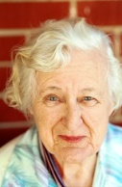
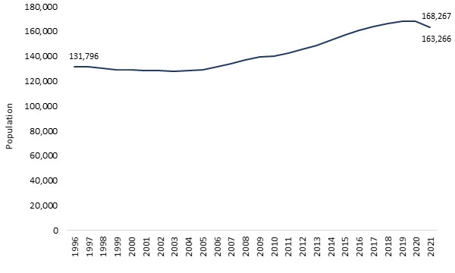
The estimated population of Greater Dandenong remained stable at about 130,000 during the decade to 2006 before rising steadily to 2020, raising the population by about 40,000 or a third. This growth was largely due to residential developments in Keysborough South and Central Dandenong, as well as construction in dispersed locations throughout the city.
In the succeeding year though, the estimated population declined by 5,000 to 163,000 – a decline which is attributed to the fall in settlement and overseas students resulting from the COVID epidemic.
It should be noted that the 2021 estimate is higher than the population recorded in the Census of that year, of 158,000, due largely to the fact that a small but unknowable proportion of residents did not complete the Census.
Population Age Profile
Examination of the structure of the population relies upon the Census, which records the ages of residents. Among the population recorded in the 2021 Census were 17% 0-14 year-olds, 13% young people aged 15-24, 54% people aged 25-64, and 16% of retirement age.
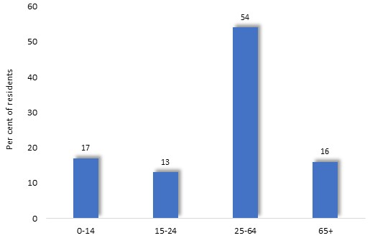

Young People

Persons aged 12 to 24 years are counted here as young people, as this range best matches the age span of those assisted by most youth service providers. In some instances though, other ages are specified, either to match the structure of the available data or because they are more suitable.
In 2021, nearly 20,300 residents in Greater Dandenong were aged 12-24 years, representing approximately one in six residents. Approximately 154 residents of this age were Aboriginal or Torres Strait Islanders.
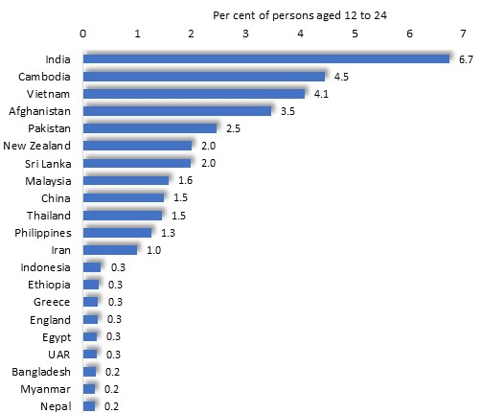
Cultural Diversity
In 2021, nearly two-fifths (39%) of Greater Dandenong residents aged 12-24 were born overseas. They come from 86 different birthplaces, including India, Afghanistan, Vietnam, Cambodia, Sri Lanka, China, Pakistan and Burma.

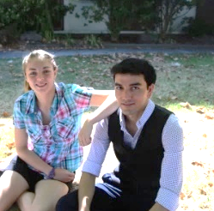
Selected birthplaces of persons aged 12 to 24: Greater Dandenong, 2021

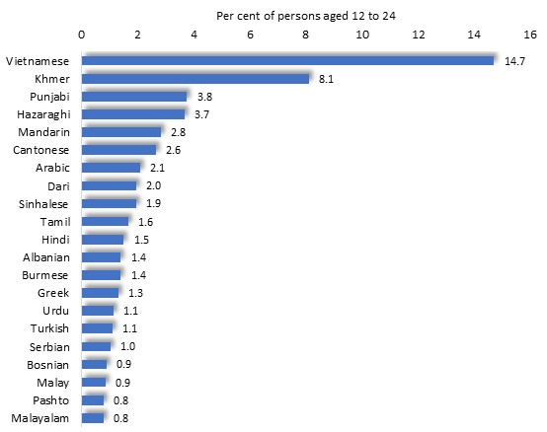

Languages spoken by persons aged 12 to 24: Greater Dandenong, 2021

Spoken Languages
Sixty-six per cent of 12 to 24 year-olds speak languages other than English at home, including Vietnamese, Mandarin, Cantonese, Arabic and Dari. By contrast, 31% of young people across Melbourne speak languages other than English at home.
Approximately 2.8% of young people aged 12 to 24 in Greater Dandenong, numbering 542, have limited fluency in the use of spoken English. Limited fluency is most widespread among those who speak languages such as Malay, Tigrinya, Karen and Nuer (each exceeding 10%). The greater numbers of young people with limited English fluency however, include those who speak Khmer and Vietnamese, each accounting for 112 people, as well as Mandarin (numbering 50), Malay (46) and Hazaraghi (41).
Educational Participation and Outcomes
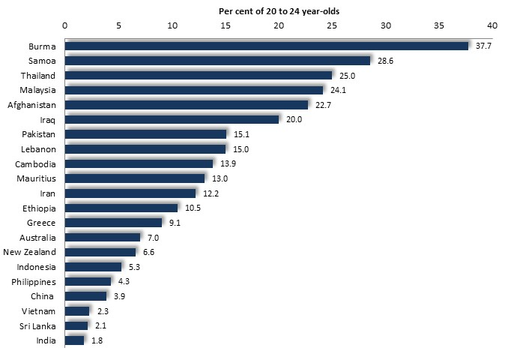
In 2021, 8.1% of local 20- to 24-year-olds had left school before completing year 11 (‘left school early’) - compared with 6.3% across Melbourne.

Per cent of 20-24 year-olds who had left school before

completing Year 11: Greater Dandenong, 2021

Early school leavers included one-fifth of young adults from Burma, Samoa, Thailand, Malaysia, Afghanistan and Iraq, compared with less than one in ten from Australia, and one in twenty from Philippines, China, Vietnam and India.
Nearly a third (32%) of 20-24 year-olds in Greater Dandenong were attending university and other tertiary institutions in 2021 (a rise from 20% in 2006), compared with 38% of those across Melbourne. By contrast, 12% of young adults of this age from Greater Dandenong were attending TAFE institutions, compared with 9.3% of those across Melbourne.
Disengagement of 20-24 year-olds by age and gender: Greater
Youth Disengagement Dandenong and metro. Melbourne 2021
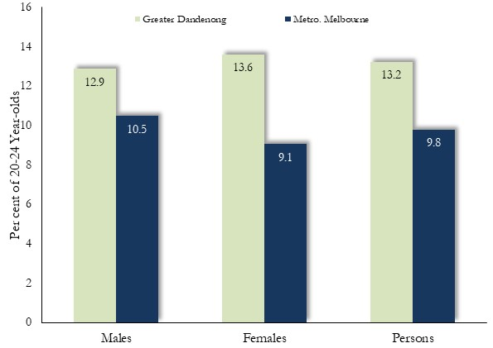
Counting the number of young people who are not in paid work or enrolled in education – termed ‘disengagement’ – gauges the overall educational and economic advancement of young people in the community.
In 2021, the Census found that 1,900 15-24 year-olds in Greater Dandenong were neither employed nor enrolled in education. The proportion of young people who were disengaged rose with age from 6.1% of 15-19 year-olds, to 13.2% among those aged 20-24 years.
Disengagement and Gender
In 2021 rates of disengagement among 20-24 year-olds stood at 12.9% among males and 13.6% among females. The difference is almost entirely due to the high rate of disengagement among young women with children.
Disengagement and Birthplace
In 2021, the rate of disengagement in Greater Dandenong was 14.5% among Australian-born young people, rising to 20% or more among those from Burma, Thailand, Iran, Afghanistan and Malaysia.

Disengagement rates by birthplace, Greater Dandenong, 2021
 | No. disengaged | % disengaged
Burma | 21 | 39.6
Thailand | 40 | 32.3
Iran | 21 | 26.3
Afghanistan | 109 | 22.6
Malaysia | 72 | 22.4
New Zealand | 37 | 18.9
Australia | 735 | 14.5
Pakistan | 26 | 12.6
China | 21 | 11.5
Cambodia | 60 | 10.2
Philippines | 17 | 10.0
Vietnam | 50 | 9.5
Sri Lanka | 19 | 5.7
India | 54 | 3.7

Mental Health
The 2021 Census inquired in 2021, for the first time, about the presence of chronic illnesses, including mental health disorders. In response to this inquiry, 5.5% of 15 to 24 year-olds recorded that they were experiencing a mental health disorder, including 3.5% of males and 7.6% of females.
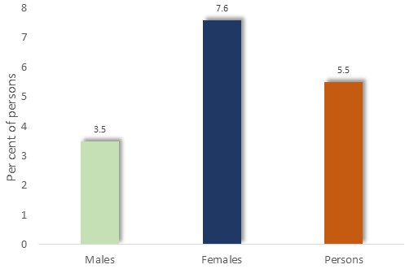
Prevalence of mental health disorders among persons aged 15 to 24: Greater Dandenong, 2021

Families, Births and Children
Births
In 2020/21, 2,185 births were recorded in Greater Dandenong, representing a rise of 26%, or 453, since 2001/2, though a decline of 251 or 10% from 2018/19, in the most recent two years.
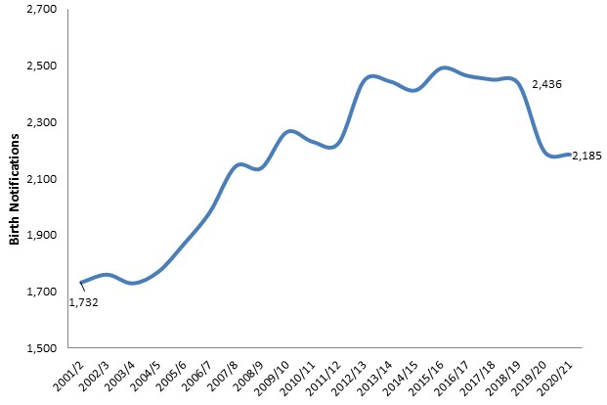

Annual Births: Greater Dandenong, 2001-2021

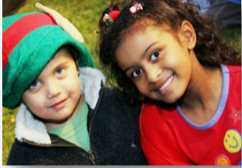

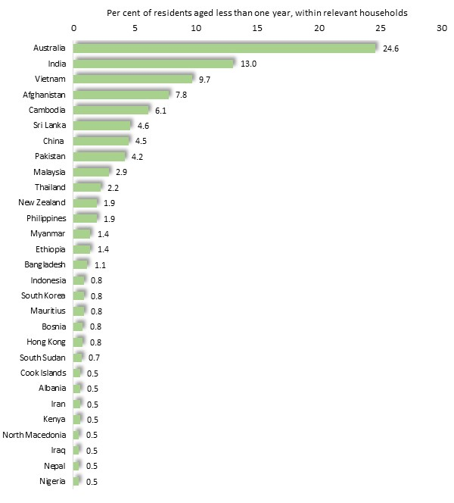
A count of infants and the birthplaces of their mothers, within households whose members were living in Greater Dandenong at least 12 months before the August 2021 Census, provides an indication of the range of birthplaces among women who gave birth in that year.

Birthplaces of women who had given birth in the previous year: Greater Dandenong 2021

Among these infants, 75% had an overseas-born mother - the highest proportion in Victoria - with birthplaces incuding India, Vietnam, Affghanisttan, Cambodia, Sri Lanka, China and Pakistan. These birthplaces alone, account for half of the births to these residents during the year to August 2021.
A selection of birthplaces is presented above, right.

Birth rates by age: Greater Dandenong and Melbourne, 2021
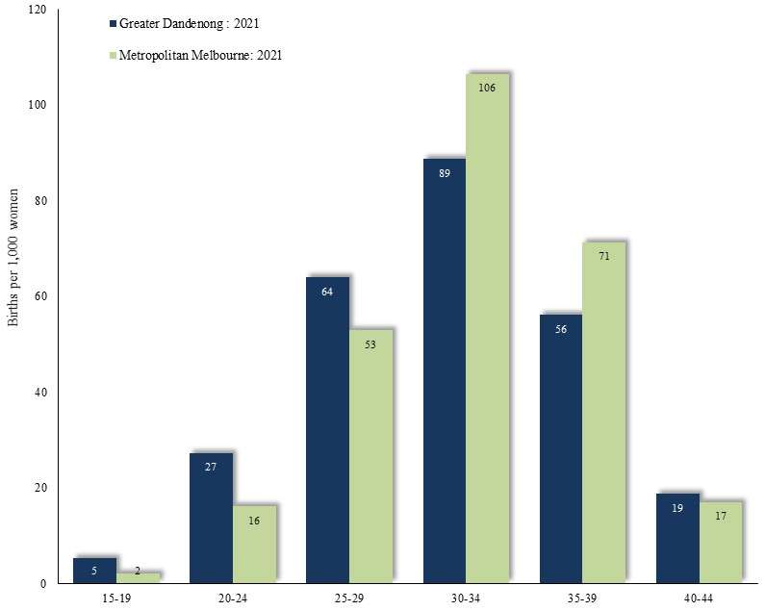

Birth Rates
In 2021, birth rates among women aged 15-29 in Greater Dandenong were substantially higher than for Melbourne, and lower among women over 30 – a circumstance frequently encountered in localities of social disadvantage. The average number of children a woman may be expected to bear in a lifetime, based on current birth rates, is 1.3 – lower than the corresponding level of 1.7 in 2000, and the same as the metropolitan level in 2021.
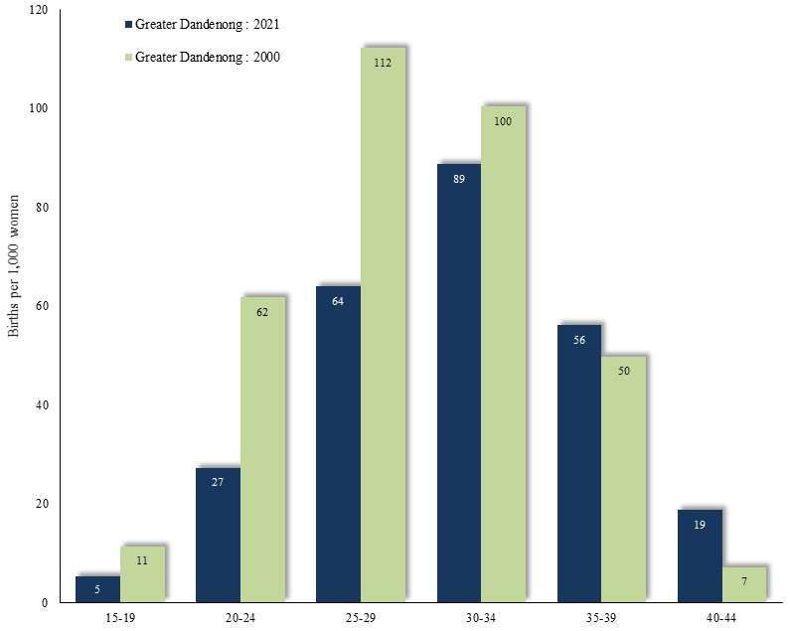

Birth rates by age: Greater Dandenong, 2000 and 2021

A comparison between the birth rates in Greater Dandenong in 2021 and 2000 – nineteen years earlier – shows a decisive fall in birth rates among women aged less than 30 years, coupled with a smaller rise in rates among older women.

Average Children ever Born by Age and Education Level:
Circumstances which Influence Birth Rates Greater Dandenong, 2021
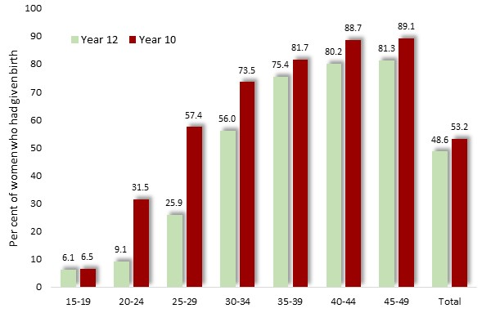
Fertility rates are strongly influenced by education. For example, among 20-24 year-olds, those with incomplete secondary education are over three times more likely to have children than those who competed year 12.

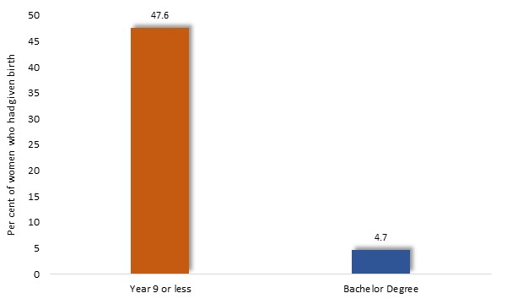
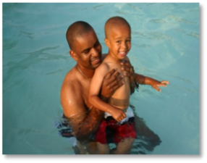
More strikingly, 47% of 20-24 year-old women in Greater Dandenong with year nine or less secondary education had given birth, compared with 4.7% - or one-tenth that proportion – of women with university degrees.

Proportion of women aged 20-24 who had given birth, by educational attainment: Greater Dandenong, 2021

Birth rates and Birthplace
Birth rates also vary widely with birthplace. The proportion of 20-24 year old women in Greater Dandenong who had given birth is illustrated here for a selection of birthplaces.
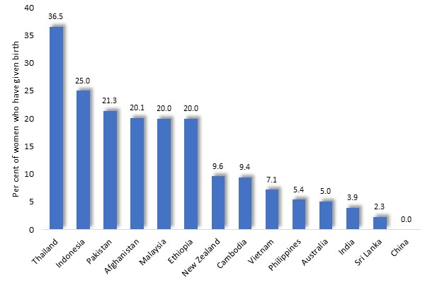
The proportion of these young women who had given birth ranges from over 20% of those born in Thailand, Indonesia, Pakistan, Afghanistan, Malaysia and Ethiopia, to its lowest levels of 5% of less among those from Australia, India, Sri Lanka and China.

Proportion of women aged 20-24 who had given birth, by birthplace: Greater Dandenong, 2021

Birth rates and Religion
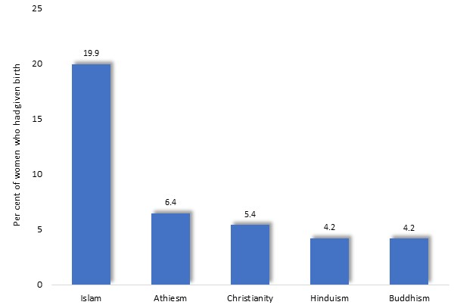
The proportion of women aged 20-24 who had given birth, also varies widely with religion. In 2021, women in Greater Dandenong who adhered to Islam featured the highest levels of childbirth – about five times higher than among those who follow Buddhism and Hinduism.

Proportion of women aged 20-24 who had given birth, by religion: Greater Dandenong, 2021

Such disparities in the proportion of young women who had given birth may not be attributed to religion alone, but to associated conditions such educational attainment.
Where the same information is disaggregated by educational attainment, wide differences in the proportions of young women who have given birth emerge, between those with completed secondary education and those who left school early. For example, among 20-24 year-old women in Greater Dandenong, who adhere to Hinduism, 43% of those with less than year 11 education had given birth, compared with just 2% of those with complete secondary education. A similar pattern, though less pronounced, may be seen among adherents to other religions.
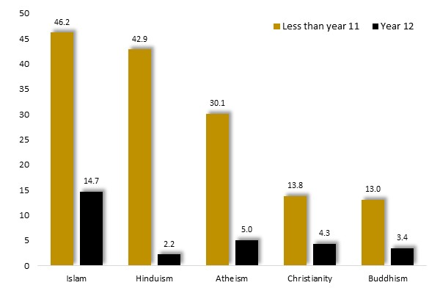
Proportion of women aged 20-24 who had given birth, by religion and educational attainment: Greater Dandenong, 2021

Families Family Types: Greater Dandenong, 2021
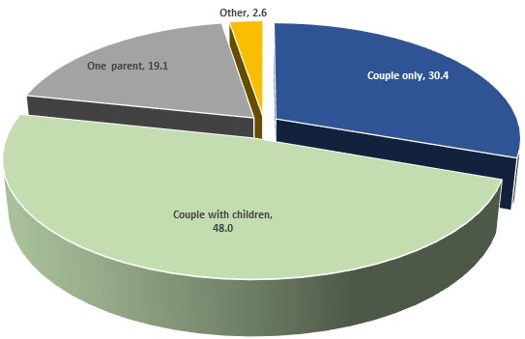
In 2021, there were approximately 40,000 families in Greater Dandenong. Among them, a third (30%) were couples only, 48% couples with children, 19% are headed by a single parent, and the balance, other family types.

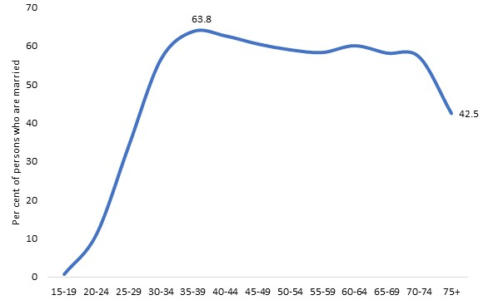
Marriage Proportion of persons who are married, by
age: Greater Dandenong, 2021
In 2021, 49% of Greater Dandenong residents aged 18 or more were married – 89% in registered marriages and 11% defacto.

The proportion of residents who were married rose steeply to its peak of 64% among those aged 35-39 years, before declining slightly into older age, and falling steeply among people aged 75 or more, as a consequence of mortality.

Early Marriage Proportion of 20-24 year-olds who are married, by birthplace: Greater Dandenong, 2021
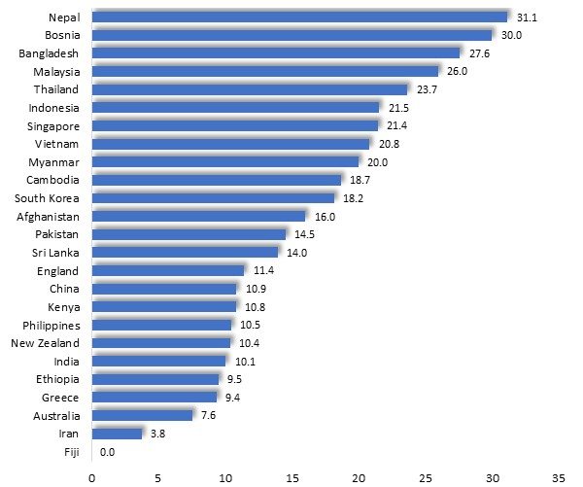

While 11% of 20-24 year-olds in Greater Dandenong are married (registered or defacto), this proportion varies widely with birthplace. Over a quarter of 20-24 year-olds from Nepal, Bosnia, Bangladesh and Malaysia are married, compared with fewer than 10% among similarly-aged residents from Greece, Australia, Iran and Fiji.

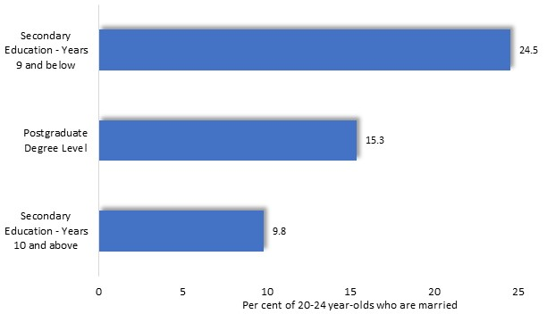
The proportion of young adults who are married is highest among those with limited secondary education, and higher among those with further secondary or post-school educational attainment.

Proportion of 20-24 year-olds who are married, by religion and sex: Greater Dandenong, 2021

The propensity of couples to be married also varies widely among Victorian municipalities, especially among young people. The proportion of 20-24 year-olds that are married descends from 25% in Glenelg and Pyrenees, to less than 10% in affluent metropolitan municipalities, such as Bayside, Nillumbik, Manningham and Boroondara.
Other Marriage Trends
Across Australia, people marry less often and later in life than in the past. Between 1980 and 2020, the median age of marriage has risen from 23 to 31 among women and from 26 to 32 years among men. Meantime, the proportion of 20-24 year-old men who marry in a 12-month period has declined to a tenth of its 1980 level.
In addition, the influence of tradition upon marriage has dwindled, with the proportion of Australian marriages presided over by a civil celebrant rising from 3% in 1906, to 10% by 1960, before climbing to 80% by 2020. A further trend is the apparently rising number of same-sex couples, as well as the formal recognition of registered marriage between individuals of the same sex, since 2017. Approximately 500 persons in Greater Dandenong reported in the 2021 Census that they were members of same-sex couples - representing 0.6% of all residents living as couples. Among these 500 residents, 41% were living as husband, wife or partner and 59% stated that they were living as de facto partners.
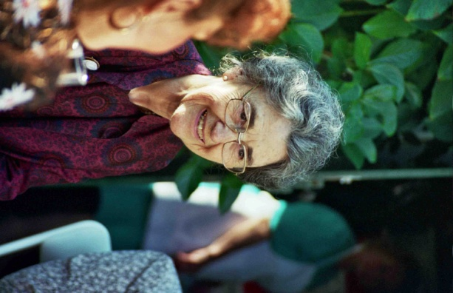
Older Residents

Population: In 2021, approximately 17,760 people in Greater Dandenong, or 11% of residents, were aged 70 years or more. This number represents a rise of 14% in the number of residents of this age range, foreshadowing future growth in the number of older residents.

Persons aged 70 years or more, by selected birthplaces, 2021
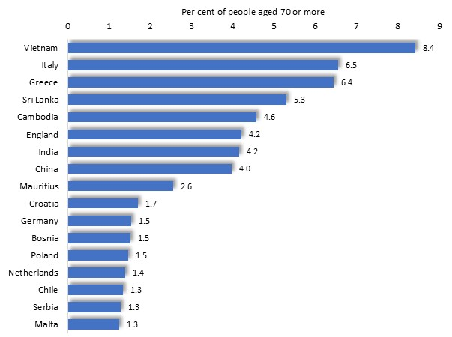
Cultural Diversity
In 2021, three-quarters (75%) of local residents aged 70 or more were born overseas – higher than the metropolitan level of 5%, and the second largest proportion in Victoria.
Their birthplaces include Italy, Vietnam, Greece, England, Sri Lanka and China.

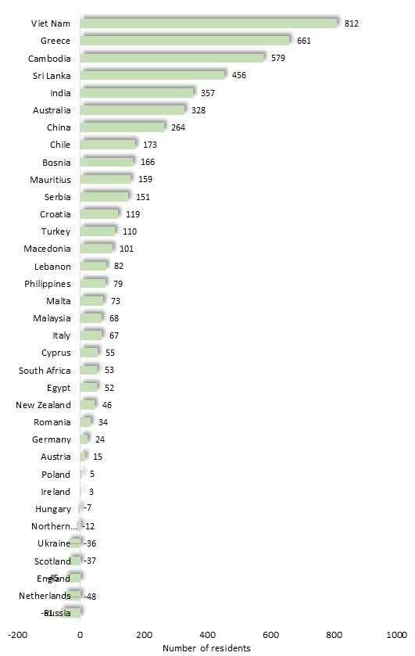

Change in population aged 70+, by selected birthplaces, 2006 to 2021

The 2021 Census also recorded that 30 Indigenous residents were aged 70 or more.

Cultural Diversity Trends
During the 15-year period from 2006 to 2021, the number of residents aged 70 or more, from European countries, such as Russia, Netherlands, Britain, Germany, Italy, Malta and others, either declined or rose to only a small extent.
During the same period, the number of older residents from Asian nations such as Vietnam, Cambodia, China, Sri Lanka and India grew substantially (diagram, right).

Spoken Languages
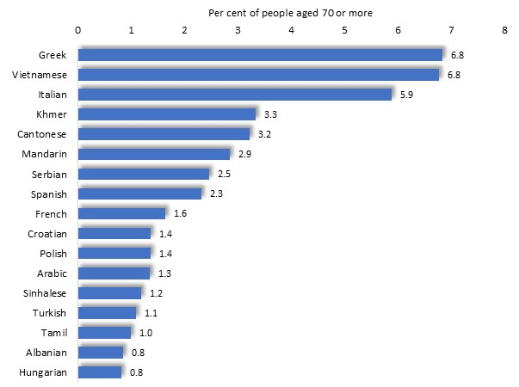
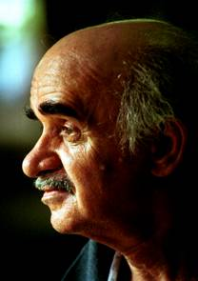
Reflecting the cultural diversity of residents aged 70 or more, over half (56%) speak languages other than English at home, including Greek and Vietnamese (each spoken by 6.8% of older residents), Italian (5.9%), Khmer (3.3%), Cantonese (3.2%), Mandarin (2.9%) and others.

Persons aged 70 years or more, by selected spoken languages: Greater Dandenong, 2021

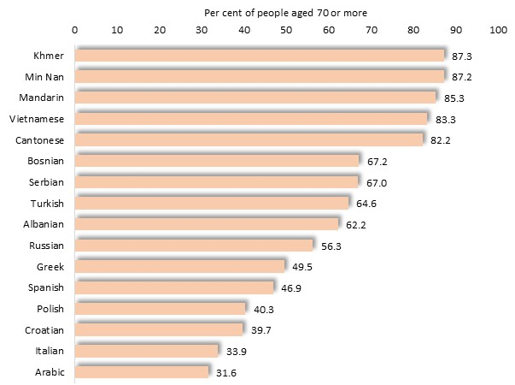
English Fluency
Nearly a third (30%) of residents aged 70 or more has limited fluency in the use of spoken English - the highest proportion in Victoria.
These include over four-fifths of older residents who speak Khmer, Vietnamese, Mandarin, Cantonese and Min Nan.

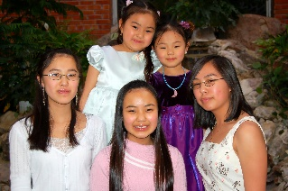
Per cent of residents aged 70 years or more, who have limited English fluency: Greater Dandenong, 2016

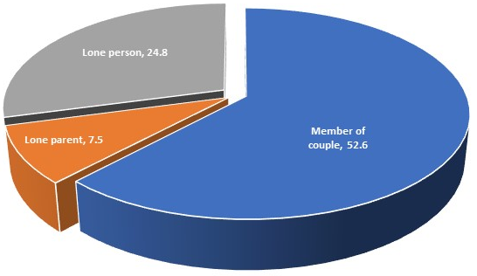
Household Types
Of the 91% of residents aged 70 or more, who live in private households, over half are members of a couple, about a quarter are lone persons, and 7.5% are lone parents.

Relationship in Household, Persons aged 70+ and living in a private dwelling, 2021

Older residents living with children
The proportion of older residents who live with – and potentially receive support in daily living from – their children varies widely with birthplace. Of residents aged 70 or more in 2021 who were living in a private residence, 34% of those from Afghanistan, 21% of those from Burma, and approximately 15% of older residents from Burma, China, Macedonia, the Philippines and Vietnam were living with one of their children. By contrast 2% of Australian-born residents of that age were living with one of their children.

Incomes, Employment and Welfare Dependence
Incomes and employment
In 2021, the median income among Greater Dandenong residents aged 55-59, an age when many are approaching retirement, stood at $707 (including $874 among men and $525 among women) - the lowest in Melbourne in 2021 and substantially less than the corresponding Victorian median of $1,017.
Among residents of this age, 61% were in paid employment – including 69% of males and 53% of females – lower than the Victorian level of 73%. Consequently, a substantial proportion of residents may enter their older age with a recent history of low income and non-employment, exposing them to the risk of financial hardship during retirement.
Pensions
In June 2022, the ratio of aged pension recipients to persons aged 65 years or more in Greater Dandenong (expressed as a percentage) was 68% - higher than the metropolitan level of 52%, and the second highest level of dependence upon the pension in the State.

Cultural Diversity and Settlement
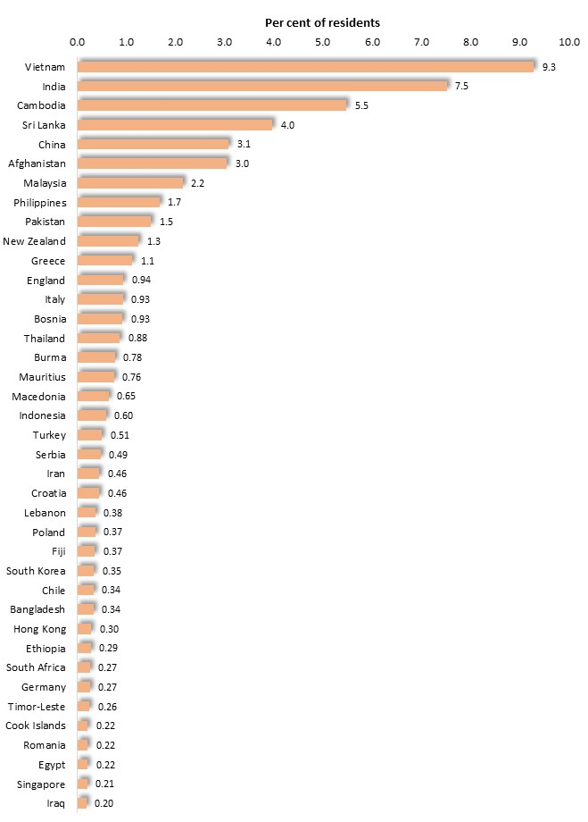
Cultural Diversity
The 2021 Census found that Greater Dandenong is the most culturally diverse locality in Australia, as it was in 2016, with residents from at least 154 different birthplaces and well over half (63.4%) of its population born overseas.
Major birthplaces, aside from Australia, included Vietnam, India, Cambodia, Sri Lanka, China, Afghanistan, Malaysia, Philippines, Pakistan, and New Zealand.
More than four out of five (88%) residents have at least one overseas-born parent.

Population by Selected Birthplaces: Greater Dandenong, 2021

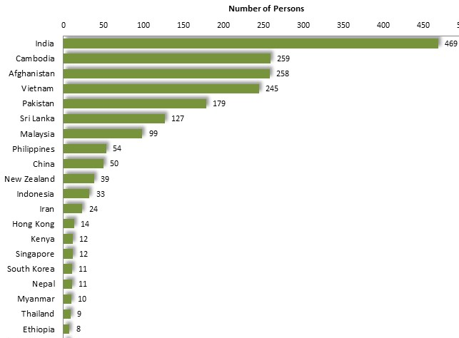
Recently-arrived Residents
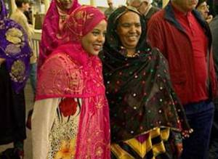
The Census recorded that approximately 2,038 residents of Greater Dandenong had arrived in Australia after 2019, representing 1.3% of the population - compared with 6.4% in 2016, but still the third highest proportion in Victoria.

Residents who had arrived in Australia in the past 18 months, by birthplace: Greater Dandenong, 2021
Among these new arrivals, 23% were born in India, 12.7% were from each of Cambodia and Afghanistan, 12% were from Vietnam, and 9% were from Pakistan. Together, these ten nations account for nearly seven-tenths (79%) of residents who had arrived in Australia in the 18 months prior to the 2021 Census.
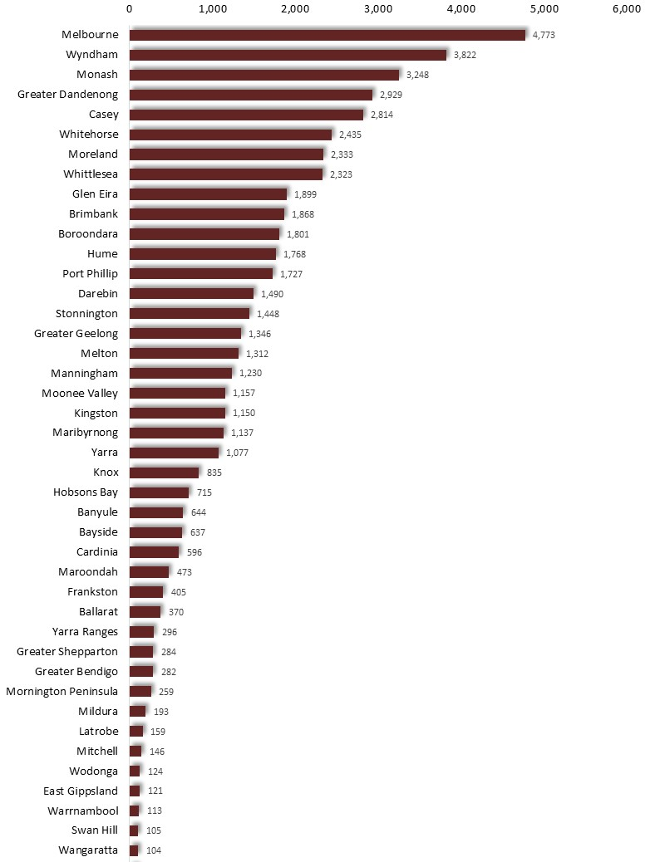
Settlement
In 2020/21, 56,000 people settled in Victoria from overseas. About one in twenty of them, numbering 2,920 people, settled in Greater Dandenong - representing the fourth highest rate of immigrant settlement among Victorian municipalities (after Melbourne, Wyndham and Monash).

Migrant settlement by Birthplace: Greater Dandenong, 2020/21



Among these settlers over half (51%) had arrived under skilled provisions, 46% under family reunion schemes, and 3% as humanitarian arrivals.
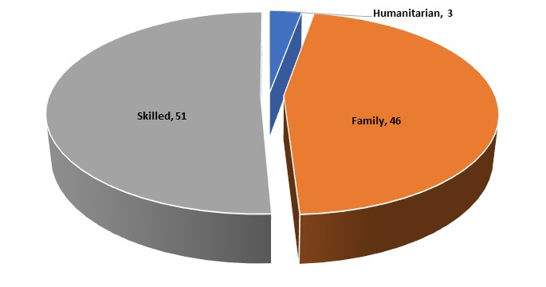
Settlement by Stream: Greater Dandenong, 2020/21

People Seeking Asylum

The following remarks summarise information published by the Commonwealth Department of Immigration and Border Protection concerning the number, geographic distribution and characteristics of People seeking asylum who had arrived in Australia by boat, who were living in Victoria in June 2022.
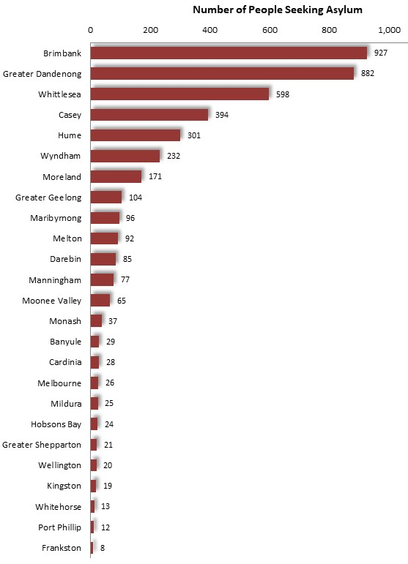

Municipality of Residence
People seeking asylum by Municipality of Residence: June 2022

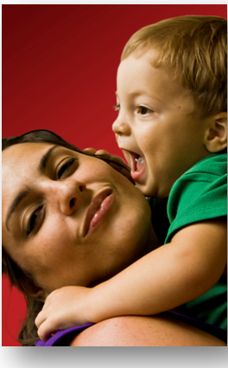
At this time, 4,791 people seeking asylum, who had arrived in Australia by boat, were living in Victoria.
Four-fifths (20%) were male and over one-fifth (20%) female.

Twenty-one per cent of those people seeking asylum whose municipality could be determined - numbering 882 - resided in Greater Dandenong - the second largest number in any Victorian municipality, after Brimbank with 927 people seeking asylum.

Changes in Number of People seeking asylum
In the period from September 2014 to June 2022, the number of people seeking asylum residing in Victoria fell by 51%, or approximately 4,492 people.

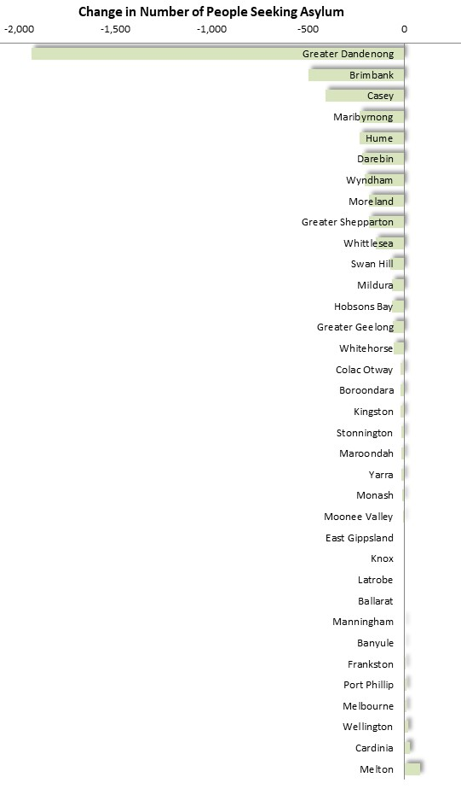
Change in Number of People Seeking Asylum, by Municipality: September 2014 to June 2022

During this period, a decline of 1,935 was recorded within Greater Dandenong – the largest in Victoria – accompanied by falls of 498 in Brimbank and 395 in Casey (diagram above). Overall, the number of people seeking asylum halved across Victoria in that time, falling from 8,777 to 4,285
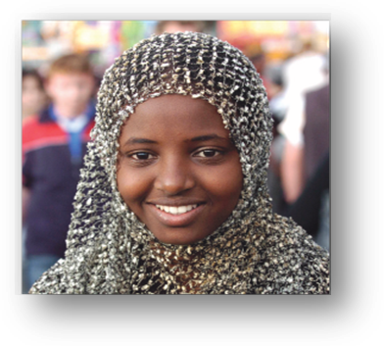
Suburb of Residence
Among people seeking asylum in Greater Dandenong, about two-thirds (591) resided in the suburbs of Dandenong and Dandenong North, with a further 138 in Springvale, 131 in Noble Park and Noble Park North, 15 in Springvale South and Dingley Village, and 14 in Keysborough. (Total slightly exceeds the municipal total, due to the inclusion of Dingley Village)

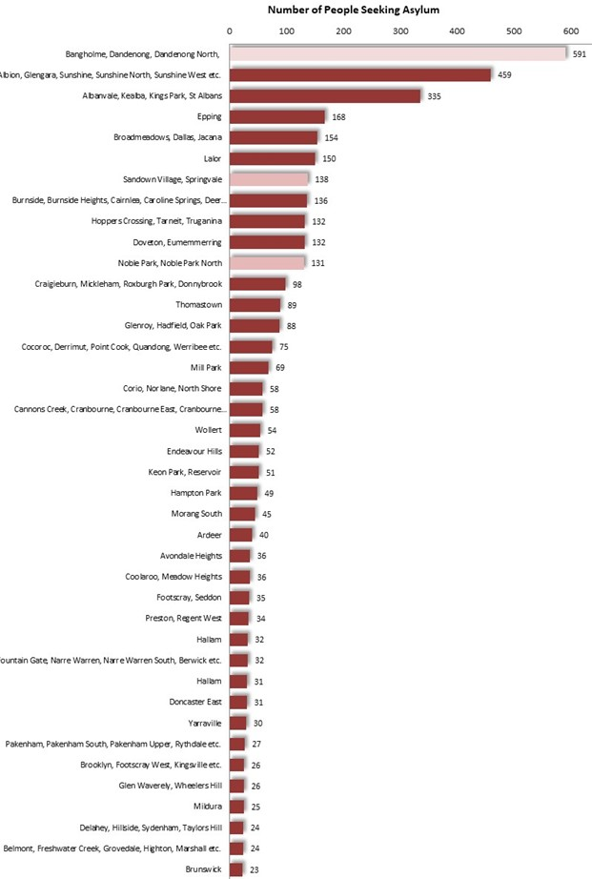
The diagram at left illustrates the number of people seeking asylum in a selection of Victoria suburbs and towns.

People seeking asylum, by Suburb of Residence: June 2022

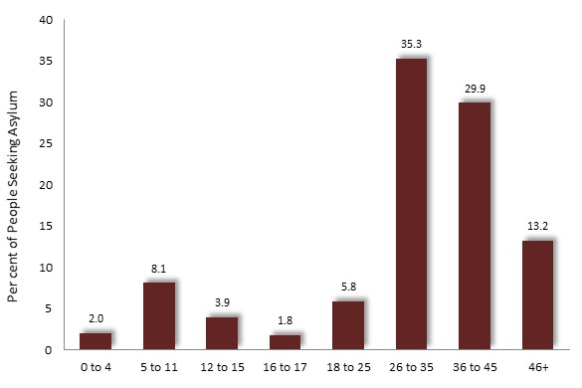
Age
Information concerning age, birthplace and other social characteristics of people seeking asylum, is available at a State-wide level.

People seeking asylum across Victoria, by Age: June 2022

Among the 4,791 people seeking asylum in Victoria, nearly a quarter (22%) were aged up to 25 years, nearly two-thirds (65%) were 26 to 45 years old, and 13% over 45.

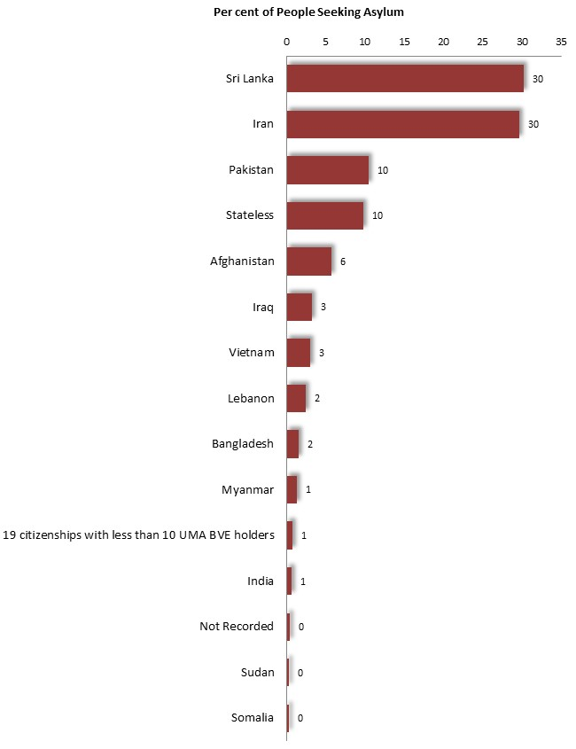
Birthplace
People seeking asylum throughout Victoria are largely from Sri Lanka (accounting for 1,448 or 30%) Iran, Afghanistan, Pakistan and Iraq. Together, these birthplaces account for nearly four-fifths (79%) of People seeking asylum in Victoria (accompanying diagram).

People seeking asylum across Victoria by Selected Birthplace: June 2022

Spoken Languages
More than two-thirds of the residents of Greater Dandenong speak languages other than English in their homes, while one in seven has limited fluency in the use of spoken English.
Spoken Languages: Greater Dandenong, 2021
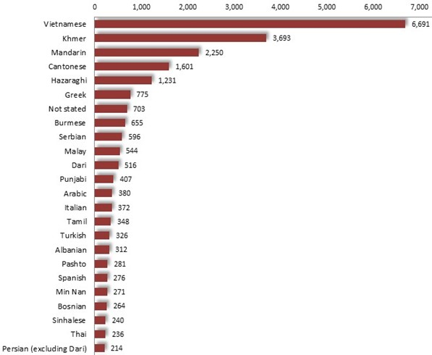
Spoken Languages
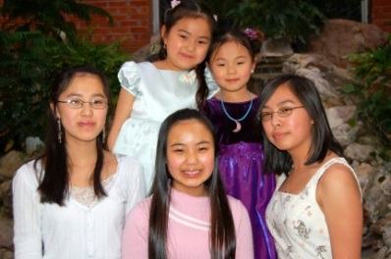
In 2021, over 69% of residents spoke languages other than English in their homes – the largest proportion in Victoria and over twice the metropolitan level of 31%. Among the more than 135 different languages spoken are Vietnamese, Khmer, Chinese, Greek, Punjabi and Sinhalese.
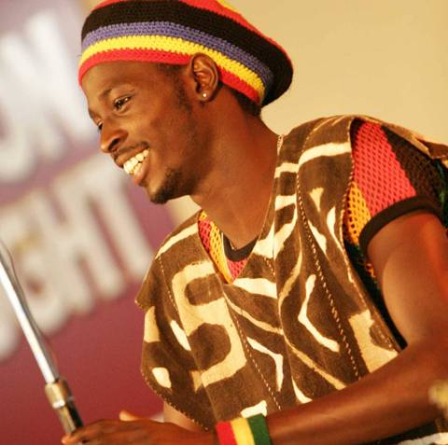
Greater Dandenong has the widest diversity of languages in Victoria and the second highest in Australia.

English Fluency Limited English fluency by Spoken Language: Greater Dandenong, 2021
Nearly one in five residents - accounting for nearly 23,000 people or 18% of the population at the time of the 2021 Census - has limited fluency in the use of spoken English – about four times the metropolitan level of 4.6%.
Many residents who speak Vietnamese, Khmer, Chinese languages, Afghani languages and Greek have limited English fluency (above right).
The prevalence of limited fluency in the use of spoken English, varies widely among the municipalities of Victoria and is highest in Greater Dandenong.
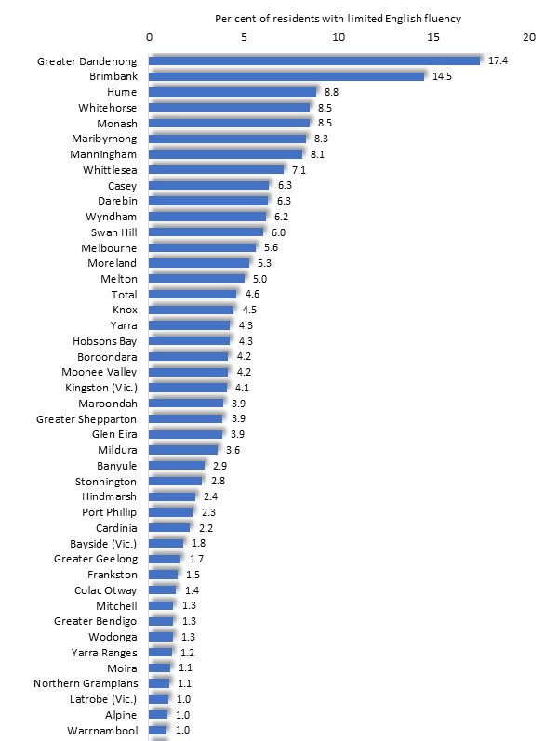
(Municipalities where the prevalence of limited English fluency was less than 1% are omitted from the accompanying diagram)

Limited English fluency: Selected Victorian municipalities, 2021



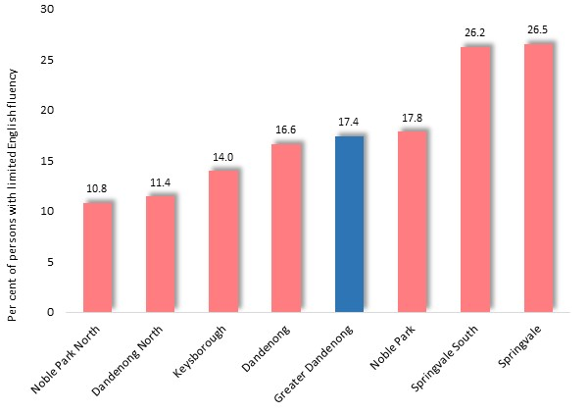
The prevalence of limited English fluency varies among the suburbs of Greater Dandenong, from over 26% in Springvale and Springvale South, to 10.8% in Noble Park North.

Prevalence of Limited English Fluency: Suburbs of Greater Dandenong, 2021

Religion

Religious Faith in Greater Dandenong
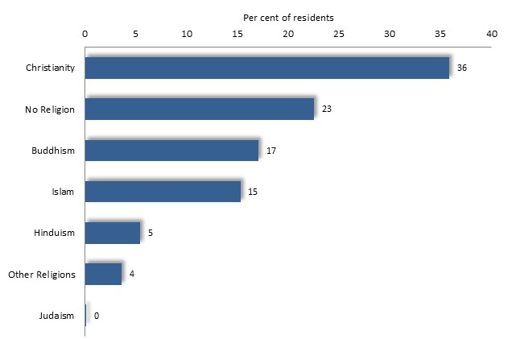
The diversity of Greater Dandenong is reflected in its range of religious faiths, which include Buddhism, adhered to by approximately 17% of residents, Islam [15%], Hinduism [5%] and Christianity [36% - down from 41% in the 2016 Census]. A further 23% of residents are atheists.

Per cent of residents who adhere to major faiths: Greater Dandenong, 2021

Perhaps reflecting settlement patterns and the age makeup of the population, the proportion of residents who follow Islam and Hinduism tends to decline with age, whereas the prevalence of Christianity, Buddhism and Atheism is relatively stable across age groups.

Religion and Birthplaces
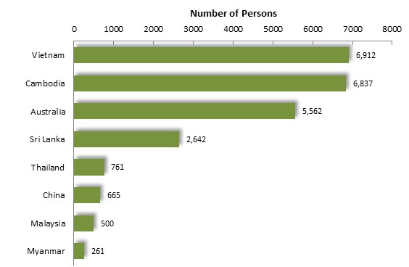
Major birthplaces among Greater Dandenong residents who adhere to each major religious category, vary widely. The number of residents from various birthplaces who adhere to each of the major religious, is illustrated below.

Number of people by selected birthplace who adhere to Buddhism: Greater Dandenong, 2021

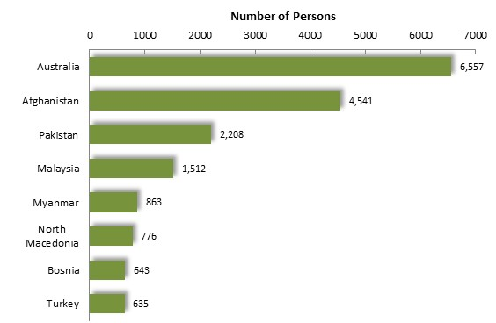

Number of people by selected birthplace who adhere to Islam: Greater Dandenong, 2021

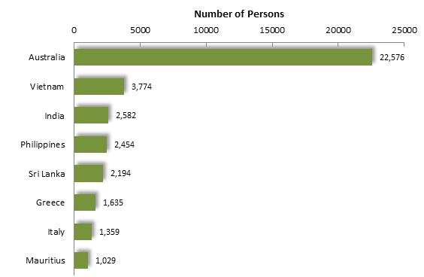

Number of people by selected birthplace who adhere to Christianity: Greater Dandenong, 2021

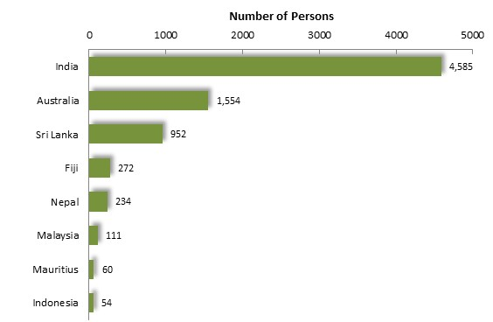

Number of people by selected birthplace who adhere to Hinduism: Greater Dandenong, 2021

Detailed Faith Groups
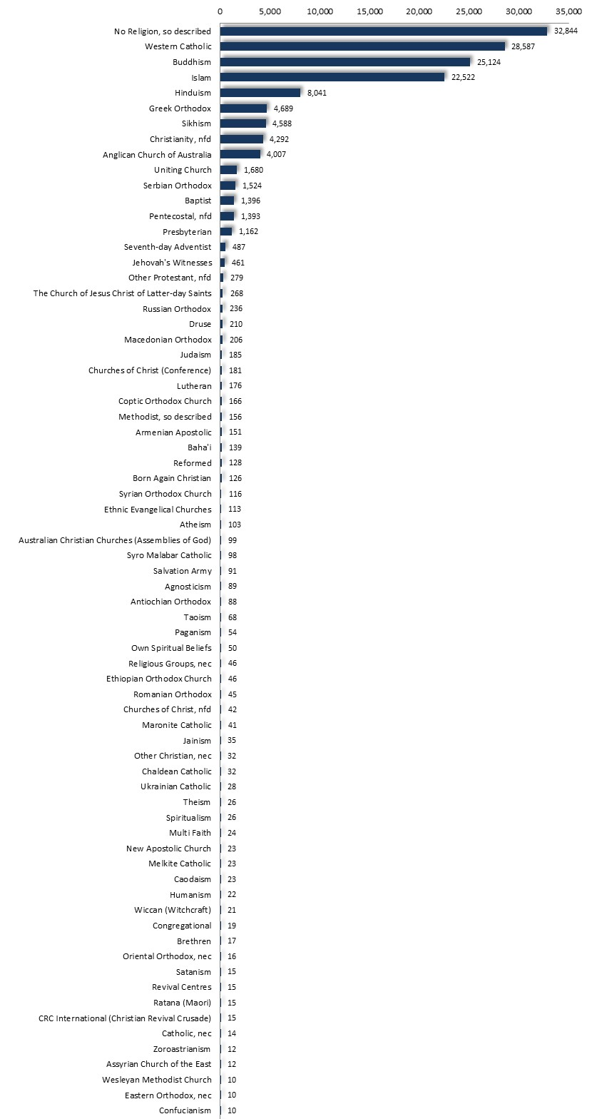
A selection of the major faith groups in Greater Dandenong, featuring detailed denominations of Christianity and based on the findings of the 2021 Census, is illustrated at left.

Detailed categories of religious faith: Greater Dandenong, 2021

Aboriginal and Torres Strait Islander Residents
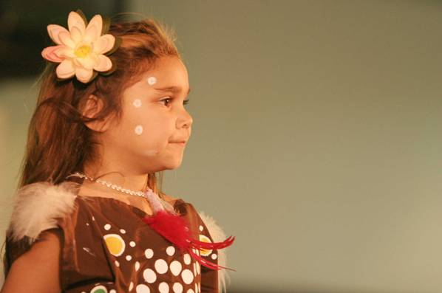
Population
In the past forty years, the number of Aboriginal and Torres Strait Islanders recorded by the Census in Greater Dandenong increased four-fold, from 150 in 1981, to 615 by 2021, representing 0.4% of the population. Within this city and its adjoining municipalities, the 2021 Census recorded 7,076 Aboriginal residents.
Per cent of Population by Age: Aboriginal and
Non-Aboriginal Residents, Greater Dandenong, 2021
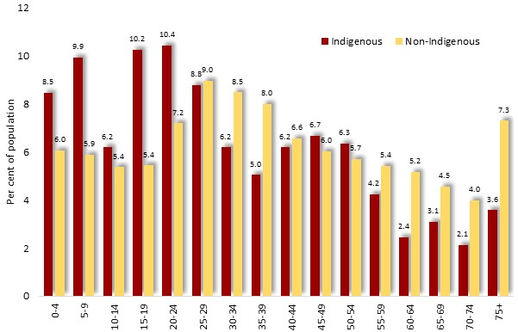
Indigenous people living in Greater Dandenong are relatively young, with nearly half (45%) aged less than 25 years, compared with 30% of the general population. Conversely, 9% are aged 65 years or more, compared with 16% of non-Aboriginal residents. Their median age is 28 years, compared with 37 for the general population, reflecting their lower life expectancy and higher birth rates.

Families with Children by Type: Aboriginal and
Families non-Aboriginal Residents, Greater Dandenong, 2021
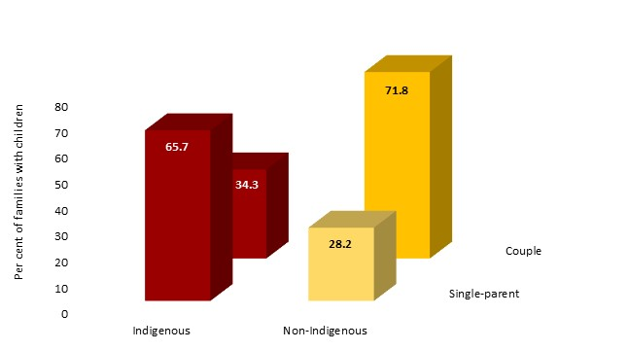
In 2021, nearly two-thirds (65.7%) of couple and single-parent families in Greater Dandenong with Indigenous members were one-parent families – more than twice the level of 28% among other families. In the same year, 47% of local Indigenous families with children had no parent in paid employment compared with 32% across all families in Greater Dandenong.
Early birth rates were relatively high among young Aboriginal and Torres Strait Islander women, with 6.7% of 15-24 year-old women in Greater Dandenong having borne a child, compared with 4.7% of non-Aboriginal women of that age.
Education
In 2021, 30% of young Indigenous adults aged 20 to 24 years, had left school before completing year 11 – over three times the corresponding level of 8% among non-Indigenous young adults in Greater Dandenong. Among Indigenous residents aged 25 to 44 years, 3.3% held a degree or higher qualification in 2021, compared with 18% of non-Indigenous people of that age across Greater Dandenong.
Further information of relevance comes from State-wide sources. The 2021 Australian Early Development Index found that 42% of Australian prep. pupils of Aboriginal or Torres Strait Islander descent were vulnerable in one or more domains of development, compared with 22% of all prep. pupils across the nation.
Employment
The 2021 Census recorded an unemployment rate of 13% among 25 to 64 year-old Indigenous residents of Greater Dandenong, compared with 4% among the general population.
Housing
Indigenous residents Greater Dandenong are less than half as likely to own or be purchasing their homes (26%) as the general population (63%), and more often rent their accommodation. Twenty-seven per cent of Indigenous residents rent from government or community agencies, compared with 2.9% of others.
Disability and Health Long-term conditions by Indigenous Status:
Greater Dandenong, 2021
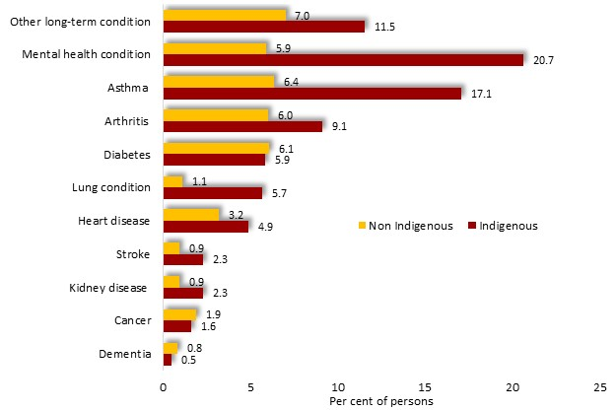
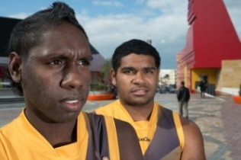
The 2021 Census revealed that the prevalence of severe disability stood at 14.4% among Indigenous residents – nearly twice the corresponding rate of 7.7% among the general population.
The prevalence of long-term health conditions – particularly those relating to mental health, lung function and asthma, and heart disease – is also markedly higher among Indigenous residents in Greater Dandenong (diagram, above right). For example, the 2021 Census recorded that approximately 21% of Indigenous residents had experienced mental health conditions sometime in the previous 12 months, compared with approximately 6% of non-Indigenous residents. A similar disparity was recorded in the prevalence of asthma, experienced by 17% of Indigenous residents and 6.4% of others.

Trends in Social Conditions
An examination of the findings of the 2006 and 2021 Censuses provides a glimpse of changes in social conditions among Indigenous people in Greater Dandenong during that 15-year period.
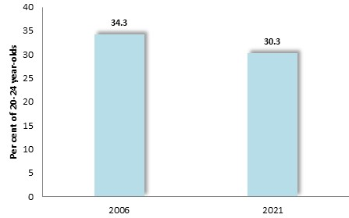
Per cent of 20-24 year-olds who had left school before completing year 11: Greater Dandenong, 2006 and 2021

The proportion of young Indigenous residents who had left school before completing year 11 declined from 34% to 30%, in the 15 years to 2021.


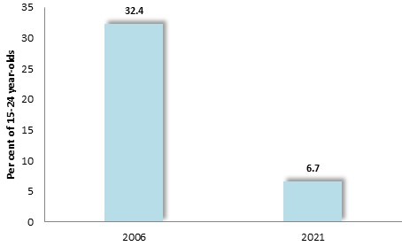

Per cent of Aboriginal 15-24 year-old women with children: Greater Dandenong, 2006 and 2021

During the same period, the proportion of 15 to 24 year-old Indigenous women who had one or more children fell from 32% to 6.7%.

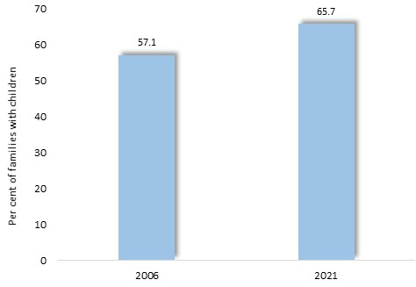
Per cent of Aboriginal families that are one-parent families: Greater Dandenong, 2006 and 2021

The proportion of Indigenous families with children that were headed by one parent rose slightly between 2006 and 2021, from 57.1% to 65.7%.

The percentage of homes that were owned or being purchased by their Indigenous occupants declined from 35% to 25% during the period 2006 to 2021.
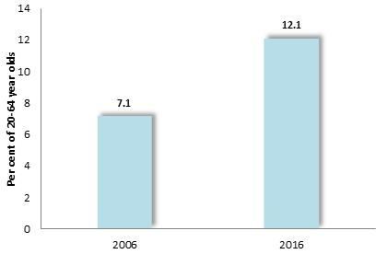
Per cent of 20-64 year-old Aboriginal residents with a severe or profound disability: Greater Dandenong, 2006 and 2021

The prevalence of severe or profound disability among Indigenous residents of Greater Dandenong rose from 7.1% of 20 to 64 year-olds in 2006, to 12.1% by 2021.

LGBTI Communities

Population
A widening acceptance of differences in sexual orientation and identity has encouraged more candid responses to inquiries about such issues, making estimates of the population of lesbian, gay, bisexual, transsexual or intersex (LGBTI) people more reliable than in the past.
One Australian survey found that 6.5% among participants aged 20-29 identified themselves as homosexual, a figure which tended to decline among older respondents. The findings of further studies indicate that the prevalence of bisexuality in Australia may be approximately 5%, transsexuality 0.4% and intersex, 0.02%.
The sum of these figures, of about 12.5%, gives an indication of the proportion of Australian adults who are lesbians, gay, bisexual, transsexual or intersex - equivalent to 670,000 Victorian adults and 17,000 Greater Dandenong residents in 2021. Indeed, similar findings emerged from the 2017 Population Health Survey, where 12% of 18-24 year-old survey participants indicated that they were LGBTI, and a further 3% of these respondents stated that they ‘did not know’ if they were heterosexual - suggesting a possible prevalence of LGBTI individuals of up to 15%.

Discrimination and abuse
Many young people experience antagonism and aggression within their families, stemming from their gender identity or sexuality, an experience which may be accentuated within particular cultural groups. Victimization of young LGBTI people may occur at school, sport, social and other settings, resulting in social exclusion from peers, harassment, threats, violence and accompanying fears for their personal safety. One inquiry found that just 12% of same-sex attracted young people in an Australian sample felt safe at school and 43% on the street.
Further research reveals similarly adverse experiences among adult members of LGBTI communities. One inquiry determined that 44% of a sample of 1,750 LGBTI Australians had experienced “verbal abuse relating to their sexuality or gender” and 16% had been physically abused. Similarly, 34% of LGBTI survey participants in the 2017 Victorian Population Health Survey had experienced discrimination in the previous year, compared with 16% of others.
Mental Health
Exclusion, harassment, abuse and violence jeopardizes the mental health of many young people and adults.
An Australian study of 15,000 22-17 year-old women found that, compared with heterosexual women, those who were same sex attracted experienced higher rates of doctor-diagnosed depression (26.2% compared with 10.9%) or anxiety disorders (9.3% vs. 4.6%) in the previous four years, while a greater proportion had harmed or tried to kill themselves in the previous six months (17.3% vs. 2.7%) (Diagram, below).

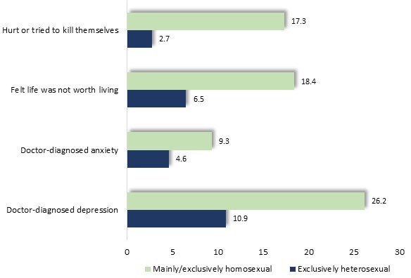
Mental health concerns: young, LGBTI women (McNair et al, 2004)

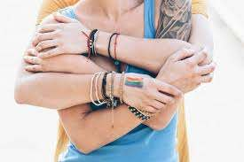
LGBTI participants in the 2017 Victorian Population Health Survey registered unfavourable mental health outcomes, including lower levels of satisfaction with life, with 28% assessing their life satisfaction as ‘fair’ or ‘poor’ compared with 20% of others; higher rates of psychological distress (24% compared with 15% of non-LGBTI individuals); and elevated levels of doctor-diagnosed depression or anxiety (45% compared with 26% of non-LGBTI survey participants). Another Australian study, of over 800 trans young people aged 14-25, found that 75% had been diagnosed during their lifetimes with depression and 72% with anxiety; 80% had self-harmed; 48% had attempted suicide; and 89% had felt rejected by their peers. Among respondents to the 2019 Australian ‘Private Lives’ survey, depression had been diagnosed among 39% of LGBTI participants - nearly ten times higher than the corresponding figure of 4.1% among the general population.
Relevantly, a higher prevalence of mental health concerns among members of LGBTI communities was recorded in the 2021 Census, which found that among Greater Dandenong residents who were members of same-sex couples, 10% were experiencing mental health disorders, compared with 5.1% of members of opposite-sex couples.
Social Connection
Similarly, the proportion of LGBTI individuals who participated in the 2017 Victorian Population Health Survey, who did not feel valued by society, was higher, at 17%, than among others (12%), though other perceptions of connection with the community were similar to the average for all survey participants. Fewer LGBTI individuals were members of sports (17% vs 25%) or religious (12% vs. 15%) groups, than others, though no substantial differences were recorded in involvement in professional organizations, community groups or volunteering.
Health
Among respondents to the 2017 Victorian Population Health Survey, LGBTI individuals recorded less favorable health, with 36% assessing their health as ‘excellent’ or ‘very good’ compared with 43% of others. Elevated rates of smoking (18% daily smokers, compared with 12% among others), and of chronic health conditions (36% compared with 25%) were also documented by the survey.
Distribution of Same-sex Couples among the Community
Evidence presented by the findings of the 2021 Census provides some suggestion about social environments which may set limits upon opportunities for people to give free and open expression to their sexual preferences. In particular, those who were less educated, employed in menial occupations or residing in some communities, may have fewer opportunities to safely enjoy a cohabiting, same-sex relationship than some of their more educated, affluent and professional counterparts in inner-urban localities.
The 2021 Census recorded 2.8 million Victorian residents living as couples. Among them, 15 per 1,000, or 42,000, stated that they were living with a partner of the same sex. Similar numbers of females and males were cohabiting in same-sex relationships, with women accounting for 47% and males for 53%.
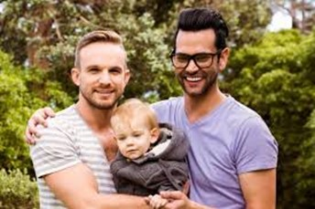
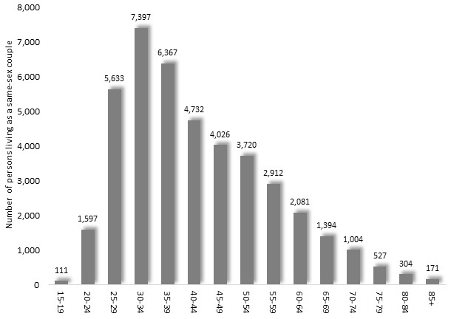
Age
The number of people identifying themselves as living in same-sex, cohabiting couple relationships, varied with age, reaching a peak of nearly 7,400 among people aged 30 to 34, before declining with increasing age.

Number of persons cohabiting as members of same-sex couples: Victoria, 2022

Education
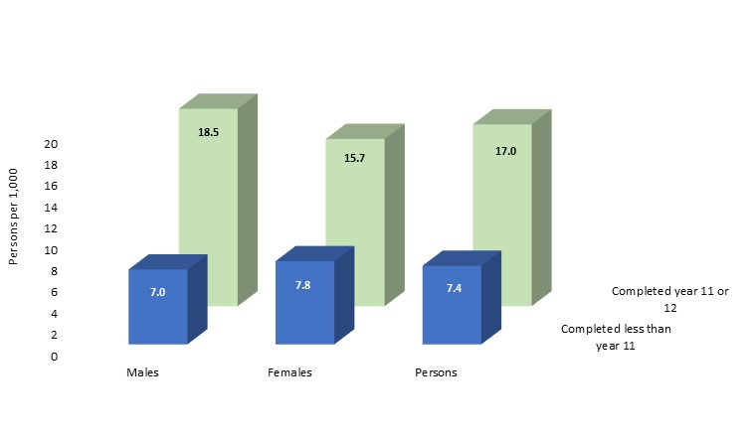
Persons living as same sex couples per 1,000 people living as couples, by educational attainment: Victoria, 2021

People who recorded in the Census that they were living as same-sex couples were more likely to have completed secondary school. Among people who had completed year 11 or 12, 17 per 1,000 of those living as couples declared that they were same sex couples, compared with 7.4 per 1,000 of those with less than year 11 education.
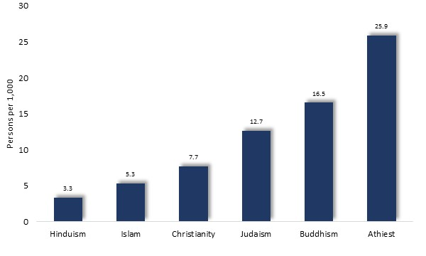
Religion
The proportion of people identifying themselves as members of same-sex cohabiting couples, also varied with religion.

Proportion of cohabiting couples which were same-sex couples, by major religion: Victoria, 2021

The prevalence of same-sex couples among cohabiting couples ranged from 3.3 per 1,000 among those who adhered to Hinduism, to 26 per 1,000 among those with no religion.

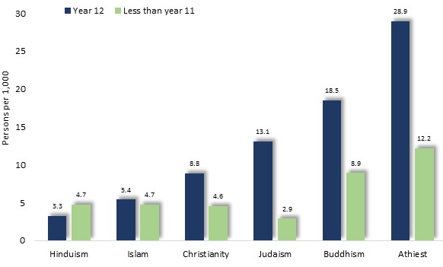
Proportion of cohabiting couples which were same-sex couples, by major religion and educational attainment: Victoria, 2021

Among people of most religious faiths, the proportion of cohabiting couples that were constituted of people of the same sex was highest among people with completed secondary education.

Locality
Among people living in couple relationships with same-sex partners, substantial proportions reside in inner-urban localities. More than 50 per 1,000 of members of cohabiting couples in Yarra, Hepburn, Port Phillip and Melbourne, reported in the 2021 Census that they were living with a same sex-partner. By contrast, fewer than 6 per 1,000 people living as couples in Moira, Swan Hill, Horsham and the Northern Grampians identified themselves as members of same-sex couples
Such trends provide some suggestion about differences in levels of acceptance of, and opportunity to live in social diversity, among some segments of society, peer groups and communities.

Educational Outcomes

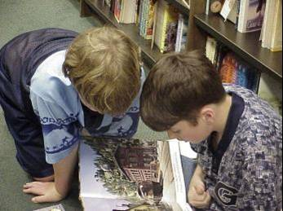
Young people in Greater Dandenong experience less favorable early school development, leave school earlier, less often attend university, are more often disengaged from employment and education, and are more likely to be unemployed later on in life, than those throughout Melbourne.

Early Childhood Progress
The Australian Early Development Census (AEDC) measures the progress of all pupils in their first year of school across Australia, in five domains of development: physical, social, emotional, language and cognitive, and communication and general knowledge.
The 2021 AEDC findings revealed that 28% of prep pupils in Greater Dandenong were ‘developmentally vulnerable’ in one or more of these fields of development – substantially more than the Victorian level of 20%, and the second highest rate in Melbourne.
For each metropolitan municipality, the percentage of prep pupils who are considered ‘developmentally vulnerable’ in one or more domains, is illustrated in the diagram below.

Percent Prep. Pupils Developmentally Vulnerable in one or more Domains by metropolitan Municipality, 2021
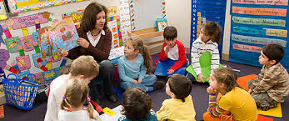
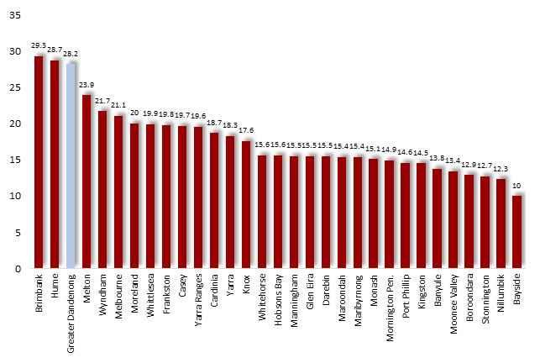

Locally, the proportion of prep. pupils who are ‘developmentally vulnerable’ ranged from 34% in Dandenong and Springvale South, 31% in Noble Park, 28% in Springvale, 25% in Noble Park and 19% in Keysborough.
Notably however, the proportion of children in Greater Dandenong who were recorded as developmentally vulnerable had declined from 37% in 2012 to 28% by 2021.
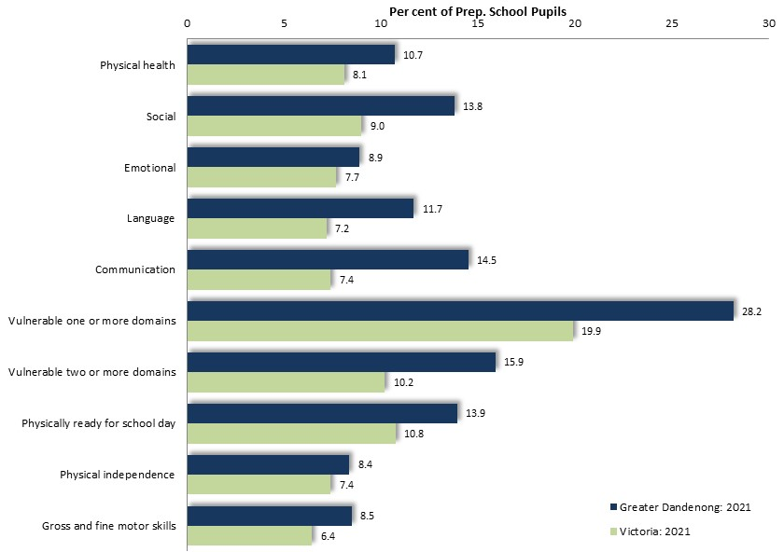
Results from Greater Dandenong for each of the domains of personal development among prep. pupils is illustrated at right.

Percent Prep. Pupils Developmentally Vulnerable, by Domain: Greater Dandenong and Victoria, 2021

Pre-School and Kindergarten Participation
The 2021 Australian Early Development Indicators recorded that 6.7% of prep. pupils in Greater Dandenong schools had not participated in a pre-school program in the preceding year – nearly double the corresponding proportion of 3.8% across Victoria and the second highest level in Melbourne.

Percentage of Prep. Grade Pupils who did not attend a Pre-school Program: metropolitan Municipalities, 2021
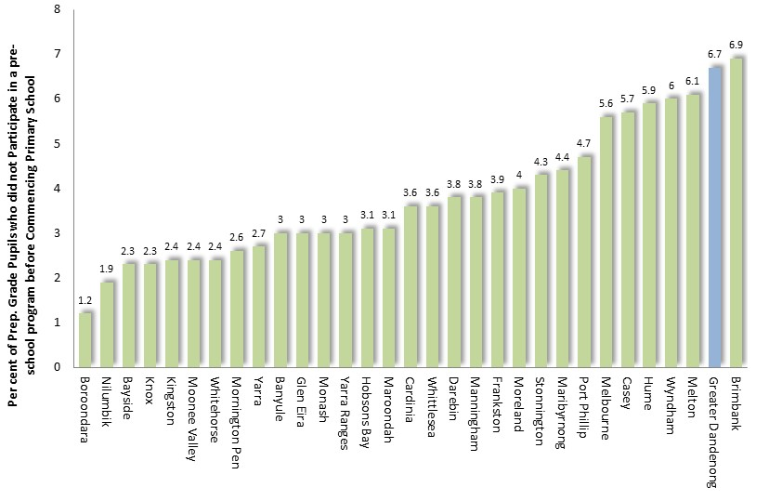

Literacy and Numeracy in Primary and Secondary School
Each year, primary and secondary students throughout Victoria in years 3, 5, 7 and 9, are tested for literacy and numeracy by the State Government. Results for 2019 show differences between results for pupils in Greater Dandenong and the Victorian average.

Literacy
The proportion of Greater Dandenong pupils in years 3, 5, 7 and 9 who did not meet the national literacy benchmarks in 2019, were approximately twice the Victorian average in these year levels. Among local pupils in year 9, the proportion whose test results were below the national benchmark was the third highest in the state.
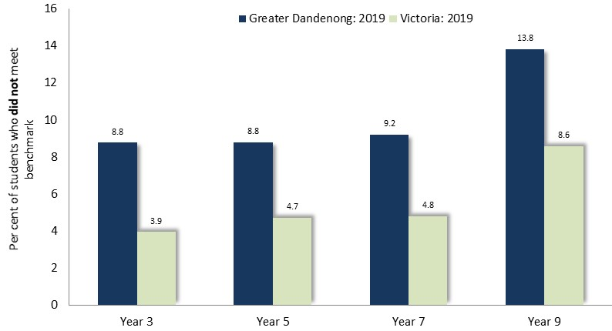
Per cent of pupils below the national literacy benchmark by year level: Greater Dandenong and Victoria, 2019
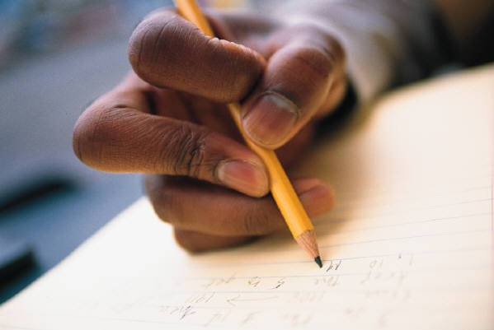

Numeracy
The proportion of Greater Dandenong pupils who did not meet numeracy benchmarks was also approximately twice the Victorian level. Among year 9 pupils, the proportion from Greater Dandenong who did not meet the benchmark was the highest in the state.
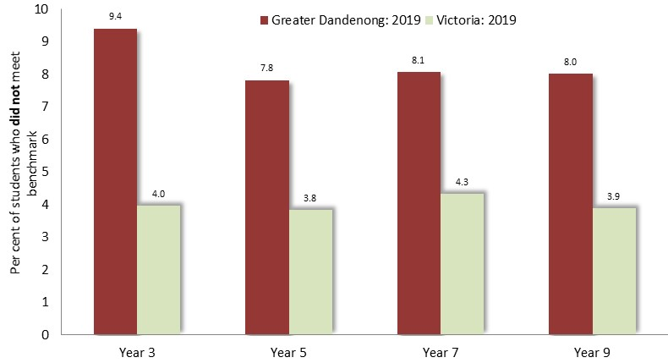

Per cent of pupils below the national numeracy benchmark by year level: Greater Dandenong and Victoria, 2019


Early School Leaving
Current Conditions
The 2021 Census found that 8.1% of young adults aged 20-24 in Greater Dandenong had left school before completing year eleven – including 9% of males and 7.2% of females - compared with 6.3% across Melbourne. The rate of early departure from secondary school in Greater Dandenong though, represents a pronounced decline from the corresponding rate of 13% recorded in the 2016 Census.
Rates of early school leaving among young people within Greater Dandenong, ranged from 25% in Dandenong, 14% in Dandenong North, approximately 10% in Noble Park and Springvale, and lower in Noble Park North (8.6%), Springvale South (7.4%) and Keysborough (5.8%).

Historic Trends
The rate of early school leaving among residents rises from 8.1% among those aged 20-24, to over two-fifths of residents aged 60-64 and about three-quarters of those over 85. Among residents aged 45 years or less – or born after 1976 – early leaving rates among men have surpassed those among women by a widening margin.

Early School Leaving by Age: Greater Dandenong, 2021

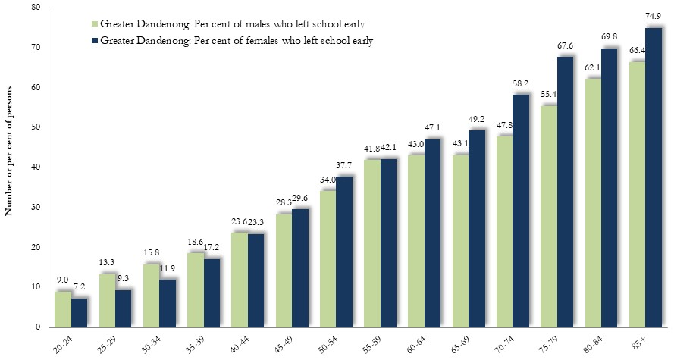

This mirrors a pattern seen across Victoria, though the higher rates of early leaving among men are more pronounced and commenced earlier.

Early School Leaving and Birthplaces
In 2021, 52% of 20-24 year-old residents who had left school before completing year 11 were born overseas.
The proportion of young adults from selected birthplaces who had left school early, is illustrated in the accompanying diagram and ranges from 64% among young people from Somalia, to fewer than 2% of those from India.
Rates of Early School Leaving by Selected Birthplaces: Greater Dandenong, 2021
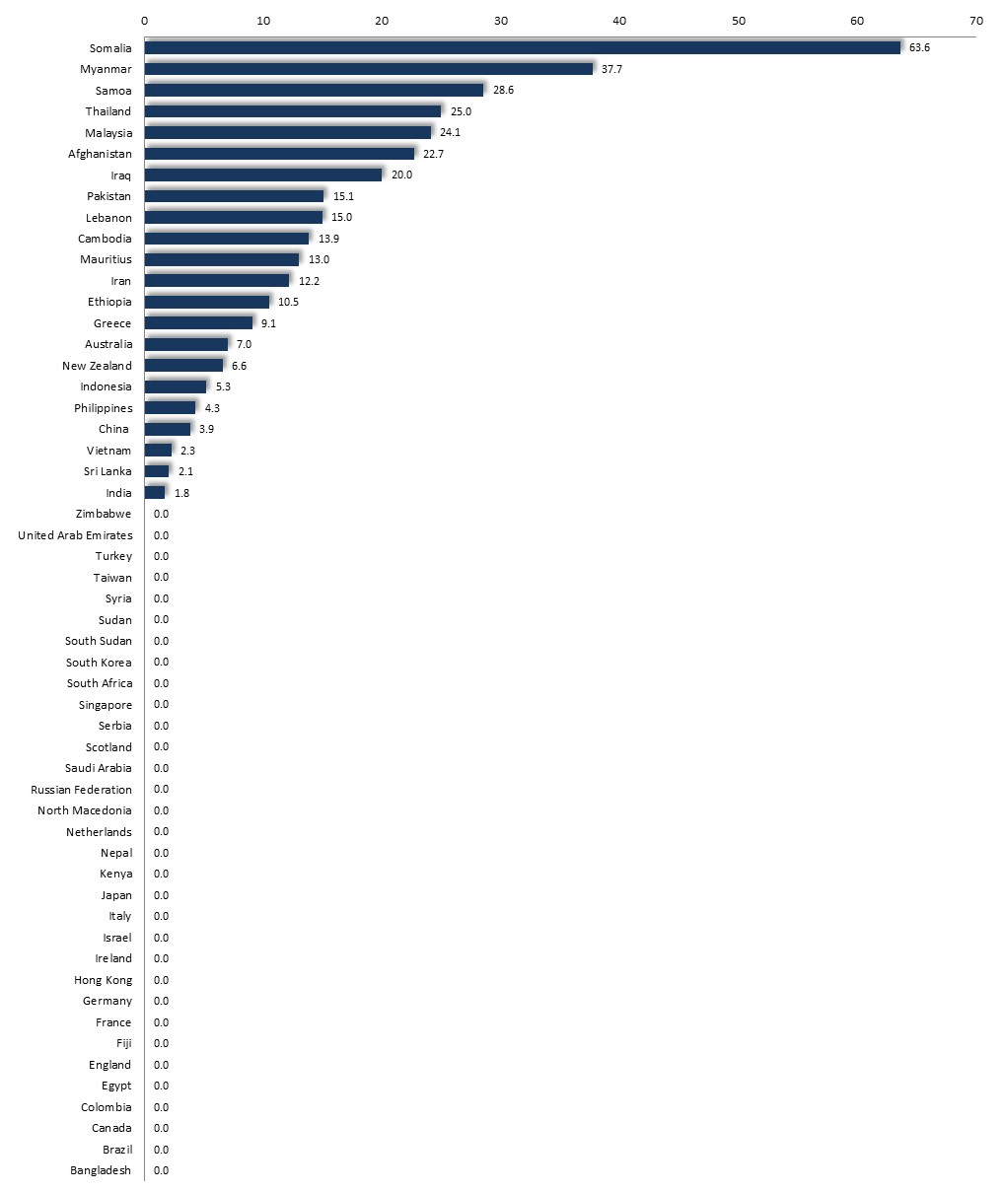

Tertiary Participation Rates
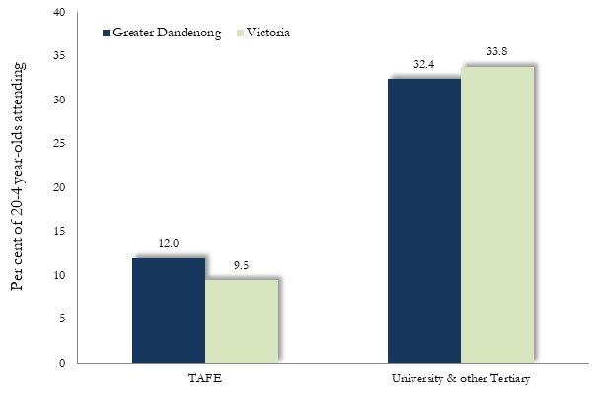
Levels of participation in tertiary education among young adults in Greater Dandenong are lower than the metropolitan average, with 32% of local 20-24 year-olds attending university or other tertiary institutions (up from 23% in 2011), compared with 38% across Melbourne.

TAFE and University Attendance: 20-24 year-olds, Greater Dandenong, 2021

Rates of attendance at TAFE though, are relatively high, with 12% of 20-24 year-olds in Greater Dandenong participating in TAFE courses, compared with 9.5% of Victorian residents that age.

Qualifications among persons aged 25-44: Greater Dandenong and Victoria, 2021
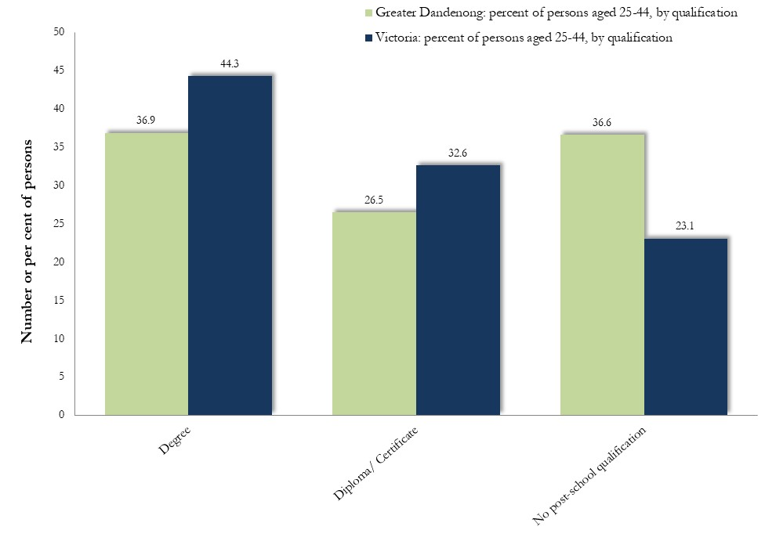
Qualifications
Consideration of qualifications holds particular relevance for residents aged 25 to 44 years, among whom employment levels are relatively high.
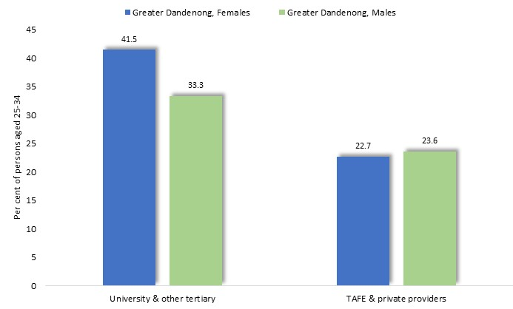
In 2021, approximately 37% of residents in this age range held a degree (compared with 44% of Victorians), 27% held a diploma or certificate and 37% had no post-school qualification. Their range of qualifications is illustrated above.

Post-school Education Attainment, by Type of Institution and Sex: persons aged 25-34 years: Greater Dandenong, 2021

Among people aged 25-34 years – selected here as a group which would have typically have recently concluded their post-school education – women were more likely than men to hold a university qualification. This is a disparity which also holds across Victoria.

Education & Employment Prospects
The 2021 Census found that, among Greater Dandenong residents aged 30-39 years, 84% of those with a degree were employed, compared with 50% of people who had left school before completing year 11.
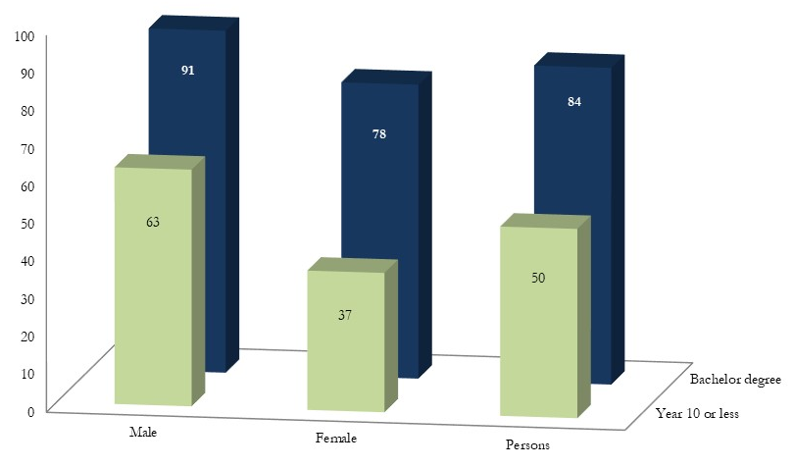
Employment Rates by Educational Attainment: Persons 30-39 years of age, Greater Dandenong, 2021

Among women the same age, this contrast is more striking, with 78% of those with a degree holding paid employment, compared with just 37% of early school leavers.

Employment and Unemployment


The findings of the 2021 Census, coupled with other sources, offer insights into employment, occupations and labour force participation among residents of Greater Dandenong, as well as the nature of the paid work which takes place within this city.

Unemployment
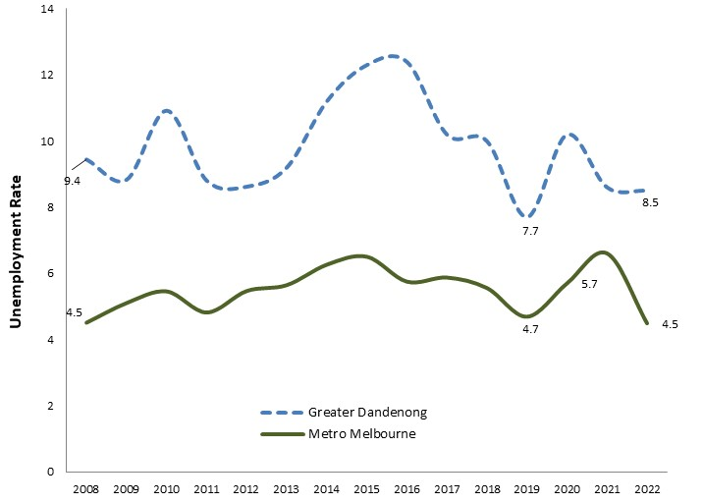
Unemployment rates in Greater Dandenong have fluctuated in the past decade, most recently declining unsteadily from 12.4% in June 2016 to 8.5% by 2022. Unemployment levels though, remain the second highest in Victoria and more than double the metropolitan average of 4.5%.

Unemployment Rates: Greater Dandenong and Metropolitan Melbourne, 2008-2022

This percentage represents 7,080 people who were unemployed in Greater Dandenong by June 2022 - a decline of 1,900 in the number of unemployed residents in mid-2016.

Among the suburbs of Greater Dandenong, unemployment rates in June 2021 were highest in Dandenong, at 14.1%, and lowest in Keysborough, at 4.7%.
Unemployment Rate by Suburb: Greater Dandenong and Melbourne, June 2022
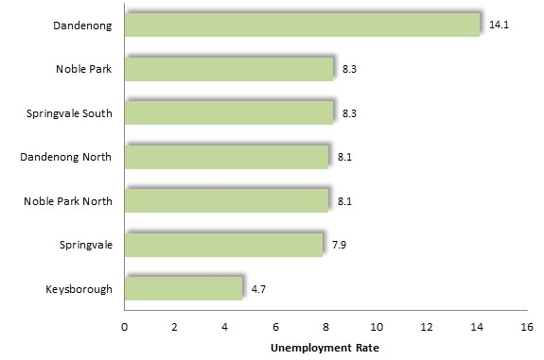
Unemployment by Age: Greater Dandenong and Victoria, 2021
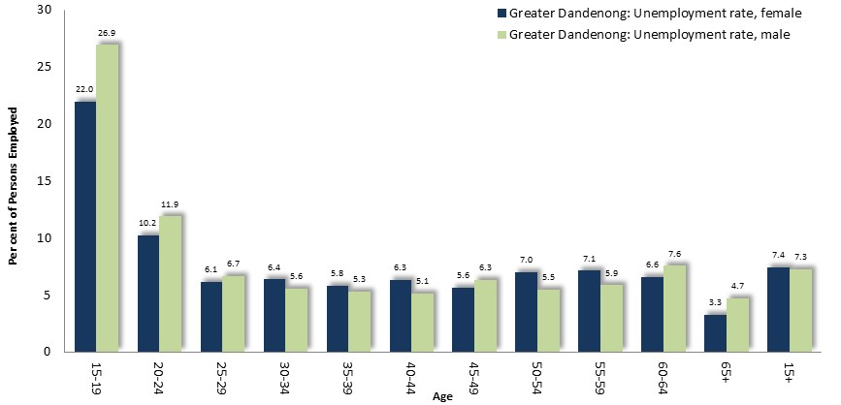
Unemployment rates among residents of various age groups were documented by the 2021 Census and are shown at right.
At this time, the peak unemployment rate was 24% among 15-19 year-olds - higher than the corresponding Victorian rate of 17% among this age group.
Unemployment rates differed only slightly in each age group between women and men, but was decisively higher among males among residents aged 15 to 29. Among residents aged 15 or more overall though, their unemployment rates were similar, at 7.4% for women and 7.3% among men.
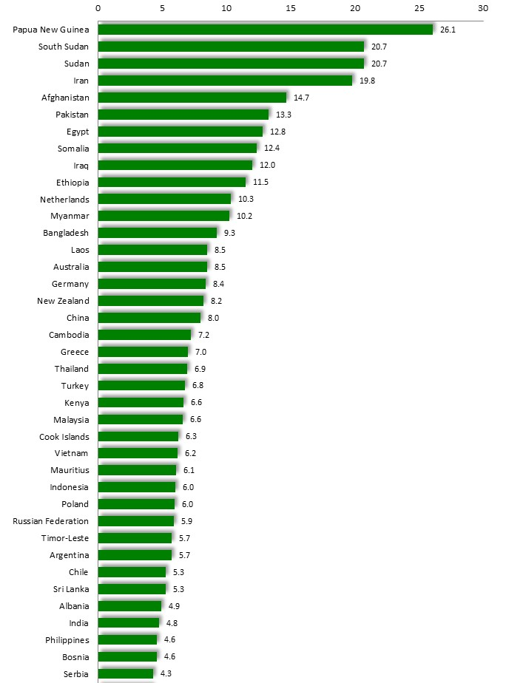

Unemployment levels varied widely with birthplace in 2021, from less than 5% among residents from Macedonia, Nepal, Fiji, Serbia, Bosnia, India and Philippines, to more than 20% among those from Papua New Guinea and Sudan.

Unemployment by Selected Birthplace: Persons aged 15 to 64, Greater Dandenong, 2021

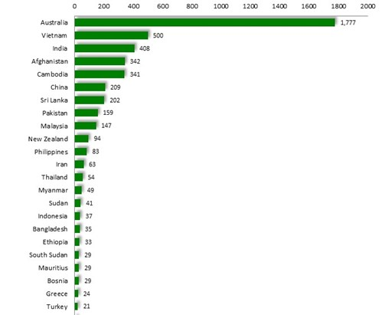
Notably though, the greater numbers of residents who are unemployed include those from Australia – accounting for about 1,800 residents – as well as residents from Vietnam, India, Afghanistan, Cambodia, China and Sri Lanka.


Numbers of Persons who are Unemployed, by Selected Birthplace: Persons aged 15 to 64, Greater Dandenong, 2021

Overseas-born residents account for over two-thirds of unemployed residents.

Families with No Parent in Paid Employment
The 2021 Census revealed that among families with children in Greater Dandenong, the head of the family had no paid work in 55% of single parent families, while 27% of couple families with children had no parent in paid employment (diagram, below).
Overall, 32.4% of families with children in Greater Dandenong had no parent in paid employment – the highest level in Melbourne, and substantially higher than the corresponding State figure of 24%.

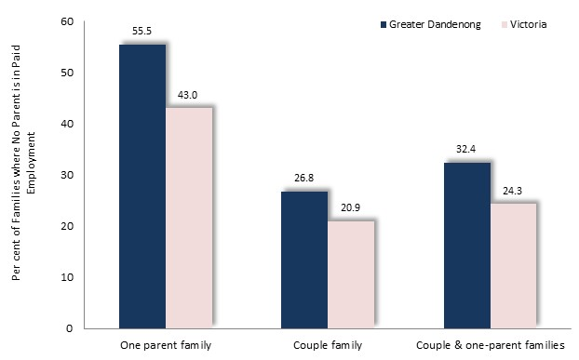
Per cent of Families with Children that have No Parent in Paid Employment, by Family Type: Greater Dandenong and Victoria, 2021

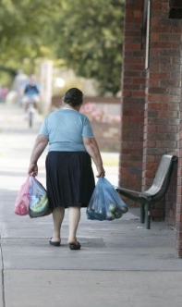

Occupations and Industry of Employment among Residents
In 2021, approximately 66,000 residents, or approximately two-fifths (42%) of the population, held paid work – a rise of 7,000 since 2016.
The distribution of employed residents of Greater Dandenong, among the major categories of occupation, is illustrated on the right. Occupations of Employed Residents: Greater Dandenong and Victoria, 2021
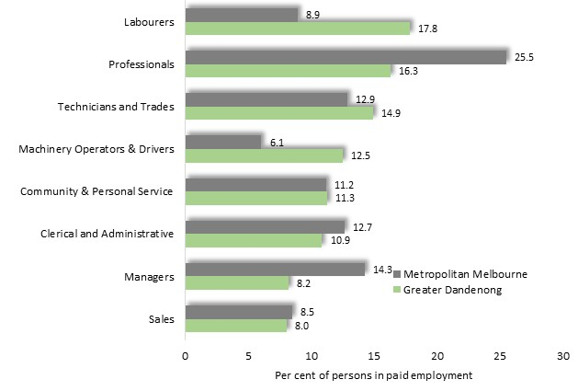
Notably, the proportion of employed residents who were labourers, machinery operators, technicians and trades workers, exceeded the State average. By contrast, the representation of local workers in professional or managerial occupations was markedly lower than the Victorian level.

Occupations of Employed Residents: Greater Dandenong, 2021
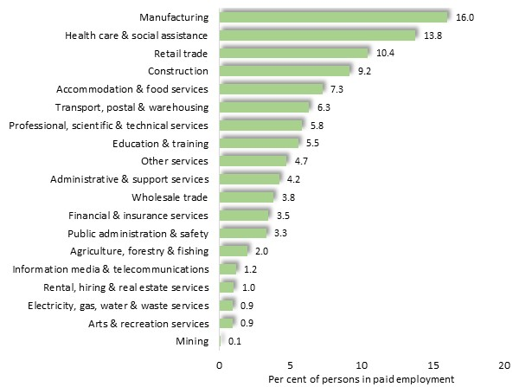
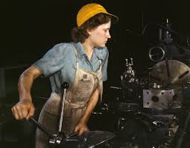
The distribution of employed residents among categories of industry was similar to the metropolitan pattern, with the principal exception of manufacturing, which accounted for 16% of jobs held by residents, compared with 7% of employment across Melbourne.

Business

By 2022 there were 20,482 businesses operating from Greater Dandenong.
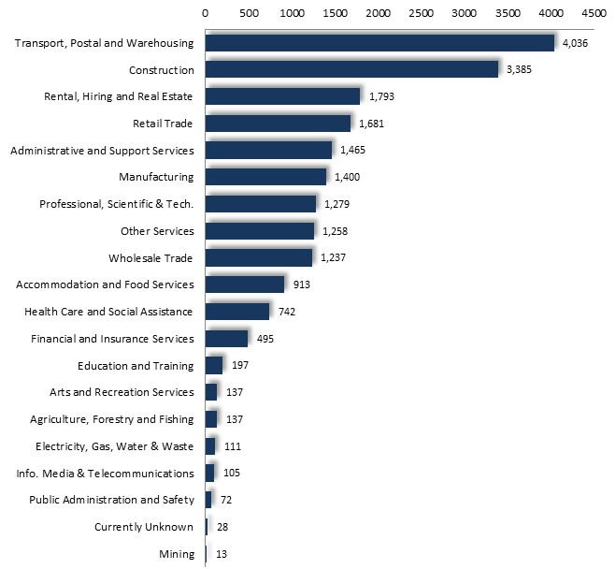
Among the categories of industry accounting for the largest numbers of businesses were transport and warehousing (accounting for one-fifth of businesses in the municipality); construction; rental, hiring and real estate; retain; administrative and support; manufacturing; and retail trade. Together, these six industry divisions account for approximately two-thirds of all businesses within Greater Dandenong.

Number of Businesses by Industry Division: Greater Dandenong, 2022

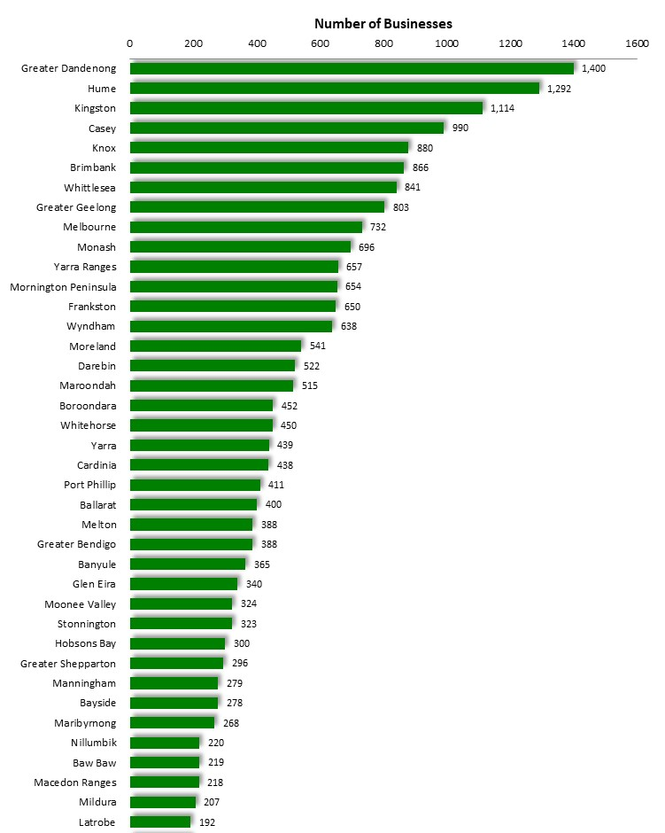
Among the suburbs of Greater Dandenong, half of all businesses – including 70 per cent of manufacturing - are situated in Dandenong, Dandenong North or Dandenong South.

The number of local businesses in the manufacturing sector was the largest among the municipalities of Victoria (illustration, left), those in transport and warehousing were the sixth highest in the state, and the number in public administration and safety were ranked eighth.

Counts of Business in Manufacturing Division: Victorian municipalities, 2022

Incomes and Financial Disadvantage
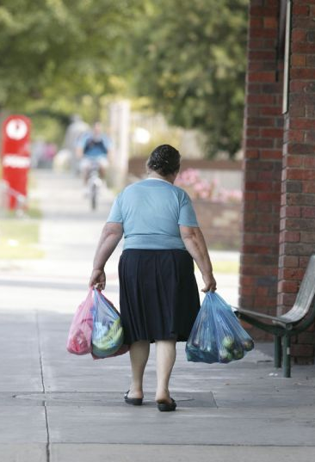
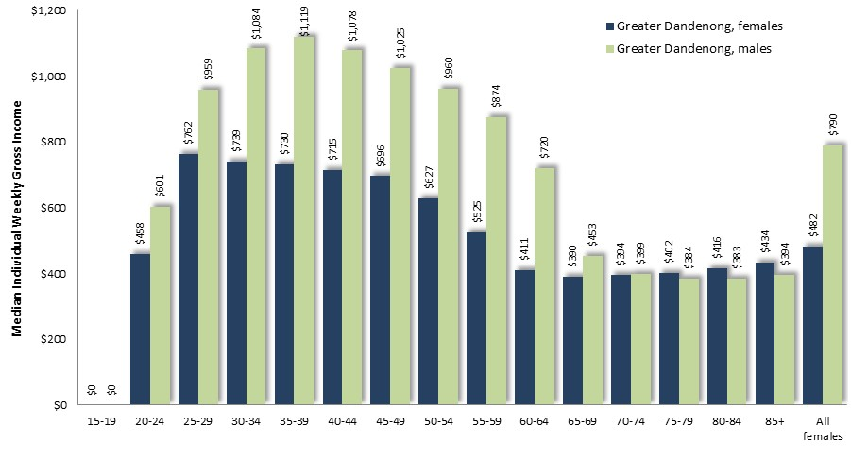
In 2021, the median individual weekly gross income in Greater Dandenong stood at $619 – the lowest in Melbourne and substantially less than the State-wide level. However, in the decade to 2021, individual gross incomes had risen from 70% to 76% of the Victorian level.

Median Incomes by Sex: Greater Dandenong, 2021

At $482 per week, incomes among females aged 15-85 years in Greater Dandenong were 61% of those for males, at $790. The disparity between female and male income levels in Greater Dandenong was most prominent among residents of working age (diagram, above).
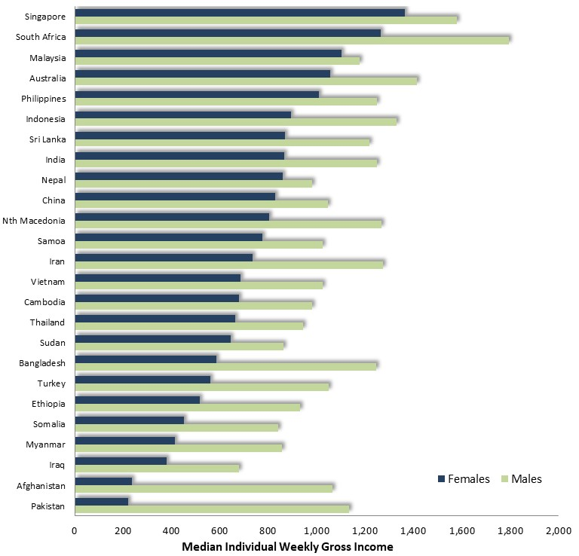
Median Income by Gender and Selected Birthplaces: Persons aged 25-64, Greater Dandenong, 2021

Income levels also vary widely by birthplace. Among residents aged 24 to 44 (ages of high employment levels), incomes ranged from $367 among those born in Taiwan, to $1,137 among those from New Zealand.
Female incomes were lower than for males among all birthplace groups, though most notably among residents from Pakistan, Afghanistan, Bangladesh, Syria and Egypt, among whom female median gross incomes were less than half those for men.

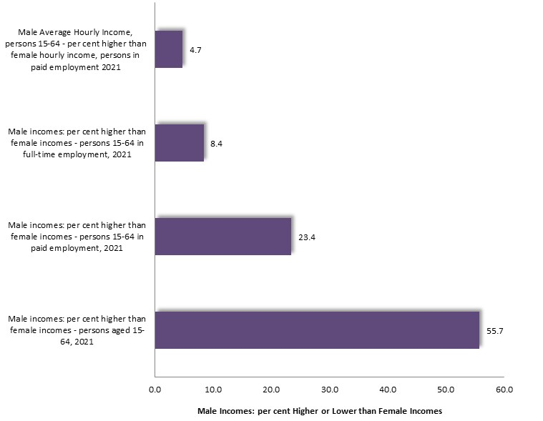
Incomes and Gender
In the findings of the 2021 Census, median gross incomes among men aged 15 or more were 56% higher than among women of the same age.

Median gross incomes by sex: Greater Dandenong, 2021

The disparity declines among persons in paid employment, where median male incomes were 23%. The difference in incomes falls further among people in full-time employment, to 8.4%. Finally, male hourly median incomes are 4.7% higher than for females.
These results show that most of the differences in income between women and men in Greater Dandenong are due to the lesser proportions of women who hold paid work, and among those in such employment, the lower average hours of paid employment among women.

This difference in hourly incomes among women and men in paid employment differs with age. Among people aged less than 35 years, female hourly incomes are slightly higher than for men. Among succeeding age groups, male hourly incomes surpass those of women, first by 1.3% among people aged 35-39, then to a greater extent among people aged 40 to 64 years.
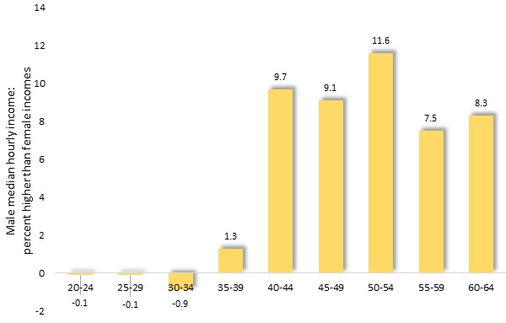
Male incomes: per cent higher than female hourly incomes, by age group: Greater Dandenong,2021

These differences are similar to those seen across Victoria, except that here, gross median hourly incomes among women aged 20-34 In Greater Dandenong exceed those of men by 0.4%, compared with 4% across Victoria.


Centrelink Support
In June 2022, 7.1% of Greater Dandenong residents held a Health Care Card – the fifth highest dependency upon such support in Victoria and substantially more than the Victorian level of 5.1%, reflecting extensive financial hardship.
More than one-fifth (20.1%) of occupied dwellings in Greater Dandenong attract rental assistance payments, the highest level in Victoria and substantially more than the State-wide level of 11.3%.
The 2022 Centrelink payments also revealed a high level of dependency of older local residents upon the aged pension, with the number of residents relying on this payment equal to 68% of the number of residents aged 65 years or more – the highest level in Melbourne and in excess of the metropolitan ratio of 52%.
The table below sets out a selection of ratios between the relevant population and the number of Centrelink beneficiaries in mid-2022, confirming the level of dependence of various segments of the local population upon pensions and benefits, including older, disabled and unemployed people, and families facing financial difficulties.
Notably, in 2021, 32% of families with children in Greater Dandenong had no parent in paid employment – the highest level in metropolitan Melbourne and substantially more than the State level of 24%.

The Index of Relative Socio-economic Disadvantage
Greater Dandenong is ranked as the second most disadvantaged municipality in Victoria, on the 2016 Commonwealth Government Index of Relative Socio-economic Disadvantage (at the time of writing, still the latest version of this index currently available).
This index was based on Census findings about income levels, education, English fluency, home ownership and others.
- Greater Dandenong was ranked as the second most socio-economically disadvantaged municipality in Victoria (after Central Goldfields) – the same as its ranking 20 years before, in 1996.
- By contrast, the least disadvantaged locality in Victoria was Nillumbik, as it was five years earlier.
- Within Greater Dandenong, the suburbs of Dandenong and Springvale were the most disadvantaged on this index, and are among the most disadvantaged 2% in Victoria. Keysborough was the least disadvantaged suburb in Greater Dandenong, though still among the 27% most disadvantaged in the State.
Gambling
Gambling Losses
Legal gambling in Victoria include sports betting, racing, lotteries, keno, lotto and the Casino. Electronic gambling machines (EGMs or ‘pokies’) though, account for nearly half of all legal gambling losses and most problems, as they are widely accessible and provide people with the means to gamble continuously. In addition, EGM losses are highest among disadvantaged residents - those least able to afford them.
In 2021/22, $102 million was lost to electronic gambling machines in Greater Dandenong - an average of $281,000 each day, and equal to the cost of feeding nearly 39,500 children for one year.
EGM gambling losses in that year were equivalent to $801 per adult – the second highest rate of losses per adult in Victoria, nearly twice the metropolitan level of $431 per adult and over six times the rate of losses in Boroondara ($94 per adult) - the most affluent municipality in the State.
Since the introduction of EGMs in Victoria in 1992, over $4 billion has been lost to gambling machines in Greater Dandenong alone (in 2022 dollars).
Information about the level and rate of EGM gambling loses, the number and density of EGMs, within Greater Dandenong and metropolitan Melbourne, in the year 2021/22, is set out below.
EGM Losses and Machines: Greater Dandenong and Metro. Melbourne, 2020/21
In addition to EGM losses, an estimated $231 million is lost each year by residents to other legal forms of gambling, bringing total annual gambling losses to $333 million in this municipality an average of $2,615 per adult, and approximately 4.8% of total incomes in Greater Dandenong.

Gambling Machines
924 EGMs operate at 14 clubs and hotels within Greater Dandenong – the fourth highest number in any Victorian municipality. Under State Government municipal gambling machine limits, 989 EGMs are permitted to operate in this municipality. This means that 65 more may be installed in local venues before the cap is reached. Clubs account for nine of the existing 14 venues with EGMs and over half (59%) of the annual EGM gambling losses in Greater Dandenong ($60 million in 2021/22).
Impact of Gambling Losses
Many people gamble to ease boredom, social isolation or depression, while others are swayed by unrealistic expectations about the chances of winning, or lured by convenient access to venues. In addition though, gambling machines are designed to addict and deceive users, enticing them into losing more money than they otherwise might gamble.
Gambling-related problems generally arise when a person persistently loses more money than they, or their household, can comfortably afford. The resulting financial hardship often contributes to personal distress, family poverty, conflict, violence and breakup, decreased attendance and productivity at work, deceptive or criminal actions to obtain money, and homelessness.
At least 1 in 100 adults have severe gambling problems – a figure the Productivity Commission acknowledges may be three times higher; and about two-thirds of EGM gamblers experience mild to severe gambling problems. Among the approximately 17% of adult residents of Greater Dandenong who use gaming machines, annual gambling losses may average approximately 13% of their gross income (based on total losses among venues in this municipality) – the highest level of gaming losses relative to income levels in Victoria.
Gambling-related problems are most widespread among people with limited education, low incomes, manual occupations or without paid work – circumstances widespread in Greater Dandenong.

‘Benefits’ of Gambling
The gambling industry claims that it supports the community and creates jobs. However, in 2021/21, the clubs in Greater Dandenong returned just 2.8% of their gambling revenue to the community as gifts, donations, sponsorships and support for veterans.
Moreover, investigations of the spending patterns of gambling show that funds lost to gambling machines are largely diverted from expenditure on goods and services, such as household items, with the consequence that growth in the retail sector is lower than it would have been if EGMS had not been introduced. For example, gaming venues often detect from expenditure at local businesses as they divert expenditure from other goods and services.

Housing
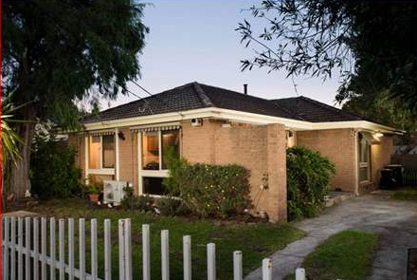
Housing Structure
In 2021, approximately 70% of households in Greater Dandenong were detached, 11% were flats and 18% semi-detached structures. During the 20 years to 2021, the number of detached dwellings in Greater Dandenong rose by approximately 3,700 and the number of semi-detached dwellings by nearly 5,300, while the number of flats declined by 1,970.
The distribution of housing structure varies across the metropolitan area, with flats accounting for 88% of dwellings in Melbourne, 52% of dwellings in Yarra, to 1% in outer-metropolitan Cardinia.
Within Greater Dandenong, flats tend to be concentrated among sections of Springvale, Noble Park and Dandenong - particularly in proximity to transport corridors.

Housing Tenure
Levels of home ownership in Greater Dandenong are lower than the metropolitan average and have fallen in recent years. In 2021, nearly two-thirds (62%) of private dwellings in Greater Dandenong were either owned or being purchased by their occupants – a decline from 65% in 2011. Across metropolitan Melbourne, a slightly higher proportion of homes (67%), were owned or being purchased.
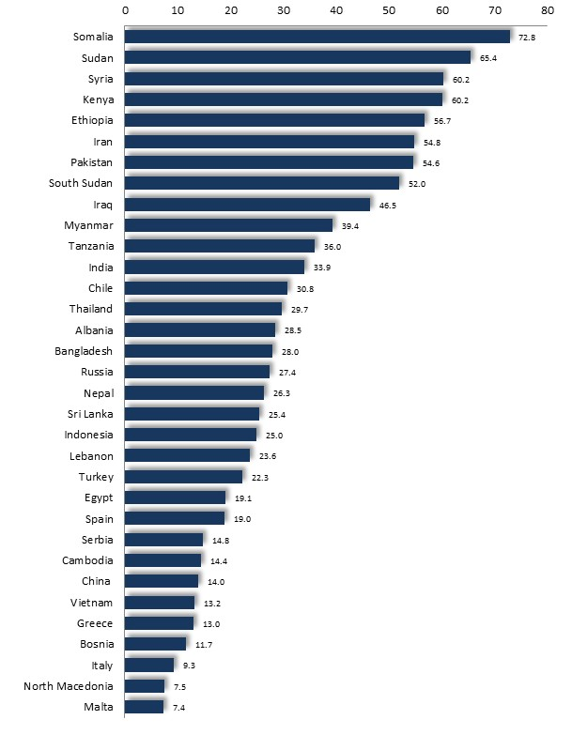
In Greater Dandenong, 35.6% of dwellings are rented, compared with 30.8% across Victoria and 31.2% in Greater Dandenong in 2016.
Local home ownership levels are lowest among recent settlers, with more than half of those from Somalia, Sudan, Syria, Ethiopia, Iran, Pakistan and Afghanistan renting their accommodation, compared with fewer than one in ten from Italy, Macedonia and Malta (accompanying diagram).

Per cent of Persons Renting their Homes, by Selected Birthplaces: Greater Dandenong, 2021

Housing Costs
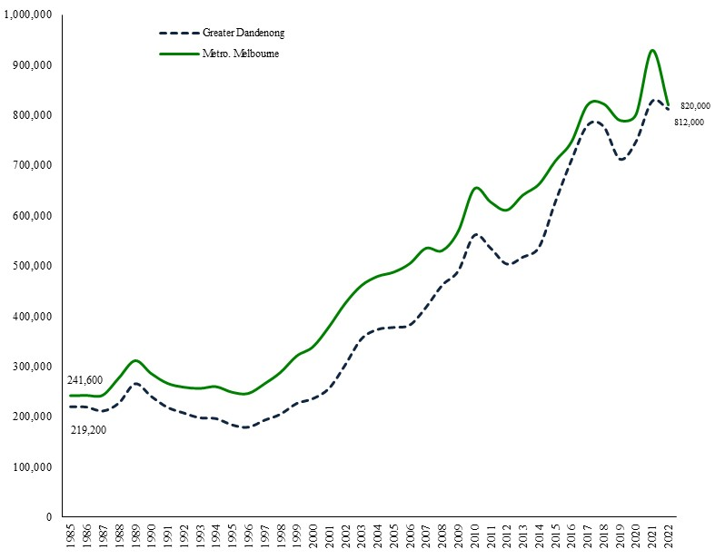
In the 20 years to 2022, median housing costs in Greater Dandenong had nearly trebled in real terms, rising by 168%, compared with 93% across Melbourne in the same period (after adjustment for inflation).

And in the years from 2011 to 2022, house purchase prices rose by 61% (after inflation), nearly twice the corresponding rate of 34% across metropolitan Melbourne (diagram, right). Local median purchase prices reached $812,000 by June 2022.
As a consequence, local price increases have outstripped growth in incomes, with the median cost of houses rising from 3.2 years of median household income in 1996, to 10.3 years in 2021.

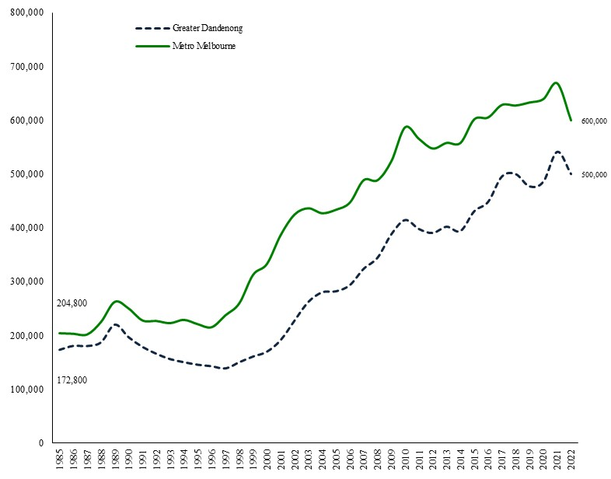
Median Unit Purchase Costs: Greater Dandenong and metropolitan Melbourne, 1985 to 2022 (adjusted for inflation)

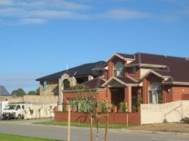
Meantime, the median price of units in Greater Dandenong rose 22% during the decade to 2020 – more than twice the rate of growth recorded across Melbourne during this period, of 9.7%.

Rental Cost and Affordability
In June 2022, the average cost of renting a three-bedroom house in Greater Dandenong was $400 – similar to the metropolitan average of $430.
In the past 23 years, local median rental costs have risen by 36% for three-bedroom houses real terms –slightly higher than the corresponding rise across metropolitan Melbourne, of 30%.
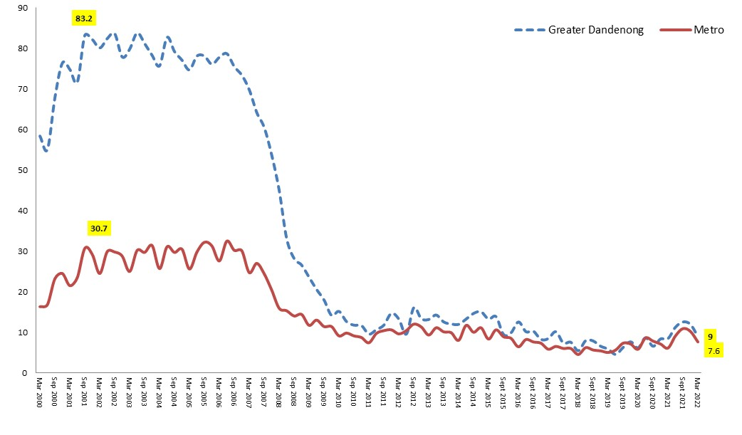
Per cent Rental Properties Affordable, Greater Dandenong and Metropolitan Melbourne 2000-2022

Consequently, the proportion of local, rental properties affordable to Centrelink recipients has fallen from 83% in 2001, to 9% by 2022 (diagram, left), thereby aggravating the financial difficulties faced by many households.

Rent-related Poverty
Per cent of renting households living in poverty, by household type: Greater Dandenong and Victoria, 2021
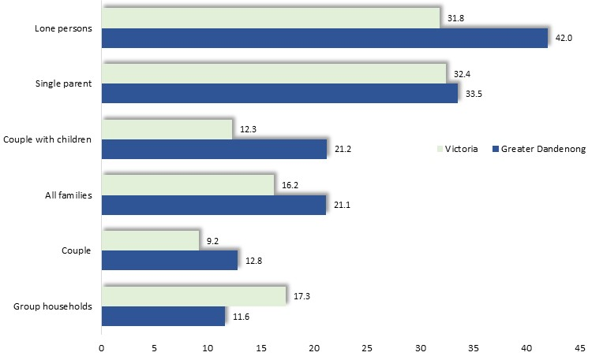
Findings of the 2021 Census show that about one-fifth (21%) of families in Greater Dandenong which are renting their accommodation are living in poverty – higher than the Victorian figure of 16% and the third highest proportion in the State. The percentage of local households living in poverty ranged from 13% among couples, to 21% for couples with children, 34% among single parent households, and 42% of sole persons.
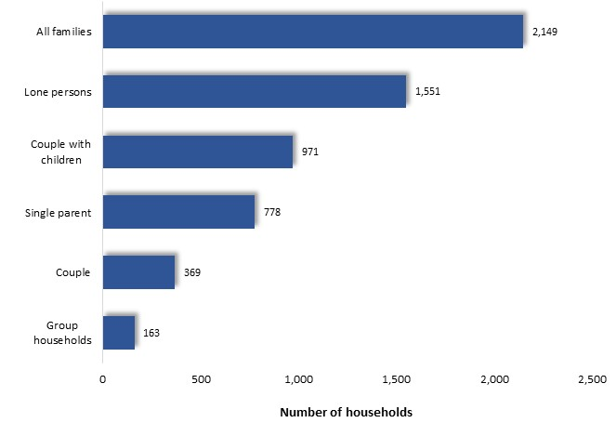
Where numbers are taken into consideration, couples with children account for nearly half of all local renting families in poverty, while lone persons represent nearly half of households in poverty.

Number of renting households living in poverty, by household type: Greater Dandenong and Victoria, 2021

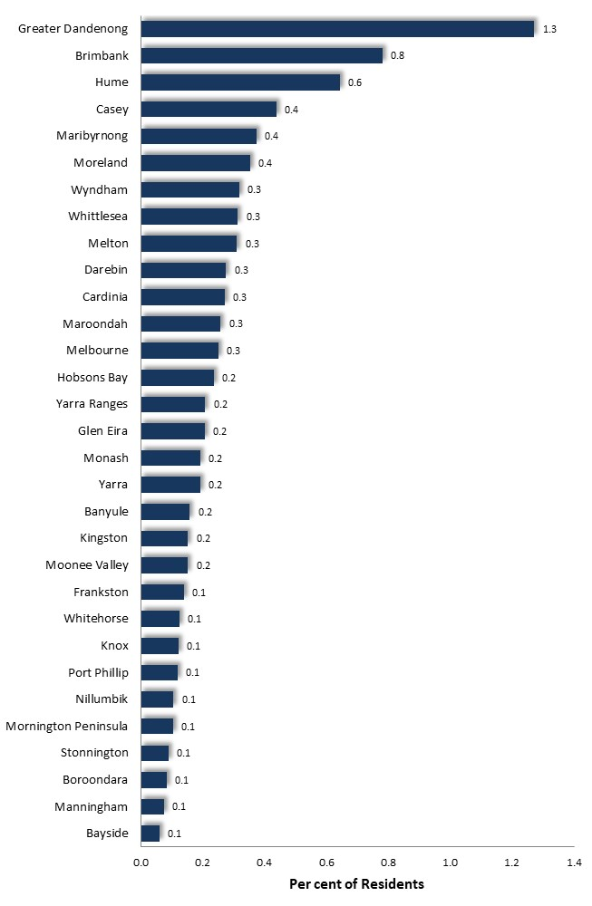

Overcrowding of Private Dwellings
To measure the proportion of private dwellings that were overcrowded, conditions were defined as persons living in private dwellings where there are either 4 or more persons in a dwelling with 0 or 1 bedroom or 6 or more persons in a dwelling of 2 bedrooms

Proportion of private dwellings that are overcrowded: metropolitan municipalities, 2021

Based on these criteria and the findings of the 2021 Census, 1.3% of private dwellings, numbering 645 homes, were overcrowded – the highest number and proportion in metropolitan Melbourne.
Similarly, 3% of private dwellings in Greater Dandenong accommodated 7 or more persons in 2021, compared with an averge of 1% across Victoria.

Homelessness
The Australian Bureau of Statistics determined that in 2021, 2,366 people in Greater Dandenong were homeless or living in 'severely overcrowded' conditions. This number is the largest in Victoria, accounts for 1.5% of the municipal population - the highest proportion in the State and over four times the Victorian level, and represents a rise of 851, or 56 per cent, during the past decade.
Most of these residents were living in overcrowded dwellings (46%) or in boarding houses (31%), with lesser numbers in supported accommodation, temporary arrangements with friends or elsewhere, else in squats, tents or sleeping out (diagram, below).
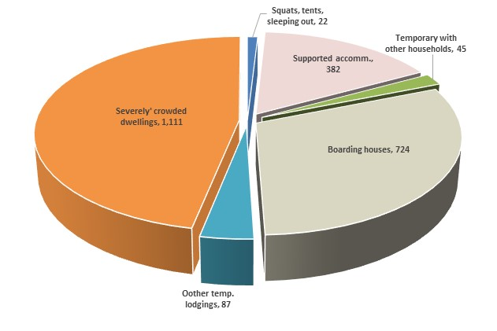

Percent of Homeless Persons, by Type of Shelter: Residents of Greater Dandenong, 2021

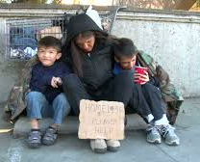

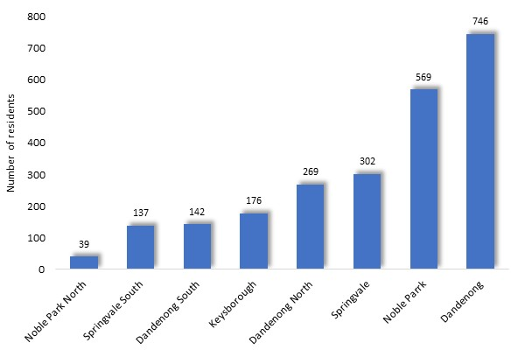

Number of Homeless Persons by Suburb: Greater Dandenong 2021

Residents who were homeless or living in severely overcrowded conditions resided largely in Dandenong and Noble Park, with few in Keysborough, Noble Park North or Springvale South.

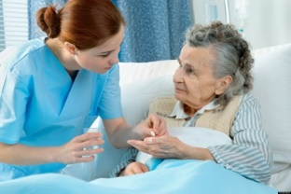
Non-Private Accommodation
In 2021, 3,390 residents of Greater Dandenong resided in non-private dwellings, 30% of them in retirement accommodation, 19% in nursing homes, 13% in public hospitals, 9% in hotels or motels and 20% in boarding houses.

Transport
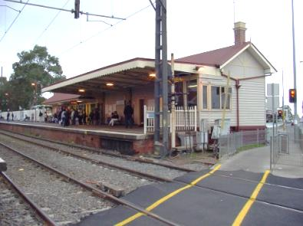
Car Ownership
The findings of the 2021 Census provide a glimpse of differences in levels of access to private transport among different family types. At this time, 23% of two-parent families with young children (<15 years) had either one or no cars (that is, fewer cars than parents), compared with 18% of such families across Melbourne.
Per cent of Families with One or No Car (two-parent) or No Car (one-parent):
Greater Dandenong and Victoria, 2021
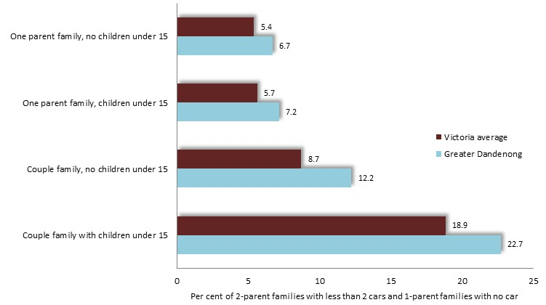
Among one-parent families with children aged less than 15, 6.7% of those in Greater Dandenong, and 5.4% across Victoria, had no car.

Mode of Travel to Work
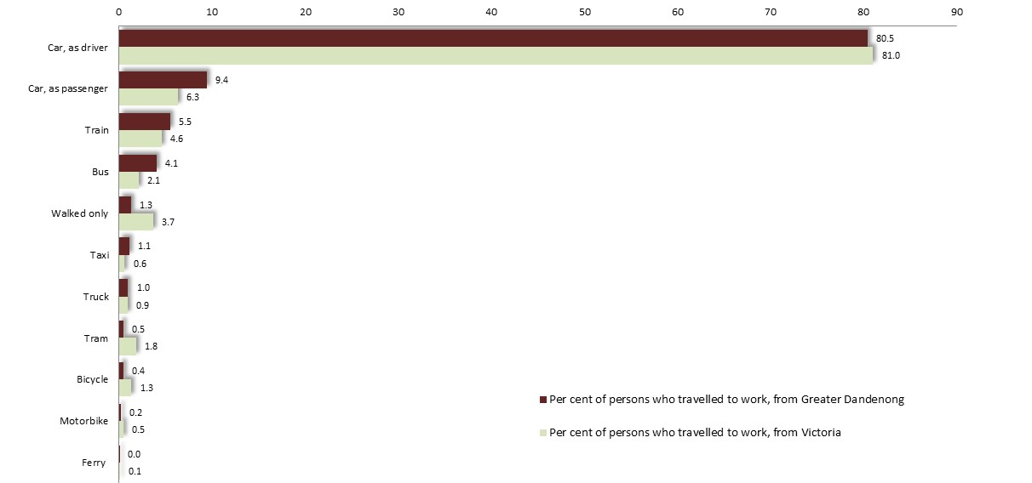
The 2021 Census found that more than four-fifths (80.5%) of residents of Greater Dandenong who travel to work, journeyed by car – either as a driver or passenger. A further 11% travelled by train, 4% by bus and 1.4% walked only to work.

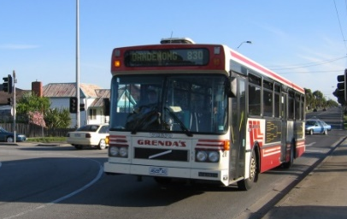
Mode of Travel to Work: Greater Dandenong and Victoria, 2021

These patterns are broadly similar to those across Victoria, though more local residents travel by car or bus, and fewer use other modes of transport.

Per cent of Residents who Travelled to Work Solely by Active
or Public Transport: Selected municipalities, 2021
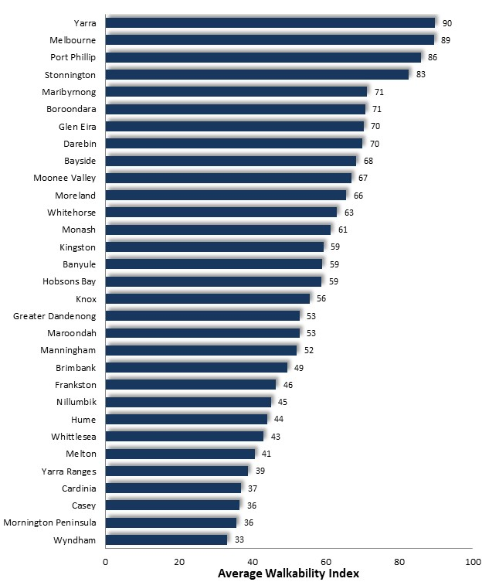
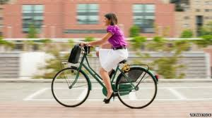
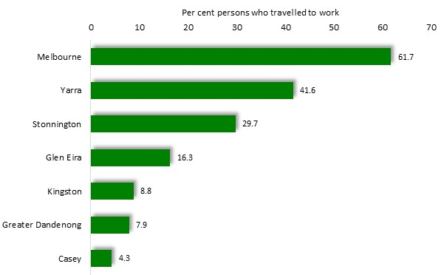
The proportion of residents who journey to work solely by public or active (walking only or cycling) modes of transport, tends to decline with increasing distance from central Melbourne. For example, among municipalities extending from the CBD across south-east metropolitan area, the percentage of employed residents who had used active transport to travel to work at the time of the Census diminished from over 62% in Melbourne, to less than 5% in Casey and Cardinia.

Walkability
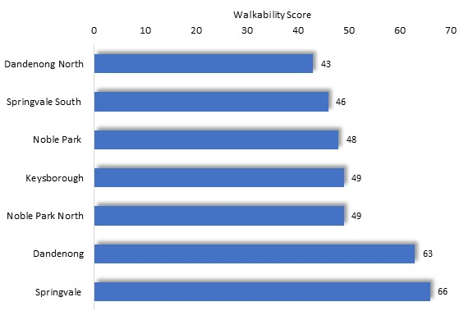
Measures of the ease of walking to key detinations, such as shops, are prepared by ‘Walkshare’. Calculations published in 2022 assiged a walkabllity score of 53 to Greater Dandenong, similar to the average among metropolitan municipalitises of 58. Scores for other municipalites in Melbourne ranged from about over 85 for inner metropolitan Yarra, Port Phillip and Melbourne, to less than 37 for Wyndham, Casey, Mornington Peninsula and Cardinia. Among the suburbs of Melbourne, the lowest walkability sores were assingned to Ferny Creek and Langwarrin South, at 16 and 12 respectively, and the highest scores to Fitzroy and Carlton at 96 and 97 respectively.
And within Greater Dandenong, scores varied from their highest level in Springvale, to the lowest for Dandenong South.

Socio-economic Disadvantage

Greater Dandenong is a community of marked cultural diversity and ongoing migrant settlement, which faces the challenges of low-income levels, high unemployment, unfavourable educational outcomes, a substantial rate of refugee settlement, lower levels of mental and physical health than the Victorian average, and elevated crime rates.
Cultural Diversity and Settlement
Greater Dandenong is the most culturally diverse community in Australia, with 63% of its residents born overseas, residents from at least 154 different birthplaces, and languages other than English spoken at home by nearly three-quarters (72%) of residents – the highest level in the state.
In 2020/21, 2,919 migrants settled in Greater Dandenong, the fourth highest number in Victoria. Among them, humanitarian migrants numbered 85 – about a tenth of the 750 who settled in Greater Dandenong in 2010/11 – though the highest number in Victoria.

In addition to these settlers, the Commonwealth Government reports that there were 882 people seeking asylum residing in this municipality in 2022, the second highest number in any Victorian municipality and accounting for 21% of all people seeking asylum in the state.
Fluency and Literacy in English
In 2021, about one in six residents, accounting for 23,000 people or 14.4% of the population, had limited fluency in spoken English – over three times the metropolitan proportion of 4.5%, and the highest level in Victoria.

An estimated 26% of residents have very limited English literacy.
Education
The 2021 Australian Early Development Indicators recorded that 28% of local prep. pupils were vulnerable on one or more aspects of development – the highest level in Melbourne and more than the State average of 20%. It also revealed that 6.7% of prep. pupils in Greater Dandenong schools had not participated in a pre-school program in the preceding year, the second highest level in Melbourne and substantially more than the metropolitan level of 3.8%.
Information published by the State Department of Education and Training in 2019 showed that 14% of year 9 pupils in Greater Dandenong did not meet national literacy benchmarks – the third highest level in Victoria and more than the Victorian level of 9%.
In 2021, 8.1% of 20 to 24 year-olds had left school before year 11, compared with 6.3% across Melbourne.
Thirteen per cent of 20 to 24 year-olds were neither in paid employment nor enrolled in education in 2021 – among the highest levels in Melbourne, and more than the corresponding metropolitan figure of 9.8%.


Employment and Unemployment
According to Commonwealth Government estimates, unemployment rates in Greater Dandenong stood at 8.5% in June 2022 – among the highest levels in Victoria and nearly double the Victorian rate of 4.3%.
Of all residents in paid work in 2021, 24% held management or professional occupations [compared with 41% across Melbourne] and 41% worked labourers or machinery operators [metro. 14%].

At this time, the industries of manufacturing, construction, health care and retail trade accounted for over half of the employment of residents.
Incomes
In 2021, median individual weekly gross incomes in Greater Dandenong stood at $619 - 77% of the metropolitan level, and the second lowest in Melbourne. Thirty-two per cent of families with children in Greater Dandenong had no parent in paid employment – the highest level in metropolitan Melbourne and more than the State level of 24%.
The number of health care card holders in Greater Dandenong in June 2022 represented 7.1% of the population, compared with 5.1% across Melbourne, and the fifth highest level in Victoria.
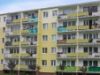
Local financial hardship is exacerbated by gambling losses incurred within the municipality. In 2021/22, $103 million was lost to gambling machines in venues across Greater Dandenong, equivalent to $801 per adult – the second highest rate of losses per adult in Victoria, and nearly twice the metropolitan level of $432 per adult. Local gambling losses are further aggravated by the rise of on-line and sports betting.
Housing
Local house purchase prices rose by 61% (after inflation) in the decade to 2022, compared with 34% across metropolitan Melbourne. In the 30 years to 2022, median housing costs in Greater Dandenong have almost quadrupled in real terms. Local price increases have outstripped growth in incomes, with the median cost of houses in Greater Dandenong trebling from 3.2 years of average household income in 1996, to 10.3 years in 2021.
The cost of renting has also risen, with the proportion of rental properties affordable to Centrelink recipients in Greater Dandenong falling from 83% in 2001, to 9% in 2022, thereby aggravating the financial difficulties faced by many renting households. Estimates based on the findings of the 2021 Census reveal that approximately 21% of renting family households and 42% of renting lone person households are living in poverty.
As a measure of the prevalence of rent-related financial stress, 20.1% of households received rental assistance in Greater Dandenong in 2022 – the second highest level in Victoria, and nearly twice the metropolitan level of 11.3%.
According to the Australian Bureau of Statistics, 2,366 persons in Greater Dandenong were homeless in 2021, representing 1.5% of residents. The number and percentage of homeless persons in Greater Dandenong were the highest in Victoria.

Families
In 2021, 7.4% of women aged 20-24 had given birth, nearly twice the metropolitan proportion of 5.4%.
More than four-fifths (82%) of residents who gave birth in 2014/15 were born overseas.

One-parent households accounted for 28% of families with dependent children in 2021, compared with 24% across Melbourne.
Mental Health

The 2015 VicHealth Indicators Survey measured ‘wellbeing’ through responses to questions about standard of living, achievements in life, community connection, personal relationships, safety and future security. The result for Greater Dandenong residents was the third lowest level in Victoria. Personal resilience was also measured in the survey, with residents of Greater Dandenong scoring at 5.5 out of 10 – the lowest score in the State.

Health
Adjusted for differences in age structure among Victorian municipalities, the disability rate in Greater Dandenong in 2021 was 7.9% - the seventh highest in the state, and substantially more than the corresponding Victorian rate of 6.2%.
The 2015 VicHealth Indicators Survey found that residents of Greater Dandenong consumed an average of 1.7 serves of vegetables each day, substantially less than the metropolitan average of 2.3 and the lowest level in Victoria. The survey also disclosed that 15% of Greater Dandenong residents consumed take-away meals at least once per week - the third highest in Victoria.
The 2020 Victorian Health Survey recorded that 13% of residents of Greater Dandenong had run out of money to purchase food at some time during the previous 12 months – the second highest level of food insecurity in the state.

The survey results also showed that 30% of residents participated in 30 minutes or more of physical activity on four or more days each week - the second lowest proportion in the State.
Gender Equity
Women in Greater Dandenong experience higher rates of limited English fluency, are less often in paid work and receive lower incomes in employment than men. They account for six in seven sole parents, experience higher rates of mental illness, are more often assaulted in the home than males, and are twice as likely to feel concerned for their personal safety at night than men.
The 2015 VicHealth Indicators Survey sought to measure support for gender equality, recording the level of agreement that men should take control in relationships and be head of the household and that women prefer a man to be in charge in a relationship. The percentage of surveyed participants who expressed opposition to gender equity, stood at 36% across Melbourne compared with 58% in Greater Dandenong – the highest level in Victoria.

In 2021/22, the rate of incidents of alleged violence within families, recorded by police in Greater Dandenong, was 20% higher than the State level and the third highest rate in Melbourne.
Crime and Safety
In the 17 years from 2004/5 to 2021/22, the rate of violent offences in Greater Dandenong rose by 64% to a level 50% higher than the metropolitan average and the second highest in Melbourne (outside the CBD.)
The 2015 VicHealth Indicators Survey found that 36% of Greater Dandenong residents felt safe walking alone in their neighbourhoods at night – substantially less than the metropolitan level of 56% and the lowest level in Victoria.

Young People
Sixty-six per cent of 12 to 24 year-olds speak languages other than English at home, compared with 25% across Victoria.
In 2021, 7.2% of residents aged 15 to 24 had limited fluency in the use of spoken English, compared with 3.8% of people of the same age, across metropolitan Melbourne.
8.1% of 20 to 24 year-olds in Greater Dandenong had left school before completing year 11 (‘left school early’) - compared with 6.3% across Melbourne.
In 2021, 1,900 15-24 year-olds are neither employed nor enrolled in education – termed ‘disengagement’. Local disengagement rates rose with age, from 6.9% among 15-19 year-olds, to 13.2% among those aged 20-24 years.

In 2021, 7.8% of women aged 20 to 24 years had given birth, nearly twice the corresponding proportion of 4.1%, for metropolitan Melbourne.

Older Residents
In 2021, 16% of residents were aged 65 years or more. 76% of these residents were born overseas, compared with 41% across Victoria – the largest proportion in the State
In 2021, sixty per cent of residents aged 65 or more spoke languages other than English at home, and 39% of residents aged 65 or more had limited fluency in the use of spoken English, compared with 20% of older people across Victoria.
At $707, the median income among Greater Dandenong residents aged 55-59 – many approaching their retirement - was substantially lower than the corresponding figure of $1,017 across Victoria.
The ratio of aged pension recipients to persons aged 65 years or more in Greater Dandenong was 68% in June 2022 - the highest in Melbourne, and 52% across metropolitan Melbourne, reflecting a substantial dependency upon the pension for income support among these residents.
Indigenous Residents
In 2021, nearly two-thirds (63%) of Indigenous families with children in Greater Dandenong were one-parent families – over twice the level of 28% among the general population. Early birth rates were relatively high, with 7.1% of 15-24 year-old Indigenous women in Greater Dandenong having given birth, compared with 5% of non-Indigenous women of that age.
In the same year, 44% of Indigenous residents in Greater Dandenong had left school early – more than the corresponding level of 29% among non-Indigenous young adults, while 3.3% of Indigenous 25 to 44 year-olds held a degree, compared with 18% of non-Indigenous residents.
The 2021 Census recorded an unemployment rate of 15% among Indigenous residents, compared with 7% among the general population.
Median personal weekly incomes among Indigenous residents of Greater Dandenong in 2021 were approximately four-fifths of those among the general population – at $489 and $619 respectively.
The Census revealed that the prevalence of disability requiring daily assistance with self-care, mobility or communication, among Indigenous people in Greater Dandenong was 14.4% - nearly twice the corresponding rate of 7.7% among the general population. In a relevant trend, long-term health conditions were experienced by 62% of Indigenous residents, compared with 28% of the general population.

Overall Disadvantage
The 2016 Index of Relative Socio-economic Disadvantage, based on the findings of the 2016 Census, ranked Greater Dandenong as the second most disadvantaged municipality in Victoria, after Central Goldfields This is the same ranking as for 1996, 20 years ago. (An updated Index, based on the findings of the 2021 Census, has not yet been published by the Australian Bureau of Statistics).

Social Inclusion and Personal Wellbeing
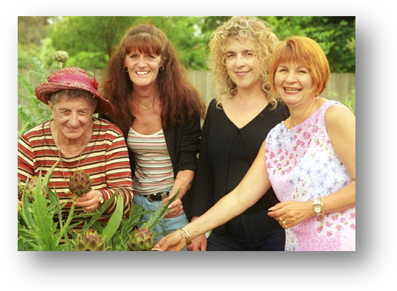
A number of surveys have been conducted about general levels of satisfaction with life, connection with family and friends, affiliation with the community, feelings of trust in others, multiculturalism, and being heard or able exert an influence upon events of importance to them. Some surveys are conducted at a local level, supplying insights into local conditions. Others are undertaken at a state-wide or national level, but owing to their larger number of participants, still shed light upon variations in perceptions and experiences among people of different age, sex and socioeconomic circumstances.
Some of these findings, and their relation to conditions in Greater Dandenong, are recounted here.
Satisfaction with Life
The 2020 Victorian Population Health Survey found that 26.3% of Greater Dandenong residents felt a 'fair' or 'poor' level of satisfaction with life - the eight highest level in Victoria. Across metropolitan municipalities, low levels of satisfaction with life among residents of these municipalities were strongly associated with feelings that people could not be trusted, dissatisfaction with levels of contact with families or friends, limited contact with family, perceptions of not being valued by society and single parenthood.

The earlier, 2015 VicHealth Indicators Survey, sought to measure personal wellbeing through responses to a sequence of questions concerning standard of living, achievements in life, community connection, personal relationships, safety and future security. The survey recorded an index of wellbeing of 75 for Greater Dandenong residents - the third lowest level in Victoria.
Wellbeing
The 2020 Victorian Population Health Survey also found that residents of Greater Dandenong scored relatively low in their perceptions of trust, feeling valued by society and contact with friends and family. These are set out in the accompanying table.
Low/Medium Life Satisfaction | 8th highest in Vic at 26.3%, and slightly higher than Vic level of 22.3
Feeling of Trust: most people could be trusted 'never' or 'not often' | 3rd highest in Vic at 22.2% and substantially higher than Victorian average (14.2%)
I feel valued by society: 'never' or 'not often' | third highest in Victoria, at 17.1%, third highest in Victoria (11%)
Has no close friends or family that they talk to regularly | highest in Vic at 9.3%, third highest in Victoria and about double the Victorian average (4.3%)

Wellbeing: Social Disadvantage, age and sex
Responses to inquiries featured in the 2015 VicHealth Survey showed that Victorians living in circumstances of disadvantage - among them, those on lower incomes, unemployed people, disabled residents, members of LGBTI communities, or people from non-English-speaking countries - tended to register less confidence in others and satisfaction with life, than others.
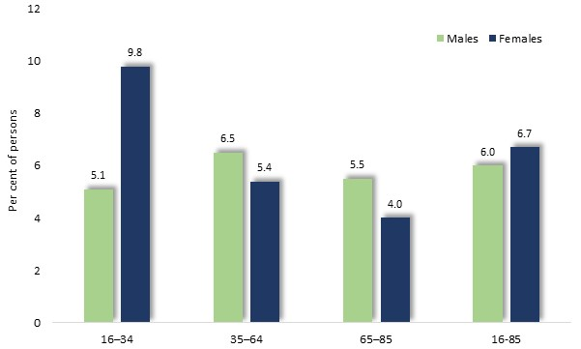
The 2020/21 National Study of Mental Health and Wellbeing provides some suggestion of how measures of social connection vary with age and sex, which may hold some relevance here. It found that 6.3% of people aged 16-85 years - including similar proportions of women and men - felt that they received 'fair' or 'poor' support from friends or family. Notably, among those aged 16-34 years, the prevalence of such limited perceived support was twice as high among women, at 9.8%, as among men, at 5.1%.

Perceptions of limited support from families, by sex and age: Australia, 2020

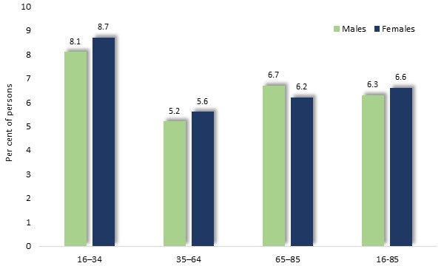
The survey also determined that 6.3% of participants felt 'fair' or 'poor' confidence in having their say about social issues. The prevalence of such concerns was similar for males and females, and highest among younger people, at 8.4%.

Perceptions of ‘fair’ or ‘poor’ confidence in having your say about social issues: Australia, 2020

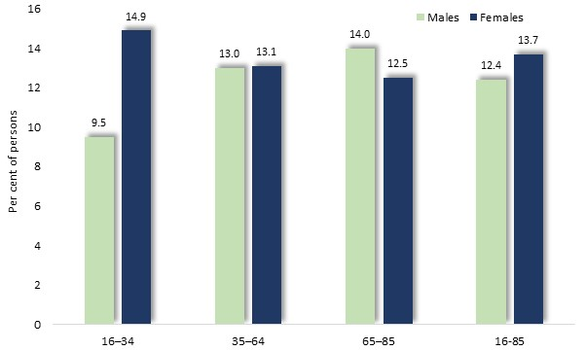
Finally, the Study inquired about participants' perceptions of connection with the community, finding that 12.9% of Australians aged 16-85 years felt a 'fair' or 'poor' sense of being part of a community.

Perceptions of ‘fair’ or ‘poor’ connection with the community: Australia, 2020

The results differed little with age and sex, with the exception that, among people aged 16-34 years, nearly 15% of women, compared with 9.5% of men, felt such limited connection with a wider community.
Acceptance of Cultural Diversity
The 2020 Population Health Survey found that 9% of Greater Dandenong residents felt that multiculturalism ‘never’ or ‘not often’ made life in their area better, slightly higher than the state-wide figure of 7%. Such misgivings about multiculturalism were most prevalent in Yarriambiack, with 14% of residents surveyed offering this assessment, and least prevalent in Yarra, where 2.4% of residents echoed this sentiment.
The proportion of Victorian residents who held such views about multiculturalism rose with age, and was higher among men than women (corresponding findings are not available for individual municipalities).
At a national level, the 2021 Scanlon Cohesion survey found that 23% of respondents disagreed with the proposition that: ‘accepting immigrants from many different countries makes Australia stronger’.

Discrimination and Attitudes to Birthplace and Religious Groups
Successive national surveys conducted by the Scanlon Foundation, show that the proportion of Australians who have experienced of discrimination due to skin colour, ethnic origin or religion during the previous 12 months, rose in Australia from 9% in 2007 to 19% in 2018/19, before declining to 14% by 2021.
Asked about their perceptions of people from different countries in the 2021 survey, negative feelings towards people from the United Kingdom and Germany were expressed by 6% of respondents to this survey, toward people born in India, 27%; Lebanese, 38%; China, 43%; and Sudan, 46%.

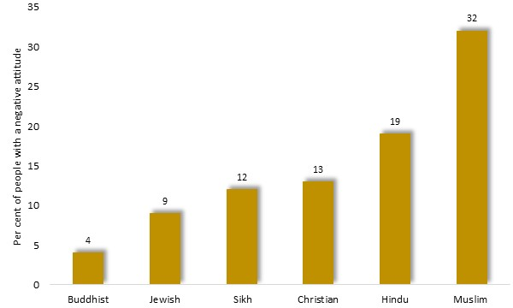
The proportion of Australians who registered similarly negative feelings toward faith groups ranged from 4% toward Buddhists, to 32% toward Muslims.

Proportion of survey respondents who held a negative attitude toward religious groups, by religion: Australia, 2021

Volunteering
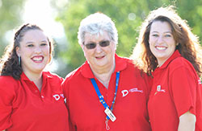
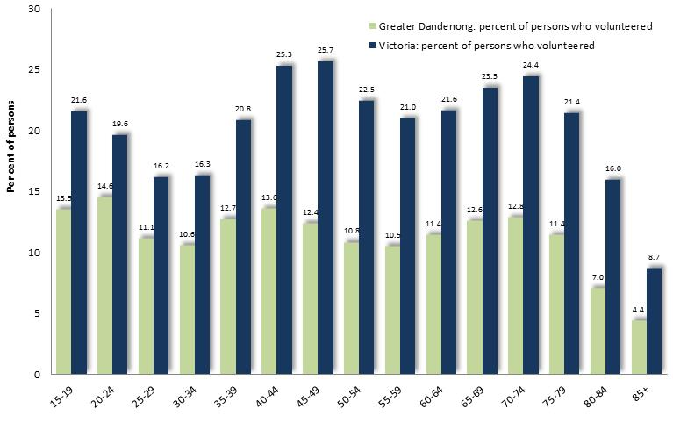
The 2021 Census found that 7.6% of Greater Dandenong residents – numbering 9,300 people - had volunteered at some time in the previous 12 months – the second lowest rate in Victoria, and half the State average of 14.2%. The proportion of residents who volunteered is highest among young people, those of middle age, and residents in their early older age.

Percentage of residents who volunteered in the previous year, by age and gender: Greater Dandenong and Victoria, 2021

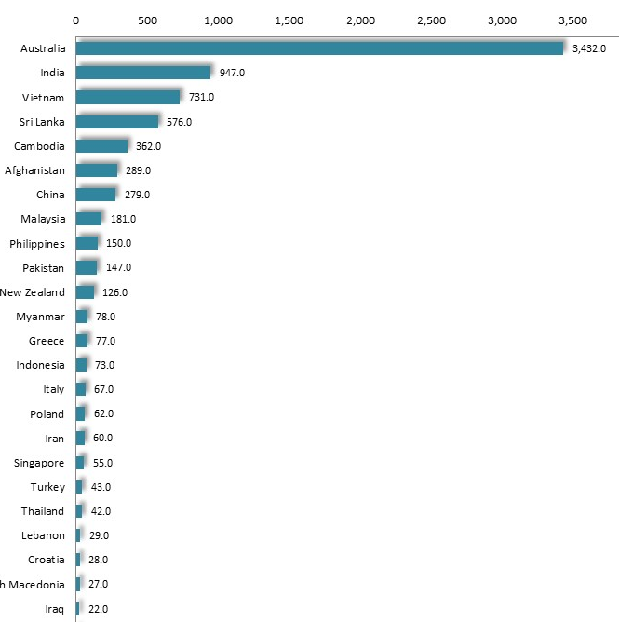
Australian-born residents account for nearly a third of volunteers in Greater Dandenong. Others are from countries such as India, Vietnam, Sri Lanka, Cambodia and Afghanistan.

Number of residents who volunteered in the previous year, by birthplace: Greater Dandenong and Victoria, 2021

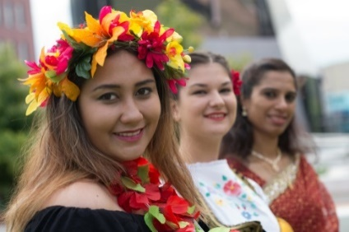
Educational attainment is associated with the likelihood of volunteering, with 8.7% of residents with at least year 11 or 12 education having volunteered in the previous 12 months, compared with 5.3% of those who completed year 10 or less, echoing a similar trend across Victoria.
Arts and Culture
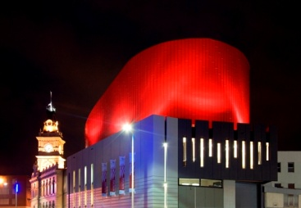
National Participation Trends
The Attendance at Selected Cultural Venues and Events Survey (the latest available) found that cinemas and live music performances were among the more popular events, attracting over half of Australians aged 14 years or more during the previous 12 months. By contrast, fewer than 20% of Australians had attended musicals, operas, dance and theatre performances.
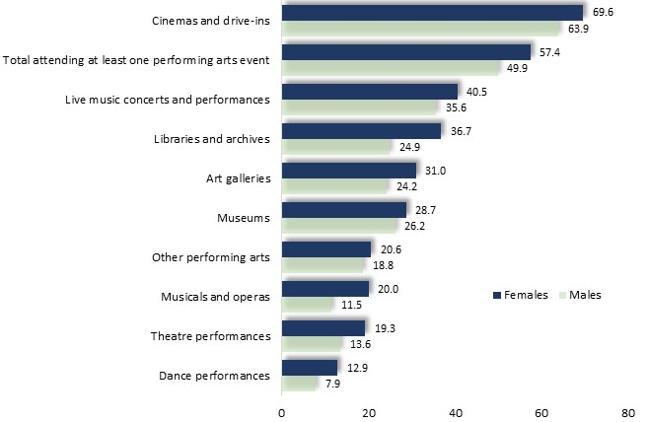
Women were more likely to have attended arts events and performances than men, with 85% of those aged 14 years or more attending at least one venue or event in the previous year, compared with 78% of males. Moreover, women were decisively more likely to have attended libraries (37% vs. 25% of males), and musicals (20% vs. 12%).
Per cent of persons who attended selected events during the previous year, by sex: Australia, 2017/18

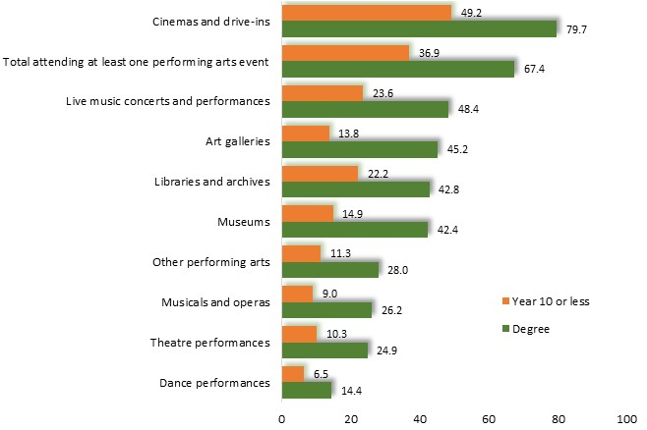
Levels of attendance were relatively stable throughout the lifespan, declining only among people aged 65 years or more. For example, the proportion of people attending at least one event declined gradually, from 95% among those aged 15 to 17, to 88% among 35-44 year-olds, and 56% of people aged over 75 years.
Education levels influenced arts attendance, with 93% of people with university degrees attending an event in the previous year, compared with 65% of those with year 10 or less.

Per cent of persons who attended selected events during the previous year, by education level: Australia, 2017/18

Moreover, degree holders were three times more likely than those with year 10 schooling only, to attend art galleries, museums and musicals, and twice as likely to attend other events.
Attendance was also associated with income, with households among the highest fifth in incomes, three times more likely to have attended live music, dance, musicals and operas as those on the lowest fifth of incomes.
Reasons for Non-Participation in Arts and Culture
A further national survey of participation in the arts, conducted in 2016, investigated levels of participation of people of various ages and genders. Reasons for not participating in the arts included difficulty finding time and lack of interest common reasons for lack of engagement. Travel limitations and having no-one to participate in such activities with them, were more prevalent reasons among women, whereas lack of interest was more often cited by men.
Reasons for not participating in arts or cultural activities: Australia, 2016
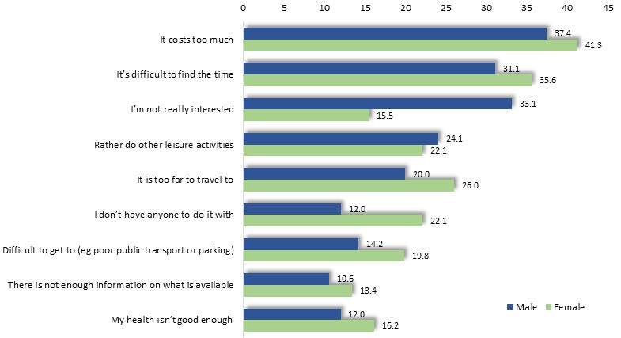

Local Trends
Of those who purchased tickets to performances at the Drum theatre in 2016/17, approximately 1,000 were residents of Greater Dandenong, representing approximately 0.6% of the population of this municipality.
Per cent of residents who had participated in an
arts event during the previous three months, 2012
Locally, the 2012 VicHealth Indicators Survey (the more recent local survey of this kind, at the time of writing) found that local levels of participation in arts activities or events were relatively low, with 50% of residents attending arts activities or events during the previous 3 months, compared with 66% of Victorian residents. More broadly, participation levels were highest in the more affluent metropolitan localities, and lowest in rural communities and disadvantaged metropolitan areas.
Per cent of residents who created art or craft during the previous three months, 2012


Gender Differences in Social Conditions and Outcomes
Early Childbirth
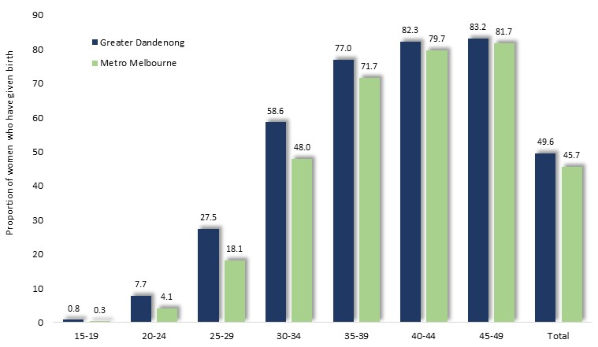
Per cent of women who had given birth, by age: Metropolitan Melbourne and Greater Dandenong, 2021
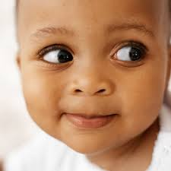
The proportion of younger women in Greater Dandenong who had given birth is more than twice the corresponding rate in Melbourne.
For some young women, early childbirth is either a consequence or a cause of limited educational and vocational opportunities.


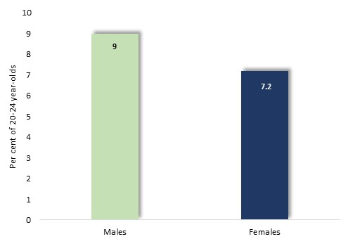
Early School Leaving
Per cent of persons aged 20 to 24 years, who had left school before completing year 11, by gender: Greater Dandenong, 2021

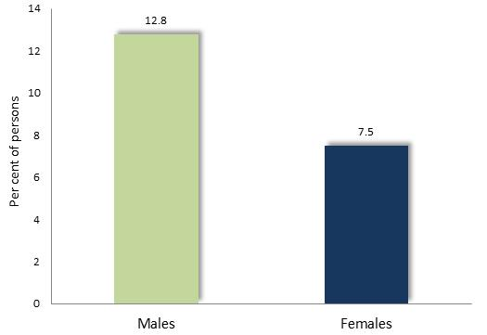
English Literacy

Per cent of persons aged 20 to 24 years, with limited English literacy: Australia, 2011
The 2011–12 Programme for the International Assessment of Adult Competencies, found that among Australians aged 20-24 years, 12.8% of males and 7.5% of females were rated as having an English literacy level of or below Level One Literacy, the lowest levels on the scale of literacy

Tertiary Qualifications
The 2021 Census found that, among 25-44 year-old residents, 30% of men and 37% of women had attained a university degree.
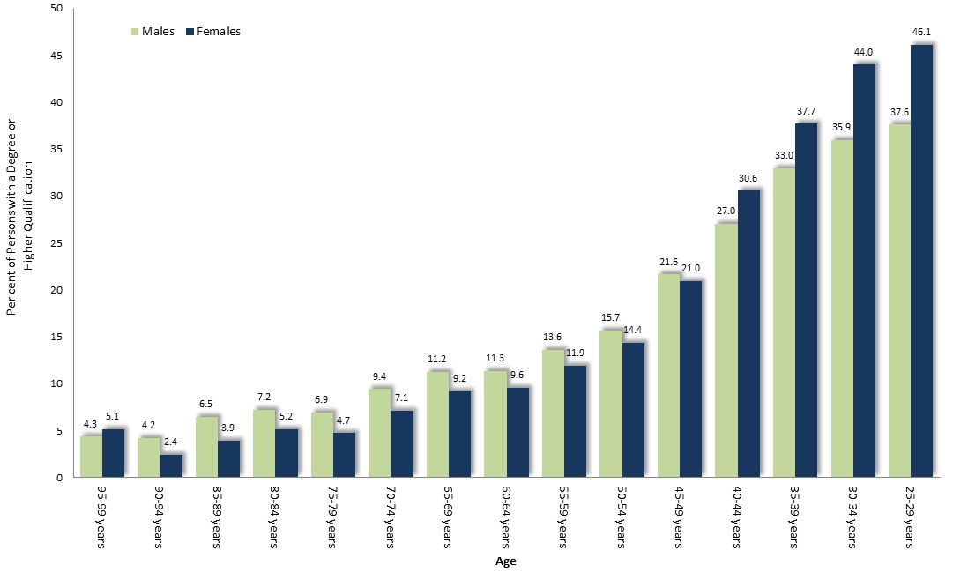

Per cent of persons who hold a tertiary qualification, by gender and age: Greater Dandenong, 2021
The 20211 Census revealed that among people aged 25-29 years, 46% of women and 38% of men held a degree.
Women aged 25-29 years are about ten times more likely to hold a degree than those born 60 years earlier.


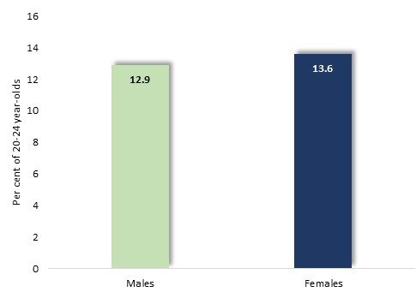
Youth Disengagement

Per cent of persons aged 20-24 years, who were neither in paid employment nor enrolled in education or job training, by gender: Greater Dandenong, 2021
Despite their higher school retention levels, disengagement levels among young women in Greater Dandenong are higher than for males, due to the fact that most young women with children are not in paid employment or enrolled in education.

Paid Employment
The 2021 Census found that among persons aged 15 years or more in Greater Dandenong, 61% of men were in paid employment, compared with 49% of women.
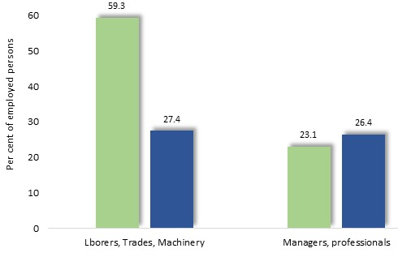
Per cent of persons in paid employment who were employed as managers or professionals, by gender: Greater Dandenong, 2021

The Census also revealed that 59% of men in paid employment worked as tradespersons, labourers or machinery operators, compared with 27% of women.
Conversely, over 26% of women in paid work were employed as managers or professionals, compared with 23% of employed men.

Fields of Qualification
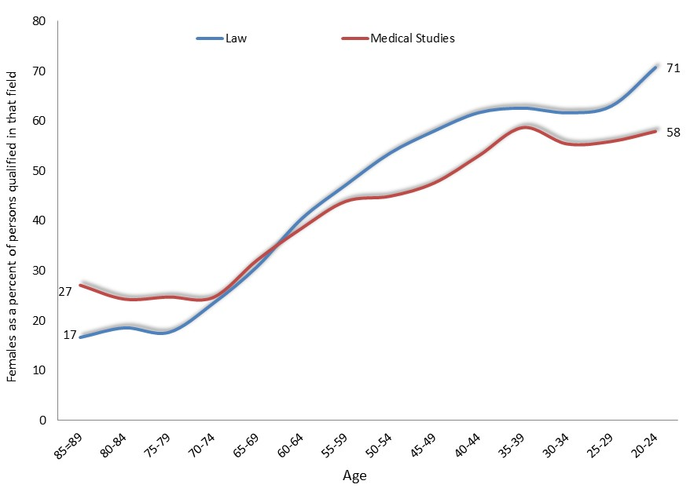
Women as a percentage of persons with tertiary qualifications in medicine and law, by age: Victoria, 2021


The rising proportion of women with tertiary medical and legal qualifications, with decreasing age, reflects trends which extend across the previous 75 years.
Similar increases, though less pronounced, have occurred in the representation of women in scientific, engineering, accounting, management and other fields.

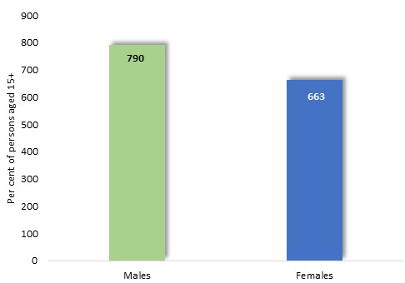
Incomes


Median weekly gross individual income among persons aged 15 years or more, by gender: Greater Dandenong, 2021
In 2021, median weekly individual gross incomes stood at $790 among males - 64% higher than the corresponding level among women, of $482 p.w. (Median male incomes were 53% higher than those among women in 2016.)

Median income levels by employment status and level, by gender: Greater Dandenong, 2021
The income gap between women and men was lower among those in paid employment, and less among those in full-time work. The difference between women’s and men’s hourly income was smaller still, at 4.7%.
These findings confirm that income differences between women and men are due largely to the lesser proportion of women who hold paid employment, and the lower percentage of those in paid work who are employed full-time – conditions largely related to child-rearing responsibilities.

.

Disparity between men’s and women’s hourly incomes, Victoria, 2021

The 2021 Census also showed that the disparity in hourly income between women and men is higher older women and lowest among young women – suggesting a trend towards increased pay equity among women who have more recently entered paid employment.

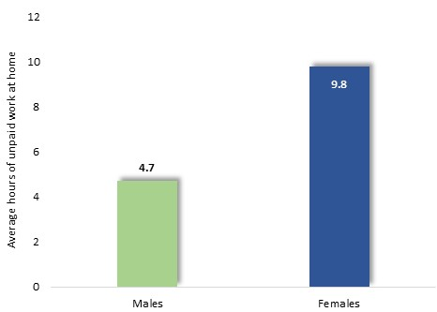


Unpaid Work at Home
In 2021, 20-79 year-old males performed an average of 4.7 hours of unpaid work at home, less than half the corresponding average among women, of 9.8 hours.

Average hours of unpaid work performed each week, by gender: Greater Dandenong, 2021


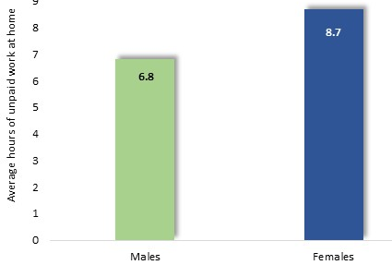
Disability
The 2021 Census recorded that 6.8% of males in Greater Dandenong, and 8.7% of females, had a severe or profound disability, requiring them to obtain daily assistance in communications, mobility or self-care.

Per cent of persons with a severe or profound disability, by gender: Greater Dandenong, 2021

When these figures are adjusted to compensate for age differences between women and men, this disparity declines slightly to 8.6% among men and 9.3% for women.

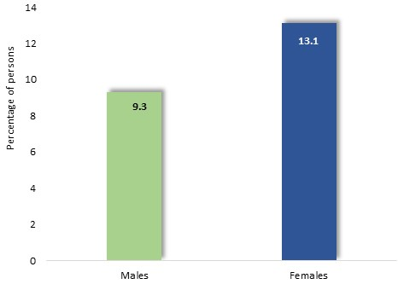
Unpaid Assistance to Persons with Disability
The 2021 Census also showed that 9.3% of males and 13.1% of females in Greater Dandenong, provided unpaid care for a person with a disability or chronic illness.

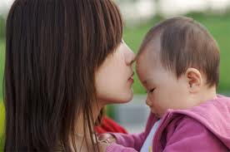
Per cent of persons who provide unpaid care for a person with a disability, by gender: Greater Dandenong, 2021

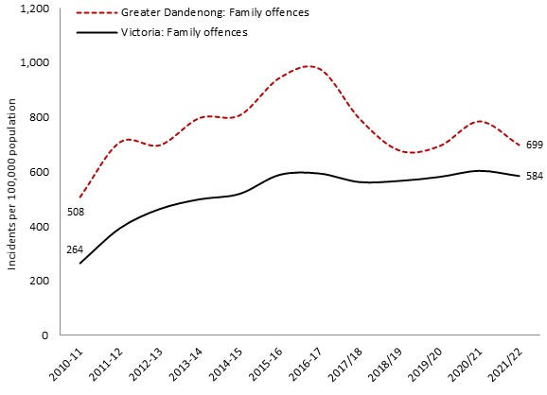
Family Violence
In 2021/22, the rate of incidents of family violence recorded by police was the third highest in Melbourne. Women accounted for 73% of victims of such crimes.

Number of recorded victims of alleged family violence incidents, by gender: Greater Dandenong, 2021/22

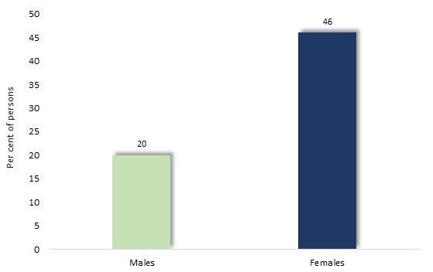
Perceptions of Personal Safety
A 2015 survey conducted by the State Government found that nearly half (46%) of females and a fifth (20%) of males in Greater Dandenong did not feel safe while walking alone at night in their neighbourhoods.

Per cent of women and men who feel unsafe walking alone in their neighbourhoods at night: Greater Dandenong 2015

Attitudes to Gender Equity
The 2015 VicHealth Indicators Survey sought to measure support for gender equality, recording the level of agreement among respondents to two statements:
- Men should take control in relationships and be head of the household
- Women prefer a man to be in charge in a relationship
The result was a score representing the percentage of respondents with a low support for gender equity, which ranged from 18% in Indigo Shire to 58% in Greater Dandenong, averaging 36% across Melbourne.

Percentage of people who express low support for gender equality, by selected characteristics: Victoria, 2015
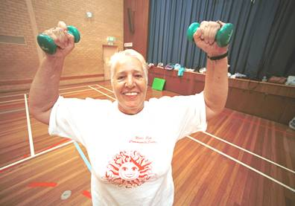
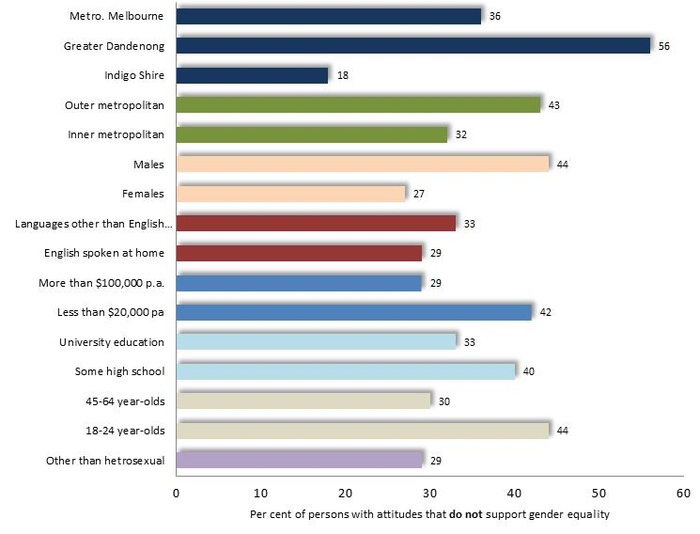
Segments of the community which expressed the lowest support for gender equality included younger people, men, people with limited education, unemployed residents, those from non-English-speaking countries and people living in outer-metropolitan localities.
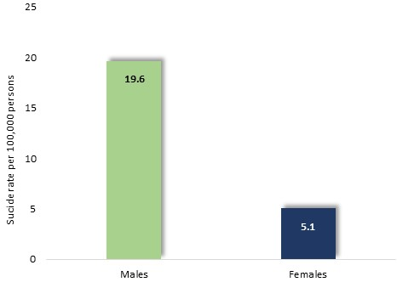
Suicide
In 2020, the suicide rate among Australians was 18.6 per 100,000 persons among males and 5.1 among females – reflecting a long-standing disparity between male and female rates.

Suicide rate (per 100,000) by gender: Aus, 2020


Mental Health
The 2021 Census found that 7.7% of females and 5.3% of males in Greater Dandenong were experiencing mental health conditions – such as anxiety or depression.
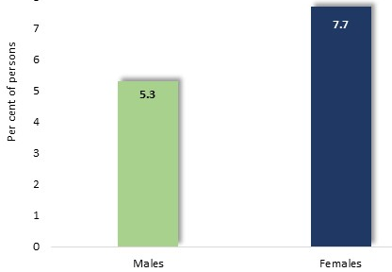

Prevalence of mental health disorders, by sex: Greater Dandenong, 2021
The National Survey of Mental Health and Wellbeing found that the prevalence of post-traumatic stress disorder in Australia is almost twice as high among Australian women (15.8%) as for men (8.6%), while depression (at 14.5% among women and 8.6% among men), social phobia (12.8% and 8.4% respectively) and generalised anxiety disorder (7.3% and 4.4%) are also more widespread among women.

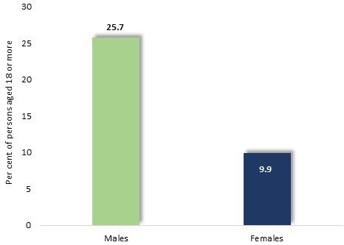
Alcohol Consumption
The 2019 National Drug Strategy Survey revealed that nearly 18% of Australians aged 18 years or more were at risk of long-term harm owing to their level of alcohol consumption. Males were more than twice as likely to be exposed to such risk, with nearly 26% risking long-term harm, compared with nearly 10% of females.

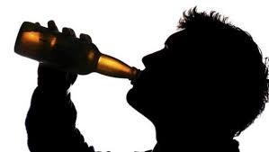

Per cent of adults at lifetime risk of alcohol-related harm, by sex: Australia, 2019



Mortality
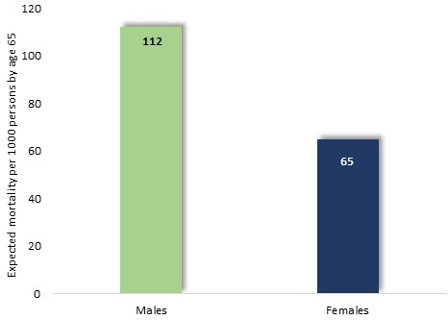
Mortality rates among males tend to be higher than among females throughout the lifespan. Based on mortality rates in Australia in 2020, 112 males per 1,000 would be expected to die by 65 years, compared with 68 females.

Proportion of persons expected to be deceased per 1,000 individuals, by age 65: Australia: 2016-18 age-specific mortality rates

Family Violence

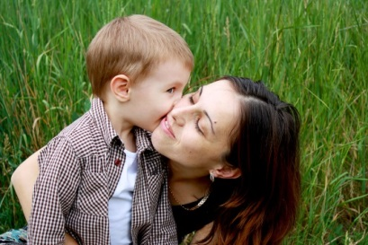
Violence within families, including the abuse of children, cannot be measured with accuracy. However, random surveys of the general population offer the best available method for measuring the prevalence of the such violence.
One of the most important of these surveys in recent times was the 2016 Personal Safety Survey (Australian Bureau of Statistics, 2017c), conducted among 21,000 Australian adult women and men. Survey participants were asked about their experience of physical or sexual assault and violence (assault or threats of assault) since the age of 15 and in the past 12 months. The findings of this survey provide an important glimpse of the extent and nature of violence within families and intimate relationships.

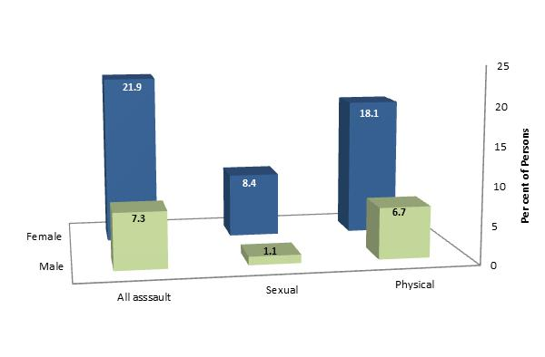
Intimate Partner Violence
Approximately 22% of women and 7% of men had been assaulted by a partner since the age of 15.

Per cent of persons who been assaulted by an intimate partner since aged 15, by gender of victim and type of assault

Women were three times as likely to have been physically assaulted by a partner as men, and nearly eight times more likely to have been sexually assaulted by a partner (diagram, below).
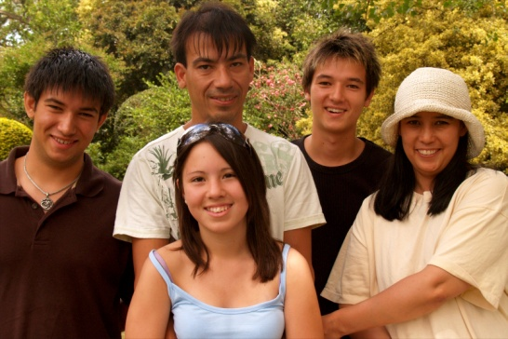
Per cent of most recent instances of partner violence where police were involved, by category of partner and gender of victim
 | Current partner violence | Previous partner violence
Females | 17% | 35%
Males | 4% | 25%

Involvement of Children and Pregnancy
Where women had children in their care when violence occurred, at some time since the age of 15, 31% of those who experienced violence from a former partner, and 23% of those who experienced violence from a current partner, stated that the children had seen or heard the violence.
Eighteen per cent of women who had experienced violence from a current partner since the age of 15, and were pregnant during the relationship, were pregnant when the violence occurred. Five per cent of them stated that this was their first experience of such violence from their partner.
Children as Witnesses to Partner Violence
Approximately one in ten (11%) Australian adults had witnessed violence inflicted upon their mother by a partner before the age of 18, and one in twenty-five (4.5%) had experienced violence by their mother toward her partner.

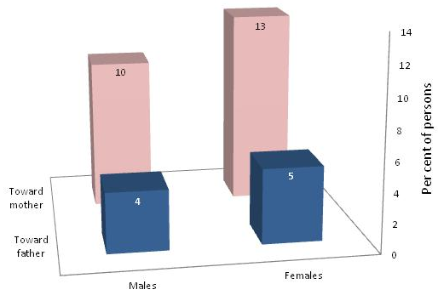
Per cent of persons who had witnessed violence between their parents during childhood, by gender of person and category of violence

Notably, those adults who had witnessed partner violence before the age of 15 were over twice as likely to have experienced partner violence in adulthood (26%) as those who had not witnessed such violence (12%).

Child Abuse Per cent of adults abused in childhood, by gender of victim and type of abuse
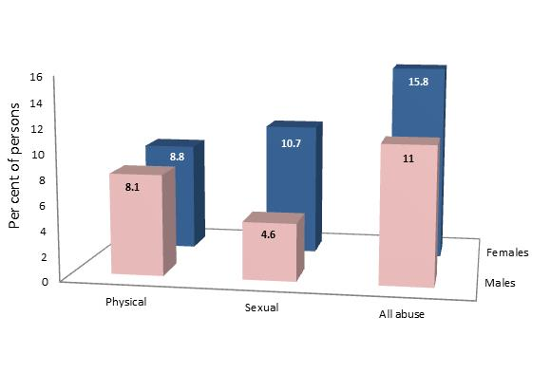
Approximately one in six (16%) females and one in ten (11%) males were abused before the age of 15.
Among women, 9% had been physically abused and 11% sexually abused.
By contrast, about 5% of men had been sexually abused in childhood and 8% physically abused.
.

Local Measures of the Incidence of Family Violence and Child Abuse
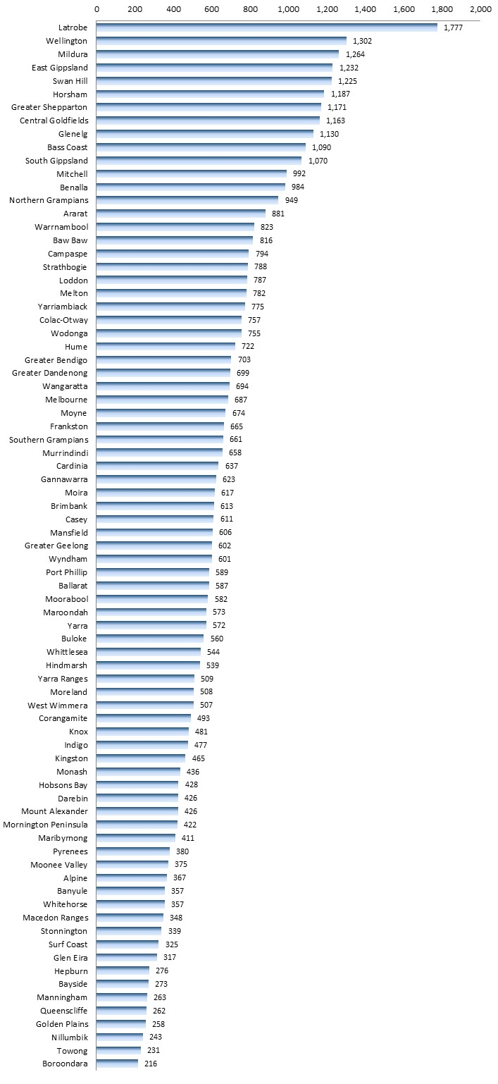
Local measures of the incidence of family violence and child abuse are less reliable, since they only reflect those instances of violence which reach the attention of responsible agencies, such as the police, the courts and child protection authorities.

Family-related Alleged Violent Offences, 2021/22 [per 100,000 residents], by Municipality

The rate of family-related alleged violent offences (per 100,000 residents) in Greater Dandenong, documented by Victoria Police, stood at 699 per 100,000 residents in 2021/22 – the third highest rate in metropolitan Melbourne and 20% higher than the Victorian level. Women accounted for 73% of alleged incidences of violence within families.
The rate of such recorded violent family offences has risen in Greater Dandenong by 37% since 2010/11, and by 121% across Victoria in this period.

Rate of alleged violent offences, per 100,000 population: Greater Dandenong and Metro. Melbourne, 2010/2022

Crime and Safety


Rate Comparison
In the 17 years since 2004/5, the rate of police-recorded violent crime in Greater Dandenong has risen by 64%, drug offences increased by 39%, while the level of property offences declined by 30%.
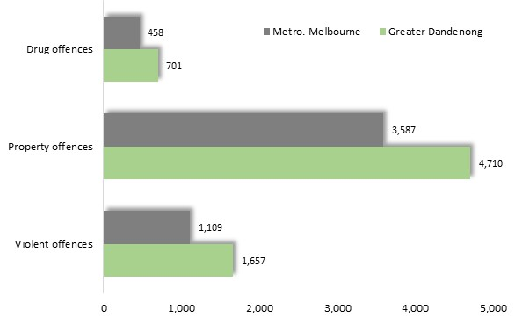
The past four years though, have seen declines in all major categories of alleged offences, including a 17% reduction in the rate of violent offences, a 35% fall in the rate of property offences, and an 18% decrease in drug offences.
Despite these declines, 2021/22 alleged offence rates in Greater Dandenong were 50% higher than metropolitan Melbourne for violent offences, 53% higher for drug offences and 43% higher for overall offences.

Crime Rates: Greater Dandenong and metropolitan Melbourne, 2021/22 (police-recorded alleged offences, per 100,000 population)

The local rate of violent offences was the third highest in the metropolitan area, while the rates of drug and property offences were the sixth highest in metropolitan Melbourne.

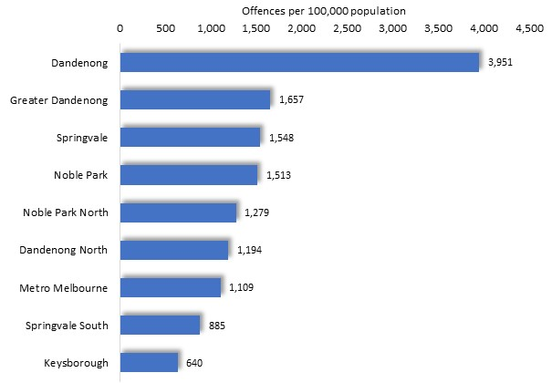
Crime rates vary widely within Greater Dandenong.
In 2021/22, the rate of violent offences in Dandenong was more than twice the municipal average and about six times the level in Keysborough (diagram left).

Violent Crime Rates: Greater Dandenong Suburbs, 2021/22

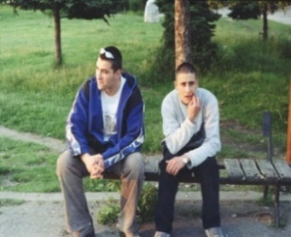
Crime Trends
The decline in crime rates in Greater Dandenong in recent years, reverses a trend of increasing rates of alleged offences during the preceding decade.
For perspective, changes in rates of violent crime and drug offences in Greater Dandenong and metropolitan Melbourne, during the period 2004/5 to 2021/22, are illustrated below.
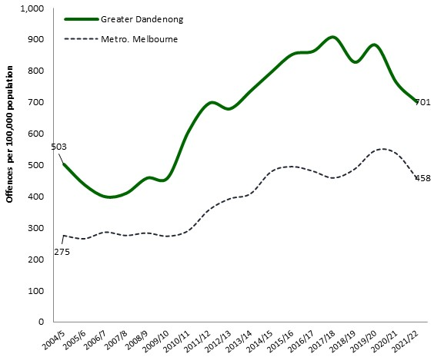
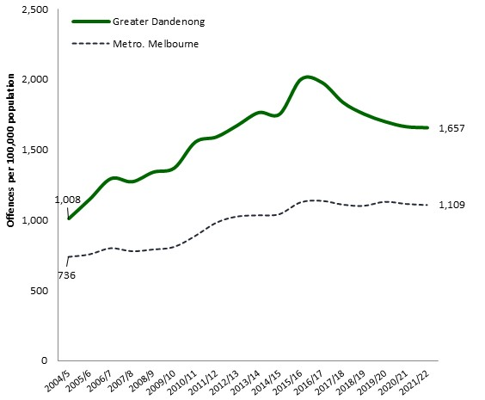
Violent Crime Rate: 2004/5-2021/22 Drug Crime Rate: 2004/5-2021/22

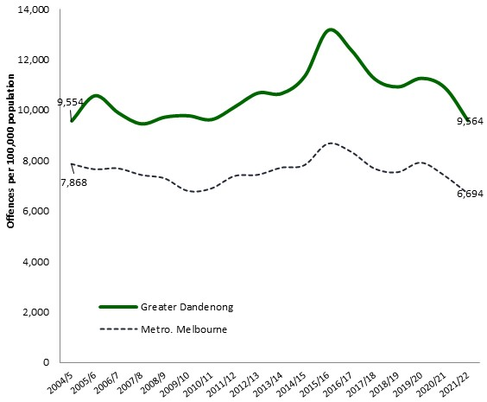
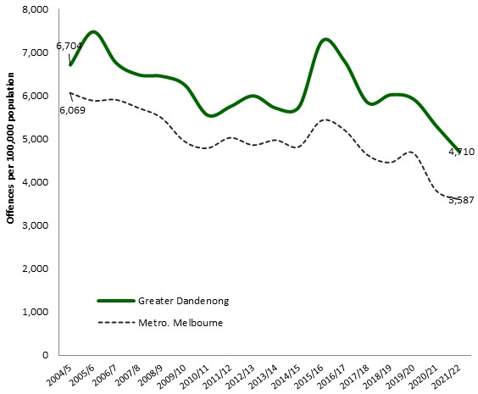
Property Crime Rate: 2004/5-2021/22 Overall Crime Rate: 2004/5-2021/22

Notably, all show a pronounced decline in rates of alleged offences during the past four or five years. In the years before this time, rates of alleged violent and drug-related offences rose, while the overall rate of offences remained relatively stable – albeit with marked fluctuations during this time.

Personal Safety
The 2015 Vic Health Indicators Survey found that 64% of Greater Dandenong residents felt unsafe walking alone in their neighborhoods at night – substantially more than the metropolitan percentage of 44% and the highest level in Victoria.
The proportion of people who feel unsafe in their neighborhoods at night in Victoria, rose from 39% of people aged 35-44, to 67% of residents aged 75 or more, and stood at 27% among men overall, and 63% among women.
The accompanying diagram illustrates the proportion of respondents to the VicHealth survey who stated that they felt safe walking at night in their neighbourhood. Notable trends include the lower proportion of women than of men, who felt safe, and the decline in the proportion of people who felt safe, with increasing age.

Percentage of people who feel safe walking at night in their neighbourhood by age and gender: Victoria, 2015

The survey found that people in inner metropolitan and regional areas, those with high incomes and members of couple households, were more likely to feel safe at night.
Percentage of people who feel safe walking at night in their neighbourhood
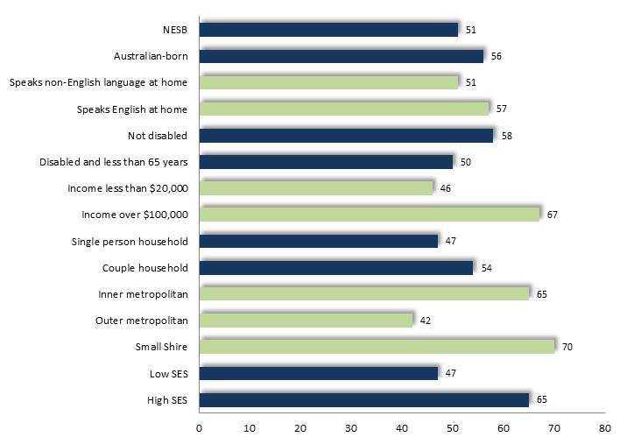
by selected characteristics: Victoria, 2015

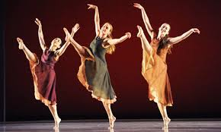
Physical Health

Self-assessed Health
A little over one-quarter (22%) of Greater Dandenong residents rated their overall health as ‘fair’ or ‘poor’ in the 2020 Population Health Survey, similar to the Victorian level of 21%.

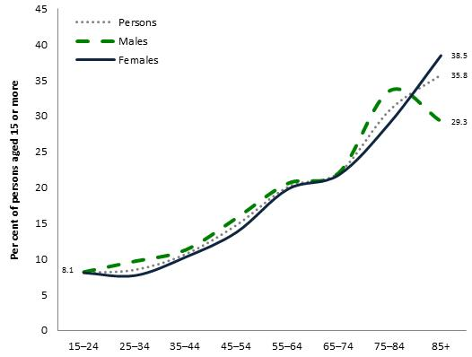
Self-assessed health, by age and gender: Victorian adults, 2017

The earlier, 2017 Population Survey published detailed results by age and sex, though at a State-wide level. Its findings showed that the proportion of Victorians who assess their own health as 'fair' or 'poor' rises steeply with age to about a third among those aged 85 years or more, but differs little between women and men (diagram, right).
Chronic Illness
In 2021, for the first time, the Census featured questions that inquired whether respondents were currently experiencing any of a selection of seven broad categories of chronic illnesses. The results for Greater Dandenong residents are summarized here, with consideration of variations in the prevalence of chronic illness by age and sex.
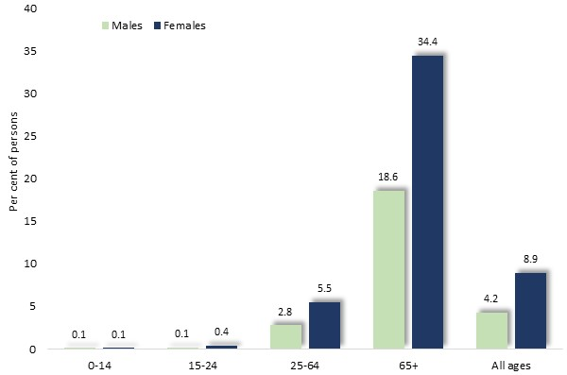
Arthritis

Affecting about 7% of residents, arthritis is most prevalent among older residents of Greater Dandenong, and about twice as common among women than men.

Per cent of residents with arthritis, by sex and age: Greater Dandenong, 2021

Cancer
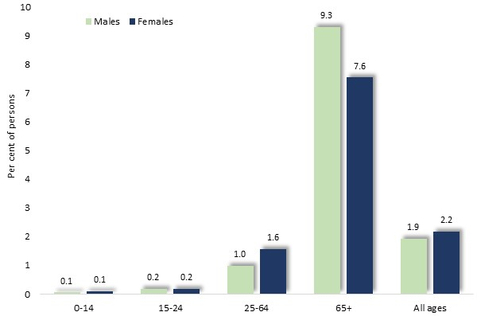
Approximately 2% of residents – including similar proportions of women and men – stated that they were living with cancer. As with arthritis, the prevalence of cancer was age-related, reaching its peak among older residents.

Per cent of residents with Cancer, by sex and age: Greater Dandenong, 2021

Diabetes Mellitus
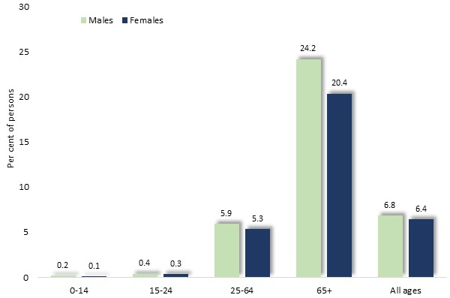
Nearly 7% of residents stated that they had diabetes mellitus – including over 5% of people of working age, and more than 20% of residents aged 65 or more. Its prevalence was similar among men and women.

Per cent of residents with diabetes, by sex and age: Greater Dandenong, 2021

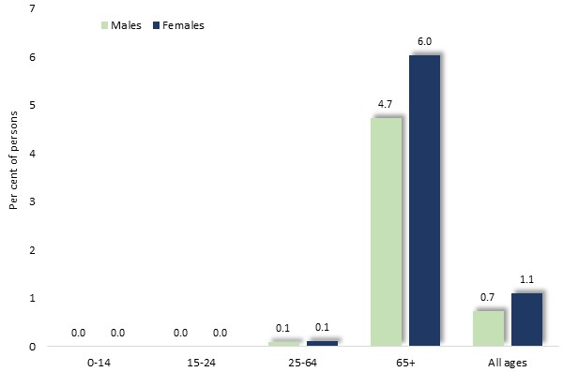
Dementia
The Census findings indicated that dementia affected approximately 1% of residents, including slightly more women than men. Dementia was almost wholly confined to residents aged 65 years or more, among whom it afflicted approximately 5.4% of residents.
Per cent of residents with dementia, by sex and age: Greater Dandenong, 2021

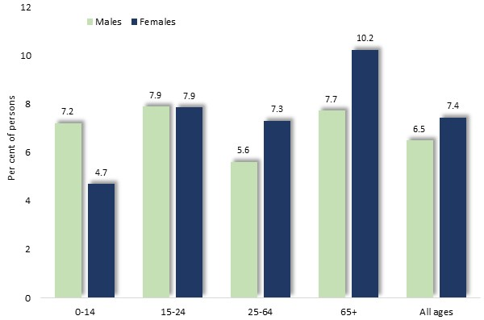
Asthma
The prevalence of asthma was relatively uniform across the lifespan as well as between women and men. Among children, it was more widespread among boys than girls, affecting 7.2% of males aged 0 to 14 years, and 4.7% of females of this age.
Per cent of residents with asthma, by sex and age: Greater Dandenong, 2021

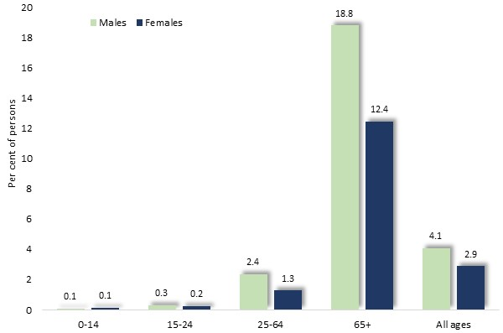
Heart Disease
The findings of the 2021 Census indicated that approximatley 3.5% of Greater Dandenong residents had heart disease. The prevalence of such conditions rose stteply with age, to 15% of people aged 65 or more, and was most widespread among men.
Per cent of residents with heart disease, by sex and age: Greater Dandenong, 2021
Kidney Disease
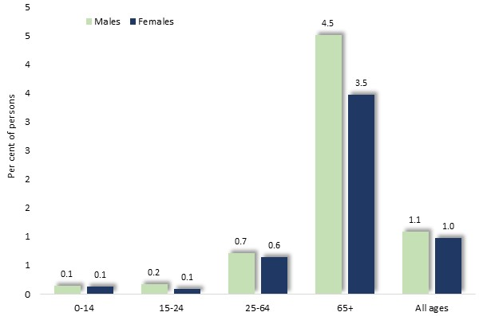
Kidney disease affected approximately 1% of residents, most of them in their older age, and featuring similar proportions of men and women.

Per cent of residents with kidney disease, by sex and age: Greater Dandenong, 2021

Lung Disease
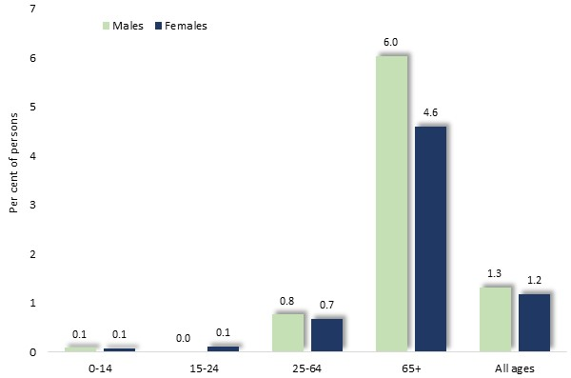
Lung diseases, including chronic obstructive pulmonary diseases such as emphysema and bronchiectasis, were recorded among approximately 1% of residents, chiefly those in their older age.

Per cent of residents with arthritis, by sex and age: Greater Dandenong, 2021

Stroke
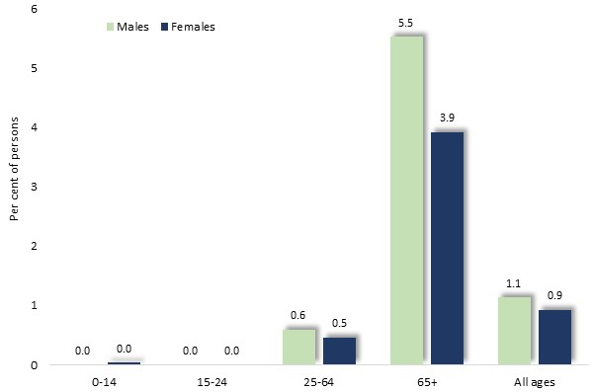
About 1% of residents stated that they were living with the effects of stroke. Here too, those affected with such conditions were largely in their older age, where males predominated.

Per cent of residents with stroke, by sex and age: Greater Dandenong, 2021

Chronic Illnesses: All ages
This and two accompanying charts, further below, illustrate the prevalence of these chronic conditions among Greater Dandenong residents.
Asthma, diabetes mellitus and arthritis are the most common, each affecting over 6 % of residents.
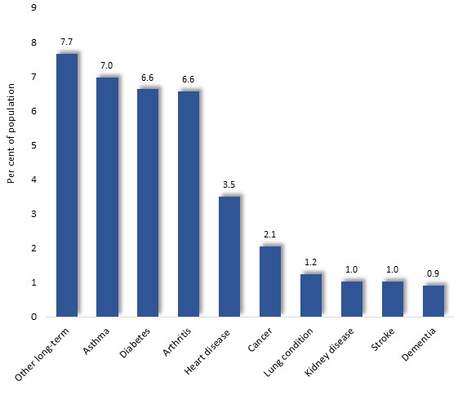

Prevalence of Selected Chronic Illnesses: persons of all ages, Greater Dandenong, 2021

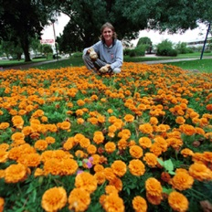
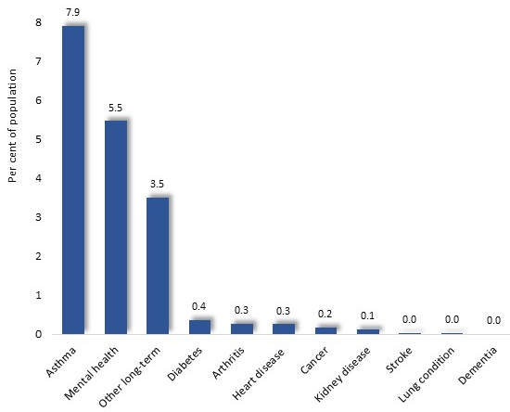
Chronic Illnesses: persons aged 15-24
Among young people though, asthma and mental health conditions predominate among the chronic conditions affecting this age group.

Prevalence of Selected Chronic Illnesses: persons aged 20-24, Greater Dandenong, 2021

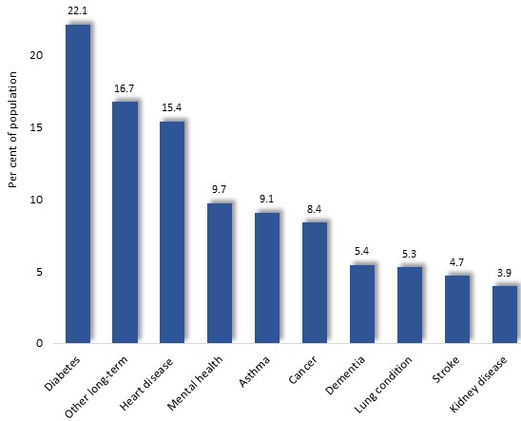
Chronic Illnesses: persons aged 65 or more
By contrast, among people aged 65 years or more, all of these chronic conditions affect an appreciable number of Greater Dandenong residents. Among them are diabetes mellitus and heart disease, which each affect at least one in six older residents.

Prevalence of Selected Chronic Illnesses: persons aged 65+, Greater Dandenong, 2021

Exercise, Sport and Physical Recreation


Benefits of Physical Activity
Physical activity among children and adults reduces heart disease; helps prevent stroke and high blood pressure; minimizes the probability of developing type-two diabetes; lowers the prospect of breast and colon cancer; builds healthy bones, muscles and joints; and promotes mental health and social connection.

Physical Activity among the General Population
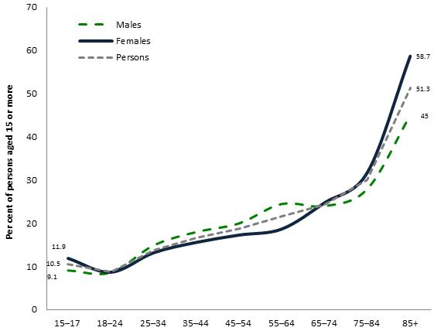
The 2018 National Health Survey found that approximately one in ten 15 to 17 year-olds obtain no exercise in a typical week. This figure rose gradually throughout adulthood to nearly one in five people aged 55-64, before swelling in older age to over half of Australians aged 85 years or more.

Per cent of persons who engage in no physical exercise in a typical week: Australia, 2018

The proportion of people who obtain no exercise each week was strikingly similar among women and men.

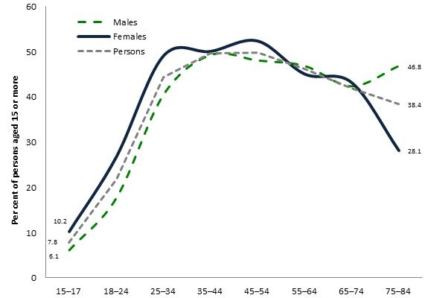
Sedentary behaviour

The 2018 National Health Survey also revealed that by their mid-20s, most people in paid employment spend nearly half their working days seated at work – a trend seen among both women and men.

Per cent of employed persons who spend most of their working days seated, by age and sex: Australia, 2018

Local Measures of Physical Activity
Surveys paint a picture of physical activity among residents of Greater Dandenong. The 2017 Victorian Population Health Survey reported that 44% of adults in Greater Dandenong engaged in insufficient exercise, compared with 51% of those across Victoria. The earlier, 2015 VicHealth Indicators Survey, documented the proportion of residents who did not engage in physical activity for 30 minutes or more on any day of the week. Results ranged from 33% for Greater Dandenong, to 7% among residents of Port Phillip, with an overall figure of 18% among metropolitan residents.

Popular Types of Sport and other Physical Recreation

The 2021 Ausplay Sports Participation Survey shed light upon the participation of Australians in a range of sporting and physical recreation pursuits, focusing upon activities during the previous 12 months. While results at a municipal level were not generated by the survey, its findings contribute to an understanding of the activities in which residents of Greater Dandenong may engage, and how their patterns of participation may vary with age and sex.

All age groups
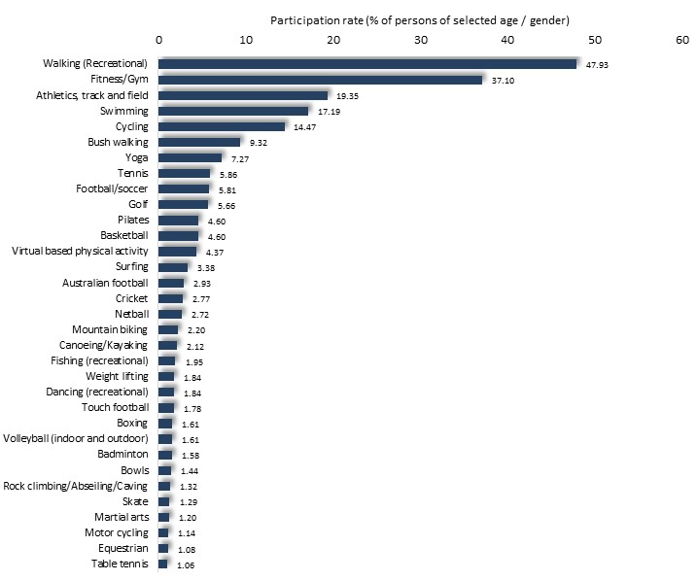
Popular physical pastimes among Australians include walking – accounting for nearly half of those surveyed – as well as fitness, athletics, swimming and cycling.

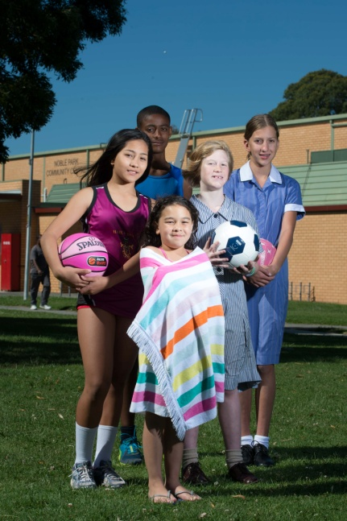

Per cent of persons of all ages who participate in sport and physical recreation, by type of activity: persons of all ages, Australia, 2021

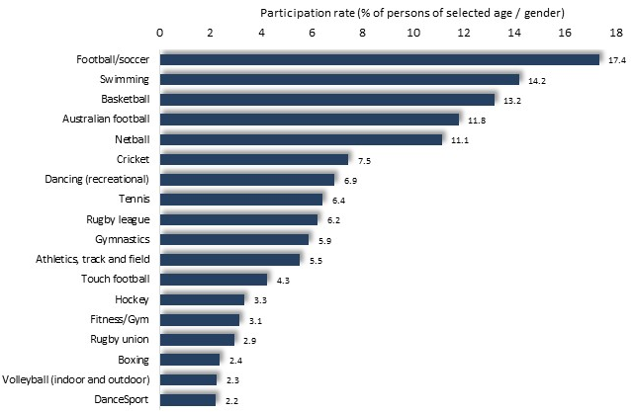
Persons aged 12-14 years
Children aged 12 to 14 years were most inclined towards sporting activities, such as soccer, swimming, basketball, Australian football and netball – each accounting for the participation of at least 10% of people in this age group.

Per cent of persons who participate in sport and physical recreation, by type of activity: persons aged 12-14, Australia, 2021

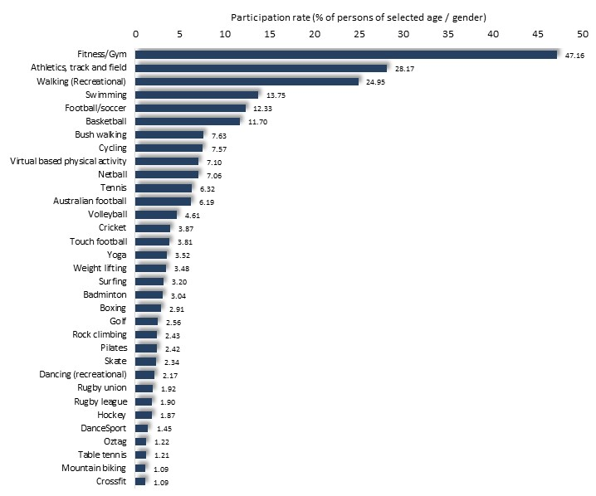
Persons aged 18-24 years
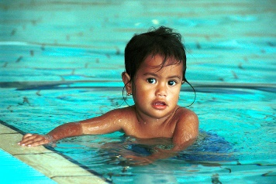
Among young people, fitness, athletics, swimming, basketball, soccer and walking rose to prominence among their favoured sporting and physical recreation activities. Each attracted the participation of over a fifth of all young Australian adults, including nearly half in the case of fitness and gym.

Per cent of persons who participate in sport and physical recreation, by type of activity: persons aged 18-24, Australia, 2021

Older people, aged 65 or more
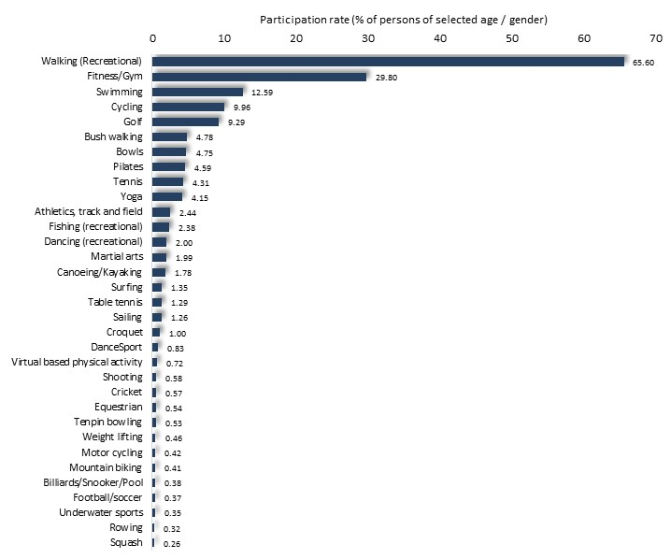
Among older people, walking, fitness, swimming and cycling, remain popular. They are joined by activities such as golf, bowls, Pilates yoga and fishing - sports which chiefly attract people in their middle or older age.
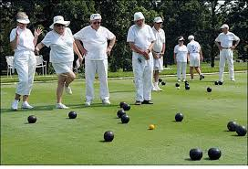

Per cent of persons who participate in sport and physical recreation, by type of activity: persons aged 65+, Australia, 2021

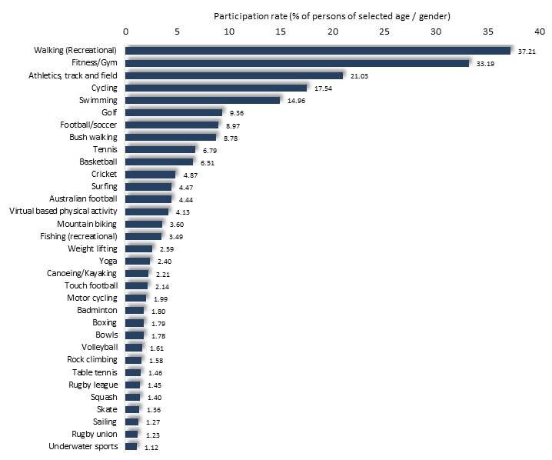
Males
Aside from age, there are also wide differences in participation in sport and physical recreation, between women and men.
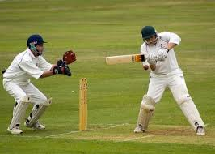
Among males overall, walking, fitness or gym, athletics, cycling, swimming, golf, soccer, basketball and cricket are among the most popular

Per cent of persons of all ages who participate in sport and physical recreation, by type of activity: males, Australia, 2021



Females
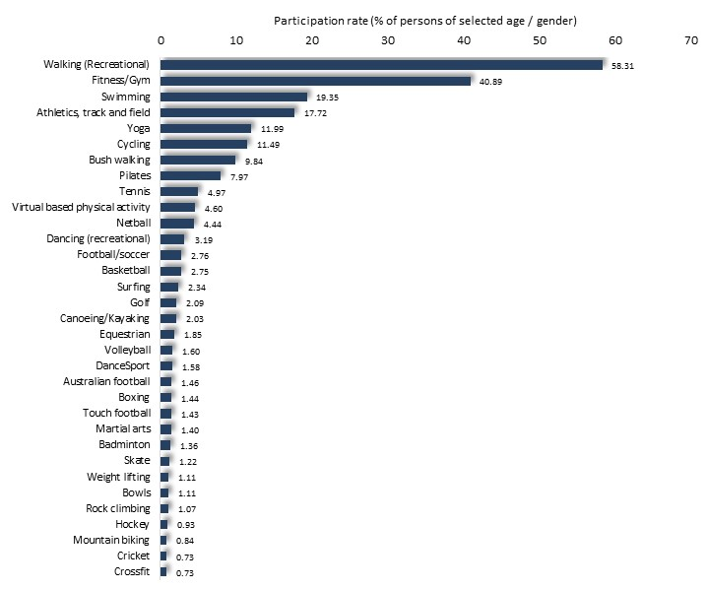
A similar pattern is seen among women, with walking, fitness, athletics and cycling among the most popular activities. Others, distinctly popular among females, include yoga, Pilates, netball, dancing, equestrian sports and others.

Per cent of persons of all ages who participate in sport and physical recreation, by type of activity: females, Australia, 2021

Participation in Popular Sports, by Age and Sex
The 2021 Ausplay Survey also documented variations in the prevalence of sport and physical recreation pursuits among people of different ages. Examples of these trends, as they apply to some of the more popular activities, are presented here.

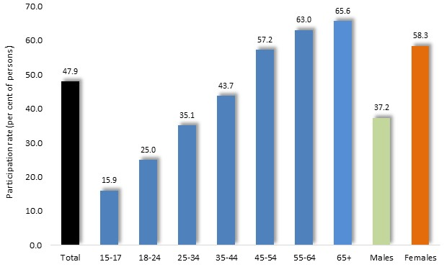
Walking (recreational)
The proportion of Australians who engage in walking for exercise rises with age, from about one in six teenagers, to two-thirds of people aged 65 years or more.
Walking is decisively more popular among females than males.

Participation in walking, by age and sex: Australia, 2021

Fitness/Gym
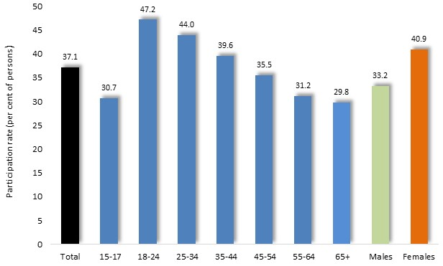
Levels of participation in fitness or gym is more stable across the lifespan, rising to 42% among young adults, then declining moderately with age to 30% among people aged 65 or more.

Participation in fitness or gym, by age and sex: Australia, 2021

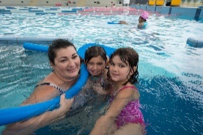
Swimming
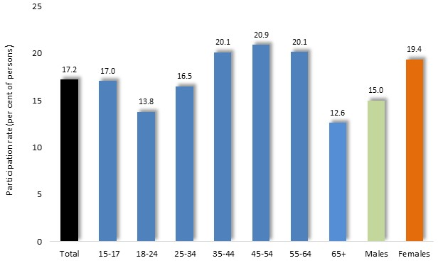
Similarly, swimming is enjoyed by about one-fifth of people in most age ranges, retaining its popularity among those aged 65 years or more.

Participation in swimming, by age and sex: Australia, 2021

Athletics, Track and Field
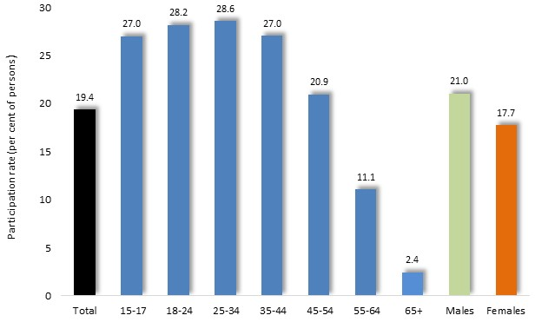
Athletics is popular among young and middle-aged people, before declining steeply in older age.

Participation in athletics, by age and sex: Australia, 2021

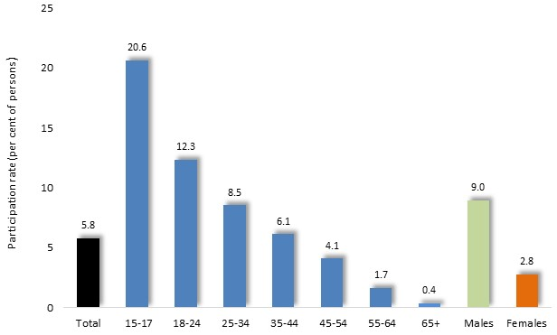
Soccer
Soccer is popular among teenagers, with about one-fifth participating in this sport. Its popularity wanes sharply though, among older people.
Levels of participation in soccer are about three times higher among men than women.

Participation in soccer, by age and sex: Australia, 2021

Yoga
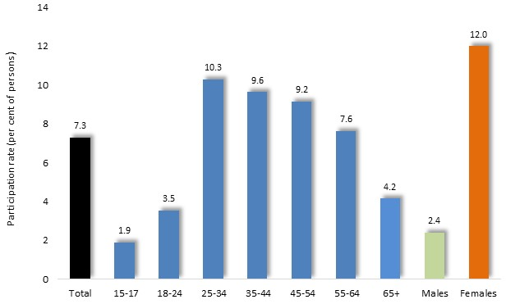
Yoga rises to the peak of its popularity among young adults, with substantial levels of participation persisting among people in their older age.
This activity is about five times more popular among women than men.

Participation in yoga, by age and sex: Australia, 2021

Participation in Sporting Clubs and Associations
In 2019, Eime et al, investigated levels of participation by Victorians in sporting activities through membership in sporting clubs affiliated with any of ten major State Sport Associations: Australian football, Basketball, Cricket, Football (Soccer), Gymnastics, Hockey, Netball, Sailing, Swimming, and Tennis. This study generated information concerning residents of each Victorian municipality and about differences in levels of participation among males and females.
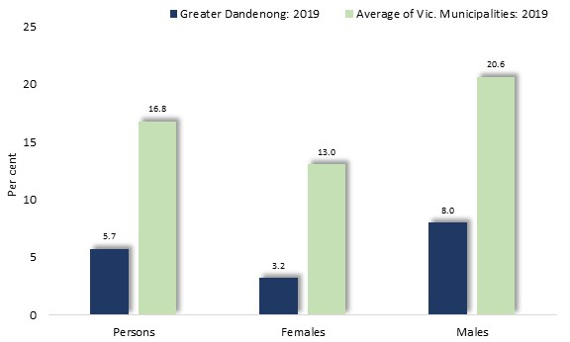
Participation by Greater Dandenong residents was about one-third of the State average and the lowest in Victoria.

Participation in sporting clubs by sex: Greater Dandenong and Victoria, 2019

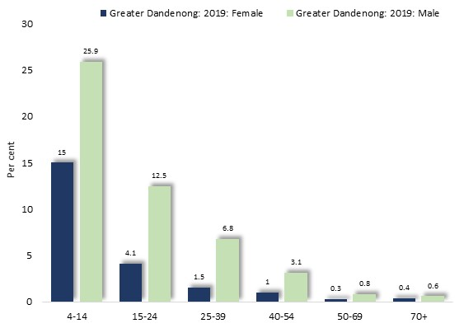
A further notable trend is that the participation rate among females was less than half that for males.

Participation in sporting clubs by age and sex: Greater Dandenong, 2019

Rates of participation in sporting clubs by Greater Dandenong residents declined from 22% of children to less than 1% among people aged 50 years or more. Among females, rates of participation among children aged 4 to 14 years was substantially lower than among males.
In succeeding years, this disparity widens as participation among females descends to less than 2% among those aged 25 years or more.

Mortality
Life Expectancy
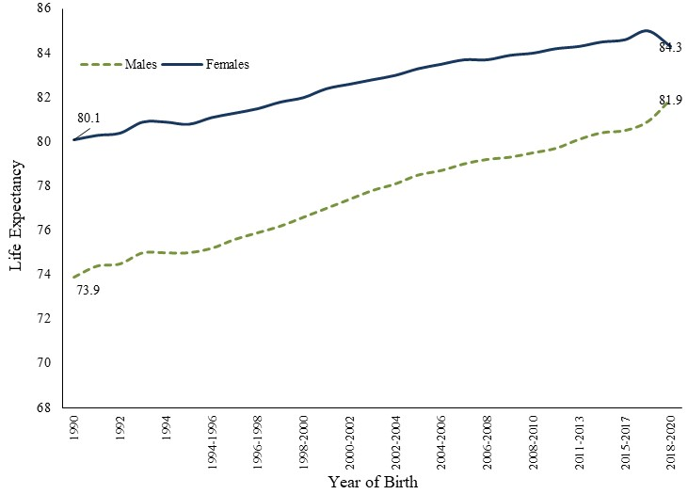
Life expectancy from birth provides an indication of physical health. In the 1880s, Australian life expectancy from birth was 47 years among males and 51 among females. By 2020, this figure had reached 82 years in Victoria.
Life Expectancy by Sex: Victoria, 1990 to 2020

In 2020 life expectancy in Greater Dandenong was estimated at 82 (including 84 among women and 79 among men), the same as the Victorian level.

Probability of Death within a Year, by Age and Sex: Australia, 2016-2020
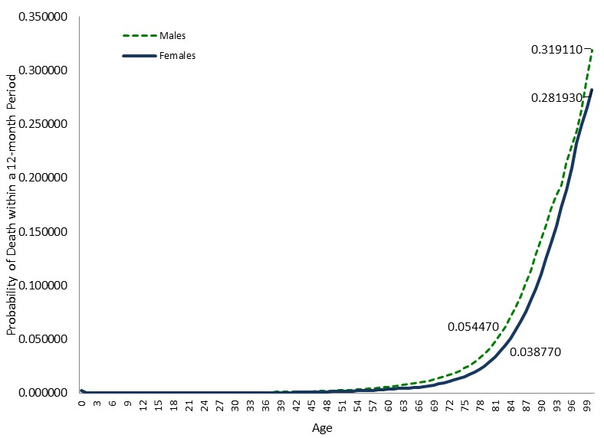
Mortality Rates
Australian mortality rates remain below 10 per 1,000 persons, or 1%, in all age groups to 64 years. Above that age, rates rise steeply. The diagram at right depicts the age-specific mortality rates for males and females in Australia, in 2016-2020.

Mortality Trends
Improvements in health care, nutrition, hygiene, road safety and other conditions, have contributed to a marked decline in death rates across Australia in the past half century. Between 1980 and 2020, national mortality rates declined by over 60% among people aged less than 25.
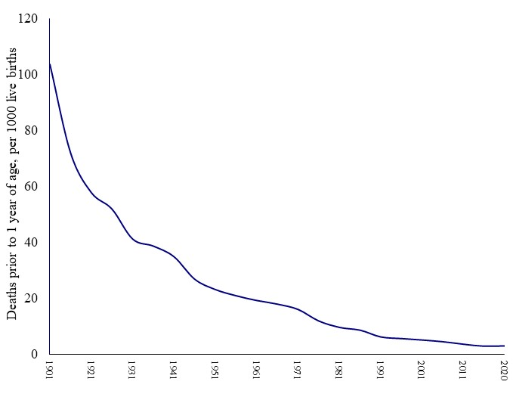
Infant Mortality Rate: Australia, 1901 to 2020

Still more pronounced has been the decrease in infant mortality in Australia, with rates falling from 250 per 1,000 in 1850, to 104 by the opening years of the twentieth century, before plunging to 3.2 by 2020.
These declines are attributed to conditions such as reduced exposure to infection through milk, food, water, sewerage; better education and hygiene; improved nutrition and housing; an increasing tendency to delay birth, coupled with longer birth intervals; and improved medical care and maternal counselling.

Mortality and Socioeconomic Disadvantage
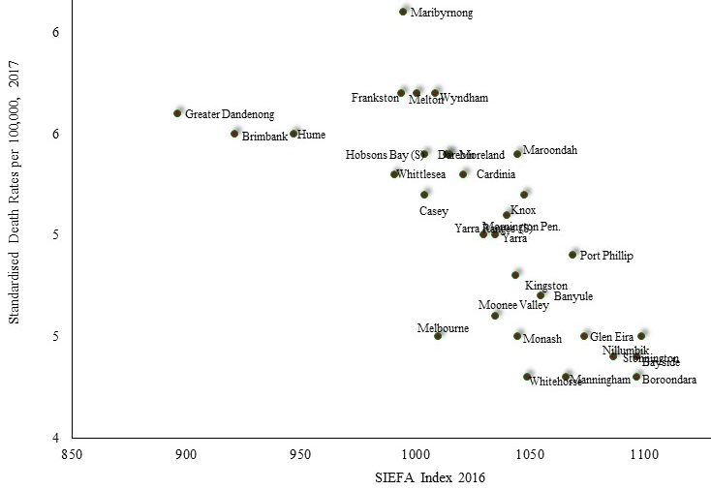
Disadvantaged localities generally register higher mortality rates, after taking the age profile of the local population into account. In metropolitan Melbourne in 2020 for instance, the age-standardized mortality rates were highest, at about 6 per 1,000 population, in Greater Dandenong and lowest in more advantaged localities, such as Whitehorse, Manningham and Boroondara.

Correlation between standardized mortality rate 2017 and the SEIFA Index, 2016: Metropolitan municipalities
Similarly, the Commonwealth Government ‘Australia’s Health Tracker’ calculated rates of mortality by several major causes, finding that the most disadvantaged fifth featured substantially higher rates of mortality than the more disadvantaged areas:

Causes of Death
Records of death in Victoria show pronounced variations in the pattern of mortality among different age groups. Major causes of death in 1-14 year-olds, include drowning, cancers and exposure to heat and smoke. With increasing age, external causes preponderate, with suicide, transport accident, assaults and poisoning accounting for well over half of all mortality among 15 to 24 year-olds.
By middle age, suicide, transport accidents, poisonings are joined by cardiovascular disease and cancer as major causes of death, while in older age, cancers, liver disorders, chronic lower respiratory diseases and cardiovascular conditions predominate, accounting for over a half of all deaths among people aged 85 years or more.

Percent of Deaths: Major Causes, all ages – Victoria, 2021
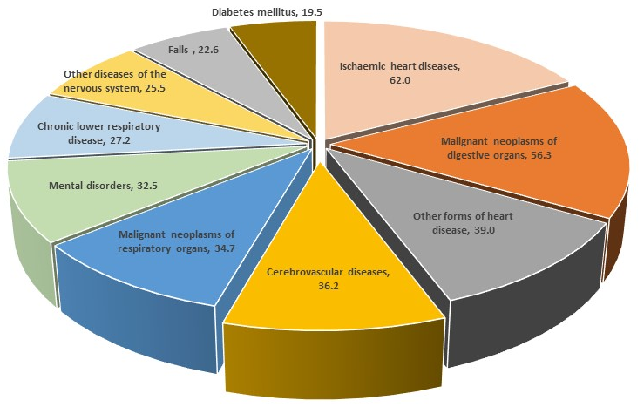

In 2020, 1,047 residents of Greater Dandenong died, representing a standardized mortality rate of 5.2 – similar to the Victorian rate of 5.5.

Disability

The 2021 Census inquired as to whether respondents had a severe or profound disability requiring them to obtain daily assistance with mobility, communication or personal care. For the purpose of convenience here, such persons are referred to as people with disabilities.
Within Greater Dandenong, 11,473 residents, or 7.7% of the municipal population, recorded that they had such a disability, compared with 5.8% across Victoria. This percentage is somewhat higher than the level of 6.0%, recorded in the 2006 Census. About 4,500 residents, or about two-fifths (39%) of people with a disability, are aged less than 65.
Age Prevalence of Disability by Age: Greater Dandenong and metropolitan Melbourne, 2021
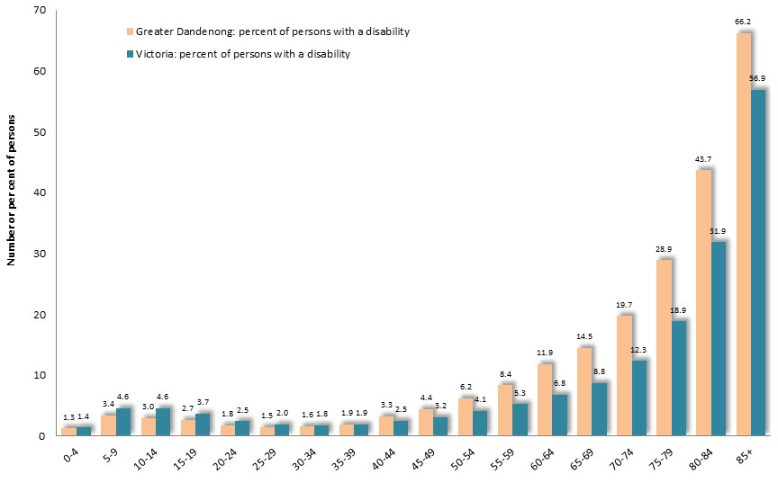
The prevalence of severe or profound disability rises markedly with age, from less than 3% among residents aged up to 5-14 years, less than 2% among those aged 20-39, rising to 15% of those aged 65-69, and 66% of those over 85 years.

Number of Persons with a Disability, by Gender: Greater Dandenong, 2021

Gender
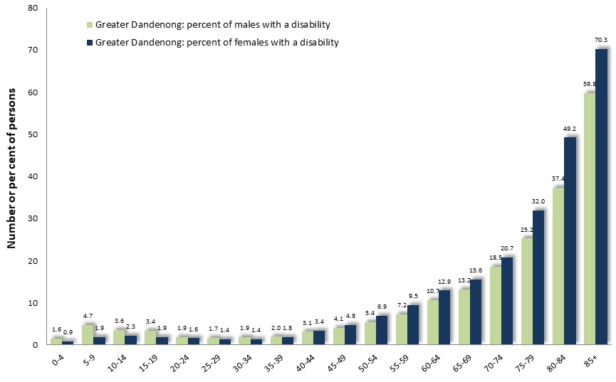
Females account for 56% of Greater Dandenong residents with a disability and males for 44%. For younger residents, males predominate among those with a disability, while among people aged over 75 years, women form a majority, due to their greater longevity.

Number of Persons with a Disability, by Birthplace: Greater Dandenong, 2021
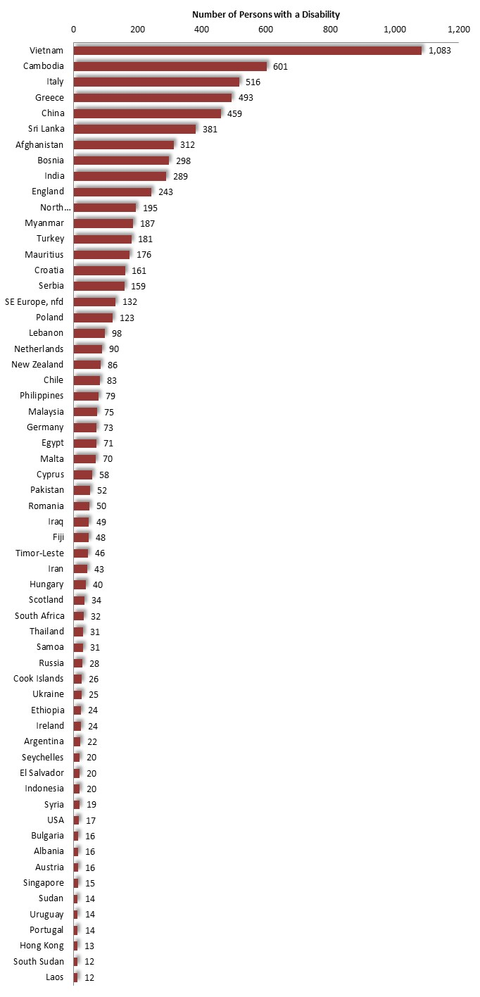
Birthplaces
The number of people of each birthplace who have a severe or profound disability reflects the range of local birthplaces well as the differing age profiles of residents of these birthplaces.
Thirty per cent of disabled residents were born in Australia, 9.4% in Vietnam, 5.2% in Cambodia, 4.5% in Italy, and 4.3% in Greece.

Disabled Persons in non- Private Accommodation, by Type of Dwelling: Greater Dandenong, 2021

Living at Home
Of all disabled persons in Greater Dandenong, 85% reside in private dwellings and 15% in non-private settings such as a nursing homes or other age accommodation.
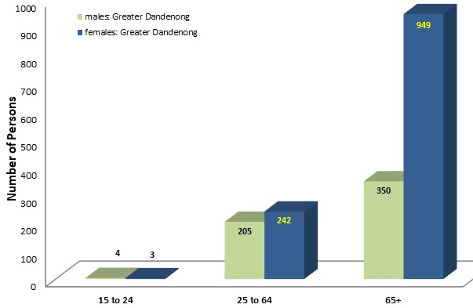
Of those living at home, 14% or 1,165, live alone.
The number of disabled people who are living alone, rises steeply with age. Among those aged over 64 years, approximately two-thirds are women.

Lone Persons with a Disability, by Age: Greater Dandenong, 2021

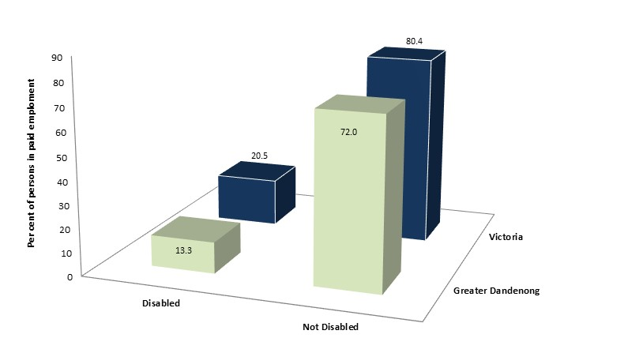
Employment
The findings of the 2021 Census reveal that 13% of disabled 25-64 year-olds in Greater Dandenong, were in paid employment, compared with 72% of those without a disability.
Rates of employment among disabled people of this age, were lower than State-wide levels.
Education and Incomes
About half (51%) of disabled Greater Dandenong residents aged 25-64 years, had left school before completing year 11, compared with approximately a quarter (24%) of others the same age (diagram right).
At $389 per week, median personal gross incomes among disabled residents of this age, were 57% of those among non-disabled people.

Disability among Indigenous Residents
Among Aboriginal and Torres Strait Islanders in Greater Dandenong in 2021, 13.5% were disabled – about twice the rate among non-indigenous residents. This is a disparity which recurs in most municipalities.

Forecast Changes in the Number of People with a Disability
Finally, forecasts of the change in number and proportion of people with disability in Greater Dandenong, based on the findings of the 2021 Census and population projections prepared by the Victorian Government, indicate that in the decade from 2022 to 2032, the prevalence of disability may rise by over one-fifth (23%), including projected growth of over 40% among the number of people aged 80 years or more with a disability.

Carers
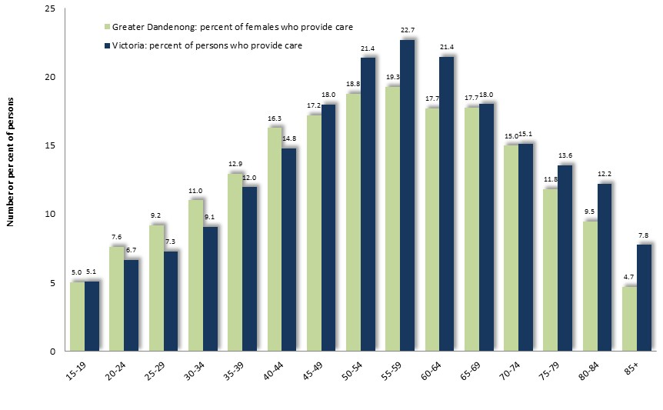
The 2021 Census recorded that 11.2% of residents provided unpaid care for a person with a disability, chronic medical condition or age-related conditions – slightly lower than the State figure of 13.8%.
The highest proportions of residents who provide care are seen among those in their later middle age, largely reflecting the age and health of their parents.

Proportions of Residents who Provided Unpaid Care for Others, by Age: Greater Dandenong and Victoria, 2021

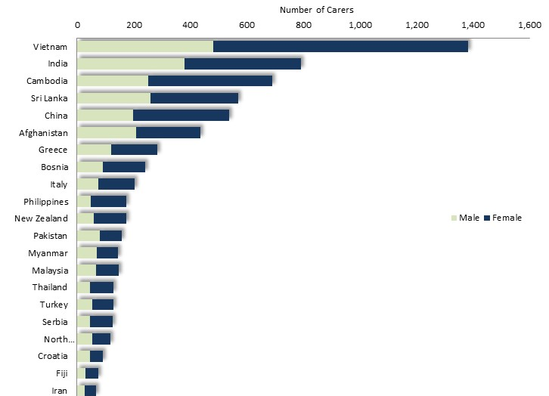
Among Greater Dandenong residents, 13.1% of female residents provided such care, compared with 9.3% of males. Women account for 58% of those who provide unpaid care for people with a disability or long-term health condition.

Forty-one per cent of residents who provide care were born in Australia, 12% in Vietnam, 7% in India, 6% in Cambodia and 5% in Sri Lanka.
The numbers of women and men who provide care is illustrated in the accompanying chart.
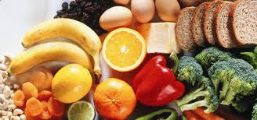
Nutrition

A succession of recent surveys has inquired into the dietary habits of Australians. Much of this research has concerned itself with the consumption of fruit, vegetables and high-calorie foods or beverages.

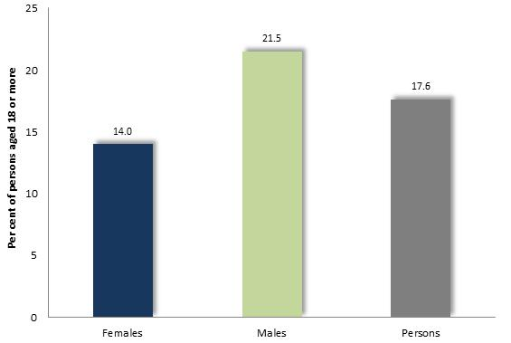
Fruit and Vegetable Consumption
The 2018 National Health Survey – the most recent available investigation in this sequence of surveys – found that approximately 18% of adults eat less than one serve of fruit per day, including 14% of women and 22% of men.

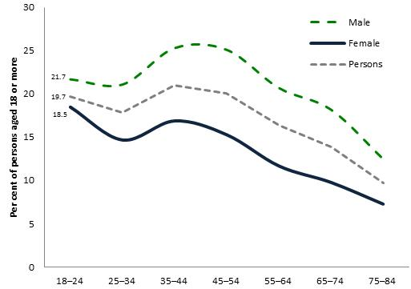

The percentage of people that eat less than one serve of fruit each day declines from late middle-age and is substantially higher among males than females during most of the lifespan.

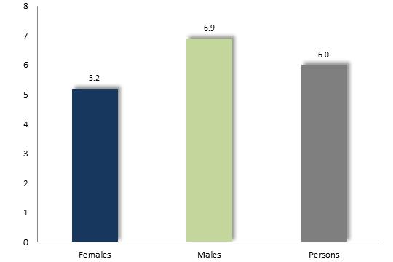

Six per cent of adults consume less than one serve of vegetables per day (5-6 serves daily are recommended), including 6.9% of males and 5.2% of females.

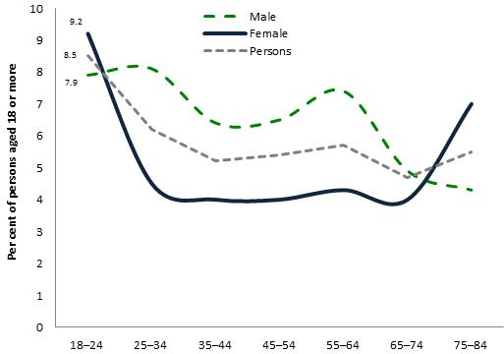

The proportion of adults who eat less than one serve of vegetables dwindles in the first decades of adulthood, then remains relatively stable until older age.

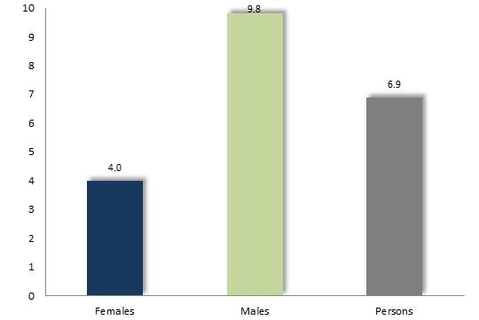
Consumption of Sugar-sweetened Drinks
The 2018 National Health Survey determined that approximately one in ten (9.8%) males consume two or more metric cups per day of selected sugar-sweetened drinks, more than twice the corresponding proportion of 4% among women.

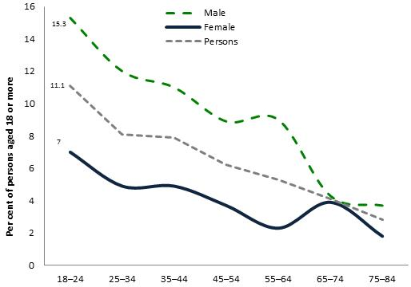
The accompanying diagram depicts the percentage of adults who consume two or more cups per day of sugar-sweetened drinks. From its peak of just over 11% among young adults, this proportion declines throughout most of adulthood.

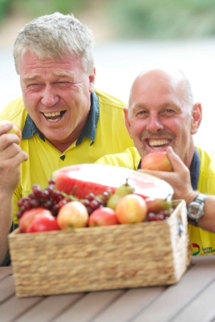
Local Measures
Vegetables: The 2017 Victorian Population Health survey found that 1.5% of Greater Dandenong residents met vegetable consumption guidelines, a quarter of the Victorian level of 5.4% - including 8.4% of females and 2.2% of males.
Other studies, at a state or national level, have found that people with limited education or on lower incomes, consume less vegetables than others. Similarly, the 2017 Victorian Population Health survey determined that 3.6% of residents of socioeconomically disadvantaged municipalities did not meet vegetable consumption guidelines, about half the corresponding level of 7.1% among residents of the least disadvantaged localities.
Fruit: The 2017 Victorian Population Health survey found that 38% of Greater Dandenong residents met fruit consumption guidelines, almost matching the Victorian level of 43%. As with vegetable consumption, a lesser proportion, of 38%, of residents from the most disadvantaged municipalities met fruit guidelines than among those of the least disadvantaged localities, of 46%.
High-Calorie Foods: The 2017 Victorian Population Health survey disclosed that 11% of Greater Dandenong residents consumed sugar-sweetened drinks daily, similar to the Victorian figure of 10%. The proportion of Greater Dandenong residents who consumed takeaway meals or snacks more than once per week was 15%, the same as for Victoria.

Obesity

Obesity, resulting from the deposition of fat where energy intake exceeds requirements, contributes to diabetes mellitus, hypertension, stroke, cardiovascular disease, gout, sleep apnea, breast and endometrial (uterine) cancer, and gall bladder disease.

Prevalence of Obesity by Gender: Australia, 2018 Obesity among Adults
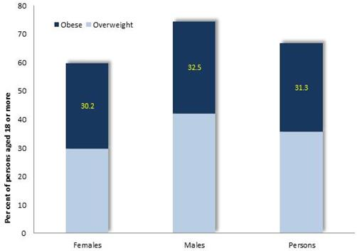
The 2018 National Health Survey found that among people aged 18 years or more, 31% are obese (representing a rise from 19% in 1995) and 65% (represented by the total height of the column) are classified as overweight or obese.
Obesity is more widespread among males, at 33%, than among females, at 30%. (diagram, left).

Prevalence of Obesity by Age: Australia, 2018

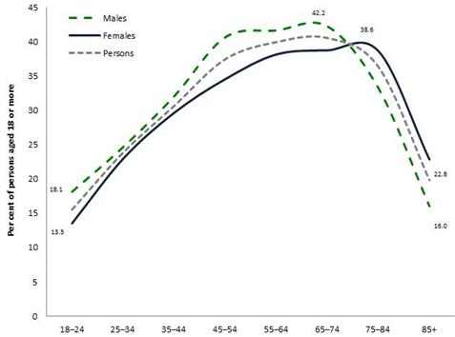
The prevalence of obesity rises steeply with age to a peak in older age, before declining steeply.
The findings of a number of investigations point to a rise in the national prevalence of overweight/obesity over nearly two decades, from 57% in 1995 to 75% by 2018 (National Health Survey 2018).

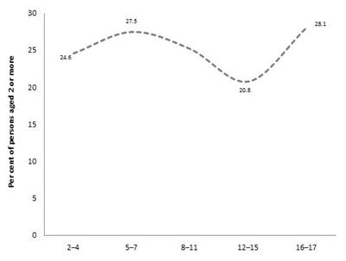
Prevalence of Obesity among Children

Prevalence of Obesity among Australian Children, by Age: 2018


Obesity is considered a particular problem for children, owing to its physical, psychological and social consequences, and as a significant proportion of overweight children remain so in adulthood.
The 2018 National Health Survey found that approximately one-quarter of children are overweight or obese, with a prevalence of 20 to 30 per cent between ages 2 and 17. (diagram above left)
Local Measures of Obesity
The 2020 Population Health Survey recorded self-reported obesity – a method which tends to underestimate the prevalence of obesity – found that just over one-fifth (21%) of Victorians were obese, a figure which ranged from 38% in Yarriambiack to 9% in Melbourne. Within Greater Dandenong, 19% of residents were found to be obese, slightly lower than the state-wide average.
By contrast though, research conducted in 2014/15 by Torrens University, estimated that 26% of adults in Greater Dandenong were obese and 63% overweight.
A variety of studies have determined that the prevalence of obesity is higher among people on lower incomes, of limited educational attainment and those with health problems, circumstances which are prevalent among residents of Greater Dandenong. The 2017 Victorian Population Health Survey for example, reported that the prevalence of obesity among residents of the most disadvantaged five municipalities was 24% - almost twice the corresponding level among the least disadvantaged localities, of 13%.

Food Insecurity
Food insecurity is a term generally applied to a lack of continuous, reliable access to nutritious food. Its contributing causes include low incomes; rising costs of housing and utilities; household financial crises; transport limitations; inadequate household storage or food preparation facilities; lack of skill or confidence in shopping, budgeting or preparing food; as well as psychological, physical or mental impairments.
At least one in twenty households are experiencing food insecurity at any given time, a persistent condition for some, and recurring or transient for others. Surveys indicate that food insecurity is most prevalent among low-income households, Aboriginal and Torres Strait Islanders, unemployed people, renters, refugees and people seeking asylum, those with chronic illnesses, mental health conditions or drug problems, homeless people and those living in remote communities.
Prevalence of Food Insecurity
Surveys of food insecurity in Australian indicate that approximately one in 20 Australians runs out of food due to financial constraints, in any 12-month period. The measures of prevalence arising from population surveys featuring this inquiry include 5.2% in 1995, 6.1% in the 2001 Child Health Survey, 5.2% in the Victorian VicLanes survey 4% in the 2011/12 National Health Survey and 3.6% in the 2014 Victorian Population Health Survey.
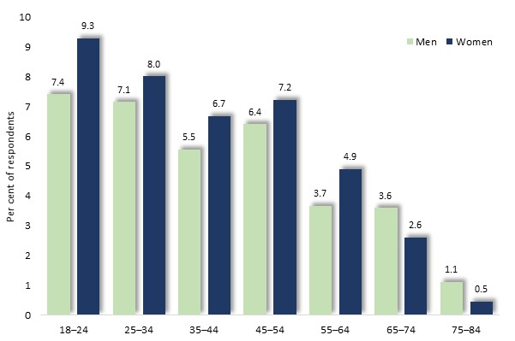
The 2020 Population Health Survey found that 13% of residents of Greater Dandenong had run out of money to buy food at some time during the previous 12 months, the highest level in Victoria and more than twice the state-wide figure of 6%. Within metropolitan Melbourne, the proportion of residents surveyed who reported such hardship tended to be highest among the more disadvantaged localities, such as Brimbank, Whittlesea and Maribyrnong, and lower in Bayside, Boroondara, Whitehorse and other more affluent municipalities.
The same survey found that, across Victoria, the proportion of people who ran out of money for food approached ten per cent among people aged 18-24, declining with age to fewer than 1% among those aged 75 years or more.

Prevalence of Food Insecurity by Age and Sex: Victoria, 2020 Population Health Survey

The prevalence of food insecurity with hunger was higher among younger people, declining from 6% among 18-24 year-olds to just over 1% among people aged 65 year or more.
Within Greater Dandenong, 4.3% of survey respondents reported the experience of such food insecurity.
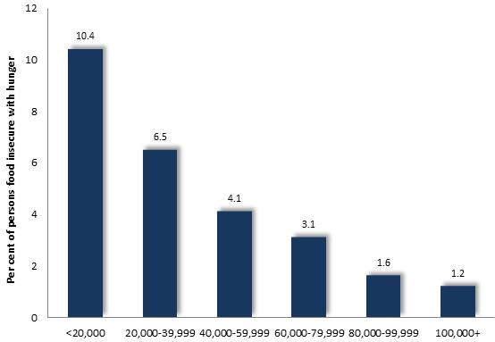
Prevalence of Food Insecurity by Annual Household Income: Victoria, 2014 (Victorian Population Health Survey)

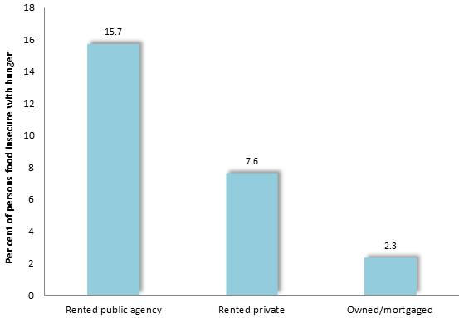
In relation to socioeconomic disadvantage, such food insecurity was recorded among 11.9% of unemployed people, compared with 2.5% of those in paid employment; 15.7% of people residing in government-owned accommodation, compared with 2.5% of those who owned or were purchasing their accommodation; and 10.4% of persons in households on annual incomes below $20,000, in contrast to 1.2% of those in households with incomes exceeding $100,000 (Accompanying diagrams).

Prevalence of Food Insecurity by Housing Tenure Type: Victoria, 2014 (Victorian Population Health Survey)

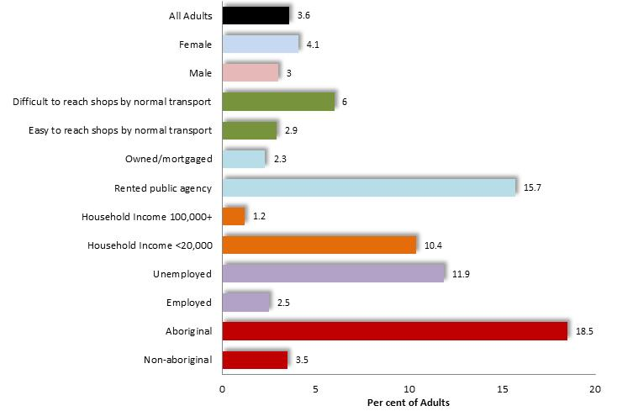
The prevalence of food insecurity among selected segments of the community is illustrated at left.

Prevalence of Food Insecurity by Adults within Selected Segments of the Community: Victoria, 2014 (Victorian Population Health Survey

Other evidence confirms a similarly high prevalence of food insecurity among disadvantaged segments of the community.
Diabetes Mellitus

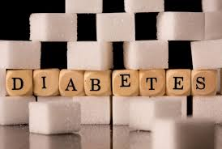
Diabetes mellitus is a condition characterized by high blood sugar. There are two major types of diabetes. Type 1, otherwise known as ‘juvenile onset’ or ‘insulin-dependent’ diabetes, generally appears during pubescence and is usually managed by insulin injection. Accounting for 85% of diabetes mellitus, Type 2 or ‘late onset’ diabetes, is most prevalent among people who are overweight, engage in a sedentary lifestyle or have a family history of the disease, and is generally treated with a blend of exercise and dietary modification.
Prevalence
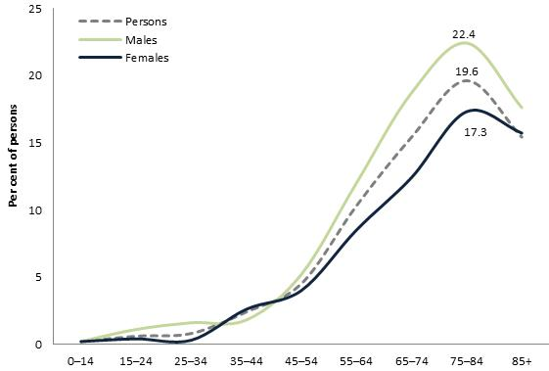
The 2018 National Health Survey found that fewer than 1% of children have been diagnosed with diabetes mellitus, a figure which rose to a peak of 22% among people in older age, before diminishing slightly among those aged 85 years or more.
From middle age, the proportion of people with doctor-diagnosed diabetes is slightly higher among males.
The prevalence of diabetes is expected to rise markedly in the future, with research sponsored by the Baker Heart and Diabetes Institute in Melbourne forecasting that 14% the population, or about one in seven Australians, will have the condition by 2050.
Local Conditions
The 2021 Census found that approximately 9,700 people, or 6.6% of Greater Dandenong residents, including similar proportions of women and men, had doctor-diagnosed diabetes mellitus – slightly higher than the Victorian prevalence of 5.5%.
A local measure of the prevalence of diabetes mellitus was furnished by the Australian National Data Service in 2017, which estimated that 6.3% of Greater Dandenong respondents aged 25-64 years had diagnosed diabetes, nearly double the average of 3.7 among Victorian municipalities.

The Service determined that diabetes was most prevalent among people:
- from Europe (15%);
- on the lowest 20% of incomes (5.9%, compared with 2.6% of those on the higher 20% of incomes); and
- with more limited education (8.1% of people with year 10, compared with 2.8% with year 12).

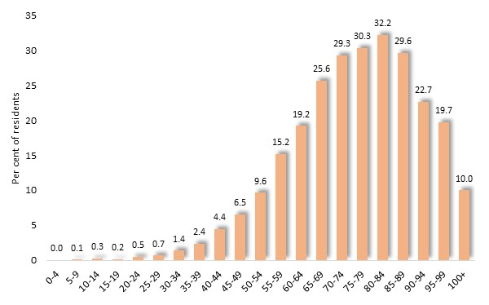
The prevalence of diabetes mellitus recorded in the 2021 Census rose from less than 1% among those aged less than 30 years, to nearly a third (32.2%) among residents aged 80-84 years, before declining among older residents.

Prevalence of Diabetes Mellitus by Age: Greater Dandenong, 2021

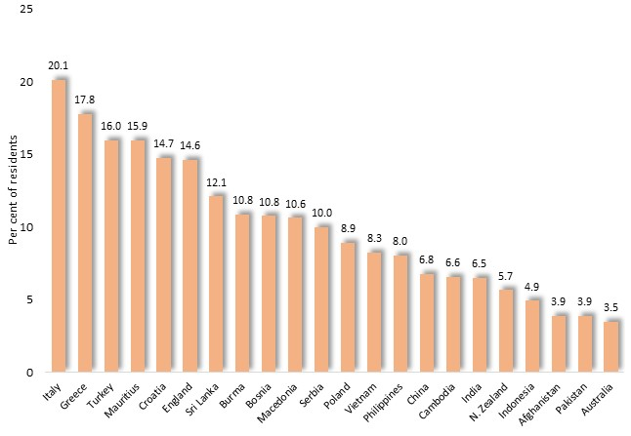
Diabetes also varies with birthplace, among Greater Dandenong residents.

Prevalence of Diabetes Mellitus by Birthplace: Greater Dandenong, 2021

Among the selection of major birthplaces illustrated here, its prevalence swells from 3.5% among Australian-born residents, to over 15% among those born in Italy, Greece, Turkey and Mauritius – partly reflecting the relatively high average age of such residents.

Cancer

Each year, cancer accounts for approximately 300 deaths each year within Greater Dandenong - almost a third of all mortality in this city. While more detailed information about cancer in this municipality is not at hand, national data furnishes a glimpse of likely trends within this community.

Cancer Diagnosis
A substantial proportion of the population will be diagnosed with cancer at some time in their lives, with a half of males and a third of females receiving such a diagnosis by the age of 85. Notably, the Australian Cancer Council reports that socioeconomically disadvantaged localities featured higher rates of diagnosis for many types of cancer, including an incidence at least 50% higher for lung, cervical, liver, head and neck cancers

Living with Cancer
The 2014/15 Australian Health Survey found that 1.6% of the Australian population (residing outside hospitals, nursing and convalescent homes) had cancer – a proportion which rises with increasing age, from fewer than 1% of people less than 45 years of age, to 7.7% among those aged over 75. A higher proportion of men (1.8%) than women (1.2%) were living with cancer. Broadly similar findings emerged from the 2021 Census, which, for the first time, inquired about the prevalence of a range of broad categories of chronic illness among the Australian population. Within Greater Dandenong, 2.1% of residents reported that they were living with cancer, including 1.9% of males and 2.2% of females. The prevalence of cancer among the municipal population rose steeply with age, from 0.2% of persons aged 15-24, to 2.1% of those aged 25-64 years, and 10.9% of people aged 65 years or more

Mortality
In contrast to the incidence of cancer diagnoses, and proportion of people living with cancer, 50,000 people died in Australia because of cancer in 2022 - representing a rate of 1.9 deaths per 1,000 persons. It was estimated in that year, that a person in Australia had a 1 in 7 (or 15%) risk of dying from cancer by the age of 85 (1 in 6 or 17% for males and 1 in 8 or 13% for females).
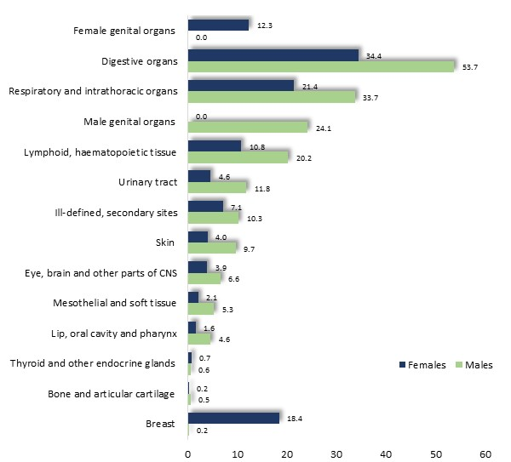
The highest incidences of cancer in Australia in 2021, were recorded for cancers of the digestive organs (with a standardized mortality rate, of 149 per 100,000 persons, and accounting for 29% of mortality due to cancer), respiratory organs (8,966), breast, lymphatic tissue, eye and central nervous system, female genital organs and skin.

Standardized Mortality Rate, per 100,000 persons, by tissue type: Australia, 2022

Surviving Cancer
Conversely, the probability of surviving cancer for five or more years in Australia is calculated at 70% in 2014-2018 - a figure which has risen from 52% in the period 1989-3.
Rates of survival are highest, at 70% or more, for cancers of the colon, rectum, cervix, uterus, and prostate, as well as melanoma, and lowest for cancers of the liver, lung, pancreas, brain, and oesophagus, at approximately 20%.

Survival Rates by Selected Cancer Type: Australia, 2021
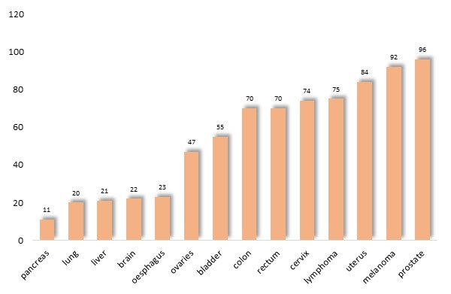

Mental Health and Psychological Wellbeing

Local Measures Prevalence of Mental Health Conditions – the 2021 Census
The 2021 Census inquired about whether respondents were experiencing any of a selection of major chronic illnesses, including mental conditions, such as depression, anxiety and others. Within Greater Dandenong, mental health conditions were documented among 6.5% of residents, lower than the Victorian figure of 9.5%.

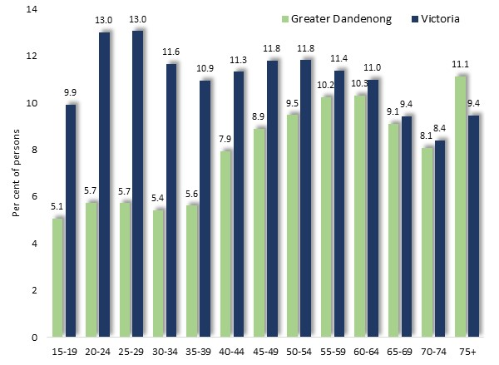
Among teenagers and younger adults, the relevance of mental health conditions was approximately twice as high among those in Victoria as for people in Greater Dandenong - a differences which declined with age.

Prevalence of mental health conditions by age: Greater Dandenong and Victoria, 2021

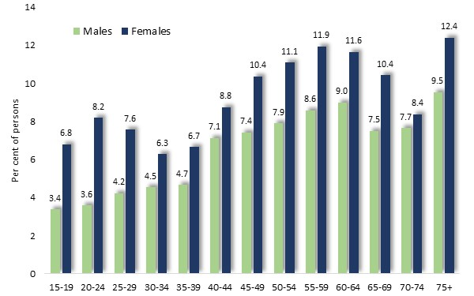
The Census also found that 7.7% of females and 5.3% of males aged 15 years or more in this municipality were experiencing a mental health condition - echoing a disparity observed in the findings of other Australian investigations.

Prevalence of mental health conditions by age and sex: Greater Dandenong and Victoria, 2021

Notably, the prevalence of mental health conditions among 20-24 year-olds was over twice as high among women as men.

Prevalence of mental health conditions by Indigenous status and sex: Greater Dandenong, 2021
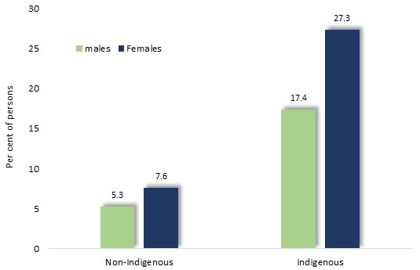
The 2021 Census also determined that 22% of Indigenous residents in Greater Dandenong were experiencing a mental health condition, nearly four times the prevalence of such conditions among non-Indigenous residents, of 6.4%.
Within the Indigenous community, the prevalence of mental health conditions was 27% among women - substantially higher than the corresponding rate of 17% among Indigenous men.

In addition, the prevalence of such conditions was higher among people with limited formal education, older people, members of same-sex-attracted couples, people who were not married, members of lone-person households and lower income earners (diagram below).

Prevalence of mental health conditions by Selected Variables: Greater Dandenong, 2021
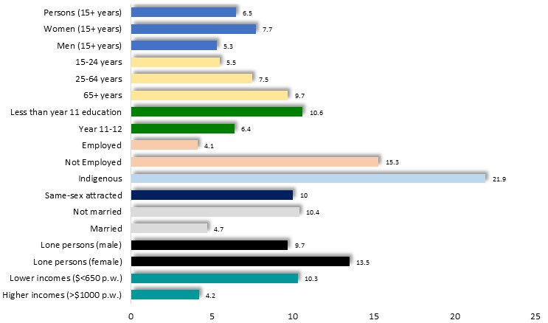

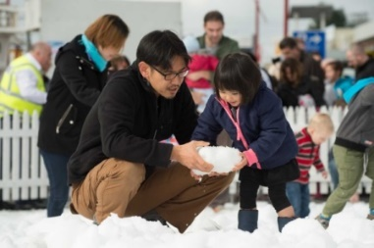
Local Level Surveys
The 2020 Population Health Survey found that about one-fifth (24%) of Greater Dandenong residents were experiencing ‘high’ or ‘very high’ levels of psychological distress, the same as for Victoria. The proportion of residents in such distress varied widely across the state, from 9% in South Gippsland to 31% in Darebin. Across Victoria, the prevalence of such psychological distress was highest among people aged 18-24 years, at 43% among women and 27% among men, and declined with increasing age.
In the same survey, more than one in four (26%) Greater Dandenong residents assessed their personal satisfaction with life as ‘medium’ or ‘low’, more than the state-wide level of 22% and the eighth highest level in Victoria. The proportions of Victorian residents who offered a similar assessment of their lives ranged from 2.5% in Queenscliff to 30% in Brimbank. Across Victoria, the proportion of people who rated their satisfaction unfavorably tended to decline with increasing age.
Further questions inquired about levels of social contact, with friends or family. The 2020 Population Health Survey found that 9.3% of Greater Dandenong residents had no close friends or family whom they talked to regularly – the highest level in the state, and about twice the corresponding Victorian level of 4.7%. The survey also determined that approximately one in six (17%) Greater Dandenong residents spoke with friends a few times a month or less often, similar to the Victorian level of 18%.
Finally, seventeen per cent of Greater Dandenong respondents to the 2020 Population Health Survey voiced the opinion that they either ‘never’ or ‘not often’ felt valued by society, substantially more than the corresponding figure for Victoria, of 11% and the third highest level in the State. Across Victoria, the prevalence of such feelings ranged from 3% in Queenscliffe to 18% in Latrobe and was higher among older residents.
National Survey Results
At a national level, further details concerning the prevalence of mental health conditions are supplied by the findings of the 2020-21 National Study of Mental Health and Wellbeing.
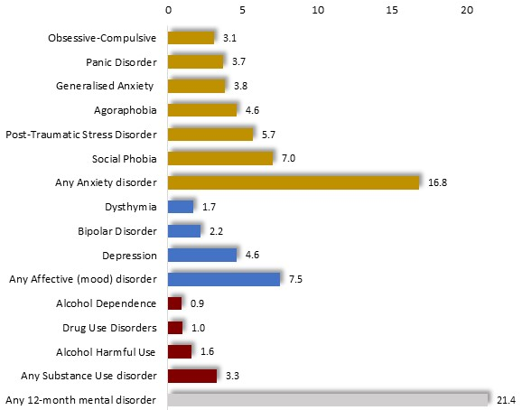
Over one-fifth (21.4%) of survey participants aged 16-85 years, stated that they had experienced a mental disorder within the previous 12 months.

Prevalence of mental health conditions by type of condition: persons aged 16-85: Australia, 2021/22

Among them, 17% cited an anxiety disorder, such as post-traumatic stress, acrophobia or social phobia; 7.5% a mood disorder, such as depression; and 3.3% a substance abuse disorder relating to the consumption of alcohol or other drugs.
Anxiety Disorders
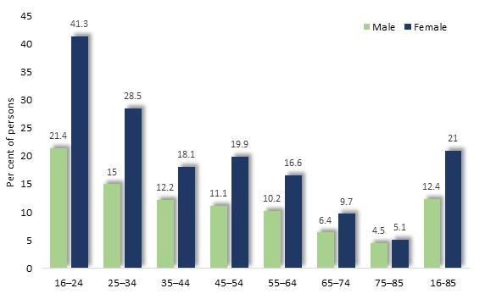
The experience of anxiety disorders within the previous 12 months was recorded by 21% of female survey participants and 12% of males.

The prevalence of anxiety disorders by age and sex: Australia, 2021/22

The prevalence of such conditions was highest among younger people - at 41% and 21% respectively - among 16-24 year-old females and males, and declined with age. In particular, conditions such as panic disorder, agoraphobia, social phobia, anxiety and post-traumatic stress disorder were approximately twice as prevalent among women as men.

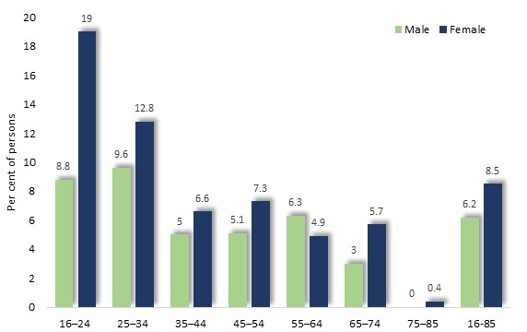
Affective, or mood, disorders
Overall, 7.5% of 16-85 year old survey participants stated that they had experienced an affective - or mood - disorder in the previous 12 months, including 8.5% of women and 6.2% of males.

The prevalence of anxiety disorders by age and sex: Australia, 2021/22

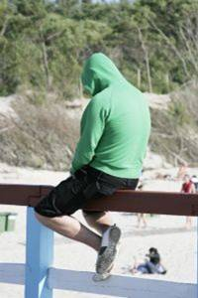

The prevalence of mood disorders declined with age among women, from 19% among 16-24 year olds to less than 1% among those aged 75 years or more. The prevalence of mood disorders among males was more stable across the lifespan.

Substance use disorders
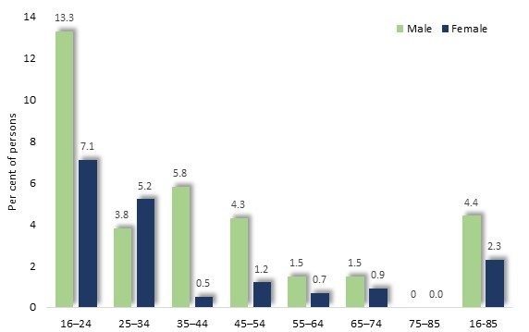
Substance use disorders had been experienced by 3.3% of Australian survey participants aged 16-85 years during the previous 12 months, and their prevalence was higher among men (4.4%) than women (2.3%).

The prevalence of anxiety disorders by age and sex: Australia, 2021/22

Such conditions were most widespread among younger people, affecting approximately 13% of 16-24 year-old males and 7% of females. Among people aged 35-44 years, this disparity was even more striking, with 5.8% of males and 0.5% of females stating that they had experienced this disorder within the previous 12 months.

Suicide

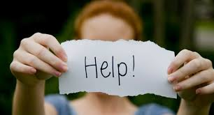
Suicide Rates
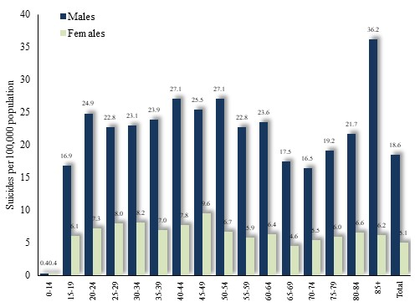
Each year in Australia, approximately one person in 1,000 takes their own life.

Suicide Rate by Age, Australia, 2020

In 2020, male suicide rates stood at 18.6 per 100,000 – over three times higher than the corresponding female rate of 5.1 per 100,000. Suicide rates also vary with age but are highest among elderly males.

Suicide Rate by Sex: Australia, 1900 to 2020
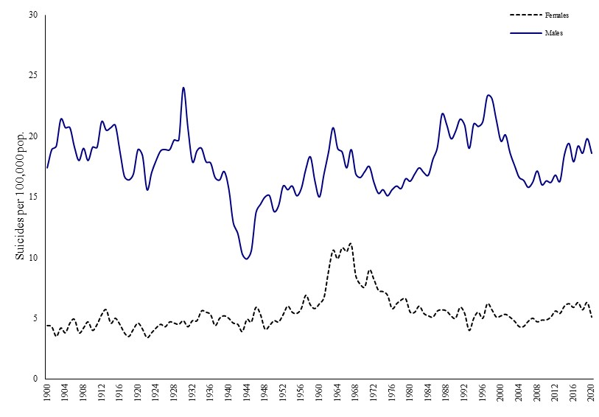
The suicide rate among females has remained fairly steady in the past century or so, aside from a rise in the 1960s. Male rates on the other hand, rose in 1926-30, declined during World War Two, then rose again in the period 1986-2000, before subsiding to its present level.

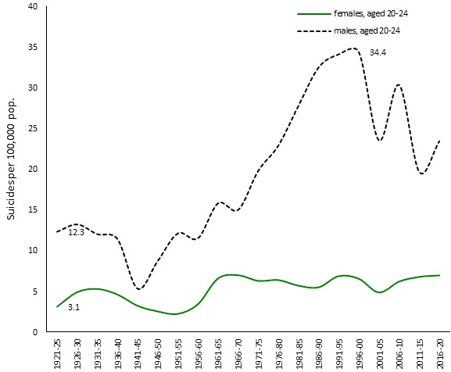
A notable trend is the trebling in the suicide rate among 20-24 year-old males, from about 5.3 per 100,000 in the early 1940s, to 34 by 1996-00, followed by an unsteady decline.

Suicide Rate by Sex: Persons aged 20 to 24, Australia, 1921 to 2020

In the period 2017-21, the suicide rate in the SA3 area of Dandenong (which encompasses most of the Greater Dandenong municipaliy) averaged 7.5 deaths per 100,000 – substantially lower than the Victorian average of 10.5 during this period.

Suicide and Unemployment
A variety of factors contribute to suicide, including personally traumatic events, personal resilience, mental health issues and conditions, chronic illness, unemployment and others.
Explanations advanced by researchers include a lesser fear of death and sensitivity to pain among males, a higher prevalence of impulsive-aggressive tendencies, an unwillingness to acknowledge or communicate their own distresses, limited range of social support and connection, a reluctance to seek help, lack of awareness of, or confidence in, support services, and a propensity to select more lethal methods of suicide. It is possible that these factors share a common direct or indirect underlying cause in the well-documented tendency among men to suppress emotions and their expression - a condition which may largely originate from social pressures and other influences.
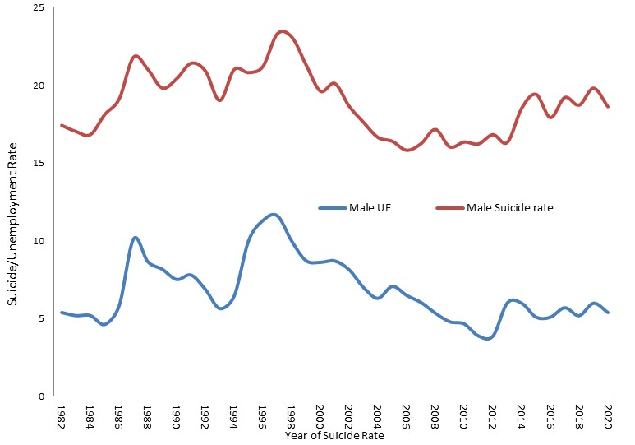
In addition, Australian male suicide rates are strongly associated with the unemployment rate among men four years earlier, suggesting a delayed influence of unemployment upon suicide.

Unemployment Levels and Suicide Rates Four

Alcohol Consumption

Effects and Costs of Alcohol Consumption
Alcohol consumption contributes to a variety of health conditions; among them: disorders of the liver; cardiovascular disease; central nervous system conditions; cancers of the mouth, larynx, oesophagus, gastrointestinal system, breast and liver; and serious foetal developmental defects. Alcohol use during pregnancy contributes to impaired childhood physical and mental development, learning difficulties, abuse and neglect and problems in adolescence. In 2014, VicHealth estimated that proximately 157,000 Victorians are hospitalised from the effects of alcohol each year and 5,600 die from its consequences - the equivalent of about 4,400 hospitalisations and 150 deaths in Greater Dandenong in 2022.
Alcohol intoxication is also implicated in almost half of assaults, contributes to a third of road accidents leading to injury or death and causes at least 3,300 deaths each year, across Australia.. The 2016 Australian Personal Safety Survey concluded that alcohol was a contributing factor in half of the most recent assaults inflicted upon women and two-thirds of those experienced by men.
In 2013, the Australian Institute of Criminology assessed the cost of alcohol misuse upon the Australian economy at the equivalent of $17.5 billion per annum in 2022 – equating to $113 million in Greater Dandenong.

Prevalence of Alcohol Consumption
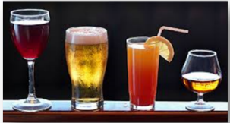
The 2019 National Drug Strategy Household Survey found that just over 5% of Australians aged 14 years or more were daily drinkers, while 40% of Australians consumed alcohol at least weekly.
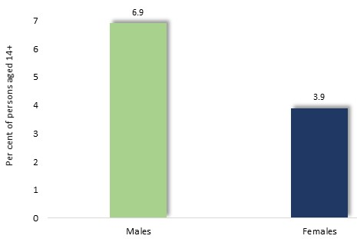
The prevalence of daily alcohol consumption among Australians aged 14 or more was greater among males, at nearly 7%, than among females, at less than 4%.

Prevalence of Daily Alcohol Consumption by Sex: 2019

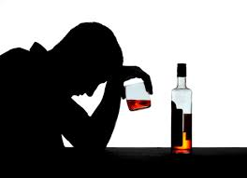
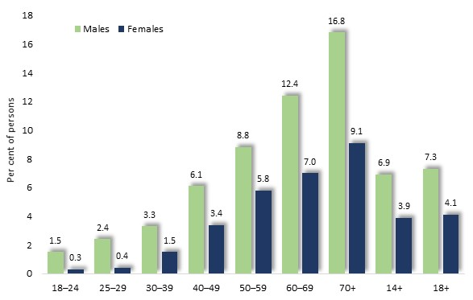
Among both females and males, the prevalence of daily alcohol consumption rises steeply with age to its peak among people over 70.

Prevalence of Daily Alcohol Consumption by Age and Sex: 2019

Local Patterns of Alcohol Consumption Volume of Liquor Sold per Adult:
Greater Dandenong and Victoria, 2015/16
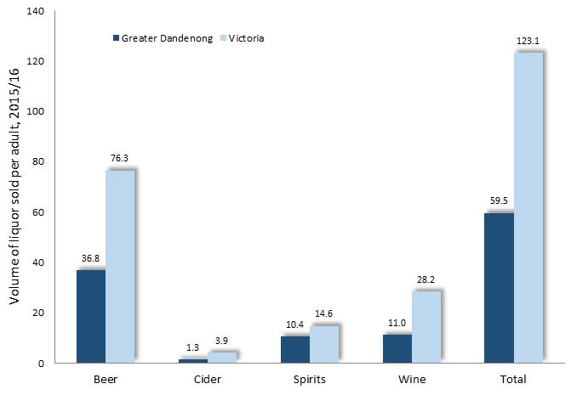
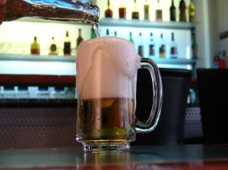
Local measures indicate that overall levels of alcohol consumption are lower in Greater Dandenong than the metropolitan average, though harms arising from alcohol abuse in this community are substantial.
In 2017, the Victorian Commission for Gambling and Liquor Regulation released details of the volume of alcohol sold in each Victorian municipality during 2015/16. These data showed that volumes of beer, cider and wine sold, per adult, in Greater Dandenong were each substantially lower than the Victorian average and among the lowest in the State (diagram above).

Local Measures of Alcohol-related Harm
The profile of local harm associated with alcohol may not necessarily match consumption patterns though. Measures of the social and health impacts of excessive alcohol consumption, published by Turning Point, record levels of the impact of alcohol upon Greater Dandenong residents that exceed metropolitan levels.
- The rate of ambulance attendances for alcohol intoxication (with or without other substances) in Greater Dandenong during 2021/22 was 19% higher than metropolitan levels.
- Similarly, rates of local ambulance attendances relation to acute effects of alcohol consumption in 2019 – the latest year available – was 18% greater than the metropolitan average.
- The rate of family violence incidents in Greater Dandenong recorded by police in 2021, where alcohol was definitely or likely involved, was 21% higher than the metropolitan level.
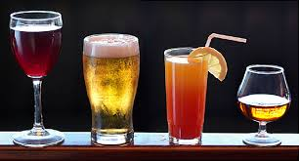
- And rate of mortality due to circumstances associated with alcohol use in Greater Dandenong in 2020 was also 21% higher than the metropolitan rate.

Illicit Drug Use
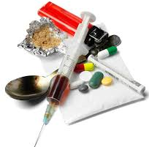
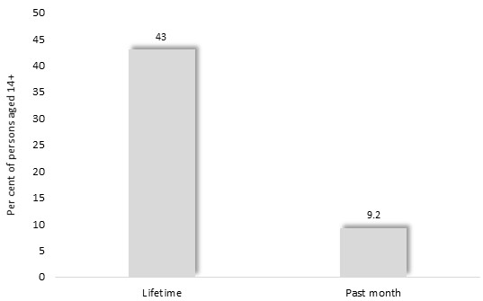
Prevalence and Patterns of Illicit Drug Use
The 2019 National Drug Strategy Household Survey found that 43% of Australians aged 14 years or more had used illicit drugs in their lifetimes (including abuse of pharmaceuticals), and 9.2% during the previous month.

Prevalence of Monthly and Lifetime Use of Illicit Drugs, persons 14+, Australia: 2019

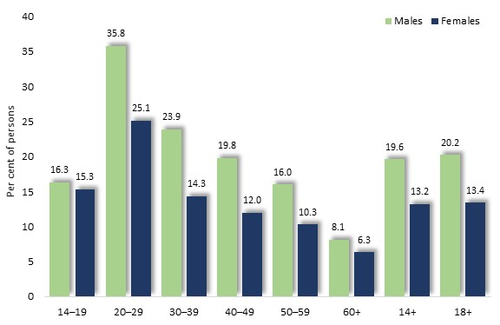

The proportion of people who had used illicit drugs in the previous month was highest among young adults and males.

Prevalence of the Use of Illicit Drugs During the Previous Month by Sex and Age, Australia: 2019

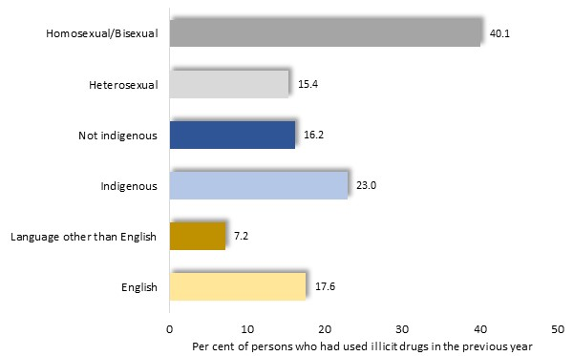
The prevalence of illicit drug use was also slightly higher among people with limited formal education, those who were unemployed and those living in less affluent localities. The highest rates of use of illicit drugs in the previous 12 months though, were recorded among indigenous people and same-sex attracted persons (diagram, right).

Prevalence of the Use of Illicit Drugs During the Previous Month by Selected Social Characteristics, Australia: 2019

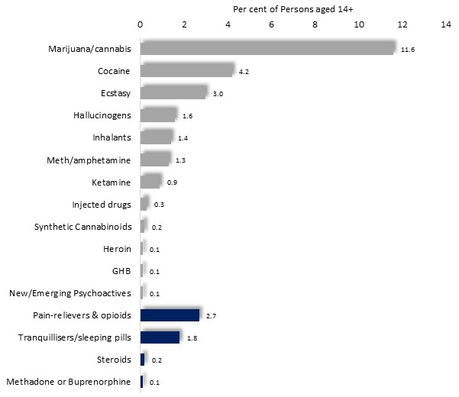
The illicit drugs most widely used in the previous month were cannabis, cocaine and ecstasy.
Pain-relieving drugs and tranquillizers were the most popular pharmaceutical drugs – illustrated in blue in the accompanying chart.

Prevalence of the Use of Illicit Drugs During the Previous Month among Persons aged 14+, by Drug Category, Australia: 2019

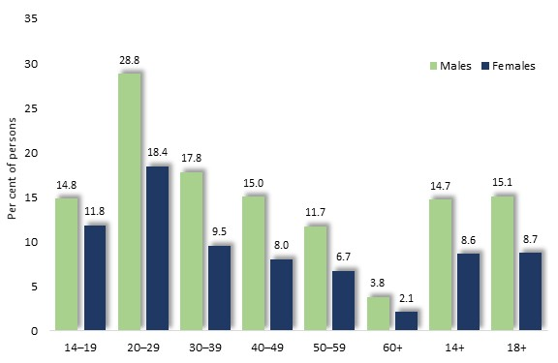
Cannabis
Cannabis, the most popular illicit drug, had been used by over a third (37%) of Australians over 14, and 12% in the past month, according to the findings of the 2019 National Drug Strategy Household Survey.
Prevalence of the Use of Cannabis During the Previous Year, by Sex and Age, Australia: 2019

Cannabis is most popular among males and people aged in their 20s.

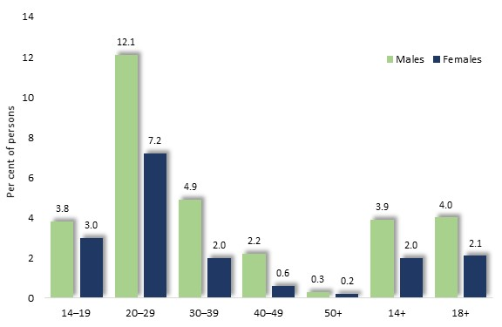
Ecstasy
The survey found that ecstasy had been used by approximately 13% of Australians aged 14 years or more at some time in their lives, and in the past month by 4.2%. Its use was most widespread among males and younger adults.
Prevalence of the Use of Ecstasy During the Previous Year, by Sex and Age, Australia: 2019

A further report concluded that users of ecstasy were largely under 25 years, most consuming the drug at nightclubs and music events, adding that 40% using ecstasy for two or more days without sleep, on occasion.
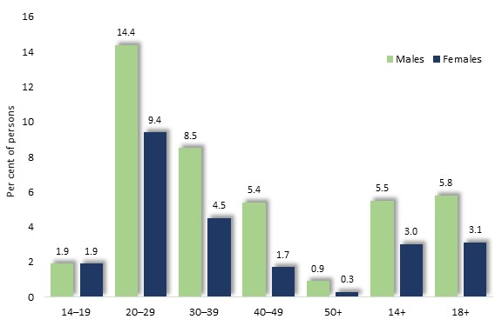
Cocaine
The 2019 National Drug Strategy Household Survey determined that 11% of Australians aged 14 or more had ever used cocaine, and 4.5% in the previous month. As with ecstasy, its use is most common among males and young adults.

Prevalence of the Use of Cocaine During the Previous Year, by Sex and Age, Australia: 2019

Amphetamines - including ‘Ice’
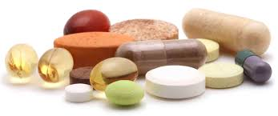
The Survey found that 5.8% of Australians had used methamphetamines at any time in their lives, and 1.4% in the past 12 months, chiefly by young adults and males. Other inquiries have determined that people who are unemployed, less educated and affected by mental illness are most highly represented among its users. A 2014 Victorian Parliamentary inquiry received evidence that, while ice seldom causes abrupt fatality, its use contributes to neurological and other health problems, aggression and violence, depression, crime, unemployment, and deterioration in family and social relationships.’
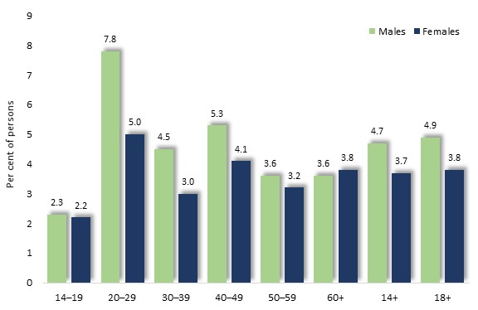
Pharmaceuticals
The 2019 National Drug Strategy Household Survey established that during the previous year, 4.2% of Australians aged 14 years or more had misused pharmaceuticals: among them, 4.7% of males and 3.7% of females.

Prevalence of the Misuse of Pharmaceuticals During the Previous Year, by Sex and Age, Australia: 2019
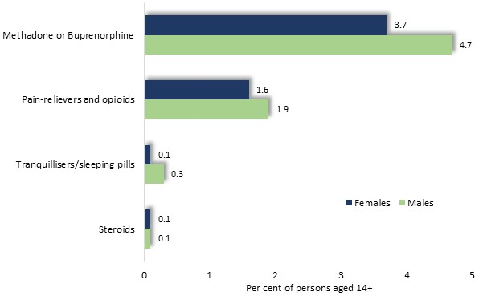

Major pharmaceuticals used included methadone or buprenorphine - used to alleviate opiate addiction, pain relievers and opioids, tranquilizers, and steroids.

Prevalence of the Illicit Use of Pharmaceuticals During the Previous Year, by Sex and Age, Australia: 2019
Local Measures of Illicit Drug Use
Local measures of incidents involving the use of illicit drugs indicate that the prevalence of their misuse is higher than metropolitan levels.
Illicits: In 2019, the rate of hospital admission for conditions related to ingestion of any illicit drug in Greater Dandenong was 51% higher than the metropolitan level.
Amphetamines: The rate of ambulance attendances in 2021/22 in Greater Dandenong, for incidents involving use of crystal meth or any methamphetamine, were 88% and 75% higher than the metropolitan average, respectively. For each of these drug categories, the rate of attendances in Greater Dandenong was the highest in Victoria outside the central metropolitan municipalities of Melbourne, Yarra and Port Phillip.
Cannabis: In the same year, the local rate of hospital admission for cannabis ingestion exceeded the metropolitan average by 84%.
Heroin: Rates of ambulance attendances for consequences of heroin use and for heroin overdose in 2021/22 were 57% or 51% higher than for metropolitan Melbourne, respectively. In 2019, hospital admission rates for heroin use were approximately twice metropolitan levels.
Pharmaceuticals: The rate of ambulance attendance for medical consequences of pharmaceutical drug use in Greater Dandenong in 2021/22 was similar to Melbourne metropolitan levels.
These trends are presented in the accompanying table.

Smoking
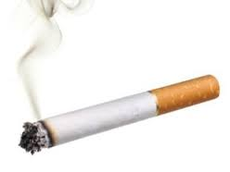

Smoking is responsible for various respiratory and cardiovascular effects, including emphysema and chronic bronchitis, heart attacks, aneurisms and stroke; and is linked to a higher incidence of pancreatic, lung, bladder and cervical cancer. The 2018 Australian National Health Survey found that smokers are 3.6 times more likely to experience chronic lung conditions than those who had never smoked. In the United States, the American Cancer Society estimated that smoking contributes to nearly one in five deaths, reducing the average life span by 13 years in males, and 15 years among females. It may be expected that smoking has similar implications for health and the human life span in Australia. Indeed, it is estimated that up to two-thirds of deaths of smokers may be attributed to smoking, with smoking reducing life span by about ten years in smokers, in Australia. Smoking may be responsible for approximately 22,000 deaths each year in Australia – equivalent to four-fifths of all drug-related mortality, and a possible 140 deaths within Greater Dandenong.
Summing the contribution of drugs to human illness, the Institute for Health Metrics and Evaluation concluded that tobacco accounts for 8.3% of the burden of disease in Australia, compared with 2.7% for alcohol and 2.6% for illicit drugs.
Measures of the financial and health costs of drug use, also place tobacco at the top of the list. The cost of drug use (adjusted to 2022 dollars) has been estimated at $85 billion per year (the equivalent of $126 million within Greater Dandenong, annually), with tobacco accounting for $44 billion nationally, alcohol for $21 billion and illicit drug use for $12 billion.
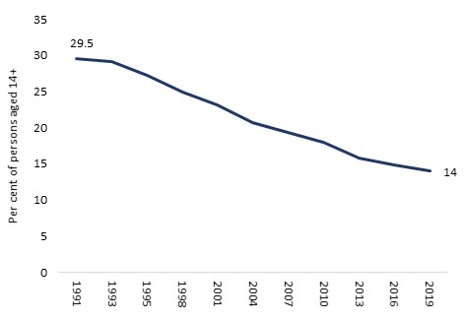
Prevalence of Smoking
The 2019 National Drug Strategy Household Survey (the latest available at the time of writing) reported that the proportion of Australians aged 14 years or more who smoke had halved in the previous 28 years, from 30% of those aged 14 years or more in 1991, to 14% by 2019.
Prevalence of Smoking: Australia, 1991-2019
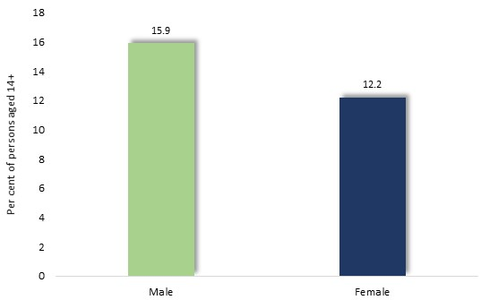
Similarly, the survey found that the proportion of children exposed to smoke within their homes daily, had fallen from 19.7% in 2001, to 2.1% by 2019.
The Survey also determined that smoking was more prevalent among males, with 15.9% of those aged 14 years or more smoking, compared with 12.2% of females.

Prevalence of Smoking by Sex: Australia, 2019

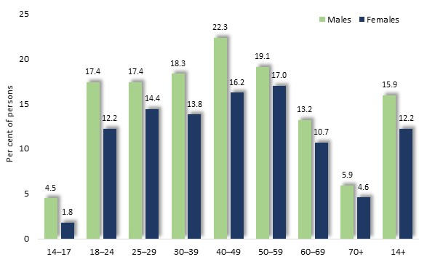

The prevalence of smoking surges among people aged 18 to 24 years, rising gradually in adulthood before subsiding in older age.
Prevalence of Smoking by Sex and Age: Australia, 2019

Local Prevalence of Smoking
Local area surveys indicate that the prevalence of smoking is slightly higher in Greater Dandenong than the state average, the 2020 Population Health Survey revealing that 13% of residents were daily smokers, similar to the Victorian prevalence of 12%.
Across Victoria, this survey found that the prevalence of daily smoking ranged from 22% in the Central Goldfields, to 3.6% in Surf Coast.

Smoking and Community Characteristics
The prevalence of daily smoking among Australians aged 14 years or more also varies with employment, socio-economic circumstances, nationality, mental health and other circumstances.
The 2018 Victorian Smoking and Health Survey found that the prevalence of smoking varied with educational attainment, from 16% of people with incomplete secondary education, to 9% among those who completed secondary school. Similarly, while 16% of the most socioeconomically disadvantaged people smoked, this number declined to 10% among more advantaged residents.
Smoking is also more prevalent among people with poorer physical or mental health, the Australian Institute of Health and Welfare reporting that smokers are more likely than others to rate their health as poor, have asthma, have been diagnosed with mental illness and to report higher levels of psychological distress.
The 2020-21 National Study of Mental Health and Wellbeing, for example, found that 16% of people with a mental health disorder during the previous year, were current smokers, as compared with 11% of those without such conditions.
Smoking and Pregnancy
Smoking during pregnancy is associated with an increased likelihood of miscarriage, premature and stillbirth, low birth weight and infant mortality. The Australian Institute of Health and Welfare (2012) reported that 12% of Australian women were smoking before learning they were pregnant, and 8% persisted afterward. Pregnant women aged less than 35 years were more likely to smoke at some time during their pregnancy (13%) than older women (8%).
Use of E-cigarettes
The 2020-21 National Health Survey and National Drug Strategy Household Survey found that the use of e-cigarettes had risen steeply in recent years, and was most common among young people and males. The 2022 Victorian Smoking and Health Survey determined that 6.1% of residents aged 18 years or more were current users of e-cigarettes – a doubling of the 3% recorded in the 2018-19 survey. Use of e-cigarettes was more prevalent among males, at 7.5%, than among females (4.6%).
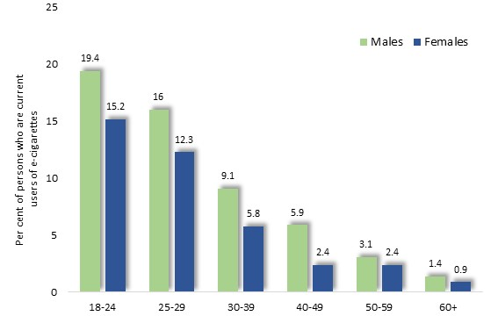
Use of e-cigarettes by age and sex: Victoria, 2022

The proportion of people who were current users of e-cigarettes had risen substantially during the few years between these surveys, with current use among 18-24 year-old females, for instance, surging from 2.8% to 15.2%. Nearly half (46%) of current users of e-cigarettes were also current smokers.
Over half (58%) of current e-cigarette users vaped nicotine.
Other studies show that reasons given for favouring e-cigarettes include their perceived safety and lower cost, and as a means to reduce smoking.

Climate Change and Community Health and Wellbeing


Climate change has occurred on many occasions during the 4.5-billion-year history of the Earth, due to natural conditions such as fluctuations in the intensity of the sun, alterations in the orbit of the Earth, meteorite impacts, the evolution of life, volcanoes, continental movements and others (4, 92).
Among conditions which normally regulate climate is the level of naturally occurring gases such as carbon dioxide, methane, nitrous oxide and water vapor, which absorb and trap some of the heat from the sun which would otherwise pass into space. This natural ‘greenhouse effect’ raises earth’s temperature by about 33 degrees, which prevents the planet from freezing and sustains conditions congenial to human life (34, 4).
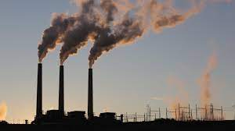
Climate Change due to Human Activity
However, the tempo of human activities, including the burning of coal, oil and gas to power vehicles, generate electricity and support industry, has accelerated during the past 150 years, raising the amount of carbon dioxide and other greenhouse gases emitted into the air. This has trapped further heat in the atmosphere, triggering rises in average, global temperatures, which have reduced the extent and depth of ice sheets, raised ocean temperatures and acidity, changed weather patterns, and disrupted natural environments and animal habitats (4, 11, 10).

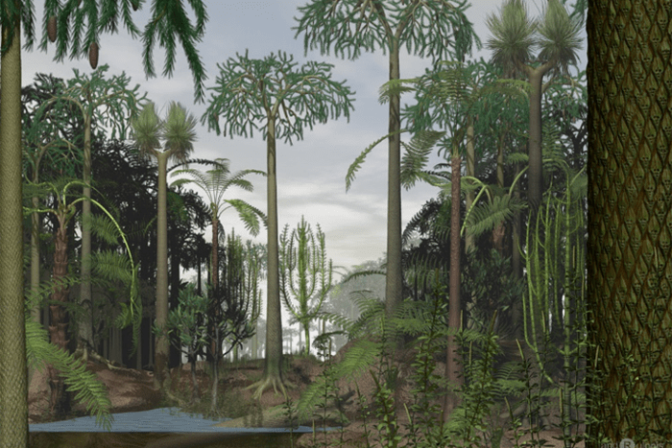
The Role of Fossil Fuels in Human-caused Climate Change
Coal, oil, gas, oil have their origin in algae, bacteria and plants, which thrived in swampy, tropical forests and swamps 350 to 500 million years ago (15, 16, 17). After they died, these organisms formed deposits in the soil or sea floor, sank beneath the ground, and under rising pressure and temperature were gradually converted to coal, oil, gas and other hydrocarbons (85). Millions of years later, they formed sources of energy, enabling human civilization to “...harness the power of ancient suns.” (89)
The industrial revolution found wide applications for fossil fuels, with the combustion of coal powering steam engines, generating electricity and suppling heat for buildings; oil refined to produce paraffin and kerosene for lamps; and gas used to light streets and homes (87).
Today, fossil fuels form the primary energy source for human civilization, accounting for over nine-tenths of the energy used in Australia (88).
A further human activity which increases levels of greenhouse gases in the atmosphere and raises global average temperatures, is the clearing of forests. Deforestation reduces the absorption of carbon dioxide by plants, boosting its level in the atmosphere (35, 36, 38).

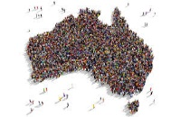
Global Warming and Population Growth
Sustained and increasing combustion of fossil fuels, as well as clearing of natural habitat, especially forests, for farming and other human activity, is largely driven by population growth. The world’s population has risen 15-fold since the late 17th century (90) and is expected to surge by a further two billion, to 9.7 billion persons, by 2050. As one investigator explains: "...every week an extra 1.5 million people need food and somewhere to live. This amounts to a huge new city each week, somewhere, which destroys wildlife habitats and augments world fossil fuel consumption" (55).
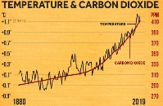
Observed Changes to Climate
During the past two hundred years, accelerating industrial activity has been matched by rising fossil fuel consumption (4), raising atmospheric carbon dioxide from 280 parts per million to more than 400 ppm at present (13) – a level unsurpassed in the preceding two million years (14).
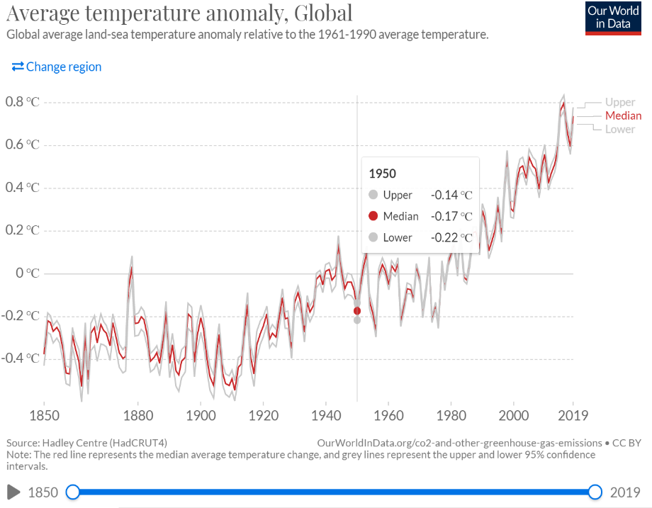
This has caused a rise in average global temperatures of about one degree during the past 150 years (10, 9, 51). Much of this change has occurred in recent years, with each of the past few decades warmer than any since 1850 (4), and NASA reporting that the past five years had been the warmest five years in centuries (10).

Temperature average difference from 1961-1990 average temperature: 1750-2019 (31)

If greenhouse emissions decline, global temperatures are forecast to rise by a further three degrees (41, 48) while if no action is taken to arrest global warming, the CSIRO warns of a 5.1 degree rise by the close of the century (1).
Temperature changes of this scale may trigger major climatic changes: the Australian Academy of Science informs us that the last ice age, 20,000 years ago, was just five degrees colder than today, yet the earth was largely engulfed in ice and the oceans were 100 meters lower than current levels (41).


Extreme Weather Events
Climate change is expected to raise the intensity and frequency of extreme weather events, such as flooding, droughts, fires, heat waves, hurricanes and cyclones (2, 5, 41), with Australia among the regions of the world most vulnerable to such circumstances (3).
A rising frequency of fire-risk days due to rising temperatures and drying conditions is forecast in the southeast (4), coupled with declining rainfall and snow (2, 4), and an increase in droughts (3, 11).
Despite these developments, a rise in the number of heavy rainfall events is also expected in Australia and around the world. Climate change is also expected to worsen storms and floods around the world (2, 10), including Victoria (4, 11).
Further trends include rapid melting of ice, currently raising sea levels by an average of 3 mm. per year (51) and exposing coastal and island communities to the risk of flooding (10, 4, 5, 11). Rising sea levels are likely to persist for centuries, regardless of any steps taken to arrest climate change in the meantime (4).

IMPACTS OF CLIMATE CHANGE
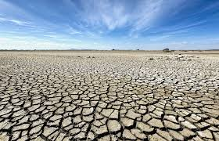
Agricultural Disruption
Rising temperatures and declining rainfall throughout the world are expected to increase the frequency and duration of droughts (7, 10), thereby reducing water available for irrigation of crops and the reducing productivity of livestock (2). Australian forecasts point to a temperature rise of four degrees in Victoria and Melbourne during the next fifty years, a doubling in the days over 35 degrees, and dwindling rainfall (8), reducing water available for agriculture and diminishing crops (2).
Further risks to agriculture associated with global warming include the disruption of pollination of plants by insects and other animals (78, 51), and the introduction of new pests to the environment (80, 81).
The impacts of climate change upon agriculture may be accentuated by the loss of farming land. Nearly one third of the world’s arable land was lost in the past 40 years due to poor conservation practices, and soil is now being depleted between 10 and 100 times faster than it is forming (20).

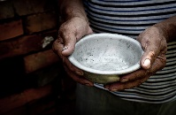
Impact on Food Production
In Australia, rising temperatures are expected to deplete crops (8), with predictions that a temperature rise of three degrees may diminish crop yields of wheat by 18%, and fruit and vegetables by 14% (41), thereby raising the price of food and worsening hardship for more disadvantaged segments of the community (66, 67). These include people on low incomes and or without paid employment, who are represented in significant numbers among the Greater Dandenong community, and among whom a high prevalence of food insecurity is well-documented (60, 61, 62, 63, 64, 65).
Food rural communities, such declines in agricultural production may jeopardize their prosperity and wellbeing, displacing many of their residents from the land (3).

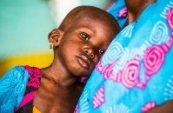
Malnutrition and Conflict
The United Nations reports that drying and degradation of the land, dwindling access to water and rising sea levels, due to climate change, are exacerbating world hunger (95), a trend which has prompted forecasts that by 2030, 100 million people may be plunged into poverty by climate change (40). Many expert observers caution that the resulting hunger, and competition for diminishing land and water resources, may ignite regional conflicts, displacing large numbers of people from their homelands and precipitating refugee crises throughout the world (3, 4, 2).


Destruction of Marine Life
Global warming is raising the temperature of the sea, harming ocean life and commercial fishing areas. In addition, rising ocean temperatures are already inducing some marine species to move to cooler waters 'outside their normal range' (3), jeopardizing marine ecosystems and disrupting the fishing industry. Meantime, as carbon dioxide accumulates in the atmosphere, some dissolves into the sea water (79) raising the acidity of the oceans (34), damaging marine organisms and depleting biodiversity in many regions, including the Great Barrier Reef (3). Such acidification of oceans, once well underway, may take thousands of years to be reversed (41).

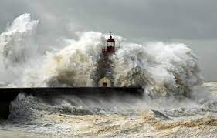
Rising Sea Levels and Coastal Flooding
As global average temperatures rise, ice resting upon Antarctica, Greenland and elsewhere will continue to melt and drain into the sea, thereby raising ocean levels. Until the nineteenth century, sea levels rose a few centimetres each century – a rate which has soared to 3 centimetres per decade in the past twenty years (51). It is forecast that sea levels may rise by up to two meters by the close of this century if the rate of carbon dioxide emissions does not slow, exposing an estimated 650 million people in coastal cities and communities to the risk of annual flooding (73).
In addition, island nations such as Tonga, Fiji, Samoa, Tuvalu, Kiribati others face a growing menace to natural habitats, infrastructure, water supplies and farming, from rising storms, waves, tides and surges stemming from climate change (75, 76).
Increasing sea levels and storm surges are also a growing threat to coastal areas in Australia (3,4), with the Australian Academy of Science predicting that historical 1-in-100-year coastal flooding events are likely to occur annually by 2100, jeopardizing people and infrastructure in many communities. Notably, more than 85% of Australia’s population lives along the coast, with an estimated $226 billion in commercial, industrial, road, rail and residential assets at risk of flooding in the event of a 1.1 m sea level rise by 2100 (41).


Heatwaves
Rising average global temperatures have been accompanied by an increase in the number and intensity of hot days (10, 3, 4). In Australia, the number of record hot days has doubled since 1960, with heatwaves more intense than in the past (1). And it is forecast that the likelihood of a serious heatwave occurring in a particular year will soar from 1.7% in 2010, to 79% in future, while days where the temperature exceeds 35 degrees may treble in many Australian cities and towns (41).
Notably, heatwaves are often amplified in urban areas such as Greater Dandenong, where dark surfaces and buildings retain heat and hot air, raising the temperature by 1-3 degrees and elevating evening temperatures by up to 12 degrees (1). With increasing global urbanization, a rising proportion of the Australian population is likely to be exposed to the risk of further elevated temperatures (1).
Heatwaves increase the incidence of cardiovascular illness, renal disease, heat stroke, mental confusion and other conditions. The 2019 heatwave in southeast Australia in 2009, which raised temperatures in parts of Victoria to 49 degrees (83), was accompanied by a 2.8-fold rise in cardiac arrest callouts; a tripling in number of patients dead on arrival; and an overall increase of 62% in deaths (6). Elsewhere in the world, heatwaves have caused 70,000 deaths in Europe in 2003 and 55,000 in Russia in 2010 (1).
Those most vulnerable to heatwaves include older or disabled people, due to their lesser physical resilience and mobility; children; people in lower socioeconomic circumstances – conditions widespread in Greater Dandenong – due in part to the cost of, and access to, air conditioning; people with pre-existing illnesses such as heart, lung or kidney disease; and indigenous people in remote communities (1, 3, 6, 41). Outdoor workers too, may be vulnerable, especially if they are required to keep pace with machines or are paid by output (1).

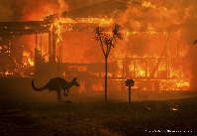
Bushfires
Dwindling rainfall in southern Australia, coupled with rising temperatures, intense heatwaves and more frequent droughts, is expected to raise the likelihood of bushfires (3, 1, 7, 41).
Though Victoria accounts for just three percent of the land area of Australia, historically it has endured half of the losses from the nation’s bushfires and two-thirds of the accompanying fatalities (7). The impact of bushfires is illustrated by the destruction inflicted by the 2019/20 Australian bushfires, which caused $10 billion in damage, burned over ten million hectares including 80% of the Blue Mountains World Heritage Area, and whose smoke affected 11 million Australians (41, 96).
In Victoria, longer fire seasons and 60% more fire risk days are forecast for the near future (11) with the annual average $180 million cost of bushfires in Victoria expected double to nearly $400 million by mid-century (7).

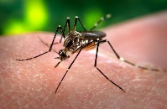
Spread of Tropical Diseases
Climate change is altering the geographic distribution of tropical diseases, as they shift south under warming climatic conditions (3). It is forecast that rising global average temperatures may be accompanied by an increase in the incidence of Ross River virus, dengue fever, Zika, Lyme disease and others, in more southerly regions of Australia (41, 72).


Destruction of Natural Habitats and Wildlife
Dwindling natural habitats – stemming from rising increased temperatures, reduced rainfall, droughts, fires and other climate change impacts – coupled with deforestation and other land clearing (29), threaten many species with extinction (10, 9). Such risks are most acute in South America, New Zealand and Australia (26, 54) – a country which accounts for half of all the world’s mammalian extinctions in the past 200 years (41).
In addition, rising temperatures are pushing many species southward in Australia as they shift from regions of rising temperature in favour of cooler environments (4, 79, 77). However, southward movement in the relatively dry Australian continent may be difficult for many species (41).
The destruction of natural environments also injures their human inhabitants and visitors, for as one commentator explains, nature bestows “…inspiration, and learning, physical and psychological experiences…that are central to quality of life and cultural integrity” (51).

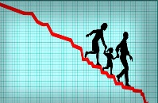
Economic Decline
Climate changes may exact a substantial economic toll upon civilization, through dwindling water supplies; rising costs of food; increasing utility, water, and petrol costs; damage to coastal infrastructure due to rising sea levels and storm surges; and the expense entailed in mobilizing health and community services to address the impact of fires, storms and heatwaves.
In Australia, a downturn in tourism is a further economic risk, with coral reef bleaching and death jeopardizing the $6.4 billion p.a. (56) tourism industry at the Great Barrier Reef (53), while tourism at national parks in northern Australia is imperilled by extreme heat and water scarcity; Australian beaches by rising sea levels and coastal flooding; and ski tourism by dwindling snowfall (54).
* * * *
As carbon dioxide and other greenhouse gases accumulate in the atmosphere, they fuel a continued rise in average global temperature, resulting in worsening storms, floods and droughts, changes in rainfall patterns, heatwaves and wildfires, rising sea levels and coastal flooding.
Coupled with the impact of land clearing to feed a burgeoning world population, these events pose a growing risk to housing and infrastructure, coastal communities, food supply, the natural environment, and to the health, wellbeing and peace of vulnerable communities throughout the world.

BIBLIOGRAPHY: CLIMATE CHANGE
1. Hughes, L., Hanna, E. and Fenwick, J. (2016). The Silent Killer: climate change and the health impacts of extreme heat. Climate Council of Australia.
2. Mercy Corps (2019). How Climate Change Affects People Living in Poverty. Mercy Corps.
3. US Environment Protection Authority (2017). International Climate Impacts.
4. Australian Academy of Science (2015). The Science of Climate Change: questions and answers.
5. Dept. Agriculture, Water and the Environment (undated). Understanding Climate Change. Australian Government
6. Dept. Human Services (2009). January 2009 Heatwaves in Victoria: An Assessment of Health Impacts. Victorian Government.
7. Hughes, L. and Alexander, D. (2017). Climate Change and the Victoria Bushfire Threat. Climate Council of Australia.
8. Melbourne Sustainable Society Institute (2015). Appetite for Change: Global Warming Impacts on Food and Framing Regions in Australia. University of Melbourne.
9. Watson, J. (2016). Bring Climate Change Back from the Future. Nature. Vol. 534, No. 7608. 21 June 2016
10. NASA (undated). What is Climate Change? National Aeronautics and Space Administration.
11. Department of Environment, Land, Water and Planning (2020). Victoria’s Climate Science Report 2019, The State of Victoria Department of Environment, Land, Water and Planning.
13. Global Carbon Project (2018). Carbon budget and trends 2018.
14. Bureau of Meteorology and CSIRO (2018). State of the Climate 2018.
15. Outreach research (undated). The origin of life: The conditions that sparked life on Earth.
16. Maruyama, S, Ebisuzaki, T and Kurokawa, K. (2018). Origin and evolution of Earth and Life: Towards the establishment of astrobiology from Universe to genome. Proceedings of Science. https://pos.sissa.it/331/071/
17. National Geographic (2020). Fossil Fuels.
18. National Geographic (undated). Non-renewable Resources.
19. Shafiee, S. and Topal, E. (2009). When will Fossil Fuels be Depleted? Energy Policy, Vol. 37, No. 1. pp. 181-189.
20. Tilman, D. (1999). Global environmental impacts of agricultural expansion: The need for sustainable and efficient practices. Proceedings of the National Academy of Sciences of the United States of America. May 25, 1999 96 (11) Accessed at: https://www.pnas.org/content/96/11/5995.short
26. Urban, M. (2015). Accelerating Extinction from Climate Change. Science. American Association for the Advancement of Science.
34. Lindsay, R. (2020). Climate Change: Atmospheric Carbon Dioxide. Climate.Gov
35. Harris, N., Brown, S., Hagen, S., Saatchi, S., Petrova, S., Salas, W., Hansen, M.C., Potapov, P.V. and Lotsch, A. (2012). Baseline Map of Carbon Emissions from Deforestation in Regions. Science, Vol. 336, Issue 6088, pp. 1573-1576
36. Baccini, A., Goetz, S. J., Walker, W. S., Laporte, N. T., Sun, M., Sulla-Menashe, D., Hackler, J., Beck, P. S. A., Dubayah, R., Friedl, M. A., Samanta, S. and Houghton, R. A. (2012). Estimated Carbon Dioxide Emissions from Tropical Deforestation Improved by Carbon-density Maps. Nature Clim Change. Vol. 2, pp. 182–185
38. Dean, A. (2019). Deforestation and Climate Change. Climate Council.
40. Khoday, K. and Ali, W. (2018). Climate Change and the Rise of Poverty. UNDP.
41. Australian Academy of Science (2021). The Risks to Australia of a 3-degree warmer world.
48. Lenton, T.M., Rockström, J., Gaffney, O., Rahmstorf, S., Richardson, K., Steffen, W. and Schellnhuber, H.J. (2019). Climate tipping points — too risky to bet against. Nature. 27 November 2019.
51. IPBES (2019): Global assessment report on biodiversity and ecosystem services of the Intergovernmental Science-Policy Platform on Biodiversity and Ecosystem Services. E. S. Brondizio, J. Settele, S. Díaz, and H. T. Ngo (editors). IPBES secretariat, Bonn, Germany.
53. Deloitte Access Economics (2020). At what price? The economic, social and icon value of the Great Barrier Reef. Great Barrier Reef Foundation.
54. Hughes, L., Stock, P., Brailsford, L. and Alexander, D. (2018). Icons at Risk: Climate Change Threatening Australian Tourism. Climate Council.
55. Guillebaud, J. and Hayes P. (2008). Population growth and climate change British Medical Journal. 2008;337:a576
66. Beaudry, E. and McKay, F. (2020). How are Victorian Local Governments' responding to climate change and food insecurity? Health Promotion Journal of Australia. Vol. 32, No. 1.
67. Dixon, J., Donati, K.J., Pike, L.L. and Hattersley, L. (2009). Functional foods and urban agriculture: two responses to climate change-related food insecurity. NSW Public Health Bulletin. Vol. 20(2), pp. 14-18.
72. Paz, S. (2015). Climate change impacts on West Nile virus transmission in a global context. Philos Trans R Soc Lond B Biol Sci. 2015 Apr 5; 370.
73. Kulp, S. and Strauss, B.H. (2019). New elevation data triple estimates of global vulnerability to sea-level rise and coastal flooding. Nature Communications. Volume 10.
75. Mimura, N. (1999). Vulnerability of island countries in the South Pacific to sea level rise. Climate Change. Vol. 12, pp. 137–143.
76. Pacific Coastal and Marine Science Center (2020. The Impact of Sea-Level Rise and Climate Change on Pacific Ocean Atolls. US Geological Survey.
77. Chaudary, C., Richardson., A.J., Scoeman., D.S. and Costello, M.J (2021). Global warming is causing a more pronounced dip in species richness around the equator. Proceedings of the National Academy of Sciences of the United States of America. Vol. 118, No. 15.
78. Gerard, M., Vanderplanck, M, Wood, T. and Michez, D. (2020). Global warming and plant–pollinator mismatches. Emerg Top Life Sci. 2020 Jul 2; Vol. 4, No. 1, pp. 77–86.
79. IPCC (2014): Climate Change 2014: Synthesis Report. Contribution of Working Groups I, II and III to the Fifth Assessment Report of the Intergovernmental Panel on Climate Change. IPCC, Geneva, Switzerland.
80. Bebber, D.P., Ramotowski, M. and Gurr, S.J. (2013). Crop pests and pathogens move polewards in a warming world. Nature Climate Change. Vol. 1 Sept., 2013.
81. Holmes, T. and Gurr, S.J. (2014). The Global Spread of Crop Pests and Pathogens. Global Ecology and Biogeography. Vol. 23, pp. 1398–1407.
83. Australian Government Bureau of Meteorology (2009). The exceptional January-February 2009 heatwave in south-eastern Australia.
85. Rafferty, J.P. (undated). Do Fossil Fuels Really Come from Fossils? Britannica.
87. Wrigley, E.A. (2013). Energy and the English Industrial Revolution. Philosophical Transactions of the Royal Society.
88. Geoscience Australia (undated). Australia’s Energy Production, Consumption and Exports.
89. Andrews, T.G. (undated). Coal and the Industrial Revolution. National History Education Clearinghouse.
90. Kumar, K. (undated). Modernization. Brittanica.
92. NASA (2020). Global Climate Change – Vital Signs for the Planet: Graphic: Temperature versus Solar Activity.
Soc Lond B Biol Sci. Vol. 354(1379), pp. 33–50.
95. United Nations Climate Change (2018). UN Warns of Climate Change is Driving world Hunger. United Nations.
96. CSIRO (2021). The 2019-20 bushfires: a CSIRO explainer. Commonwealth Government.
97. Our World in Data (2020). Energy Use by Source: Selected World Nations, 2019. From BP Statistical Review of World Energy

Diversity of birthplaces among the residents of each municipality is measured as the probability that two people from a community, chosen at random, would come from different birthplaces. This measure provides an index of birthplace diversity which gives a balanced measure of the range of birthplaces and number of persons from each, and permits localities of widely varying population to be compared.
For 506 people seeking asylum, their municipality of residence could not be determined, due to the manner in which information concerning their suburb of residence is tabulated by the Department of Immigration and Border Protection. As a result, the total number of people seeking asylum used to calculate the percentages presented in the diagram above is less than the actual total.
Some of those people among the totals for September 2014 and June 2021 could not be reliably assigned to municipalities of residence to assemble the chart above.
The municipality of Greater Dandenong and the adjoining municipalities of Casey, Frankston, Kingston, Knox and Monash.
These were physical, emotional, social, language and communication.
Roy Morgan Research (2015). Is Australia Getting Gayer – and How Gay will we Get? Roy Morgan Research Accessed at: http://www.roymorgan.com/findings/6263-exactly-how-many-australians-are-gay-december-2014-201506020136
Australian Research Centre in Sex, Health and Society (2005). Australian Longitudinal Study of Health and Relationships Wave 1. La Trobe University, Melbourne
Conway (2015). How Many of Us are There? Accessed at: http://www.gendercentre.org.au/resources/polare-archive/archived-articles/how-many-of-us-are-there.htm
Sax (2002). How Common is Intersex? A Response to Anne Fausto-Sterling. Journal of Sex research, 2002 August Vol. 4(4), pp. 293-298
Victorian Agency for Health Information (2020). The health and wellbeing of the lesbian, gay, bisexual, transgender, intersex and queer population in Victoria: Findings from the Victorian Population Health Survey 2017. Melbourne
Fairchild, J. (2020). PiP Webinar: LGBTIQ Inclusive Prevention in Conversation with Rainbow Health Victoria. May 27, 2020 Family and Community Services (undated). I’m LGBTIQ and Experiencing Domestic Violence.
National LGBT Health Alliance (2009). Submission to the Inquiry into the Impact of Violence on Young Australians
National LGBT Health Alliance (2009). Submission to the Inquiry into the Impact of Violence on Young Australians
National LGBT Health Alliance (2009). Submission to the Inquiry into the Impact of Violence on Young Australians
McNair, R., Kavanagh, A., Agues, P and Tong, B. (2004). The Mental Health Status of Young Adult and Mid-life Non-heterosexual Australian Women. Australian and New Zealand Journal of Public Health, Vol. 29 No. 3 pp. 265-271
Strauss, P., Cook, A., Winter, S., Watson, V., Wright Toussaint, D., Lin, A. (2017). Trans Pathways: the mental health experiences and care pathways of trans young people: summary of results. Telethon Kids Institute, Perth.
Hill, A. O., Bourne, A., McNair, R., Carman, M. & Lyons, A. (2020). Private Lives 3: The health and wellbeing of LGBTIQ people in Australia. Australian Research Centre in Sex, Health and Society
Based on findings of the 2007 National Survey of Mental Health and Wellbeing
Based upon median household incomes minus rental costs, recorded in the 2021 Census, which were adjusted using equivalence scales to accommodate differing costs for households of varying size and structure. The resulting ‘equivalized’ incomes were used to determine the proportion of households of each composition which were living in poverty, using a criterion set at the equivalent of a single person in receipt of $439 gross weekly income - the upper limit of the income range of the lower 30% of individual incomes in Victoria - after paying rent. These calculations do not include multi-family households or the very small number of unclassified family types.
Many workers use more than one mode of transport, with the consequence that the sum of the percentages featured in the diagram exceeds 100
Eime, R., Charity, M., Pankowiak, A. and Westerbeek, H. (2021). Sport Participation in Victoria according to Local Government Areas: 2015-2019. Federation University, Victoria University and Sport and Recreation Spatial.
Australian Bureau of Statistics (2022). Deaths in Australia 2020
Australian Bureau of Statistics, Life Tables, States, Territories and Australia, 2016-20
Deaths Australia, 2020, Australian Bureau of Statistics
Deaths Australia, 2020. Australian Bureau of Statistics
Australia's Health Tracker: http://www.atlasesaustralia.com.au/ahpc/data.html
Australian Bureau of Statistics 2022. Deaths Australia, 2021.
Australian Institute of Health and Welfare (2012a). Information About Overweight and Obesity. Australian Institute of Health and Welfare, Canberra
Torrens University. Social Health Atlases. Accessed at: http://phidu.torrens.edu.au/social-health-atlases/data#social-health-atlases-of-australia-local-government-areas on 3 Dec. 2018
The findings of population surveys featuring this inquiry include 5.2% in 1995 (Australian Institute of Family Studies, 2018), 6.1% in the 2001 Child Health Survey, 5.2% in the Victorian VicLanes survey (Burns, 2009), and 4% in the 2011/12 National Health Survey.
Australian Institute of Family Studies (2018). Fairfield Refugee Nutrition project. Australian Institute of Family Studies, Canberra
Burns, C. (2009). Food Insecurity: what do we know? Deakin University and WHO Collaborating Centre for Obesity Prevention, Melbourne
Australian Institute of Family Studies (2018). Fairfield Refugee Nutrition project. Australian Institute of Family Studies, Canberra Burns, C. (2004). A Review of the Literature Describing the Link between Poverty, Food Insecurity and Obesity with Specific Reference to Australia. VicHealth, Melbourne Ramsey, R., Giskes, K., Turrell, G. and Gallegos, D. (2012). Food insecurity among Adults Residing in Disadvantaged Urban Areas: potential health and dietary consequences. Public Health Nutr 2012; Vol 15, pp. 227-237 VicHealth (2015). VicHealth Indicators Survey 2015. VicHealth, Melbourne McCrindle Consulting (2018A). Food Bank Hunger Report 2018. Food Bank.
Estimated from Australian mortality trends reported in Causes of Deaths Australia, 2022 (Australian Bureau of Statistics, 2022) and population estimates from Regional Population Growth, Australia, 2021, Australian Bureau of Statistics: 3218.0 , 2022)
Cancer Council of Australia, 2015
Cancer Australia, 2022
Census Australia, 2021
Australian Bureau of Statistics (2022). Causes of Death Australia, 2021
Australian Institute of Health and Welfare (2021). Cancer Data in Australia
Poynton-Smith, E. (undated). Why is the Suicide Rate Higher among Men than Women? Patterns of Action Dissertation, University of Nottingham
Goldney, R.D., Fisher, L.J., Wilson, D.H., & Cheok, F. (2002). Mental health literacy of those with major depression and suicidal ideation: an impediment to help seeking. Suicide and Life-Threatening Behaviour, 32(4), 394-403. Howerton, A., Byng, R., Campbell J., Owens, C. & Aitken, P. (2007). Understanding help-seeking behaviour among male offenders: a qualitative interview study. British Medical Journal, 334, 303. Witte, T.K., Gordon, K.H., Smith, P.N. & Van Orden, K.A. (2012). Stoicism and sensation seeking male vulnerabilities for the acquired capability for suicide. Journal of Research in Personality, 46, 384-392
Denney, J.T., Rogers, R.G., Krueger, P.M., & Wadsworth, T. (2009). Adult Suicide Mortality in the United States: Marital Status, Family Size, Socioeconomic Status, and Differences by Sex. Social Science Quarterly, 90(5), 1167-1185.
Galdas, P., Cheater, F. and Marshall, P. (2005). Men and Health-seeking Behaviour: a literature review. Journal of Advanced Nursing. Vol. 49, Issue 6. Hines, L.A., Goodwin, L., Jones, M., Hull, L., Wessely, S., Fear, N.T. and Rona, R.J. (2014). Factors Affecting Help Seeking for Mental Health Problems After Deployment to Iraq and Afghanistan. Psychiatry Online 1 Jan 2014
Bruffaerts, R., Demyttenaere, K., Hwang, I., et al. (2011). Treatment of suicidal people around the world. British Journal of Psychiatry, 199(1), 64-70.
Joiner, T. E. (2005). Why people die by suicide. Cambridge: Harvard University Press. Joiner, T.E. (2011). Lonely at the top - The high cost of men’s success. New York: Palgrave MacMillan. Schumacher, H. (2019). In countries around the world, women are more likely to be diagnosed with depression and to attempt suicide. So why is the male suicide rate still several times higher than female? BBC Future, 18 March 2019.
Carley, M. (2018). Masculinity: healthy vs toxic Comstock, C. (2016). Healthy Masculinity. ManKind Project Behavioural Health and Rape Crisis Centre (2019). Healthy Masculinity: changing the conversation Flood, M. (2020). Healthier Masculinities for Gender Equality. Workshop Melbourne. Women’s Health in the South East. January 20, 2020
Australian Bureau of Statistics (2016c). Labour Force Australia 2016.
Male national suicide rates exhibit a correlation with unemployment rates four years earlier, of 0.77. In contrast, the correlation between female susicide rates and earlier unemployment levels is a comparatively low, 0.14.
Gao, C., Ogeil, R., and Lloyd, B. (2014). Alcohol’s Burden of Disease, Australia. VicHealth, Turning Point, Foundation for Alcohol Research and Education
Australian Medical Association, 2017; May and Gossage, 2017; Burns et al, 2013; National Drug Research Institute, 2013a, 2013b, 2013c, 2013d; O’Leary et al, 2012; Hulubowycz, 1994
Australian Bureau of Statistics (2017c). Personal Safety Survey, 2016.
Downey, M. (2016). Resurgence in Ecstasy Market, with a shift to the Crystal form of the Drug. National Drug and Alcohol Research Centre, University of New South Wales
Goldsmind, S., Johnston, I., Kapira, M., Clayden, C., Petriecevie, M., and Webber, K. (2017). Australian Methamphetamine User outcomes. Statistics Bulletin 03. Australian Institute of Criminology.
Cook, S., Johnson, P., Martinow, K. and Elder, J. (2014). ‘Inquiry into the supply and use of methamphetamines particularly ice in Victoria’, Final Report Vol. 1. Law Reform, Drugs and Crime Prevention Committee, Victorian Government. Melbourne
Banks, E., Joshy, G., Weber, M., Liu, B., Egger, S., Paige, E., Lopez, A., Sitas, F. and Beral, V. (2015). Tobacco smoking and all-cause mortality in a large Australian cohort study: findings from a mature epidemic with current low smoking prevalence. BMC Medicine Feb. 2015. Accessed at: https://bmcmedicine.biomedcentral.com/articles/10.1186/s12916-015-0281-z on 12 Feb, 2018
Australian Bureau of Statistics (2011b). Facts at Your Fingertips: Health, 2011: Tobacco smoking in Australia. Accessed at: http://www.abs.gov.au/ausstats/abs@.nsf/Lookup/4841.0Chapter32011 on 16 September
Institute for Health Metrics and Evaluation (2014). Data Visualization. Seattle
Australian Institute of Health and Welfare (2013b). National Drug Strategy Household Survey: detailed report. Accessed at: http://www.aihw.gov.au/publication-detail/?id=60129549469 on 14 September, 2015
Australian Institute of Health and Welfare (2012b). Australia's Health 2012 - Summary of Findings. Australian Institute of Health and Welfare, Canberra
As the organisms from which they originated grew by photosynthesis, which uses the energy of the sun’s light to combine carbon dioxide and water into the molecules required for their growth and survival.

