Summaries of Research about Gender Equity
Prevalence of Family Violence, Harassment and Stalking

Violence within families, including the abuse of children, cannot be measured with accuracy by records compiled by the police, courts or specialist agencies. Instead, random surveys of the general population offer the best available method for measuring the prevalence of the such violence.
The Personal Safety Survey was conducted by the Australian Bureau of Statistics from March 2021 to May 2022, through face-to-face interviews with 11,905 Australians – including 9,832 women and 2,073 men – aged 18+ and living in private dwellings.
Survey participants were asked about their experiences of physical and sexual threats or assault; sexual harassment and stalking; abuse and witnessing of violence at home, during their childhood; and perceptions of personal safety alone after dark.

Violence
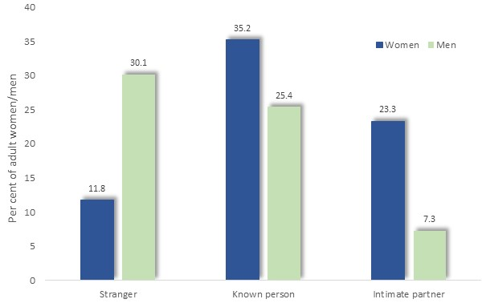
Thirty-nine per cent of women and 43% of men had experienced violence (assault or threats of assault) since the age of 15. For women, violence was less likely to have been perpetrated by a stranger than for men, and more likely to have been committed by someone known to them, including by an intimate partner - that is, a cohabiting partner, boy- or girl-friend, or date, or ex-boy- or girl-friend.

Per cent of persons who experienced violence since age 15, by sex and perpetrator type: Aus., 2021/22

In the previous 12 months, 4.2% of women and 6% of men had experienced violence.
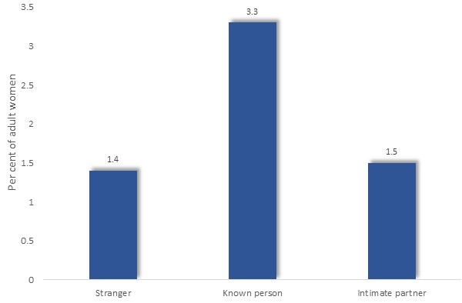
Among women, 1.4% experienced violence by strangers, and 3.3% by known persons, including intimate partners (1.5%).

Per cent of women who experienced violence in the previous 12 months, by perpetrator type: Aus., 2021/22

Physical and Sexual Assault
Since age 15
19.9% of adult women had been sexually assaulted since age 15 (compared with 5.1% of men), with 19.8% of women sexually assaulted by a male and 0.6% by a female.
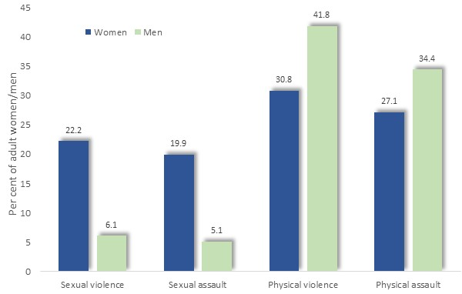
Thirty-four per cent of men and 27% of women had been physically assaulted since age 15 - 24.4% by males and 7.1% by females.

Per cent of persons who had experienced violence since age 15, by sex and type of violence: Aus., 2021/22

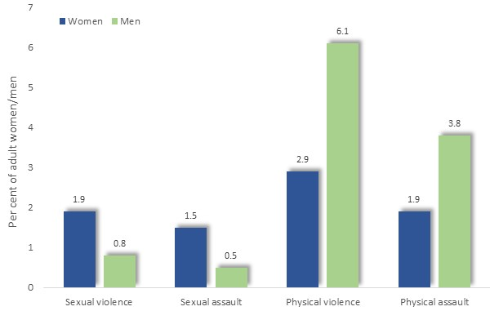
In past 12 months
In the previous 12 months, 1.5% of women had been sexually assaulted (compared with 0.5% of men) and 1.9% physically assaulted.

Per cent of persons who had experienced violence in the previous 12 months, by sex and type of violence: Aus., 2021/22

Intimate Partner Violence
Intimate partner violence had been experienced since age 15 by 23.3% of women and 7.3% of men.
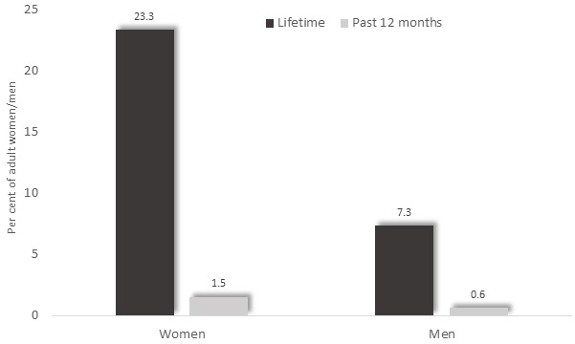
Per cent of persons who had experienced intimate partner violence, by sex and time-span: Aus., 2021/22

During the previous 12 months, 1.5% of women and 0.6% of men had experienced intimate partner violence.

Homocides
In 2010-2018, there were 240 female victims of homicide in which a male offender killed a current or former partner, the equivalent of 34 such incidents per year, on average. Women therefore represented 77% of the victims in intimate partner homicides. (Australian Domestic and Family Violence Death Review Network, & Australia's National Research Organisation for Women's Safety. (2022). Australian Domestic and Family Violence Death Review Network Data Report: Intimate partner violence homicides 2010–2018 (2nd ed.; Research report 03/2022). ANROWS)

Witnessing Violence towards a Mother and/or Father by a Partner, During Childhood
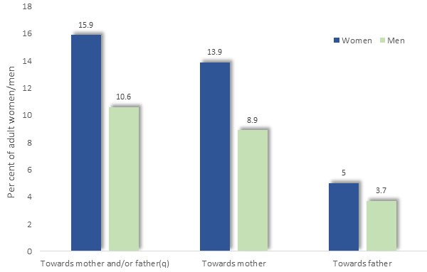
Sixteen per cent of women, and 11% of men, had witnessed violence toward their mother or father, by their partner, before the age of 15 years.
In most instances, the violence had been directed toward their mother, with women three times as likely to report witnessing violence directed toward their mother as to their father.

Per cent of persons who had witnessed violence toward their mother or father by their partner, before age 15, by sex: Aus., 2021/22

Child Abuse
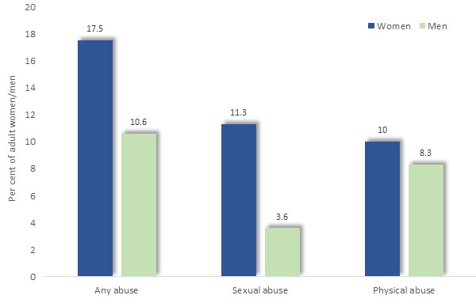
Eighteen per cent of women and 10.6% of men had been abused before age 15.
Eleven per cent of women had been sexually abused, compared with 3.6% of men, and 10% physically abused, compared with 8.3% of men.

Per cent of persons who had been abused before the age of 15, by sex and type of abuse: Aus., 2021/22

Stalking
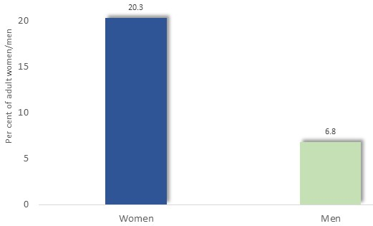
As with intimate partner violence and sexual assault, women predominated among those who had experienced stalking, with 20.3% of women and 6.8% of men reporting that they had been stalked at some time since the age of 15.

Per cent of persons who had been stalked since age 15, by sex: Aus., 2021/22

Women were six times more likely to have been stalked recently, with 3.4% of women and 0.6% of men recalling such incidents in the previous 12 months.

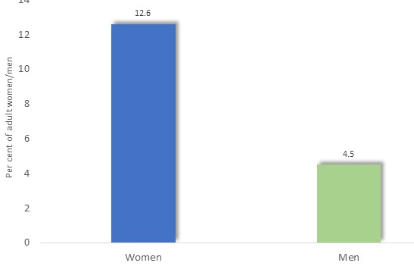
Sexual Harassment
During the previous 12 months, 12.6% of women had been sexually harassed - nearly three times the corresponding proportion of males, of 4.5%.
12.2% of women had been harassed by a male and 1.1% by a female.

Per cent of persons who had been sexually harassed during the previous 12 months, by sex: Aus., 2021/22

Among the incidents reported by women were inappropriate comments or written communication, and unwanted physical contact.
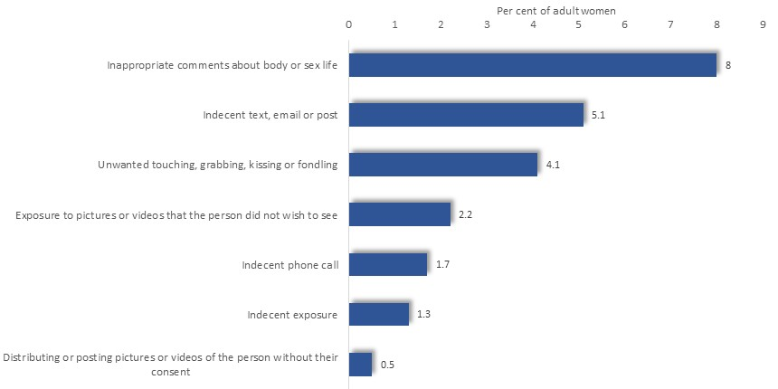
Per cent of women who had been sexually harassed during the previous 12 months, by type of harassment: Aus., 2021/22

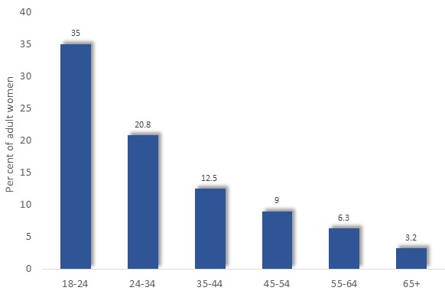
The proportion of women who had been sexually harassed in the previous 12 months reached 35% among those aged 18-24 years, declining steeply with age.

Per cent of women who had been sexually harassed during the previous 12 months, by age: Aus., 2021/22

In addition to younger women, those who identified as LGBTIQ, were disabled, unemployed or experiencing financial problems, were more likely to have been sexually harassed than others.
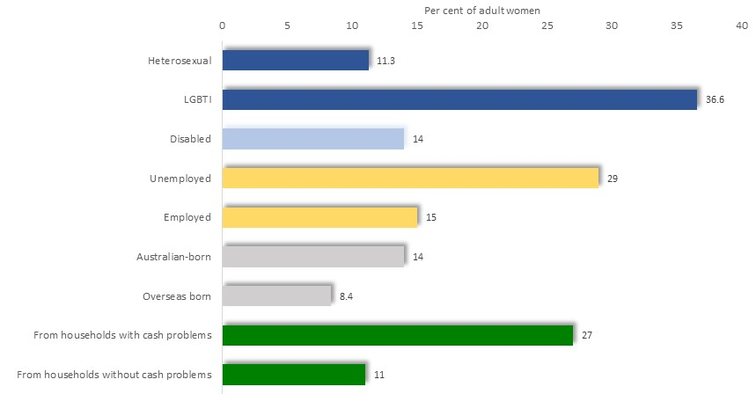
Per cent of women who had been sexually harassed during the previous 12 months, by selected characteristics: Aus., 2021/22

Asked about the location where incidents of harassment occurred, places of work, entertainment, residences and outside were each identified by about a quarter of the women who had been harassed.

Perceptions of Personal Safety
Perceptions of personal safety when using public transport alone after dark, as well as walking near their home alone at night, were the subject of further inquiries.
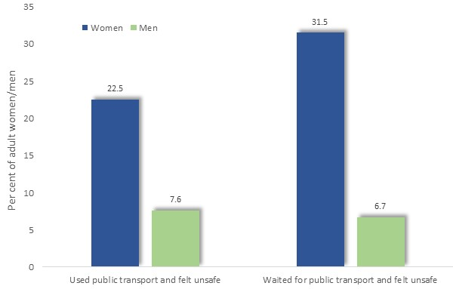
While Using Public Transport after Dark
Women were three times more likely than men than men to feel unsafe while using public transport alone after dark, and over four times more likely to feel unsafe while waiting for public transport after dark.

Per cent of persons who felt unsafe while using public transport by sex: Aus., 2021/22

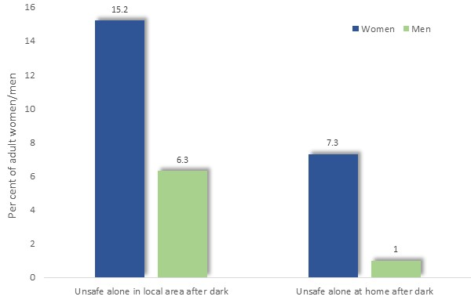
While Alone after Dark
Women were over twice as likely to report apprehensions about their personal safety at night, with 15.2% declaring that they felt unsafe walking alone in their local area after dark, compared with 6.3% of males.
Further, 7.3% of women and 1% of men, felt concerns for their personal safety while alone at home after dark.

Per cent of persons who felt unsafe at home after dark: Aus., 2021/22
Local Measures of the Incidence of Family Violence and Child Abuse
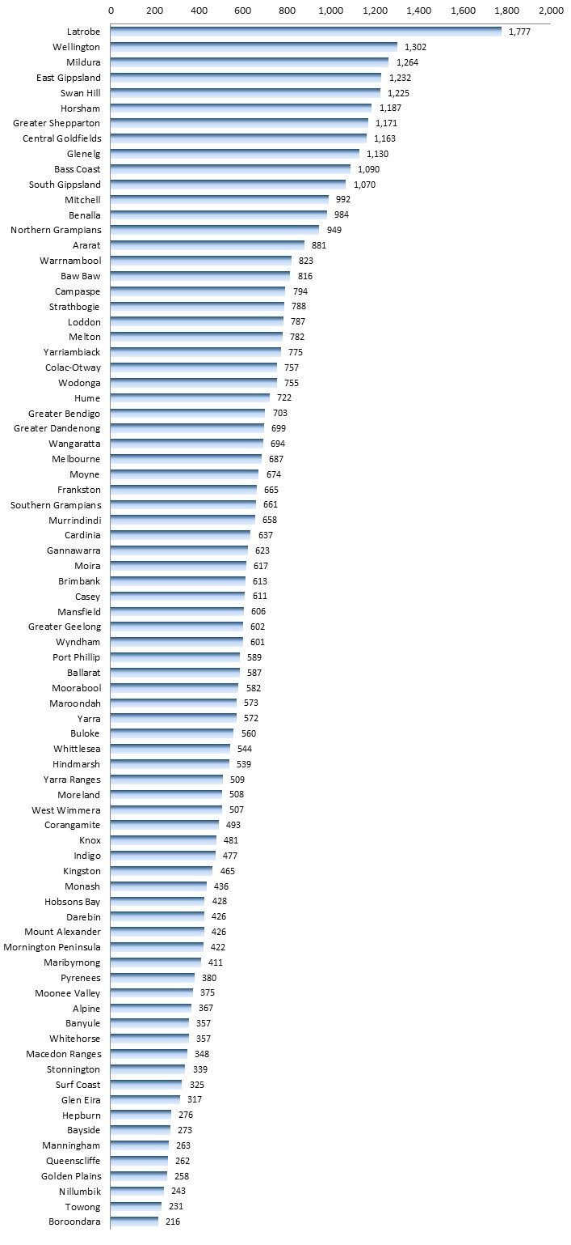
Local measures of the incidence of family violence and child abuse are less reliable, since they only reflect those instances of violence which reach the attention of responsible agencies, such as the police, the courts and child protection authorities.
Family-related Alleged Violent Offences, 2021/22 [per 100,000 residents], by Municipality

The rate of family-related alleged violent offences (per 100,000 residents) in Greater Dandenong, stood at 699 per 100,000 residents in 2021/22 – the third highest rate in metropolitan Melbourne and 20% more than the Victorian level. Women accounted for 73% of alleged incidences of violence within families.
The rate of such offences has risen in Greater Dandenong by 37% since 2010/11, and by 121% across Victoria in this period.

Rate of alleged violent offences, per 100,000 population: Greater Dandenong and Metro. Melbourne, 2010/2022
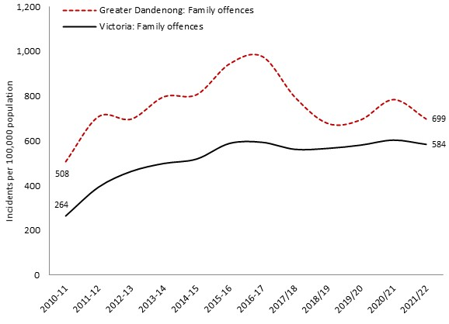
Sexual Offending against People aged Less than 18 years
In 2023, the University of New South Wales published a report entitled ‘Understanding Child Sex Offending Behaviors and Attitudes among Australian Men’ which recounted the findings of an online survey of 1,965 Australian men recruited from an online consulting service. The survey found that:
- 19.6% of survey respondents acknowledged sexual feelings towards people aged less than 18 years, and/or offended sexually against them.
- 9.4% had sexually offended against people aged less than 18.
- 15.1% had sexual feelings about people aged less than 18. (Though elsewhere (p. 30), the report states that 10.2% of respondents had sexual feelings towards people aged less than 18.
Asked about younger children, 4% of respondents affirmed that, if no-one could find out, they would have sex with children aged less than 10 years of age, and 5.7% with children aged 12 to 14 years.
Sexual coercion
A related topic is being compelled or intimidated into participating in sexual activity, often termed ‘sexual coercion’. De Vissier et al (2020) reports on the findings of interviews with a representative sample of over 20,000 Australians aged 16–59 years, in which the experience of sexual coercion at some time their lifetimes was reported by 4.8% of men and 22.4% of women, and by 3% of men and 10% of women at or before the age of 16 years. Consequences of such experienced included psychosocial distress, high levels of anxiety about sex, with few discussing these experiences with a professional. These findings are similar to those reported in an earlier inquiry (De Vissier et al, 2003).
Gendered Drivers of Family Violence
Attitudes, beliefs and behaviours which are widespread in our society contribute to harassment and violence against women. The report ‘Change the Story’ by Our Watch explored this issue in detail, identifying four gender-related circumstances which cause family violence or aggravate the severity of such crimes:
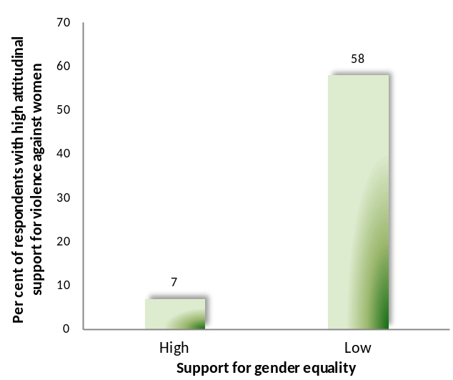
Rigid gender roles and stereotyped constructions of masculinity and femininity: men with conventional attitudes about the superior status and entitlement of males, and the differing roles of women and men are more likely than others to commit violence against women. A striking illustration of this connection was supplied by the findings of the 2013 VicHealth Community Attitudes Towards Violence Against Women survey, of 17,500 Australians aged 16 and over. The survey findings revealed attitudinal support for violence against women among 58% of respondents with low support for gender equity, compared with just 7% of those with high support for gender equity (diagram, left) (VicHealth, 2014).
The authors of ‘Change the Story’ recommend that efforts be made to encourage all people - especially children and young adults – to repudiate conventional ideas about male superiority, control and status; adopt values and personal identities that embody respect and equality between women and men; and to share domestic and child-rearing responsibilities (Our Watch, 2015).
Men’s control of decision-making and limits to women’s independence in public and private life: Men who feel entitled to control women or consider them to be of lower status, are more likely to inflict violence upon them, and, where they control women through financial means, fear, isolation or other means, may often do so with impunity. The report urges that more women be provided with the means to obtain paid employment, thereby placing financial security and independence within their reach; barriers to their participation and decision-making in public life be removed; aggressive and dominating behaviour by men at work and in relationships be opposed; and opportunities be fostered for women to come together to socialise, provide mutual support and advocate for causes of common concern.
Male peer relations that emphasize aggression and disrespect towards women: social interactions among men who disrespect, belittle and dominate women tend to reinforce such patterns of thinking and accentuate violence. It is proposed that such beliefs be contested, with boys and men encouraged to adopt attitudes founded upon an understanding of the equal status, rights and entitlements of women and men.
Excusing or justifying violence against women: beliefs and ideas that support, excuse or discount violence against women. The report recommends strenuous efforts to resist and refute such notions (Our Watch, 2015).
Reinforcing factors in family violence
Our Watch (2015) maintains that other social and political circumstances influence gender inequality and the frequency, severity and prevalence of violence against women. Termed ‘reinforcing factors’ by its authors, these include a tendency to commit or excuse violence; aggravation of violence by alcohol and other drugs; and the impact of socioeconomic disadvantage. To negate those conditions which reinforce violence against women, a number of broad approaches are recommended; among them:
- Refuting the notion that men are inherently aggressive, while cultivating heathy, respectful relationships and support for respect and equality among women and men.
- Encouraging parents not to inflict violence upon their children, coupled with the prevention of child abuse.
- Contesting excuses offered for violence given by some men.
- Fostering resilience within relationships and communities to enable them to endure disruptive social or economic change – which otherwise may challenge the sense of personal identity and self-esteem held by many men.
- Addressing poverty and other financial hardship; racial, cultural, religious or gender identity-based discrimination; the challenges of settlement; single parenthood; and other forms of disadvantage (Our Watch, 2015).
The task of addressing the conditions which cause or contribute to violence against women may require persistent effort. As Our Watch (2018) explains, “Because we know the underlying drivers of violence are complex, deeply entrenched and exist at all levels of our society, primary prevention also seeks to work at all levels of society. It is an ambitious, long-term approach, aiming for social transformation on a scale that will create a safe and equal society for every woman and her children.”

REFERENCES

ABC News (2018). Street harassment survey reveals girls as young as 11 catcalled and followed. Tuesday 22 May 2018
Australian Bureau of Statistics (2023). Personal Safety Survey. ABS, Canberra.
Boxall H, Morgan A & Brown, R. (2020). The prevalence of domestic violence among women during the COVID-19 pandemic. Statistical Bulletin no. 28. Canberra: Australian Institute of Criminology. https://www.aic.gov.au/publications/sb/sb28
Crime Statistics Agency (2019). Alleged Offences Against the Person by Family Incident Flag, by Municipality.
deVissier, O., Badcock, P.B., Rissel, C.E., Richters, J. Smith, A.M.A., Grulich, A.E. and Simpson, J.M. (2020). Experiences of sexual coercion in a representative sample of adults: the Second Australian Study of Health and Relationships. Sex Health. Nov. Vol. 11, No.5, pp. 472-80
deVissier, O., Smith, A.M., Rissel, C.E., Richters, J. and Grulich, A.E. (2003). Sex in Australia: Experiences of Sexual Coercion Among a Representative Sample of Adults. Australia and New Zealand Journal of Public Health 2003. Vol. 27(2), pp. 198-203
Johnston, M. and Bennett, E. (2015). Everyday Sexism: Women’s Experiences of Street Harassment. The Australia Institute
Our Watch (2015). Change the Story: a shared framework for the primary prevention of violence against women and their children in Australia. Our Watch, VicHealth and ANROWS
Our Watch (2018). Changing the Picture: a national resource to support the prevention of violence against Aboriginal and Torres Strait Islander women and their children. Our Watch, Melbourne
VicHealth (2014). Community Attitudes Towards Violence Against Women 2013. VicHealth, Melbourne

