Literacy by Selected Characteristics, Australia, 2012
From the 2011–12 Programme for the International Assessment of Adult Competencies, Australian Bureau of Statistics, 2013

The information presented here is largely drawn from the findings of the 2011–12 Programme for the International Assessment of Adult Competencies, which measured levels of literacy and numeracy among a random sample of Australians, through face-to-face interviews. The survey assessed respondents’ ability to understand written English as well as their proficiency in numerical calculations.
English literacy levels were grouped into six ranges, from ‘below Level 1’ to ‘Level 5’ - the highest level. Throughout this note, persons at, or below, Level 1 literacy are described as having ‘limited English literacy’.

Literacy: Age and Gender
Overall, approximately 14 per cent, or one in seven, women and men across Australia aged 15 to 74, had limited literacy. Among younger age groups a higher proportion of males than females had limited literacy, whereas among older Australians, limited English literacy was more prevalent among women.
For both women and men, the proportion of people with limited English literacy declined slightly from teenage prevalence of 11.6% (13.9% among males and 9% among females), to 8.8% among those aged 35 to 39 years, before rising with increasing age to a peak of 30% among people aged 65 to 74 (accompanying diagram).

Per cent of Persons with Limited English Literacy, by Age and Sex: Persons aged 15-74 years, Australia, 2012
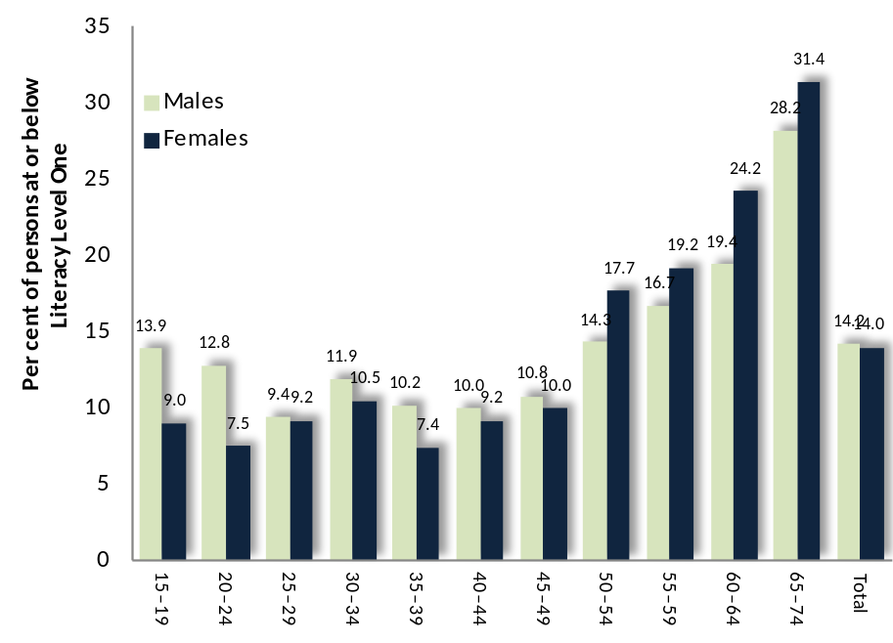

Trends in Literacy Levels: 1996 to 2011
In the fifteen years from 1996 to 2011, the proportion of Australians aged 15 to 74 with limited literacy has declined from approximately 18.7% to 14.3%. This decline is most marked among older Australians, with the proportion of people aged 65-74 with limited literacy falling from 56% to 29%. During this period, the proportion of those whose first language was not English, who had limited English literacy, almost halved from 41% in 1996 to 23% by 2011.
In this time, the rate of limited literacy among people whose first language was English barely changed, falling from 13% to 12%.

Per cent of Persons with Limited English Literacy, by Age and Sex: Australia, 1996 and 2012

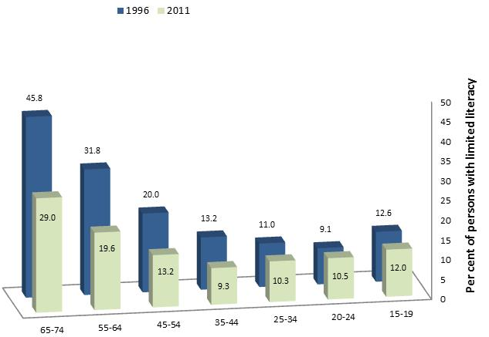

Literacy: English as a First or Second Language
Survey respondents were asked if English was their first language, or a second language.
Among people aged 15-74 years whose first language was English, 12% had very limited English literacy, compared with 25% of those whose first language was not English.
Among all age groups, limited English literacy was approximately twice as prevalent among those for whom English was a second language than among people for whom English was a first language. (Diagram below)

Per cent of Persons with Limited English Literacy, by Age and whether English is a first or second language: Australia, 2012
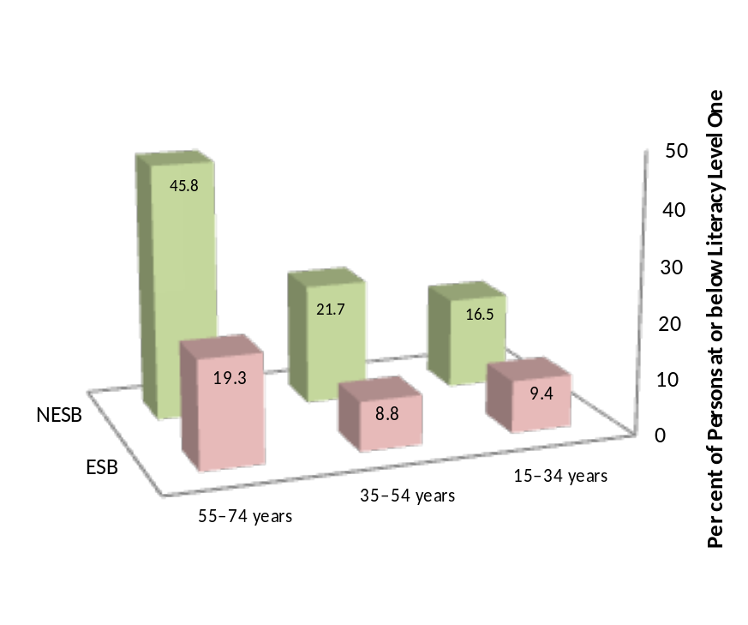

This difference is most pronounced among older and unemployed people.
Per cent of Persons with Limited English Literacy, by Selected Characteristics: Australia, 2012
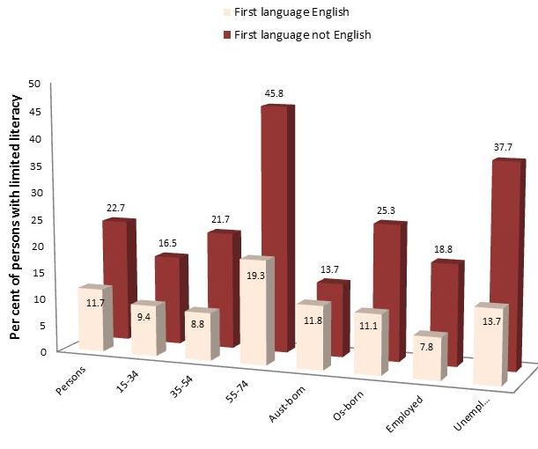

Literacy: Labour Force Status
The proportion of people with limited English literacy was lowest among those in paid employment, higher among people who were unemployed, and highest among those not in the labour force. Among people of each labour force category, a higher proportion of males than females, had limited literacy in English.

Per cent of Persons with Limited English Literacy, by Sex and Labour Force Status: Australia, 2012
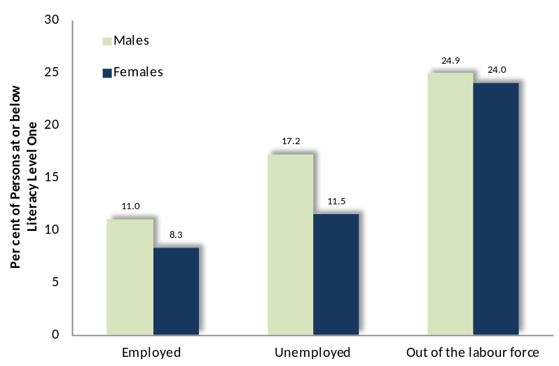
These results are set out in the table below, which also features the results for persons in each category of labour force status.
 | Employed | Unemployed | Not in labour force
Males | 11.0 | 17.2 | 24.9
Females | 8.3 | 11.5 | 24.0
Persons | 9.8 | 14.4 | 24.3

The interaction of age and labour force status is explored in the diagram below, which shows that among people in paid employment, the proportion with limited literacy initially fell with increasing age, before climbing steeply to 15%, or about one in six, among employed people aged 55 to 64.

Per cent of Employed Persons with Limited English Literacy, by Age: Australia, 2012
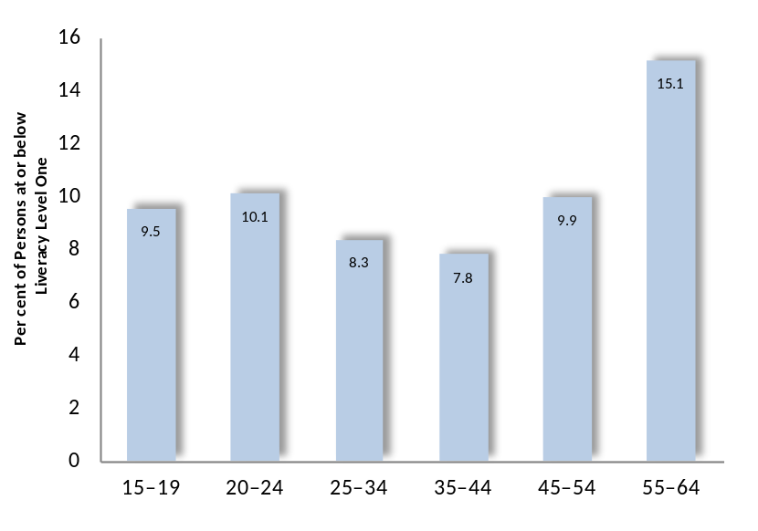

Literacy and Access to Modes of Written Communication
There are marked differences between people with limited and high levels of literacy, in their exposure to reading materials, including diagrams and maps, the internet and emails, books, magazines and newspapers. In everyday life, people with higher levels of literacy are five times more likely than those with limited literacy, to read diagrams, books or maps, and twenty times more likely to write or read memos, letters or emails.

Access to, or Use of, Written Media by Literacy Level: Australia, 2012
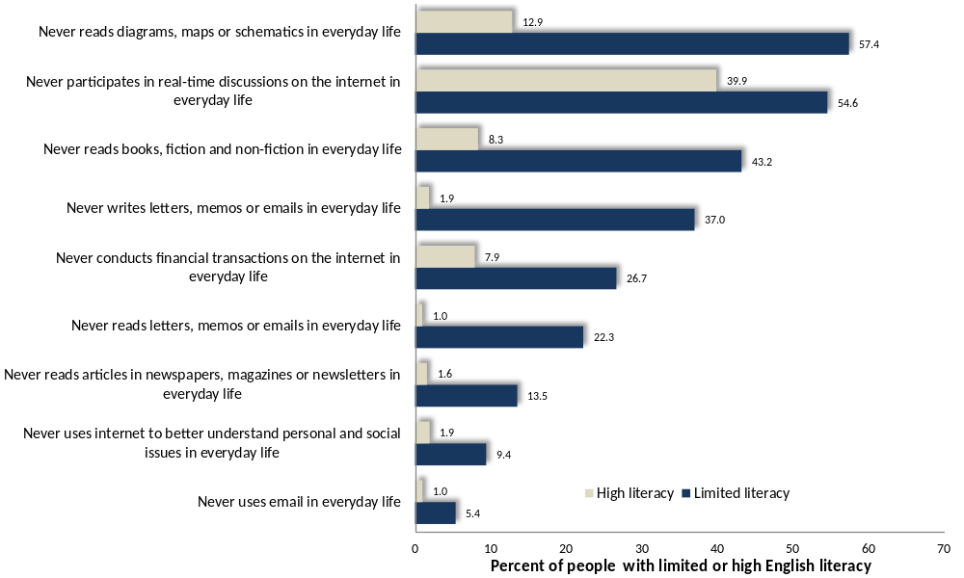

The Prevalence of Limited English Literacy among Victorian Municipalities
To generate sound estimates of the overall proportion of people aged 15-74 with limited literacy in specific localities, the prevalence of limited literacy among various combinations of age, educational and birthplace were determined from an earlier national survey of literacy – the 2006 Adult Literacy and Life Skills Survey - then coupled with information about the population of these segments of the community, based on the findings of the 2006 Census. The results suggested that approximately 26% of residents of Greater Dandenong aged 15 to 74 - or 21,000 people - have limited English literacy (Literacy Level One), compared with 16% of Victorian residents.
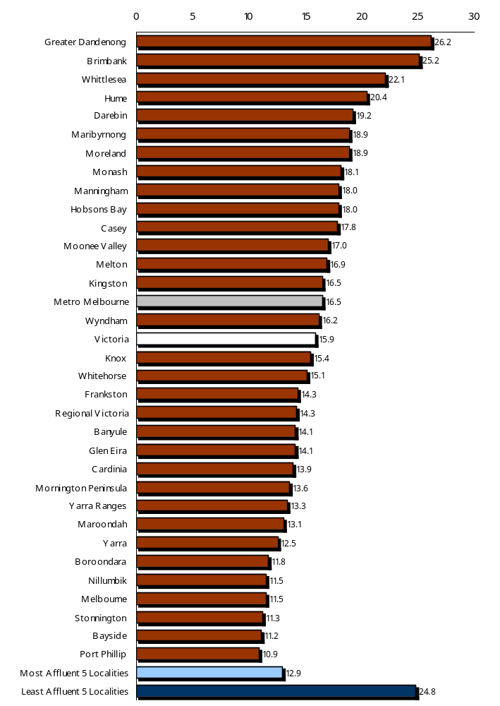
The estimated prevalence of limited literacy ranges from approximately a quarter of 15-74 year-olds in Greater Dandenong, Brimbank and Whittlesea, to a little over one in ten in Port Phillip, Bayside and Stonnington. Among those in Greater Dandenong with limited literacy are residents born in non English speaking countries - who account for four-fifths of people with limited English fluency in this community, and people educated to year ten or less - who represent two-thirds of residents with limited literacy.

Estimated Per Cent of Residents with Limited English Literacy

The illustration below depicts the estimated proportion of residents at Literacy Level One, within the 6,000 Census Collection Districts of metropolitan Melbourne, with the darker areas representing the highest concentrations of low literacy. Notably, the prevalence of limited literacy is greatest in the metropolitan suburbs to the north and west, and in the southeast – in the latter instance, concentrated in, and around, Greater Dandenong.

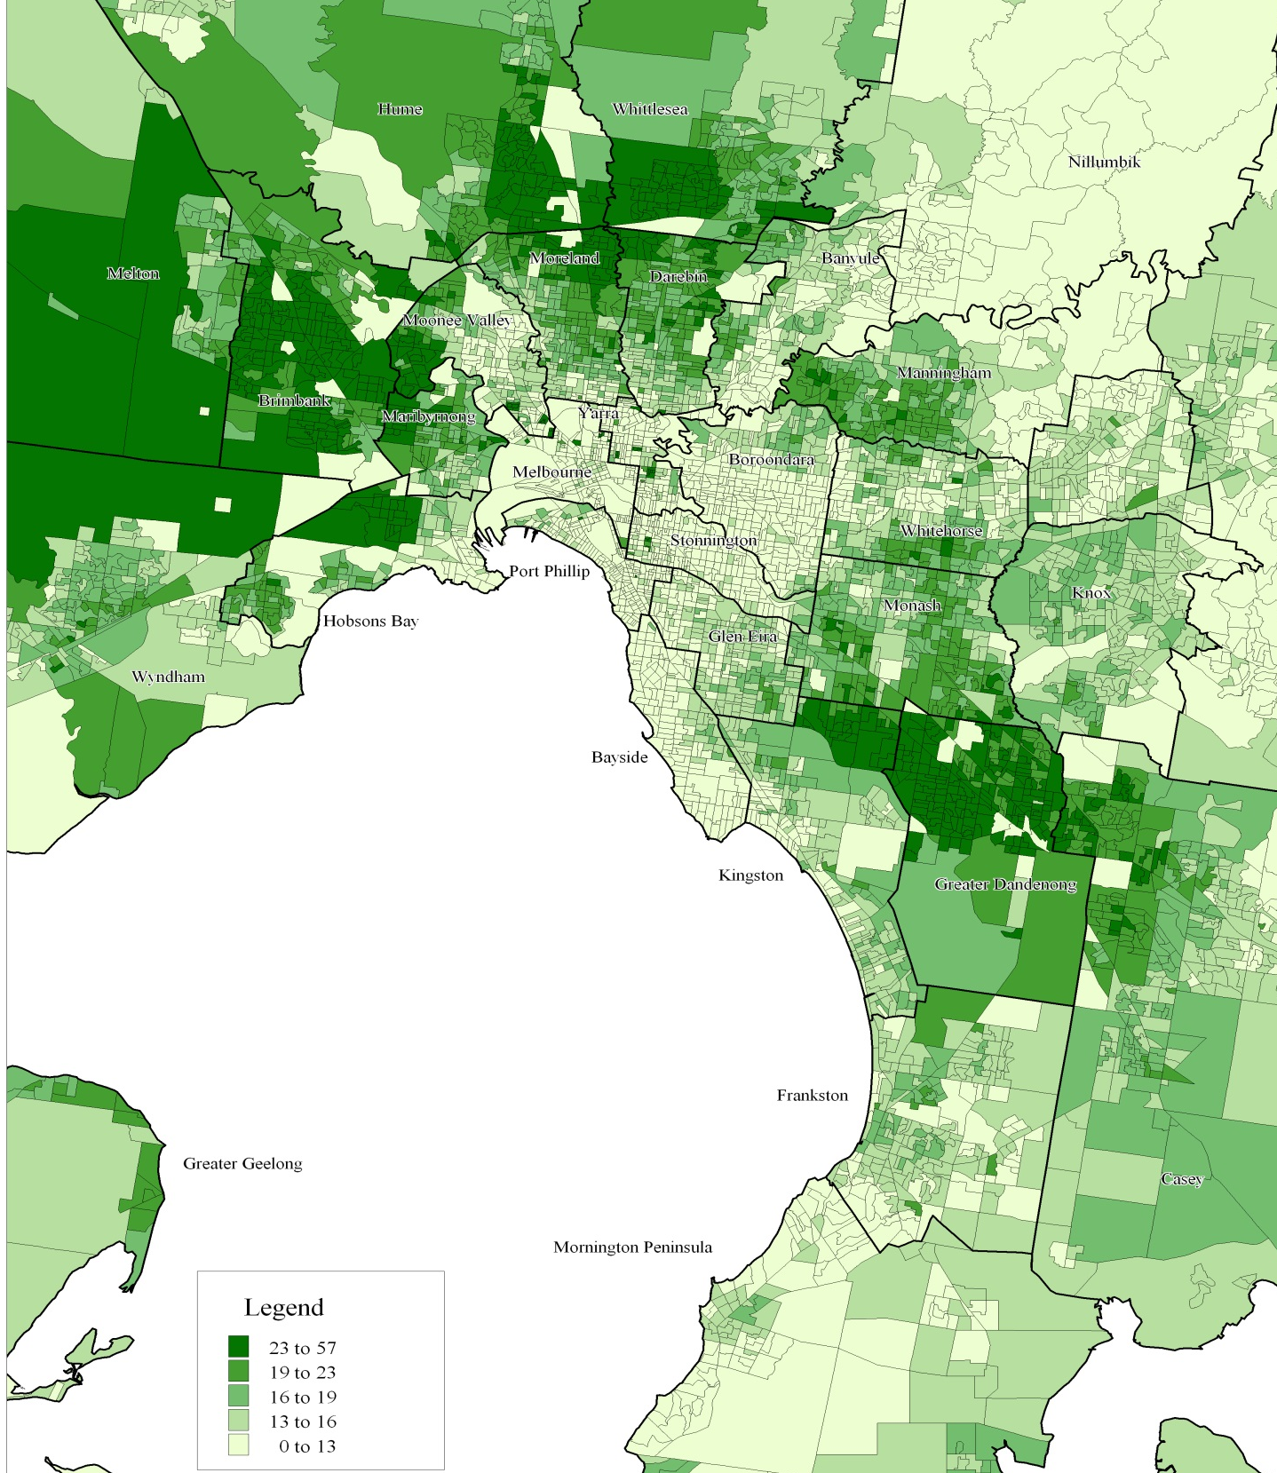
Estimated per cent of Residents with Limited English Literacy: 2006

Literacy in Languages Spoken at Home
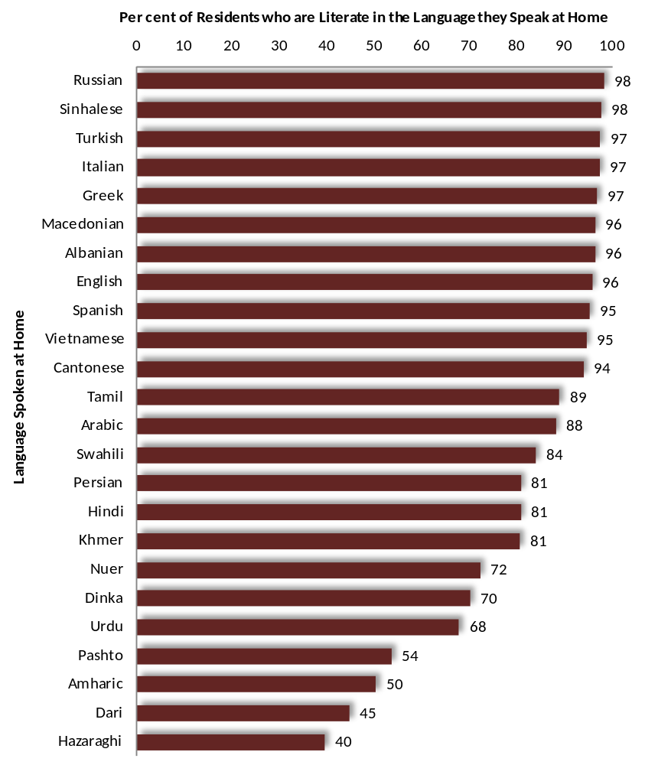
Estimates based upon the findings of the 2011 Census coupled with documented levels of literacy in a variety of nations, indicate that the rate of literacy among residents of Greater Dandenong, in their spoken languages, may vary widely - from nearly 100% among speakers of Russian, Sinhalese, Turkish, Italian, Greek and others, to 50% or less among those who speak Amharic, Dari and Hazaraghi in their homes (illustration at right).
It should be cautioned though, that these figures are estimates only, based upon the limited information available.

